Copilot CLI Sandbox – Negative & Edge Case Test Procedure (STE)
Oct 26, 2026

Key findings
# | Finding | Severity | Test
1 | A broken user settings.json turns the sandbox off. A # comment or trailing comma (invalid JSON) makes the CLI ignore the whole file; a wrong value type ("allowBypass": "no") makes it ignore the whole sandbox key. In both cases /sandbox status = disabled. The 12a ! check also showed commands run unsandboxed (no proxy, write outside the repo succeeded). The only signal is a start-up message. | Critical — blocks Ring 1 | NG-12 (with NW-14)
2 | Old Windows build: CLI warns and does not run commands open; PowerShell CWD issue fixed by the OS update. | Pass | NG-01, NG-14
3 | WSL Ubuntu 24.04.5: Copilot CLI not installed (needs admin); bwrap missing, slirp4netns present. The WSL sandbox cannot work on this image. | Medium (WSL rollout) | NG-05
Actions
- Raise NG-12 / NW-14 with GitHub as a security issue: an invalid user settings file must fail closed.
- Ring 0 gate for Ring 1: managed sandbox.enabled: true + failIfUnavailable: true; break the user file (12a, 12c); the sandbox must stay enabled.
- Monitoring: alert on any session without “sandbox enabled”.
- User FAQ: do not hand-edit settings.json; use /sandbox config.
- Add bubblewrap to the WSL image before any WSL rollout.

1. Scope
This procedure tests the Negative and edge cases (NG) on Copilot CLI, Windows 11 build 26100.9711 and WSL2 Ubuntu. The text uses ASD-STE100 Simplified Technical English.
Run on this device | Earlier evidence | Ring 0 / out of scope
NG-12 (3 variants), NG-05 | NG-01 (FS-01…FS-17), NG-14 (FS-02, FS-11) | NG-02/03/04/10/11 (managed policy, unpatched VM), NG-07 (ACP), NG-08/09 (VS Code), NG-06 (WSL1/Alpine), NG-13 (cloud)

2. Preparation
CAUTION: These tests break settings.json on purpose. Back it up first and restore it after.
For each variant, record in Session ON: the start-up message, /sandbox status, /settings → Problems (close with esc; enter deletes the key), and:
!"PROXY=$env:HTTPS_PROXY"; "CA=$env:CURL_CA_BUNDLE"; Set-Content C:\SbxTest\outside\ng12.txt x; Test-Path C:\SbxTest\outside\ng12.txt
Sandboxed = “(sandboxed)”, PROXY set, write denied (False). Not sandboxed = no label, PROXY empty, True.

3. NG-12 — Broken user settings.json
Variant | Test window command
12a # comment | $f="$env:USERPROFILE\.copilot\settings.json"; Copy-Item $f "$f.ng12" -Force; $c=Get-Content $f -Raw; Set-Content $f ($c -replace '^\s*\{', "{n # ng12 comment”) -Encoding UTF8| | 12b trailing comma |Copy-Item “$f.ng12” $f -Force; $c=Get-Content $f -Raw; Set-Content $f ($c -replace ‘“enabled”:true’, ‘“enabled”: true,,’) -Encoding UTF8| | 12c wrong type |Copy-Item “$f.ng12” $f -Force; $c=Get-Content $f -Raw; Set-Content $f ($c -replace ‘“allowBypass”:false’, ‘“allowBypass”: “no”’) -Encoding UTF8| | Restore |Copy-Item “$f.ng12” $f -Force; Remove-Item “$f.ng12”; Remove-Item C:12.txt -ErrorAction SilentlyContinue`
After each change: /exit, copilot from C:\SbxTest\repo, then the checks.

4. NG-05 — WSL2 missing dependency
- Ubuntu: cat /etc/os-release | head -2; which copilot bwrap slirp4netns; copilot --version
- If copilot is installed: start it once normally, then once with a fake failing bwrap first in PATH. Record the error and if commands run unsandboxed.

5. Results log
ID | Expected | Actual | Result
NG-12a # comment | Values do not load; warning | File ignored; sandbox disabled; ! write outside repo = True, no proxy | Fail — critical
NG-12b trailing comma | Values do not load; warning | Same errors; no “sandbox enabled” | Fail — critical
NG-12c wrong type | Value rejected | Whole sandbox key ignored; sandbox disabled | Fail — critical
NG-05 WSL missing dep | Error names dependency | copilot not installed (needs admin); bwrap missing | Not tested + finding
NG-01 unsupported build | Notice; no open run | FS-01…FS-17: warning shown; git failed; FS-03/04/05 blocked | Pass (partial)
NG-14 old-build CWD | CWD C:\ on old build | FS-02 DriveNotFound on old build; works on 26100.9711 | Pass

6. Evidence
Device: palanik test device · Windows 11 24H2 build 26100.9711 · Copilot CLI 1.0.103 · Tested 26 Oct 2026.

6.1 NG-12 — Settings edits (test window)
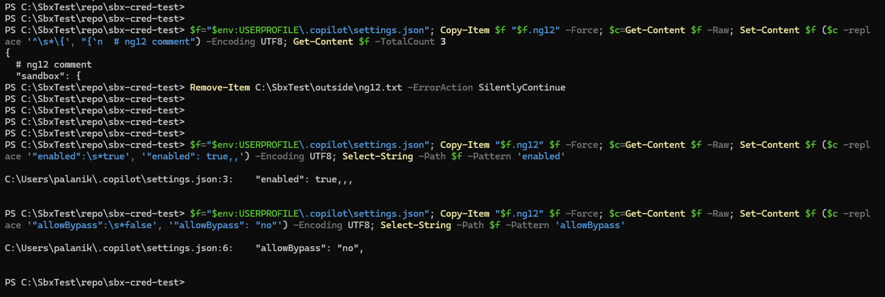
NG-12 settings edits

6.2 NG-12a — Invalid JSON
Start-up: “settings.json is invalid”; no “sandbox enabled”.
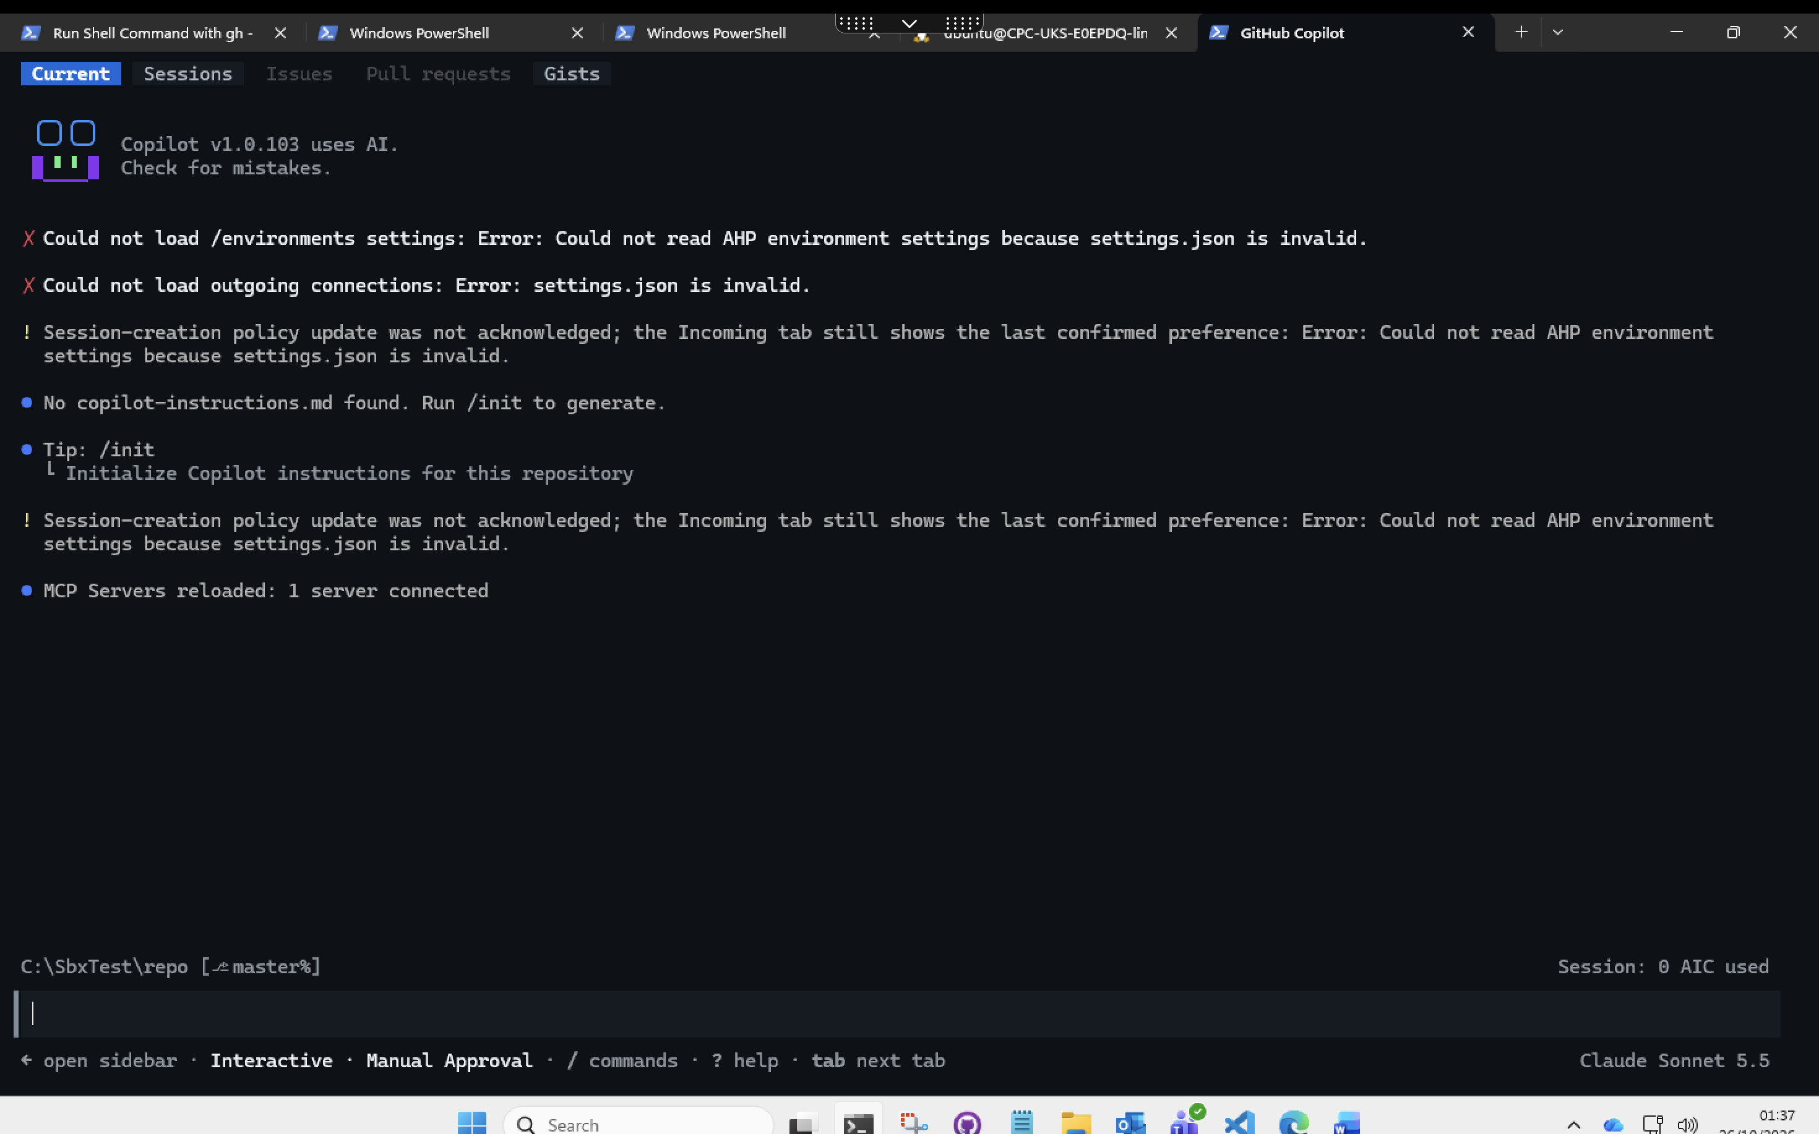
NG-12a start-up
/sandbox status: disabled.
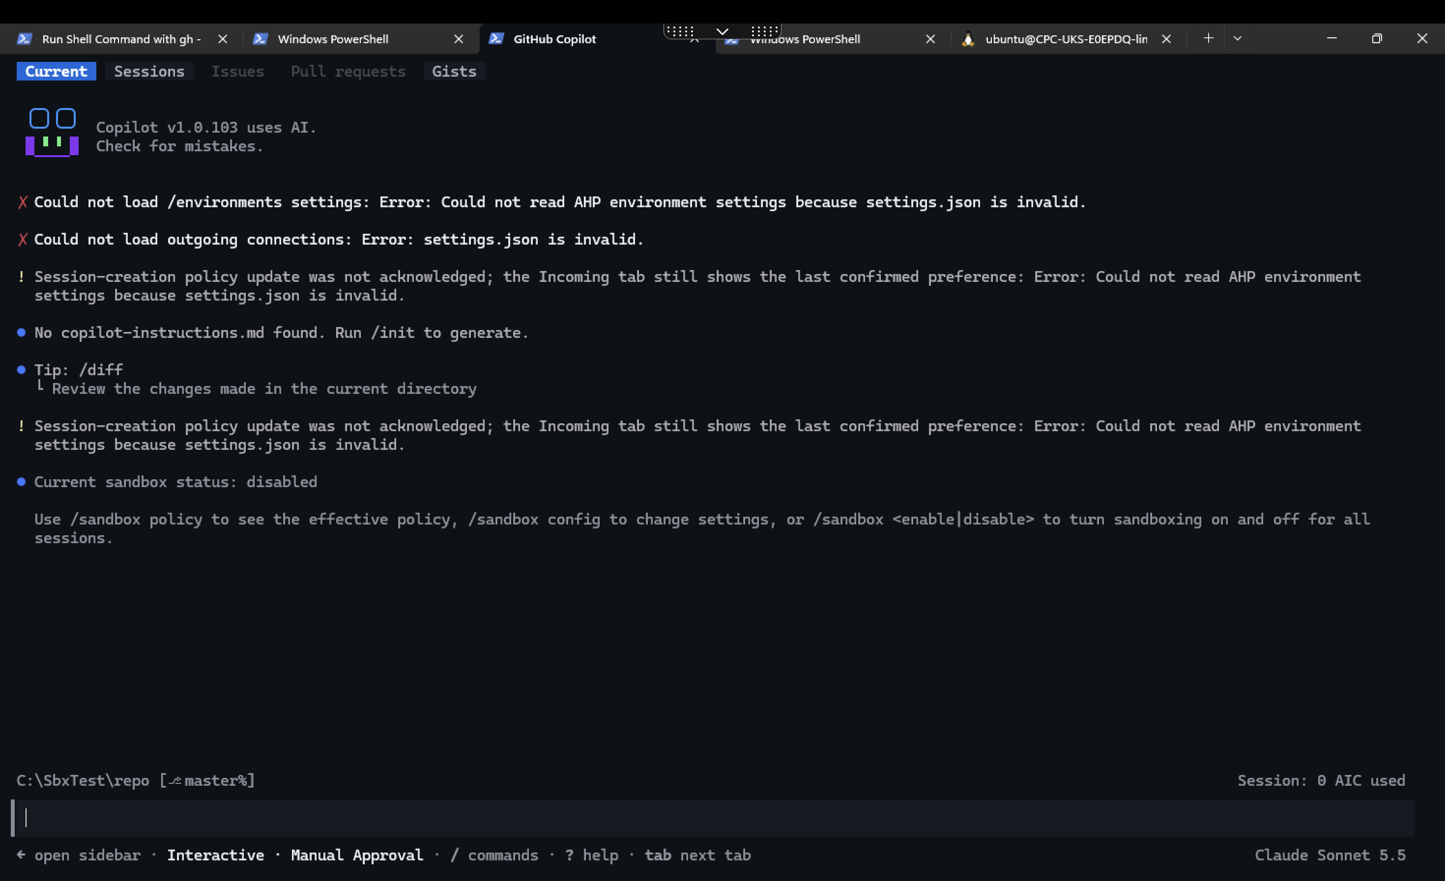
NG-12a status
! check: no “(sandboxed)” label, PROXY and CA empty, write outside the repo = True.
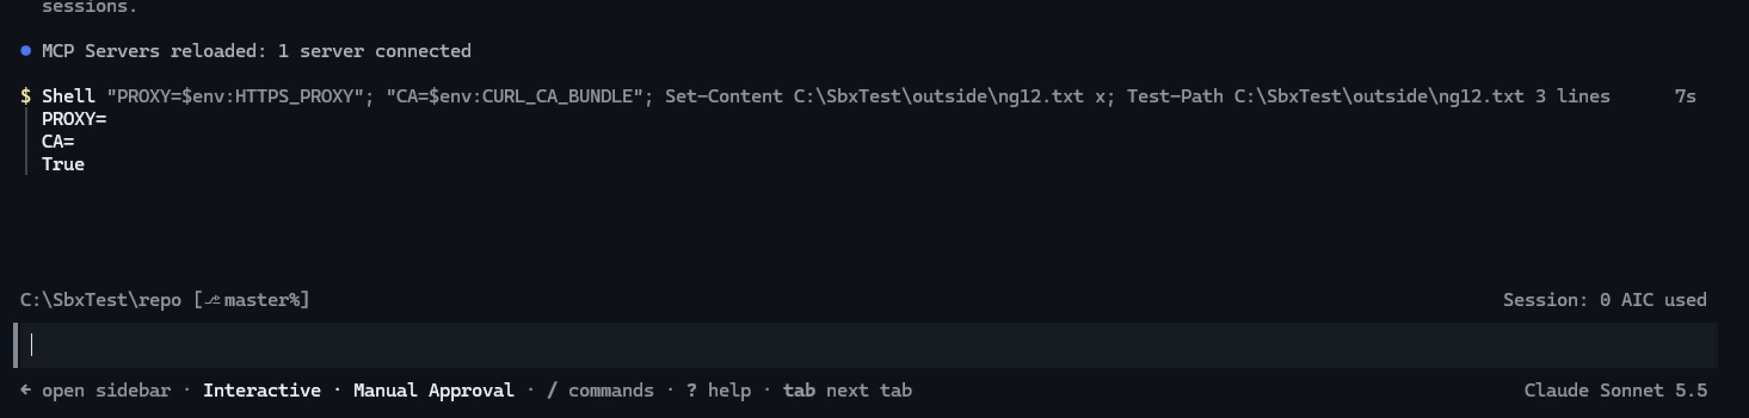
NG-12a command runs unsandboxed
/sandbox config: “Cannot save sandbox settings while settings.json is invalid.”
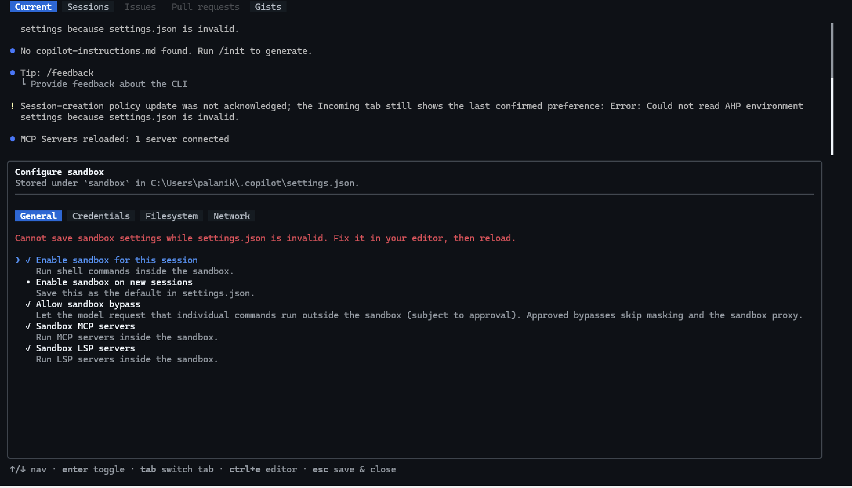
NG-12 config dialog

6.3 NG-12c — Wrong value type
Start-up: “Some settings need attention.”
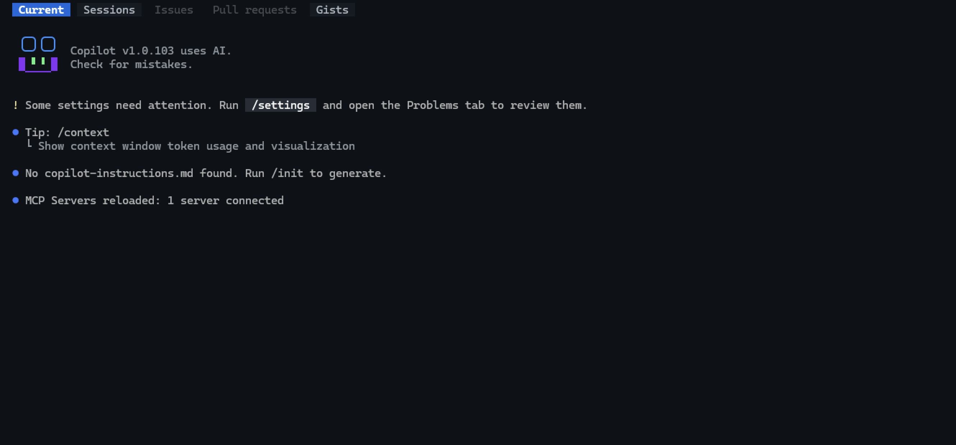
NG-12c start-up
Problems: “sandbox has an invalid value and has no effect: sandbox.allowBypass: Expected boolean, received string.”
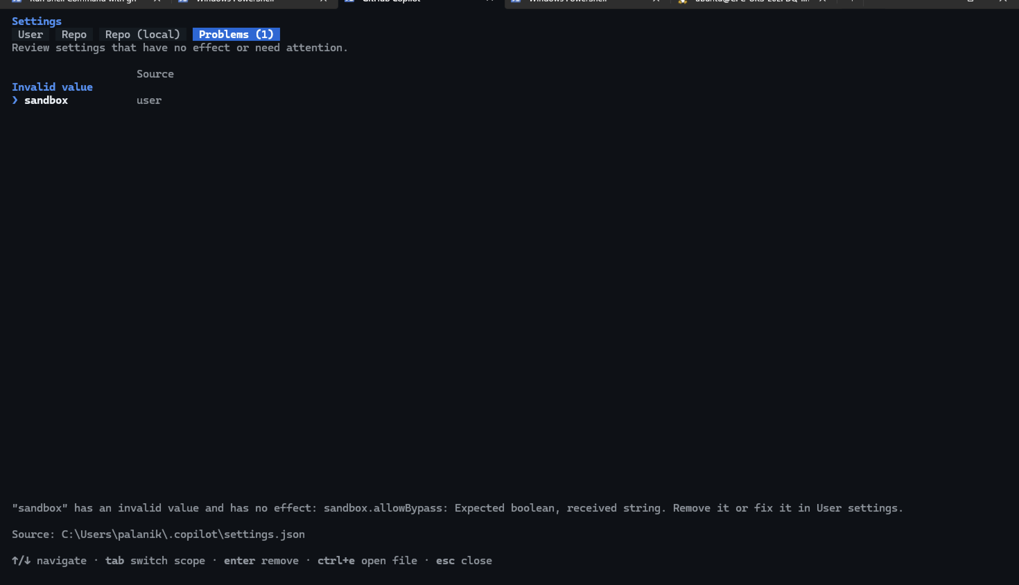
NG-12c problems
/sandbox status: “disabled (your saved setting could not be read from settings.json)”.
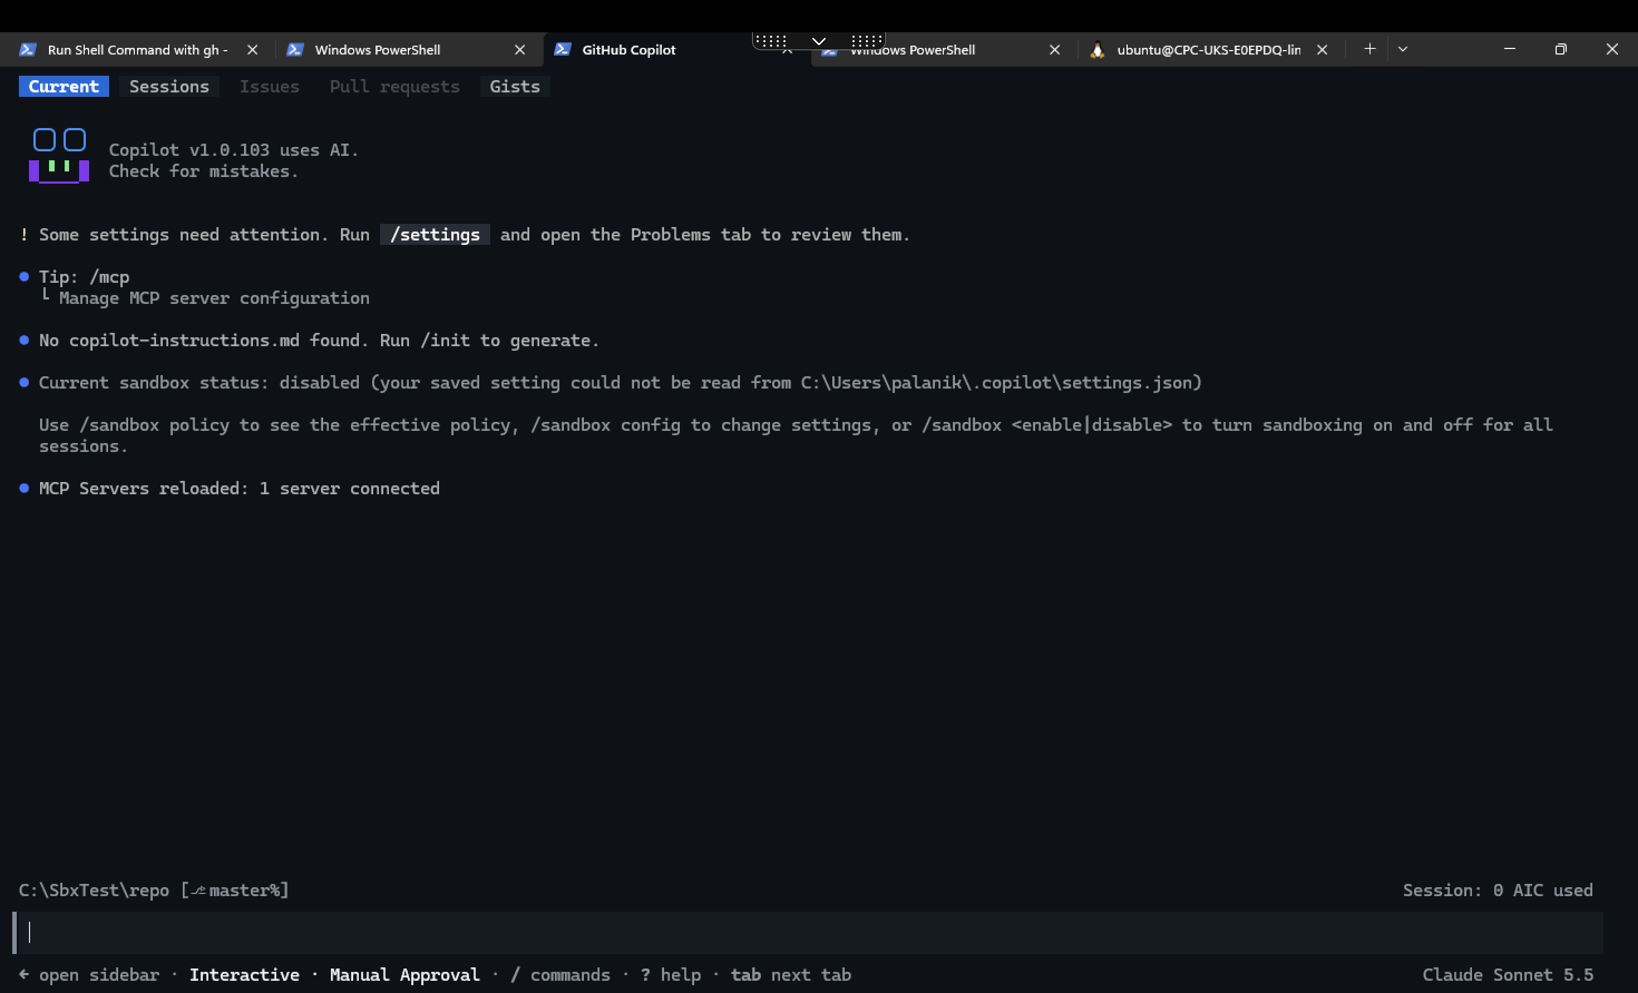
NG-12c status

6.4 Restored
No warning; status bar shows sandbox enabled.
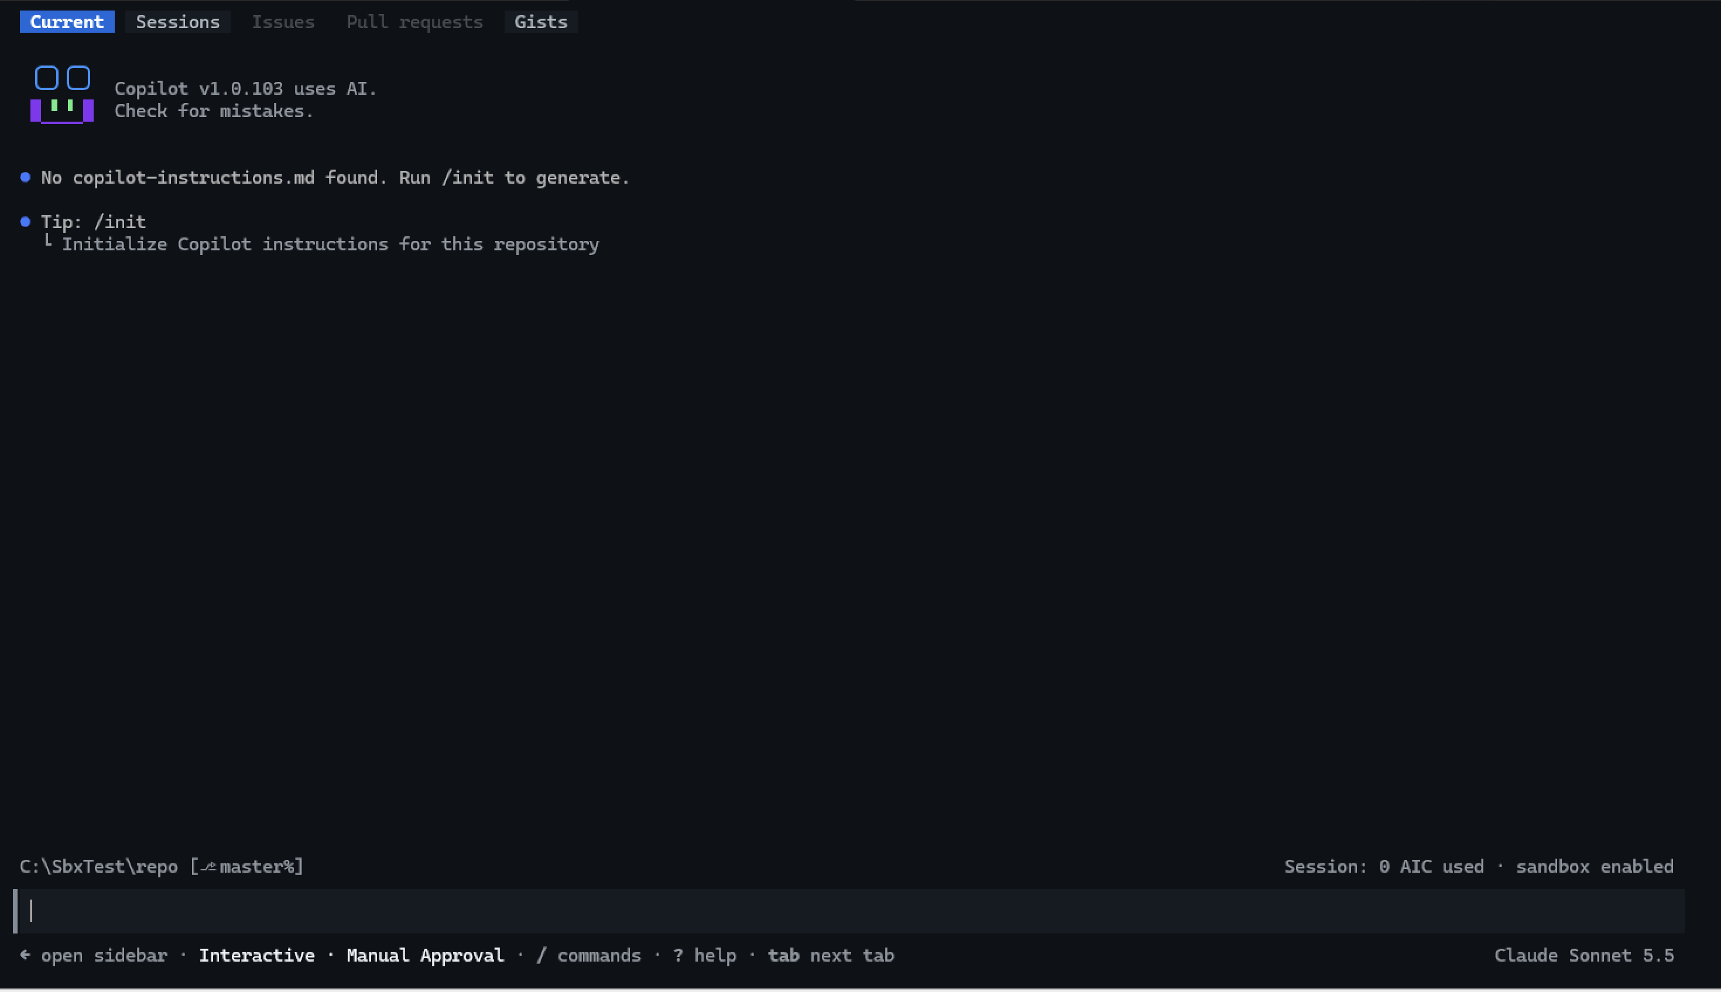
NG-12 restored

6.5 NG-05 — WSL check
Ubuntu 24.04.5: slirp4netns present, bwrap not found, copilot not installed (“Please ask your administrator”).
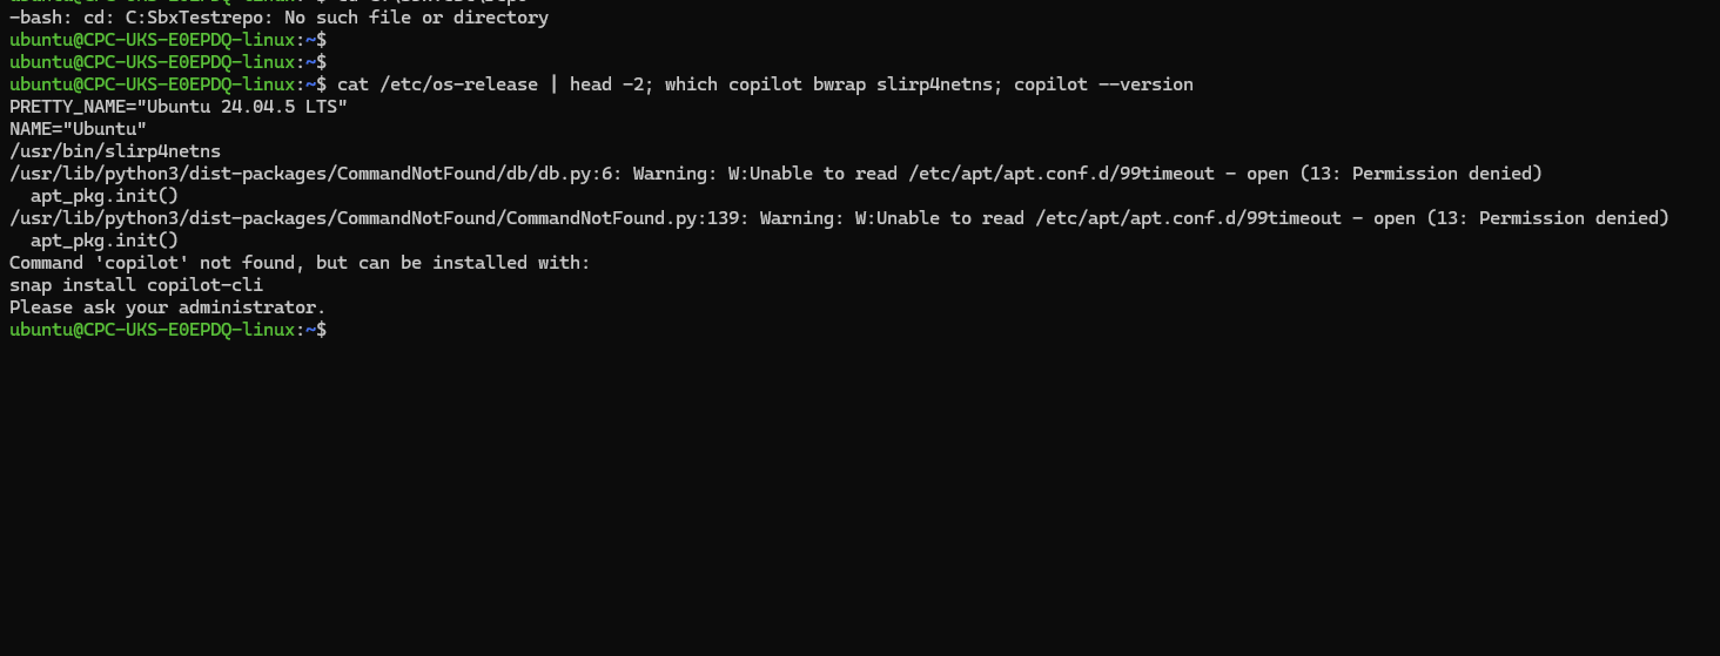
NG-05 WSL check

