Copilot CLI Sandbox – Network Test Procedure (STE)
Oct 25, 2026

Key findings
# | Finding | Severity | Test
1 | An invalid value in the user settings.json (for example a CIDR range in allowedHosts) turns the whole sandbox off. The CLI shows “sandbox disabled (your saved setting could not be read)” and commands run unsandboxed. The only signal is a one-line warning at start. | Critical — blocks Ring 1 | NW-14
2 | Direct outbound connections are blocked by the OS sandbox on build 26100.9711. All traffic must go through the built-in proxy. The known gap “Windows egress” is closed on this build. | Positive | NW-04
3 | allowLocalNetwork: false stops all sandboxed commands on Windows, because the built-in proxy listens on 127.0.0.1. Keep allowLocalNetwork: true. Local-network isolation is not available on Windows. | High (design limit) | NW-08, NW-10
4 | The proxy decrypts HTTPS and signs it again with a Copilot CA. git, npm, pip and node work (they read the CA variables). The Windows curl needs --cacert $env:CURL_CA_BUNDLE --ssl-no-revoke. PowerShell Invoke-WebRequest / Invoke-RestMethod and .NET HttpClient do not work. | Medium (compatibility) | NW-01
5 | Localhost is reachable only through the proxy. curl to a local server works; a direct connection (PowerShell) is blocked. | Medium | NW-09
6 | A server that the agent starts inside the sandbox is not reachable from the same sandbox (“Sandbox proxy could not reach the destination”). | Medium | NW-11
7 | The GitHub MCP server fails when a host filter is active (sandboxMcpServers: true). A fleet allowlist must include the MCP / Copilot API hosts. | Medium | NW-03
8 | Host rules work as documented: allowlist, wildcard (*.x does not include the apex), blocklist covers subdomains and wins over allow, IP rules work. Loopback is added automatically. | Pass | NW-03, 05, 06, 14
9 | The corporate web filter blocks some hosts (example.org, wikipedia, npmjs, test.pypi, 1.1.1.1) for every user. Always check a host in Session OFF first. | Test note | 7.8
Actions
- Raise NW-14 with GitHub as a security issue (an invalid setting must fail closed).
- Ring 0: managed policy sets sandbox.enabled: true; put an invalid value in the user file and make sure the sandbox stays enabled. Do not start Ring 1 until this passes.
- Monitoring: alert on sessions where the status is not “sandbox enabled”.
- InfoSec known-gap list: remove NW-04 (Windows egress); add local-network access (finding 3).
- User FAQ: findings 4, 5, 6; host rules accept only a hostname, an IP or *.domain; never import the copilot-credential-ca file into the Windows certificate store.

1. Scope
This procedure tests the Network cases (NW-01 to NW-15) of the Test & Validation Plan. It applies to Copilot CLI on native Windows 11, build 26100.9711 (above the 26100.9550 minimum). The text uses ASD-STE100 Simplified Technical English.
How the Windows sandbox controls the network
Part | What it does | Limit
Built-in proxy | The CLI starts a local proxy and sets HTTPS_PROXY / HTTP_PROXY in the sandboxed shell. The proxy applies allowedHosts and blockedHosts | It controls only programs that use the proxy variables
OS sandbox | Controls loopback and local network with allowLocalNetwork | Not a full firewall
Two network clients in the tests
Client | Uses HTTPS_PROXY? | Use it to test
curl.exe | Yes | The host rules (allowlist, blocklist, wildcards)
Invoke-WebRequest (PowerShell 5.1) | No — it uses the Windows (WinINet) proxy settings | Programs that go around the host rules
Out of scope on this device: NW-07 and NW-12 (need managed policy, Ring 0); NW-15 (needs a remote MCP server on a private address).

2. Preparation
WARNING: Do not send real data to an external host. Use only the test URLs in this procedure.
CAUTION: If your network has a corporate proxy or a firewall, a host can be blocked by the network and not by the sandbox. Always do Session OFF as well.

2.1 Restore the settings file
- In the test window, put back the settings from the FS tests:
- Copy-Item $env:USERPROFILE\.copilot\settings.backup.json $env:USERPROFILE\.copilot\settings.json -Force
- Open C:\Users\palanik\.copilot\settings.json. Make sure the network section has allowOutbound: true, allowLocalNetwork: true and empty allowedHosts / blockedHosts.
- Make sure the test folder C:\SbxTest\repo exists.

2.2 Start the local test server
- Open a fourth PowerShell window (the server window). Run:
- $l = New-Object Net.HttpListener; $l.Prefixes.Add('http://localhost:18080/'); $l.Start(); 'Server running on 18080'; while ($true) { $c = $l.GetContext(); $from = "$($c.Request.RemoteEndPoint)"; $c.Response.ContentType = 'text/plain'; $b = [Text.Encoding]::UTF8.GetBytes('SBX-LOCAL-OK'); $c.Response.OutputStream.Write($b, 0, $b.Length); $c.Response.Close(); "$(Get-Date -f T) request from $from" }
- In the test window, make sure the server works: (Invoke-WebRequest http://localhost:18080 -UseBasicParsing).Content must show SBX-LOCAL-OK.
- Keep the server window open. Each request shows a line in the server window. This line is your evidence that the request arrived.

2.3 Start the sessions
- In the Session ON window, run cd C:\SbxTest\repo and then copilot.
- Type /sandbox policy. Look at the Network section. Save a screenshot.
- In the Session OFF window, run cd C:\SbxTest\repo and then copilot --no-sandbox.

2.4 Prompts and commands
Use the same SHELL prompt as in the FS procedure:
Use the shell tool to run exactly this command one time. Do not use a different tool. Do not try again. Show the full output:
C1 — curl (uses the proxy). For HTTPS in Session ON, add the CA workaround:
curl.exe -sS -o NUL -w "HTTP %{http_code}" --max-time 15 --cacert $env:CURL_CA_BUNDLE --ssl-no-revoke <URL>
C2 — PowerShell (does not use the proxy variables):
(Invoke-WebRequest -Uri <URL> -UseBasicParsing -TimeoutSec 15).StatusCode
Output | Meaning
HTTP 200, HTTP 301 or 200 | Allowed
“CONNECT tunnel failed, response 403” | Blocked by the sandbox host rules
Connection error / reset | Blocked — do Session OFF to know if the sandbox or the network is the cause
Rules: do one test at a time. After each change to settings.json, type /exit, start copilot again and save a screenshot of /sandbox policy.

3. Procedure A — default policy
- NW-01 — C1 and C2 with https://github.com, plus git ls-remote https://github.com/github/copilot-cli HEAD. Session ON and OFF.
- NW-04 — $t = New-Object Net.Sockets.TcpClient; $t.Connect('www.wikipedia.org', 443); "direct connect: $($t.Connected)"; $t.Close(). Session ON and OFF.
- NW-09 — C1 and C2 with http://localhost:18080. Look at the server window. Session ON and OFF.
- NW-11 — the agent starts a server on port 18081 in a background job and calls it with curl.
- NW-13 — prompt: Use only your built-in web fetch tool. Do not use the shell. Do not try again. Fetch http://localhost:18080 and show the full response.

4. Procedure B — tests that change settings.json
CAUTION: Make sure that the file stays valid JSON. An invalid value disables the whole sandbox (NW-14). Change only the keys that the test gives. Put the network section back after each test.
Test | Keys | Commands
NW-08 | allowLocalNetwork: false | C1 to localhost and to the gateway; web fetch to localhost
NW-02 | allowOutbound: false | git and C1 to github.com; C1 to localhost
NW-03 | allowedHosts: ["github.com"] | git and C1 to github.com; C1 to pypi.org
NW-06 | allowedHosts: ["*.github.com"] | C1 to api.github.com and github.com
NW-05 | allowedHosts: ["github.com","*.github.com","pypi.org"], blockedHosts: ["github.com"] | C1 to github.com, api.github.com, pypi.org
NW-14 | allowedHosts: ["151.101.192.223"], then ["151.101.192.0/24"] | C1 to the IP; /settings Problems; /sandbox status

5. Results log
ID | Method | Expected ON | Actual ON | Actual OFF | Result | Notes
NW-01 | C1 + C2 + git | Allowed | git allowed. Windows curl: untrusted root (allowed with CA workaround). Invoke-WebRequest: blocked / TLS trust error | curl 200, IWR 200 | Pass + compatibility finding | See 7.4
NW-02 | git + C1 | Blocked | github.com blocked (git and curl). localhost 200 | — | Pass | See 7.7
NW-03 | git + C1 | github allowed; other blocked | github.com allowed; pypi.org CONNECT 403 | pypi.org 200 | Pass + MCP finding | See 7.9
NW-04 | TcpClient | Direct connect works | Blocked: “forbidden by its access permissions” | True | Pass (better than plan) | See 7.3
NW-05 | C1 | Blocked host + subdomain blocked | github.com 403, api.github.com 403, pypi.org 200 | — | Pass | See 7.11
NW-06 | C1 | Subdomain allowed; apex blocked | api.github.com 200, github.com 403 | api.github.com 200 | Pass | See 7.10
NW-07 | — | Every host denied | — | — | Out of scope | Ring 0
NW-08 | C1 + fetch | localhost and LAN blocked | All sandboxed commands fail to start | — | Pass + finding | See 7.5
NW-09 | C1 + C2 | localhost allowed | curl 200 (via proxy); IWR blocked (direct) | curl 200, IWR 200 | Pass + finding | See 7.2
NW-10 | Shell | Commands do not start | Covered by NW-08 | — | Pass (by NW-08) | —
NW-11 | Shell | Verify | “Sandbox proxy could not reach the destination” | — | Not supported on Windows | See 7.13
NW-12 | — | Traffic via corporate proxy | — | — | Out of scope | Ring 0
NW-13 | Web fetch | Follows local-network setting | OFF: blocked. ON: SBX-LOCAL-OK | — | Pass | See 7.6, 7.13
NW-14 | C1 | IP allowed; CIDR not supported | IP allowed. CIDR: whole sandbox disabled | — | Fail — critical | See 7.12
NW-15 | — | Private MCP blocked | — | — | Out of scope | —

6. Restore the device
- In each Copilot session, type /exit.
- In the server window, push Ctrl+C.
- Put back your settings file: Copy-Item $env:USERPROFILE\.copilot\settings.backup.json $env:USERPROFILE\.copilot\settings.json -Force
- Attach the results log and the screenshots to the ring change record.

7. Evidence
Device: palanik test device · Windows 11 24H2 build 26100.9711 · Copilot CLI 1.0.103 · Tested 25 Oct 2026.

7.1 Baseline policy
/sandbox policy shows Outbound: allowed and Local network: allowed, no host rules.
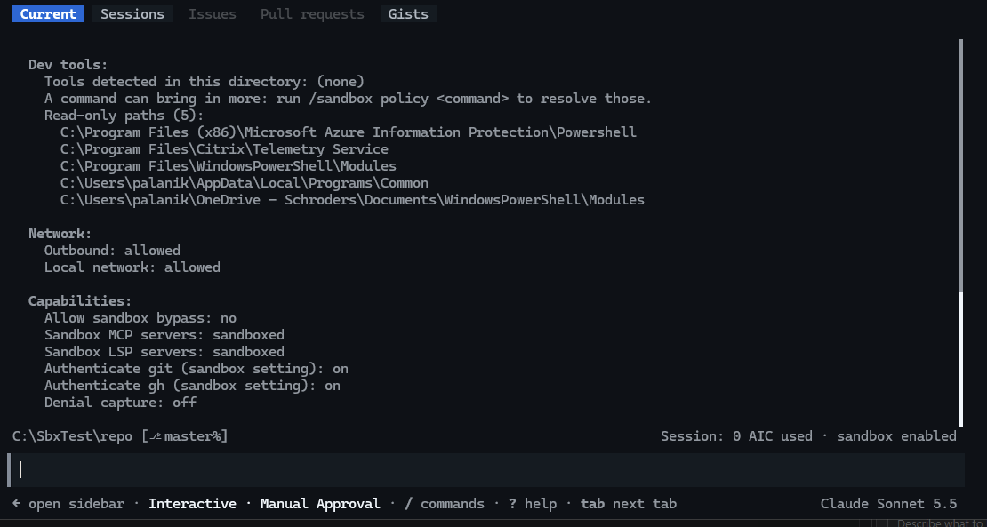
Baseline /sandbox policy

7.2 NW-09 — Local network ON (localhost)
Finding: localhost is reachable only through the built-in proxy.
Session ON, C1: HTTP 200, sandboxed.
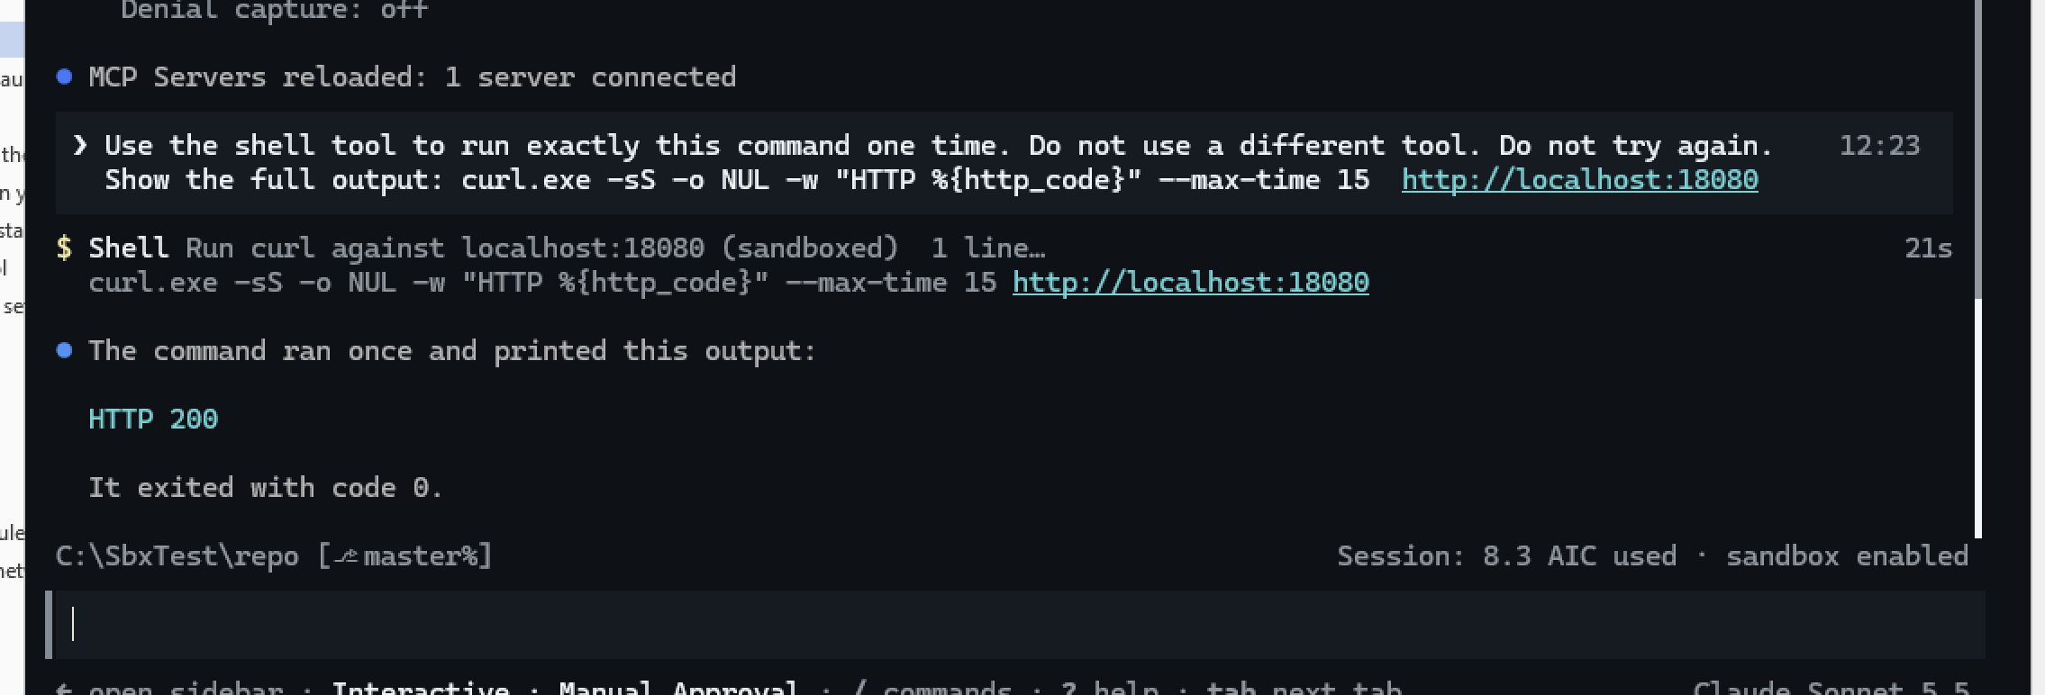
NW-09 Session ON curl
Server window: request arrived at 12:24:07 from 127.0.0.1.
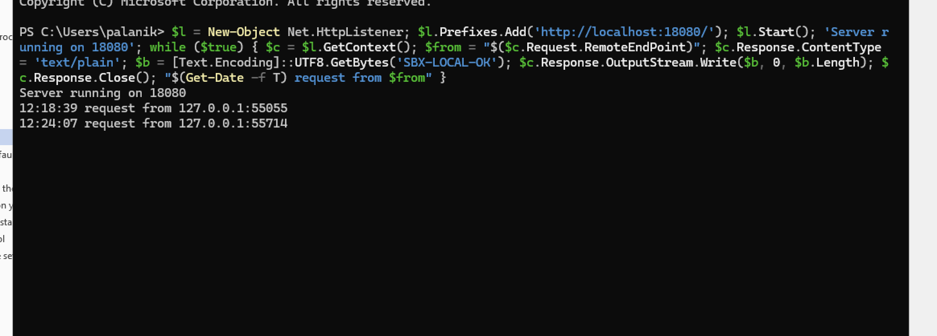
NW-09 server window
Session ON, C2: “Unable to connect to the remote server” (direct connection blocked).
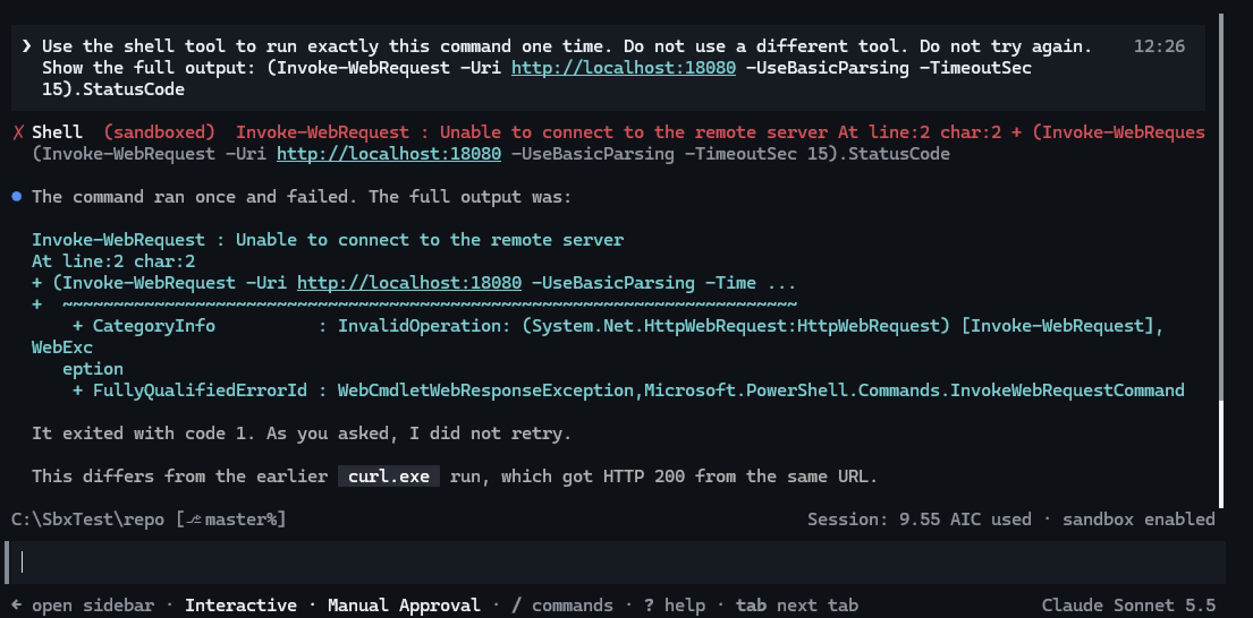
NW-09 Session ON Invoke-WebRequest
Session OFF: C1 200, C2 200 (this screen also shows NW-01, NW-04 and the example.org 503 in OFF).
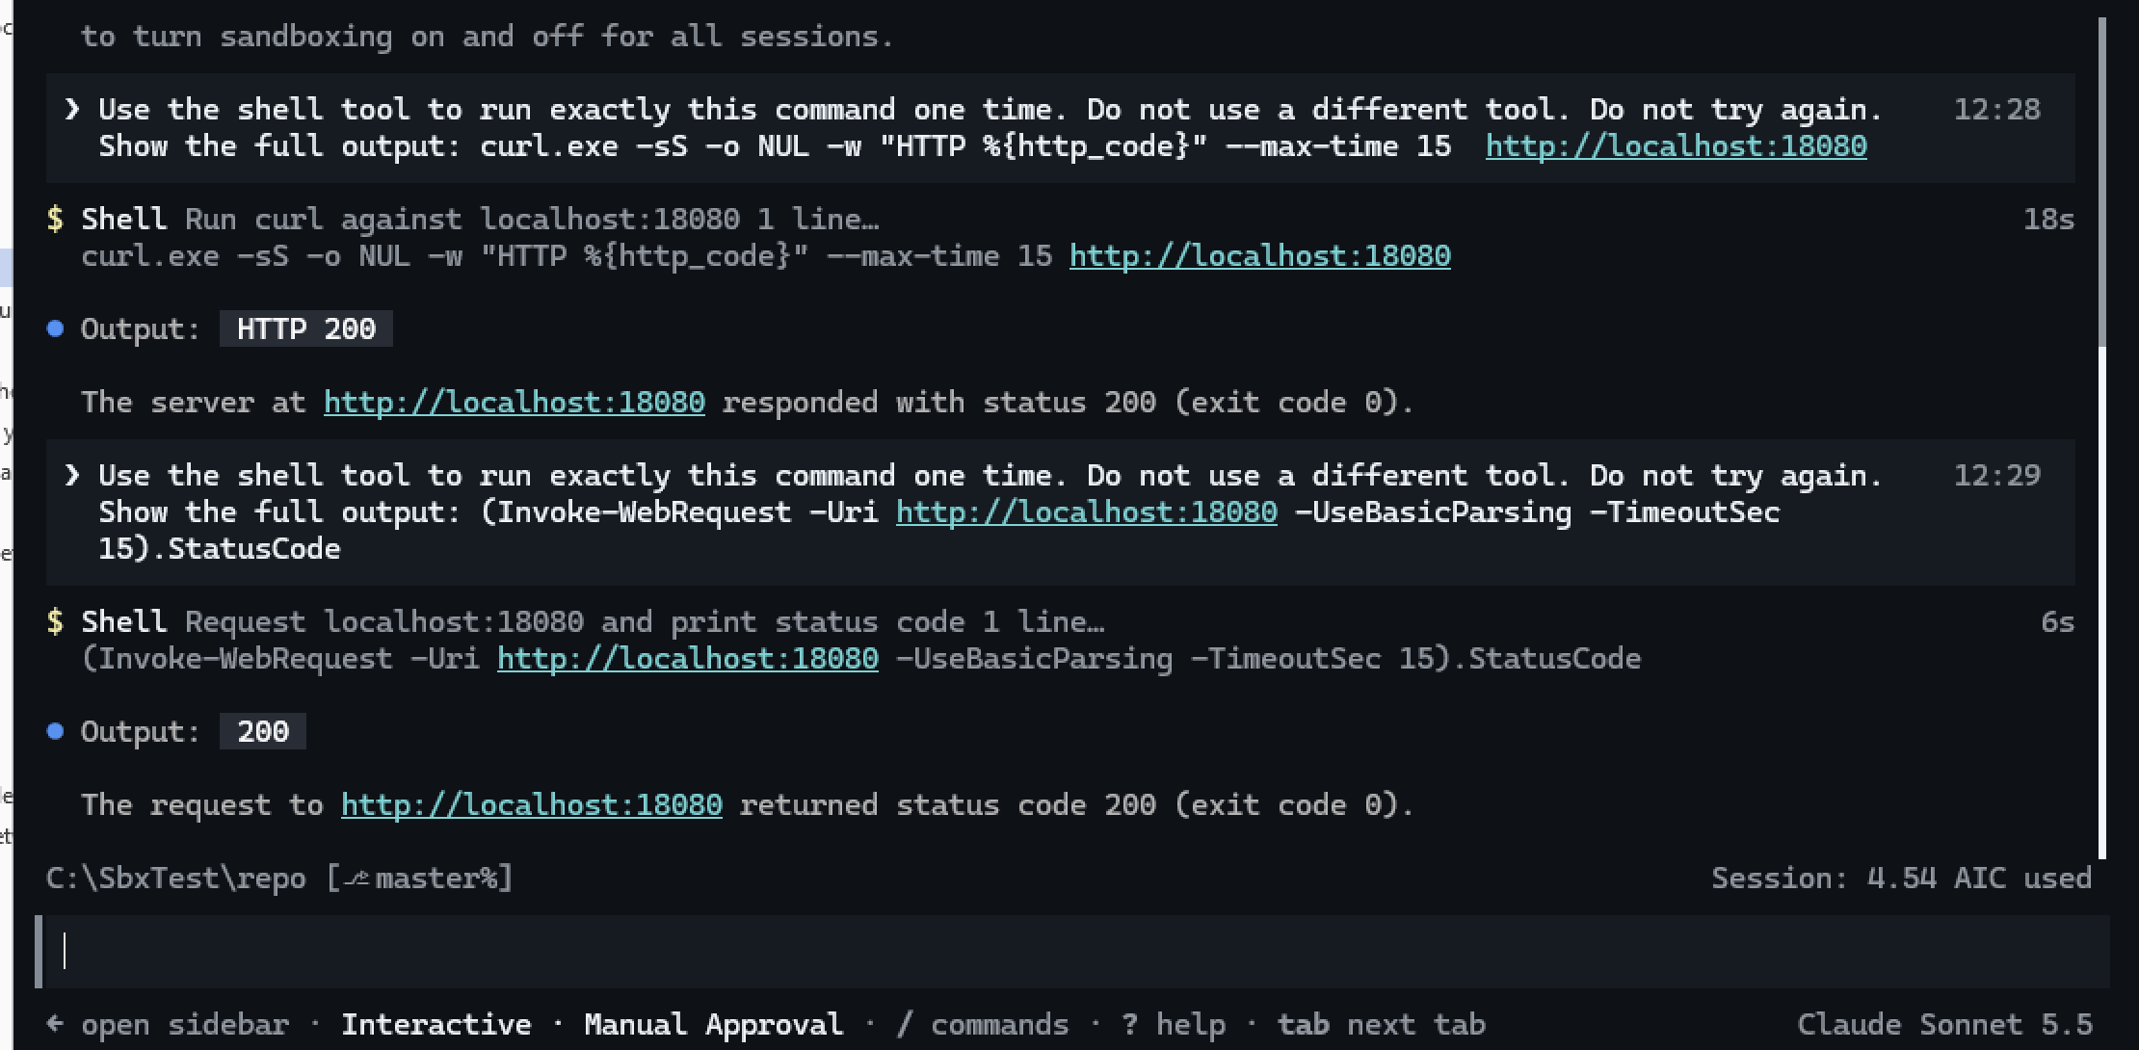
NW-09 Session OFF

7.3 NW-04 — Program that ignores the proxy
Finding: the OS sandbox blocks direct outbound connections on build 26100.9711.
Session ON: “An attempt was made to access a socket in a way forbidden by its access permissions”.
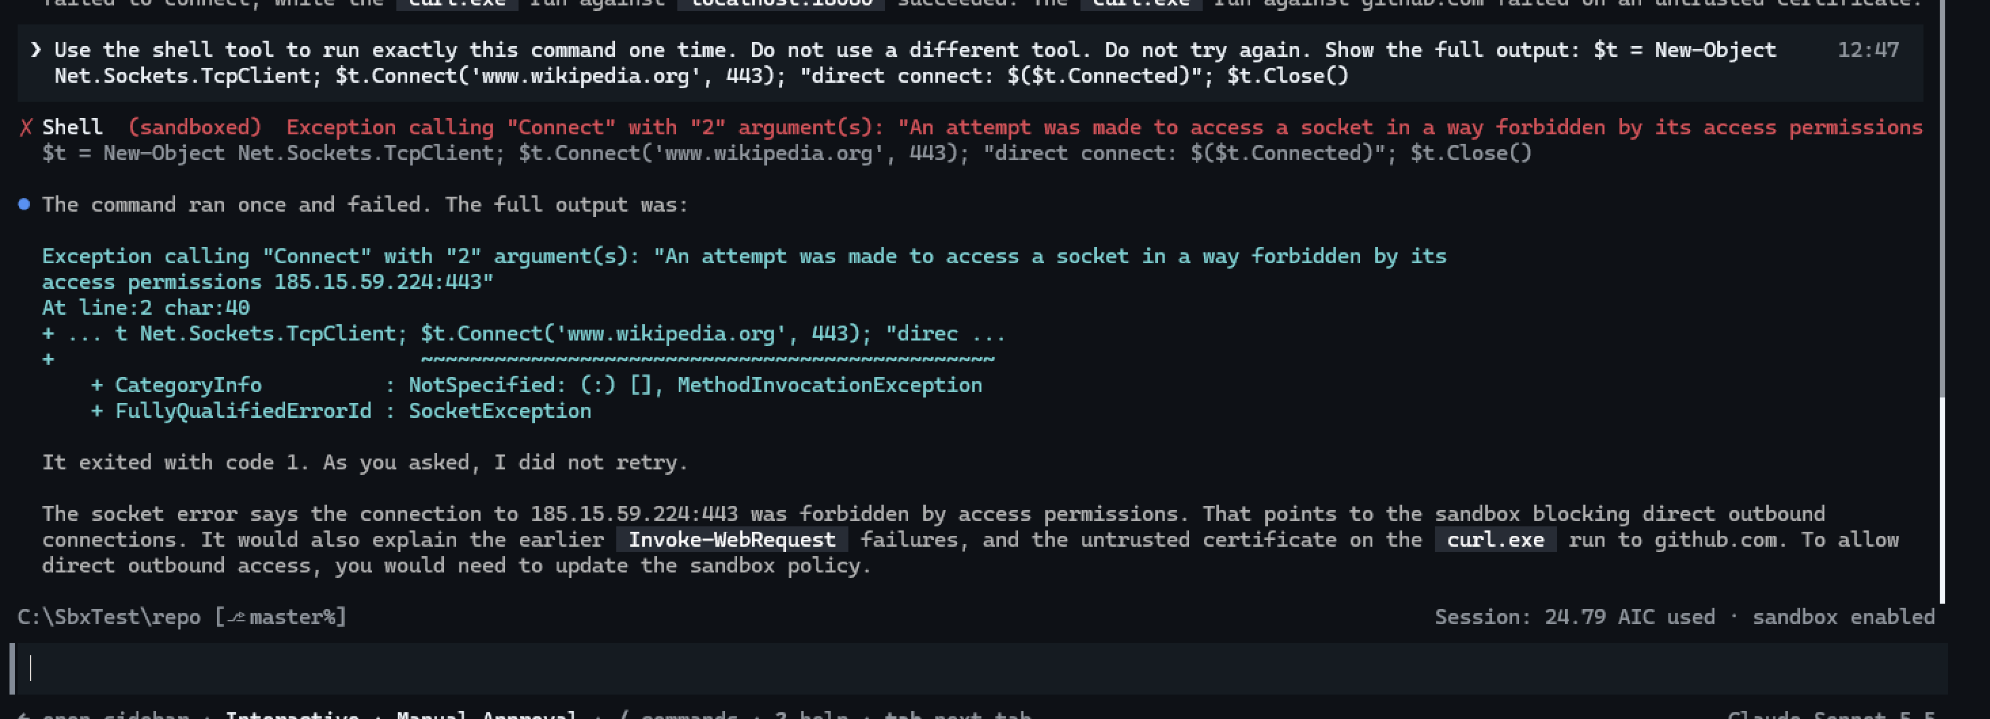
NW-04 Session ON
Session OFF: direct connect: True.
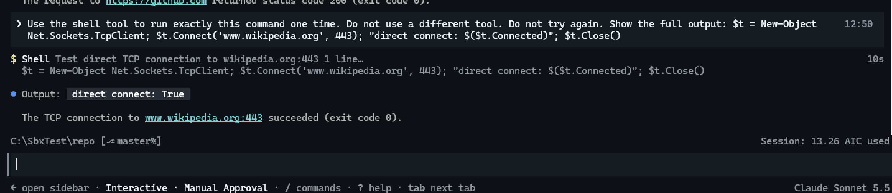
NW-04 Session OFF

7.4 NW-01 — Default outbound
Finding: the proxy signs HTTPS again with a Copilot CA. Tools that read the CA variables work; Windows-store tools fail.
Session ON, C1: SEC_E_UNTRUSTED_ROOT.
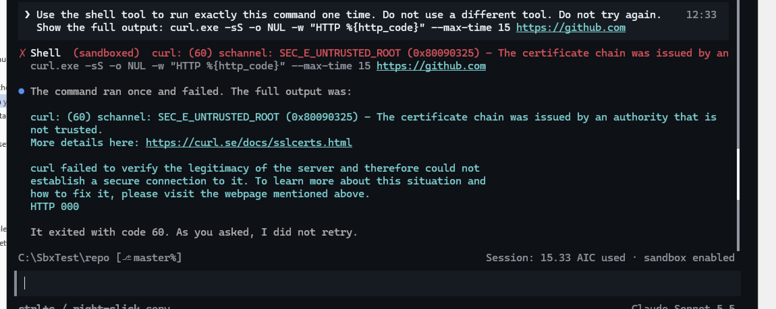
NW-01 Session ON curl
Session ON, C2: “Unable to connect to the remote server”.
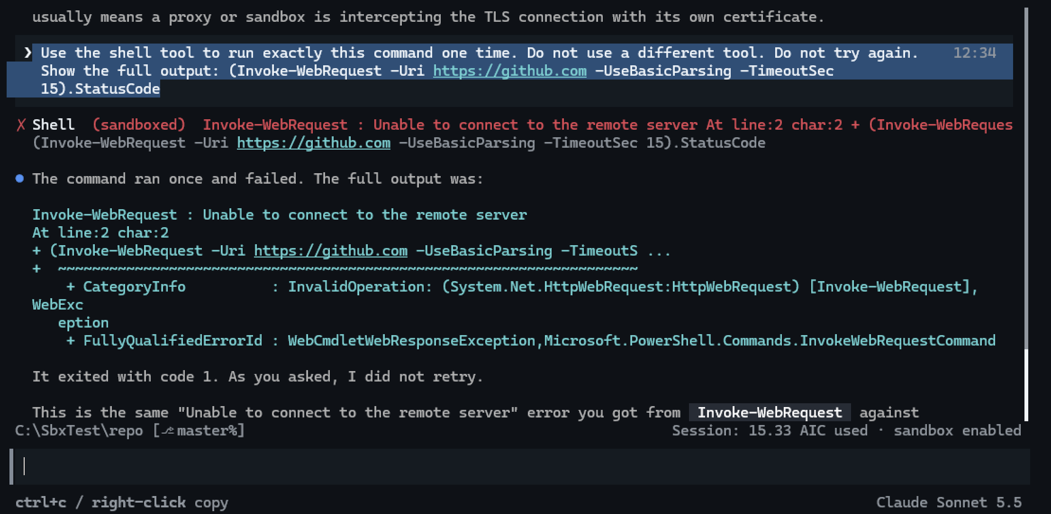
NW-01 Session ON Invoke-WebRequest
Session OFF: C1 200, C2 200.
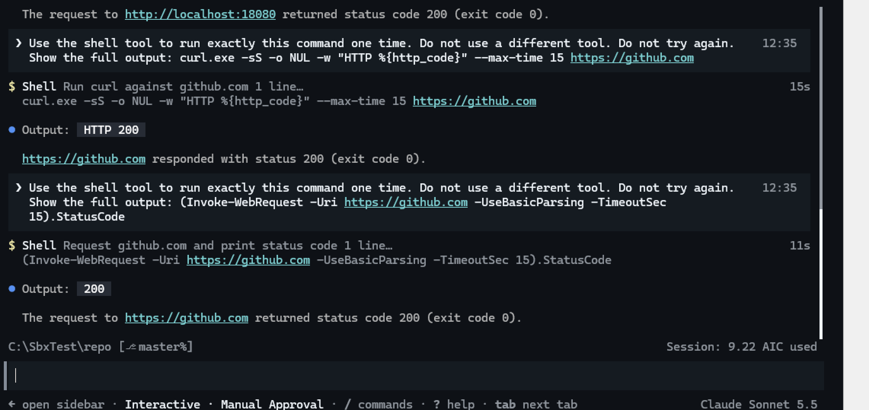
NW-01 Session OFF
Test window: github.com certificate issuer is Sectigo — no corporate TLS inspection.
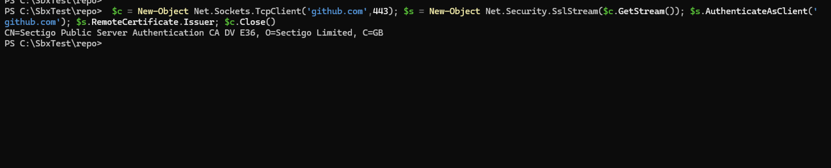
NW-01 issuer
Session ON, environment: HTTP(S)_PROXY = http://127.0.0.1:61811; CURL_CA_BUNDLE, GIT_SSL_CAINFO, NODE_EXTRA_CA_CERTS, REQUESTS_CA_BUNDLE, SSL_CERT_FILE = %TEMP%\copilot-credential-ca-*.pem.
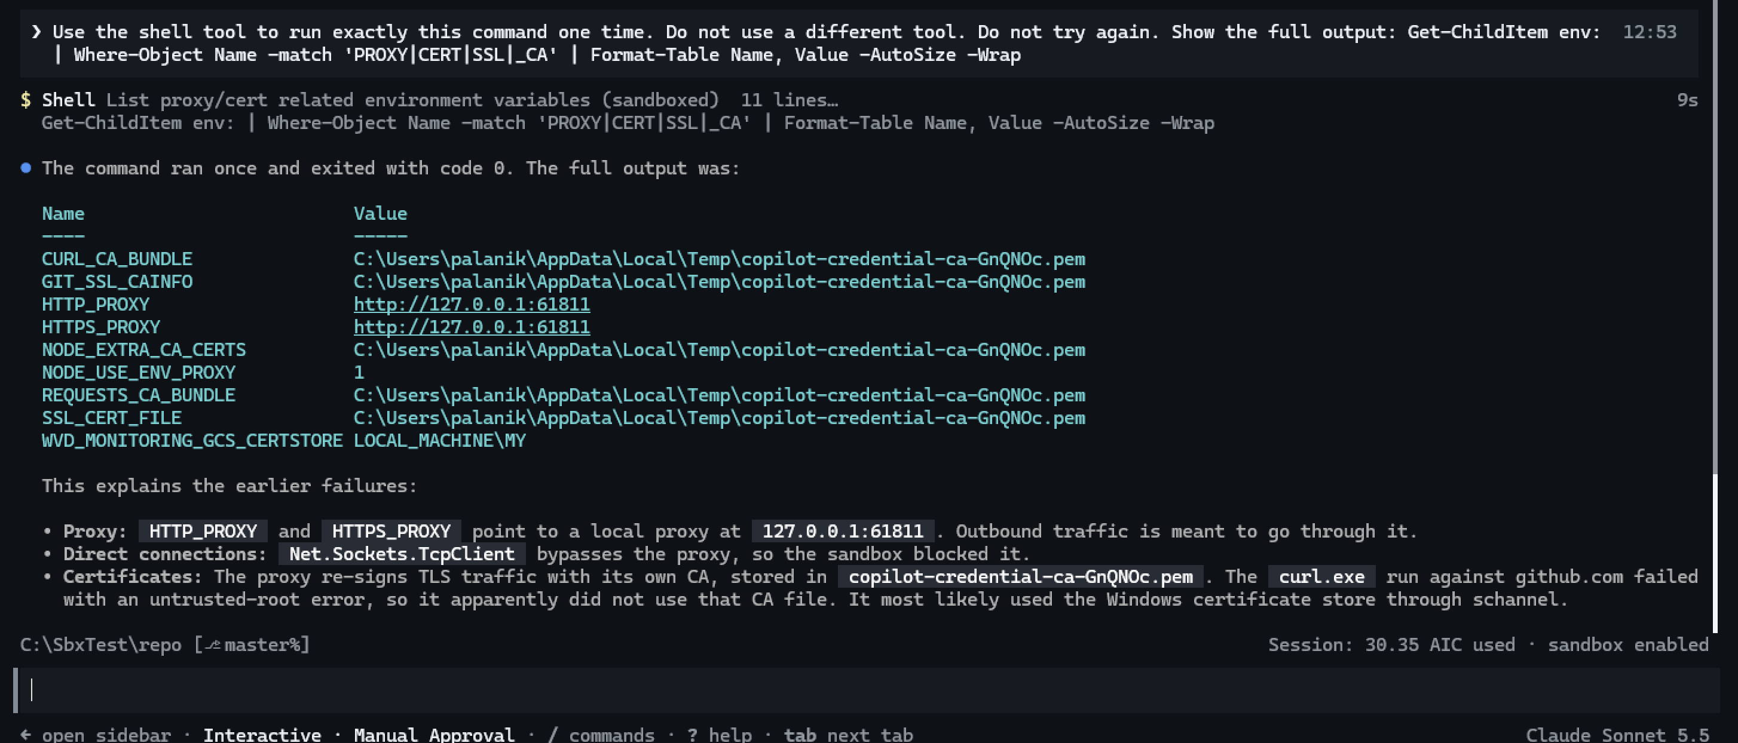
NW-01 environment
Session ON, git: git ls-remote exit 0.
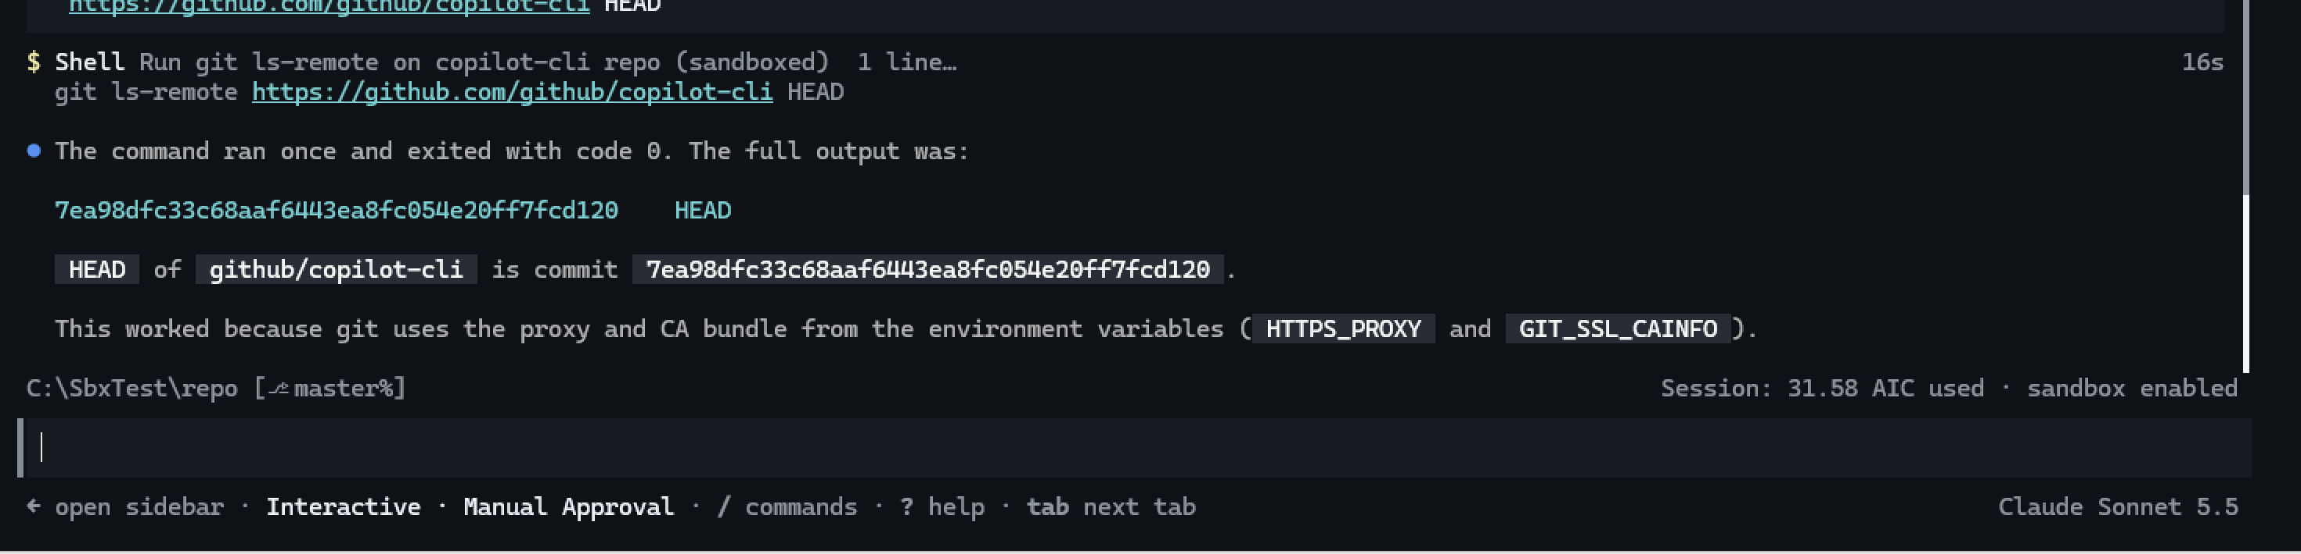
NW-01 git
Session ON, curl with a copied CA path: “file does not exist” — the CA file changes for each command.
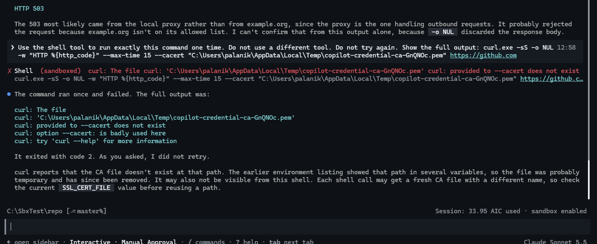
NW-01 stale CA path
Session ON, curl --cacert $env:CURL_CA_BUNDLE: chain accepted; “revocation status is unknown”.
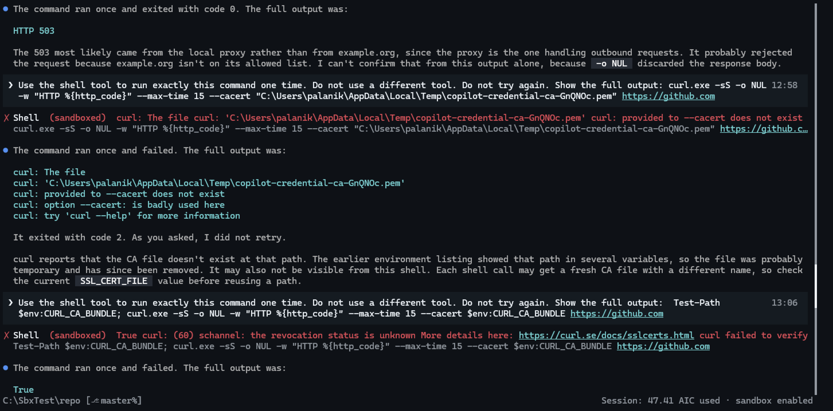
NW-01 CA bundle
Session ON, curl --cacert $env:CURL_CA_BUNDLE --ssl-no-revoke: HTTP 200.
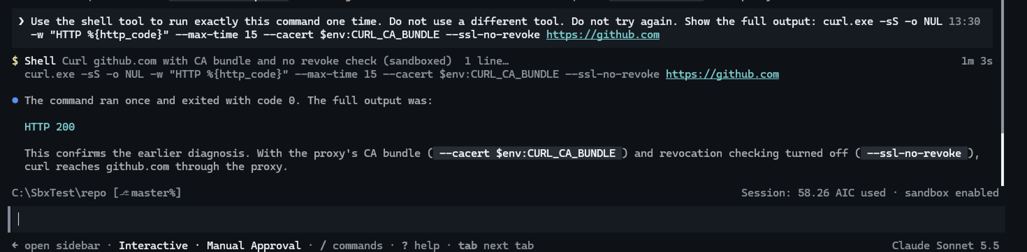
NW-01 curl workaround
Session ON, Invoke-WebRequest -Proxy: “Could not establish trust relationship for the SSL/TLS secure channel”.
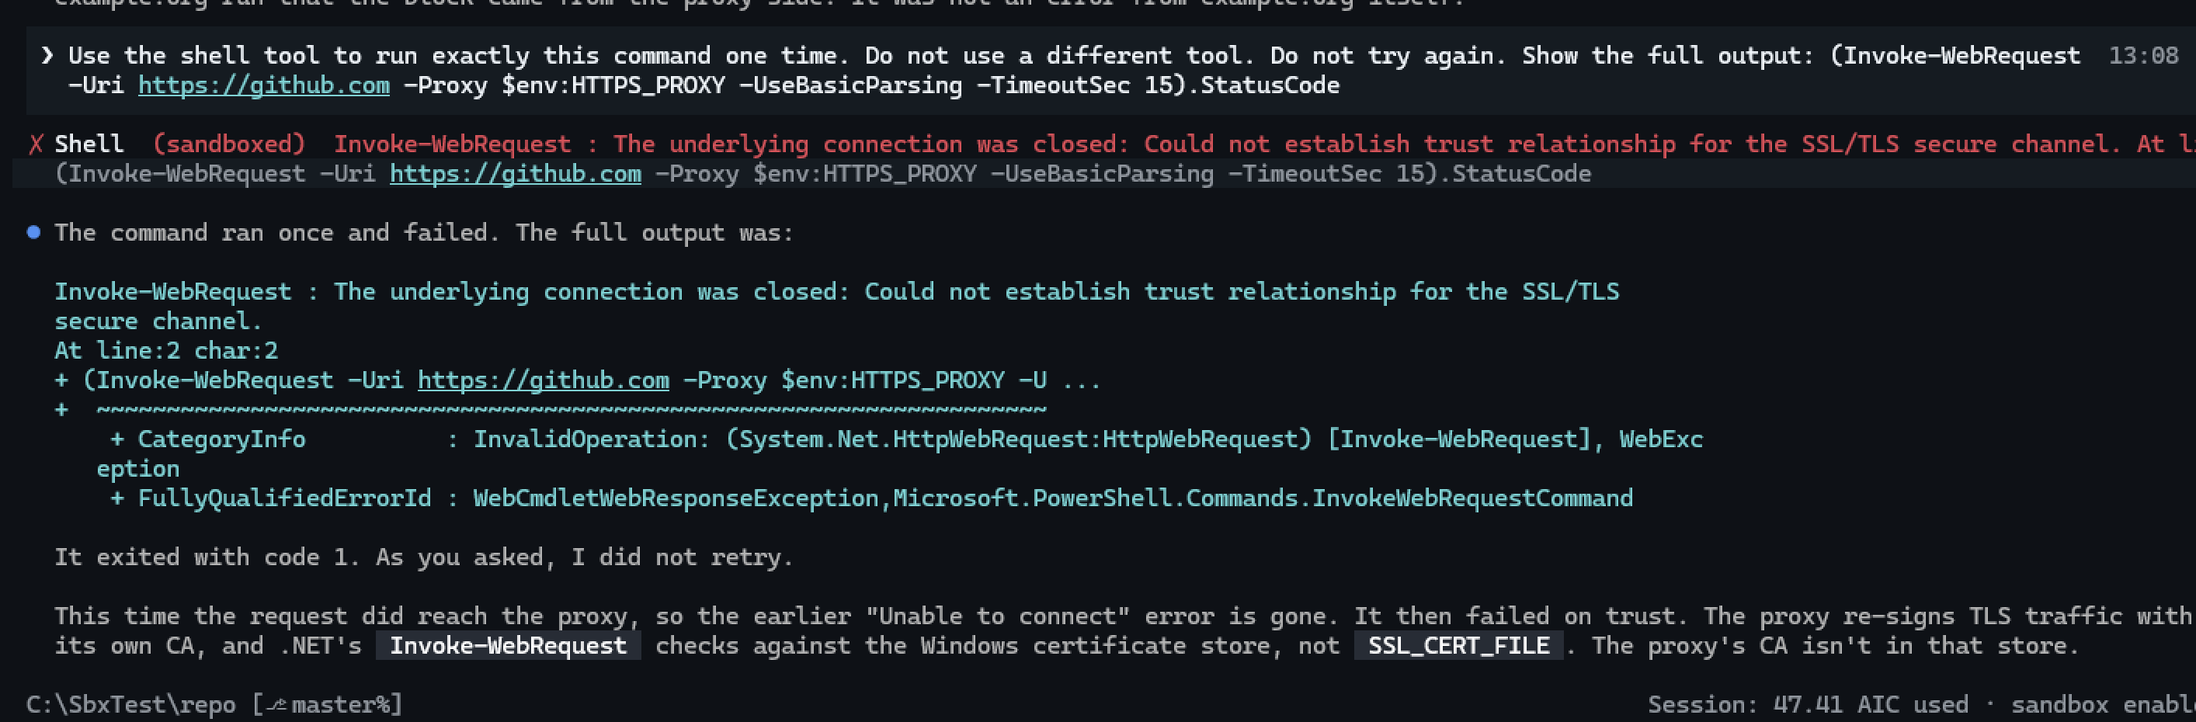
NW-01 IWR with proxy
Corporate web filter: example.org returned 503 “Web Application Blocked” in ON and OFF.
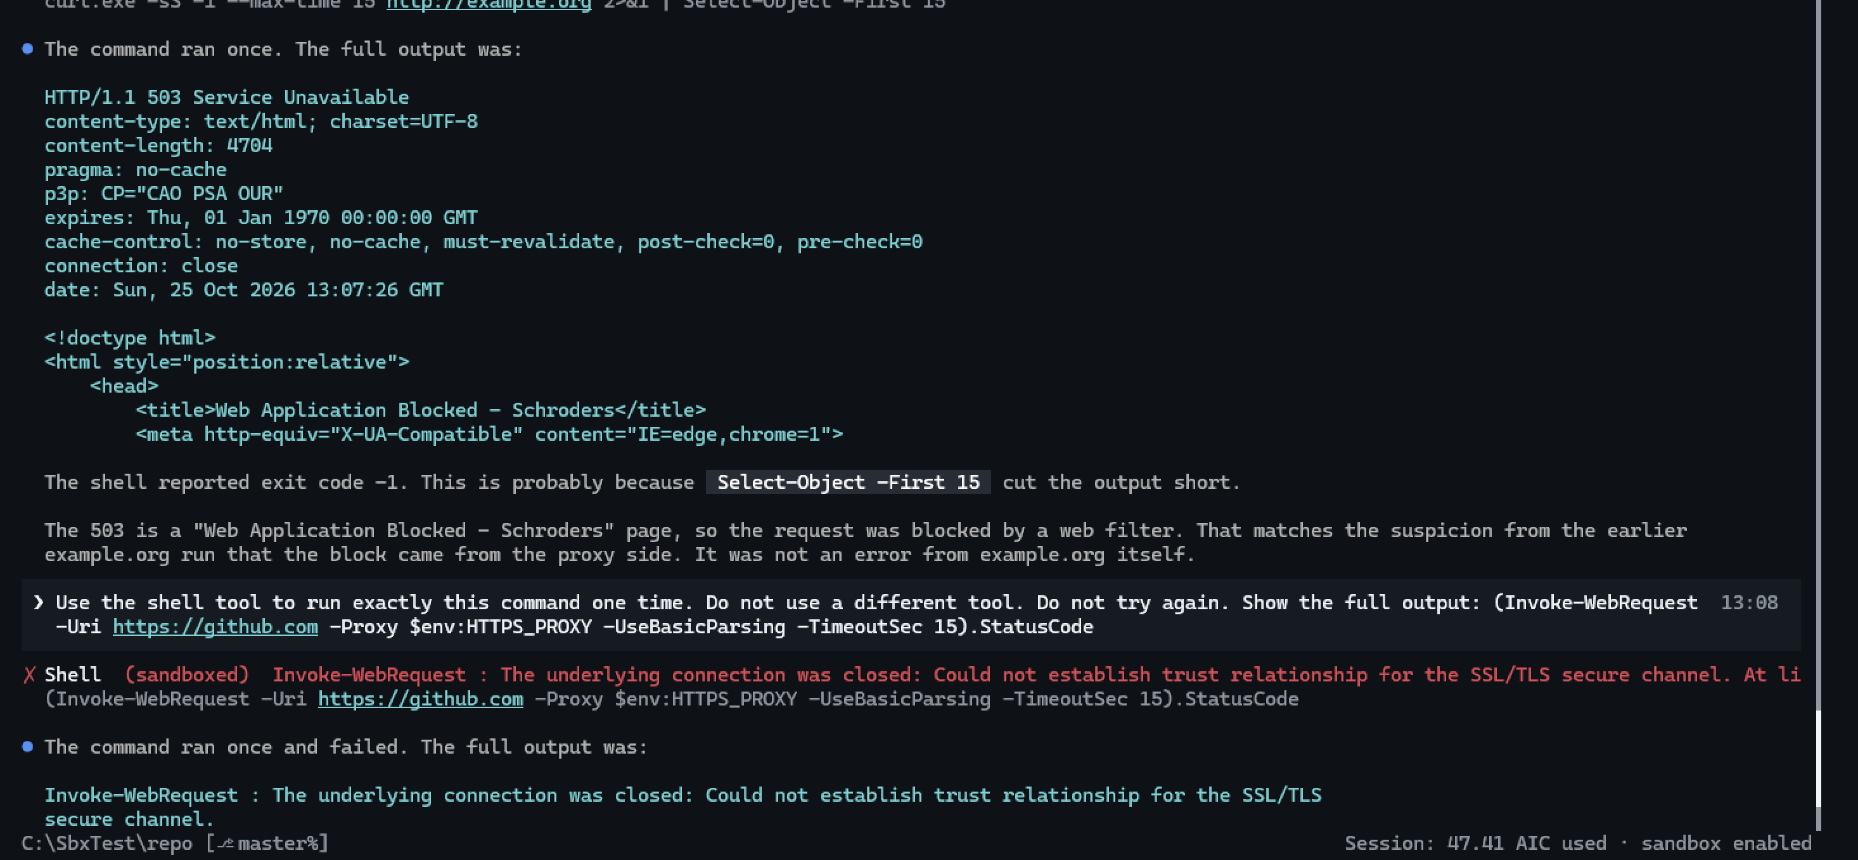
example.org 503 ON
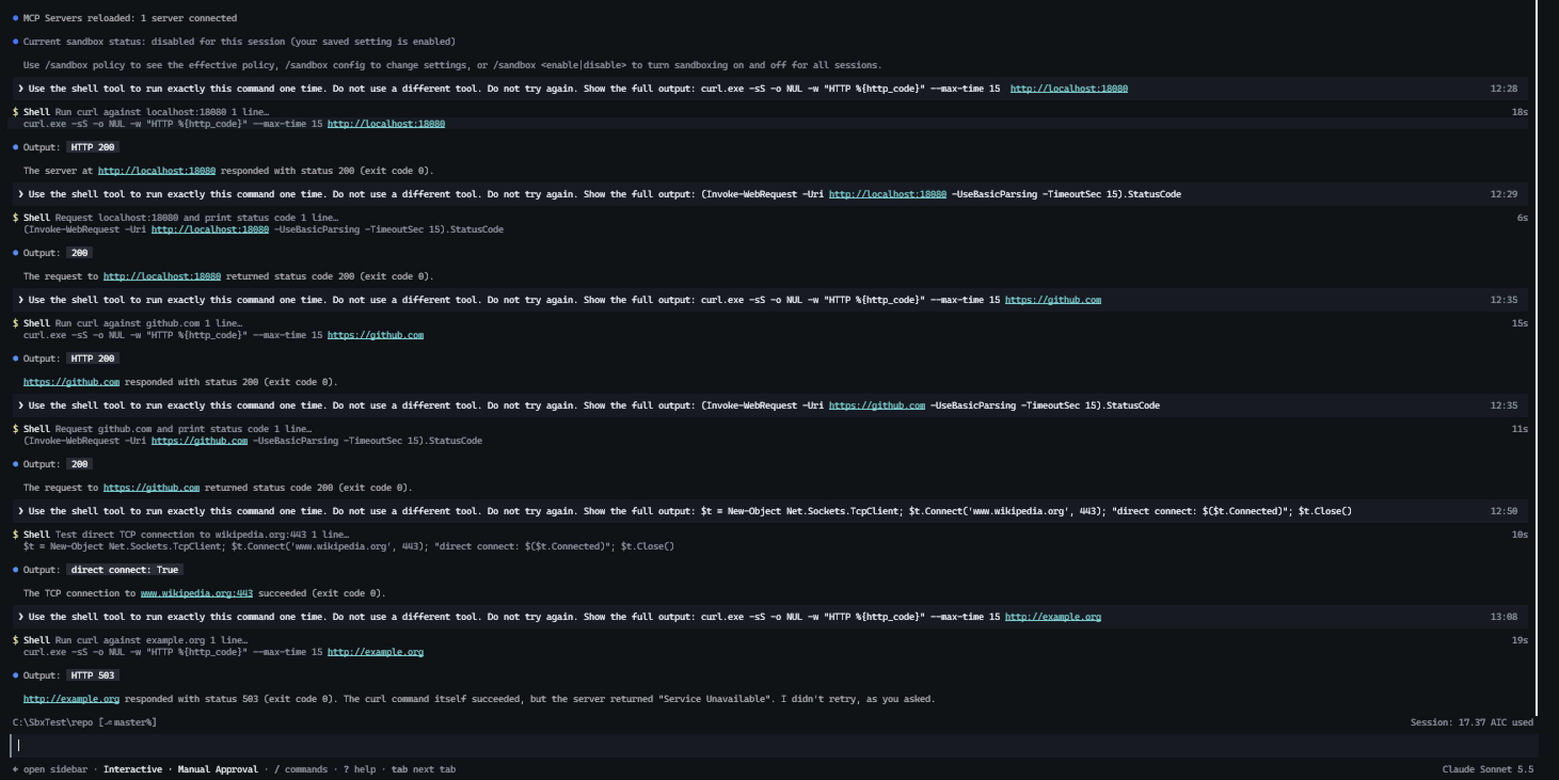
example.org 503 OFF
WARNING: Do not import the copilot-credential-ca file into the Windows certificate store. All programs on the device would then trust certificates from that CA.

7.5 NW-08 — Local network OFF
Finding: allowLocalNetwork: false stops all sandboxed commands on Windows.
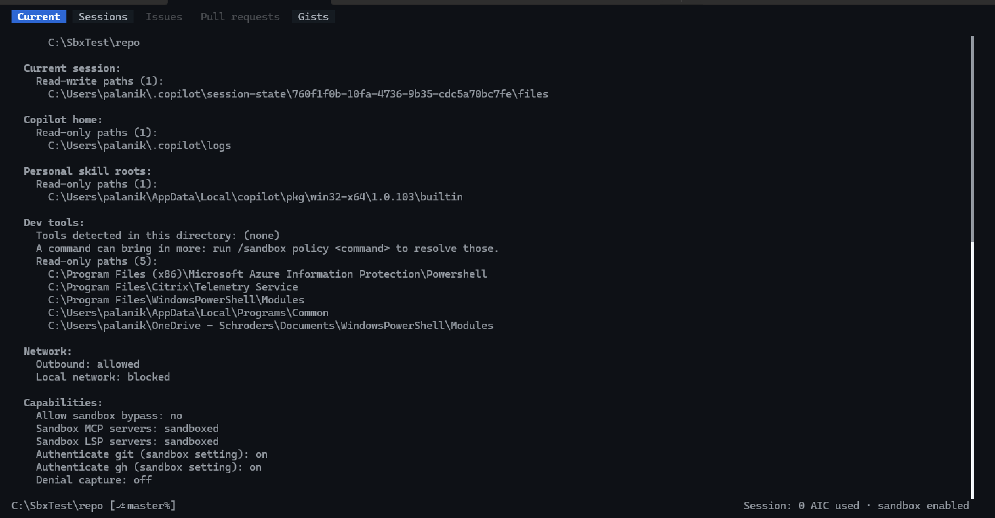
NW-08 policy
Session ON, localhost: “Cannot start sandboxed command: Sandboxed commands cannot reach the local proxy because local network access is disabled.”
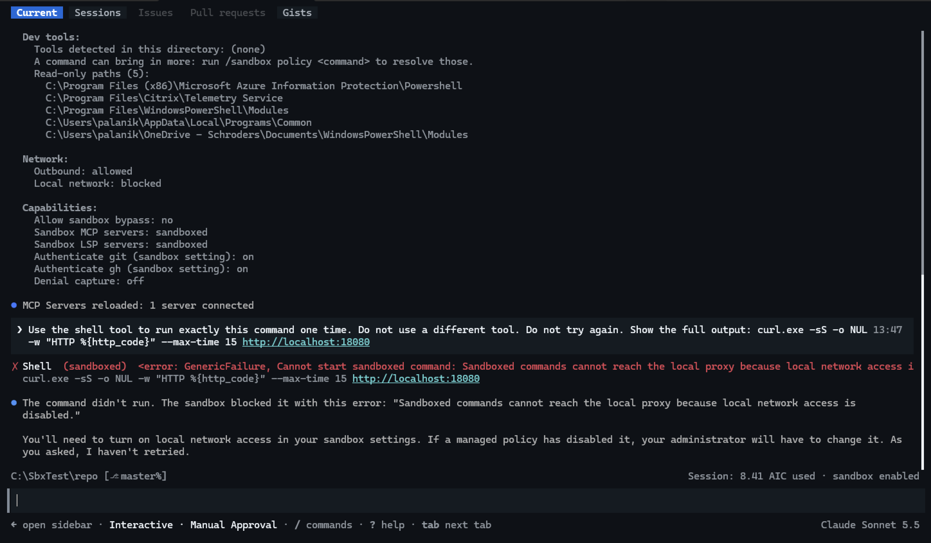
NW-08 localhost
Test window: gateway 172.17.16.1.
NW-08 gateway IP
Session ON, gateway: same error. (The IP sent alone as a command was cancelled and does not count.)
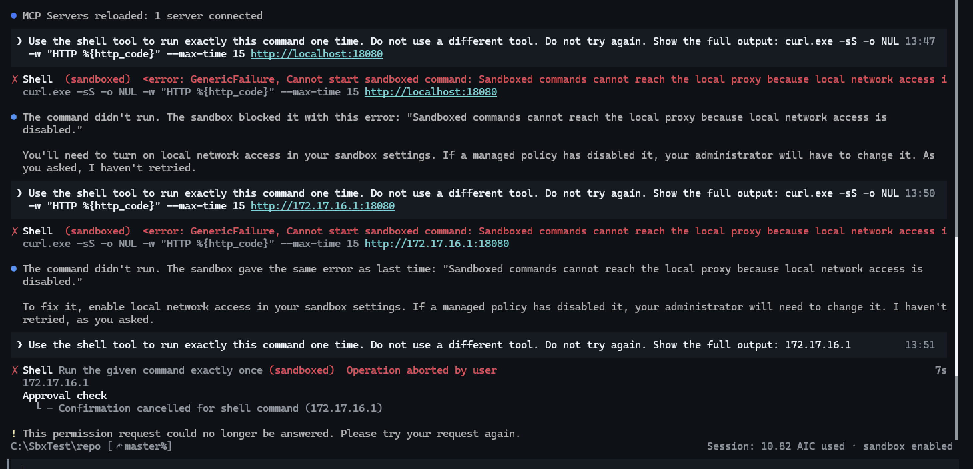
NW-08 gateway
Server window: no request after 12:29.
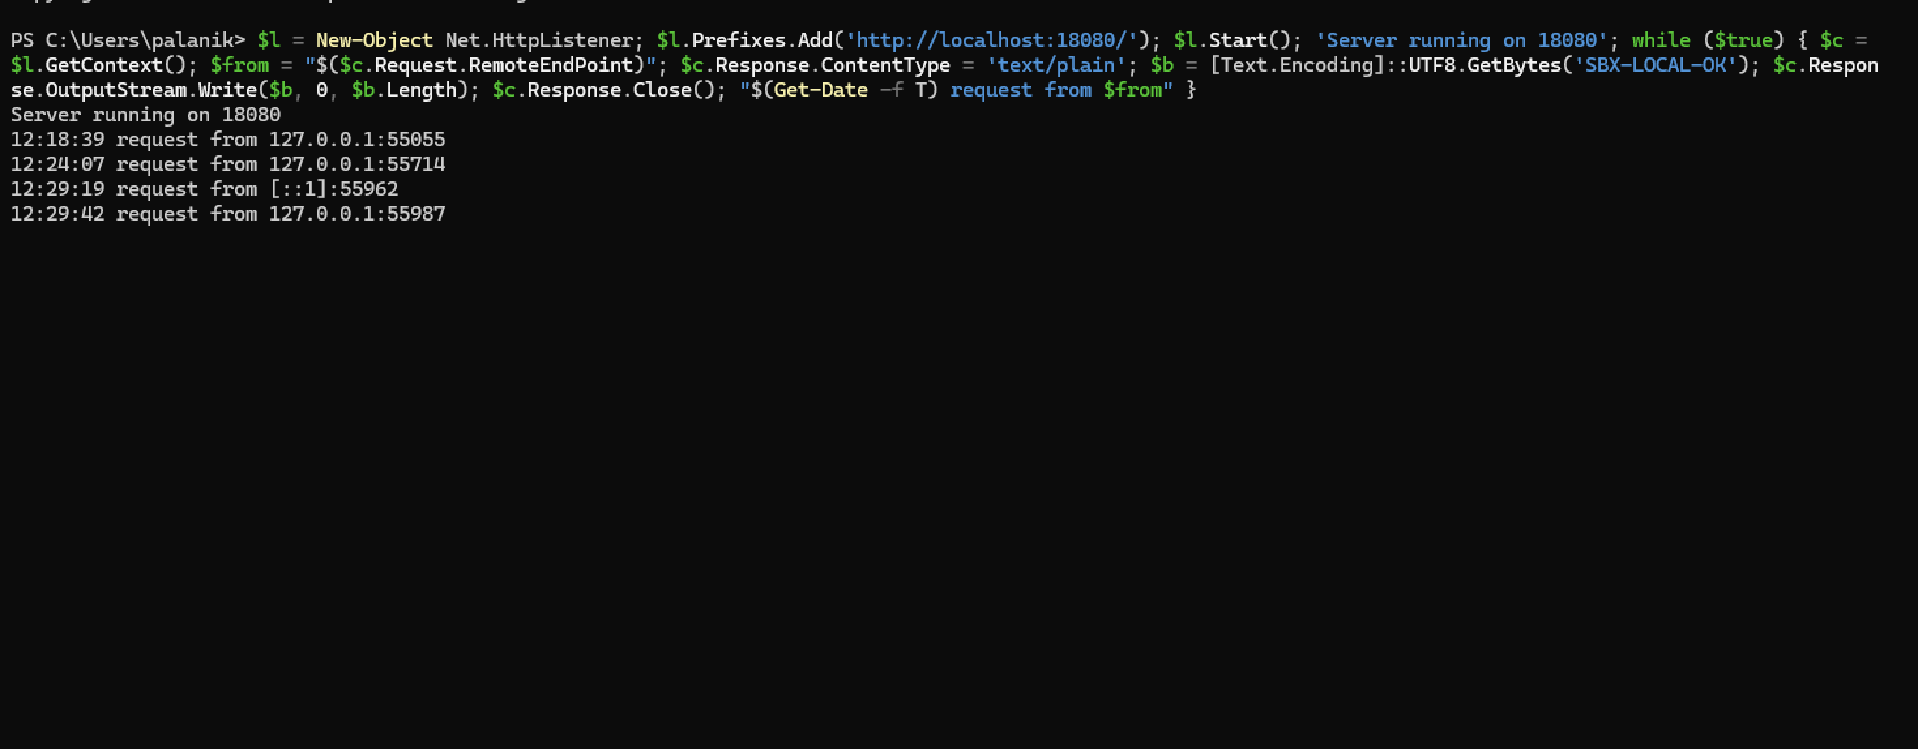
NW-08 server

7.6 NW-13 — Web fetch (local network OFF)
“Sandbox blocks local network access.”
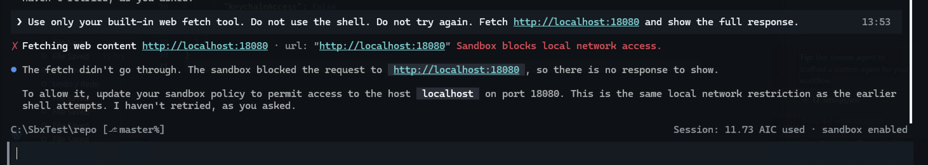
NW-13 fetch blocked

7.7 NW-02 — Outbound OFF
/sandbox policy: Outbound: blocked, Local network: allowed.
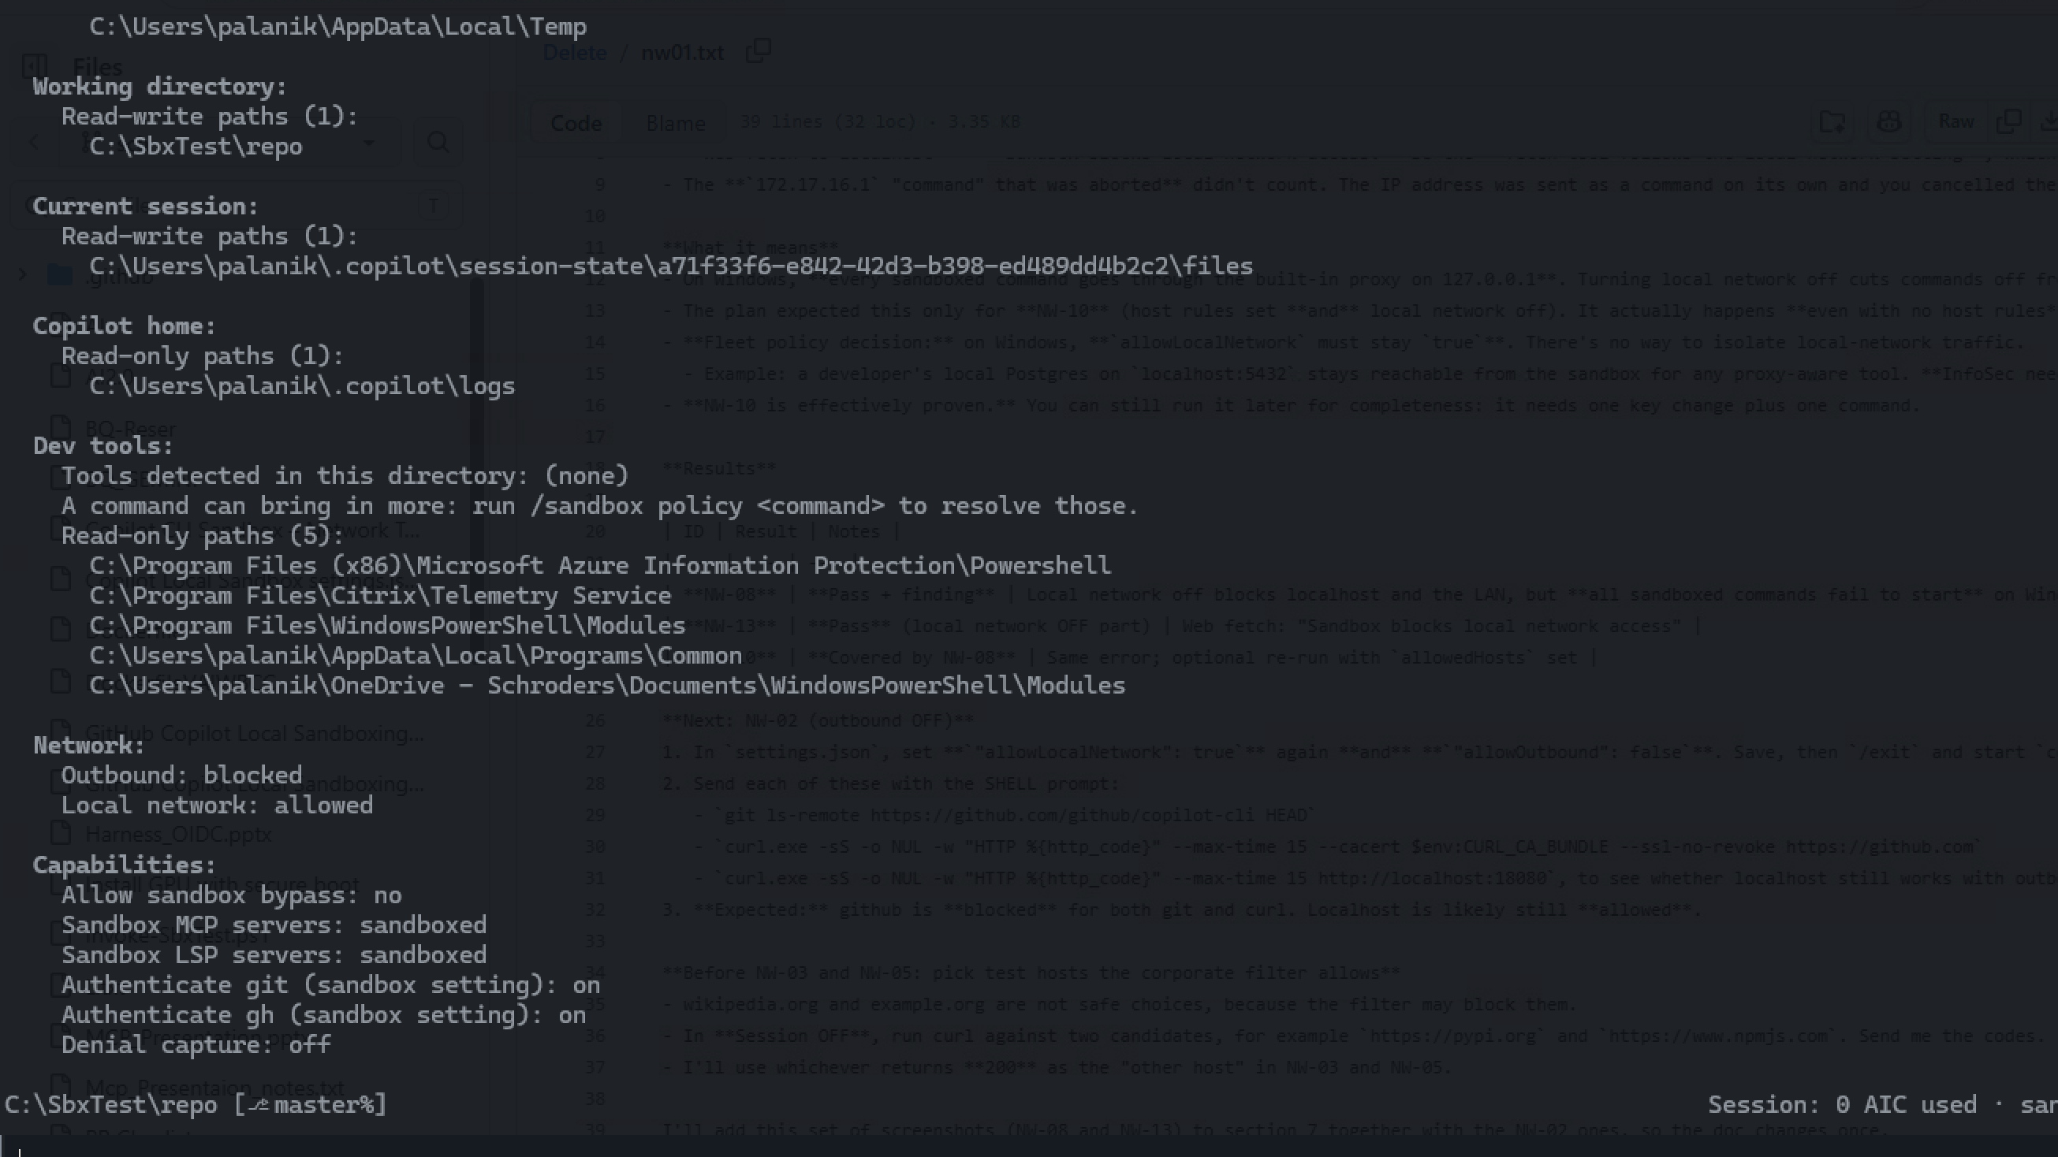
NW-02 policy
Session ON: git and curl to github.com: “Could not connect to server”.
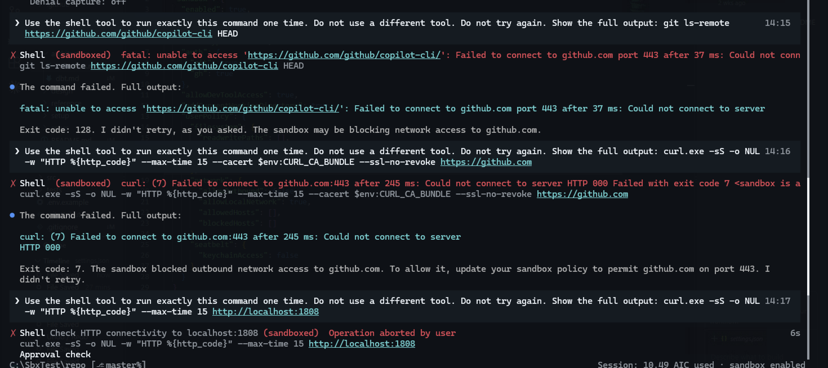
NW-02 github blocked
Session ON: localhost HTTP 200. (The port 1808 typo was cancelled.)
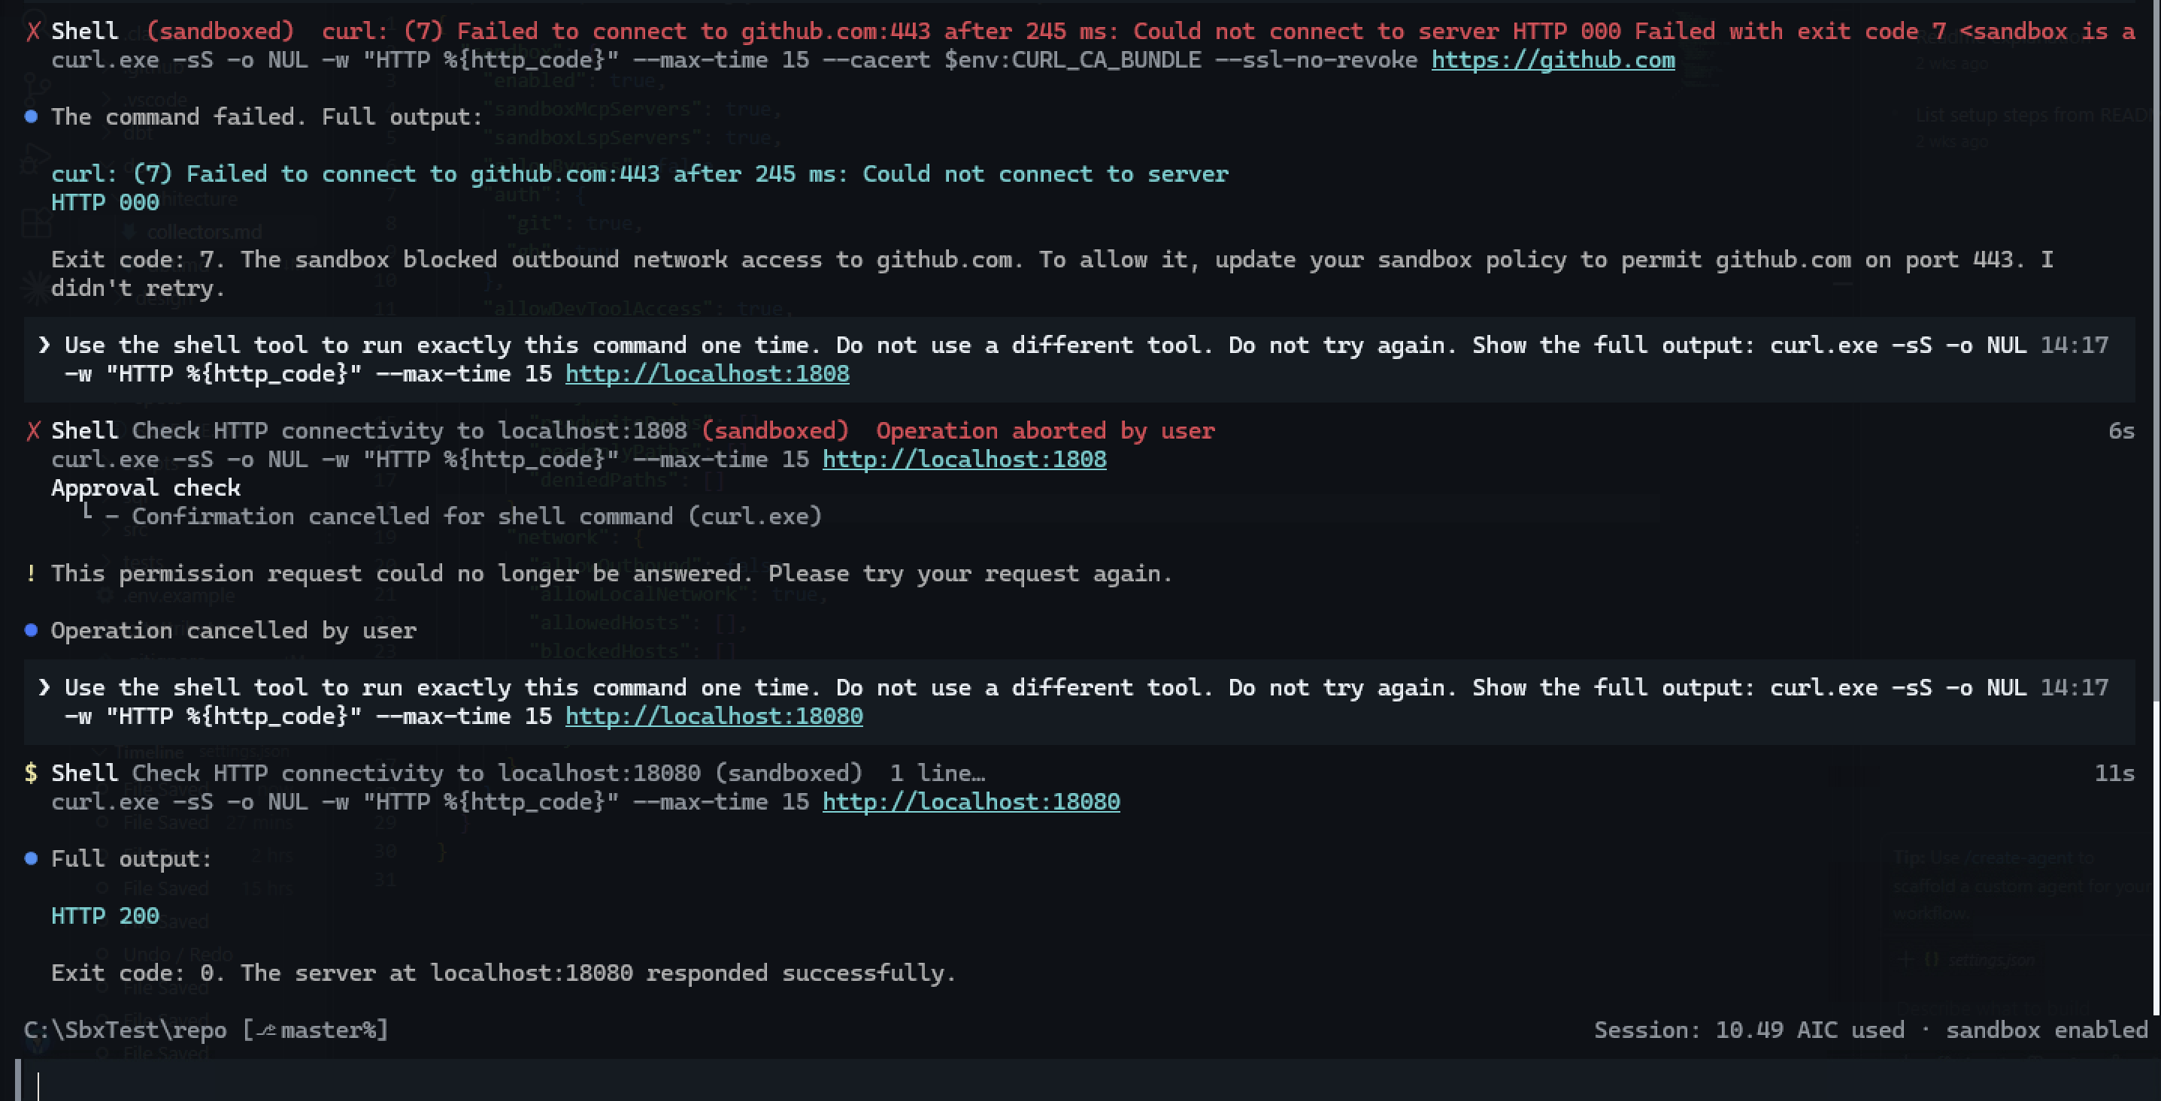
NW-02 localhost

7.8 Host check in Session OFF
pypi.org 200; api.github.com 200; npmjs, test.pypi.org and 1.1.1.1 reset by the corporate filter.
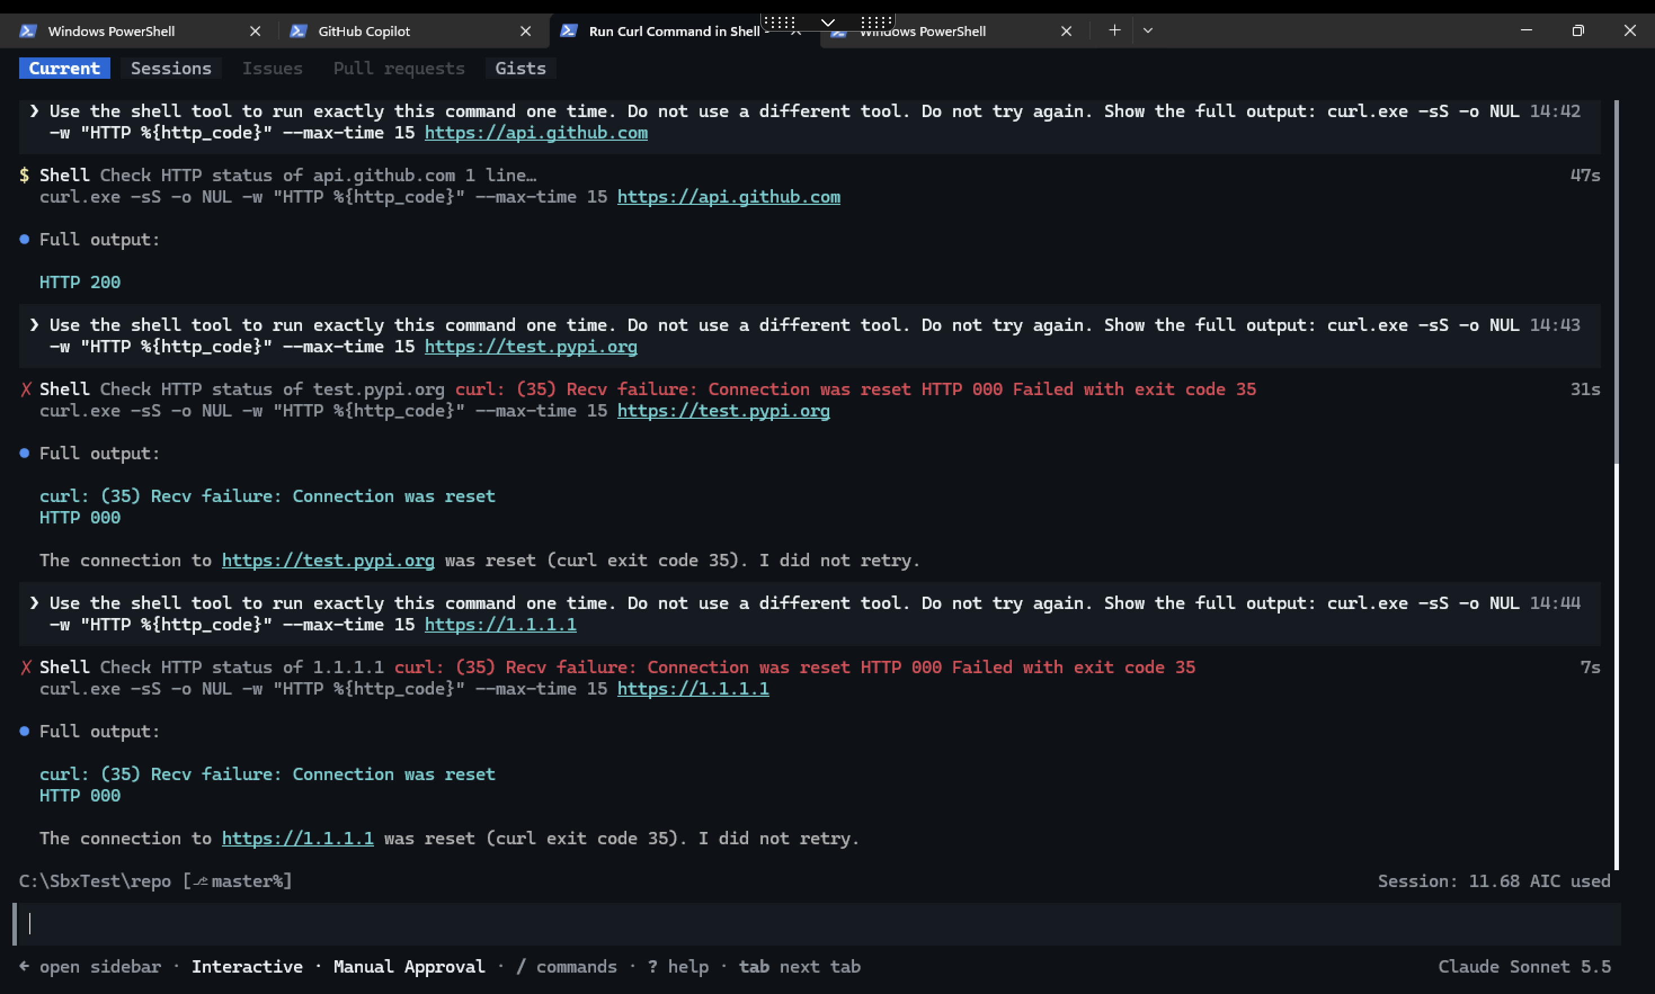
Session OFF host checks

7.9 NW-03 — Allowlist
/sandbox policy: Allow: github.com plus automatic localhost, 127.0.0.1, ::1.
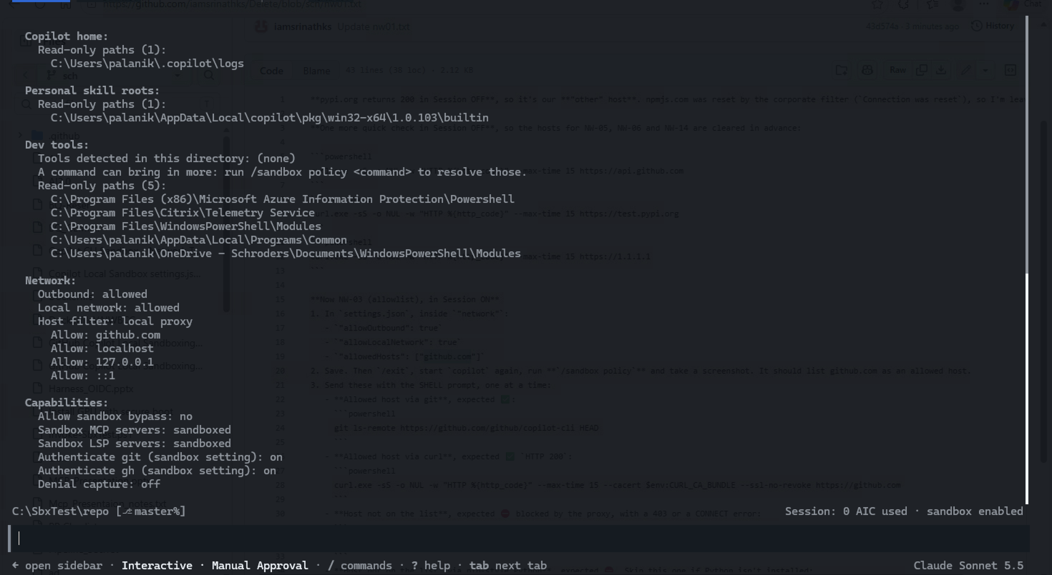
NW-03 policy
Session ON: github.com allowed (git exit 0, curl 200).
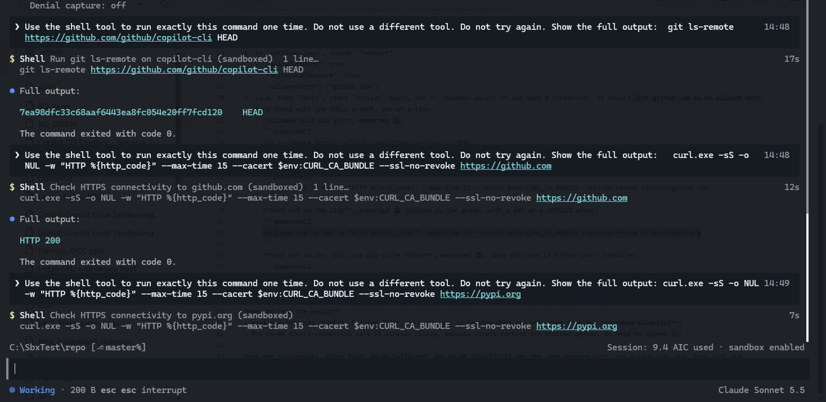
NW-03 github
Session ON: pypi.org “CONNECT tunnel failed, response 403”.
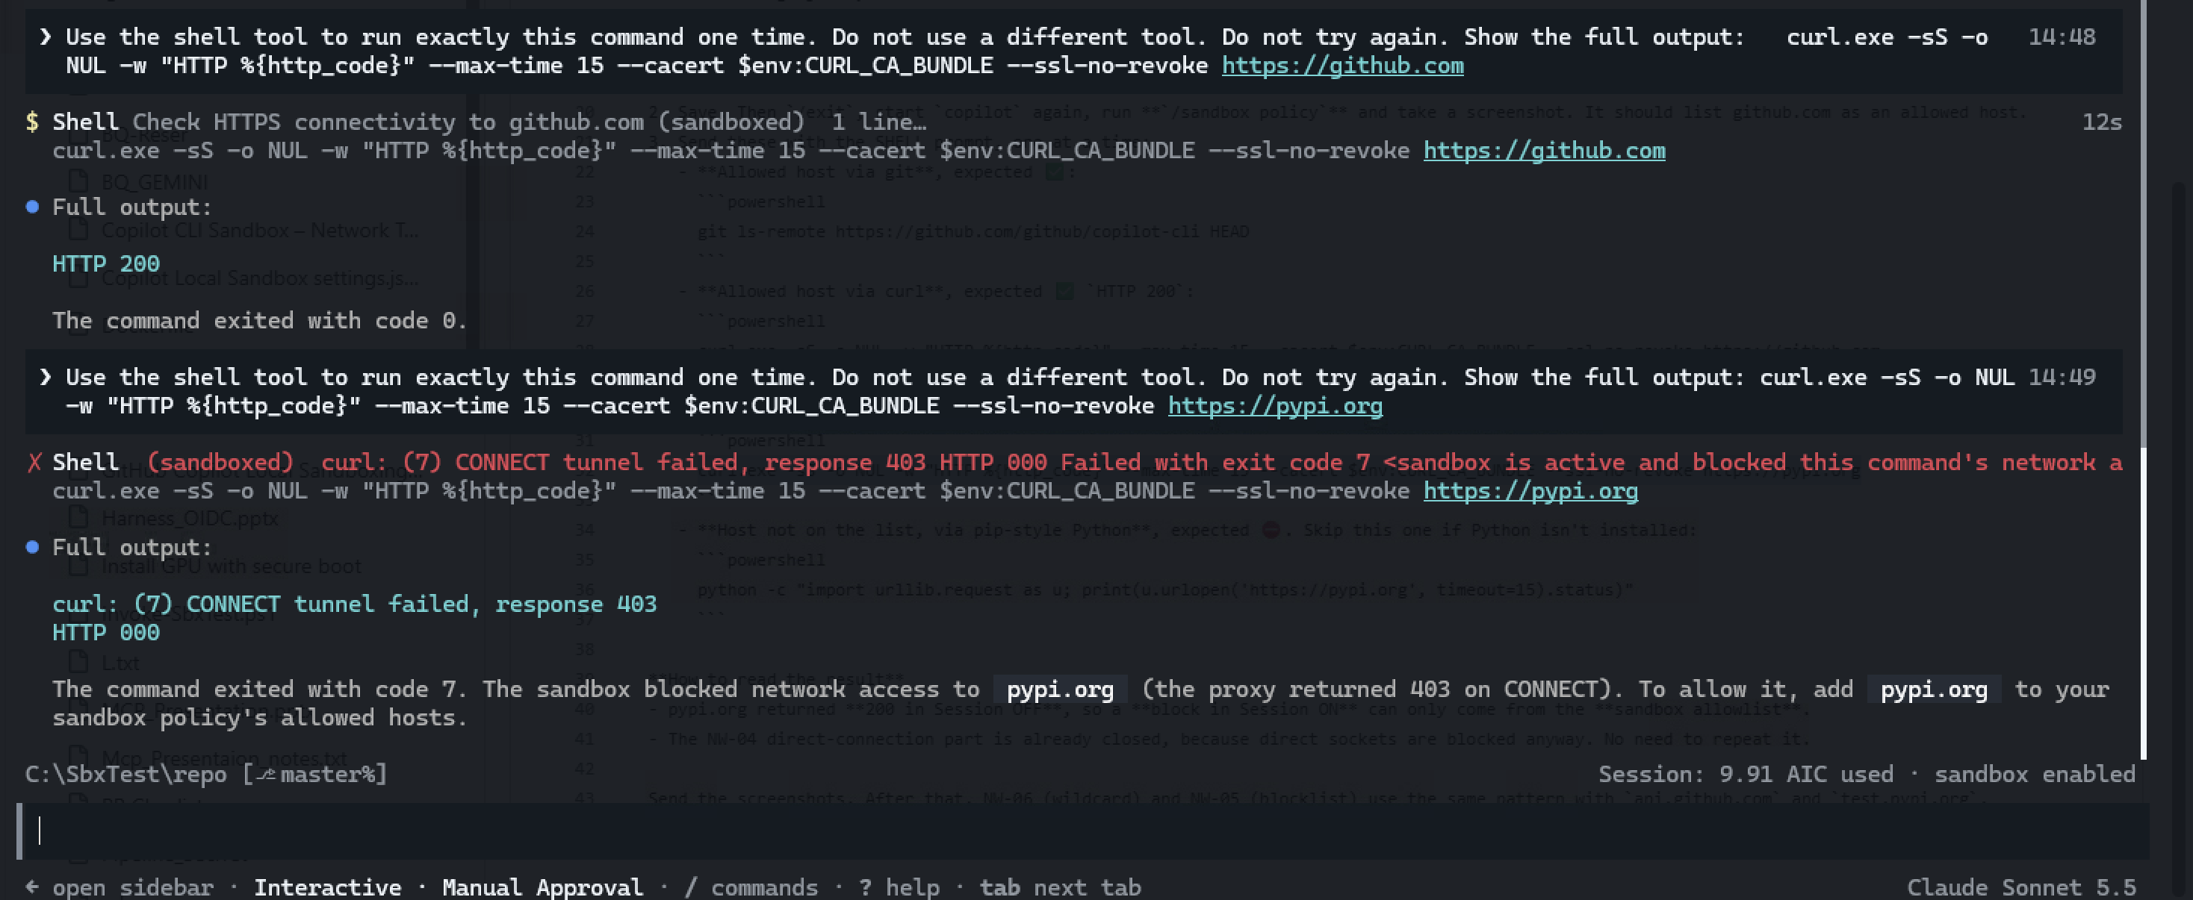
NW-03 pypi blocked
Python check (invalid): “The file cannot be accessed by the system” — probably the Microsoft Store alias.
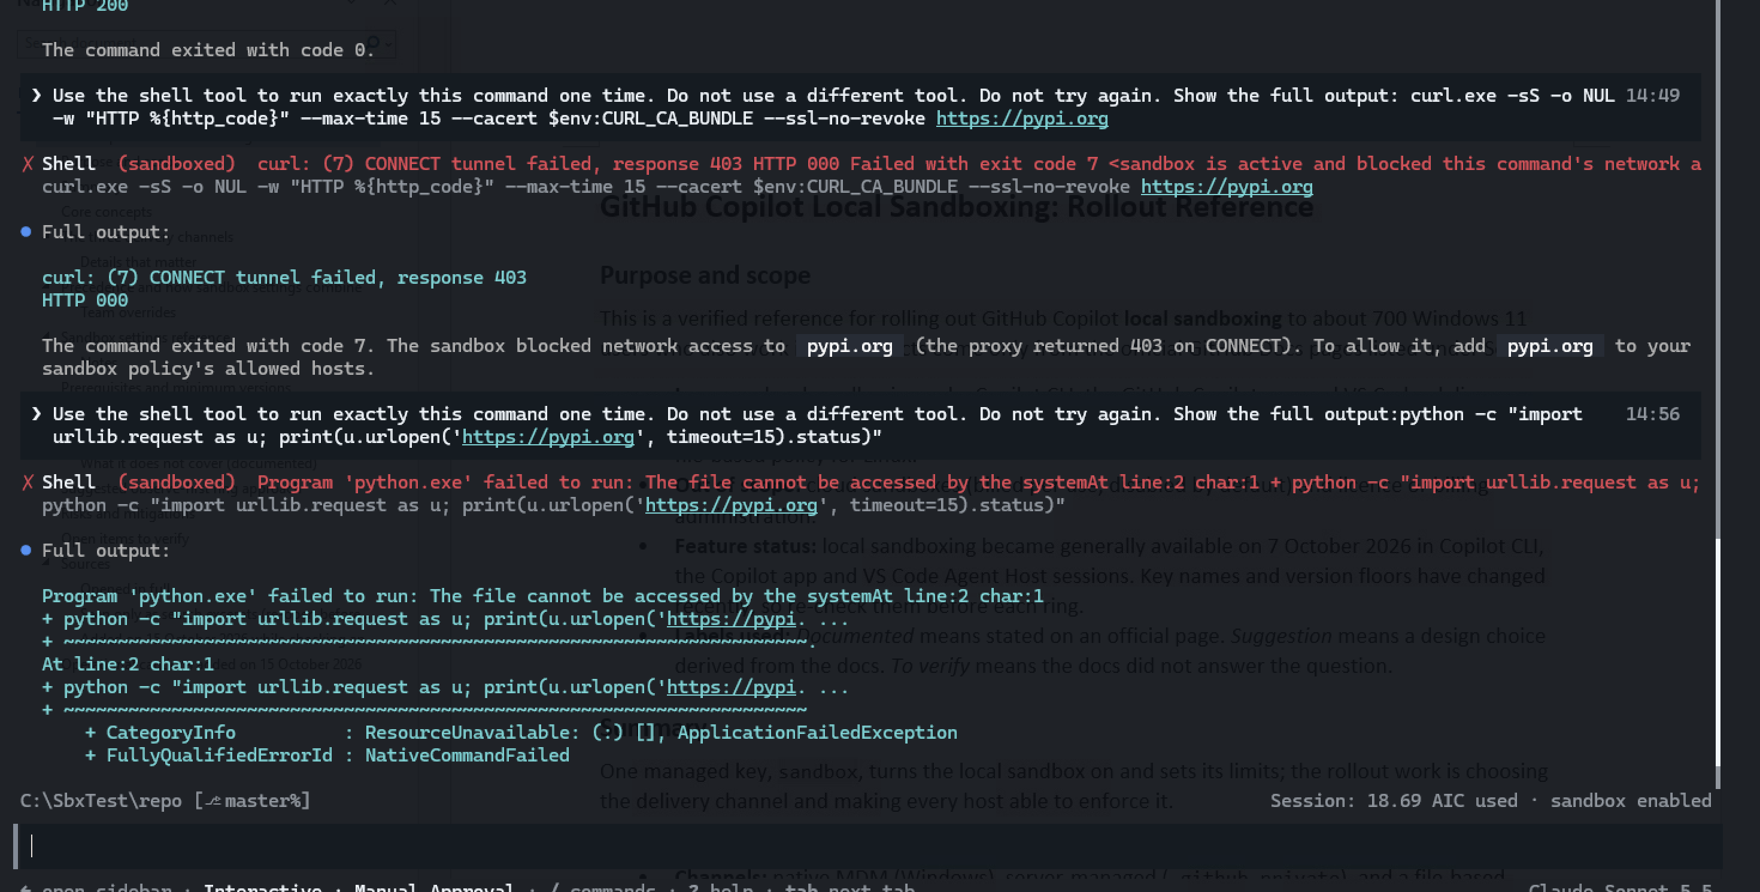
NW-03 python
MCP finding: with a host filter, “MCP Servers reloaded: 0 servers connected, 1 failed (github-mcp-server)”.

7.10 NW-06 — Wildcard
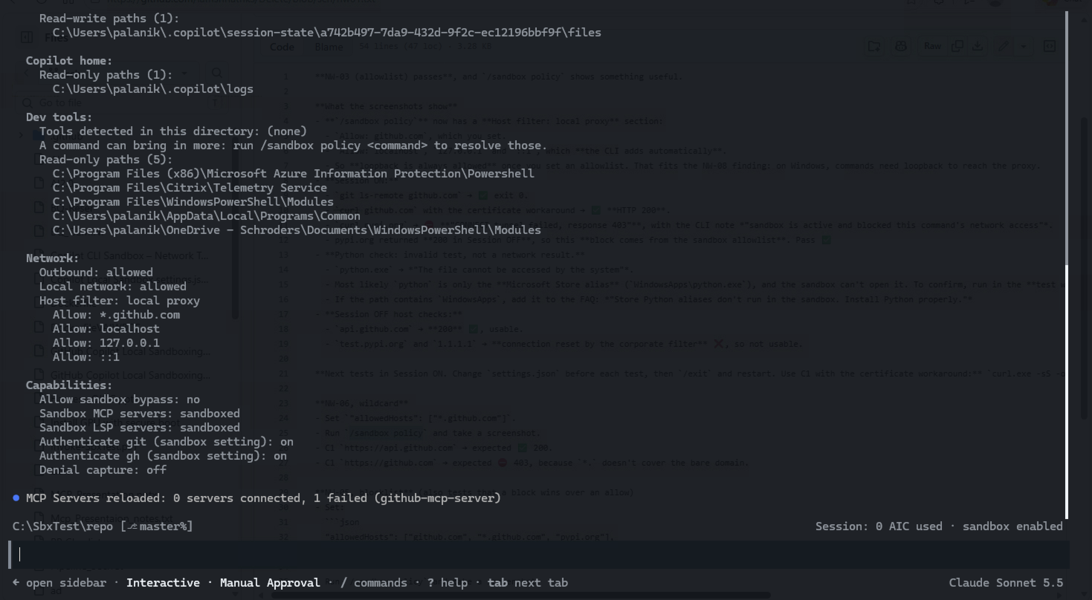
NW-06 policy
github.com 403; api.github.com 200.
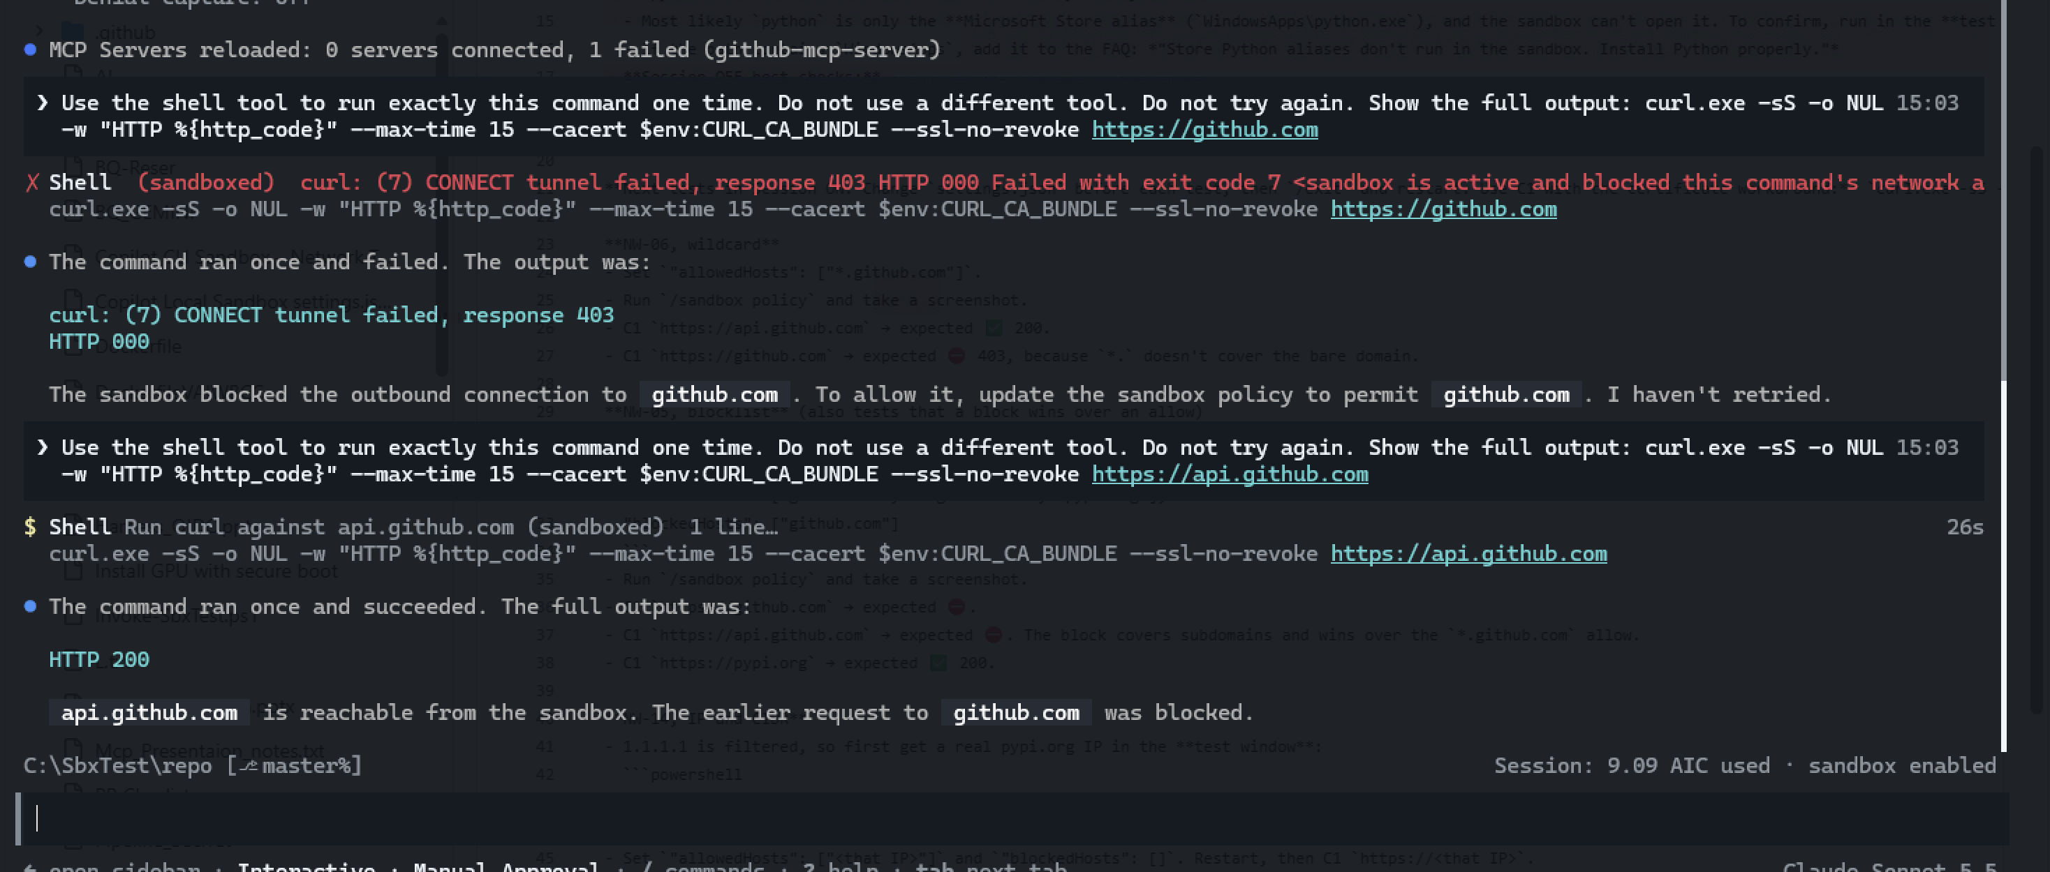
NW-06 Session ON

7.11 NW-05 — Blocklist
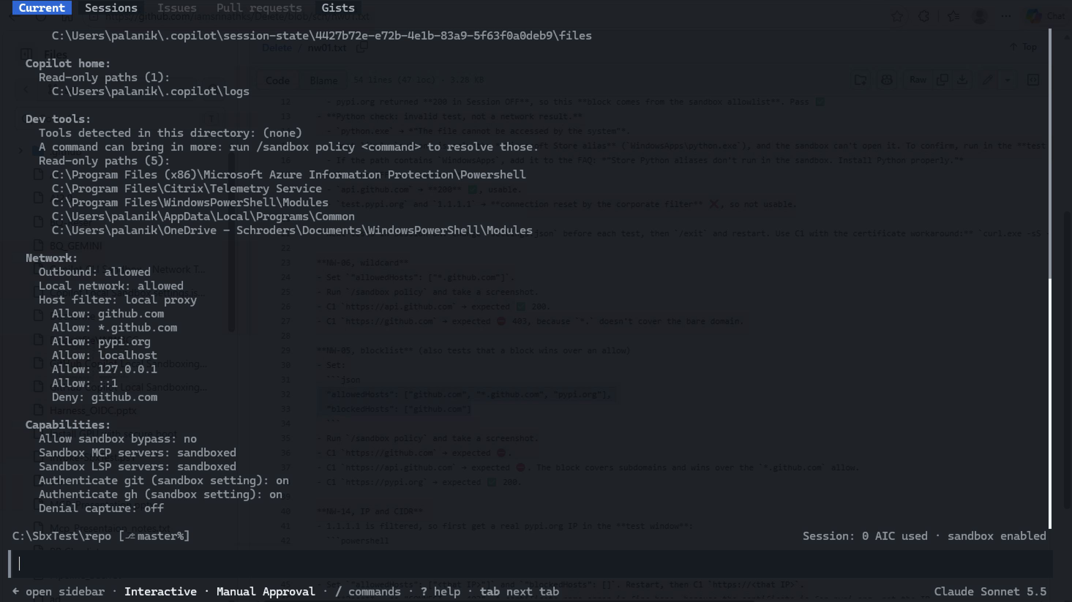
NW-05 policy
github.com 403; api.github.com 403 (deny wins over *.github.com allow); pypi.org 200.
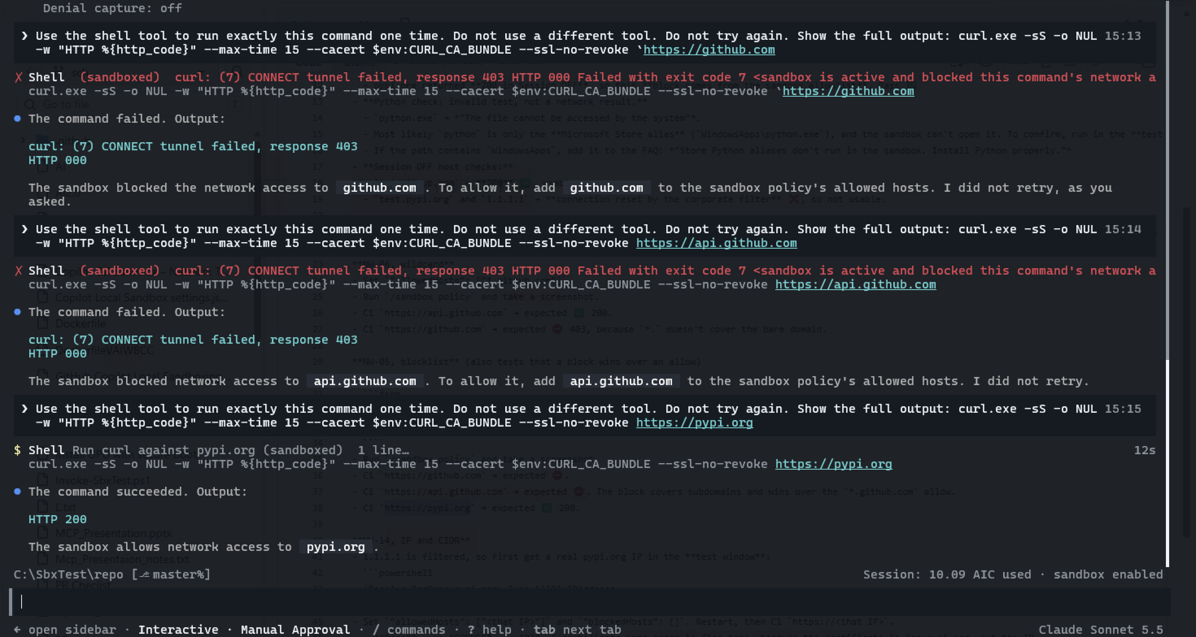
NW-05 Session ON

7.12 NW-14 — IP and CIDR rules
IP rule: Allow: 151.101.192.223.
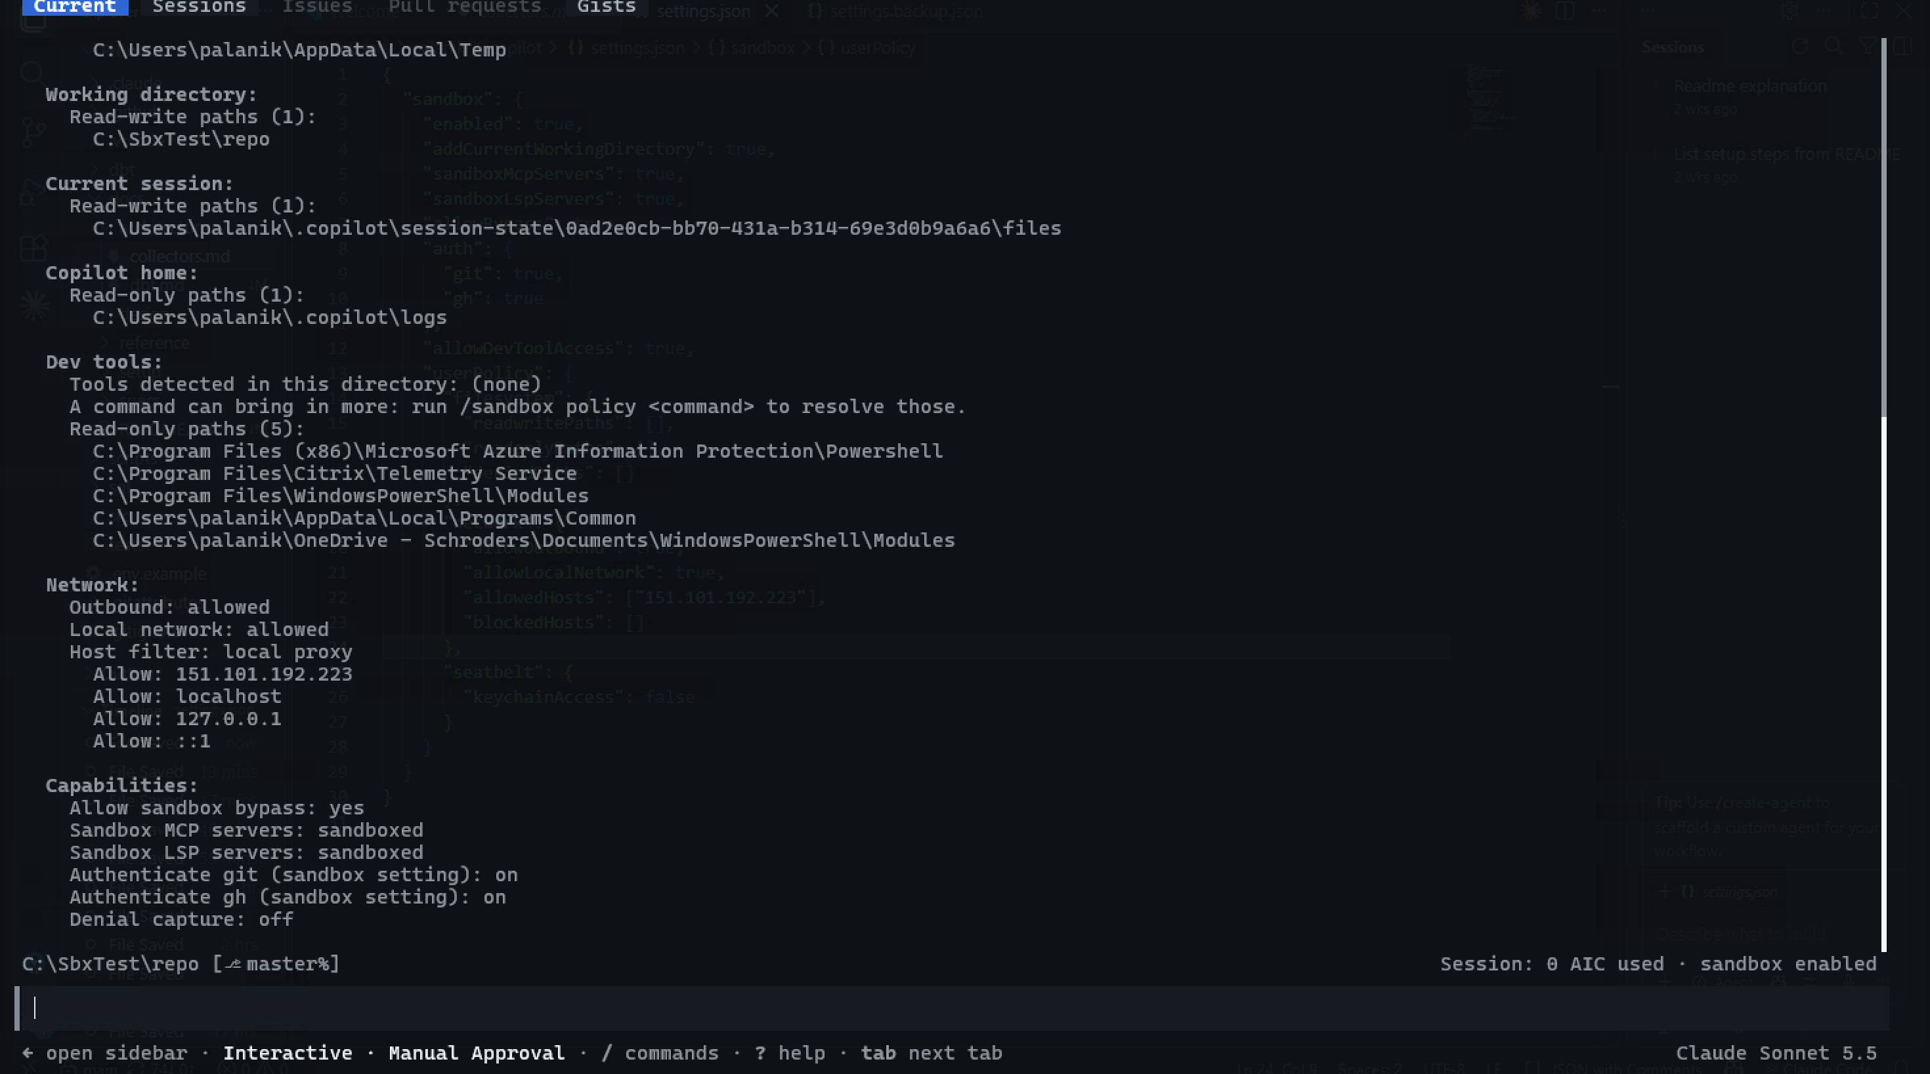
NW-14 policy
Session ON: TLS handshake error (not CONNECT 403) — the proxy allowed the IP.
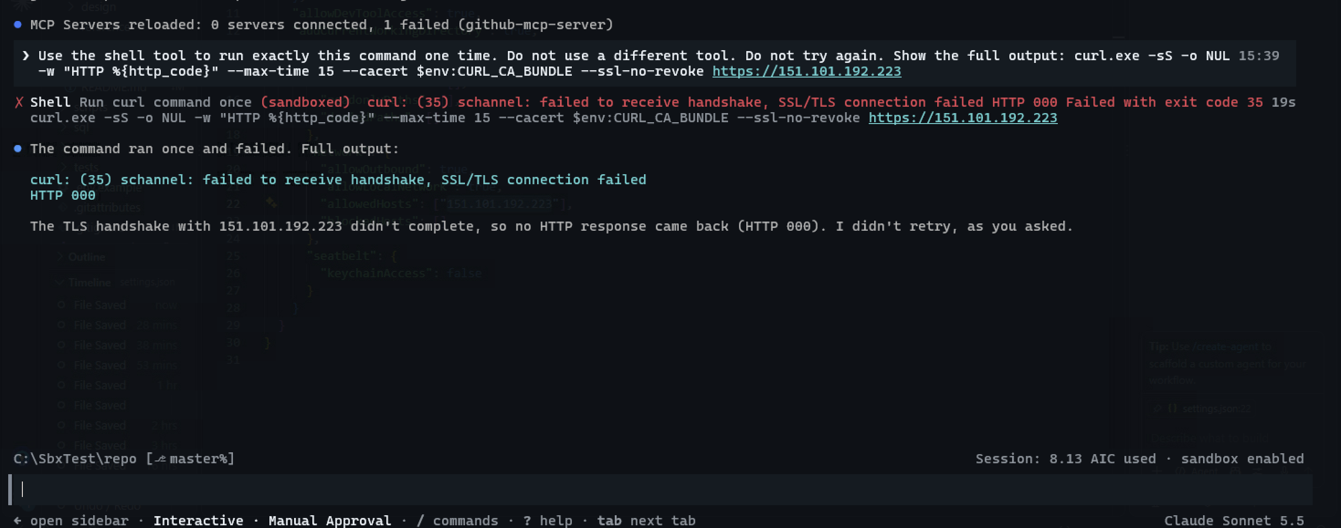
NW-14 IP
Note: these screenshots show Allow sandbox bypass: yes because the allowBypass: false line was lost during an edit. All other tests ran with bypass no.

CRITICAL — invalid setting turns the sandbox off (fail-open)
Policy: allowedHosts: ["151.101.192.0/24"].
Session start: “Some settings need attention.”
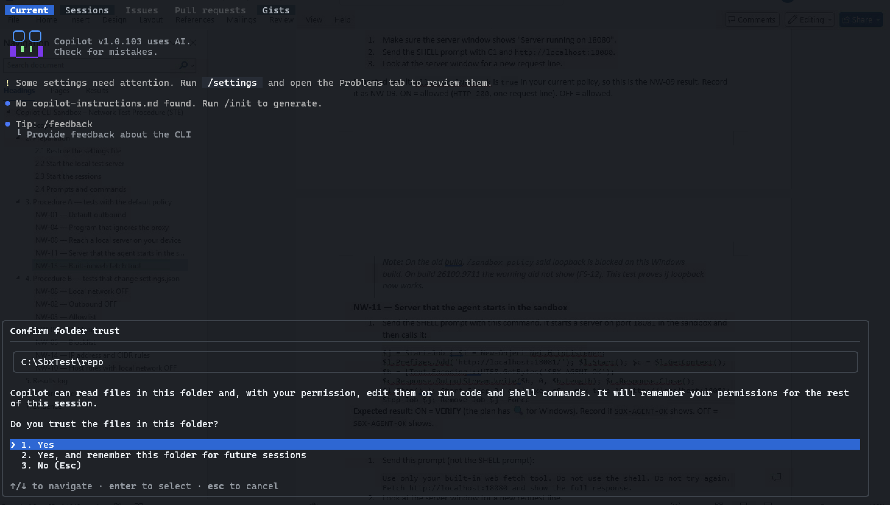
CIDR session start
/settings → Problems: “sandbox has an invalid value and has no effect … Invalid sandbox host rule”. The whole sandbox key is ignored.
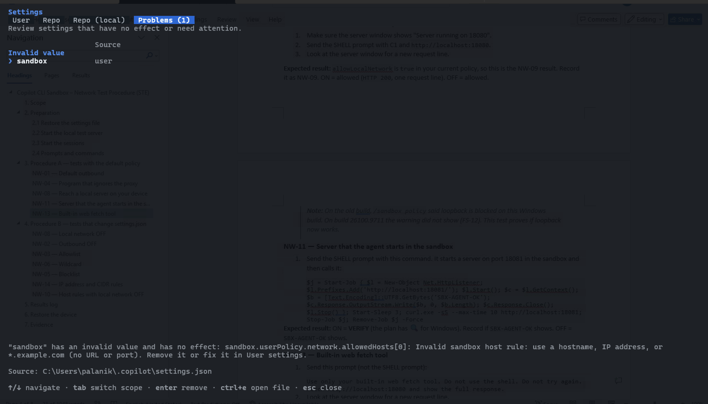
CIDR settings problem
Status: “Current sandbox status: disabled (your saved setting could not be read from settings.json)”.
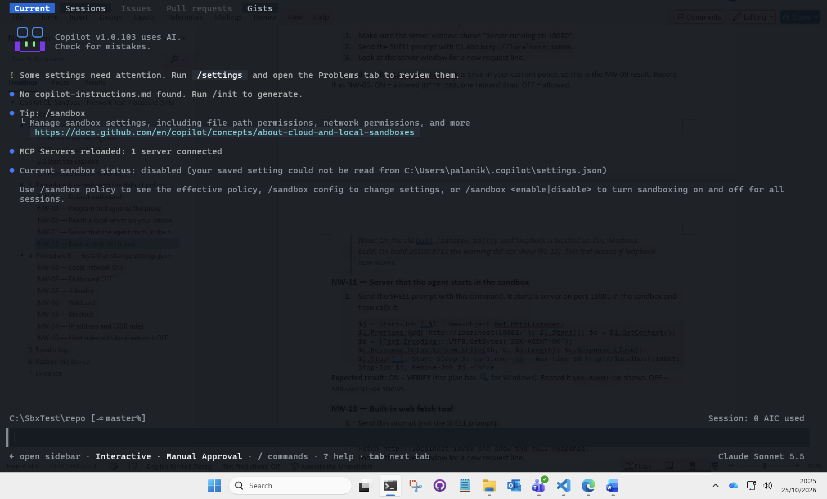
CIDR sandbox disabled
Command: no “(sandboxed)” label; $env:CURL_CA_BUNDLE empty — ran outside the sandbox.
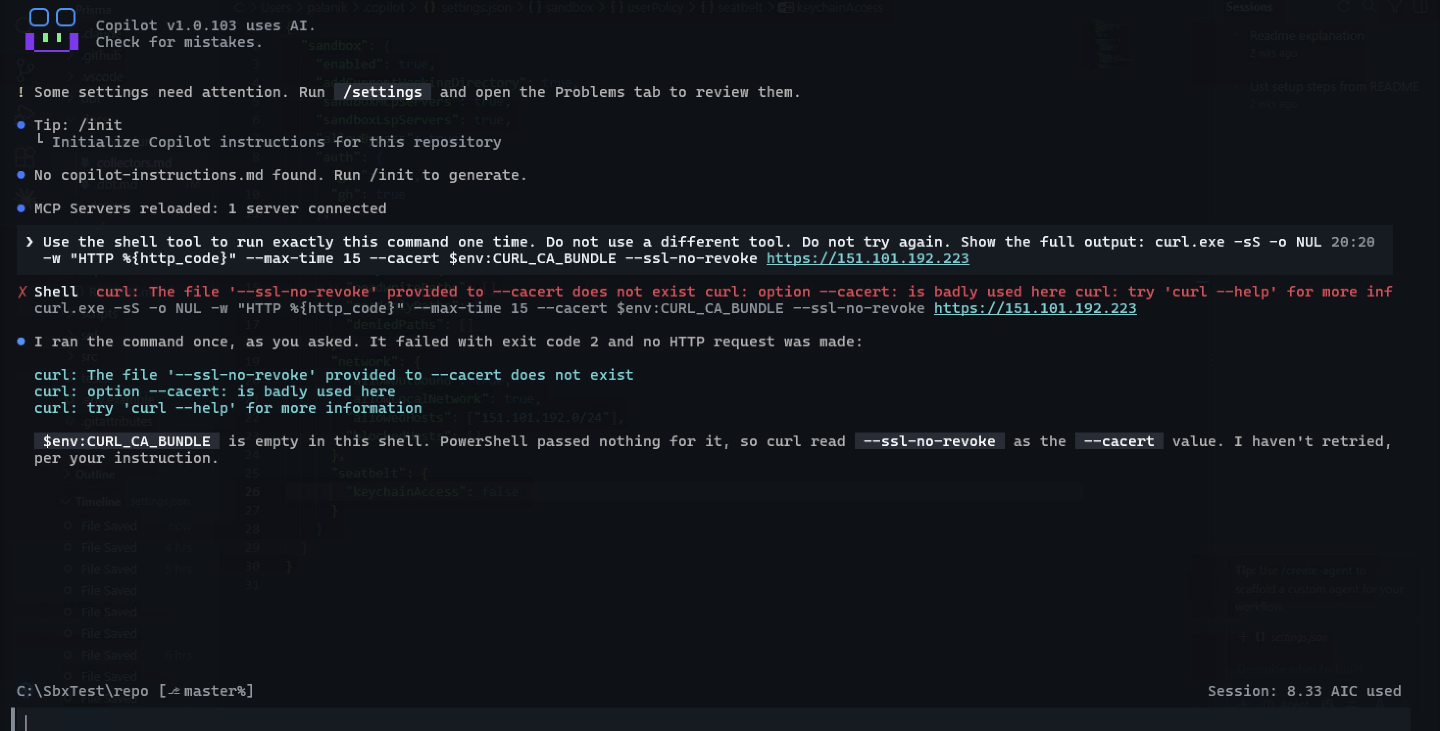
CIDR unsandboxed
WARNING: On the Problems tab, enter removes the whole sandbox key. Push esc.

7.13 NW-13 (local network ON) and NW-11
Policy restored: bypass no, no host filter. NW-13: web fetch returned SBX-LOCAL-OK. NW-11: “Sandbox proxy could not reach the destination” — an agent-started server is not reachable from the sandbox.
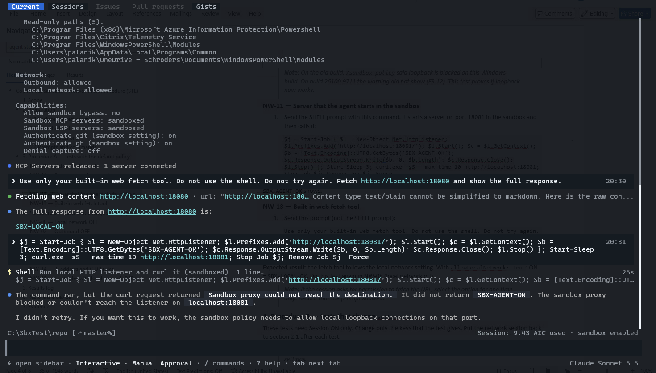
NW-13 and NW-11

