Giving Feedback Modified from Toastmasters: Evaluate to Motivate
- Advice vs Feedback
  - Advice: Avoid giving advice which tells a person what they should do. Avoid “you sentences” such as:
    - “You didn’t...”
    - “You should have...”
    - “You failed to...”
  - Feedback is more objective in that it is about what you observed or felt. Use “I/me/my” phrases like:
    - “I believe...”
    - “I suggest that…”
    - “My reaction was...”
- The purpose is to help and encourage the speaker.
  - Evaluate the presentation, not the person
  - Provide honest and sincere praise.
  - Give positive reinforcement when improvements occur.
  - Give constructive feedback when needed.
  - If you see symptoms of fear or insecurity, consider your next words carefully
- Avoid being disingenuous
- Always end your evaluation positively.

Brene Brown Feedback Thoughts

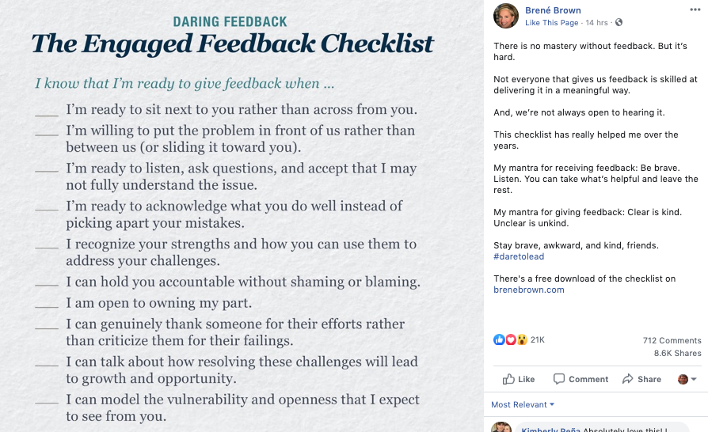
Receiving Feedback
Consider what state you are in at the time you receive feedback (SARAH)
- Shocked: “What, really, did I hear you right? After all the work I put in?
- Annoyed: “No way, others obviously just don’t get it”
- Resistant: “I get it, but I just don’t buy it”
- Accepting: “What do I need to consider? Can you give me an example?”
- Helpful: “What would you suggest that I do differently?” This is how we grow!

Reasons feedback may be difficult to hear
- Truth: you may feel the feedback is incorrect
- Relationship: the feedback is hard to receive because of the person giving it
- Identity: The feedback may not align with your personal self-image

Working toward agreement
- Focus on the other person and what they are saying.
- Ask questions to understand the other person’s perspective
- Communicate information, as needed, to offer your point of view
- Identify potential areas for change and actions
- Come to an agreement and commit to the action plan of change
- Thank the other person for their time

