Igloo Software

# Challenge B – Marble Machine

A few things regarding my solution. I took liberties with the user interface. It said prompt a user for a number and instead I prompt them to click a marble. I consulted with UX and they liked this interface better. In reading the first requirement I got confused as to the expected output. I think it could be interpreted as if they selected red, instead of just seeing all the permutations of marbles up to red that it also showed permutations of different combinations of those marbles. So [blue, red] would be a valid output if they selected red. I figured the way I did it was fine (and I realised this possible requirement too late) but thought I should mention it.

Here is a sample drawing of my algorithm for an array of three (or red marbled selected)

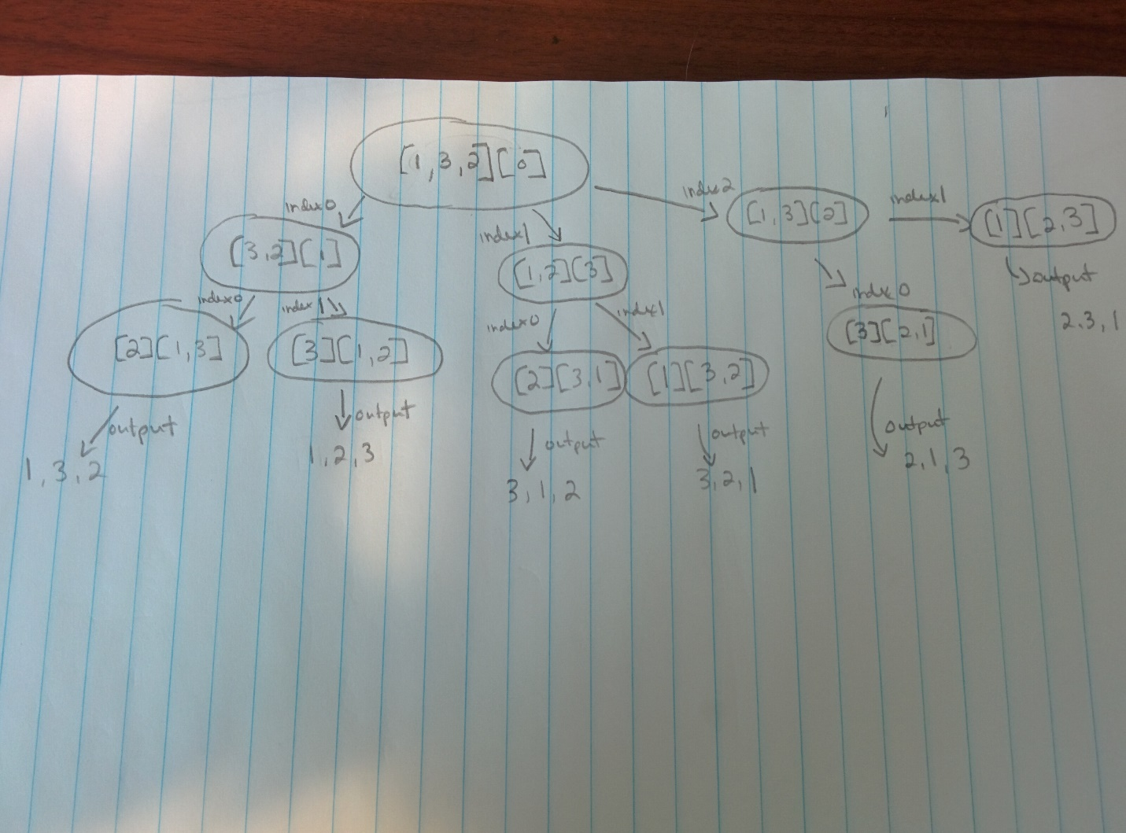

Each time it says “index0” or “index1” it means following that line will move the item that is index from the left array to the right array (remaining array, current array respectively). So for example on the far left the first line down index0 moves the number 1 from the left array to the right array. Following left again, we see it moves index0 (now 3) from the left array to the right array. At this point, we only have one element remaining in the left array so we output (and you can see that logic in the code). I achieve the output you see below by iterating over selected marble arrays. So for example, if the user selected yellow marble (4) I would run my permutation function on two marbles first then on three marbles and then finally on four and output all the results.

1. The source code can be found in the folder App.
2. This is the resulting output if a user chose red.

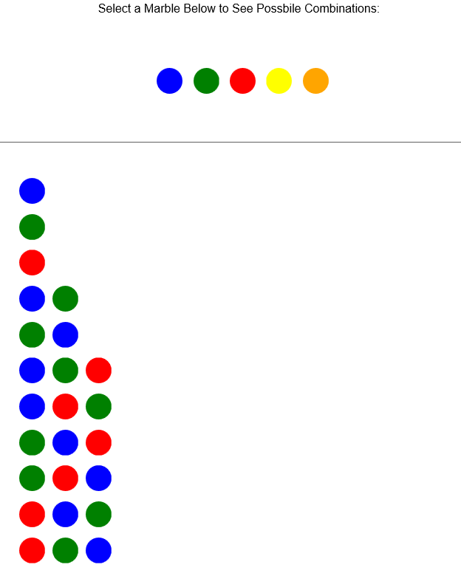

1. I tested my app in:
   1. Google Chrome 48.0.2564.116 m
   2. Firefox 44.0.2
   3. Chromium 48.0.2564.116 Ubuntu 14.04 (x64)
   4. Microsoft Edge 25.10586.0.0