AIND2 Mimic Me Project

## 1. Display Feature Points

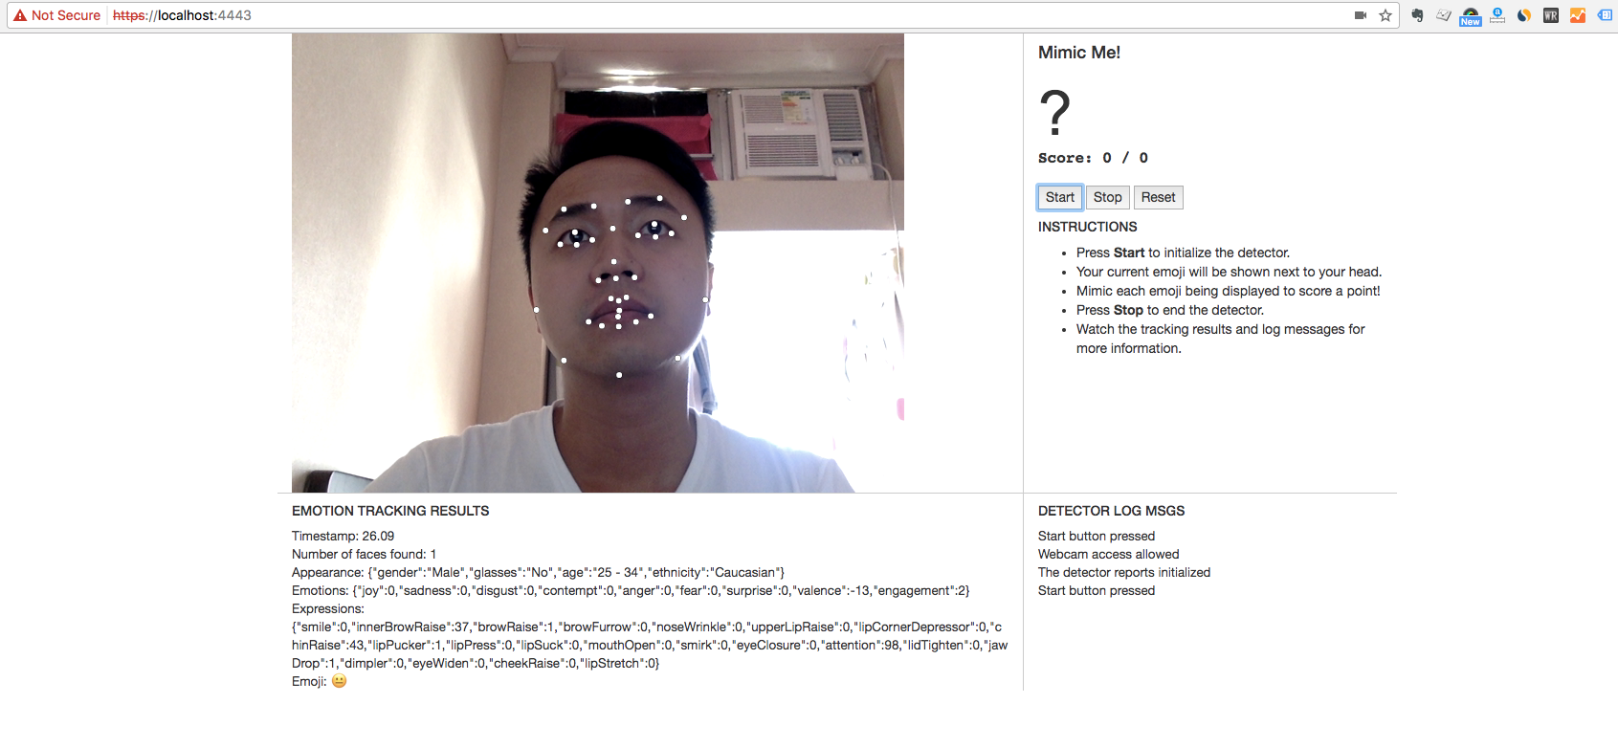

First, set the style of the ctx variable to white, such that the point will appear in white color. Then loop through all the feature points of the face, draw a dot at the x,y coordinates of each feature point.

## 2. Show Dominant Emoji

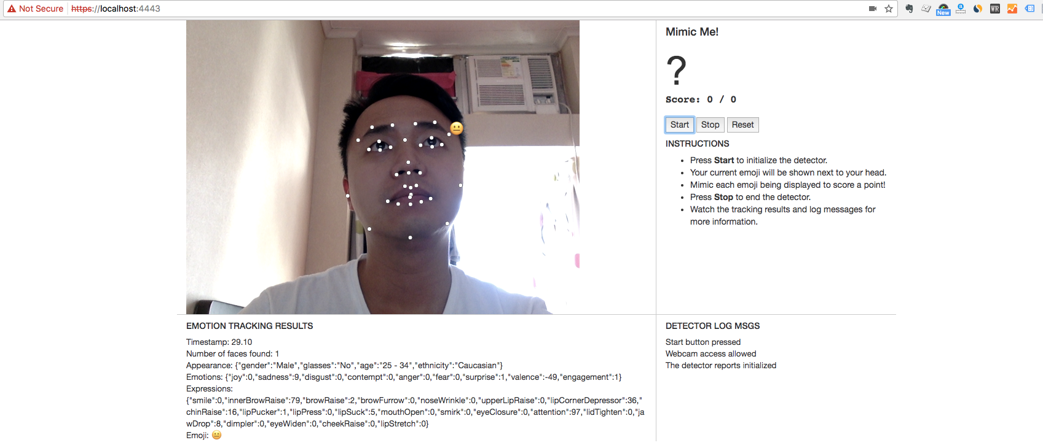

First, set the font size of the ctx variable, to control the appearance size of the emoji that we are going to draw. Then have to find out feature point that is the closet to the top right corner. Loop through all the feature points, calculate the distance between each point to the top right corner, then select the one that is having the shortest distance. On that point, draw the dominant emoji there.

## 3. Implement Mimic Me!

I created a class object “Game” to host all the states and actions of the game. Here is the details:

constructor()

This is the constructor which is to initialize all the variables inside the Game object. A Game instance is created at the event of “onInitializeSuccess”.

checkResult(input)

This is to check if the input emoji is same as the target emoji when the game is running, otherwise it won’t do the checking. This is to prevent the game from updating score if the game is paused. Convert the dominant emoji to unicode using the toUnicode() function before doing the comparison.

This function is also called at the event listener *onImageResultsSuccess*, such that whenever a new dominant emoji is detected, it will be compared against the target emoji.

toStateWinRound()

Make all the necessary handlings when there is a emoji match. Specifically,

1. Increment the score
2. If the score reaches the maximum score, finish the game with an alert message and then restart the game
3. Otherwise, proceed to next round

toStateNextRound()

Make all necessary handlings when goes to next round. Specifically,

1. Get a random emoji from a fixed set of emojis
2. Set the target emoji

start()

Mark the isRunning flag to be true, reset all the variables and start the first round of the game.

This function is also called at the event listener *onInitializeSuccess*.

stop()

Mark the isRunning flag to be false, reset all the variables.

reset(startOver=false)

Reset the variables score and target emoji. If the startOver parameter is true and the game is still running, it means restart the game and hence proceed to a new round.

This function is also called at the click event of *onReset*.

setGameScore(score)

It is a wrapper function to standardize the set game score action. It includes set the variable score and use the global function *setScore* to display the current score on webpage.

setTarget(emoji='')

It is a wrapper function to standardize the set target emoji action. It includes set the variable current_emoji and use the global function *setTargetEmoji* to display the current target emoji on webpage. It can also clear the target emoji by passing nothing or empty string into this function.

getRandomEmoji()

Randomly pick one emoji out of the fixed list of emojis.

