Apparel Innovation Brands

Dunn


Dunn's Formation and Initial Strategy:
- Dunn was established in the mid-1960s by Daniel Dunn and his colleagues in Anaheim, California. The brand was initially named the Dunn Rubber Company, differentiating itself by making shoes in-house and selling them directly to customers.
- In the early 1980s, Dunn experienced a significant turning point. The brand tried to expand too rapidly into a variety of markets, including athletics and dance, which ultimately led to financial hardship and bankruptcy in the mid-1980s. Despite these challenges, the company managed to restructure and come out of bankruptcy by the late 1980s.
Brand Evolution and Strategic Shifts:
- The late 1980s marked a resurgence for Dunn, with the introduction of its first signature skate shoe, the Danny Caballero, a high-top skate shoe with additional padding. This period saw the company sold to a venture investment firm, McAllen De Leu & Co., for approximately $70 million.
- In the 1990s and early 2000s, under McAllen De Leu & Co., Dunn reconnected with its core skate and surf audience. It sponsored key cultural events like the Wave Tour and Crown of Skateboarding. It also made a foray into media production with significant skateboarding films.
Acquisition by Apparel Innovation Brands and Expansion:
- In the early 2000s, Dunn was acquired by Apparel Innovation Brands for around $390 million, ushering in a new growth phase. The acquisition led to a deep dive into consumer research, identifying Dunn's target demographic as "Creative Expressers." The brand's strategy was reoriented to focus more on art, music, and street culture.
- Dunn expanded its product range and started collaborations with various artists and designers, also venturing into apparel lines.
- Internationally, Dunn expanded significantly post-acquisition, opening flagship stores in major cities like Shanghai, and broadening its market reach to include regions like India and Mexico.
Recent Strategic Focus and Developments:
- Geographical Expansion and Concept Stores: Following its growth trajectory in the 2010s, Dunn has not only expanded its international footprint but also delved into innovative retail experiences. It established large, experiential concept stores in major cities like London and Seoul with over 2,000 stores in 95 countries and a strong e-commerce platform​​​​.
- Research and Development Emphasis: Dunn has placed significant emphasis on innovation. This commitment to R&D is drive by a passion for innovation, leading to peak revenues and market dominance, as well as the creation of iconic products like the Authentic and Old Skool silhouettes​​.
- Cultural and Lifestyle Integration: Staying true to its skateboarding roots, Dunn, has integrated broader youth culture elements into its brand. This includes a strong connection with music, fashion, and art, appealing to a diverse audience that values self-expression and individuality. ​​.
- Interactive Retail Experience: Dunn's concept stores offer more than just shopping; they provide immersive experiences that reflect the brand’s lifestyle. Their stores feature interactive elements, skate parks, and events.
- Performance: However, Dunn experienced a 13% decline in sales towards the end of 2022, which was marked by sharp inflation and stiffer competition from rivals like Nike.
Below are some examples of their products:
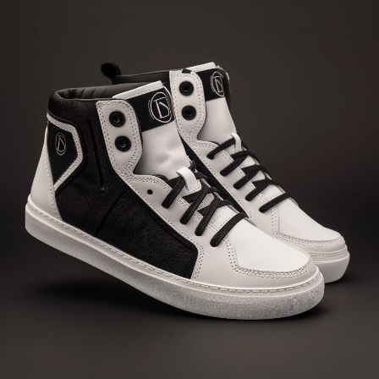
RatFang



RatFang, an iconic brand in the outdoor gear and footwear, has a rich history that reflects its commitment to quality, sustainability, and innovation.
Early Beginnings and Growth:
- RatFang was founded in the 1950s in New England by the Ratcliffe family. Initially, it was a small operation focusing on rugged outdoor boots designed for harsh weather conditions.
- The brand quickly gained a reputation for its durable, waterproof boots, which became popular among outdoor enthusiasts and workers alike.
Strategic Expansion and Market Positioning:
- In the 1970s and 1980s, RatFang expanded its product line to include a range of outdoor wear. This expansion was driven by the increasing popularity of outdoor activities and the growing demand for high-quality, reliable outdoor gear.
- The company's strategy was focused on blending style with functionality, making its products appealing not just to outdoor workers but also to those in the fashion and casual wear markets.
Challenges and Innovations:
- RatFang faced stiff competition in the 1990s as the market for outdoor gear became increasingly crowded. To differentiate itself, RatFang began to focus on sustainable practices, using environmentally friendly materials and processes in its manufacturing.
- Innovations in design and technology became a hallmark of RatFang, with the brand introducing new materials and construction techniques to improve the durability and comfort of its products.
- Acquisition by Apparel Innovation Brands:
- In the early 2000s, RatFang, a burgeoning outdoor gear brand, underwent a significant transformation when it was acquired by Apparel Innovation Brands for nearly $2.2 billion​​. This acquisition was a strategic move, enabling RatFang to leverage Apparel Innovation Brands' vast resources. It significantly bolstered RatFang's research and development, marketing, and global distribution capabilities.
- Under the new ownership, RatFang expanded its global footprint, particularly in Asia and Europe, which represented a substantial portion of their global revenue​​. Alongside this geographical expansion, RatFang also enhanced its online retail capabilities, particularly through direct-to-consumer (DTC) digital sales, which were expected to grow at a compound annual growth rate (CAGR) of 23 to 35 percent​​.
- Recent Developments and Future Focus:
- In recent years, RatFang has continued to establish itself as a leader in the outdoor gear market. The brand is widely recognized for its quality, innovation, and commitment to sustainability- with an ambitious environmental vision aiming for their products to have a “net positive impact” on nature by 2029, focusing on circularity and regeneration​​.
- RatFang's current strategic focus aligns with modern market trends. The brand is intensively working on expanding its digital footprint to enhance customer engagement through various online platforms. This strategy is inspired by RatFang's success in digital growth, as they experienced strong double-digit growth across all regions, with a plan to drive most of their growth over the next five years through digital channels​​. Additionally, RatFang continues to emphasize sustainable practices in all aspects of its operations​​.

Recent Performance and Growth Strategies of RatFang:
- Flagship Store and Brand Reach: RatFang launched a flagship store in New York City’s SoHo neighborhood. The new flagship store serves as a cornerstone of RatFang’s brand, showcasing its heritage and innovation. It offers unique customer experiences like product customization and personalizations of laser etching and heat pressing embroidery.
- Financial Performance: RatFang reported flat sales for the third quarter with revenue of $595.5 million​​, RatFang experienced a period of stable yet steady sales. This stability has prompted RatFang to explore new growth avenues, particularly focusing on underrepresented market segments and innovative product lines.
- Membership Programs and Community Engagement: RatFang introduced a membership program named "Rat Nest"​​​​. This program aims to foster a strong community by offering exclusive access to products, events, and special promotions. The success of this program was significant, overachieving its initial targets, indicating a strong brand loyalty and customer engagement.
- Expanding Product Lines and Customer Segments: RatFang is focusing on expanding its product lines in specific areas like women’s outdoor apparel and hiking equipment​​. This is part of a broader strategy to tap into new customer segments and drive brand loyalty.
- Technological and Operational Upgrades: RatFang is investing in upgrading its distribution and e-commerce systems, making the online shopping experience more engaging and efficient​​. These upgrades are part of RatFang’s commitment to staying at the forefront of retail technology.
- Omnichannel Strategy and Brand Awareness: Embracing an omnichannel approach, RatFang is integrating its in-person and online experiences. This strategy includes enhancing its social media presence and other digital communications to create a 360-degree brand experience​​.
- Focus on Physical Retail Presence: RatFang plans to expand its physical retail presence in key markets, aiming to strengthen its brand identity and connect more deeply with customers​​.
Below are some examples of their products:
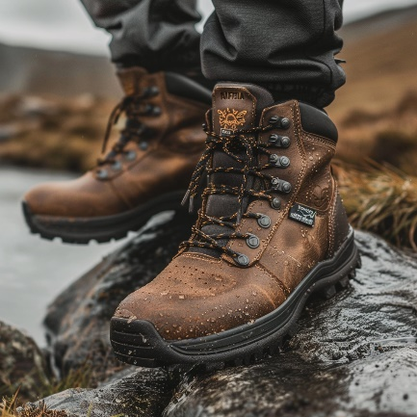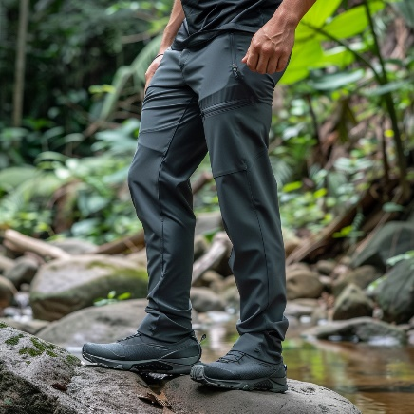
Murphies


Murphies, a renowned real-world workwear and apparel company, represents a story of resilience, innovation, and strategic growth in the face of changing market dynamics.
Origin and Founding:
- Murphies was established in the 1920s in Texas by the Murphy family. The company started as a small outfit making durable work garments for local industrial workers.
- Known for its tough and practical designs, Murphies quickly became a go-to brand for workers in various industries, from construction to automotive work.
Expansion and Brand Evolution:
- During the 1950s and 1960s, Murphies expanded its product line beyond just workwear to include casual wear, leveraging its reputation for durability and comfort.
- The brand's clothing became popular not only among workers but also among youth and subcultures, who appreciated the rugged style and robust quality of Murphies’ garments.
Market Challenges and Innovations:
- Facing intense competition and changing fashion trends in the 1970s and 1980s, Murphies began to innovate in both design and marketing. It introduced new styles and fabrics, while maintaining the durability that the brand was known for.
- Murphies also started to sponsor sports events and music festivals, connecting with a broader audience and establishing itself as a culturally relevant brand.
- Acquisition by Apparel Innovation Brands: In the late 1990s, Murphies experienced a pivotal moment in its corporate journey when it was acquired by Apparel Innovation Brands for $830 million. This acquisition was more than a financial transaction; it signified a strategic transformation for Murphies. With the backing of one of the nation's largest apparel conglomerates, Murphies gained access to extensive resources, facilitating global expansion and marking a new chapter in its history.
- This partnership enabled Murphies to not only broaden its geographical footprint but also to enhance its online presence, adapting swiftly to the burgeoning digital retail landscape. The focus shifted to creating a strong e-commerce platform, catering to a global audience, and ensuring that Murphies' quality workwear was accessible to a wider customer base.
- Recent Developments and Strategic Direction: Today, Murphies stands as a beacon in the workwear and casual apparel industry, recognized for its unique blend of practicality, style, and durability. The brand has successfully maintained its core values while evolving to meet the demands of a diverse and changing consumer base. Its appeal stretches across various demographics, from skilled tradespeople to artists and subcultures, reflecting a broad spectrum of society.
- Murphies' recent strategic initiatives have been centered around sustainability. The brand is committed to integrating eco-friendly materials and processes into its manufacturing, echoing the increasing environmental consciousness of consumers. This shift towards sustainable practices is not just a response to market trends but a reflection of Murphies' dedication to being a responsible and forward-thinking brand.
- In keeping with its tradition of innovation and staying relevant, Murphies has embarked on a series of collaborations and partnerships. These initiatives range from high-fashion collaborations, aimed at bringing a contemporary twist to classic workwear designs, to unique partnerships that blend functionality with artistic expression. For instance, a recent collaboration with a renowned designer, known for his workwear-inspired fashion line, was aimed at bridging the gap between rugged durability and high-fashion sensibility.
- Another significant collaboration was with a popular actress known for her passion for vintage car restoration. This partnership resulted in a collection that combined practical workwear with stylish, delicate design elements, catering specifically to the Gen Z female demographic. These collaborations are not just business strategies but are reflective of Murphies' commitment to staying connected with its customer base through shared values and attitudes.
- As Murphies looks to the future, its focus is on maintaining the delicate balance between honoring its heritage and innovating for a new generation. The brand continues to be a common thread among diverse groups, bound by a shared appreciation for quality, authenticity, and practical style.
- There was a noticeable 3% year-over-year decline in revenue in the third quarter of the fiscal year. Specifically, Murphies' revenue dropped significantly by approximately 15% during this period. While some brands within the Apperal Innovation Apparel, like the outdoor-focused lines, showed revenue increases, Murphies struggled during this time.
- The decline in Murphies' revenue can be attributed to a variety of factors, including shifting market trends and possibly the brand's ongoing efforts to realign its product offerings with its new focus on sustainability and eco-friendly practices. Despite these challenges, Murphies continues to be an important player in the workwear and casual apparel sector, with a strong legacy and a loyal customer base. The brand's strategic focus on sustainability and its ventures into new collaborations suggest a forward-thinking approach, aiming to regain and enhance its market position in the upcoming periods.

Below are some examples of their products:
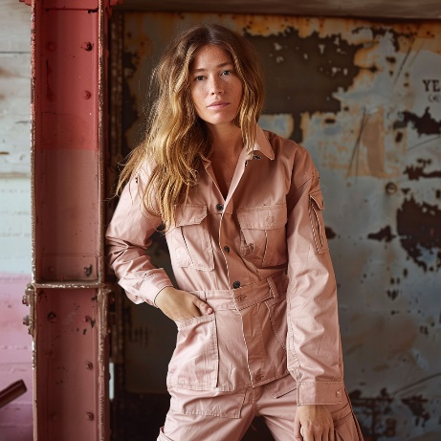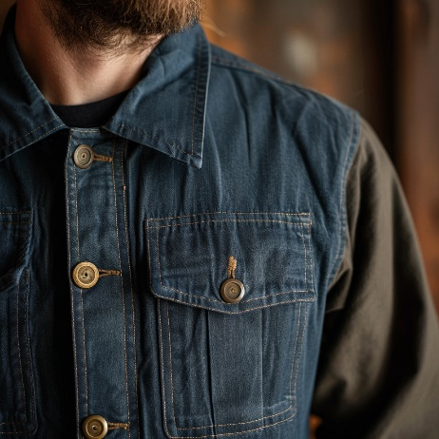

New Port

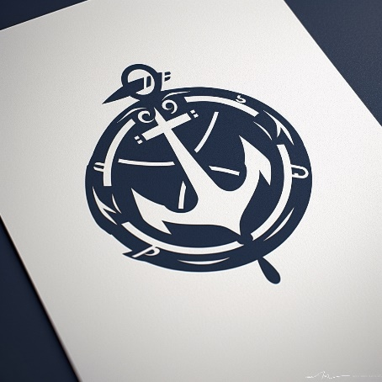
Early Years (1965-1973): New Port was founded in 1965 by a group of outdoor enthusiasts, starting as a small retail operation focused on premium-grade backpacking and climbing equipment. By 1968, the company expanded to wholesale and manufacturing, and in the early 1970s, it added outerwear to its product line.
Innovation in Product Design (1975-1990): The brand was known for its innovative product designs. In 1975, New Port introduced a groundbreaking geodesic dome tent, setting a new standard for lightweight, high-performance tents. The same year, the company also launched shingled construction sleeping bags with synthetic insulation. The 1980s saw New Port entering the "extreme skiwear" market, and in 1988, the Expedition System, a line of severe cold weather clothing, was introduced.
Challenges and Strategic Shifts: New Port faced internal challenges in the 1980s, primarily due to attempts to manufacture all of its products in-house, leading to obsolete materials and late deliveries. In 1988, Odyssey Holdings, Inc. acquired the company. The new management, appointed in the early 1990s, focused on revamping operations, which included closing discount outlets and discontinuing unprofitable lines.
Dramatic Turnaround (1994 and Beyond): The company's fortunes began to turn around in 1994, when it was purchased at a public auction and underwent significant transitions, including new leadership under CEO Marsden S. Cason. The company then sought to diversify into the casual apparel industry, introducing "Summit Shops" selling Tekware.
Market Expansion and Challenges: New Port faced competition and market challenges, particularly from brands with similar product lines. Despite this, the company was poised for growth, leveraging its strengths in brand recognition, product differentiation, and innovative design.
Acquisition by Apparel Innovation Brands: In the late 1990s, New Port experienced a pivotal moment when it was acquired by Apparel Innovation Brands for approximately $26 million. This acquisition signified a major shift in New Port's trajectory, providing it with the resources for extensive global expansion, innovative marketing strategies, and advanced product development. Under the umbrella of Apparel Innovation Brands, New Port successfully penetrated international markets and made significant strides in the digital retail landscape, enhancing its online presence and e-commerce capabilities.
Headquarters and Global Presence: In 2021, to better align with its strategic focus and growing international presence, New Port relocated its headquarters to Salt Lake City Utah.
Recent Challenges and Resilience: In 2022, New Port faced a significant cybersecurity challenge. A credential stuffing attack targeted its website, compromising nearly 195,000 customer accounts. The company's quick response in addressing and resolving this issue showcased its commitment to customer security and trust.
Recent Performance: Despite a challenging global economic climate, New Port has demonstrated remarkable growth. The brand saw a 16% increase in its annual revenue, reaching $3.5 billion. This growth was consistent across various regions and sales channels, with direct-to-consumer sales soaring by 19% and wholesale revenue growing by 14%. The EMEA region witnessed a 23% increase in sales, while the APAC region surged by 34%. However, the American market showed modest growth due to a challenging wholesale environment.
Innovative Initiatives: New Port has launched several innovative initiatives, including a line of performance footwear that has achieved significant recognition in competitive sports. The brand also initiated an Athlete Development Program to address systemic barriers in outdoor sports. Moreover, its global loyalty membership program expanded significantly, adding over one million new members in a quarter, reaching a total of 18 million members.
Strategic Focus and Sustainability Initiatives: Today, New Port stands as a leader in both workwear and casual apparel, blending functionality, style, and quality. The brand's current strategic focus is deeply rooted in sustainability. By 2025, New Port aims to use 100% recycled, regenerative, or renewable materials for its top apparel products, reflecting its commitment to reducing its environmental impact. The brand has also set ambitious goals to use recycled content in most of its fabrics by 2023 and eliminate single-use plastic packaging by 2025.
New Port's "Exploration Without Compromise" vision includes scaling up circularity in its operations. The brand has launched a fully circular line of apparel, emphasizing waste reduction and product lifespan extension through initiatives like the Renewed Collection and Lifetime Warranty programs. Additionally, New Port has introduced a seal to identify its most sustainable products, ensuring that these items are made with at least 75% recycled or responsibly sourced materials.
Below are some examples of their products:
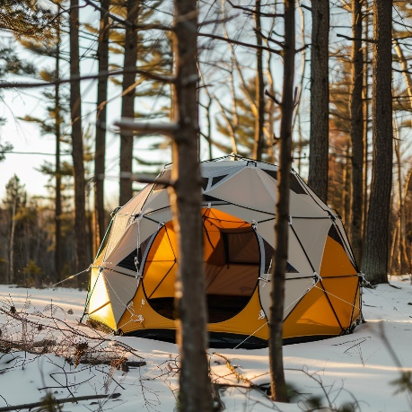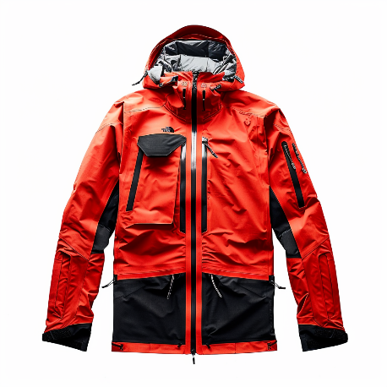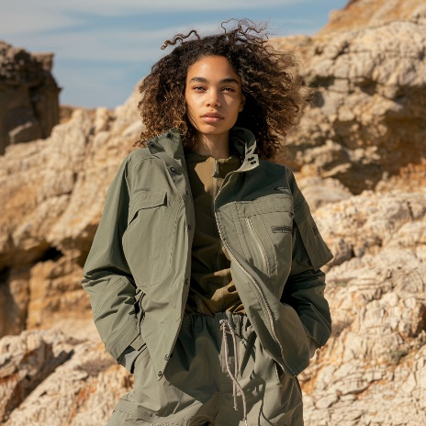

Ritz Running

Origin and Early Development:
- Ritz Running was founded in 2009 by a group of dedicated runners and footwear specialists in the mountainous region of Utah. Their goal was to create a running shoe that offered both comfort and improved running performance.
- The founding team, noticing a gap in the market for footwear that allowed for a more natural foot position and stride, developed their first shoe with a zero-drop heel and a foot-shaped toe box. This design was intended to promote a more natural running form and reduce injury risk.
Brand Growth and Market Strategy:
- Initially, Ritz Running focused on the local running community, gaining popularity through grassroots marketing and local running events. Their unique shoe design appealed to runners seeking a more natural running experience.
- The brand quickly gained a reputation for its innovative design, leading to expanded distribution in specialty running stores across the United States. Ritz Running's approach combined technical innovation with a deep understanding of runner's needs, setting them apart in a competitive market.
Expansion and Strategic Evolution:
- With growing popularity, Ritz Running began to expand its product line, introducing various models catering to different running surfaces and conditions, while always maintaining its core design principles.
- The brand's commitment to a natural running philosophy resonated with a growing segment of runners who were looking for alternatives to traditional running shoes. This led to a loyal customer base and strong brand recognition in the running community.
Acquisition by Apparel Innovation Brands:
- In a strategic move to broaden its market reach and benefit from greater resources, Ritz Running was acquired by Apparel Innovation Brands in 2018 for $55 million.
- Under Apparel Innovation Brands, Ritz Running accelerated its global expansion, leveraging the conglomerate's extensive distribution network. The brand also benefitted from increased research and development capabilities, allowing for continuous innovation in running shoe technology.
Recent Developments and Future Focus:
- Ritz Running's recent developments include advanced cushioning technologies and environmentally sustainable materials, reflecting a commitment to innovation and ecological responsibility.
- The brand's future focus is on expanding its presence in international markets and continuing to evolve its product line with cutting-edge technology and sustainable practices.

Performance:
- In the last quarter of the previous year, they reported a slight decrease in net sales compared to the previous year, a marginal change of -0.1%. Despite this, the company showed a remarkable turnaround in profitability. Their GAAP Net Income soared by 125.4%, a significant recovery from a substantial loss in the previous year. This improvement was reflected in the GAAP Net Income Margin, which shifted from a negative 18.7% to a positive 4.8%.
Below are some examples of their products:
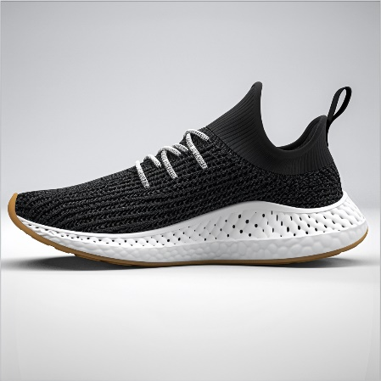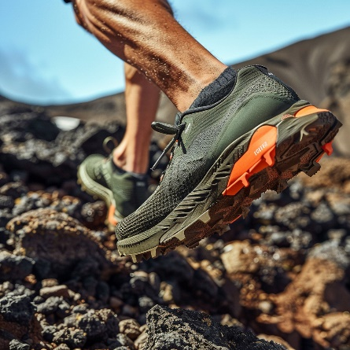

Kroes & Ribas
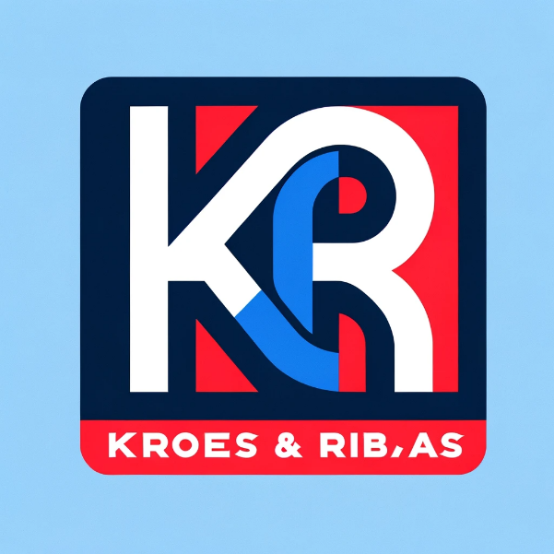

Founding and Early Years:
- Kroes & Ribas began its journey in 1952 as Northern Canvas Products, founded by Martin Kroes in Boston, Massachusetts. Initially, the company specialized in manufacturing durable bags and packs for the military, including duffels, backpacks, and safety equipment.
Transformative Changes:
- The pivotal moment for Kroes & Ribas came in 1976 when Martin's son, Lucas Kroes, joined the company. Lucas, a visionary and creative thinker, shifted the company's focus from military to consumer markets. He noticed the growing popularity of military-style bags among college students and launched a consumer line of backpacks and shoulder bags.
Brand Evolution and Market Expansion:
- The transition to consumer products was a resounding success. In 1981, Julian Ribas joined the company, bolstering its presence on the East Coast. By 1984, Kroes & Ribas introduced a lifetime warranty for their products, a testament to their durability and quality. In the following year, the brand began using vibrant prints and colors, being the first to integrate the lively '80s style into its product line.
International Growth and Strategic Partnerships:
- Kroes & Ribas expanded internationally in 1986, starting with France, where their products quickly gained popularity. This expansion was facilitated by a partnership with the French distributor Kostia Belkin. The brand's marketing strategies evolved significantly in the 1990s, becoming as iconic as their backpacks. In 1999, Kroes & Ribas introduced wheeled luggage for the consumer market.
Acquisition by Apparel Innovation Brands:
- In 2000, Kroes & Ribas joined the Apparel Innovation Brands. This acquisition marked a new phase in the brand's development, offering greater resources and market reach.
Designer Collaborations and Artistic Reinvention:
- Starting in 2003, Kroes & Ribas began collaborating with artists and designers, transforming their backpacks into works of art. Their first collaboration was with Dutch tattoo artist Hendrikus Johannes Everhardus Schiffmacher, followed by partnerships with Belgian fashion designer Walter Van Beirendonck and other renowned designers like Kris Van Assche and Raf Simons.
Performance:
- In recent years, Kroes & Ribas has posted strong results, demonstrating robust revenue and margin growth. The company has benefitted from a resurgence in the popularity of travel gear, school packs, and lifestyle accessories, cementing its position as a leader in these segments. Despite the overall positive performance, Apparel Innovation Brands announced in early 2023 its decision to sell the Kroes & Ribas brand, along with other backpack brands in its portfolio. This decision was part of a broader strategy to refocus on its biggest strategic opportunities and enhance its overall financial performance.
- As part of this strategic realignment, Apparel Innovation Brands has been engaged in active portfolio management, constantly evaluating its brand portfolio to ensure optimal alignment with its strategic vision. The decision to sell Kroes & Ribas, while reflective of a shift in focus, does not diminish the brand's strong performance and market position. Kroes & Ribas continues to be a well-regarded brand with a loyal customer base, known for its quality products and innovative designs.
- The sale process for Kroes & Ribas is expected to be carefully managed, with the aim of finding the most suitable new owner who can further enhance the brand's potential and continue its legacy of innovation and quality. This transition phase is seen as a new opportunity for Kroes & Ribas to evolve and grow under new ownership, potentially unlocking new markets and opportunities.
Below are some examples of their products:
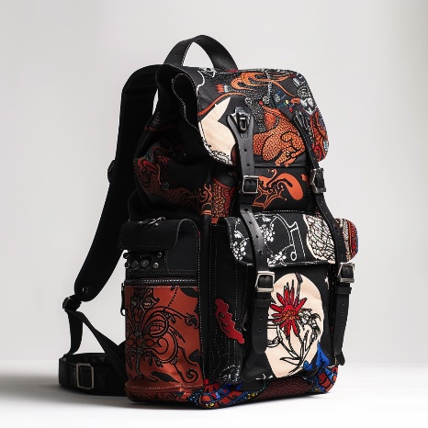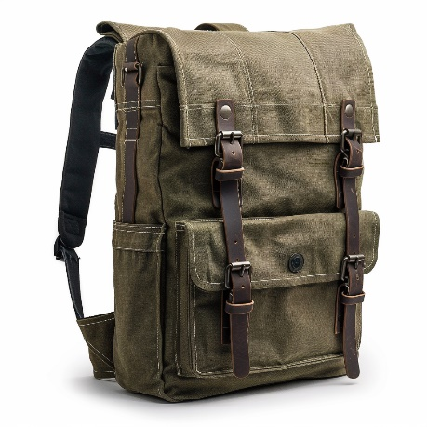

Baxter Trails
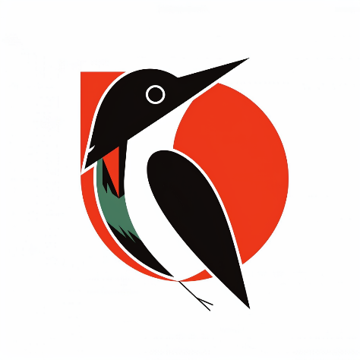
Foundation and Early Strategy: Baxter Trails, founded in 1995 in New Zealand, emerged as a pioneer in the ethical and sustainable production of natural performance apparel. The brand specialized in harnessing the unique qualities of fine merino wool, sourced from the most ethical and sustainable farms in New Zealand. This focus on merino wool was rooted in the brand's commitment to offering products that were not only high-performing but also environmentally friendly and ethically produced.
Innovative Approach to Materials: The core of Baxter Trails' product line was the innovative use of merino wool, which was ultra-fine and significantly softer than traditional wool, making it ideal for performance wear. The brand developed various fabrics suitable for different conditions, from lightweight eyelet fabric for running to brushed fleece layers for colder weather. This adaptability of merino wool was a key factor in the brand's success.
Sustainable Practices and Ethical Sourcing: Sustainability was at the heart of Baxter Trails' operations. The brand was committed to ethical manufacturing practices and animal welfare. They pioneered a direct sourcing system from merino wool growers as early as 1997, ensuring that all partners met their strict conditions on treatment of animals and land stewardship. This approach enabled them to launch a traceability program, allowing customers to trace the wool in their garments back to the farms where it was grown.
Global Expansion and Product Innovation: Baxter Trails expanded globally, with headquarters in Wellington, New Zealand, and a significant presence in the United States. The brand's staff, deeply integrated into the outdoor lifestyle, were instrumental in researching trends and driving innovation. The brand consistently sought to expand the uses of merino wool, experimenting with new technologies and blends, such as combining merino with Tencel for summer garments.
Acquisition by Apparel Innovation Brands: Baxter Trails was its acquired by Apparel Innovation Brands in 2017 for $205 million. This acquisition was preceded by a major supply contract worth $100 million with merino farmers, emphasizing the brand's commitment to sustainable and ethical sourcing practices.
Future Vision: Baxter Trails remained dedicated to its mission of natural performance products and aimed to be the global leader in this sector. The brand continued to innovate, exploring natural fibers to blend with merino and focusing on sustainable practices. With a vision set on the future, Baxter Trails aimed to push the boundaries of natural fiber use, maintaining its commitment to quality, sustainability, and ethical practices.
Performance: As of April 2022, the brand recorded global sales of approximately $173 million, with global unit sales reaching 5.2 million units. Given the brand's commitment to sustainability, quality, and innovation in natural fiber outdoor apparel, it's likely that these factors have continued to resonate with their target demographic. This would be particularly relevant in a market where consumers are increasingly valuing sustainable and ethical practices. Moreover, the outdoor apparel market has generally seen a positive trend, partly due to a surge in outdoor activities following the global situation in recent years.
Below are some examples of their products:
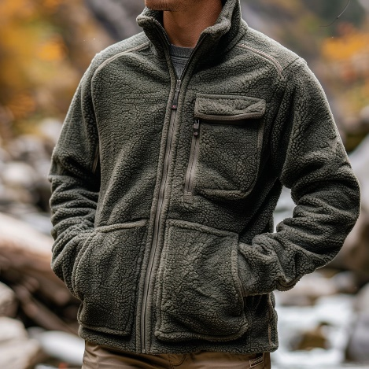

Cruzwear


Foundation and Early Years:
- Cruzwear was founded in the late 1960s in a small Midwestern town in the United States. It began as a family-run operation, with founders who were passionate about outdoor activities and recognized a gap in the market for durable, functional backpacks.
- The brand's first product was a rugged, high-quality backpack designed for hikers and campers, which quickly gained popularity for its durability and practicality.
Growth and Market Expansion:
- In the 1970s and 1980s, Cruzwear expanded its product line to include a variety of outdoor gear, such as sleeping bags, tents, and outdoor apparel. This period marked significant growth, with the brand becoming a household name among outdoor enthusiasts.
- The company's commitment to quality and its understanding of the needs of outdoor adventurers propelled its growth. Cruzwear's products became known for their innovative designs, reliability, and comfort.
Strategic Partnerships and Collaborations:
- By the 1990s, Cruzwear had established various partnerships and collaborations that furthered its market presence. The brand teamed up with schools, colleges, and other organizations, supplying customized backpacks and gear.
- These collaborations not only expanded Cruzwear's reach but also reinforced its reputation as a versatile and customer-focused brand.
Acquisition by Apparel Innovation Brands:
- In 1993, Cruzwear was acquired by Apparel Innovation Brands. This acquisition marked a new chapter for Cruzwear, providing access to greater resources, research and development capabilities, and an expanded distribution network.
- Under Apparel Innovation Brands, Cruzwear continued to innovate, introducing new materials and technologies to enhance the functionality and sustainability of its products.
Recent Developments and Strategic Focus:
- In recent years, Cruzwear has emphasized sustainability and eco-friendliness in its product designs, responding to growing consumer awareness about environmental issues.
- The brand has also focused on expanding its digital presence, enhancing online customer experiences, and tapping into new markets with evolving consumer lifestyles.
- Cruzwear has consistently maintained its commitment to quality and functionality while adapting to changing market trends and consumer preferences.

Performance: Cruzwear has maintained a strong commitment to quality and functionality while adapting to changing market trends and consumer preferences. The Adaptive Collection, in particular, has positioned Cruzwear at the forefront of an emerging market in adaptive fashion, projected to be worth a significant amount by 2026. This strategic move not only caters to a previously underserved community but also showcases Cruzwear's dedication to inclusivity and innovation.
Cruzwear's sales have been trending positively. The brand has seen strong revenue and margin growth, particularly in its core products like travel gear, school packs, and various accessories. This growth has been driven by a return to usage occasions and Cruzwear's strong market position in these segments.
Divestiture Considerations: Reflecting strategic shifts similar to those of its real-world inspiration, Cruzwear is currently under review for potential divestiture by its parent company, Apparel Innovation Brands. This decision is part of the company's broader strategy to optimize its brand portfolio and focus on top strategic priorities. While Cruzwear remains a profitable and iconic brand, the parent company believes that the brand could achieve its full potential under different ownership that can provide dedicated focus and resources.
This strategic move indicates a shift in the company's focus, aiming to ensure that Cruzwear and its sibling brands are positioned to maximize their potential while aligning with the parent company's strategic goals. The divestiture consideration, though still in the exploratory phase, reflects a dynamic market environment and the need for specialized management to propel Cruzwear’s future growth
Below are some examples of their products:
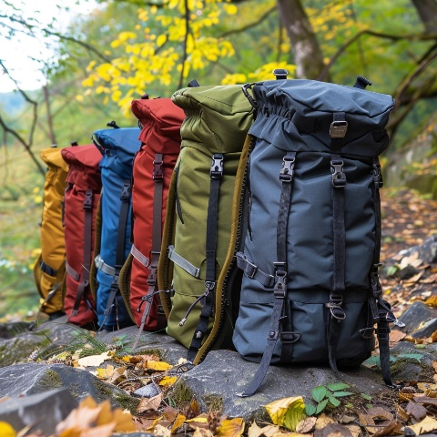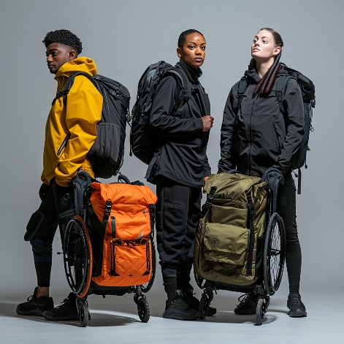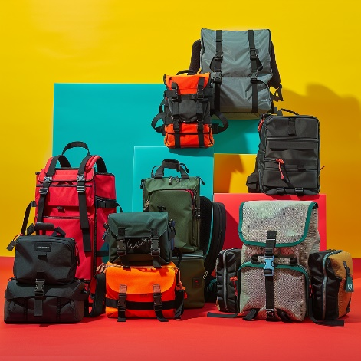

Boodraj Bags


Founding and Early Years:
- Boodraj Bags, established in the mid-1980s in Belgium, was founded by a group of three friends, each bringing a unique perspective to the world of fashion accessories. They started in a small studio, driven by a vision to create bags that were both functional and fashionable, blending European craftsmanship with a playful and vibrant aesthetic.
Brand Identity and Growth:
- The brand quickly became known for its iconic monkey keychain, a symbol of adventure and fun. Boodraj Bags' initial product line focused on casual, lightweight backpacks and handbags, featuring bold colors and unique patterns that appealed to a youthful, style-conscious demographic.
- Throughout the late 1980s and 1990s, Boodraj Bags expanded its range, introducing luggage, school bags, and accessories. The brand positioned itself as a provider of everyday solutions for dynamic, adventurous individuals, balancing practicality with a sense of whimsy.
Strategic Expansion and Challenges:
- In the early 2000s, Boodraj Bags faced the challenge of maintaining its unique brand identity amidst a rapidly changing fashion industry. To address this, the company began a strategic expansion into new markets, including Asia and North America, adapting its designs to cater to diverse consumer tastes while retaining its core brand ethos.
Acquisition by Apparel Innovation Brands:
- A significant turning point for Boodraj Bags came with its acquisition by Apparel Innovation Brands, a global leader in lifestyle and fashion, in the 2004 for $70 million. This acquisition provided Boodraj Bags with the resources and support to innovate further and expand its global presence.
- Under Apparel Innovation Brands, Boodraj Bags leveraged synergies in design, technology, and marketing, enhancing its product quality and expanding its reach. The brand benefited from shared expertise in sustainable practices, aligning with a growing consumer preference for eco-friendly products.
Recent Developments and Strategic Focus:
- In recent years, Boodraj Bags has focused on digital transformation, enhancing its online presence and e-commerce platforms. This shift catered to the evolving shopping behaviors of a digitally-savvy customer base.
- The brand also introduced a series of smart bags, integrating technology for enhanced functionality, like built-in charging ports and security features, appealing to the modern, tech-oriented consumer.
- Boodraj Bags continues to prioritize sustainability, incorporating recycled materials into its products and adopting more eco-friendly manufacturing processes.
Current Market Position and Future Outlook:
- Today, Boodraj Bags is recognized as a vibrant and innovative brand in the fashion accessory market. Its commitment to blending functionality with playful design continues to resonate with a global audience.
- Looking forward, Boodraj Bags aims to further its commitment to sustainability and innovation, exploring new materials and technologies to stay at the forefront of the fashion accessory industry.
Performance:
Boodraj Bags, while maintaining a strong market presence with consistent sales, has experienced some challenges in keeping up with the rapidly evolving fashion and consumer trends. Despite this, the brand continues to sell its products globally at an impressive rate. To address these challenges and rejuvenate its appeal, particularly among millennials, the brand has initiated a strategic overhaul, focusing on a new creative vision that aligns with contemporary aesthetics and values. This new direction emphasizes digital engagement, tapping into online platforms and social media to connect with a younger, more tech-savvy demographic. The brand's performance remains robust, driven by strong revenue and margin growth, and its products continue to be leaders in their category, especially in travel gear and school accessories.

Possible Divestiture:
Recently, there has been speculation about a potential divestiture of Boodraj Bags by its parent company, Apparel Innovation Brands. This decision is part of a strategic refocusing effort by Apparel Innovation Brands to concentrate on its core competencies and biggest strategic opportunities. Despite the potential sale, Boodraj Bags continues to perform well, indicating the brand's strong business fundamentals and market appeal. The divestiture process is expected to be carefully managed to ensure that Boodraj Bags finds an owner that can best support its future growth and development.
Below are some examples of their products:
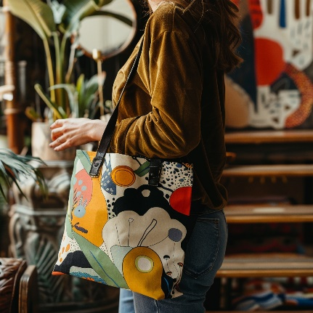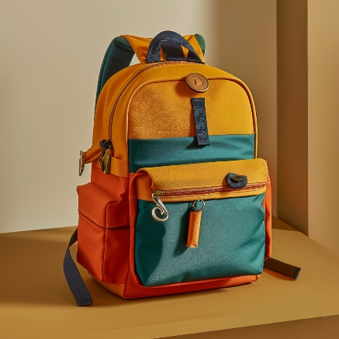

BlackPeak Outfitters

Foundation and Early Development:
- BlackPeak Outfitters began its journey in 1986, drawing inspiration from the majestic Alpine regions. Initially, the company started as a manufacturer of rugged travel bags, using durable materials akin to those used in military gear.
- The brand's early products, notably the Alpine Duffle, combined material expertise with a distinctive style: bold colors, prominent logos, and a flag emblem symbolizing a connection to polar exploration, a nod to the great pioneers of the Arctic and Antarctic.
Strategic Expansion into Apparel:
- By the early 1990s, BlackPeak Outfitters expanded its product line to include sportswear and outdoor apparel. The brand introduced signature items like the lightweight, weather-resistant Summit Anorak, designed for extreme conditions.
- As the 2000s rolled in, BlackPeak Outfitters broadened its offerings further, launching a children's clothing line and introducing footwear.
Global Reach and Retail Expansion:
- The first BlackPeak Outfitters store opened in a renowned Alpine town, marking the beginning of its retail expansion. The brand steadily increased its global presence, with notable store openings across Europe and Asia.
- By the mid-2000s, the brand operated over 200 stores worldwide, primarily across Europe but also extending to locations like South Korea.
Acquisition by Apparel Innovation Brands:
- In 2006, BlackPeak Outfitters joined the Apparel Innovation Brands family, a move that significantly bolstered the brand's global presence and operational capabilities. This acquisition mirrored a strategic partnership that enhanced the brand's design innovation and expanded its reach in the premium outdoor apparel market.
Brand Philosophy and Imagery:
- BlackPeak Outfitters has consistently incorporated themes of adventure, travel, and environmental consciousness into its branding. The brand's name and emblematic flag reflect a heritage of exploration and resilience in extreme conditions.
- The product range includes casual apparel and sportswear for all ages, alongside accessories like bags, belts, and hats. The brand is particularly known for its iconic jackets and durable outdoor gear.
Collaborations and Social Initiatives:
- Throughout its history, BlackPeak Outfitters has engaged in notable collaborations, enhancing its brand visibility and reinforcing its commitment to exploration and environmental sustainability. These collaborations have ranged from special edition clothing lines to supporting environmental research and expeditions.
Performance:
- The European market showed consistent growth, achieving its eighth consecutive quarter of growth.
- In the Asia-Pacific region, with a particular emphasis on Greater China, there was notable growth, indicating an expanding market presence for BlackPeak Outfitters in these areas.
- The Americas, however, experienced a downturn, primarily due to challenges in the US Wholesale sector.
- For the fiscal year 2024, BlackPeak Outfitters is expected to see its total revenue remain flat or slightly up in constant dollars. This forecast considers the current challenging environment in the US Wholesale sector. The brand is expected to benefit from a lower promotional environment, leading to an increase in gross margins by at least 100 basis points. The operating margin is anticipated to expand due to these higher gross margins, supporting modest increases in selling, general, and administrative expenses (SG&A)​
- Below are some examples of their products:
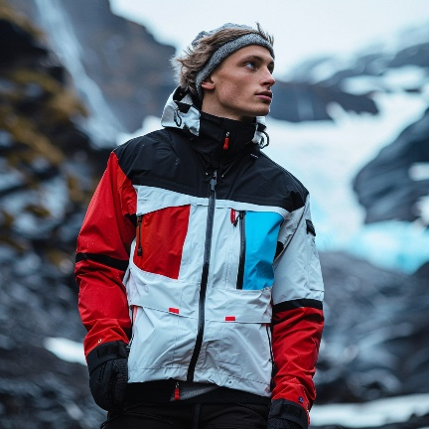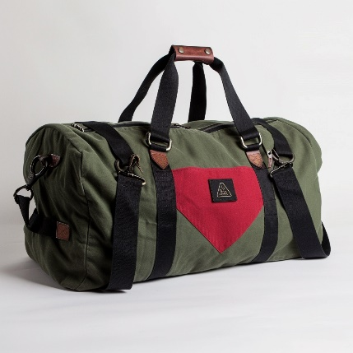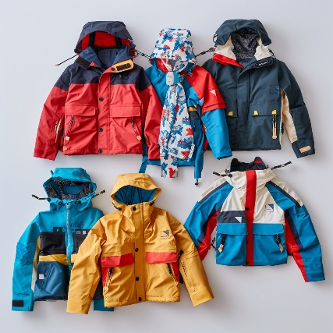

Ritter’s Rags

Founding and Early Growth: Ritter's Rags was established in 1994 in a small mountain town, founded by a pair of ski instructors, Richard and Patricia Ritter. Initially, the company focused on creating high-performance merino wool ski socks, which revolutionized the category and significantly impacted the way outdoor enthusiasts approached their gear.
Key Product and Material: Merino wool became the cornerstone of almost every product made by Ritter's Rags. Renowned for its softness, moisture management, temperature regulation, and odor-resistant properties, this material was pivotal in the brand’s base layers, hiking socks, running socks, and other outdoor apparel. The aim was to enable longer, more comfortable outdoor experiences without the distractions of discomfort.
Strategic Development and Organizational Change: Following a decade of substantial growth, Ritter's Rags encountered challenges related to company culture and strategic vision. This period required a significant change management effort to align the expanding team with the company's mission and vision. Through collaborative storytelling and strategic mapping, the company successfully navigated these challenges, reinforcing its organizational structure and strategic focus.
Acquisition and Expansion: The brand gained significant traction for its unique blend of comfort and durability. In 2005, Ritter's Rags caught the attention of RatFang, leading to its acquisition. This strategic move helped Ritter's Rags to expand its market reach and refine its product line. Further solidifying its industry position, in 2011, Ritter's Rags transitioned to becoming a subsidiary of Apparel Innovation Brands, a conglomerate known for its diverse portfolio in the outdoor apparel sector.
Current Focus and Values: Ritter's Rags continues to thrive on its founding ethos – a passion for the great outdoors coupled with a commitment to sustainability. The brand emphasizes creating apparel that eliminates discomfort, thus enhancing the outdoor experience for its customers. Core values of Ritter's Rags include a relentless pursuit of sustainability, transparency in its supply chain, and a deep-seated respect for the environment. The company has set ambitious goals to make all its products fully circular by 2030, with initiatives like the Ritter's Renew Project, which aims to extend the life of products and reduce environmental impact significantly.
Performance and Growth: Under the leadership of seasoned executives, Ritter's Rags has been experiencing a notable upswing in its performance- with $22 million in revenue last year. The brand has been consistently expanding its market presence, with a focus on innovation and sustainability driving its growth. The recent appointment of dynamic leaders within the brand's management has been a strategic move to ensure the continued growth and market relevance of Ritter's Rags in the competitive outdoor apparel industry.
Below are some examples of their products:
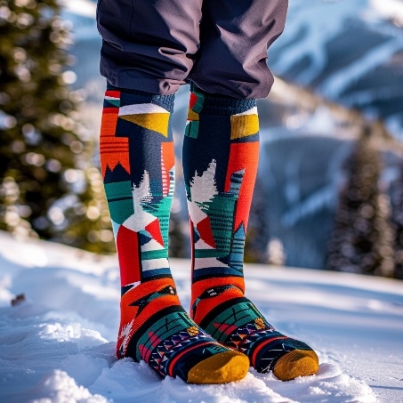

Rank

RANK
The Rise and Evolution of Rank: A Story of Streetwear Dominance
In the world of streetwear and urban fashion, few brands have made an impact quite like Rank. Founded in the early 1990s in New York City, Rank began as a humble boutique, nestled in the bustling streets of downtown. Its founder, Robert Jasper, a visionary with a keen sense of urban youth culture, started Rank with a simple yet bold mission: to create a brand that resonated with the streets, skate culture, and the burgeoning hip-hop scene.
Early Days and Cultural Resonance:
- Rank quickly became more than just a clothing store; it was a cultural hub. Jasper's early collaborations with local artists and skaters gave the brand an authentic connection to the street culture it aimed to represent.
- The brand's early releases were limited-edition skateboards and T-shirts, which often featured provocative designs and mirrored the rebellious spirit of youth culture. This exclusivity and boldness quickly garnered a cult following.
Brand Growth and Strategic Collaborations:
- As Rank grew in popularity, it began to collaborate with other artists and brands, further cementing its status in streetwear. These collaborations were not just about apparel; they were a blend of art, culture, and fashion.
- Rank's collaborations were diverse, ranging from luxury brands to tech companies, each adding a unique dimension to its portfolio. This strategy not only expanded Rank's reach but also kept the brand dynamic and relevant.
Apparel Innovation Brands Acquisition:
- In 2020, Rank's growing influence caught the attention of Apparel Innovation Brands. Apparel Innovation Brands acquire Rank for 2 billion- making it Apparel Innovation Brands largest acquisition. The acquisition marked a new chapter for Rank, giving it access to a vast network of resources and distribution channels.
- This partnership allowed Rank to maintain its core identity while expanding its global footprint. Apparel Innovation Brands' expertise in scaling brands complemented Rank's creative energy, leading to a harmonious blend of business acumen and creative vision.
Recent Developments and Future Directions:
- Today, Rank continues to thrive Bringing in 500 million in revenue last year. Its recent ventures include eco-friendly lines, tech-integrated wearables, and a push into digital fashion spaces.
- The brand remains true to its roots, regularly releasing limited-edition collections that pay homage to its street and skateboarding origins. Rank's commitment to authenticity and innovation has not only kept it at the forefront of street fashion but also made it a staple in contemporary culture.

Below are some examples of their products:

