Courses – Modules – Aws Learner Lab  
  
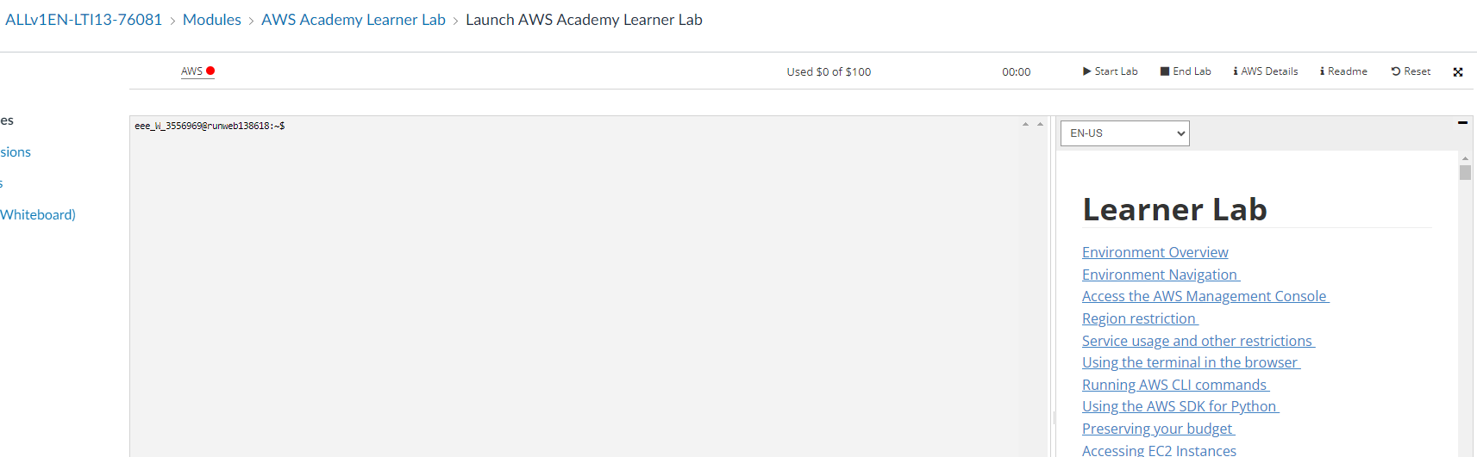  
  
To start – start lab

To end – end lab

Reset – to reset everything saved  
  
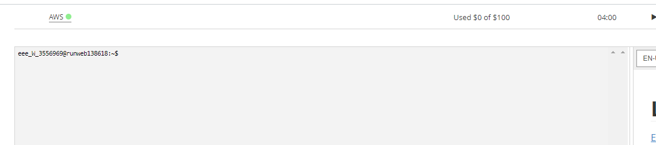  
  
when turns green, click on it, will open a new page, where we can see our account  
  
  
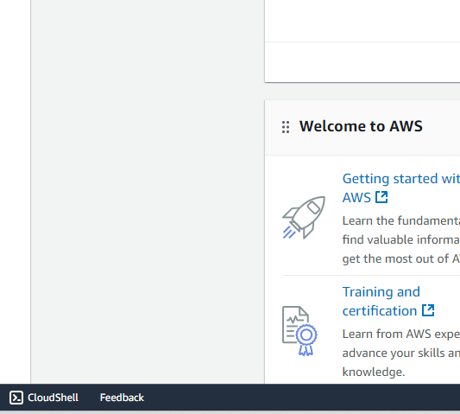  
  
Click CloudShell

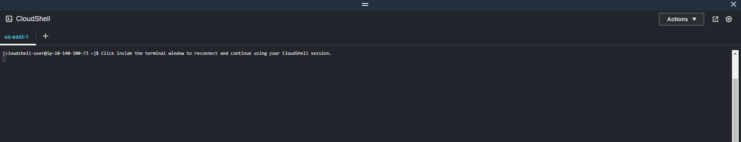  
  
This is AWS Linux VM

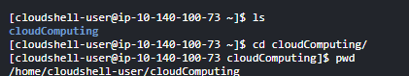

Create a folder

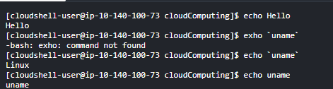

Echo – to print out anything



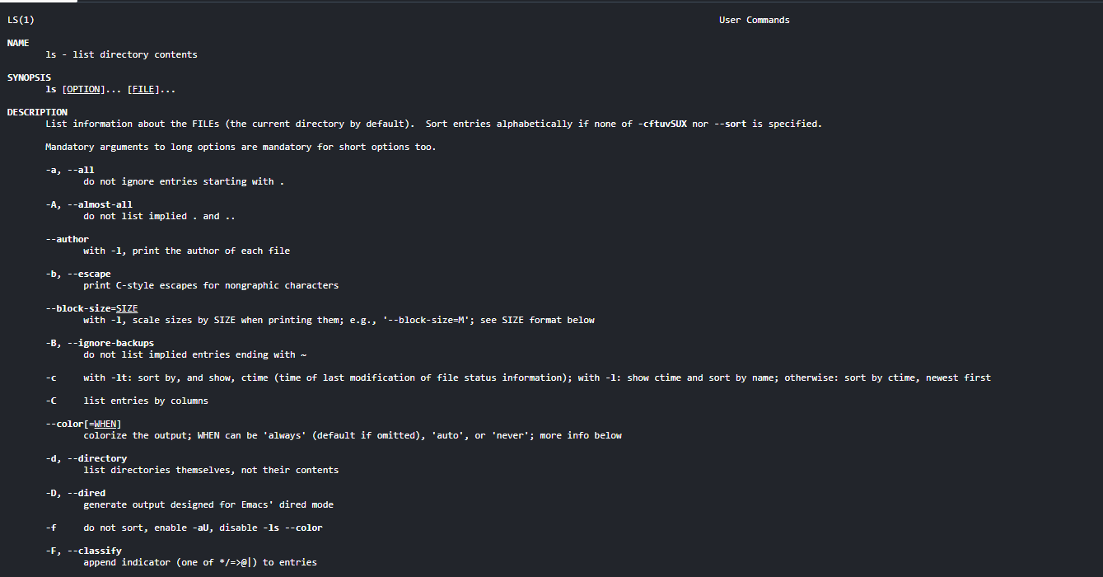

man -ls -> to get documents about the commands