**Secure Student Registration System(SSRS)**

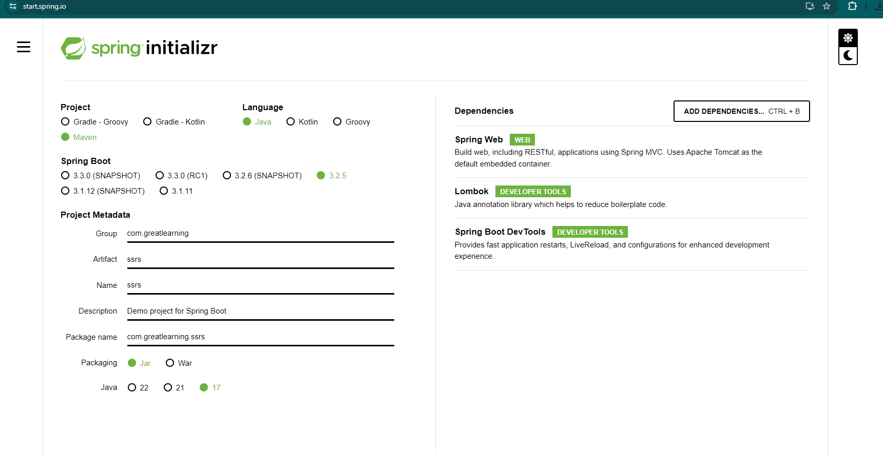

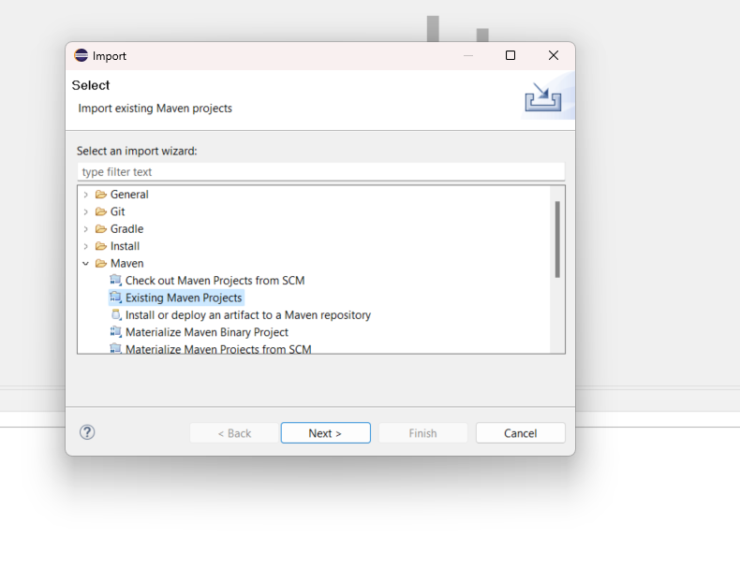

for pom.xml, add the following

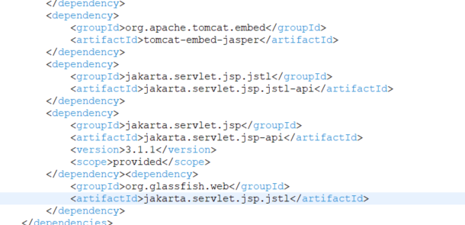

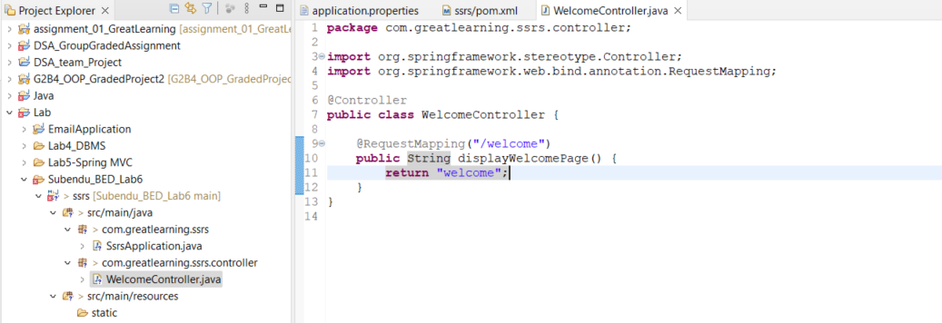

create a folder

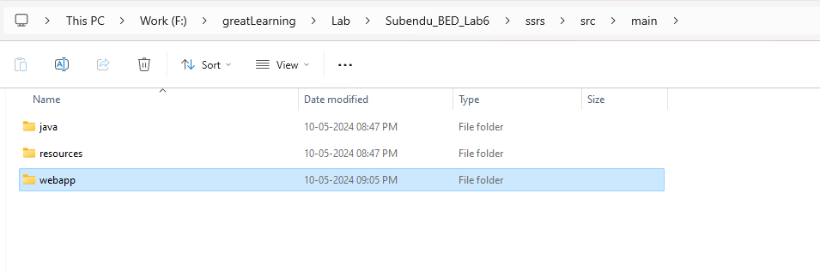

create another folder inside it as path added in application.properties

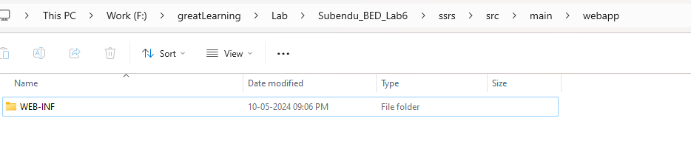

and another inside it

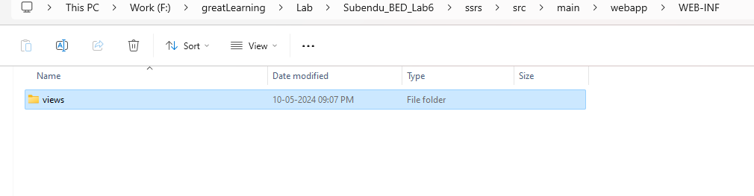

refresh the project

Add in views

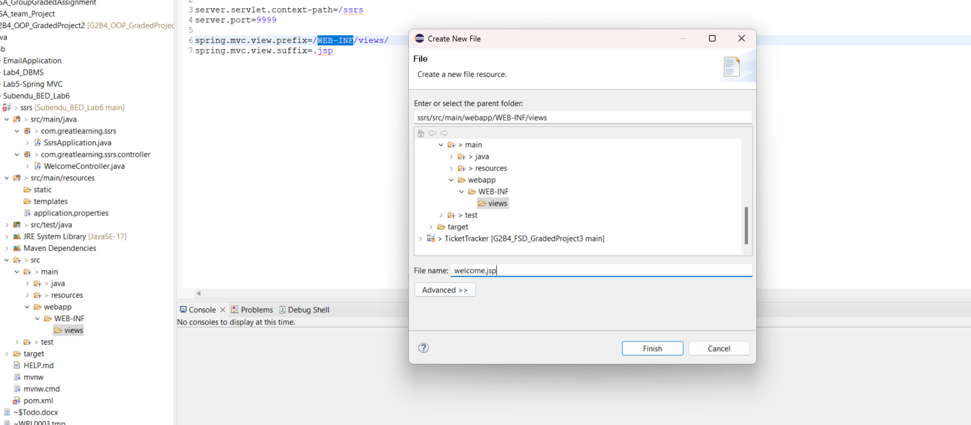

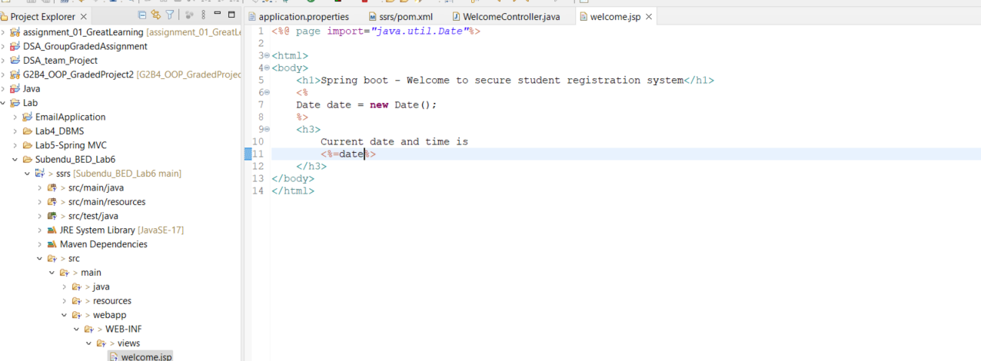

<http://localhost:3333/ssrs/welcome>

In application.properties, their should be no space