Difference between Process and Thread

[Process](https://www.geeksforgeeks.org/gate-notes-operating-system-process-management-introduction/)**:**  
Process means any program is in execution. Process control block controls the operation of any process. Process control block contains information about processes for example Process priority, process id, process state, CPU, register, etc. A process can creates other processes which are known as **Child Processes**. Process takes more time to terminate and it is isolated means it does not share memory with any other process.

The process can have the following states like new, ready, running, waiting, terminated, suspended.

[Thread](https://www.geeksforgeeks.org/operarting-system-thread/)**:**  
Thread is the segment of a process means a process can have multiple threads and these multiple threads are contained within a process. A thread have 3 states: running, ready, and blocked.

Thread takes less time to terminate as compared to process and like process threads do not isolate.

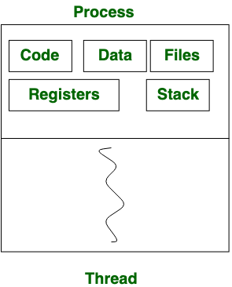

**Difference between Process and Thread:**

|  |  |  |
| --- | --- | --- |
| S.NO | Process | Thread |
| 1. | Process means any program is in execution. | Thread means segment of a process. |
| 2. | Process takes more time to terminate. | Thread takes less time to terminate. |
| 3. | It takes more time for creation. | It takes less time for creation. |
| 4. | It also takes more time for context switching. | It takes less time for context switching. |
| 5. | Process is less efficient in term of communication. | Thread is more efficient in term of communication. |
| 6. | Process consume more resources. | Thread consume less resources. |
| 7. | Process is isolated. | Threads share memory. |
| 8. | Process is called heavy weight process. | Thread is called light weight process. |
| 9. | Process switching uses interface in operating system. | Thread switching does not require to call a operating system and cause an interrupt to the kernel. |
| 10. | If one server process is blocked no other server process can execute until the first process unblocked. | Second thread in the same task could run, while one server thread is blocked. |
| 11. | Process has its own Process Control Block, Stack and Address Space. | Thread has Parents’ PCB, its own Thread Control Block and Stack and common Address space. |