Introduction
Sparkplug B is a communication protocol developed for IOT devices. The protocol itself builds on top of MQTT and Google’s Protobuf protocols. Sparkplug uses MQTT to transport the messages between multiple devices in a Sparkplug network. All of the data communicated between the devices, except for a few status messages, are encoded in a few specific Protobuf formats.

The basic diagram of a scalable Sparkplug B system is as shown below:
device

Host
MQTT queue
MQTT queue
MQTT queue
Edge Node
Edge Node
Edge Node
device
device
device
device
device

The system consists of a few edge nodes, one or more MQTT queues, and a Sparkplug host. Each of the IOT devices interfaces with one of the edge nodes in the system. It is the job of the edge node to gather raw data from the devices, encode it in the specified Protobuf format, and then put it in the MQTT queue for the host to consume as per the Sparkplug B specification. To ensure a scalable system, there can be multiple MQTT queues where the edge nodes can put their messages on. However, each edge node must connect to a single MQTT queue.

The Sparkplug host consumes the data sent by the edge nodes, and gathers it for further processing by the user. In a Sparkplug environment, the host is the only interface that an user can directly interact with.

The purpose of this challenge was to implement a Sparkplug B compliant host which can collect the data sent by the devices, and provide a few interfaces for an user to query the data. The details of the implementation of the host is specified on the next page.
Implementation
The Sparkplug B host side system implemented in this particular project has the following architecture:

CLI commands
REST API
Storage API
Storage Backend (DB, CSV file etc)
Host
User
MQTT queues

The host system acts a bridge between the MQTT queues and the storage. It listens for various (N/D)BIRTH, (N/D)DEATH, (N/D)DATA publications, and stores the information to the storage backend via the use of the interal storage APIs.

The storage API provides an interface for all other systems to talk to the storage backend, without the knowledge of how the storage is actually implemented. Right now, the storage backend is implemented as a sqlite DB. The storage APIs implement the actual SQL queries that are needed to be run for any particular action to happen. The rest of the system only calls the functions provided by the API to get their respective data. By implementing the same functions for another backend, the storaging solution can be switched without any change to the host, CLI or the REST modules.

This project provides two ways of interaction to the storage by the user - via the use of a command line REPL (Read – Eval – Print Loop), or via the use of a REST API. All three of the host system, CLI and REST interfaces are independent modules and can be run without any dependency on the other. The next section will show how the interaction using the various interfaces take place in this particular implementation.
Interactions
1. Command Line
The system provides a command line interface for querying the data, and in future sending commands to the nodes and/or devices.
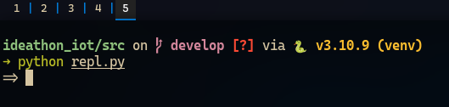
Launching the CLI gives an user the following prompt:
To get a list of commands to run, we start with help:
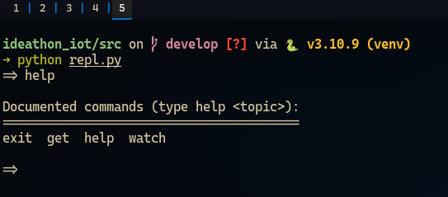

To view help for a particular command, we use help <command>. Let’s start with help get.
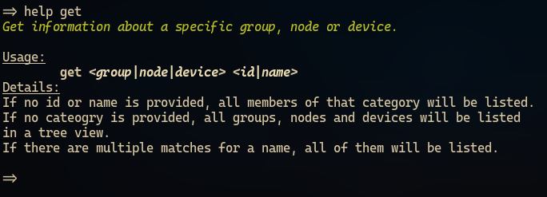

As per the instructions, get retrieves details for a particular group/node/device. Let’s try get group.
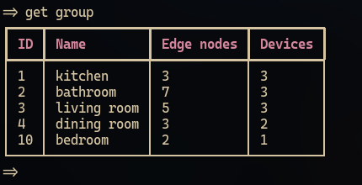

To get the list of all nodes, we can use get node.
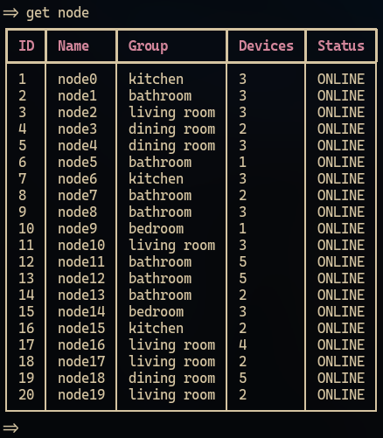

To get the details of a specific device, get node_name/device_name can be used like the following.
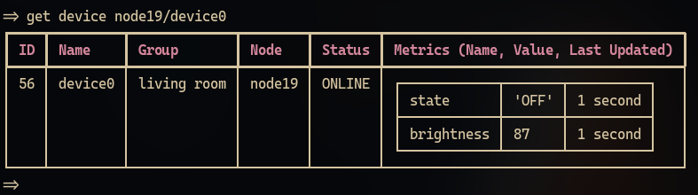

To get the complete topology of the system, we can run get without any arguments:
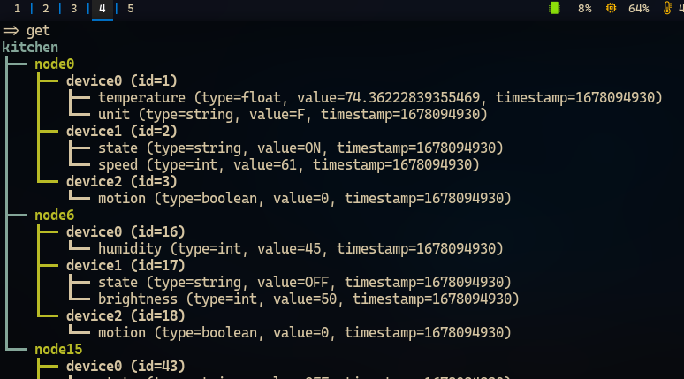

The list will contain all the groups, nodes and devices in the system in a tree view.
As per the target of this challenge, one other command is implemented in this REPL, named watch.
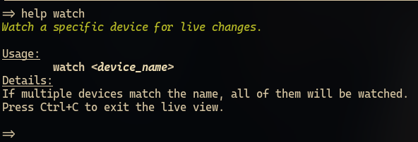

Running watch node19/device0 gives the following display:
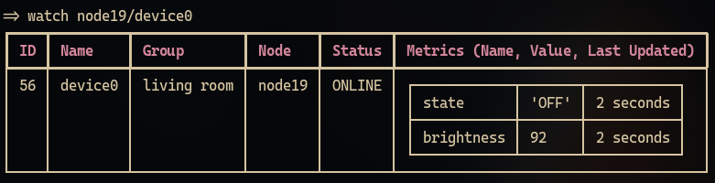

The view gets automatically updated after 1 second, notice the Metrics column.
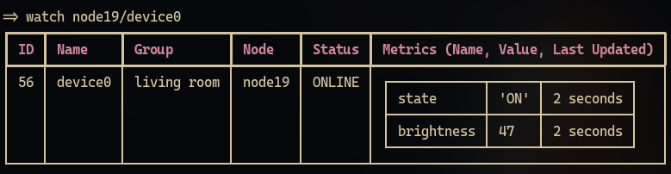

For the purpose of a minimum viable product, only these two commands are implemented. But the CLI can be easily extended to add new commands, and can even have commands that processes data on the fly, using a Python like scripting language.

Another way of interacting to the system is via the REST APIs, which will be shown in the next section.
Interactions
2. REST API
The system provides a REST API based on FastAPI which provides several endpoints for querying data.
The server can be started like the following, by using uvicorn as an example,
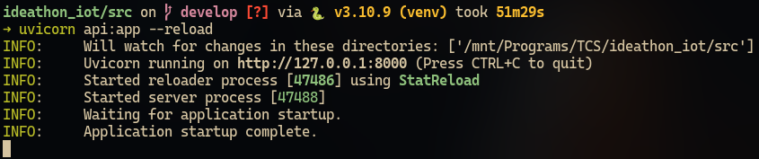

The following endpoints are provided by the API:
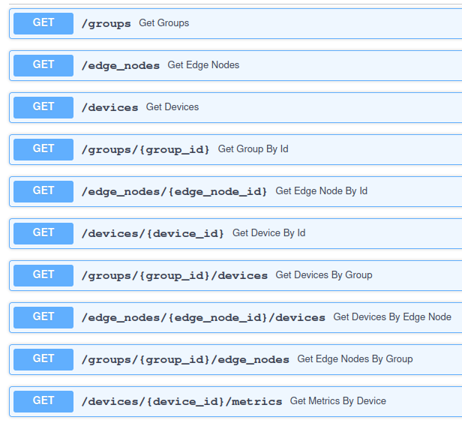

The REST API can be extended indepedently, and can also have methods to send messages to the devices. The proposed scripting language can also be exposed via the REST API, where the processing can be done on the server side, in case of a large, scalable system.
Example of the outputs given by the API endpoints are shown below:
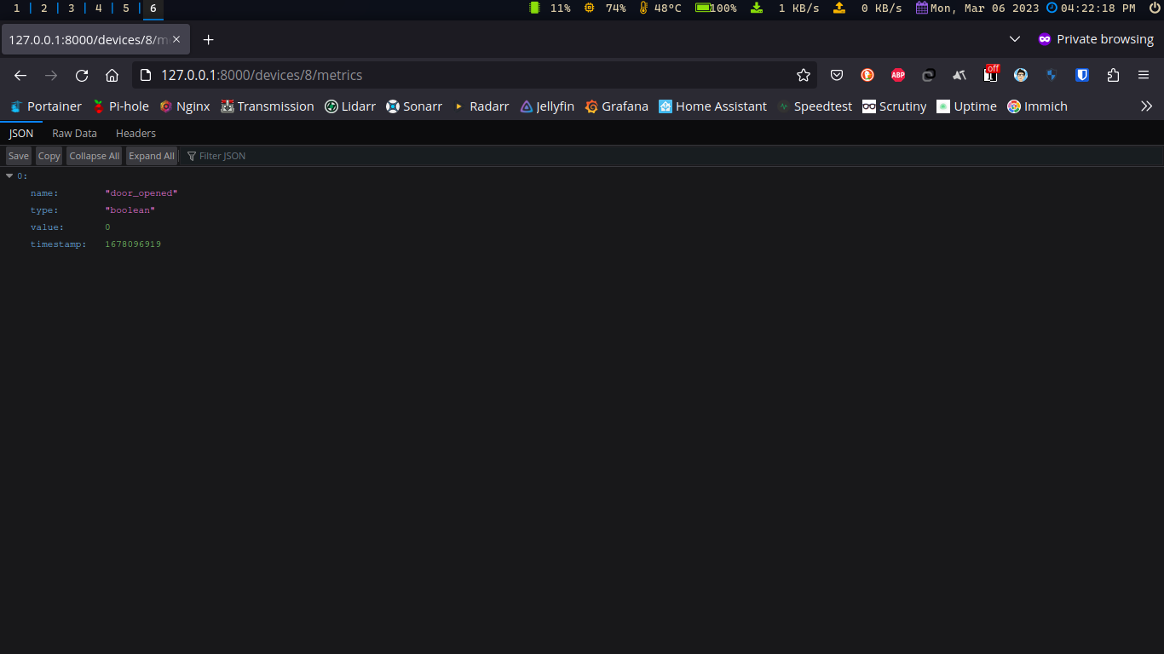

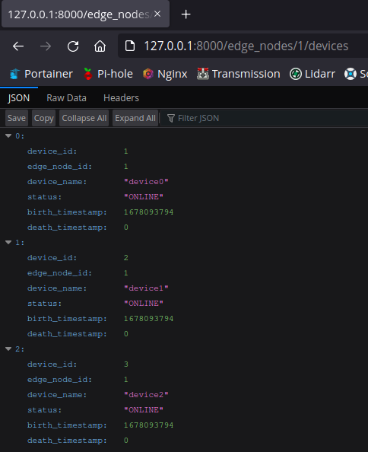

All of the endpoints return JSON responses in the key:value format.
Configuration
The application can be configured with a configuration file, which is read by the all the systems in the architecture. The configuration file looks like the following right now:
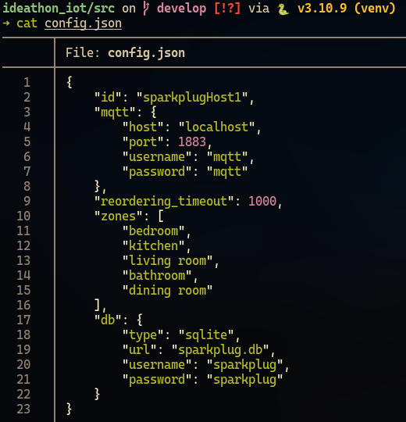

Right now, the MQTT configuration, zone/group list, and the DB connection details can be specified via the configuration file. In future, it can be extended to control the behaviour of the REST API, or the output of the CLI interface.

Conclusion
The source code for the application can be found in the following GitHub link:
IdeathonIOT on GitHub

It contains a readme which details how to setup and start the system. It also contains a client program which simulates a vast collection of IOT devices communicating over the Sparkplug B protocol.

This has been a great learning experience, and I want to thank Mr. Prateep Misra for giving me the oppurtunity to explore the world of IOT devices.

