

Creating a Jenkins Pipeline to automate the modification done to the GitHub repo pushed by the developer and created the latest docker images for the app that can be used by the other team member for adding the further features to the application

Steps are:

* Adding the dockerhub credentials to the jenkins => manage jenkins < credentails < system < global credentials(unrestricted) < update the credentials

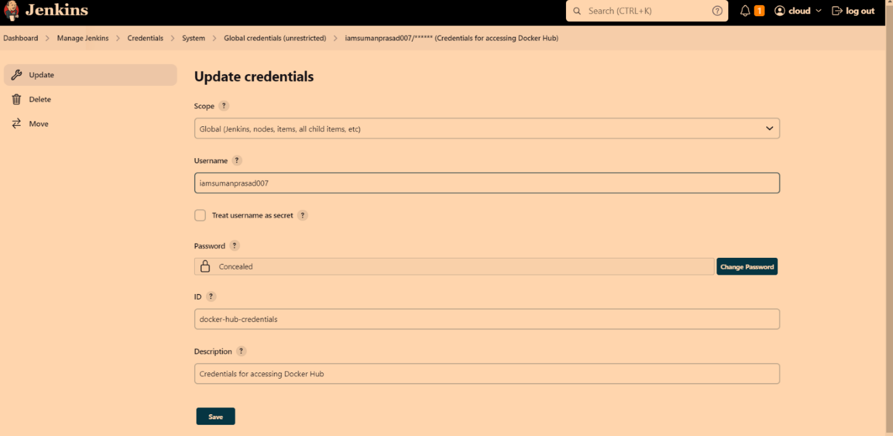

* Now, let’s create a new job

Jenkins console < new item < apptest (name_of_job) < pipeline < ok < enable poll scm [schedule = H/5 * * * *] <

Pipeline < definition = pipeline script from SCM < SCM = Git < Reporitory url = <https://github.com/iamsumanprasad007/app.git> [if it’s private privide the credentials else blank] < save < build now < console output [to see the logs & also helps to troubleshoot] << Finished: Success!!

Congratulations you have successfully, created your pipeline …

 Instructions of the CI/CD Pipeline using AWS EC2 Instance, Docker, Jenkins, GitHub, DockerHub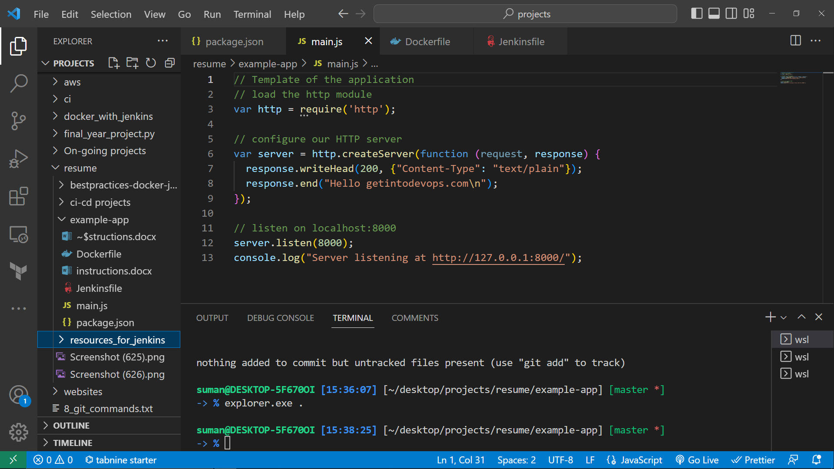

Console of the app

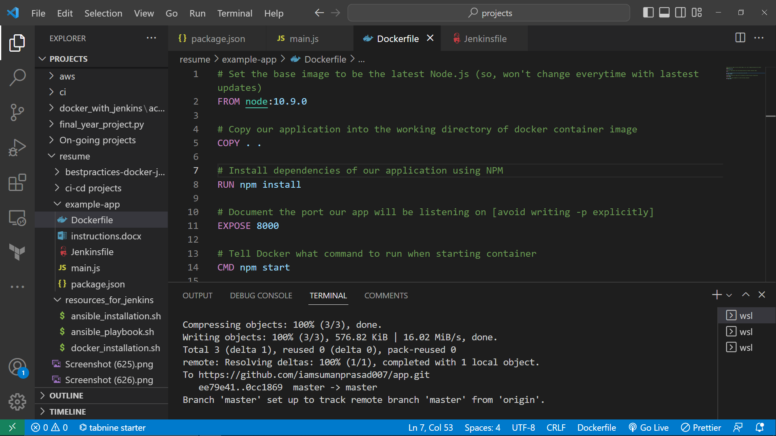

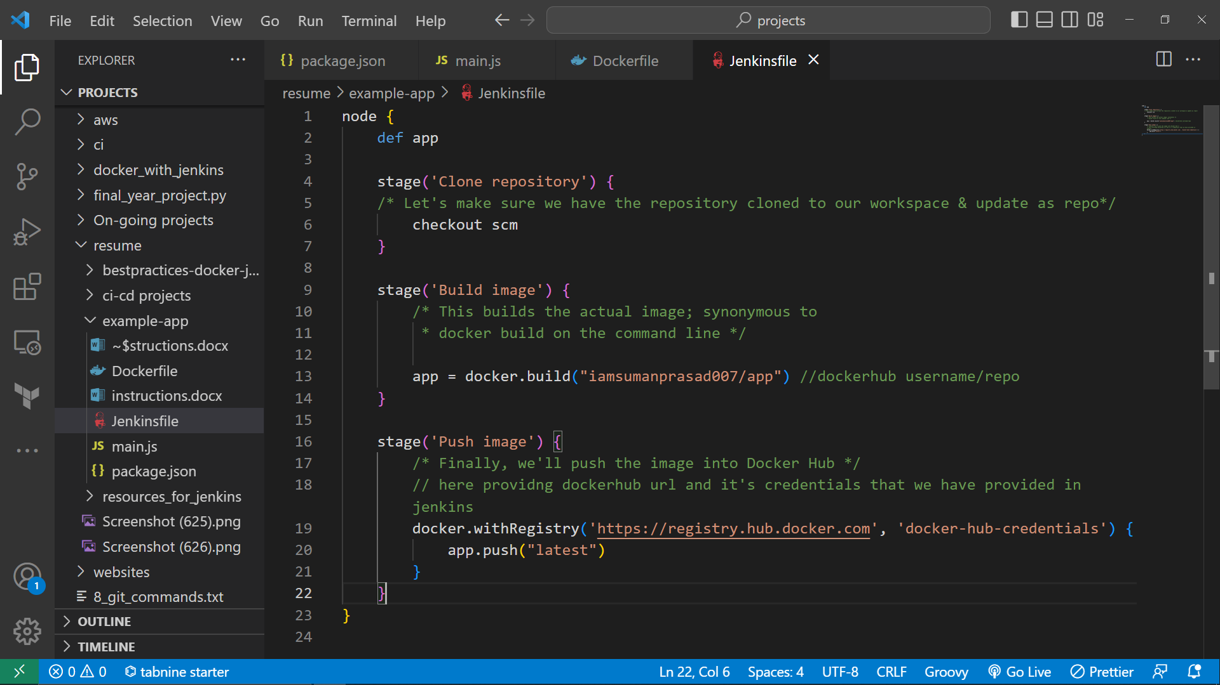

Jenkinsfile

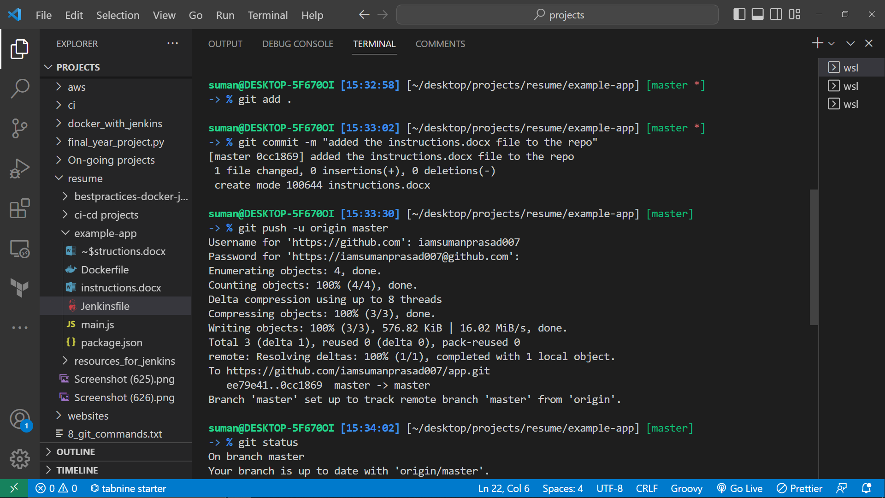

Terminal for pushing code to GitHub

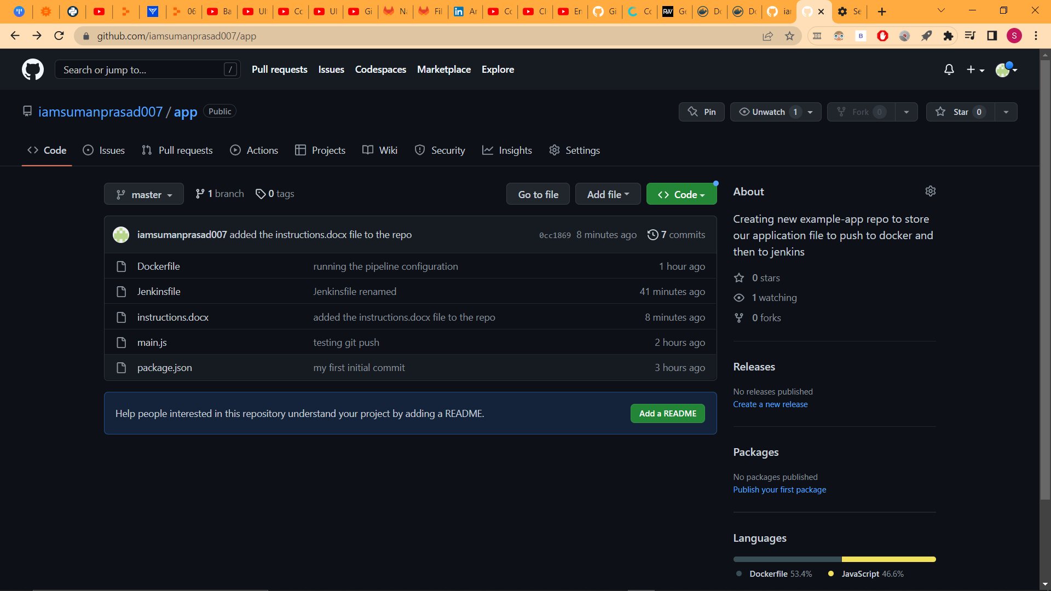

GitHub repo with all the codes and access tokens assigned to it

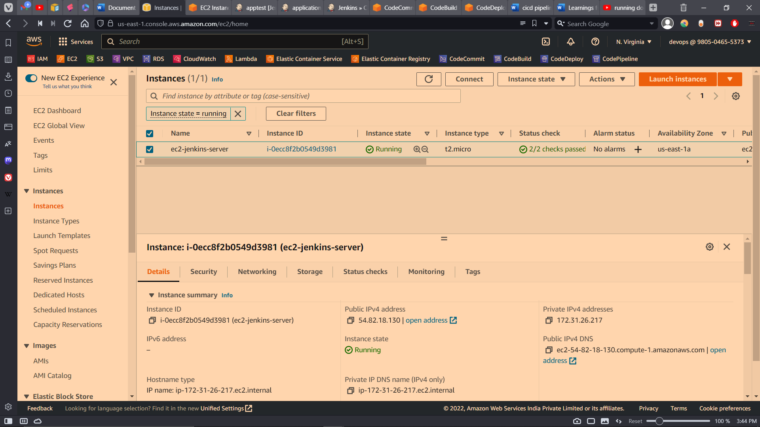

EC2 Instance configured with Docker and Jenkins

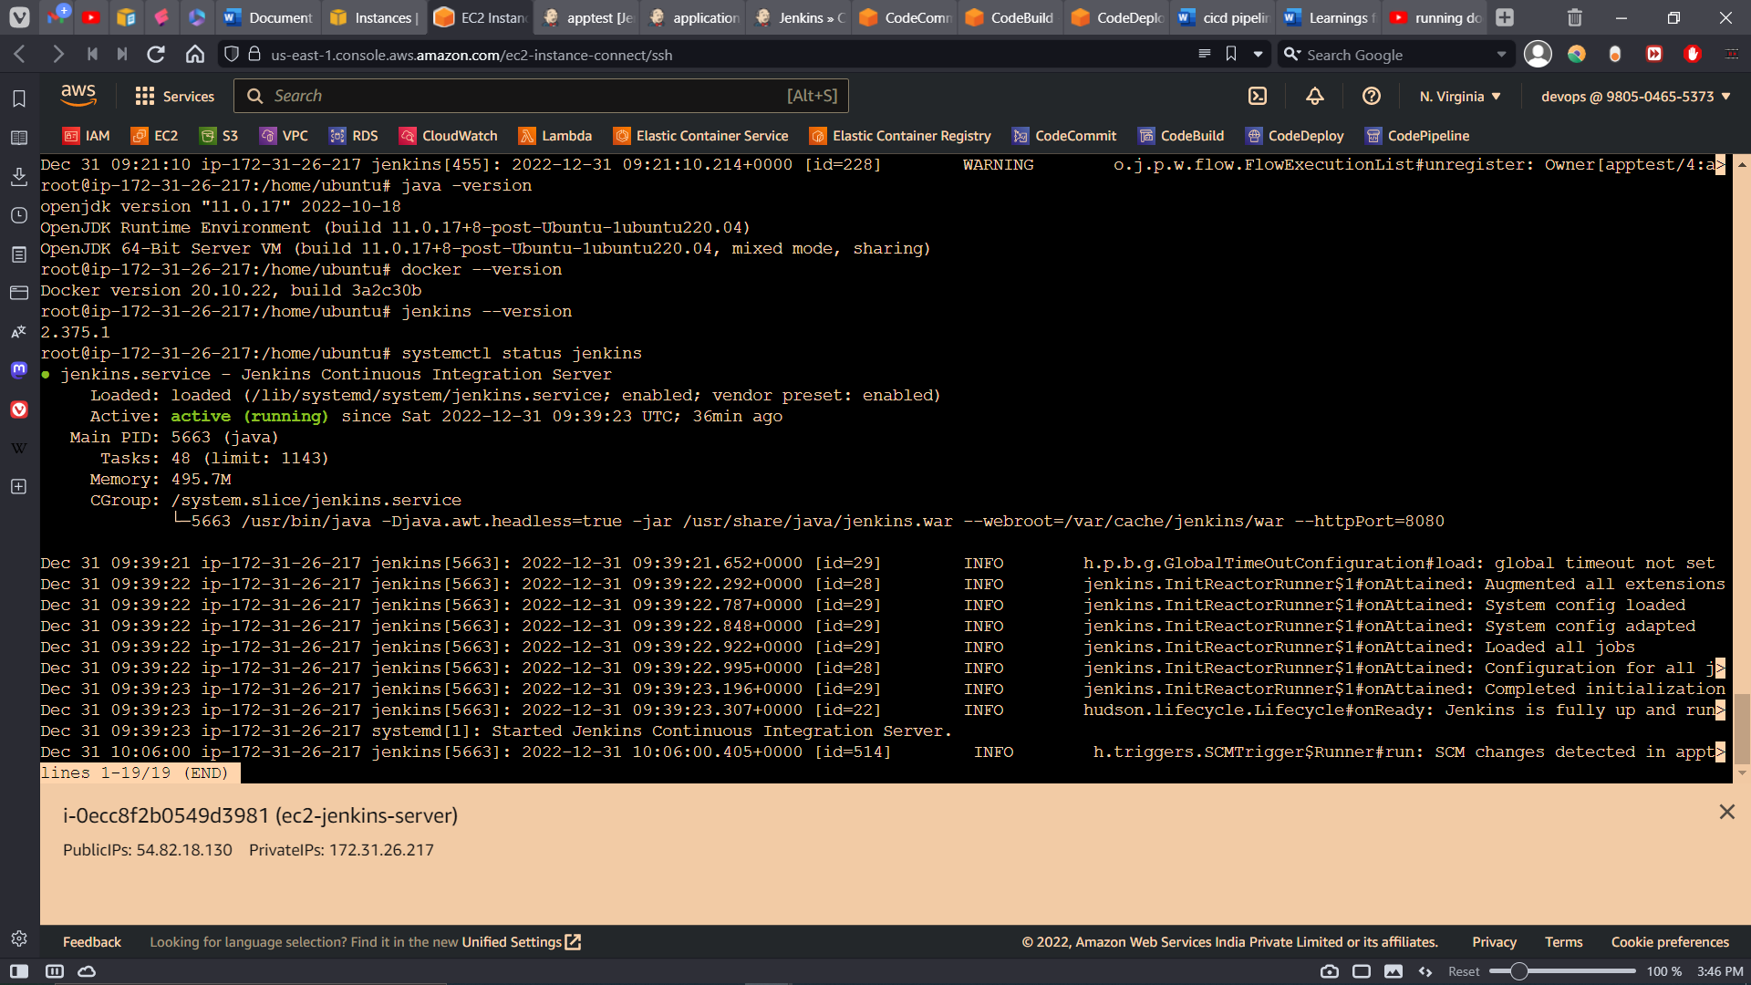

Jenkins and docker running on EC2 Instance

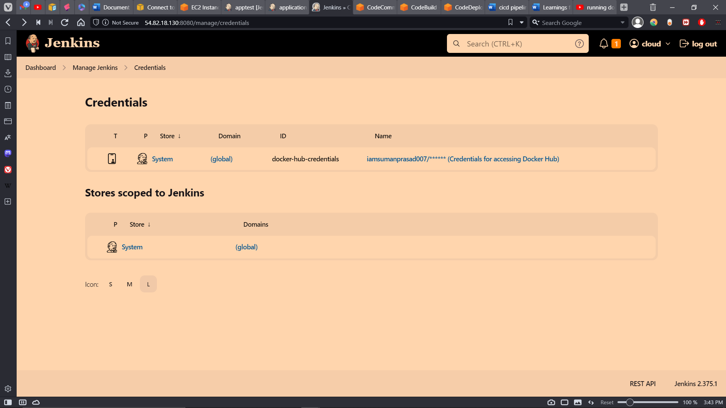

Dockerhub credentials added to jenkins

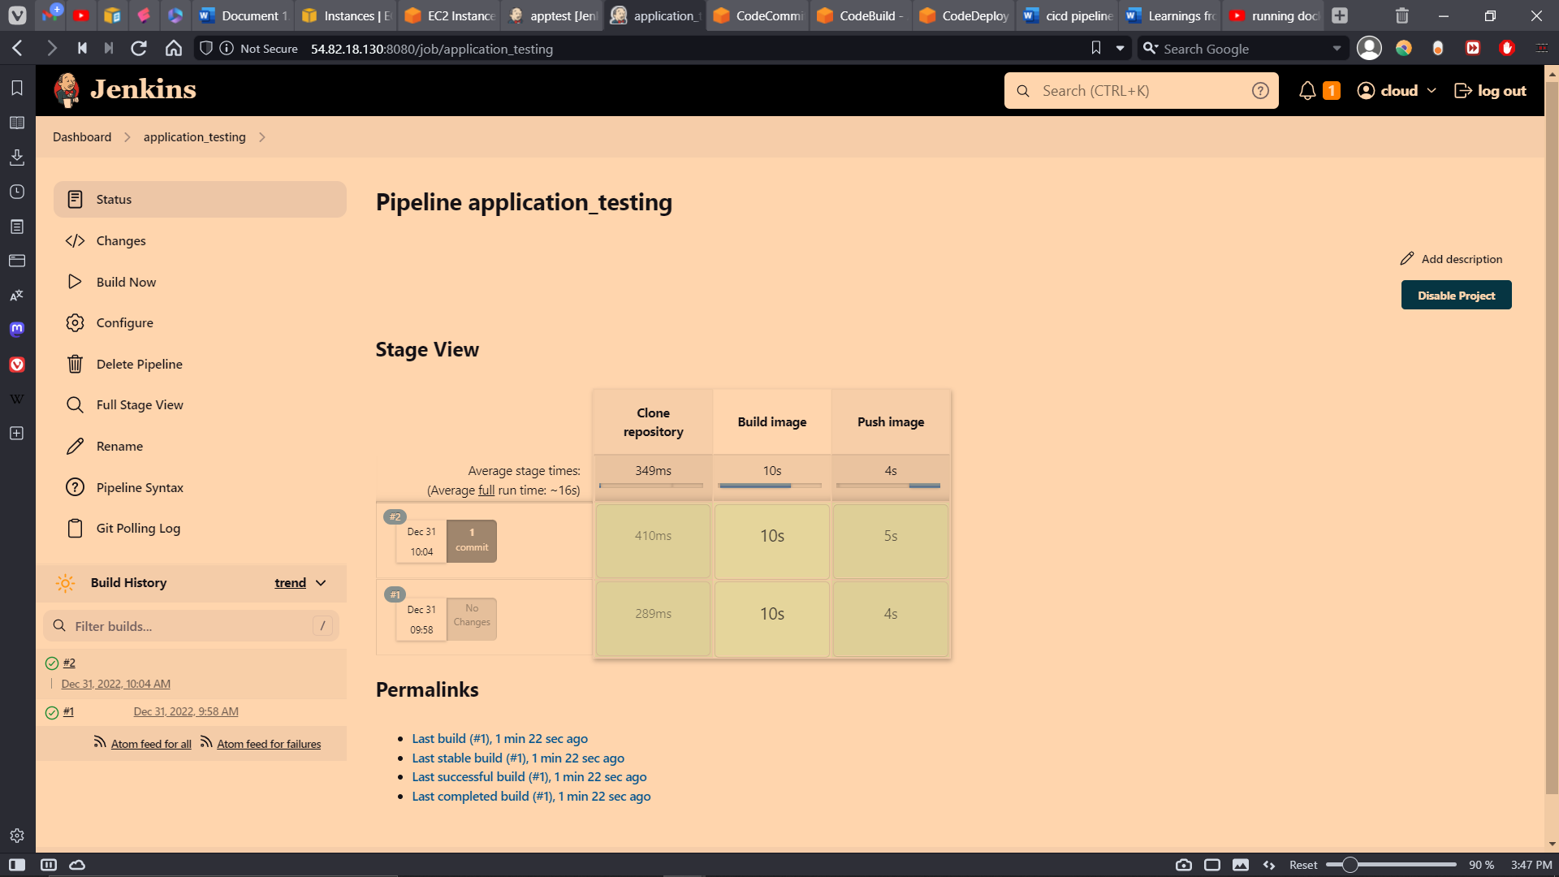

Successfully run the Pipeline

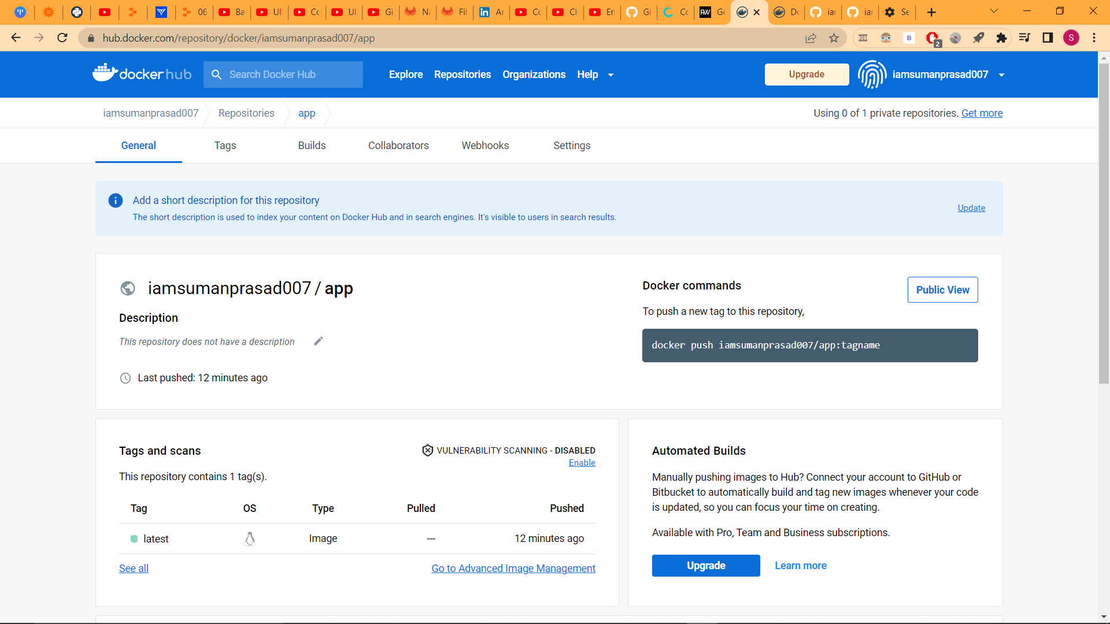

Successfully created repo on dockerhub and in the second iteration updated the DockerHub Images