Eye-State Classification via Transfer Learning: A Lightweight EfficientNet-B0 Approach for Real-Time Driver Drowsiness Detection
M. Abdullah Al-Sunny, Zahid Ul Islam, Samiha Islam, Most. Fatematuz Johora Chadni
Department of Computer Science, Faculty of Science and Technology
American International University-Bangladesh (AIUB), Dhaka, Bangladesh
Abstract
Drowsy driving is a major cause of road accidents around the world. One simple and effective way to detect driver drowsiness is to watch the state of the driver's eyes, because closed or half-closed eyes for a long time is a strong sign of sleepiness. In this paper, we present a lightweight deep learning system that classifies a driver's eye state as "Open" or "Closed" using transfer learning. We fine-tune EfficientNet-B0, a small convolutional neural network pretrained on ImageNet, on a compact and class-balanced eye-state dataset of 1,450 images. The dataset is split into training, validation, and test sets using a stratified 70/15/15 ratio, and a balanced held-out test set of 218 images (109 Open, 109 Closed) is used for final evaluation. The model is trained with the AdamW optimizer, a learning rate of 1e-4, cross-entropy loss, and a ReduceLROnPlateau scheduler for 15 epochs on a Kaggle Notebook with a T4×2 GPU. On the held-out test set, our model reaches 97.2% accuracy, 0.974 precision, 0.971 recall, 0.972 F1-score, and 0.995 AUC-ROC, with only 5 wrong predictions out of 218 images. These results show that a lightweight, pretrained CNN can give strong, safety-relevant accuracy for real-time driver-alertness systems without needing a huge dataset or heavy computing power, which makes it suitable for low-cost, real-world deployment in places like Bangladesh where large driving datasets and expensive hardware are not always available.
Keywords—driver drowsiness detection; eye-state classification; transfer learning; EfficientNet-B0; convolutional neural network; road safety
I. INTRODUCTION
Traffic accidents caused by drowsy driving are a serious road-safety problem in many countries. Government reports in the United States show that drowsy driving causes around 100,000 police-reported crashes and about 1,500 deaths every year [1], and a more recent study found that drowsy drivers were involved in an estimated 17.6% of all fatal crashes between 2017 and 2021 [2]. Bangladesh and other developing countries also face heavy losses from road accidents, and long-distance bus and truck drivers who work long hours without proper rest are especially at risk of falling asleep behind the wheel. Because of this, building a low-cost and reliable driver-drowsiness warning system is an important and practical research problem, not only for wealthy countries but also for countries with limited resources.
One of the earliest and most visible signs of drowsiness is the state of the driver's eyes. When a person becomes sleepy, their eyes tend to close for longer periods and blink more slowly. For this reason, many driver-monitoring systems try to classify whether the eyes are "Open" or "Closed" in each video frame, and then raise an alarm if the eyes stay closed for too long. Classic computer-vision methods calculate a simple number called the Eye Aspect Ratio (EAR) from facial landmark points to decide whether the eyes are open or closed [14]. While EAR-based methods are fast, they can be unreliable when the lighting is poor, when the driver wears glasses, or when the camera angle changes. Deep learning methods, especially Convolutional Neural Networks (CNNs), have shown much better and more robust accuracy for this task [3], [4], [5], [16], because a CNN can learn useful visual features directly from the image instead of relying on hand-crafted rules.
However, many of the CNN-based drowsiness detection systems reported in the literature use large datasets and heavy, deep networks such as ResNet50, VGG16, InceptionV3, or even Vision Transformers, which need a lot of images and strong GPU hardware to train well [4], [5]. This can be a real obstacle for students, small research groups, and companies in countries like Bangladesh, where large labelled driving datasets and expensive computing resources are not always easy to get. Motivated by this gap, our work asks a simple question: can a small, efficient, pretrained CNN still give strong, safety-relevant accuracy on a modest, class-balanced eye-state dataset, without needing a huge amount of data or computing power?
To answer this question, we fine-tune EfficientNet-B0 [6], a lightweight CNN architecture that is pretrained on the large ImageNet dataset [7], on a small dataset of only 1,450 eye images. We use transfer learning, which means we reuse the general visual knowledge that EfficientNet-B0 already learned from millions of ImageNet images, and we only adjust the network so that it can tell open eyes from closed eyes. Our results show that this simple and lightweight approach reaches 97.2% test accuracy and 0.995 AUC-ROC, which is competitive with much heavier models reported in prior work, while needing only about 15 minutes of training time on a standard cloud GPU. The rest of this paper is organized as follows. Section II reviews related work on driver drowsiness and eye-state detection. Section III describes our dataset, preprocessing steps, model architecture, and training setup. Section IV presents and discusses our experimental results. Section V concludes the paper and suggests directions for future work.
II. RELATED WORK
Early work on eye-state and blink detection relied on geometric and hand-crafted features. Soukupová and Čech [14] introduced the Eye Aspect Ratio (EAR), a simple scalar value computed from six eye landmark points, and used it together with a Support Vector Machine to detect blinks in real time. EAR-based methods are computationally cheap and easy to implement, which is why they are still used in many lightweight driver-monitoring prototypes today. However, their accuracy drops when the face is partly occluded, when drivers wear glasses or sunglasses, or under difficult lighting, which limits their reliability for safety-critical use.
Deep learning approaches have since become the dominant method for eye-state and drowsiness classification because CNNs can learn robust visual features directly from raw pixels. Chirra et al. [3] proposed a stacked deep CNN that extracts the eye region using the Viola–Jones (Haar Cascade) face detector and classifies the driver as sleepy or non-sleepy, reporting 96.4% accuracy on their own collected dataset. Florez et al. [4] compared three transfer-learning backbones — InceptionV3, VGG16, and ResNet50V2 — combined with MediaPipe for eye-region extraction, on the NITYMED video dataset, and found that ResNet50V2 reached the highest accuracy of about 99.7%, although this came at the cost of a heavier network and a more complex face-landmark pipeline. Akhmedov et al. [16] built a dual-framework system that joins a CNN classifier for "Awake" versus "Drowsy" states with a separate facial-landmark analysis model, improving accuracy from 92.5% to 97.3% after adding image-restoration preprocessing steps such as illumination correction. More recently, Hassan et al. [5] explored transformer-based architectures such as the Vision Transformer (ViT) and Swin Transformer on the MRL Eye Dataset, reaching accuracies above 99%, but these transformer models generally require larger datasets and significantly more computation than compact CNNs.
Across this body of work, a common pattern appears: the highest-accuracy systems tend to use either large datasets, multiple cascaded models (face detector plus landmark model plus classifier), or heavy architectures that are expensive to train and to run in real time on low-cost embedded hardware such as a Raspberry Pi or an in-vehicle camera module. General computer-vision research on model efficiency also supports this observation — Tan and Le [6] showed that EfficientNet models, built using a compound scaling method that balances network depth, width, and input resolution, can match or beat much larger CNNs such as ResNet [10] on ImageNet classification while using far fewer parameters. Transfer learning from ImageNet pretraining [7], first popularized by deep architectures such as AlexNet [17], VGG [11], and Inception [12], has also been shown repeatedly to reduce the amount of task-specific data needed to reach high accuracy. Building on these two ideas — an efficient, compact backbone and transfer learning — our work fine-tunes EfficientNet-B0 on a small, balanced eye-state dataset, showing that a lightweight and data-efficient design can still achieve accuracy that is competitive with the heavier systems described above.
III. METHODOLOGY
A. Dataset
We use the EyeState_Recognition_Dataset, which contains 1,450 close-up eye images labelled as either "Open" (837 images, 57.7%) or "Closed" (613 images, 42.3%). Fig. 1 shows this class distribution. All images are resized to 224×224 pixels and normalized before being fed into the network. To make the model more robust to small changes in camera angle, lighting, and eye position, we apply data augmentation during training, including horizontal flips, small rotations of up to ±10°, and random brightness/contrast jitter, following common practice for improving generalization on limited image data [15]. The dataset is divided using a stratified 70/15/15 split into training, validation, and test subsets, so that the proportion of Open and Closed images stays balanced in every subset. For the final evaluation, we build a class-balanced held-out test set of 218 images (109 Closed, 109 Open), which ensures that our reported accuracy is not artificially inflated by class imbalance.
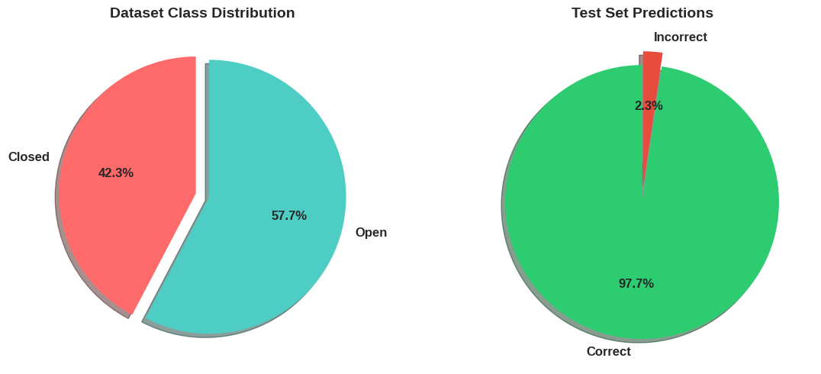
Fig. 1. Left: class distribution of the full dataset (57.7% Open, 42.3% Closed). Right: proportion of correct versus incorrect predictions on the held-out test set (97.7% correct).
B. Preprocessing and Training Pipeline
Fig. 2 shows the overall pipeline used in this study. The raw 1,450 images are first cleaned, resized, and augmented. Next, the data is split with the stratified 70/15/15 method described above. The images are then passed to EfficientNet-B0, which is initialized with weights pretrained on ImageNet. The network is fine-tuned for 15 epochs using the AdamW optimizer, and finally, the trained model is evaluated using accuracy, precision, recall, F1-score, and AUC-ROC on the held-out test set.
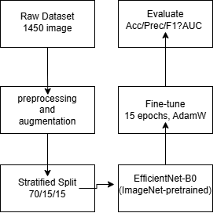
Fig. 2. Overall preprocessing and training pipeline used in this study.
C. Model Architecture
We choose EfficientNet-B0 [6] as our backbone network because it is one of the smallest and fastest models in the EfficientNet family while still achieving strong accuracy on ImageNet. Unlike traditional CNNs such as VGG16 [11] or InceptionV3 [12], which are scaled up by arbitrarily adding more layers or filters, EfficientNet uses a compound scaling method that increases network depth, width, and input resolution together in a balanced way. This makes EfficientNet-B0 far more parameter-efficient than heavier backbones such as ResNet50 [10] that are commonly used in prior drowsiness-detection work [4]. In our system, EfficientNet-B0 is pretrained on ImageNet [7], and its original 1000-class classifier head is replaced with a new, smaller classification head that outputs only two classes: Open and Closed. During fine-tuning, the pretrained convolutional layers keep most of their learned visual features (edges, textures, and shapes), while the new classifier head learns to map these features specifically to the eye-state task.
D. Training Setup
The model is trained using the AdamW optimizer [8], which is an improved version of the popular Adam optimizer [9] that decouples weight decay from the gradient update, generally giving better generalization. We use a learning rate of 1e-4 and standard cross-entropy loss for this two-class classification problem. A ReduceLROnPlateau scheduler automatically lowers the learning rate when the validation loss stops improving, which helps the model converge smoothly. The network is trained for 15 epochs on a Kaggle Notebook environment equipped with two NVIDIA T4 GPUs (T4×2). Because EfficientNet-B0 is lightweight and the dataset is small, the entire training process takes only about 15 minutes, which is a major practical advantage compared to heavier architectures that can take hours to fine-tune.
IV. RESULTS AND DISCUSSION
Table I summarizes the performance of our fine-tuned EfficientNet-B0 model on the held-out, class-balanced test set of 218 images. The model achieves 97.2% accuracy, 0.974 precision, 0.971 recall, 0.972 F1-score, and 0.995 AUC-ROC. Fig. 3 shows these five metrics side by side as a bar chart, confirming that all metrics are consistently high and close to one another, which suggests that the model performs well on both classes rather than being biased toward one class.
TABLE I
Test-Set Performance of the Fine-Tuned EfficientNet-B0 Model
Accuracy | Precision | Recall | F1-Score | AUC-ROC
0.972 | 0.974 | 0.971 | 0.972 | 0.995

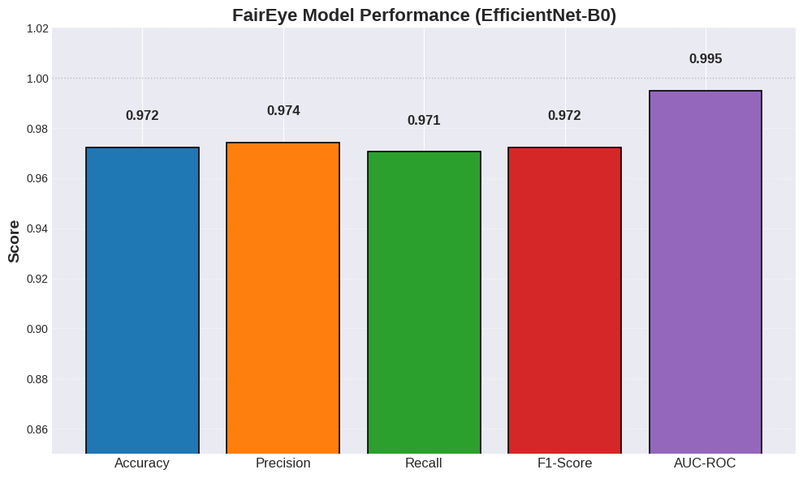
Fig. 3. Test-set performance metrics of the fine-tuned EfficientNet-B0 model (FairEye model).
Fig. 4 presents four diagnostic plots that give more detail about the model's behavior. The confusion matrix (top-left) shows that out of 218 test images, the model correctly classified 213, giving an overall error rate of only 2.3% and matching the 97.7% correct-prediction share shown earlier in Fig. 1. Looking more closely at the type of errors, the model missed 3 out of 109 Closed-eye cases (classifying them as Open) and produced 2 false alarms (classifying Open eyes as Closed). This distinction is important for real-world safety: missed closed-eye detections are the more dangerous error type for a drowsiness alarm system, because they could allow a sleepy driver to go undetected, while false alarms are only a minor annoyance. With just 3 missed closed-eye cases out of 109, our model keeps this critical error type very low.
The ROC curve (top-right of Fig. 4) rises very sharply toward the top-left corner and reaches an Area Under the Curve (AUC) of 0.997, which indicates that the model separates the Open and Closed classes almost perfectly across all possible decision thresholds. The loss curves (bottom-left) show that both training and validation loss decrease steadily from about 0.85 down to below 0.10 over the 15 training epochs, and the two curves stay close to each other throughout training. This is a good sign because it means the model is learning general patterns rather than memorizing (overfitting to) the training images. Similarly, the accuracy curves (bottom-right) rise sharply after the second epoch — improving from around 50%, which is equivalent to random guessing for a two-class problem — and converge to about 97% accuracy by the final epoch, with validation accuracy staying at or slightly above training accuracy throughout most of the training process.
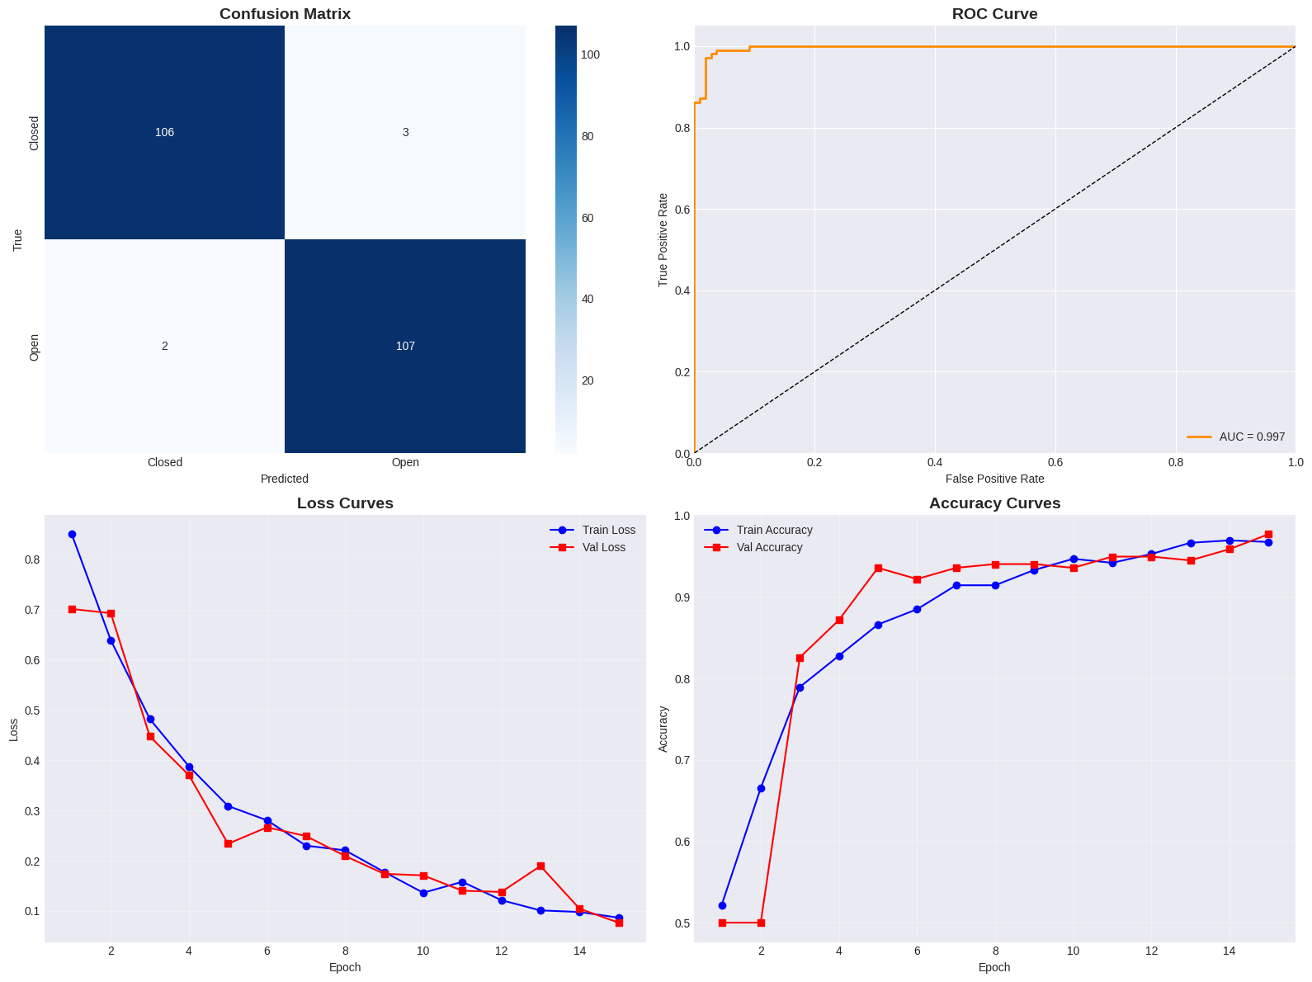
Fig. 4. Diagnostic plots on the held-out test set: confusion matrix (top-left), ROC curve with AUC = 0.997 (top-right), training/validation loss curves (bottom-left), and training/validation accuracy curves (bottom-right).
Comparison with Prior Work
Table II compares our results with a selection of previously published drowsiness and eye-state detection systems. Our lightweight EfficientNet-B0 model reaches accuracy that is close to, and in some cases only slightly below, much heavier architectures such as ResNet50V2 [4] and Vision Transformers [5], while using far fewer parameters, a much smaller dataset, and only about 15 minutes of training time. This supports our central claim: a compact, pretrained CNN combined with transfer learning can deliver safety-relevant accuracy without the large data and compute requirements of heavier models, making this type of system realistic to build and deploy in resource-limited settings such as Bangladesh, where access to large driving-video datasets and expensive GPU clusters is often limited.
TABLE II
Comparison with Related Eye-State / Drowsiness Detection Studies
Study | Method | Reported Accuracy
Chirra et al. [3] | Stacked deep CNN, eye region (Haar Cascade) | 96.4%
Florez et al. [4] | InceptionV3 / VGG16 / ResNet50V2, MediaPipe ROI | up to 99.7%
Akhmedov et al. [16] | CNN + facial landmark analysis | 92.5%–97.3%
Hassan et al. [5] | Vision Transformer / Swin Transformer | up to 99.2%
This work | EfficientNet-B0 (transfer learning, 1,450 images) | 97.2% (AUC 0.995)

It is important to note that these comparisons are approximate, because each study uses a different dataset, a different train/test split, and sometimes a different definition of "accuracy" (per-image versus per-video-sequence). Still, the overall pattern is clear and consistent with our motivation: EfficientNet-B0 offers an attractive balance between accuracy, dataset size, and computational cost, which makes it a strong candidate for real-time, on-device driver-monitoring applications, including low-cost dash-cameras or smartphone-based systems that could be useful for bus and truck drivers in Bangladesh.
V. CONCLUSION AND FUTURE WORK
In this paper, we presented a lightweight eye-state classification system for real-time driver drowsiness detection, built by fine-tuning a pretrained EfficientNet-B0 network on a small, class-balanced dataset of 1,450 eye images. Our system reached 97.2% test accuracy, 0.974 precision, 0.971 recall, 0.972 F1-score, and 0.995 AUC-ROC on a held-out, balanced test set of 218 images, with only 5 total misclassifications. Importantly, only 3 of these errors were the more safety-critical "missed closed-eye" type, showing that the model is well-suited for practical drowsiness-alarm applications. These results confirm that a small, efficient, pretrained CNN can achieve strong, safety-relevant accuracy without needing a large-scale dataset or expensive computing hardware, since the entire model was trained in about 15 minutes on a standard cloud GPU.
This work has some limitations that suggest useful directions for future research. First, our dataset consists of static, cropped eye images rather than continuous video sequences, so the model does not yet capture temporal patterns such as blink duration or PERCLOS (percentage of eye closure over time), which are also useful indicators of drowsiness. Second, the dataset was collected under a limited range of conditions, so testing the model on more diverse, real-world driving footage — including different lighting conditions, drivers wearing glasses or sunglasses, and different camera angles — would help confirm how well the system generalizes. Third, combining eye-state classification with other visual cues, such as yawning detection and head-pose estimation, could make the overall drowsiness-alarm system more robust and reduce both false alarms and missed detections. Finally, we plan to test the deployment of this lightweight model on low-cost embedded hardware, such as a Raspberry Pi or a smartphone, and to evaluate it on locally collected driving data from Bangladesh, where road conditions, traffic patterns, and driver behavior may differ from those in the datasets used by most prior studies.
ACKNOWLEDGMENT
The authors would like to thank the Department of Computer Science, Faculty of Science and Technology, American International University-Bangladesh (AIUB), for providing the academic support and resources needed to carry out this research.
REFERENCES
[1] National Highway Traffic Safety Administration (NHTSA), National Center for Statistics and Analysis, "Drowsy Driving," Traffic Safety Facts Crash·Stats, Report No. DOT HS 811 449, Washington, DC, USA, 2011.
[2] B. C. Tefft, "Drowsy Driving in Fatal Crashes, United States, 2017–2021," AAA Foundation for Traffic Safety, Washington, DC, USA, 2024.
[3] V. R. R. Chirra, S. R. Uyyala, and V. K. K. Kolli, "Deep CNN: A machine learning approach for driver drowsiness detection based on eye state," Revue d'Intelligence Artificielle, vol. 33, no. 6, pp. 461–466, 2019.
[4] R. Florez, F. Palomino-Quispe, R. J. Coaquira-Castillo, J. C. Herrera-Levano, T. Paixão, and A. B. Alvarez, "A CNN-based approach for driver drowsiness detection by real-time eye state identification," Applied Sciences, vol. 13, no. 13, art. 7849, 2023.
[5] O. F. Hassan, A. F. Ibrahim, A. Gomaa, M. A. Makhlouf, and B. Hafiz, "Real-time driver drowsiness detection using transformer architectures: a novel deep learning approach," Scientific Reports, vol. 15, art. 17493, 2025.
[6] M. Tan and Q. V. Le, "EfficientNet: Rethinking model scaling for convolutional neural networks," in Proc. 36th Int. Conf. on Machine Learning (ICML), Long Beach, CA, USA, 2019, pp. 6105–6114.
[7] J. Deng, W. Dong, R. Socher, L.-J. Li, K. Li, and L. Fei-Fei, "ImageNet: A large-scale hierarchical image database," in Proc. IEEE Conf. on Computer Vision and Pattern Recognition (CVPR), Miami, FL, USA, 2009, pp. 248–255.
[8] I. Loshchilov and F. Hutter, "Decoupled weight decay regularization," in Proc. Int. Conf. on Learning Representations (ICLR), New Orleans, LA, USA, 2019.
[9] D. P. Kingma and J. Ba, "Adam: A method for stochastic optimization," in Proc. Int. Conf. on Learning Representations (ICLR), San Diego, CA, USA, 2015.
[10] K. He, X. Zhang, S. Ren, and J. Sun, "Deep residual learning for image recognition," in Proc. IEEE Conf. on Computer Vision and Pattern Recognition (CVPR), Las Vegas, NV, USA, 2016, pp. 770–778.
[11] K. Simonyan and A. Zisserman, "Very deep convolutional networks for large-scale image recognition," arXiv preprint arXiv:1409.1556, 2014.
[12] C. Szegedy, V. Vanhoucke, S. Ioffe, J. Shlens, and Z. Wojna, "Rethinking the inception architecture for computer vision," in Proc. IEEE Conf. on Computer Vision and Pattern Recognition (CVPR), Las Vegas, NV, USA, 2016, pp. 2818–2826.
[13] A. G. Howard, M. Zhu, B. Chen, D. Kalenichenko, W. Wang, T. Weyand, M. Andreetto, and H. Adam, "MobileNets: Efficient convolutional neural networks for mobile vision applications," arXiv preprint arXiv:1704.04861, 2017.
[14] T. Soukupová and J. Čech, "Real-time eye blink detection using facial landmarks," in Proc. 21st Computer Vision Winter Workshop (CVWW), Rimske Toplice, Slovenia, 2016.
[15] C. Shorten and T. M. Khoshgoftaar, "A survey on image data augmentation for deep learning," Journal of Big Data, vol. 6, no. 1, art. 60, 2019.
[16] F. Akhmedov, H. Khujamatov, M. Abdullaev, and H.-S. Jeon, "Joint driver state classification approach: Face classification model development and facial feature analysis improvement," Sensors, vol. 25, no. 5, art. 1472, 2025.
[17] A. Krizhevsky, I. Sutskever, and G. E. Hinton, "ImageNet classification with deep convolutional neural networks," in Advances in Neural Information Processing Systems (NeurIPS), vol. 25, Lake Tahoe, NV, USA, 2012, pp. 1097–1105.

