**Automata and Compiler Design**

**Assignment-2**

Q1. Consider the regular language L = (111 + 11111)*. Design the minimum DFA accepting this language.

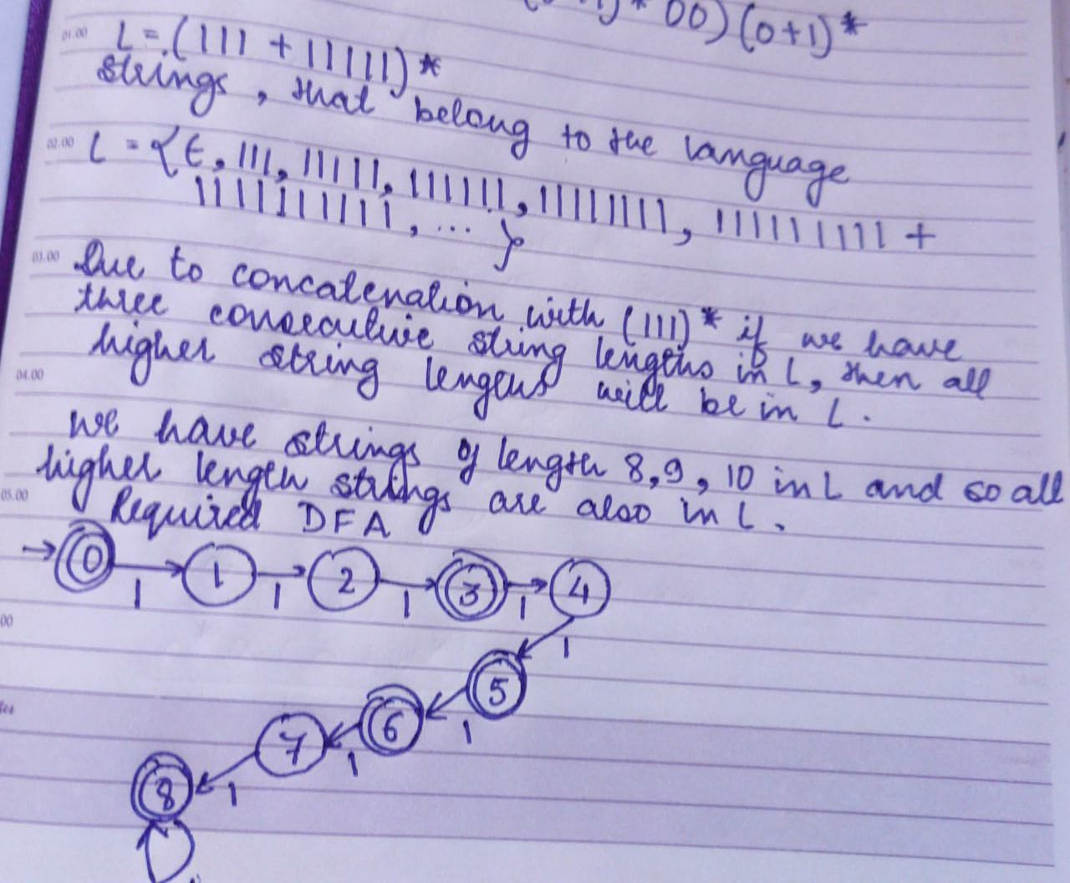

Q2. Consider the following Finite State Automaton. The language accepted by this automaton is given by the regular expression is??

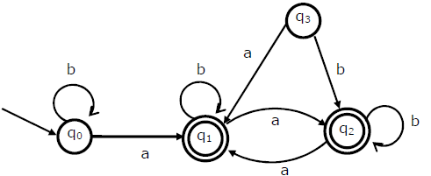

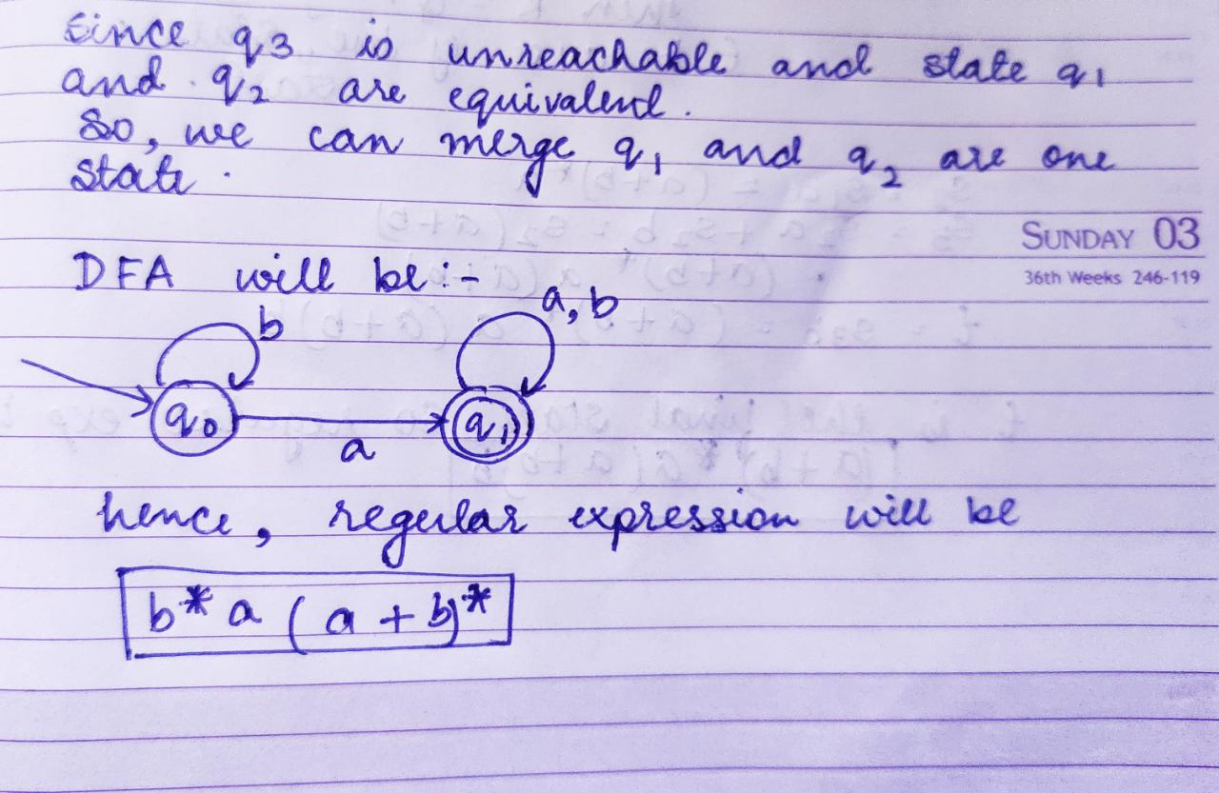

Q3. Consider alphabet ∑ = {0, 1}, the null/empty string λ and the sets of strings X0, X1 and X2 generated by the corresponding non-terminals of a regular grammar. X0, X1 and X2 are related as follows: Write the strings formed in X0?

X0 = 1 X1

X1 = 0 X1 + 1 X2

X2 = 0 X1 + {λ}

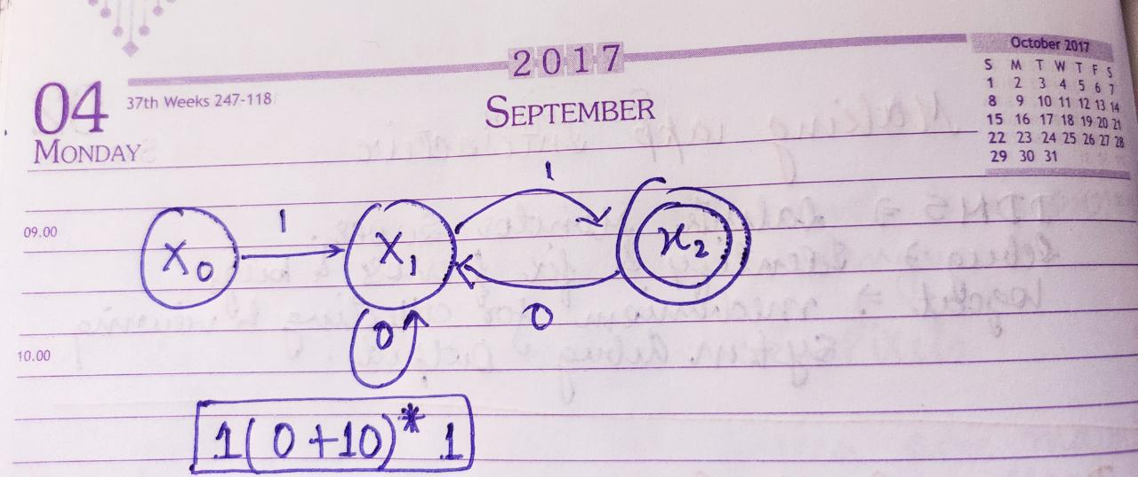

Q4. Which regular expression best describes the language accepted by the non-deterministic automaton below?

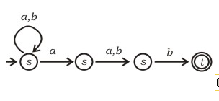

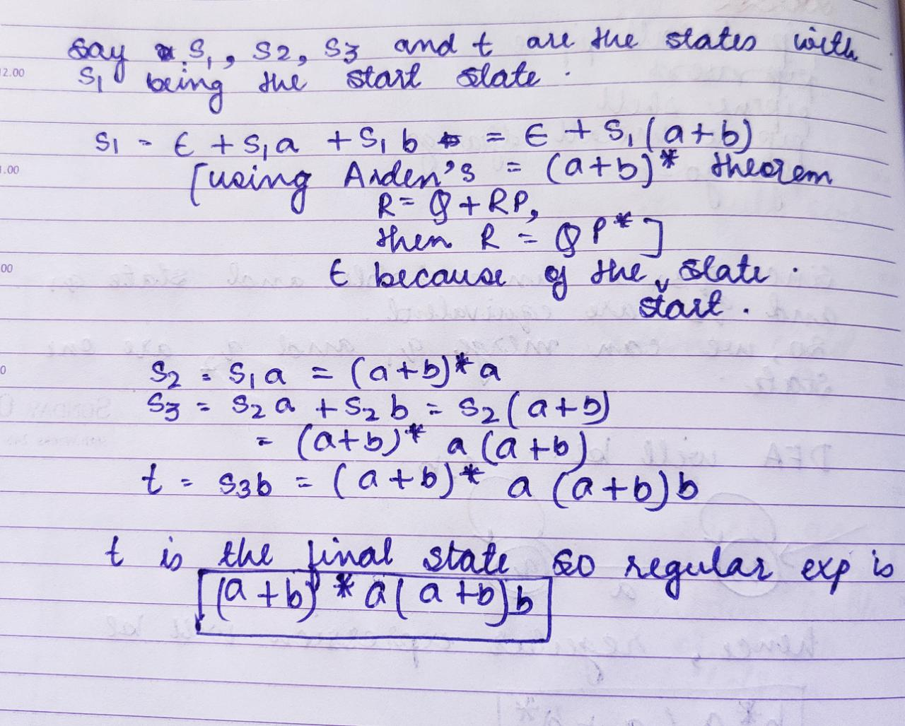

Q5. Write down the Regular expression represents the language:

“The set of all binary strings having two consecutive 0s and two consecutive 1s”?

