**About Typescript:**

* Superset of js (statics types)

Dynamic vs Static Typing -> Java, C , C++, Rust, Golang

|->JavaScript,Python,Ruby,PhP

**Using Ts pros and cons**

Pros-

1. More robust 2) Easily Spot Bugs 3) Predictability 4) Readability 5) Popular

Cons-

1. More code to write 2) More to Learn 3) Required Compilation 5) Not True Static Typing

**By Browser Ts is No read it compiled to Js To read by browser**

**Setup to install Typescript Globally run**

1. npm install –g typescript
2. Check version of ts by running command **tsc –v**

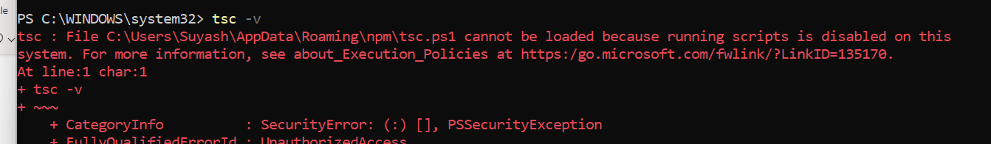

While checking version of tsc I was facing above error than I used below command by opening PowerShell “run as administration”



Above command is applicable for only 64-bit processor

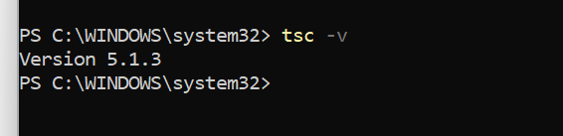

Finally, after checking ts version command executed successfully.

1. To Run Tsc File   
   Use **tsc <filename> ex: tsc index.ts**
2. To run in watch mode use **tsc --watch <filename> ex tsc –-watch index**
3. To add ts config use **tsc –init**
4. 
5. 

Creating typescript React app comand

npx create-react-app <App_Name> --template typescript

**Example:**

**export interface Props {**

**title:string**

**color?:string**

**}**

**const header=(props:Props)=>{**

**return(**

**<header>**

**<h1 style={{color: props.color ? props.color : ’blue’}}>{props.title}</h1>**

**</header>**

**)**

**}**