**Exercise: Generate a visualization**

**Introduction**

Visualizations allow you to transform complex data into easily digestible and visually appealing charts, graphs, and maps, enabling you and your team to gain insights, and effectively communicate your findings. Visuals also aid stakeholders in reaching data-driven decisions. In this exercise, you’ll engage in the process of creating interactive visualizations using Microsoft Power BI for Adventure Works. By the end of this exercise, you'll understand how to import data into Microsoft Power BI, create interactive filters, and design different types of visualizations to effectively communicate insights and contribute meaningfully to data-driven decision-making.

**Case study**

Your manager at Adventure Works, Adio, hands you a comprehensive dataset containing information on sales, order statuses, and product performance from the past month. The company wants to understand its performance, identify growth opportunities, and streamline operations to remain competitive in the fast-paced outdoor gear market. As you start reviewing the dataset, you quickly realize that it's a large amount of data. It has hundreds of rows and columns. While the raw data holds valuable insights, its size makes it challenging to evaluate and difficult to communicate insights effectively to your team and stakeholders. This is where visualizations can help!

By using Microsoft Power BI, you'll be able to create a compelling and interactive dashboard to help Adio and the entire Adventure Works team better understand the company's performance and drive strategic decision-making. There is a wide range of core visualizations available in Power BI to help you display your data effectively.

**Instructions**

Create a new Microsoft Power BI project called *Exercise: Generate a visualization*. Follow the prompts below to complete the exercise.

**Step 1: Import data**

* Launch Microsoft Power BI Desktop to allow you to create the visualizations.
* Import the Adventure Works sales dataset called *Adventure Works sales dataset.csv.* This is the dataset you want to visualize.

[Adventure Works sales dataset](https://d3c33hcgiwev3.cloudfront.net/i4LNmR9pROuHP1JLs5i4ng_3652883b57554acc8bc5cac94f5dc5e1_AdventureWorks-sales-dataset.csv?Expires=1697932800&Signature=hDUV49D5ZAHbgiU2kI4EfOu0VwZYRdOMbSyPZ0U3isGMvCkmIy-dTFw7eC~4X2SlwyZ78CXxRTg7ndt7izyzau3RzLTgEB6yWLe3j7fb~OtaTUvD6ghi69cndW82-wwvWiufCnSnptuxqvov2UK2A2Vt2WmigzRY2Ryhzp2P~xc_&Key-Pair-Id=APKAJLTNE6QMUY6HBC5A" \t "_blank)

[CSV File](https://d3c33hcgiwev3.cloudfront.net/i4LNmR9pROuHP1JLs5i4ng_3652883b57554acc8bc5cac94f5dc5e1_AdventureWorks-sales-dataset.csv?Expires=1697932800&Signature=hDUV49D5ZAHbgiU2kI4EfOu0VwZYRdOMbSyPZ0U3isGMvCkmIy-dTFw7eC~4X2SlwyZ78CXxRTg7ndt7izyzau3RzLTgEB6yWLe3j7fb~OtaTUvD6ghi69cndW82-wwvWiufCnSnptuxqvov2UK2A2Vt2WmigzRY2Ryhzp2P~xc_&Key-Pair-Id=APKAJLTNE6QMUY6HBC5A" \t "_blank)

**Step 2: Create interactive filters**

One method for filtering data is a slicer—a visual tool that enables users to filter data interactively within a report.

* To add a slicer for the product category, on the **Home** tab, select **Slicer**.

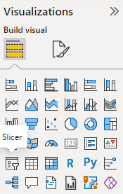

* Drag the **Product Category** field from the **Fields** pane to the slicer visual. This will create an interactive filter based on product categories.

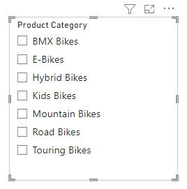

* Repeat the process to create another slicer, this time for the **Payment Method** field.
* For each slicer, add a title by selecting the **Format** tab and choosing **Title** from the options.

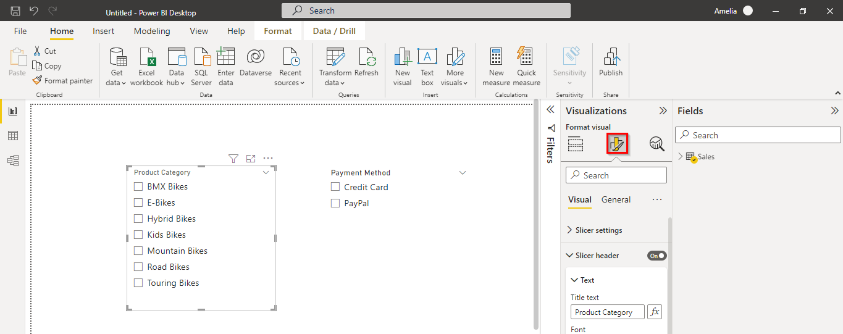

* Drag the positioning of the slicers to the right side of the report area.

**Step 3: Create a stacked column chart**

* Add a stacked column chart to your report that shows **Order Total by Product Size** and **Product Category**.

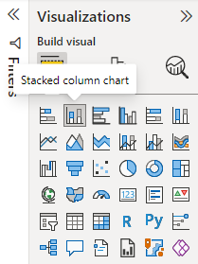

* Set the chart title to **Order Total by Product Size and Product Category for 2023**.
* Drag the stacked column chart visual to the left side of the **Report** area (next to the interactive slicer filters).

**Step 4: Create a donut chart**

* Add a donut chart for **Order Total Share** by **Product Category**.

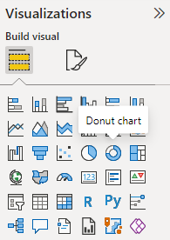

* Set the chart title to **Order Total Share by Product Category for 2023**.
* Drag the donut chart visual below the stacked column chart (created in Step 3).

**Step 5: Create a table**

* Add a table showing all product names with their corresponding order totals.

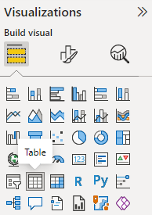

* Drag the table visual to the right side of the **Report** area, below the interactive filters (created in Step 2).

## Conclusion

In this exercise, you created visualizations that transformed complex data by presenting it in a format that is easier to understand. By using the powerful features of Microsoft Power BI, you can create interactive and compelling dashboards that drive strategic decision-making within your organization. As you continue to develop your skills in data visualization, always remember that the ultimate goal is to communicate complex information in a simple, clear, and engaging manner, enabling everyone to make better decisions and drive positive change.