I tried to host the website, but they banned me

Here is the link: <https://221619q.000webhostapp.com/>

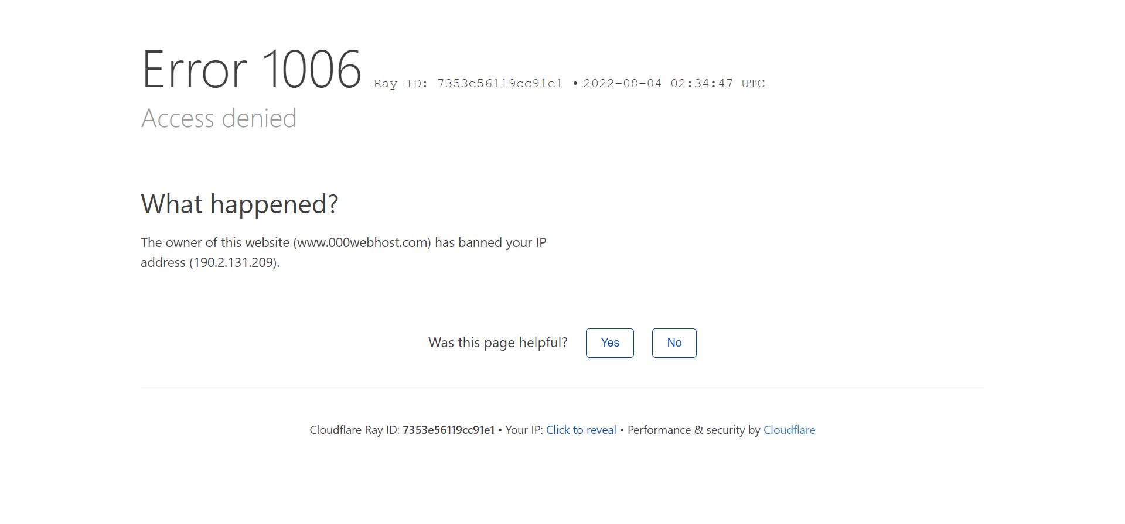

And here is the error message

And here is my about me page:

<https://iamsven.000webhostapp.com/>

And here is my official website:

<https://cornerguys05.wixsite.com/hello>