**NANYANG POLYTECHNIC SENATE MEETING**

|  |  |  |
| --- | --- | --- |
| Paper No. | : | **SEN 132(23) A7** |
| Subject | : | **Proposal to Revise the Curriculum for the Diploma in Applied AI & Analytics** |
| Classification | : | Approval Paper |
| Prepared by | : | Teo Miow Ting [Senior Manager, SIT] |
| Vetted by | : | Kelvin Ng [Deputy Director/SIT]  James Tey [Deputy Director/SIT]  Lee Chit Boon [Assistant Director/SIT] |
| Cleared by | : | Tan Soon Keow [Director, SIT] |
| Date of Meeting | : | 24 Oct 2023 |

# ****Introduction****

1. The purpose of this paper is to seek the approval of the Senate to revise the curriculum of the Diploma in Applied AI & Analytics (DAAA) and offer it as one of the constituent courses under the Common ICT Programme (CIP) in AY2025 S1.

# ****background****

1. The diploma was originally launched as the Diploma in Business Intelligence & Analytics (DBA) in AY2012. In AY2021, DBA was restructured to implement the NYP’s Professional Competency Model (NYP-PCM). The course has been renamed to DAAA in AY2023 to better represent its course aims and reflect the course curriculum.
2. DAAA continues to produce graduates who will demonstrate their competencies in building and implementing AI, data and analytics solutions to meet the requirements of PMET job demand in the Data and Artificial Intelligence domain across different sectors.

# ****rationale for the change****

1. DAAA was decoupled from Common ICT Programme (CIP) in AY2021 due to the fundamental pedagogical difference between NYP-PCM and traditional subject-based learning model, as well as the disparity in the learning scaffolds.
2. In view of CIP and the rest of School of Information Technology (SIT) diplomas implementing NYP-PCM, it is timely to review DAAA curriculum and to re-offer it as one of the constituent courses under CIP.
3. Since its launch in 2021, DAAA has been regularly seeking feedback and views from various stakeholders such as tech leaders, industry partners, teaching staff and learners for continuous improvement. The feedback and learning points were incorporated during the review of the curriculum to help enhance the overall quality of the curriculum and improve operational efficiency during course delivery.

# ****revisions to curriculum****

1. The Course Learning Outcomes (CLOs) of the diploma were reviewed and feedback from the industry panel show that the existing CLOs relating to the technical skills and competencies are still current and relevant. These CLOs are mapped to the “Professional Proficiency” NYP Graduate Attribute (GA).
2. To align with the MOE LifeSkills Framework (MOE LSF), 4 CLOs covering the NYP GAs on “Competent in 21st Century Skills”, “Innovative & Enterprising” and “Socially Responsible”, were developed to replace the previous set of 7 CLOs that was referenced to the SSG’s Critical Core Skills (CCS) and Ethics. NYP Senate’s approval was given in April 2022.
3. Please refer to Annex A for the CLOs of the course.
4. In the Skills Demand for the Future Economy (SDFE) Report 2022[1], AI, Data and Analytics related skills have been identified as the most transferable skills across sectors and job roles in the digital economy. According to a recent survey commissioned by Johnson Controls[2], 70% of business leaders from Southeast Asia have identified sustainability as an increasing priority, digitalisation plays a critical role in the Green Economy and supports companies in their sustainability agenda. The revision of the curriculum will align with the updated skills demand and incorporate sustainability and interdisciplinary-focused aspects into the curriculum.
5. Learning will be scaffolded to attain Course Competencies (CCs) through various Competency Units (CmUs) and Work-Integration Units (WIUs). Please refer to Annex B for the Course Competencies and Annex C for the Course Competency Map.
6. The revised DAAA curriculum will share a common year 1 curriculum with CIP and other SIT diplomas to give the same footing to all students. The proposed year 1 curriculum will offer 9 Competency Units (CmUs), 1 Work-Integration Unit (WIU) and 6 General Studies modules with a total of 44 credits.
7. The AI, Data and Analytics related knowledge, concepts and skills from the existing curriculum were reorganised and merged in an integrated manner to provide a more comprehensive and meaningful learning experience that equips learners with skills relevant to the complexities of real-world work situations. To support the skills demand for AI, Data and Analytics, software development, cloud and data infrastructure, the competencies of a DAAA graduate are synthesised into 5 Course Competencies (CCs) as listed below.

|  |  |
| --- | --- |
| Course Competencies | |
| CC1 | AI Innovation for Business |
| CC2 | Applied AI & Operations |
| CC3 | DataOps for Scalable AI |
| CC4 | Ethics, Governance & Sustainability in AI |
| CC5 | Full Stack Development |

1. The curriculum is structured into six programmes, allowing learners to develop the required CCs throughout the 3 years of study. Please refer to Annex D for the Course Learning Progression and the comparison of existing and proposed curriculum structure.
2. The Competency Canvases (CCVs) for DAAA are listed in the table below. The CCVs are developed based on job roles and significant tasks that graduates will be assigned in their respective industries. The Front End Development (CCV1), which is common with CIP, is offered to all learners in the first year. In their second year, learners will choose to sharpen their skills in AI application development or data engineering, by selecting AI Innovation with Deep Learning or AI Innovation with MLOps respectively, to complete CCV2 or CCV3 to meet the graduation requirement. Please refer to Annex E for Competency Canvas Table.

|  |  |
| --- | --- |
| Competency Canvases | |
| CCV1 | Front End Development Competency Canvas |
| CCV2 | AI Innovation with Deep Learning Competency Canvas |
| CCV3 | AI Innovation with MLOps Competency Canvas |

1. DAAA started the 1-year Internship Programme as an alternative study path for learners in AY2023. This is aligned with IMDA's TechSkills Accelerator (TeSA) for ITE and Polytechnics Alliance (“TIP Alliance”) initiative to equip students and graduates from ITE and Polytechnics with the skills to take up opportunities in tech or digital careers and share in Singapore’s digital growth. The 1-year Internship Programme had received enthusiastic response by learners and internship companies alike. The revised DAAA curriculum will feature internship durations of either 22 weeks or 44 weeks. The proposed curriculum will also incorporate preparation for industry skills tests and certifications.
2. Internship Programme (ITP) and Final Year Project (FYP) will be offered as WIUs. The number of hours and weeks, and credit units for ITP and FYP are listed below.

|  |  |  |  |
| --- | --- | --- | --- |
| WIU | No. of hours | No. of weeks | Credit units |
| ITP (22-week) | 880 | 22 | 22 |
| FYP (22-week) | 880 | 22 | 22 |
| OR | | | |
| ITP (44-week) | 1760 | 44 | 44 |

1. The total credit requirements for graduation for the diploma remain the same at 134 credits after the revision of the curriculum.
2. Please refer to Annex F for the Synopses and Learning Outcomes of Competency Units and Work-Integration Units.
3. The relevant data, analytics and AI-related learning objects from the existing curriculum will be reused in the revised curriculum. The reusable CmUs are as listed below.

|  |
| --- |
| Reused CmUs from Existing Curriculum |
| Statistical Research Methods |
| Programming |
| Applied Machine Learning |

1. Existing partnership with various industry leaders will be renewed to deepen the collaboration in the revised curriculum. New industry partners will also be engaged to co-create value for our learners through co-development, co-delivery, co-mentoring and co-certification. The existing co-certification arrangement are listed below.

|  |  |
| --- | --- |
| **Co-certification** | **Industry Leaders** |
| Certificate of Competency in Database Design & Administration | Oracle Academy |
| Certificate of Competency in Visual Analytics | Microsoft |
| Certificate of Competency in Predictive Analytics in Data Science | SAS Institute |
| Certificate of Competency in AI Ethics & Governance (Associate Level) | Singapore Computer Society (SCS) |

1. The proposed curriculum was shared with the autonomous universities as well as industry partners to garner their feedback.
2. Autonomous universities supported and commended the competency-based approach in the reviewed curriculum.
3. The approached industry partners were unanimous in their commendations for the new PCM framework. In particular, they are confident that the new design will result in graduates who are more work-ready and aligned with the current IT industry. Please refer to Annex G for Industry Feedback.

# Implementation Plans

1. The revised curriculum will be implemented with effect from the AY2025 intake in April 2025. There is no change to the Minimum Entry Requirements (MER) for admission into the diploma.
2. Learners under the current curriculum who need to retake modules that are no longer available as a result of the revision, may take the relevant equivalent CmUs/WIUs from the new curriculum on a case-by-case basis, on the recommendation of the course management team and subjected to approval from DSIT.
3. The School will conduct communication sessions with currently enrolled students and their parents to assure them of their graduate careers and further education options.

# Support from Advisory Committee

1. The IT Advisory Committee deliberated over the curriculum review and gave its support on 12 Sep 2023.

# ****Approval by Senate****

1. The Senate’s approval is sought to revise the curriculum for the Diploma in Applied AI & Analytics (DAAA) and offer it as one of the constituent courses under the new NYP-PCM CIP in AY2025 S1.

# Enclosures:

Annex A: Course Learning Outcomes

Annex B: Course Competencies

Annex C: Course Competency Map

Annex D: Course Learning Progression

Annex E: Competency Canvas (CCV) Table

Annex F: Synopses and Learning Outcomes of Competency Units and Work-Integration Units

Annex G: Industry Feedback

# Annex A: Course Learning Outcomes

|  |  |
| --- | --- |
|  | Apply technical knowledge and programming skills in the capacity of a business analytics IT professional. |
|  | Apply artificial intelligence and analytics technologies and tools to integrate technical and business knowledge to provide solution. |
|  | Demonstrate competence in artificial intelligence and analytics and be able to integrate and apply it effectively in different industry & domain. |
|  | Display the abilities to stay relevant by demonstrating independent learning, self-awareness and mental resilience, and personal effectiveness |
|  | Demonstrate interpersonal skills and global perspectives by communicating and working effectively with people from diverse backgrounds |
|  | Apply innovative and enterprising practices to achieve intended goals and drive continuous improvement with an interdisciplinary approach |
|  | Display personal and professional values and ethics by demonstrating inclusivity and responsibility towards the community, nation and the world, and considering impact of actions and decisions on sustainability |

# Annex B: Course Competencies

|  |  |  |
| --- | --- | --- |
| **Course Competencies (CCs)** | | **Mapped CLOs** |
| CC1 | AI Innovation for Business  Learners will be competent to deliver AI innovations by applying business needs analysis skills to deliver service excellence for customers with diverse backgrounds. | CLO1, CLO2, CLO3, CLO5, CLO6, CLO7 |
| CC2 | Applied AI & Operations  Learners will be competent in applying AI and data engineering skills by using tools and techniques to solve business problems and support decision-making. | CLO1, CLO2, CLO3, CLO4, CLO5, CLO6, CLO7 |
| CC3 | DataOps for Scalable AI  Learners will be competent to design robust and scalable DataOps strategies to manage Big Data platforms aligned to stakeholders’ business values. | CLO1, CLO2, CLO3, CLO5, CLO6, CLO7 |
| CC4 | Ethics, Governance & Sustainability in AI  Learners will be competent to apply AI ethics, governance and sustainability considerations and mitigation measures at various stages throughout the implementation of an AI solution. | CLO1, CLO2, CLO3, CLO5, CLO6, CLO7 |
| CC5 | Full Stack Development  Learners will be competent in developing IT applications according to users’ and business needs. | CLO1, CLO2, CLO4, CLO6, CLO7 |

# Annex C: Course CompetencY map

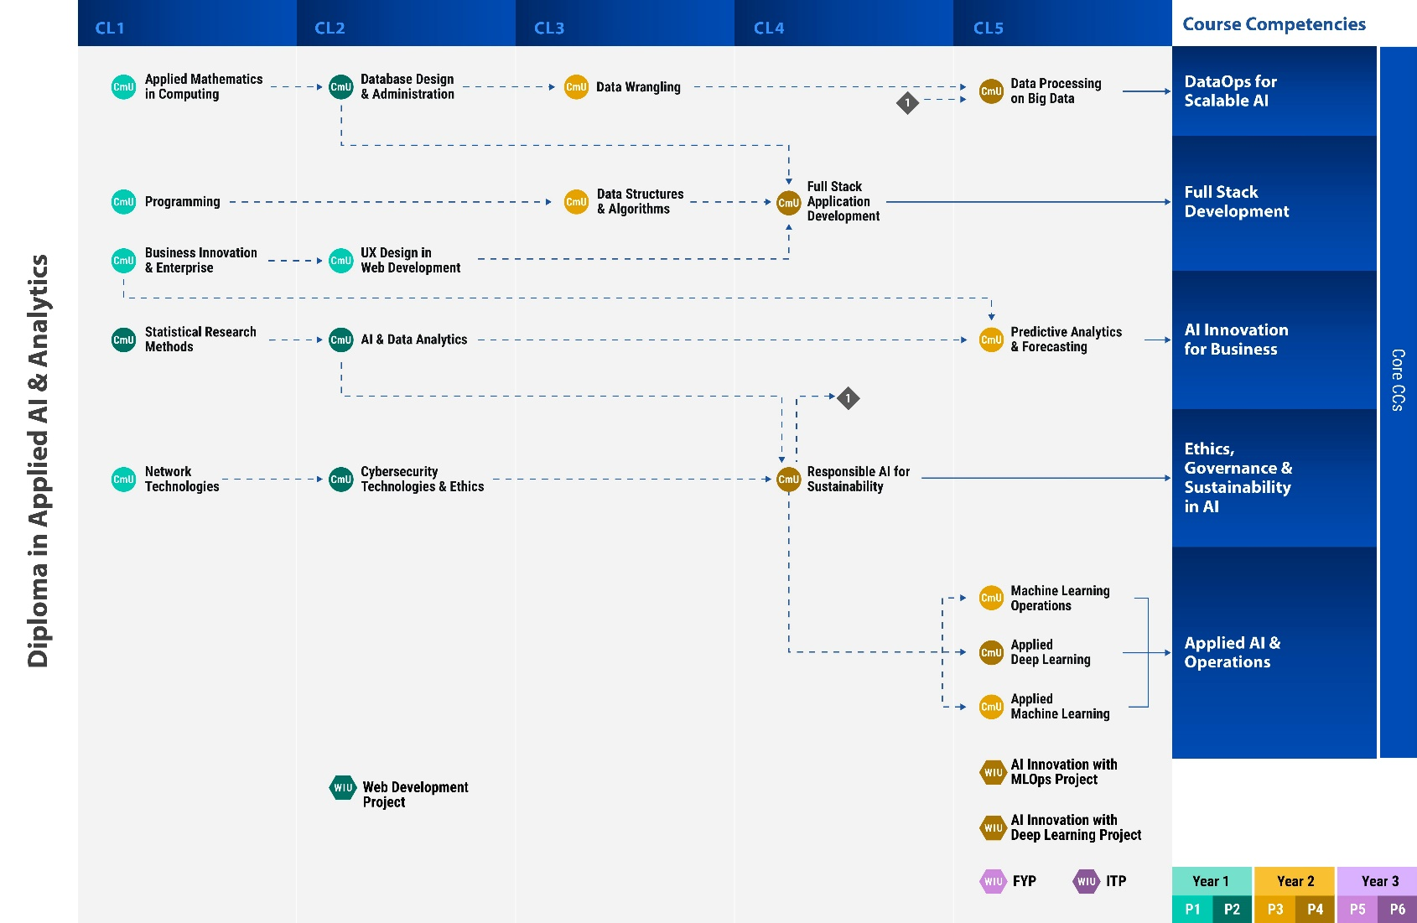

CL – Complexity Level

CmU - Competency Unit

WIU – Work Integration Unit

# Annex D: Course learning progression

|  |  |  |  |  |  |  |  |  |  |  |  |  |  |  |  |  |  |
| --- | --- | --- | --- | --- | --- | --- | --- | --- | --- | --- | --- | --- | --- | --- | --- | --- | --- |
|  | | | |  | |  | | | | |  |  | | |  | |  |
|  | | | |  | |  | | | | |  |  | | |  | |  |
| **CmUs/WIUs in Programme 1** | **Hours** | **Credits** |  | | **CmUs/WIUs in Programme 3** | | **Hours** | **Credits** |  | **CmUs/WIUs in Programme 5 & 6** | | | **Hours** | **Credits** | |
| Applied Mathematics in Computing | 30 | 2 |  | | Applied Machine Learning | | 60 | 4 |  | Final Year Project (22 weeks) | | | 880 | 22 | |
| Business Innovation & Enterprise | 60 | 4 |  | | Data Structures & Algorithms | | 60 | 4 |  | Internship Programme (22 weeks) | | | 880 | 22 | |
| Network Technologies | 60 | 4 |  | | Data Wrangling | | 60 | 4 |  | *or* | | |  |  | |
| Programming | 60 | 4 |  | | Machine Learning Operations | | 60 | 4 |  | Internship Programme (44 weeks) | | | 1760 | 44 | |
| UX Design in Web Development | 60 | 4 |  | | Predictive Analytics & Forecasting | | 60 | 4 |  |  | | |  |  | |
| General Studies | 45 | 3 |  | | General Studies | | 45 | 3 |  |  | | |  |  | |
| **Total** | **315** | **21** |  | | **Total** | | **345** | **23** |  | **Total** | | | **1760** | **44** | |
|  |  |  |  | |  | |  |  |  |  | | |  |  | |
| **CmUs/WIUs in Programme 2** | **Hours** | **Credits** |  | | **CmUs/WIUs in Programme 4** | | **Hours** | **Credits** |  |  | | |  |  | |
| AI & Data Analytics | 60 | 4 |  | | Applied Deep Learning | | 60 | 4 |  |  | | |  |  | |
| Cybersecurity Technologies & Ethics | 60 | 4 |  | | Data Processing on Big Data | | 60 | 4 |  |  | | |  |  | |
| Database Design & Administration | 60 | 4 |  | | Responsible AI for Sustainability | | 60 | 4 |  |  | | |  |  | |
| Statistical Research Methods | 60 | 4 |  | | Full Stack Application Development | | 60 | 4 |  |  | | |  |  | |
| Web Development Project | 60 | 4 |  | | Prescribed Elective | | 60 | 4 |  |  | | |  |  | |
| General Studies | 45 | 3 |  | | General Studies | | 45 | 3 |  |  | | |  |  | |
| **Total** | **345** | **23** |  | | **Total** | | **345** | **23** |  |  | | |  |  | |
|  |  |  |  | |  | |  |  |  |  | | |  |  | |
| **Programme 4 Prescribed Electives** | | |  | |  | | | |  |  | | |  |  | |
| AI Innovation with MLOps Project | | |  | |  | | | |  |  | | |  |  | |
| AI Innovation with Deep Learning Project | | |  | |  | | | |  | **Grand Total** | | | **3110** | **134** | |

# Comparison of Existing and proposed Curriculum/ STructure

|  |  |  |  |  |  |  |
| --- | --- | --- | --- | --- | --- | --- |
| **EXISTING** | | |  | **PROPOSED** | | |
| **Programme 1** | **Hours** | **Credits** |  | **Programme 1** | **Hours** | **Credits** |
| UX Design | 60 | 4 |  | Applied Mathematics in Computing | 30 | 2 |
| Network Administration | 60 | 4 |  | Business Innovation & Enterprise | 60 | 4 |
| Programming | 60 | 4 |  | Network Technologies | 60 | 4 |
| Statistical & Research Methods | 60 | 4 |  | Programming | 60 | 4 |
| Data Modelling | 30 | 2 |  | UX Design in Web Development | 60 | 4 |
| Business Needs Analysis | 30 | 2 |  | General Studies | 45 | 3 |
| General Studies | 30 | 2 |  |  |  |  |
| **Total** | **330** | **22** |  | **Total** | **315** | **21** |
|  |  |  |  |  |  |  |
| **Programme 2** | **Hours** | **Credits** |  | **Programme 2** | **Hours** | **Credits** |
| Decision Analysis | 60 | 4 |  | AI & Data Analytics | 60 | 4 |
| Data Structures & Algorithms | 60 | 4 |  | Cybersecurity Technologies & Ethics | 60 | 4 |
| Operating Systems Administration | 60 | 4 |  | Database Design & Administration | 60 | 4 |
| Data Visualisation | 30 | 2 |  | Statistical Research Methods | 60 | 4 |
| Applied Cryptography | 30 | 2 |  | Web Development Project | 60 | 4 |
| Data Storage Administration | 30 | 2 |  | General Studies | 45 | 3 |
| Visual Analytics Project | 30 | 2 |  |  |  |  |
| General Studies | 30 | 2 |  |  |  |  |
| **Total** | **330** | **22** |  | **Total** | **345** | **23** |
|  |  |  |  |  |  |  |
| **Programme 3** | **Hours** | **Credits** |  | **Programme 3** | **Hours** | **Credits** |
| Supervised Learning | 60 | 4 |  | Applied Machine Learning | 60 | 4 |
| Web Application Development | 60 | 4 |  | Data Structures & Algorithms | 60 | 4 |
| Data Wrangling | 30 | 4 |  | Data Wrangling | 60 | 4 |
| Data Integration & Clustering | 30 | 2 |  | Machine Learning Operations | 60 | 4 |
| Data Journalism | 30 | 2 |  | Predictive Analytics & Forecasting | 60 | 4 |
| Unsupervised Learning | 30 | 2 |  | General Studies | 45 | 3 |
| Data Privacy & Protection | 30 | 2 |  |  |  |  |
| Predictive Analytics Project | 30 | 2 |  |  |  |  |
| General Studies | 30 | 2 |  |  |  |  |
| **Total** | **330** | **22** |  | **Total** | **345** | **23** |

|  |  |  |  |  |  |  |
| --- | --- | --- | --- | --- | --- | --- |
| **Programme 4** | **Hours** | **Credits** |  | **Programme 4** | **Hours** | **Credits** |
| Topic Modelling & Sentiment Analysis | 60 | 4 |  | Applied Deep Learning | 60 | 4 |
| Big Data Modelling & Management | 60 | 4 |  | Data Processing on Big Data | 60 | 4 |
| Programming for Data Science | 60 | 4 |  | Responsible AI for Sustainability | 60 | 4 |
| Natural Language Processing | 30 | 2 |  | Full Stack Application Development | 60 | 4 |
| Emerging Technology Synthesis | 30 | 2 |  | Prescribed Elective: AI Innovation with MLOps Project or AI Innovation with Deep Learning Project | 60 | 4 |
| Customer Experience Analysis | 30 | 2 |  | General Studies | 45 | 3 |
| Text & Social Analytics Project | 30 | 2 |  |  |  |  |
| General Studies | 30 | 2 |  |  |  |  |
| **Total** | **330** | **22** |  | **Total** | **345** | **23** |
|  |  |  |  |  |  |  |
| **Programme 5** | **Hours** | **Credits** |  | **Programme 5 & 6** | **Hours** | **Credits** |
| Applied Machine Learning | 60 | 4 |  | Final Year Project (22 weeks) | 880 | 22 |
| Applied Deep Learning | 30 | 2 |  | Internship Programme (22 weeks) | 880 | 22 |
| Advanced Data Visualisation | 30 | 2 |  | or |  |  |
| Data Processing on Big Data | 30 | 2 |  | Internship Programme (44 weeks) | 1760 | 44 |
| Data Platform Management | 30 | 2 |  |  |  |  |
| Machine Learning Operations | 30 | 2 |  |  |  |  |
| AI Services in Analytics | 30 | 2 |  |  |  |  |
| Marketing Strategy | 30 | 2 |  |  |  |  |
| Prescribed Elective: Applied AI Project or Big Data Management Project | 30 | 2 |  |  |  |  |
| General Studies | 30 | 2 |  |  |  |  |
| **Total** | **330** | **22** |  | **Total** | **1760** | **44** |
|  |  |  |  | **Grand Total** | **3110** | **134** |

|  |  |  |  |  |  |  |
| --- | --- | --- | --- | --- | --- | --- |
| **Programme 6** | **Hours** | **Credits** |  |  |  |  |
| Final Year Project | 480 | 12 |  |  |  |  |
| Internship Programme | 480 | 12 |  |  |  |  |
| or |  |  |  |  |  |  |
| Internship Programme (24-week) | 960 | 24 |  |  |  |  |
| or |  |  |  |  |  |  |
| Final Year Project (24-week) | 960 | 24 |  |  |  |  |
| **Total** | **960** | **24** |  |  |  |  |
| **Grand Total** | **2630** | **34** |  |  |  |  |

# Annex E: competency canvas (ccv) table

|  |  |
| --- | --- |
| CCV1 | Front End Development Competency Canvas  In this canvas, learners will develop websites for businesses through a WIU by synthesising the competencies they had acquired in Business Innovation & Enterprise, Programming and Web & UX Design. |
| CCV2 | AI Innovation with Deep Learning Competency Canvas  In this canvas, learners will select suitable deep learning networks to solve business problems in value domains through a WIU by synthesising the competencies they had acquired in Predictive Analytics & Forecasting, Applied Deep Learning and Ethical & Sustainable AI. |
| CCV3 | AI Innovation with MLOps Competency Canvas  In this canvas, learners will design data pipeline for Machine Learning model deployment through a WIU by synthesising the competencies they had acquired in Machine Learning Operations, Data Processing on Big Data and Ethical & Sustainable AI. |

CCV1 Front End Development Competency Canvas

|  |  |  |
| --- | --- | --- |
| CmUs / WIUs | CL | Programme |
| Business Innovation & Enterprise | 1 | 1 |
| Programming | 1 | 1 |
| UX Design in Web Development | 2 | 1 |
| Web Development Project | 2 | 2 |

CCV2 AI Innovation with Deep Learning Competency Canvas

|  |  |  |
| --- | --- | --- |
| CmUs / WIUs | CL | Programme |
| Responsible AI for Sustainability | 4 | 4 |
| Predictive Analytics & Forecasting | 5 | 3 |
| Applied Deep Learning | 5 | 4 |
| AI Innovation with Deep Learning Project | 5 | 4 |

CCV3 AI Innovation with MLOps Competency Canvas

|  |  |  |
| --- | --- | --- |
| CmUs / WIUs | CL | Programme |
| Responsible AI for Sustainability | 4 | 4 |
| Machine Learning Operations | 5 | 3 |
| Data Processing on Big Data | 5 | 4 |
| AI Innovation with MLOps Project | 5 | 4 |

**ANNEX F: SYNOPSES AND LEARNING OUTCOMES OF COMPETENCY UNITS AND WORK-INTEGRATION UNITS**

**CmUs in Programme 1**

**Applied Mathematics in Computing [30 hours]**

**Description**

In a complex and fast changing world, Mathematics is essential for Infocomm Technologies, to solve problems and create solutions, to improve products and services, and to help us make logical choices. Through this unit, learners will develop competencies in applying mathematical concepts of matrices, functions, differential and integral calculus in the design and modelling of computing algorithms.

**Learning Outcomes**

|  |  |
| --- | --- |
| **CmU-LO#** | **At the end of this CmU, learners will be able to:** |
| CmU-LO1 | Construct linear equations and transformation using matrices in computer algorithms. |
| CmU-LO2 | Solve computing problems by representing events with functions. |
| CmU-LO3 | Construct quantitative models of change to deduce their consequences by applying differentiation and integration. |
| CmU-LO4 | Implement algorithms for problem solving using mathematical analysis. |

**Business Innovation & Enterprise [60 hours]**

**Description**

In a dynamic and competitive environment, organisations need to be innovative and enterprising. Business Innovation is the process of introducing new ideas, workflows, methodologies, services or products to help enterprises enhance their competitive edge. In this unit, learners will develop competencies in gathering business requirements from key stakeholders using effective communication and interpersonal skills. They will also develop competencies in working collaboratively with others to document user stories from users’ perspectives. With the use of digital technologies, learners will co-create ideas with others to develop digital transformation plans for businesses.

**Learning Outcomes**

|  |  |
| --- | --- |
| **CmU-LO#** | **At the end of this CmU, learners will be able to:** |
| CmU-LO1 | Perform collection of user requirements from key stakeholders using effective communication and interpersonal skills. |
| CmU-LO2 | Create user stories to gather user requirements and functionalities from the business perspective using collaboration tools. |
| CmU-LO3 | Develop digital transformation plans for businesses by incorporating digital technologies. |
| CmU-LO4 | Create ideas with key stakeholders to deliver business needs and service excellence using collaborative technologies. |
| CmU-LO5 | Demonstrate ability to craft professional and concise emails to communicate with customers on user requirements. |

**Network Technologies [60 hours]**

**Description**

Networks serve the communication needs of many people be it for work or play. A functional Internet or company network depends on the health of connect devices and therefore building and maintaining these networks is an important task. In this unit, learners will develop the competencies in the layered approach to network technology, implementation of Internet Protocol (IP) addressing scheme and the various types of network topologies. Learners will work collaboratively in teams, testing designs before implementing functional networks. Learners will also monitor, diagnose and troubleshoot network connectivity and equipment issues using common network tools.

**Learning Outcomes**

|  |  |
| --- | --- |
| **CmU-LO#** | **At the end of this CmU, learners will be able to:** |
| CmU-LO1 | Examine the basic network components, devices and their functions with reference to the different Open Systems Interconnection (OSI) layers. |
| CmU-LO2 | Implement an IP addressing scheme in a network environment using various subnetting techniques. |
| CmU-LO3 | Demonstrate configuration of a network for small and medium enterprises using simulation tools to prototype and test a variety of Wide Area Network/ Local Area Network (WAN/LAN) designs. |
| CmU-LO4 | Perform troubleshooting of network connectivity and equipment issues using common network tools. |
| CmU-LO5 | Identify areas of interests, strengths and development needs by sharing knowledge, experiences and feedback acquired from networking case studies. |
| CmU-LO6 | Identify most suitable learning techniques by sharing relevant information gathered to build a network based on business requirements. |

**Programming [60 hours]**

**Description**

Programming is an essential skill for learners to learn how to solve problems in a logical way. In this unit, learners will learn the concepts and principles behind computer programs and the building blocks that are used to create them. Learners will develop competencies in using programming constructs, data structures, and computational thinking techniques to create innovative solutions to solve problems encountered in our daily life. They will also develop competencies to perform software validation using relevant software testing and debugging techniques.

**Learning Outcomes**

|  |  |
| --- | --- |
| **CmU-LO#** | **At the end of this CmU, learners will be able to:** |
| CmU-LO1 | Solve complex problems using computational thinking techniques such as decomposition, abstraction, pattern recognition and algorithm. |
| CmU-LO2 | Apply program development process to solve computational problems using a programming language. |
| CmU-LO3 | Create a computer program using programming constructs, data types and algorithm. |
| CmU-LO4 | Verify a computer program using relevant software testing and debugging tools and techniques. |

**UX Design in Web Development [60 hours]**

**Description**

User Experience (UX) is how a person feels when using and interacting with a product such as a website or web application. A UX design is important because it fulfils a user's need and provide positive experiences that keep a user loyal to a product or brand. Through this unit, learners will develop competencies in designing and creating intuitive websites for enhanced user experiences by applying user-centred design principles, and techniques in design prototyping.

**Learning Outcomes**

|  |  |
| --- | --- |
| **CmU-LO#** | **At the end of this CmU, learners will be able to:** |
| CmU-LO1 | Design intuitive and accessible user interfaces using UX design principles. |
| CmU-LO2 | Identify elements of a good UX design by applying design principles in interface, navigation and visuals. |
| CmU-LO3 | Create user-centred web pages using standard markup language and client-side technologies. |
| CmU-LO4 | Develop interactive web content that can be viewed on different devices using responsive frameworks. |
| CmU-LO5 | Demonstrate effective oral communication skills through the presentation of prototypes as a team. |

**CmUs/WIU in Programme 2**

**AI & Data Analytics [60 hours]**

**Description**

Data analytics & visualisation help organisations make decisions through data-driven insights. Through this unit, learners will develop competencies in data pre-processing and build interactive visualisations that address diverse needs of key stakeholders. Learners will also be competent to perform data exploratory analysis to discover patterns and trends. They will also develop competencies to apply the appropriate Artificial Intelligence (AI) tools to solve real-world problems.

**Learning Outcomes**

|  |  |
| --- | --- |
| **CmU-LO#** | **At the end of this CmU, learners will be able to:** |
| CmU-LO1 | Perform data extraction, cleansing and transformation to pre-process data prior to analysis using Data Analytics software tools. |
| CmU-LO2 | Develop interactive dashboards with a global perspective to address international and cultural differences, diverse needs and expectations of the key stakeholders using data visualisation tools. |
| CmU-LO3 | Perform data exploratory analysis to identify underlying data patterns, trends and analytical insights using data visualisation tools. |
| CmU-LO4 | Apply appropriate AI tools to solve real-world problems by describing its application, value, limitations and societal impact. |

**Cybersecurity Technologies & Ethics [60 hours]**

**Description**

Cybersecurity is the key to a secure and safe digital space for online business, work and play. In this unit, learners will apply concepts and principles of cybersecurity from both personal and enterprise perspectives. They will develop competencies to design and implement cybersecurity solutions to ensure the confidentiality, integrity and availability of information and digital services. They will learn how information security policies, regulations and ethics can influence the outcomes of a safer digital world.

**Learning Outcomes**

|  |  |
| --- | --- |
| **CmU-LO#** | **At the end of this CmU, learners will be able to:** |
| CmU-LO1 | Analyse cybersecurity risks and mitigations with reference to information security policies, regulations and ethics. |
| CmU-LO2 | Implement information security using recommended tools and processes to secure clients, servers, and networks. |
| CmU-LO3 | Apply cryptographic technologies to secure data and information through encryption, digital signatures and digital certificates. |
| CmU-LO4 | Apply appropriate security techniques to address cyber threats by mitigating common application, system and network vulnerabilities. |

**Database Design & Administration [60 hours]**

**Description**

With tremendous data growth, a well-designed and high-performance database is essential for businesses to stay competitive. Through this unit, learners will develop competencies in designing database schemas using data modelling techniques. Learners will also develop competencies in implementing and administering data storage. They are expected to perform data retrieval, data manipulation and database administration using fundamental tools and techniques. They will also be competent in implementing security measures to ensure data consistency, accuracy and integrity.

**Learning Outcomes**

|  |  |
| --- | --- |
| **CmU-LO#** | **At the end of this CmU, learners will be able to:** |
| CmU-LO1 | Design conceptual model for database using entity-relational diagram with consideration of various key constraints to solve business problems. |
| CmU-LO2 | Implement data schemas in a database management system by applying data modelling techniques. |
| CmU-LO3 | Perform data retrieval and data management tasks by utilizing Extract-Transform-Load (ETL) tools and techniques. |
| CmU-LO4 | Implement data storage and security measures on a database management system to ensure data consistency, accuracy, and integrity. |

**Statistical Research Methods [60 hours]**

**Description**

Decision-making has become more data-driven, and thus statistical methods are becoming more widely used in the industry to extract and analyse data to gain useful insights. Through this unit, learners will develop competencies in predicting an event’s probability of occurrence with associated confidence requirements. Learners will also be competent in performing business research by forming hypotheses, using sampling techniques, establishing research validity and reliability, performing relevant statistical inference techniques and presenting research findings.

**Learning Outcomes**

|  |  |
| --- | --- |
| **CmU-LO#** | **At the end of this CmU, learners will be able to:** |
| CmU-LO1 | Analyse data to draw insights for business decision-making using descriptive statistical methods. |
| CmU-LO2 | Compute probabilities and frequencies for events in business domain using discrete and continuous probability distributions. |
| CmU-LO3 | Compute confidence interval for a population mean using normal distribution and the t-distribution. |
| CmU-LO4 | Apply inferential statistics on business data by applying hypothesis testing in business research. |
| CmU-LO5 | Prepare research findings using professional writing guidelines and standard citation formats. |

**Web Development Project [60 hours]**

**Description**

This unit allows learners to synthesize both knowledge and skills learnt throughout the course and enables them to become competent in using current web-based development tools and technologies such as HTML, CSS and JavaScript. Learners will develop a user-centred, interactive, and responsive website using Object-Oriented programming concepts to better organise the structure of the application. Learners will acquire competencies to showcase their website through presentation, while competently handling questions, to effectively incorporate verbal and non-verbal elements.

**Learning Outcomes**

|  |  |
| --- | --- |
| **WIU-LO#** | **At the end of this WIU, learners will be able to:** |
| WIU-LO1 | Apply collaborative learning to plan and deliver a web-based solution according to a set of given business requirements. |
| WIU-LO2 | Design a user-centric web application by applying the principle and concepts of the Innovation & Enterprise, Web and UX Design. |
| WIU-LO3 | Develop maintainable and extensible web application by applying the key concepts of Object-Oriented programming. |
| WIU-LO4 | Create interactive and responsive web application for optimal viewing on different devices using cloud and responsive web technologies. |
| WIU-LO5 | Assess learning development by gathering feedback from various sources. |
| WIU-LO6 | Demonstrate effective oral communication skills by presenting ideas clearly to achieve desired outcomes. |

**CmUs in Programme 3**

**Applied Machine Learning [60 hours]**

**Description**

Machine learning, or the ability of computer models to learn from data, is one of the most important subfields of artificial intelligence today with applications across different industries. In this unit, learners will gain knowledge of the principles, potential and limitations underlying this technology in the end-to-end machine learning process. Learners will also develop their competencies in applying machine learning models to a new problem.

**Learning Outcomes**

|  |  |
| --- | --- |
| **CmU-LO#** | **At the end of this CmU, learners will be able to:** |
| CmU-LO1 | Compare popular machine learning models used in the industry with reference to the learning algorithms used, their strengths and limitations. |
| CmU-LO2 | Apply end-to-end machine learning process with reference to selected business problem. |
| CmU-LO3 | Determine the most appropriate machine learning model by using performance metrics. |
| CmU-LO4 | Discuss the types of industry problems that machine learning can be applied to by referring to past successes as well as potential use cases |

**Data Structures & Algorithms [60 hours]**

**Description**

A data structure is a programmatic way of storing and organising data. An algorithm is a list of step-by-step instructions for solving a problem. Together, data structures and algorithms are fundamental components in every software application. Good algorithms with proper data structures allow sophisticated applications to solve complex problems efficiently. Through this unit, learners will learn about arrays, dynamic data, structures, stacks, queues and algorithms for sorting and searching.

**Learning Outcomes**

|  |  |
| --- | --- |
| **CmU-LO#** | **At the end of this CmU, learners will be able to:** |
| CmU-LO1 | Describe concepts of common data structures and its implementation with reference to operational characteristics. |
| CmU-LO2 | Demonstrate how to apply common data structures in a software application. |
| CmU-LO3 | Explain concepts of advanced algorithms in sorting and searching. |
| CmU-LO4 | Create an application by applying the fundamentals of data structures and algorithms concepts. |

**Data Wrangling [60 hours]**

**Description**

Data wrangling is the process of transforming raw data into an appropriate and usable format for data analysis and integration. Data wrangling helps to improve data usability as it converts data into a compatible format for data mining. Through this unit, learners will develop competencies in collecting data from multiple data sources using appropriate data collection tools and techniques that comply with data and privacy ethics. Learners will also be competent in using appropriate tools and techniques for the transformation, reshaping and aggregation of data from multiple sources.

**Learning Outcomes**

|  |  |
| --- | --- |
| **CmU-LO#** | **At the end of this CmU, learners will be able to:** |
| CmU-LO1 | Select data from multiple sources using collection tools and techniques that comply with data and privacy ethics. |
| CmU-LO2 | Perform data preprocessing techniques to impute data format, transform, reshape and protect the data in accordance with the business requirements and data protection principles. |
| CmU-LO3 | Identify underlying data relationships among data variables through data exploratory analysis. |
| CmU-LO4 | Apply predictive modelling techniques to predict the desired business outcomes to meet the service expectation of the key stakeholders. |

**Machine Learning Operations [60 hours]**

**Description**

MLOps helps to automate deployment of Machine Learning (ML) models in a scalable fashion and manage the risks associated with the deployed models. It helps organizations generate long-term value for data science, machine learning and AI initiatives. Deploying ML models to production system requires engineering skills to efficiently manage the entire machine learning lifecycle, from data, modelling to deployment. This unit equips the learners with the data engineering skills to build and maintain an efficient ML production pipeline.

**Learning Outcomes**

|  |  |
| --- | --- |
| **CmU-LO#** | **At the end of this CmU, learners will be able to:** |
| CmU-LO1 | Construct data pipeline using industry-relevant standards and tooling. |
| CmU-LO2 | Deploy AI models using industry best-practices and tooling. |
| CmU-LO3 | Detect concept and data drift using model monitoring. |
| CmU-LO4 | Operate ML production system by applying continuous delivery techniques. |

**Predictive Analytics & Forecasting [60 hours]**

**Description**

Predictive analytics & forecasting involve the use of machine learning methods to help discover data patterns and relationships between target prediction output and input features. Through this unit, learners will develop competencies in applying relevant predictive modelling techniques to solve business problems and meet the service expectation of the stakeholders. Learners will also be able to evaluate the accuracy and effectiveness of different predictive models using relevant metrics. Learners will be equipped with both supervised and unsupervised modelling techniques and methods to evaluate modelling results.

**Learning Outcomes**

|  |  |
| --- | --- |
| **CmU-LO#** | **At the end of this CmU, learners will be able to:** |
| CmU-LO1 | Select input features for the desired business outcomes using feature selection techniques. |
| CmU-LO2 | Examine data patterns to conduct predictive analysis using supervised and unsupervised modelling. |
| CmU-LO3 | Evaluate the use of supervised and unsupervised modelling techniques using metrics for measurement to solve business problems. |
| CmU-LO4 | Predict business outcomes using machine learning techniques to meet the service expectation of the stakeholders. |

**CmUs/WIU in Programme 4**

**Applied Deep Learning [60 hours]**

**Description**

Deep learning is an AI approach that uses multi-layered artificial neural networks to learn complex patterns. It has enabled state-of-the-art performance in many human perceptual tasks such as computer vision, speech recognition and natural language processing. It has the potential to be applied to a wide variety of problems that are too complex to solve with classical machine learning approaches. This unit equips the learners with the necessary concepts and techniques to apply deep learning to solve problems in selected domains.

**Learning Outcomes**

|  |  |
| --- | --- |
| **CmU-LO#** | **At the end of this CmU, learners will be able to:** |
| CmU-LO1 | Explain fundamental concepts of neural network with respect to its building blocks and learning process. |
| CmU-LO2 | Solve computer vision and natural language processing tasks using appropriate deep learning models. |
| CmU-LO3 | Improve deep learning model performance using hyper-parameter tuning or other techniques. |
| CmU-LO4 | Discuss the use of deep learning in selected problem domains by reference to use cases. |

**Data Processing on Big Data [60 hours]**

**Description**

Big Data platforms offer solutions that meet the increased needs of businesses for greater scale and analytics with data. In this unit, learners will develop competencies in data processing on both structured and unstructured data. Learners will also be competent in performing parallel processing on large data in Big Data platforms.

**Learning Outcomes**

|  |  |
| --- | --- |
| **CmU-LO#** | **At the end of this CmU, learners will be able to:** |
| CmU-LO1 | Perform Extract-Transform-Load (ETL) tasks on structured and unstructured data to solve business problems on Big Data platform. |
| CmU-LO2 | Apply parallel data processing methods to process large amount of data using Big Data tools. |
| CmU-LO3 | Analyse streaming data from online sources using Application Programming Interface (API) libraries. |
| CmU-LO4 | Use distributed data processing tools to manage resources on large-scale shared clusters. |

**Responsible AI for Sustainability [60 hours]**

**Description**

Ethical and Sustainability concerns have increased in importance as Artificial Intelligence (AI) is being adopted in greater efficiency across many spectrums of modern life. Learners will be able to apply governance and risk management techniques in the formulation, design, implementation of ethical and sustainable concerns in AI-powered systems. They will rely on frameworks, controls such as policies, procedures, technologies and people. Learners will be able to describe relevant regulations affecting ethics and sustainability for AI systems.

**Learning Outcomes**

|  |  |
| --- | --- |
| **CmU-LO#** | **At the end of this CmU, learners will be able to:** |
| CmU-LO1 | Describe the relevance of Ethics and Sustainability within the context of Artificial Intelligence. |
| CmU-LO2 | Implement governance and risk management practices by applying relevant frameworks and best practices. |
| CmU-LO3 | Apply appropriate controls and practices by interpreting requirements from related AI and sustainability regulations and frameworks. |
| CmU-LO4 | Demonstrate achievement of compliance with regulations on the use of AI by applying governance and risk management techniques. |

**Full Stack Application Development [60 hours]**

**Description**

As the pace of digitalisation accelerates, companies continue to develop new or enhance their existing web applications to provide better services and to ultimately drive business and customer outcomes. Web applications, traditionally developed by specialised front-end and back-end developers, are increasingly being developed by full stack developers who are highly sought after by employers because they can contribute at both ends of the development. Through this unit, learners will examine modern concepts in web technologies that form the fundamental building blocks of front-end and back-end applications. Learners will also be able to apply their knowledge and skills in building an end-to-end web solution that provides a seamless online experience to their users.

**Learning Outcomes**

|  |  |
| --- | --- |
| **CmU-LO#** | **At the end of this CmU, learners will be able to:** |
| CmU-LO1 | Develop an interactive front-end application using client-side web technologies. |
| CmU-LO2 | Develop a robust and efficient back-end application using server-side technologies. |
| CmU-LO3 | Set up data persistency using basic server management and database integration. |
| CmU-LO4 | Integrate the front-end and back-end applications into a complete web solution that fulfils a set of business requirements. |

**AI Innovation with Deep Learning Project [60 hours]**

**Description**

Deep Learning, as a subfield of Machine Learning, has proven to be highly successful in solving a wide array of complex real-world problems, especially those that involve unstructured data. Despite its success, deep learning has its fair share of criticism in terms of model interpretability and tendency of model bias. In this unit, learners will learn to identify industry relevant problems and formulate deep learning solutions to the problems. Learners will develop competencies in designing and implementation of deep learning solution guided by responsible AI principles to minimize the risks associated with deep learning.

**Learning Outcomes**

|  |  |
| --- | --- |
| **WIU-LO#** | **At the end of this WIU, learners will be able to:** |
| WIU-LO1 | Identify deep learning solutions for real world problems by highlighting technical and practical issues involved. |
| WIU-LO2 | Construct deep learning solutions using industry best-practices and responsible AI principles. |
| WIU-LO3 | Deploy deep learning solution using industry-standard platforms. |
| WIU-LO4 | Compose cover letters and resumes to effectively highlight their role and achievement in the project. |

**AI Innovation with MLOps Project [60 hours]**

**Description**

To gain competitive advantage, organizations are increasingly adopting Machine Learning (ML) solution to solve business problems. In order to scale the ML adoption, the ability to operationalize the ML development lifecycle is critical. In this unit, the learners will develop ML solutions for identified business problems and operationalize the ML models for organizational efficiency.

**Learning Outcomes**

|  |  |
| --- | --- |
| **WIU-LO#** | **At the end of this WIU, learners will be able to:** |
| WIU-LO1 | Build data pre-processing pipeline by integrating multiple data sources. |
| WIU-LO2 | Build ML models for identified business problems by applying automated machine learning. |
| WIU-LO3 | Deploy ML models using industry-standard platforms. |
| WIU-LO4 | Compose cover letters and resumes to effectively highlight their role and achievement in the project. |

**WIUs in Programme 5/6**

**Final Year Project [880 hours]**

**Description**

Through the Final Year Project, learners will synthesise the knowledge and skills they have developed from the course to deliver IT solutions for real-life problems. Projects may range from industry-commissioned, Research & Development to poly-wide and learner-initiated projects. Besides enhancing their Software Development skills, learners will develop Problem Solving and Lifelong Learning Skills as they work independently, leveraging new technologies and software tools to achieve the various milestones set by their Project Supervisors. Working within diverse group settings, learners will also deepen their repertoire of 21st-century skills to prepare them for entry into the workforce.

**Learning Outcomes**

|  |  |
| --- | --- |
| **WIU-LO#** | **At the end of this WIU, learners will be able to:** |
| WIU-LO1 | Recommend ideas to innovate solutions by analysing challenges and considering viable options. |
| WIU-LO2 | Apply knowledge and skillsets developed from the course in the project. |
| WIU-LO3 | Collaborate effectively with project mate(s) by using digital tools. |
| WIU-LO4 | Communicate effectively with supervisor(s) on the project progress and milestones. |
| WIU-LO5 | Exhibit critical thinking and problem-solving skills by analysing the underlying issue(s) to challenges. |
| WIU-LO6 | Demonstrate ability to harness resources by analysing challenges. |
| WIU-LO7 | Demonstrate professionalism when engaging with different stakeholders (e.g. supervisors, project mates, industry partners and mentors etc.). |
| WIU-LO8 | Demonstrate attainment of technical competency by undertaking Professional Certification that aligns with their area of interests, strengths and development needs. |

**Internship Programme [880/1760 hours]**

**Description**

Through this Internship Programme, learners will be assigned to real-life workplace environments to receive On-the-Job Training (OJT) where they can apply the knowledge and skills acquired in the course. The learners will be guided by Industry Internship Mentors (IIMs) and School Internship Mentors (SIMs) in achieving the learning outcomes according to the OJT blueprint. This will allow learners to develop competencies and experiences in the workplace. In addition, they will acquire important work values and ethics which include being responsible and positive, as well as taking initiative and exercising integrity. Through this OJT, learners will be industry and future-ready.

**Learning Outcomes**

|  |  |
| --- | --- |
| **WIU-LO#** | **At the end of this WIU, learners will be able to:** |
| WIU-LO1 | Demonstrate the application of knowledge and skill sets acquired from the course of study and workplace in the assigned job function(s). |
| WIU-LO2 | Solve workplace challenges by analysing the work environment and conditions and using appropriate skill sets acquired from the course of study. |
| WIU-LO3 | Articulate career options by considering opportunities in the company, sector, and industry for professional and educational advancement. |
| WIU-LO4 | Communicate and collaborate effectively and appropriately with different professionals in the work environment through written and oral means |
| WIU-LO5 | Exhibit critical thinking and problem-solving skills by analysing the underlying issue(s) to challenges. |
| WIU-LO6 | Demonstrate the ability to harness resources by analysing challenges and considering opportunities. |
| WIU-LO7 | Recommend ideas to improve work effectiveness and efficiency by analysing challenges and considering viable options |
| WIU-LO8 | Demonstrate appreciation and respect for diverse groups of professionals by engaging harmoniously with different company stakeholders (e.g. colleagues, supervisors, suppliers etc.). |
| WIU-LO9 | Exhibit professional ethics at work |

# Annex G: Industry Feedback

|  |  |  |  |
| --- | --- | --- | --- |
| **S/No.** | **Company** | **Name and Title** | **Feedback** |
| 1. | AI Singapore | Sengmeng Koo,  Head, LearnAI | AI Singapore fully endorse the PCM approach and the suggested changes with following comments.  We ask NYP to monitor companies’ pain points in preparing for the 6/12-month internship, and reduce any paperwork frictions. This will help less-resourced organisation like SMEs to tap on NYP student talents  We ask NYP to monitor MLOps project curriculum requirement in DAAA as deployment environment is moving rapidly between now and proposed start in 2025. |
| 2. | Cisco Systems (USA) | Marcella O’Shea  APJC Networking Academy Manager | Cisco Networking Academy offers a comprehensive, proven curriculum, built with expertise from Cisco technology experts and learning scientists. We build content according to market trends and industry needs to prepare students for a technology career. We meet students where they are on their learning journey, from curiosity to career development, with flexible choices for instructor-led, direct-to-learner, and hybrid options.  Cisco is supportive in working with Nanyang Polytechnic on the content adoption as part of the Cisco Networking Academy program. |
| 3. | DBS Bank | Ling Puay Hwa  MD, T&O-Investment & Trading Technology | The PCM model is an excellent initiative to equip students with the essential competencies required for IT professionals. The move towards longer internships will also better prepare students for the work place. Most importantly, the students will need to be grounded in key foundation skills such as programming and web development. I support this effort by SIT to convert all their diplomas to the PCM framework. |
| 4 | Dell Technologies Singapore | Ng Nam Guan,  Senior Director, Cloud Native Architecture | We support Nanyang Polytechnic’s decision on the restructuring of their Diploma courses to follow the PCM – Professional Competency Model; allowing NYP School of Information Technology (SIT) to equip their future students with foundational and specialised IT skillsets in an agile and adaptive manner.  We look forward to working closely with NYP-SIT to provide relevant guest lectures and other enablement initiatives as part of our continuous collaboration. |
| 5 | GRF Asia-Pacific Pte Ltd | John Lee  Managing Director | Industry professionals are supportive of restructuring the diplomas to the PCM model. |
| 6 | ISACA SG Chapter | Tan Jenny  President |
| 7 | Knime AG | Stefan Helfrich  Educator Alliance Manager |
| 8 | Parasoft South East Asia Pte Ltd | Steve Neo  Regional Business Development Director |
| 9 | Providend Pte | Christopher Tan  CEO | I am supportive of the revised curriculum by NYP School of IT. The incorporation of competency-based learning units will no doubt better prepared students for workplace. |
| 10 | Salesforce | Carolyn Phua  Program Manager | We support the proposal for the areas related and relevant to Salesforce’s superbadge / superbadge sets and self-paced module offerings within our Trailhead platform. |
| 11 | Secure Infra | Leornard Ong  Director | The PCM model is a timely initiative to address the changing demands of IT professionals  in the industry. I support the effort by SIT to convert this and other diplomas to the PCM  framework. |
| 12 | T-Systems Singapore Pte Ltd | Ricky Ng  Director Regional Cybersecurity | We support the above proposal. I’m glad that NYP is continuing update their program to keep the training content to be inline with the industry trend and development. This will enable our new workforce to have the skills relevant to the industry needs thus enhancing their employability. |
| 13 | The Institute of Banking & Finance Singapore | Tan Choon Kok  Head, Technology and Digital Transformation Dept | The re-structuring of the Diplomas (PCM), especially to accord a longer Internship Programme and/or Final Year Project, is very relevant and useful for the students to get them ready for the industry. I support this effort by SIT to convert all their diplomas to the PCM framework. |
| 14 | Wissen International Pte Ltd | Judy Saw  Business Development Director | We are supportive of the decision by NYP to embark on this PCM journey. We are sure that students and graduates will benefit from this initiative by becoming more work-ready and equipped for today’s tech-oriented industries. |

Please attach Industry Endorsement Form

# Annex G1: Test 1

This is a test sentence

# INDUSTRY ENDORSEMENT FORM

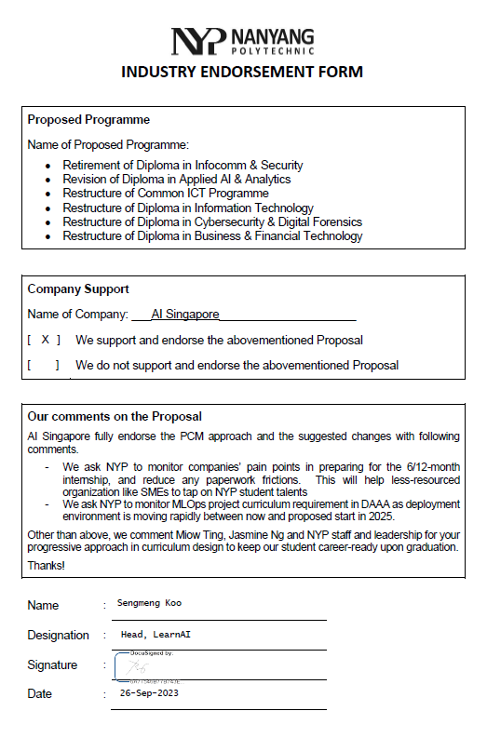

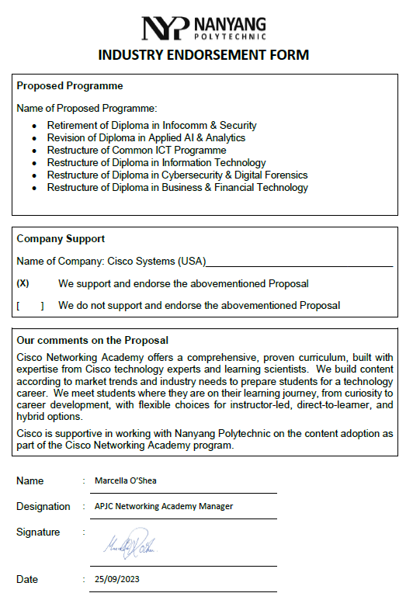

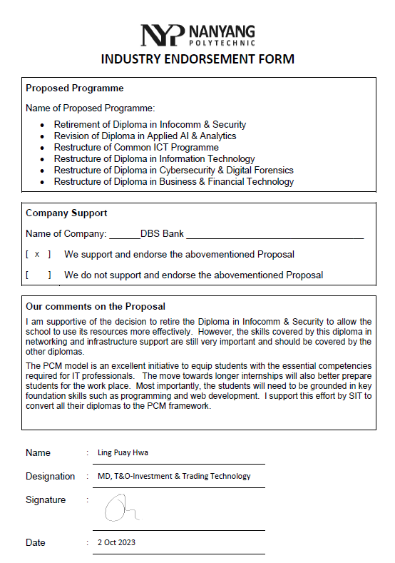

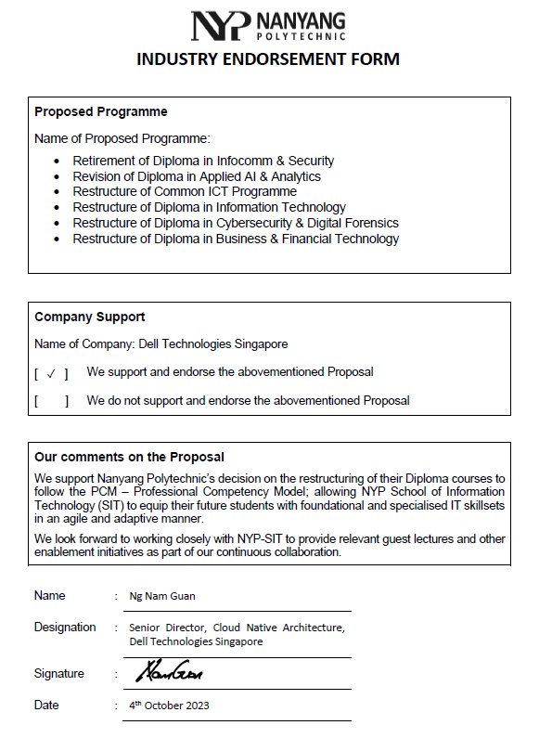

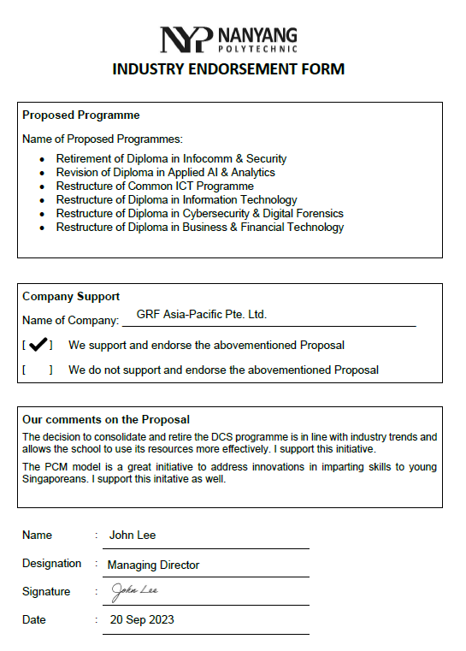

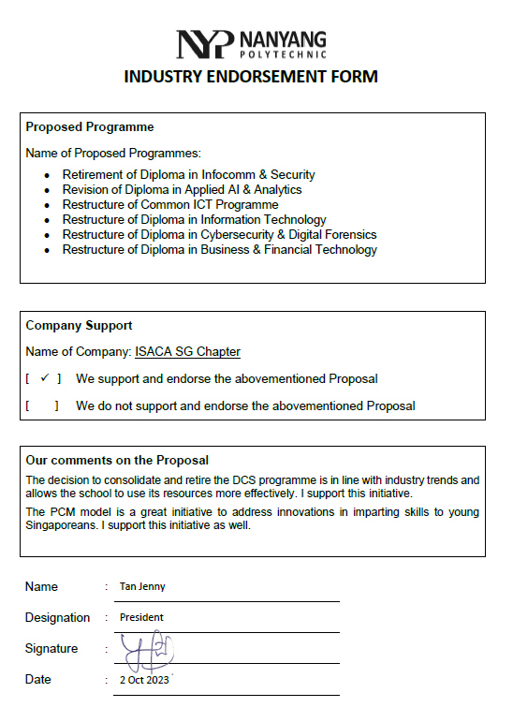

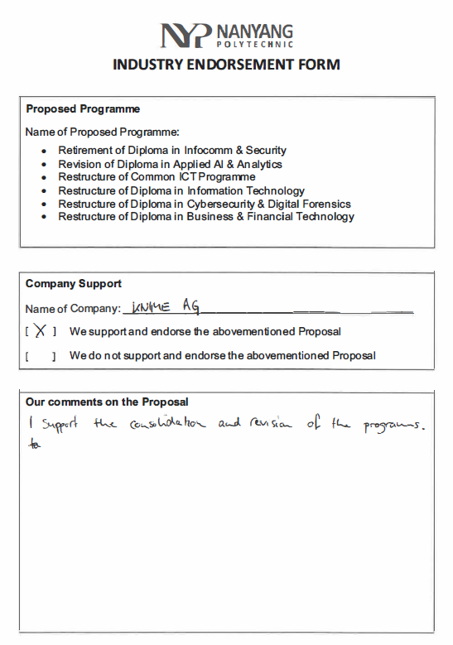

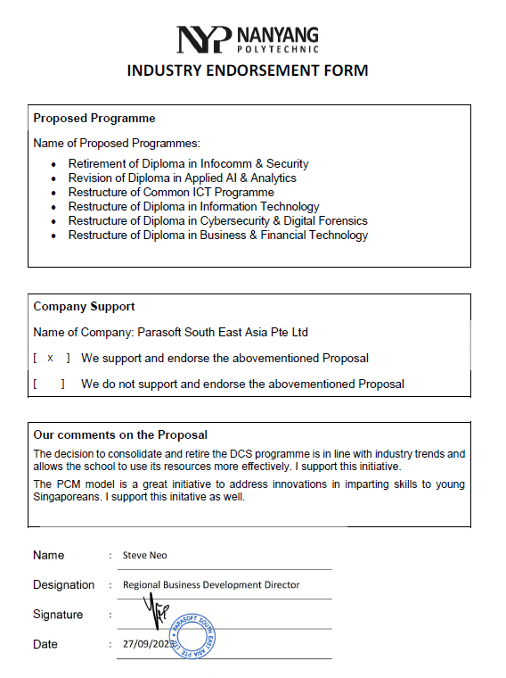

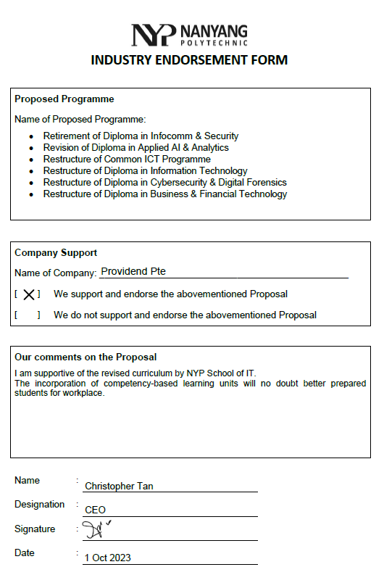

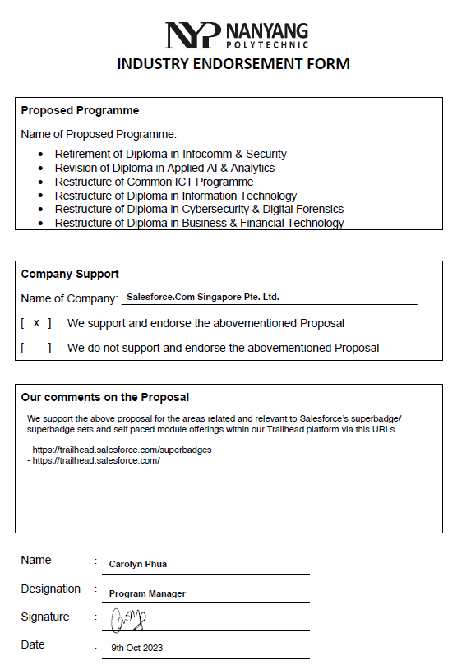

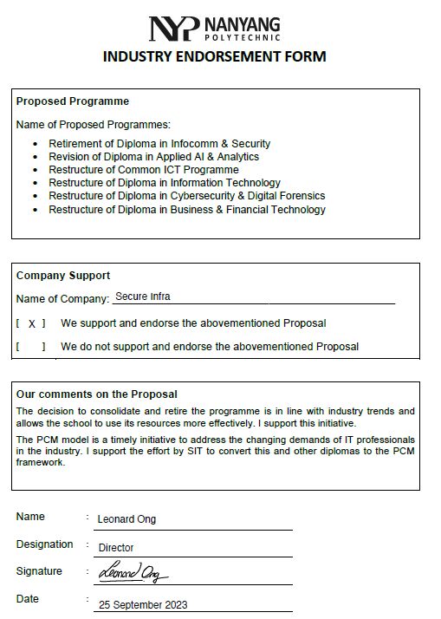

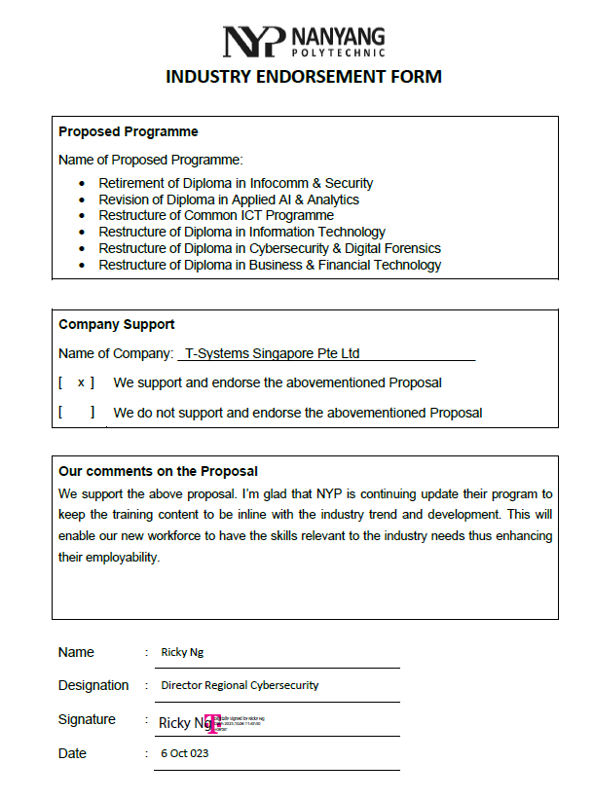

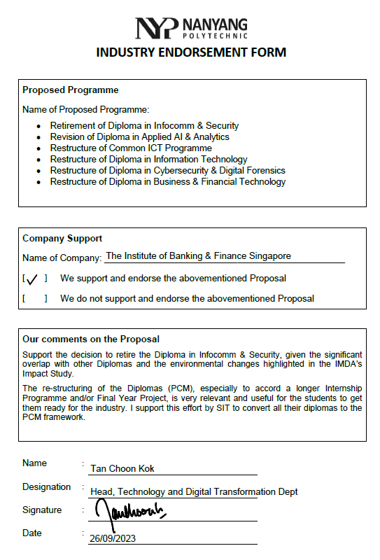

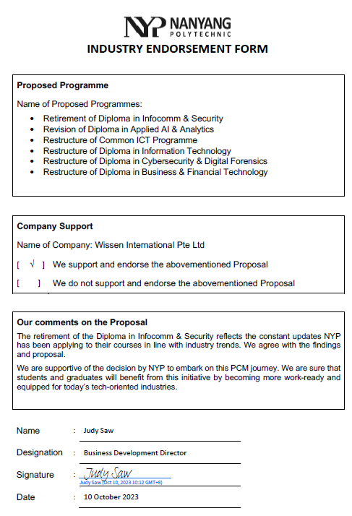

1. Skills Demand for the Future Economy (SDFE) Report 2022, Skills Demand for the Future Economy Report 2022 | Education, Career and Personal Development (myskillsfuture.gov.sg)
2. Forrester, 2021 [johnsoncontrols.com/forresterstudy](https://www.johnsoncontrols.com/forresterstudy)