##### BATTERY STATUS MONITORING SYSTEM

**Maulana Abul Kalam Azad University of Technology, West Bengal**

**(MAKAUT, WB)**



**Submitted by**

##### BANANI MANNA

ARCHISMAN MANGAL

ARITRA DALUI

SWAPNODEEP BANERJEE

MEGHA BOSE

SUSHANTO DEY

SAYAN BHUL



**DEPARTMENT OF ELECTRICAL ENGINEERING**

**MCKV Institute of Engineering**

**243, G.T. Road (North), LILUAH, HOWRAH**

DECEMBER,2023

ACKNOWLEDGEMENT

We would like to express my special thanks of gratitude to our mentor Asst. Prof. Mr. SUDEEP SAMANTA as well as our H.O.D Prof. (Dr.) TAMAL ROY who gave us the golden opportunity to do this wonderful project on the topic of "BATTERY STATUS MONITORING SYSTEM, which also helped us in doing a lot of Research and We came to know about so many new things and make something useful out of it. We are really thankful to them. Secondly, We would also like to thank our friends who helped us a lot in finalizing this project within the limited time frame.

--------------------------------------------

*Signature of HOD*

ABSTRACT

The rapid proliferation of battery-powered devices across various industries has highlighted the critical importance of effective battery management. This project focuses on the design, development, and implementation of a Battery Status Monitoring System (BSMS) aimed at enhancing the performance and reliability of battery-powered applications. The system employs advanced sensor technologies and microcontroller units to provide real-time monitoring and analysis of battery health.

The primary objectives of the project include the creation of a robust hardware and software architecture capable of monitoring multiple battery parameters, such as voltage, current, temperature, and state of charge. Through a user-friendly interface, user can access comprehensive insights into the battery status, enabling timely maintenance and optimization strategies. The system's adaptability allows seamless integration into diverse applications, ranging from portable electronic devices to renewable energy storage systems.

The successful implementation of the Battery Status Monitoring System offers a proactive approach to battery management, promoting sustainability, cost-effectiveness, and enhanced reliability in a wide range of applications. This project contributes to the advancement of battery technology and supports the growing demand for efficient and intelligent battery monitoring solutions.

OBJECTIVE

1. Hardware Development:
   1. To develop a compact and efficient sensor array for measuring battery parameters.
   2. To create a hardware module suitable for various battery-powered applications.
2. Microcontroller Implementation:
   1. To program the microcontroller for accurate data acquisition and real-time analysis.
   2. To implement algorithms for fault detection, capacity estimation, and performance optimization.
3. Fault Detection and Notification:
   1. To develop algorithms for timely fault detection.
   2. To implement a notification system for quick user or maintenance alerts.
4. Energy Efficiency Optimization:
   1. To investigate and implement strategies for energy-efficient operation.
   2. To provide recommendations for users to enhance battery life.
5. Testing and Validation:
   1. To conduct rigorous testing in simulated and real-world conditions.
   2. To address identified issues through iterative testing and refinement.
6. Project Evaluation:
   1. To evaluate project success based on system performance and user satisfaction.
   2. To identify areas for improvement and potential enhancements.

TABLE OF CONTENT

CHAPTERS

**Introduction:**

The Battery Status Monitoring System (BSMS) is a critical component in the management of energy storage systems, with a primary focus on accurately monitoring State of Charge (SOC) and State of Health (SOH) of batteries. This project proposes the utilization of the Kalman filter method to enhance the precision and reliability of battery status estimation.

The Kalman filter, a recursive mathematical algorithm, is implemented to dynamically estimate SOC and SOH based on available measurements such as voltage, current, and temperature. This approach takes into account the inherent uncertainties and variations in battery behavior, providing a more accurate representation of the actual state of the battery.

The project integrates smart sensors to capture real-time data from the battery, which is then processed through the Kalman filter algorithm. The filtered results are used to continuously update and refine the estimates of SOC and SOH. Additionally, the system incorporates wireless communication technology for seamless data transmission, allowing remote monitoring and control.

**THEORITICAL ASPECTS:**

**What is BMS?**

Battery management system (BMS) is technology dedicated to the oversight of a battery pack, which is an assembly of battery cells, electrically organized in a row x column matrix configuration to enable delivery of targeted range of voltage and current for a duration of time against expected load scenarios.

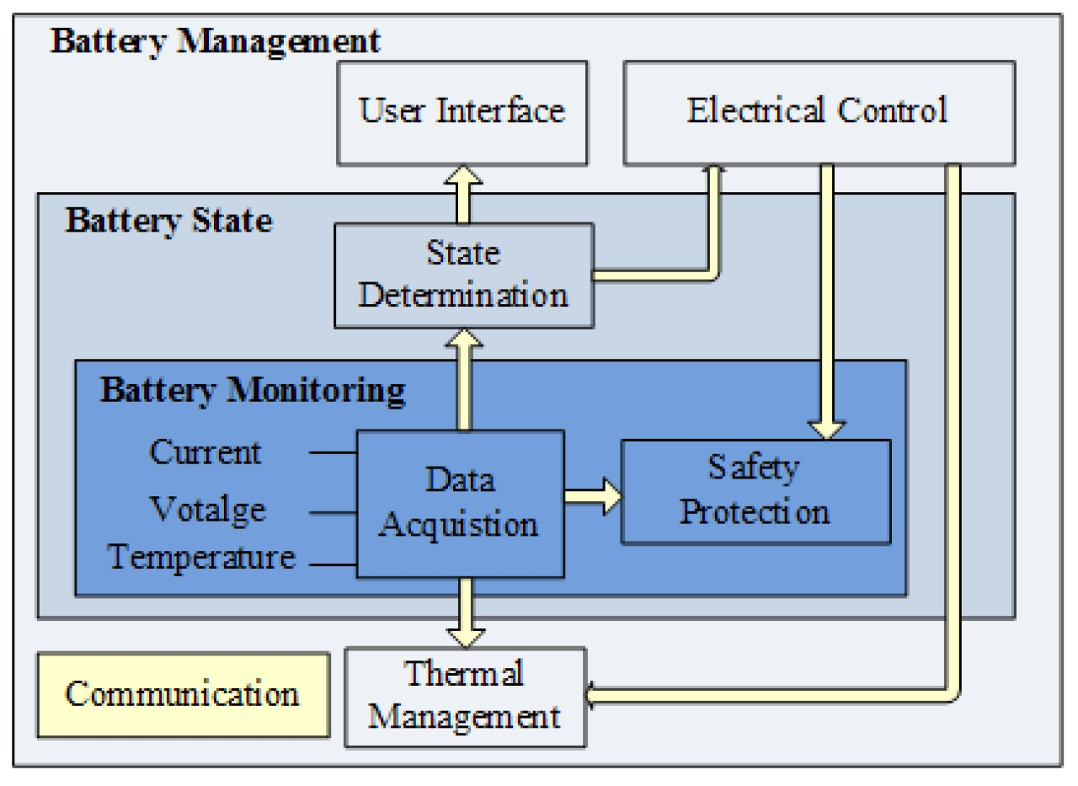

**The oversight that a BMS provides usually includes:**

* Monitoring the battery
* Providing battery protection
* Estimating the battery’s operational state
* Continually optimizing battery performance
* Reporting operational status to external devices

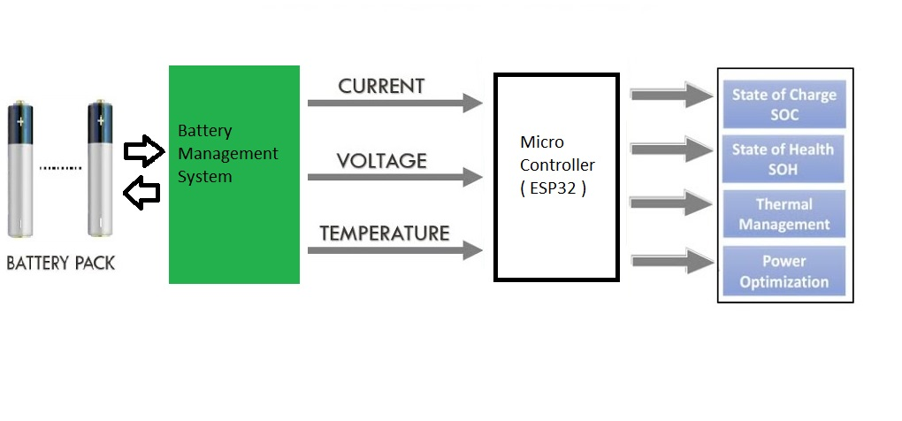

**Voltage Monitoring:**

Voltage is a key parameter indicating the electrical potential difference across the terminals of the battery.

Monitoring voltage helps determine the state of charge (SOC) and state of health (SOH) of the battery. Abnormal voltage levels can indicate issues such as overcharging, undercharging, or cell imbalance.

**Current Monitoring:**

Current monitoring involves measuring the flow of electric charge in and out of the battery.

Monitoring current is essential for assessing charging and discharging rates. Overcurrent conditions can lead to overheating and affect battery performance, while undercurrent may indicate a malfunction.

**Temperature Monitoring:**

Temperature sensors are used to measure the temperature of the battery cells or the overall battery system.

Temperature significantly affects battery performance and lifespan. High temperatures can accelerate degradation, and low temperatures can reduce efficiency. Monitoring temperature helps prevent overheating and ensures optimal operating conditions.

**What Is SOC Of Battery?**

The state of charge (SOC) of a battery is a measure of the amount of energy available in the battery at a specific point in time. The SOC is expressed as a percentage, with 100% representing a fully charged battery and 0% representing a completely discharged battery.

The SOC is an important parameter to consider when using or storing a battery, as it can affect the battery’s performance and lifespan. For example, a battery with a high SOC will be able to provide more power and will have a longer lifespan than a battery with a low SOC. Conversely, a battery with a low SOC will be less able to provide power and will have a shorter lifespan.

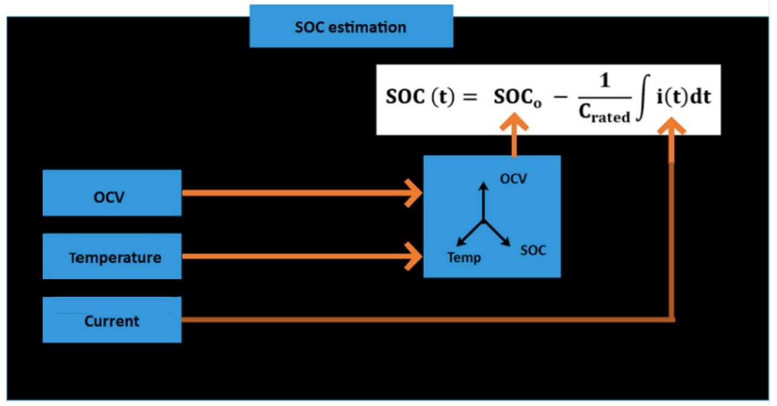

**What is SOH of Battery?**

State-of-Health:

The state-of-health (SOH of a battery describes the difference between a battery being studied and a fresh battery and considers cell aging.

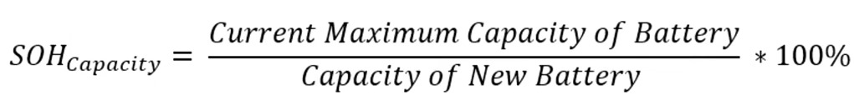

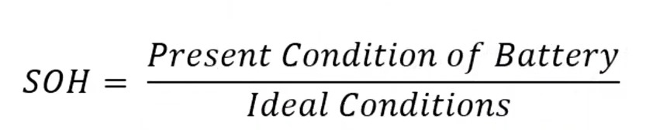

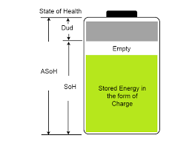

**Fault Detection and Diagnostics:**

Advanced monitoring systems include fault detection algorithms to identify issues such as overvoltage, overcurrent, overheating, and cell imbalances.

Early detection of faults allows for timely intervention, preventing potential damage to the battery and improving safety.

**Overvoltage and Undervoltage:**

Fault Detection: Monitoring voltage levels beyond acceptable thresholds.

Identifying the cause of overvoltage (e.g., overcharging) or undervoltage (e.g., excessive discharging).

**Overcurrent and Undercurrent:**

Detecting abnormal current levels during charging or discharging.

Diagnosis: Investigating the reasons for overcurrent (e.g., faulty charging equipment) or undercurrent (e.g., damaged cells).

**Overtemperature and Under temperature:**

Sensing temperatures outside the safe operating range.

Determining the cause of overheating (e.g., high charging rates) or under temperature (e.g., extreme environmental conditions).

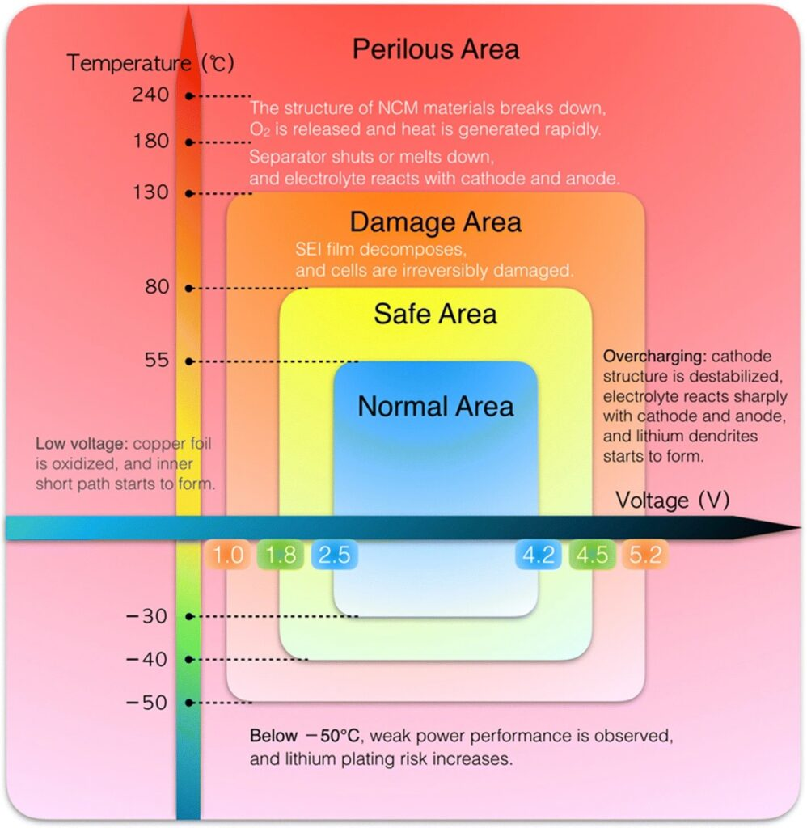

**Cell Imbalance:**

Identifying disparities in voltage or state of charge among individual cells in a battery pack.

Investigating the reasons for cell imbalances (e.g., aging cells, manufacturing variations).

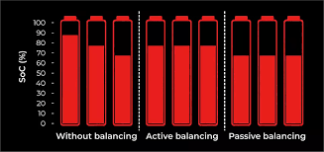

**WHAT IS KALMAN FILTER METHOD:**

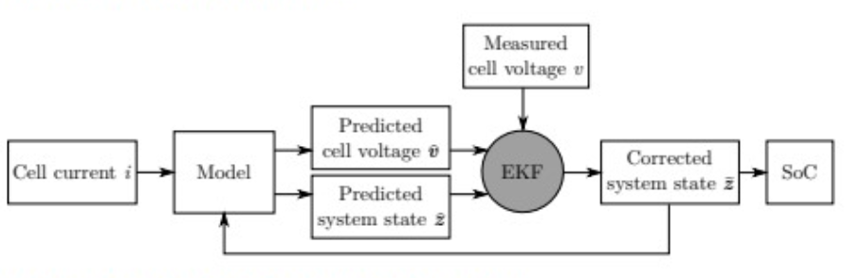

**COMPONENT USED**

1. Esp32 Microcontroller

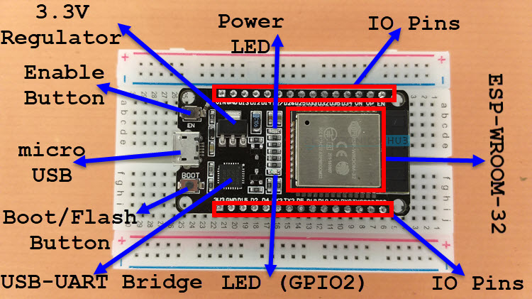

ESP32 is a low-cost System on Chip (SoC) Microcontroller from Espressif Systems, the developers of the famous ESP8266 SoC. It is a successor to ESP8266 SoC and comes in both single-core and dual-core variations of the Tensilica’s 32-bit Xtensa LX6 Microprocessor with integrated Wi-Fi and Bluetooth.

1. BMS Module:

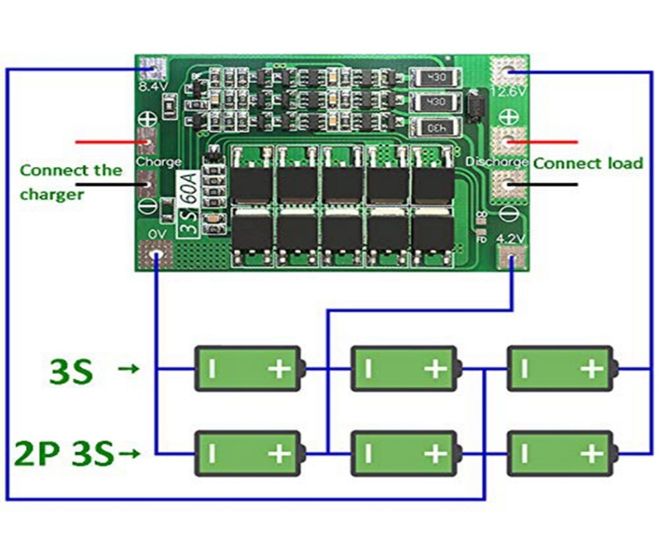

1. Acs712 Current sensor:

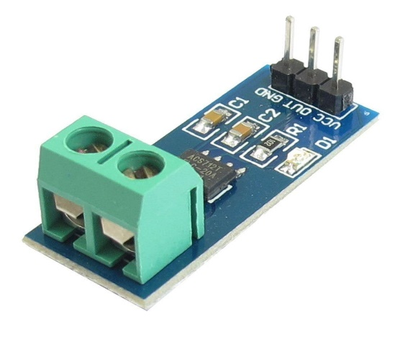

1. Voltage sensor:
2. Ds18B20 temperature sensor:

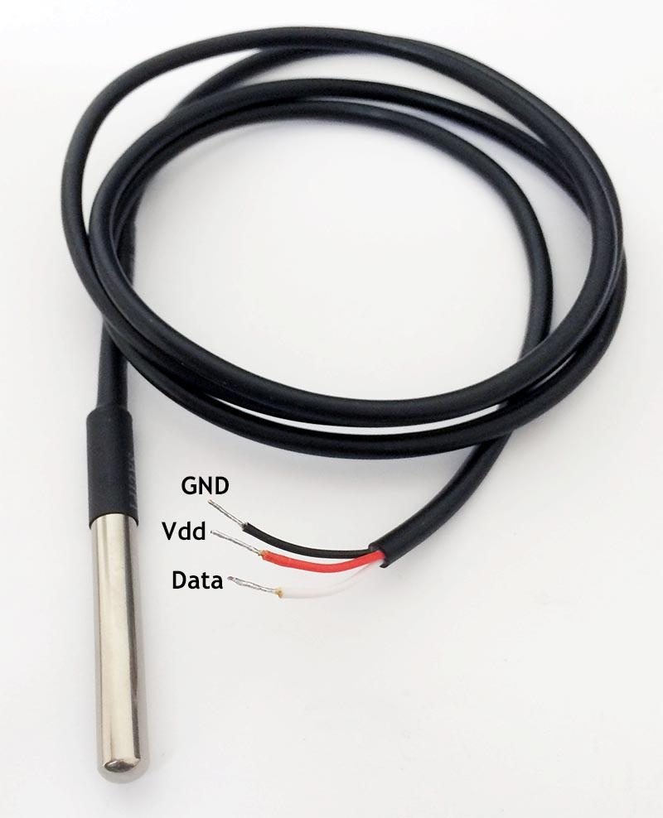

1. Resistor (voltage devider circuit):
2. Battery pack:

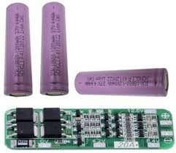

1. Adaptor:

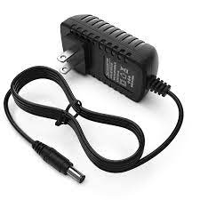

1. Light load (20 watt):



**BLOCK DIAGRAM:**

**CIRCUIT DIAGRAM:**

**WORKING OF MODEL:**

**OBSERVATIONS:**

During Recharging time:

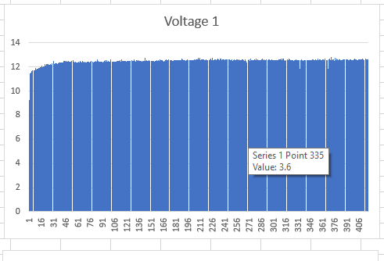

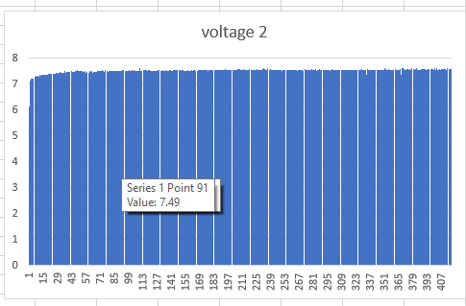

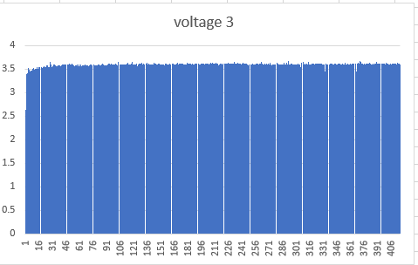

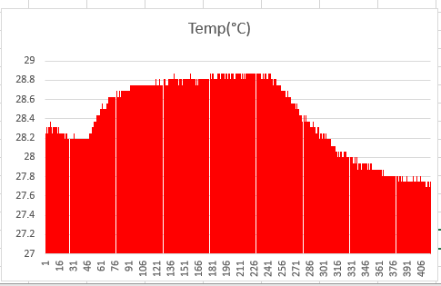

During Discharging time:

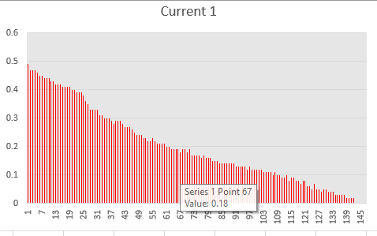

**BENEFITS:**

**CONCLUSION:**

The battery status monitoring system represents a crucial advancement in ensuring efficient and reliable power management. By continuously tracking and analyzing the health and performance of batteries, this system not only enhances the overall lifespan of the batteries but also prevents unexpected failures and disruptions in various applications, from portable electronic devices to electric vehicles and renewable energy systems. The real-time data provided by the monitoring system empowers users to make informed decisions, optimizing energy usage and contributing to a more sustainable and resilient energy infrastructure. As technology continues to evolve, the integration of such monitoring systems will play a pivotal role in addressing the growing demand for reliable and intelligent energy solutions.

**REFFERENCES:**