SOFTWARE REQUIREMENTS SPECIFICATION
University Room Booking System (URBS)

Project Title | University Room Booking System (URBS)
Project Code | FSE-URBS-2025
Supervisor | [Supervisor Name]
Co-Supervisor | Not Applicable
Team Member 1 | Abdullah Sonija — 24K-0013
Team Member 2 | Zahid Hussain — 24K-0015
Submission Date | May 2025
Version | v1.0

Version 1.0
Fundamentals of Software Engineering — Course Project
May 2025

Document History
The following table tracks all revisions made to this document.

Version | Name of Person | Date | Description of Change
v1.0 | Abdullah Sonija | May 2025 | Document Created — Initial SRS draft
v1.0 | Zahid Hussain | May 2025 | Added Use Cases and Functional Requirements
v1.0 | Abdullah Sonija | May 2025 | Added Non-Functional Requirements and DB schema
v1.0 | Abdullah Sonija | May 2025 | Backend development
v1.0 | Abdullah Sonija | May 2025 | Frontend development
v2.0 | Zahid Hussain | May 2025 | Frontend development
v1.0 | Zahid Hussain | May 2025 | Testing
v1.0 | Abdullah Sonija | May 2025 | Final review and formatting

Distribution List
The following individuals will receive this document after every sign-off:

Name | Role
[Supervisor Name] | Supervisor
[Co-Supervisor Name] | Co-Supervisor — Not Applicable
Abdullah Sonija | Team Member / Development and Documentation
Zahid Hussain | Team Member / Testing and Designing

Document Sign-Off
Once the document is prepared and reviewed, it must be formally signed off. Any subsequent changes require a new sign-off.

Version | Sign-off Authority | Sign-off Date
v1.0 | Supervisor | _______________
v1.0 | Co-Supervisor — Not Applicable | _______________
v1.0 | Abdullah Sonija | May 2025
v1.0 | Zahid Hussain | May 2025

Table of Contents
Document History 1
Distribution List 1
Document Sign-Off 1
Table of Contents 1
1. Introduction 1
1.1 Purpose of Document 1
1.2 Intended Audience 1
1.3 Abbreviations 1
1.4 Document Convention 1
2. Overall System Description 1
2.1 Project Background 1
2.2 Project Scope 1
2.3 Not In Scope 1
2.4 Project Objectives 1
2.5 Stakeholders 1
2.6 Operating Environment 1
2.7 System Constraints 1
2.8 Assumptions & Dependencies 1
3. External Interface Requirements 1
3.1 Hardware Interfaces 1
3.2 Software Interfaces 1
3.3 Communications Interfaces 1
4. Functional Requirements 1
4.1 Functional Hierarchy 1
4.2 Use Cases 1
UC-01 Register and Login 1
UC-02 Search Room Availability 1
UC-03 Submit Booking Request 1
UC-04 View Booking History 1
UC-05 Cancel Booking 1
UC-06 Manage Room Inventory 1
UC-07 Approve / Reject Booking Requests 1
UC-08 Monitor Room Utilization 1
4.3 Complete Functional Requirements 1
4.4 Input Validation Requirements 1
5. Non-Functional Requirements 1
5.1 Performance Requirements 1
5.2 Safety Requirements 1
5.3 Security Requirements 1
5.4 User Documentation 1
5.5 Additional Non-Functional Requirements 1
6. References 1
7. Appendices 1
Appendix A — Use Case Diagram 1
Appendix B — Activity Diagram 1
Appendix C — Class Diagram 1
Appendix D — Database Schema 1
Appendix E — REST API Endpoint Summary 1

1. Introduction

1.1 Purpose of Document
This Software Requirements Specification (SRS) document defines the complete functional and non-functional requirements for the University Room Booking System (URBS). The purpose of this document is to provide a clear, unambiguous, and comprehensive description of the system to be developed, serving as the formal agreement between stakeholders and the development team.
The document follows the IEEE 830 standard for SRS documents and covers all system behaviors, constraints, interfaces, and quality attributes required for successful implementation, verification, and validation of the URBS application.

1.2 Intended Audience
This document is intended for the following audiences:
- Development Team (Abdullah Sonija, Zahid Hussain) — primary reference for implementation decisions
- Course Supervisor — formal evaluation of requirements engineering quality
- University Administration — prospective stakeholders who may adopt the system
- QA/Testers — basis for test case generation and acceptance criteria
- Future Maintainers — reference for understanding system behavior and constraints

1.3 Abbreviations

Abbreviation | Full Form
URBS | University Room Booking System
SRS | Software Requirements Specification
FR | Functional Requirement
NFR | Non-Functional Requirement
JWT | JSON Web Token
RBAC | Role-Based Access Control
API | Application Programming Interface
REST | Representational State Transfer
CRUD | Create, Read, Update, Delete
UI | User Interface
DB | Database
MVP | Minimum Viable Product
SDLC | Software Development Life Cycle
IEEE | Institute of Electrical and Electronics Engineers
HTTP | HyperText Transfer Protocol
JSON | JavaScript Object Notation
ORM | Object-Relational Mapping
DXA | Device-independent Pixel (Word unit)

1.4 Document Convention
This document uses the following formatting conventions:
- Font: Arial, 12pt for body text
- Headings: Arial Bold — Section headings are numbered (1.1, 1.2, etc.)
- Requirement IDs: Functional requirements are prefixed FR-XX; Non-functional requirements are prefixed NFR-XX
- Use Case IDs: Use cases are prefixed UC-XX
- Priority levels: MUST (mandatory), SHOULD (high priority), COULD (optional)
- Tables: Used for structured data — all requirements, use cases, and actors are presented in tables
- Blue shaded rows: Column headers in all tables
- Bold text: Emphasis on key terms, IDs, and section references

2. Overall System Description

2.1 Project Background
Universities routinely face significant administrative challenges in managing shared physical resources such as lecture halls, laboratories, seminar rooms, and conference rooms. At present, room reservation processes at many institutions rely on informal methods including email chains, phone calls, and manual sign-up sheets maintained by departmental administrators.
These manual processes result in four recurring operational problems: (1) double booking — multiple parties reserving the same room for overlapping time slots; (2) lack of transparency — students and faculty have no real-time visibility into room availability; (3) manual approval bottlenecks — administrators must individually process each request without a centralized queue; and (4) poor record keeping — historical booking data is scattered across email inboxes, making utilization analysis impossible.
The University Room Booking System (URBS) is proposed to replace this manual workflow with a centralized, web-based platform that automates the reservation lifecycle from submission through approval and notification.

2.2 Project Scope
URBS is a web-based room reservation platform targeting three user roles within a university: Students, Faculty, and Administrators. The system enables users to search for available rooms, submit booking requests, and track their reservation status through a web interface. Administrators manage the room inventory and process booking approvals through a dedicated dashboard.
The core scope encompasses the following functional domains:
- User authentication and role-based access control (Student, Faculty, Admin)
- Room inventory management (Admin CRUD operations)
- Room availability search with multi-parameter filtering
- Booking request submission with automated conflict detection
- Admin approval workflow (approve / reject with remarks)
- Booking history and cancellation for end users
- In-application status notifications to users upon admin decisions

2.3 Not In Scope
The following functionalities are explicitly excluded from the current version of URBS:
- External email or SMS notification services (in-app notifications only)
- Payment processing or fee collection for room bookings
- Calendar integration with external services (Google Calendar, Outlook)
- Mobile native applications (iOS / Android) — web-only responsive UI
- Real-time occupancy sensor integration or IoT connectivity
- Public-facing booking for non-university individuals
- Video conferencing or room equipment management
- Production cloud deployment — system is demonstrated via local server

2.4 Project Objectives
The primary objectives of URBS are:
- OBJ-01: Develop a working web application with authenticated role-based access for three user types (Student, Faculty, Admin)
- OBJ-02: Implement an automated conflict detection mechanism that prevents double-booking at both the application and database layers
- OBJ-03: Deliver a complete booking lifecycle — from room search through submission, admin review, approval/rejection, and user notification
- OBJ-04: Provide an admin dashboard for room inventory management and booking approval processing
- OBJ-05: Enforce comprehensive input validation on all forms at both frontend and backend layers
- OBJ-06: Maintain a full audit trail of all booking state transitions with timestamps
- OBJ-07: Follow Agile/Scrum methodology with documented sprint artifacts and project management evidence

2.5 Stakeholders

Stakeholder | Role | Interest in System
Students | Primary End User | Book rooms for study groups and academic sessions
Faculty Members | Primary End User | Reserve rooms for lectures, meetings, and office hours
University Admin Staff | System Manager | Manage room inventory, process and approve booking requests
Course Supervisor | Evaluator | Assess requirements quality, design, and working prototype
IT Department | Indirect Stakeholder | Responsible for server infrastructure and deployment environment
University Management | Indirect Stakeholder | Benefits from operational efficiency and utilization insights

2.6 Operating Environment
URBS operates as a client-server web application in the following environment:
- Client Environment: Any modern web browser (Google Chrome 90+, Mozilla Firefox 88+, Microsoft Edge 90+, Safari 14+) on desktop or mobile devices with screen width >= 375px
- Server Environment: Local machine running Python 3.9+ with Flask framework; SQLite database for development; MySQL for production demonstration
- Network: Local area network (LAN) or localhost during demonstration; standard HTTP/HTTPS protocols
- Operating Systems: Cross-platform — Windows 10+, macOS 11+, Ubuntu 20.04+ (server-side)
- Runtime Dependencies: Node.js 18+ (frontend build), Python 3.9+ (backend), npm 8+ (package management)

2.7 System Constraints
The following constraints govern the design and implementation of URBS:
- Software Constraint: Backend must use Python Flask; Frontend must use React.js with Tailwind CSS — no alternative frameworks permitted
- Database Constraint: SQLite for development environment; schema must be compatible with MySQL for production
- Authentication Constraint: JWT-based stateless authentication must be used; no server-side session storage
- Scope Constraint: System must be demonstrable within a 2-person team over a 10-week active development window
- Hardware Constraint: No dedicated server hardware — demonstration on standard university laptop hardware
- Academic Constraint: All SDLC stages must be documented as artifacts per course milestone requirements
- User Constraint: System assumes users have basic web browser proficiency; no specialized software required on the client side
- Data Constraint: No real student or faculty personal data may be used; all demonstration data must be synthetic

2.8 Assumptions & Dependencies
The following assumptions have been made in the development of this specification:
- All users (Students, Faculty, Admin) possess a university-issued email address used as their unique login identifier
- Room data (room numbers, capacities, types) will be pre-populated by the administrator before end users access the system
- A single administrator account exists per deployment; multi-admin support is out of scope for this version
- All system time references use the server's local timezone; no multi-timezone support is required
- The system will be accessed over a trusted university network; enterprise-grade DDoS protection is out of scope
- Dependencies: React.js 18+, Tailwind CSS 3+, Flask 2.3+, Flask-JWT-Extended 4+, SQLAlchemy 2+, Flask-RESTful 0.3+

3. External Interface Requirements
This section specifies all interfaces between URBS and external hardware, software, and communication systems. A high-level context diagram is described below: the React frontend communicates with the Flask backend exclusively via RESTful HTTP/JSON API calls; the Flask backend communicates with the SQLite/MySQL database via SQLAlchemy ORM; all three tiers operate within a single deployment environment.

3.1 Hardware Interfaces
URBS is a software-only web application. It does not interface directly with any hardware peripherals, IoT sensors, biometric devices, or external hardware components. The system relies entirely on standard computing hardware provided by the end user (laptop/desktop/mobile) and the host server machine.
Minimum client hardware: any device capable of running a modern web browser with 1GB RAM and a display of 375px or wider. Minimum server hardware: a machine with 2GB RAM, 1GHz CPU, and 500MB free disk space.

3.2 Software Interfaces

Component | Interface Type | Version | Purpose
React.js | Frontend Framework | 18+ | SPA component rendering and state management
Tailwind CSS | CSS Utility Library | 3+ | Responsive UI styling without custom CSS
Axios | HTTP Client Library | 1+ | Frontend-to-backend REST API communication
React Router | Client-side Router | 6+ | URL-based navigation between application screens
Python Flask | Backend Framework | 2.3+ | REST API request handling and business logic
Flask-JWT-Extended | Auth Middleware | 4+ | JWT token issuance, validation, and RBAC enforcement
Flask-RESTful | REST Extension | 0.3+ | Structured resource-based endpoint definition
SQLAlchemy | ORM | 2+ | Database model definition and query abstraction
SQLite | Database (Dev) | 3+ | Zero-configuration local development database
MySQL | Database (Prod) | 8+ | Production-grade concurrent database
Flask-CORS | CORS Middleware | 4+ | Cross-origin request handling between React and Flask

3.3 Communications Interfaces
URBS uses the following communication protocols and standards:
- Protocol: HTTP/1.1 for local development; HTTPS (TLS 1.2+) recommended for any network deployment
- Data Format: All API requests and responses use JSON (application/json) with UTF-8 encoding
- Authentication: JWT Bearer Token transmitted in the HTTP Authorization header for all protected endpoints
- API Style: RESTful — resources are nouns, HTTP verbs (GET, POST, PUT, DELETE) define operations
- Port Configuration: Flask backend runs on port 5000; React development server runs on port 3000; CORS is configured to permit cross-origin requests between these ports
- Error Communication: All API errors return standard HTTP status codes (400 Bad Request, 401 Unauthorized, 403 Forbidden, 404 Not Found, 409 Conflict, 500 Internal Server Error) with a JSON error message body
- No external network services (SMTP email, SMS gateways, third-party APIs) are used in this version

4. Functional Requirements

4.1 Functional Hierarchy
The system is organized into six functional modules. Each module groups related capabilities and maps directly to a set of use cases and UI screens.

Module | Description | Related FRs
M1 — User Authentication & Access Control | Registration, login, JWT issuance, logout, RBAC enforcement | FR-01 to FR-04
M2 — Room Search & Availability | Room filtering by date/time/type/capacity, availability display | FR-05 to FR-07
M3 — Booking Request Workflow | Request submission, conflict detection, slot locking, Faculty priority | FR-08 to FR-11
M4 — Admin Approval Workflow | Pending queue, approve/reject with remarks, status notifications | FR-12 to FR-15
M5 — Booking History & Cancellation | Chronological history, cancellation with slot release | FR-16 to FR-18
M6 — Room Inventory Management | Admin room CRUD, soft delete, utilization dashboard | FR-19 to FR-22

4.2 Use Cases
The following use case diagram summarizes all actors and their interactions with the system. Twelve use cases are identified across four actors (Student, Faculty, Admin, System).

Use Case ID | Title | Primary Actor(s) | Type
UC-01 | Register and Login | Student, Faculty, Admin | Primary
UC-02 | Search Room Availability | Student, Faculty | Primary
UC-03 | Submit Booking Request | Student, Faculty | Primary
UC-04 | View Booking History | Student, Faculty, Admin | Primary
UC-05 | Cancel Booking | Student, Faculty | Primary
UC-06 | Manage Room Inventory | Admin | Primary
UC-07 | Approve / Reject Requests | Admin | Primary
UC-08 | Monitor Room Utilization | Admin | Primary
UC-09 | Enforce Conflict Check | System | Include
UC-10 | Notify User of Status | System | Include
UC-11 | Priority Room Access | Faculty | Extend
UC-12 | Store Reservation Record | System | Include

UC-01 Register and Login

Use Case ID | UC-01
Title | Register and Login
Actors | Student, Faculty, Admin
Feature | M1 — User Authentication & Access Control
Pre-conditions | User has a valid university email address and access to a web browser.

Step # | Actor Action | System Reaction
1 | User navigates to the URBS login page | System displays the login form with email, password fields and a Register link
2 | New user clicks Register | System displays the registration form with full name, email, password, confirm password, and role selector fields
3 | User fills in all fields and submits | System validates all inputs (non-empty, valid email format, password >= 8 characters, passwords match, role selected)
4 | Validation passes | System hashes the password with bcrypt, stores the new user record in the database, and returns a success message
5 | User enters email and password on login form and submits | System authenticates credentials against the database
6 | Authentication succeeds | System issues a signed JWT token containing user_id, role, and expiry; redirects user to their role-specific dashboard

Alternate Scenarios:
2a: Validation fails at Step 3 — System highlights the invalid field(s) with descriptive error messages; user corrects and resubmits.
5a: Authentication fails at Step 5 — System displays 'Invalid email or password'; user retries.
5b: Three consecutive failed login attempts — System displays a general error; no account lockout in MVP.

Step # | Post-Condition
1 | User is authenticated and JWT token is stored in the browser (localStorage)
2 | User is redirected to the correct role-specific dashboard (Student Dashboard / Admin Panel)

Cross-referenced Use Cases | UC-02, UC-03, UC-04, UC-05, UC-06, UC-07

UC-02 Search Room Availability

Use Case ID | UC-02
Title | Search Room Availability
Actors | Student, Faculty
Feature | M2 — Room Search & Availability
Pre-conditions | User is authenticated and has a valid JWT token. At least one room exists in the system.

Step # | Actor Action | System Reaction
1 | User navigates to the Room Search screen | System displays filter controls: date picker, start time, end time, room type dropdown, minimum capacity input
2 | User sets desired filters and clicks Search | System sends a request to GET /api/rooms/available with the filter parameters
3 | System queries the database | System returns all rooms that are not booked for the specified time window and match the type/capacity filters
4 | Results are returned | System displays room cards showing: room number, type, capacity, location, and an availability badge (Available / Booked)
5 | User reviews results | User selects a room and clicks Book Now to proceed to the Booking Form (UC-03)

Alternate Scenarios:
3a: No rooms match the filter criteria — System displays 'No rooms available for the selected criteria'; user adjusts filters.
2a: User submits search without required fields (date or time) — System displays a validation error; search is not executed.

Step # | Post-Condition
1 | A list of available rooms matching the user's filter criteria is displayed
2 | User is able to proceed to UC-03 (Submit Booking Request) with a pre-selected room

Cross-referenced Use Cases | UC-01, UC-03, UC-09

UC-03 Submit Booking Request

Use Case ID | UC-03
Title | Submit Booking Request
Actors | Student, Faculty
Feature | M3 — Booking Request Workflow
Pre-conditions | User is authenticated. User has selected a room from the Room Search screen (UC-02). Selected time slot appears available.

Step # | Actor Action | System Reaction
1 | User arrives at the Booking Form with room pre-filled | System displays the booking form: room info (read-only), date, start time, end time, and purpose textarea
2 | User fills in the purpose and confirms the time slot, then clicks Submit | System validates all fields: date is not in the past, end time is after start time, purpose is not empty (max 500 chars)
3 | Validation passes; system invokes UC-09 (Conflict Check) | System queries the database for any Approved booking for the same room and overlapping time slot
4 | No conflict detected | System creates a new Booking record with status = PENDING, locks the time slot, and saves to the database
5 | Booking record created | System displays a success message; booking status shows as Pending in the user's Booking History
6 | System triggers admin notification | Admin sees the new request appear in the Approval Queue dashboard

Alternate Scenarios:
3a: Conflict detected at Step 3 — System returns a conflict error message; the booking is not saved; user is prompted to select a different time slot.
2a: Validation fails at Step 2 — System highlights the invalid field(s) with descriptive messages; user corrects and resubmits.
UC-11 Extension (Faculty only): If the user's role is Faculty, the booking request is flagged with a priority_access = true attribute, which is surfaced to the admin in the approval queue.

Step # | Post-Condition
1 | A new Booking record exists in the database with status = PENDING
2 | The time slot is locked (prevented from being double-booked by another user)
3 | The booking appears in the user's Booking History with status Pending
4 | The admin's approval queue now includes this booking request

Cross-referenced Use Cases | UC-01, UC-02, UC-07, UC-09, UC-12

UC-04 View Booking History

Use Case ID | UC-04
Title | View Booking History
Actors | Student, Faculty, Admin
Feature | M5 — Booking History & Cancellation
Pre-conditions | User is authenticated. At least one booking has been submitted by the user.

Step # | Actor Action | System Reaction
1 | User navigates to the Booking History screen | System sends GET /api/bookings/mine (Student/Faculty) or GET /api/admin/bookings/all (Admin)
2 | Database returns booking records | System displays a sortable table with columns: Booking ID, Room, Date, Time, Purpose, Status (badge), Created At, Actions
3 | User reviews their bookings | System displays status badges: Pending (yellow), Approved (green), Rejected (red), Cancelled (grey)
4 | Admin views all users' bookings | System includes an additional Requester column showing the user name and role

Alternate Scenarios:
1a: No bookings exist — System displays 'No booking history found.' with a prompt to search for rooms.
UC-07 Extension: Admin can initiate approve/reject directly from the history view if the booking status is Pending.

Step # | Post-Condition
1 | User sees a complete chronological list of all their bookings with current statuses
2 | Cancel button is visible for bookings with status Pending or Approved

Cross-referenced Use Cases | UC-01, UC-05, UC-07

UC-05 Cancel Booking

Use Case ID | UC-05
Title | Cancel Booking
Actors | Student, Faculty
Feature | M5 — Booking History & Cancellation
Pre-conditions | User is authenticated. User has at least one booking with status Pending or Approved.

Step # | Actor Action | System Reaction
1 | User clicks the Cancel button on a booking in their Booking History | System displays a confirmation modal: 'Are you sure you want to cancel this booking?'
2 | User confirms cancellation | System sends DELETE /api/bookings/:id with the user's JWT token
3 | System invokes UC-09 (Conflict Check release) | System updates the booking status to CANCELLED, releases the locked time slot
4 | Cancellation is persisted | System displays 'Booking cancelled successfully'; the booking history updates to show Cancelled status

Alternate Scenarios:
2a: User cancels the confirmation modal — No action is taken; booking remains unchanged.
3a: Booking is already Rejected or Cancelled — Cancel button is not displayed; this scenario cannot occur.

Step # | Post-Condition
1 | Booking status is updated to CANCELLED in the database
2 | The previously locked time slot is released and can be booked by another user

Cross-referenced Use Cases | UC-01, UC-04, UC-09

UC-06 Manage Room Inventory

Use Case ID | UC-06
Title | Manage Room Inventory
Actors | Admin
Feature | M6 — Room Inventory Management
Pre-conditions | Admin is authenticated with role = ADMIN.

Step # | Actor Action | System Reaction
1 | Admin navigates to the Room Management screen | System displays the room inventory table with columns: Room Number, Type, Capacity, Status (Active/Inactive), Actions
2 | Admin clicks Add New Room | System displays the room creation form: room number, room type (dropdown), capacity (numeric), active status (toggle)
3 | Admin fills in details and clicks Save | System validates all fields: room number non-empty and unique, capacity is a positive integer, type is a valid enum value
4 | Validation passes | System creates a new Room record in the database; the inventory table refreshes to include the new room
5 | Admin clicks Edit on an existing room | System pre-fills the edit form with the room's current attributes
6 | Admin modifies fields and saves | System validates and updates the Room record; the inventory table reflects changes immediately
7 | Admin clicks Deactivate on a room | System sets is_active = false (soft delete); the room no longer appears in user-facing availability searches but historical booking records are preserved

Alternate Scenarios:
3a: Room number already exists — System returns 'Room number must be unique'; form is not submitted.
7a: Admin attempts to deactivate a room with active Pending/Approved bookings — System warns: 'This room has active bookings. Deactivating will not affect existing bookings.' Admin can proceed.

Step # | Post-Condition
1 | New room record exists in the database and is visible in availability searches
2 | Edited room attributes are reflected in both the admin table and user-facing search results
3 | Deactivated room is hidden from new booking searches; historical data intact

Cross-referenced Use Cases | UC-01, UC-07, UC-08

UC-07 Approve / Reject Booking Requests

Use Case ID | UC-07
Title | Approve / Reject Booking Requests
Actors | Admin
Feature | M4 — Admin Approval Workflow
Pre-conditions | Admin is authenticated with role = ADMIN. At least one booking exists with status = PENDING.

Step # | Actor Action | System Reaction
1 | Admin navigates to the Approval Queue | System displays all PENDING booking requests with: Requester name and role, Room, Date, Time, Purpose, Priority flag (Faculty)
2 | Admin reviews a specific request | System highlights Faculty requests with a priority badge
3 | Admin clicks Approve | System invokes UC-12 (Store Reservation Record); updates booking status to APPROVED; finalizes the reservation record
4 | Approval is saved | System invokes UC-10 (Notify User); sends an in-app approval notification to the requesting user; the request is removed from the pending queue
5 | Admin clicks Reject on a different request | System opens the rejection remarks modal with a mandatory text field
6 | Admin enters rejection remarks and confirms | System updates booking status to REJECTED; releases the locked time slot; stores rejection remarks
7 | Rejection is saved | System invokes UC-10; sends a rejection notification with remarks to the requesting user

Alternate Scenarios:
6a: Admin clicks Reject without entering remarks — System displays 'Rejection remarks are required'; modal stays open.
3a: Admin attempts to approve a request where the time slot has been released (edge case) — System re-runs conflict check; if conflict now exists, returns an error.

Step # | Post-Condition
1 | Approved booking: status = APPROVED; reservation record finalized in DB; user notified
2 | Rejected booking: status = REJECTED; time slot released; rejection remarks stored; user notified

Cross-referenced Use Cases | UC-01, UC-04, UC-09, UC-10, UC-12

UC-08 Monitor Room Utilization

Use Case ID | UC-08
Title | Monitor Room Utilization
Actors | Admin
Feature | M6 — Room Inventory Management
Pre-conditions | Admin is authenticated. At least one approved or completed booking exists in the system.

Step # | Actor Action | System Reaction
1 | Admin navigates to the Admin Dashboard | System displays utilization KPI cards: Total Rooms, Total Bookings This Month, Pending Requests Count, Approved This Month
2 | Admin reviews KPI cards | System shows counts with trend indicators where applicable
3 | Admin reviews recent activity feed | System lists the 10 most recent booking actions (submission, approval, rejection, cancellation) with timestamps

Alternate Scenarios:
1a: No booking data exists — System displays zeros for all KPIs and 'No recent activity' for the feed.

Step # | Post-Condition
1 | Admin has a high-level view of current system utilization and pending workload

Cross-referenced Use Cases | UC-01, UC-06, UC-07

4.3 Complete Functional Requirements
The following table enumerates all 22 functional requirements derived from the use cases above.

FR ID | Requirement Statement | Actor(s) | Priority | Use Case
FR-01 | System shall allow users to register with full name, university email, password (min 8 chars), and role selection (Student/Faculty/Admin) | Student, Faculty, Admin | MUST | UC-01
FR-02 | System shall authenticate users via email and password, returning a signed JWT token on success | All Users | MUST | UC-01
FR-03 | System shall enforce role-based access control (RBAC), restricting each API endpoint to authorized roles only | System | MUST | UC-01
FR-04 | System shall invalidate sessions on logout by discarding the JWT token on the client side; token expiry must be enforced server-side | All Users | MUST | UC-01
FR-05 | System shall allow users to search rooms filtered by date, time slot, room type, and minimum capacity | Student, Faculty | MUST | UC-02
FR-06 | System shall display real-time availability status (Available / Booked) for each room in search results based on existing Approved bookings | Student, Faculty | MUST | UC-02
FR-07 | System shall present room details including room number, type, capacity, location, and active status in search results | Student, Faculty | MUST | UC-02
FR-08 | System shall allow eligible users to submit a booking request specifying room, date, start time, end time, and purpose | Student, Faculty | MUST | UC-03
FR-09 | System shall automatically detect and block conflicting reservations (same room, same date, overlapping time) at request submission time | System | MUST | UC-03, UC-09
FR-10 | Faculty role shall trigger a priority access flag on the booking request, surfaced to the admin in the approval queue | Faculty, System | SHOULD | UC-03, UC-11
FR-11 | System shall set initial booking status to PENDING and lock the time slot upon successful submission | System | MUST | UC-03
FR-12 | Admin shall view all pending booking requests in a dedicated approval queue dashboard | Admin | MUST | UC-07
FR-13 | Admin shall be able to approve a pending request, transitioning status to APPROVED and finalizing the reservation record | Admin, System | MUST | UC-07, UC-12
FR-14 | Admin shall be able to reject a pending request with mandatory rejection remarks; system shall release the locked time slot on rejection | Admin, System | MUST | UC-07
FR-15 | System shall dispatch an in-app status notification to the requesting user upon any admin approval or rejection decision | System | MUST | UC-07, UC-10
FR-16 | System shall provide users with a full chronological history of their submitted bookings and their current statuses | Student, Faculty | MUST | UC-04
FR-17 | Users shall be able to cancel a Pending or Approved booking; system shall release the time slot and update the booking status to CANCELLED | Student, Faculty, System | MUST | UC-05
FR-18 | Admin shall have read access to the booking history of all users | Admin | MUST | UC-04, UC-07
FR-19 | Admin shall be able to add new rooms with attributes: room number, type, capacity, and active status | Admin | MUST | UC-06
FR-20 | Admin shall be able to edit existing room attributes | Admin | MUST | UC-06
FR-21 | Admin shall be able to soft-delete (deactivate) rooms; deactivated rooms shall not appear in availability searches; historical booking records shall be preserved | Admin | MUST | UC-06
FR-22 | Admin shall access a utilization dashboard displaying total rooms, pending request count, and monthly booking counts | Admin | SHOULD | UC-08

4.4 Input Validation Requirements
All form inputs must be validated at both the React frontend layer and the Flask backend layer. The following validation rules apply:

Form Field | Validation Rule | Error Message
Full Name (Register) | Non-empty, 2–100 characters, letters and spaces only | Full name is required (2-100 characters, letters only)
Email (Register/Login) | Non-empty, valid email format (@university.edu preferred) | Please enter a valid university email address
Password (Register) | Non-empty, minimum 8 characters, at least one letter and digit | Password must be at least 8 characters with a letter and digit
Confirm Password | Must exactly match the Password field | Passwords do not match
Role (Register) | Must be one of: Student, Faculty, Admin (dropdown selection) | Please select a valid role
Date (Booking) | Required; must not be in the past | Please select a valid future date
Start Time (Booking) | Required; must be a valid time format (HH:MM) | Please enter a valid start time
End Time (Booking) | Required; must be after Start Time by at least 30 minutes | End time must be at least 30 minutes after start time
Purpose (Booking) | Required; 10–500 characters | Purpose must be between 10 and 500 characters
Room Number (Admin) | Required; unique across all rooms; alphanumeric + dash/slash | Room number is required and must be unique
Capacity (Admin) | Required; positive integer; minimum 1, maximum 500 | Capacity must be a number between 1 and 500
Room Type (Admin) | Must be one of the valid enum values (dropdown) | Please select a valid room type
Rejection Remarks (Admin) | Required when rejecting; 10–500 characters | Rejection remarks are required (10-500 characters)

5. Non-Functional Requirements

5.1 Performance Requirements

NFR ID | Requirement | Acceptance Criterion
NFR-01 | Room availability search results must be returned within 2 seconds under normal load (up to 10 concurrent users) | Load test: 10 concurrent search requests complete in <= 2 seconds average
NFR-02 | The booking submission API endpoint must respond within 3 seconds including conflict check processing | Manual test: 10 consecutive bookings each complete in <= 3 seconds
NFR-03 | The admin approval queue must load and display up to 100 pending requests without pagination delay | Test with 100 seeded pending records: page loads in <= 3 seconds

5.2 Safety Requirements
URBS does not control physical infrastructure, medical equipment, or safety-critical systems. No direct safety requirements apply in the traditional sense. However, the following data safety measures are required:
- All booking state transitions must be atomic — a booking must never be left in an intermediate or undefined state in the event of a server error
- Database transactions must be used for all multi-step operations (e.g., approve booking + finalize reservation + release slot) to ensure data consistency on failure
- The system must not expose internal error details (stack traces) to end users; generic error messages must be shown while details are logged server-side

5.3 Security Requirements

NFR ID | Requirement | Acceptance Criterion
NFR-04 | All passwords must be hashed using bcrypt before storage; plain-text passwords must never be stored or logged | Code review confirms no plain-text password storage; bcrypt hash visible in DB
NFR-05 | All protected API endpoints must validate the JWT token and the user's role before processing any request | Requests without token return HTTP 401; requests with wrong role return HTTP 403
NFR-06 | JWT tokens must expire after 24 hours; the system must reject expired tokens | Token with manipulated expiry is rejected; expired tokens return HTTP 401
NFR-07 | Database must enforce a UNIQUE constraint on (room_id, booking_date, start_time) to prevent race-condition double-bookings | Two simultaneous identical submissions: only one succeeds; DB constraint error on second
NFR-08 | All form inputs must be sanitized at the backend to prevent SQL injection; SQLAlchemy ORM parameterization must be used for all queries | Penetration test: injected SQL strings in form fields do not alter DB queries

5.4 User Documentation
The following documentation will be delivered as part of the final project submission:
- README.md — Installation and setup guide for running the URBS application locally (backend Flask setup, frontend React setup, database initialization, test credentials)
- API Reference — Tabular documentation of all REST API endpoints with method, URL, request payload, response format, and required authorization role
- User Guide — Brief screen-by-screen walkthrough for each user role (Student, Faculty, Admin) describing how to perform core tasks
- Final Project Report — Comprehensive document covering system overview, implementation highlights, testing results, and lessons learned (Milestone 5)

5.5 Additional Non-Functional Requirements

NFR ID | Category | Requirement | Acceptance Criterion
NFR-09 | Usability | UI must be fully responsive on screen widths >= 375px (mobile) through 1920px (desktop) | Manual test on 375px, 768px, 1280px widths: all screens render correctly with no horizontal scroll
NFR-10 | Reliability | System must handle 10 concurrent booking submissions without data corruption or duplicate approved bookings | Stress test with 10 simultaneous POSTs to /bookings: no duplicate records created
NFR-11 | Maintainability | Codebase must follow a modular architecture with clear separation of frontend (React), backend (Flask), and database (SQLAlchemy) layers | New feature can be added to one layer without modifying the other layers
NFR-12 | Traceability | All booking status transitions must be persisted with timestamps for audit purposes | Booking history shows all statuses with creation and update timestamps
NFR-13 | Portability | The system must run on Windows 10+, macOS 11+, and Ubuntu 20.04+ with the documented setup procedure | Setup guide tested successfully on at least two different OS environments

6. References
# | Title / Source | Date / Version
1 | IEEE Std 830-1998 — IEEE Recommended Practice for Software Requirements Specifications, IEEE Computer Society | 1998
2 | React Documentation — React.dev — Official React.js Framework Documentation | 2024
3 | Flask Documentation — flask.palletsprojects.com — Pallets Projects, Flask Web Framework | 2024
4 | Flask-JWT-Extended Documentation — flask-jwt-extended.readthedocs.io | 2024
5 | SQLAlchemy Documentation — docs.sqlalchemy.org — ORM and Core documentation | 2024
6 | Tailwind CSS Documentation — tailwindcss.com/docs | 2024
7 | Project Guide: University Room Booking System — Course Project Guide Document, FSE Course | 2025
8 | Project Details Document: URBS Comprehensive Project Details — Abdullah Sonija, Zahid Hussain | 2025
9 | Sommerville, I. — Software Engineering, 10th Edition, Pearson Education | 2016
10 | Pressman, R. & Maxim, B. — Software Engineering: A Practitioner's Approach, 8th Edition, McGraw-Hill | 2015

7. Appendices

Appendix A — Use Case Diagram
The Use Case Diagram below illustrates the four system actors (Student, Faculty, Admin, System) and their 12 interactions with the University Room Booking System. Key relationships include:
- Include relationships: UC-03 (Submit Booking) includes UC-09 (Conflict Check); UC-07 (Approve/Reject) includes UC-10 (Notify User) and UC-12 (Store Record)
- Extend relationship: UC-11 (Priority Room Access) extends UC-03 (Submit Booking) — Faculty-only

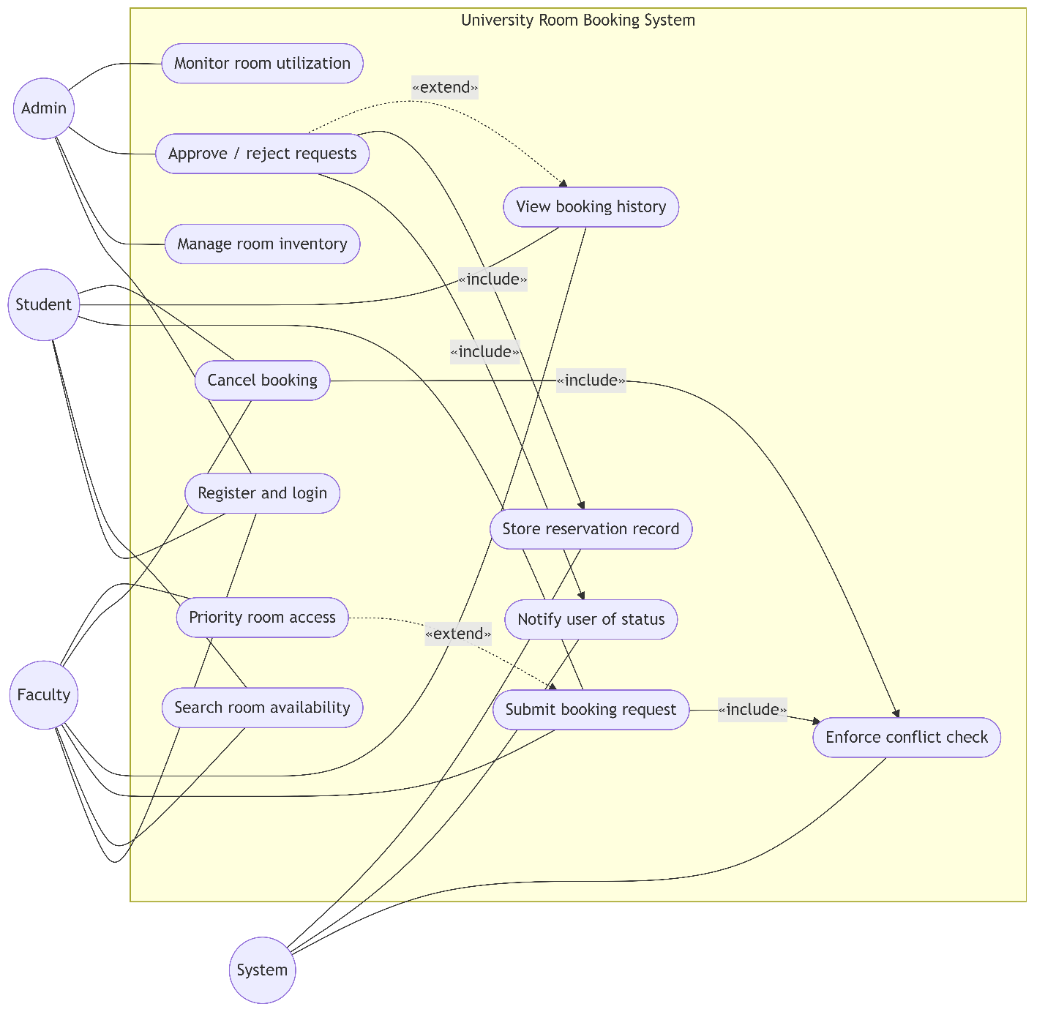

Appendix B — Activity Diagram
The Activity Diagram illustrates the complete reservation workflow across three swimlanes: Student/Faculty, System, and Admin. Key flows include:
- Happy path: Login > Browse Rooms > Submit Request > System locks slot and notifies Admin > Admin approves > System finalizes and notifies user > User views confirmed booking
- Rejection path: Admin rejects > System releases slot and sends rejection notification with remarks > User views rejected status
- Cancellation path: User cancels approved booking > System releases slot and notifies
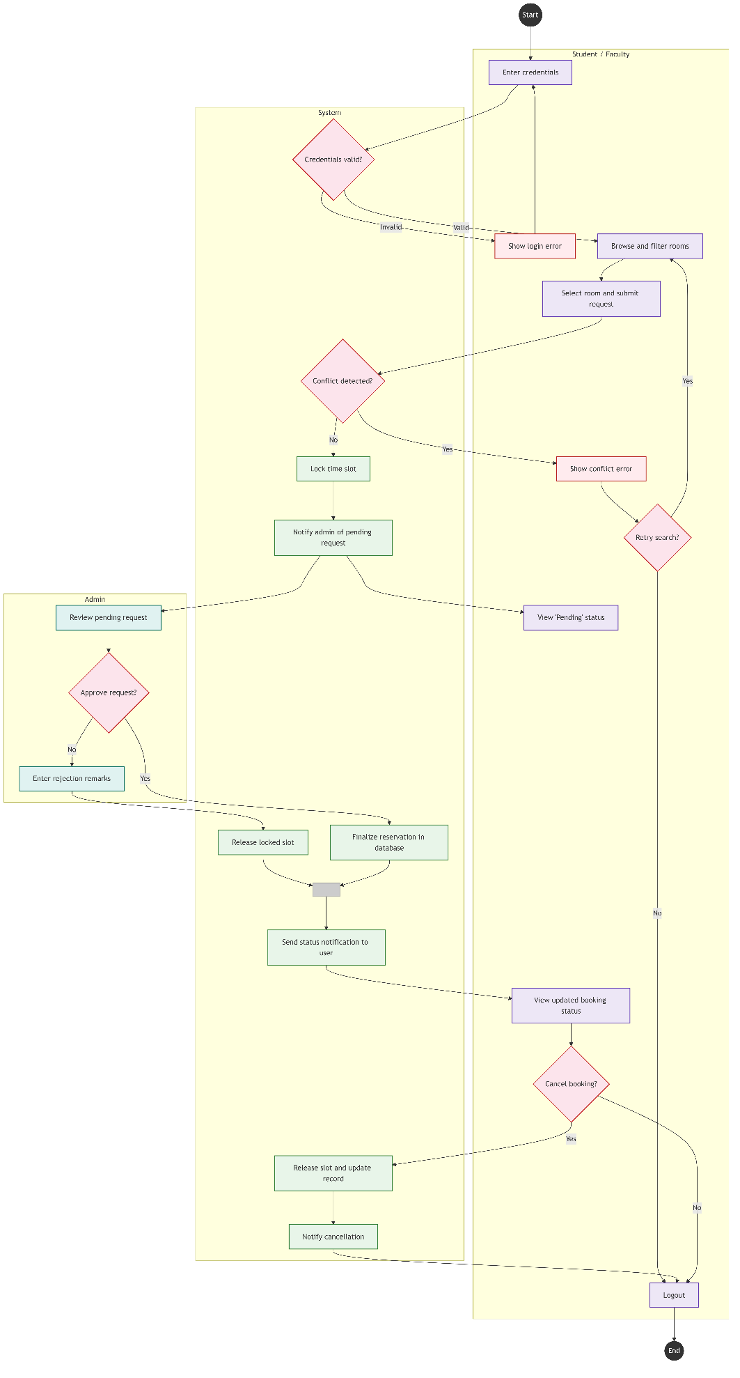

Appendix C — Class Diagram
The Class Diagram defines the object-oriented structure of URBS. Key entities include:
- Abstract base class User, with concrete subclasses Student, Faculty, and Admin
- Room class with availability management methods (checkAvailability, lockSlot, releaseSlot)
- BookingRequest class linked to Room and Reservation; uses ConflictChecker service
- Reservation class linked to BookingHistory; triggers Notification
- Enumeration classes: UserRole, RequestStatus, RoomType, NotifType
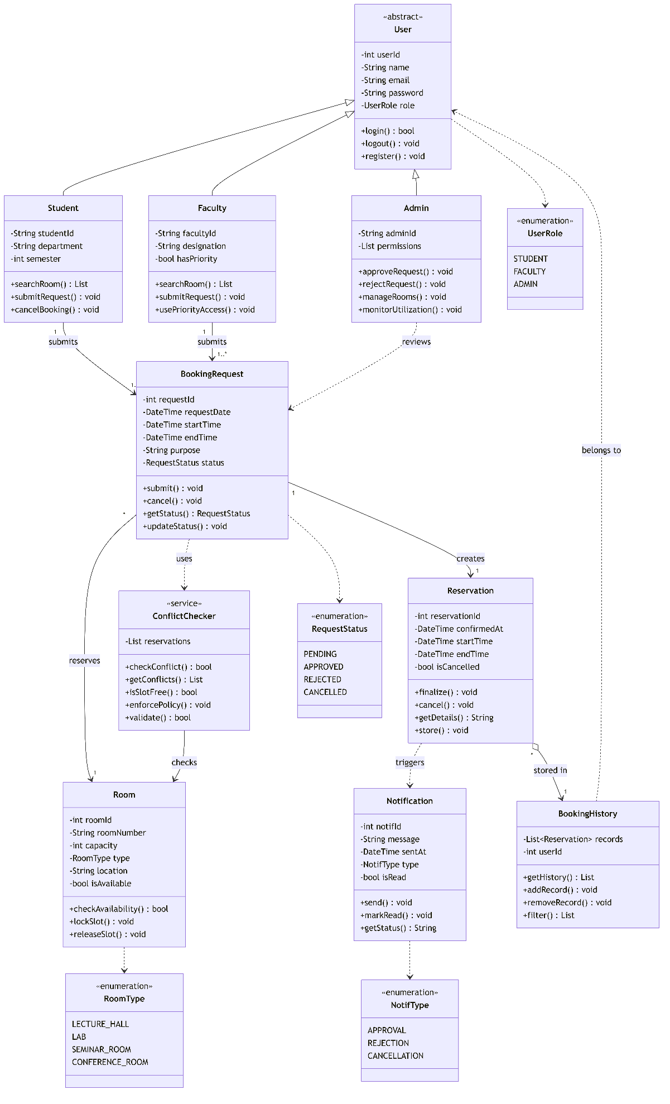

Appendix D — Database Schema
The three-table relational schema is defined as follows:

Table | Column | Type | Constraints
USER | user_id | INTEGER | PRIMARY KEY, AUTO INCREMENT
USER | full_name | VARCHAR(100) | NOT NULL
USER | email | VARCHAR(255) | NOT NULL, UNIQUE
USER | password_hash | VARCHAR(255) | NOT NULL
USER | role | ENUM | NOT NULL — STUDENT / FACULTY / ADMIN
USER | created_at | DATETIME | DEFAULT CURRENT_TIMESTAMP
ROOM | room_id | INTEGER | PRIMARY KEY, AUTO INCREMENT
ROOM | room_number | VARCHAR(20) | NOT NULL, UNIQUE
ROOM | room_type | ENUM | NOT NULL — LECTURE_HALL / LAB / SEMINAR / CONFERENCE
ROOM | capacity | INTEGER | NOT NULL, CHECK (capacity > 0)
ROOM | location | VARCHAR(200) | NULLABLE
ROOM | is_active | BOOLEAN | DEFAULT TRUE
BOOKING | booking_id | INTEGER | PRIMARY KEY, AUTO INCREMENT
BOOKING | user_id | INTEGER | FOREIGN KEY REFERENCES USER(user_id)
BOOKING | room_id | INTEGER | FOREIGN KEY REFERENCES ROOM(room_id)
BOOKING | booking_date | DATE | NOT NULL
BOOKING | start_time | TIME | NOT NULL
BOOKING | end_time | TIME | NOT NULL
BOOKING | purpose | TEXT | NOT NULL
BOOKING | status | ENUM | DEFAULT PENDING — PENDING / APPROVED / REJECTED / CANCELLED
BOOKING | admin_remarks | TEXT | NULLABLE — Populated on rejection
BOOKING | created_at | DATETIME | DEFAULT CURRENT_TIMESTAMP
BOOKING | (Constraint) | UNIQUE | UNIQUE (room_id, booking_date, start_time) — prevents double-booking

Appendix E — REST API Endpoint Summary

Method | Endpoint | Auth Required | Role | Description
POST | /api/auth/register | No | Any | Register new user
POST | /api/auth/login | No | Any | Authenticate user, return JWT
GET | /api/rooms | Yes | Any | List all active rooms
GET | /api/rooms/available | Yes | Student/Faculty | Search available rooms by filters
POST | /api/admin/rooms | Yes | Admin | Add new room
PUT | /api/admin/rooms/:id | Yes | Admin | Update room attributes
DELETE | /api/admin/rooms/:id | Yes | Admin | Soft-delete (deactivate) room
POST | /api/bookings | Yes | Student/Faculty | Submit booking request
GET | /api/bookings/mine | Yes | Student/Faculty | Get own booking history
DELETE | /api/bookings/:id | Yes | Student/Faculty | Cancel a booking
GET | /api/admin/bookings | Yes | Admin | Get all bookings (pending queue)
PUT | /api/admin/bookings/:id/approve | Yes | Admin | Approve booking request
PUT | /api/admin/bookings/:id/reject | Yes | Admin | Reject booking request with remarks
GET | /api/admin/dashboard | Yes | Admin | Get utilization KPI data

