SYSTEM DESIGN DOCUMENT
University Room Booking System (URBS)

Project Title | University Room Booking System (URBS)
Document Type | System Design Document
Project Code | FSE-URBS-2025
Supervisor | [Supervisor Name]
Team Member 1 | Abdullah Sonija — 24K-0013
Team Member 2 | Zahid Hussain — 24K-0015
Version | v1.0
Date | May 2025

Table of Contents
Table of Contents 1
1. Introduction 1
1.1 Purpose of This Document 1
1.2 Scope 1
1.3 Relationship to Other Documents 1
2. System Architecture 1
2.1 Architectural Style 1
2.2 Three-Tier Architecture Overview 1
2.3 Component Interaction Diagram (Textual) 1
2.4 Technology Stack — Full Detail 1
3. Google Sheets Integration Design 1
3.1 Data Source 1
3.2 The Core Design Problem 1
3.3 Design Solution — Merge-and-Persist Strategy 1
3.4 Availability Computation Algorithm 1
3.5 Data Persistence Design 1
4. Database Design 1
4.1 Entity-Relationship Summary 1
4.2 Full Database Schema 1
Table: users 1
Table: rooms 1
Table: bookings 1
4.3 Database Constraints and Indexes 1
4.4 Status State Machine 1
5. REST API Design 1
5.1 API Design Principles 1
5.2 Complete Endpoint Specification 1
Authentication Endpoints (No auth required) 1
Room Endpoints 1
Booking Endpoints 1
5.3 JWT Token Structure 1
5.4 Conflict Detection Logic 1
6. UI Screen Design 1
6.1 Screen Inventory 1
6.2 Navigation Flow 1
6.3 Component Architecture 1
6.4 Responsive Design 1
7. UML Design Artifacts 1
7.1 Use Case Diagram 1
7.2 Activity Diagram 1
7.3 Class Diagram 1
7.4 Sequence Diagram — Booking Request Flow 1
7.5 Deployment Diagram 1
8. Functional Module Breakdown 1
9. Security Design 1
10. Testing Strategy 1

1. Introduction

1.1 Purpose of This Document
This System Design Document (SDD) translates the requirements specified in the Software Requirements Specification (SRS v1.0) into a concrete technical architecture for the University Room Booking System (URBS). It describes the system's overall architecture, component breakdown, data model, API design, Google Sheets integration strategy, UI screen inventory, and UML design artifacts.
This document serves as the authoritative blueprint for the development team during Sprint 4 (Full-Stack Build) and provides sufficient detail to allow verification that the implemented system correctly addresses all requirements from the SRS.

1.2 Scope
This document covers the complete design of the URBS web application, including:
- Three-tier web application architecture (React frontend, Flask backend, SQLite/MySQL database)
- Google Sheets live data integration for room availability, including the persistence and merge strategy
- REST API specification for all 14 endpoints
- Relational database schema with all constraints and indexes
- Full UI screen inventory with layout descriptions
- UML artifacts: Class Diagram, Activity Diagram, Use Case Diagram, Sequence Diagram, Deployment Diagram

1.3 Relationship to Other Documents

Document | Version | Relationship
Software Requirements Specification (SRS) | v1.0 | Parent document — all design decisions trace to SRS requirements
Project Details Document (project_detail.md) | v2.0 | Source for sprint plan, task allocation, and tech stack decisions
Project Guide (Project_guide_important.md) | v1.0 | Course requirements and evaluation criteria reference

2. System Architecture

2.1 Architectural Style
URBS is designed as a decoupled three-tier web application following the Client-Server architectural style with a RESTful API communication layer. The three tiers are strictly separated with no shared code between them, enabling independent development, testing, and future replacement of any tier.

2.2 Three-Tier Architecture Overview

Tier | Technology | Responsibility
Presentation Tier | React.js 18 + Tailwind CSS 3 | Renders the UI, manages client-side state, enforces role-based routing, communicates with the backend via Axios HTTP calls
Application Tier | Python Flask 2.3 + Flask-RESTful | Processes all API requests, enforces JWT authentication and RBAC, executes business logic (conflict detection, Google Sheets sync), coordinates DB operations
Data Tier | SQLite (dev) / MySQL (prod) | Persists all user, room, and booking records; enforces DB-level constraints including the UNIQUE constraint that prevents double-booking
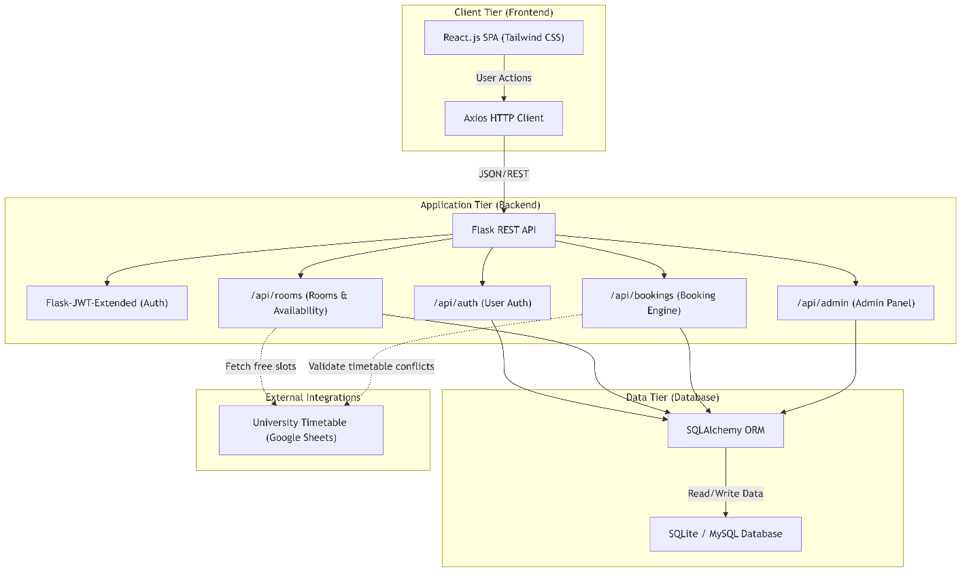
Data flow: The React client sends HTTP/JSON requests to Flask API endpoints. Flask validates the JWT token, enforces role authorization, executes business logic (including Google Sheets sync where applicable), and issues SQL queries via SQLAlchemy ORM. Results are returned as JSON to the client.

2.3 Component Interaction Diagram (Textual)

The following describes the runtime component interactions:

[Browser: React SPA]
| HTTP/JSON over REST (port 3000 -> 5000)
v
[Flask Application Server]
|-- JWT Middleware (validates token + role on every protected route)
|-- Auth Module (/api/auth/*)
|-- Room Module (/api/rooms/* + /api/admin/rooms/*)
|-- Booking Module (/api/bookings/* + /api/admin/bookings/*)
|-- Sheets Sync Service (fetches Google Sheets, merges with DB)
|-- Conflict Checker (overlap query before any booking write)
|-- Slot Release Scheduler (checks and frees expired slots)
v
[SQLAlchemy ORM]
v
[SQLite DB (dev) / MySQL DB (prod)]
Tables: users | rooms | bookings

[Google Sheets] ---- HTTPS/xlsx export ----> [Sheets Sync Service]
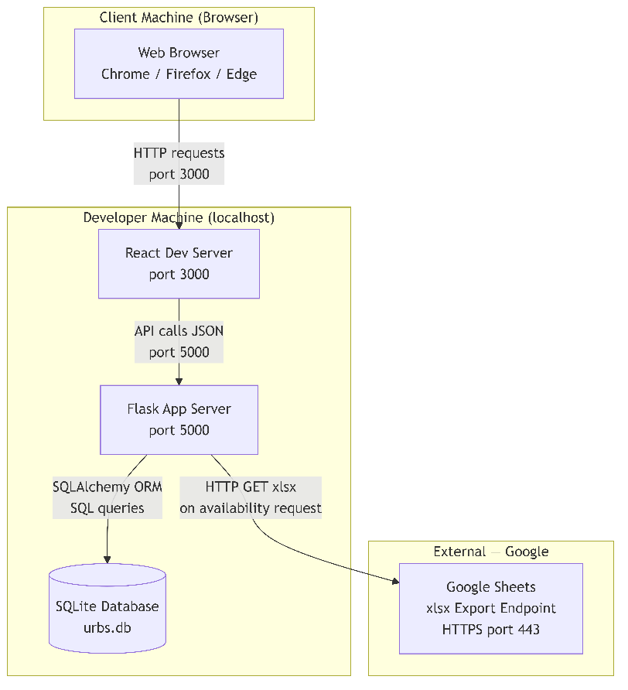
The Google Sheets Sync Service is an internal Flask module (not a separate process). It is invoked on-demand when a user requests room availability. The Slot Release Scheduler runs as a background check triggered at booking query time — it marks expired bookings as COMPLETED before returning availability results.

2.4 Technology Stack — Full Detail

Layer | Technology | Version | Justification
Frontend Framework | React.js | 18+ | Component-based SPA; virtual DOM for responsive UI updates; large ecosystem
UI Styling | Tailwind CSS | 3+ | Utility-first classes; no custom CSS needed; responsive grid built-in
HTTP Client | Axios | 1+ | Promise-based; automatic JSON parsing; easy JWT header injection via interceptors
Client-side Routing | React Router | 6+ | Declarative URL routing; protected route wrappers for RBAC on frontend
Backend Framework | Python Flask | 2.3+ | Lightweight; minimal boilerplate; ideal for ~14 endpoint REST API; 2-person team
REST Extension | Flask-RESTful | 0.3+ | Resource class pattern; input parsing via reqparse; consistent response format
Authentication | Flask-JWT-Extended | 4+ | Stateless JWT; role claims in token payload; @jwt_required decorators
Password Hashing | Flask-Bcrypt | 1+ | bcrypt algorithm; industry standard for password storage
ORM | SQLAlchemy | 2+ | Declarative models; parameterized queries (SQL injection prevention); migration support
CORS | Flask-CORS | 4+ | Enables React (port 3000) to call Flask (port 5000) during development
Sheets Integration | openpyxl / requests | latest | Fetches xlsx export from Google Sheets; openpyxl parses the spreadsheet cells
Scheduler | APScheduler (optional) | 3+ | Optional background job for periodic slot release; can also run at query time
Database (Dev) | SQLite | 3+ | Zero-config; file-based; no server needed for local development
Database (Prod) | MySQL | 8+ | Production-grade; enforces concurrent write constraints; UNIQUE index support
Version Control | Git + GitHub | — | Branch-per-feature; tagged sprint releases; parallel frontend/backend development

3. Google Sheets Integration Design
This section describes the architectural design for integrating live room availability data from a university-maintained Google Sheets spreadsheet into URBS. This is a key system differentiator — URBS does not rely solely on internally managed room data but augments it with an authoritative external source.

3.1 Data Source

Property | Value
Source Type | Google Sheets (publicly accessible xlsx export)
Export URL | https://docs.google.com/spreadsheets/d/1sivXTIf9JvaqP2k6B7-468SyZXTcOAvKyyVW4HJRxeQ/export?format=xlsx
Format | Excel (.xlsx) — fetched via HTTP GET on demand
Interpretation | Empty cell = free time slot for that room. Filled cell = already reserved externally.
Sheet Structure | Rows represent time slots; Columns represent rooms (column headers = room identifiers)
Trigger | Fetched every time a user requests room availability (GET /api/rooms/available)

3.2 The Core Design Problem
A naive implementation would simply show whatever the Google Sheet says is empty. This creates three problems:
- Problem 1 — Lost Reservations: If a user books a room through URBS and the Sheet is refetched, the URBS reservation is invisible to the Sheet. Without persistence, every re-fetch would make the room appear free again.
- Problem 2 — Stale Occupancy: If URBS-made reservations are not reflected in availability results, two users could both see a room as free and submit conflicting bookings.
- Problem 3 — Dangling Reservations: Once a booking's end time passes, the slot should become free again. Without a release mechanism, the slot stays blocked indefinitely.

3.3 Design Solution — Merge-and-Persist Strategy
URBS solves all three problems with a three-layer approach:

Layer | Mechanism | Solves Problem
1. DB Persistence | All URBS-made bookings (Approved + Pending) are stored in the local SQLite/MySQL database. They survive any number of re-fetches. | Problem 1
2. Availability Merge | When availability is requested, URBS fetches the Sheet AND queries the DB. A slot is only shown as Free if it is empty in the Sheet AND has no active DB booking. | Problem 2
3. Auto-Release | Before returning availability, URBS checks for any APPROVED bookings whose end_time < NOW(). These are updated to status = COMPLETED and the slot is freed. | Problem 3

3.4 Availability Computation Algorithm
The following pseudocode describes the complete availability computation performed by the Flask backend on every GET /api/rooms/available request:

FUNCTION get_available_rooms(date, start_time, end_time, room_type, min_capacity):

STEP 1 — Auto-release expired slots:
expired = DB.query(Booking).filter(
status == APPROVED,
booking_date <= TODAY,
end_time <= NOW()
)
FOR each expired booking: SET status = COMPLETED

STEP 2 — Fetch Google Sheets data:
xlsx_data = HTTP.GET(SHEET_URL)
sheet_rooms = parse_xlsx(xlsx_data) # dict: {room_id: [occupied_slots]}

STEP 3 — Query DB for conflicting active bookings:
conflicts = DB.query(Booking).filter(
room_id IN all_rooms,
booking_date == date,
status IN [PENDING, APPROVED],
start_time < end_time_param,
end_time > start_time_param
)
db_blocked_rooms = {b.room_id for b in conflicts}

STEP 4 — Determine sheet-blocked rooms:
sheet_blocked_rooms = {r for r in sheet_rooms if slot_overlaps(r, date, start, end)}

STEP 5 — Merge and filter:
all_blocked = db_blocked_rooms UNION sheet_blocked_rooms
available = all_rooms WHERE:
room_id NOT IN all_blocked
AND room_type matches filter (if provided)
AND capacity >= min_capacity (if provided)
AND is_active == TRUE

RETURN available rooms with availability_source tag (db / sheet / free)

This algorithm guarantees that URBS-made bookings always take precedence over stale Sheet data, and that expired slots are automatically freed before any availability result is returned.

3.5 Data Persistence Design
URBS does NOT write back to Google Sheets. The Sheet is treated as a read-only external source. All URBS-generated reservations are stored exclusively in the URBS database. This one-way integration prevents data corruption in the university's master schedule while giving URBS a reliable local record.

Scenario | Sheet Says | DB Says | URBS Shows
Room never booked | Empty | No booking | FREE
Booked via URBS (Approved) | Empty | APPROVED booking | OCCUPIED (DB wins)
Booked via URBS (Pending) | Empty | PENDING booking | OCCUPIED (DB wins — slot locked)
Booked externally (Sheet) | Filled | No booking | OCCUPIED (Sheet wins)
Booking expired (past end_time) | Empty | Was APPROVED | FREE (auto-released to COMPLETED)
Double-block (both sources) | Filled | APPROVED booking | OCCUPIED (both agree)

4. Database Design

4.1 Entity-Relationship Summary
URBS uses a three-entity relational model. The three primary entities are USER, ROOM, and BOOKING. There is no separate APPROVAL table — approval metadata (admin remarks, status transitions) is embedded in the BOOKING table to minimize joins and reflect the one-to-one relationship between a booking request and its approval outcome.

Entity | Cardinality Relationship | Description
USER | 1 USER submits M BOOKINGs | Stores all registered users across all roles
ROOM | 1 ROOM is referenced by M BOOKINGs | Stores all university rooms managed by admin
BOOKING | M BOOKINGs reference 1 USER and 1 ROOM | Central entity — booking lifecycle, status, conflict key

4.2 Full Database Schema

Table: users

Column | Data Type | Constraints | Notes
user_id | INTEGER | PRIMARY KEY, AUTO INCREMENT | Internal system identifier
full_name | VARCHAR(100) | NOT NULL | Validated: 2-100 chars, letters only
email | VARCHAR(255) | NOT NULL, UNIQUE | Login identifier; university email format preferred
password_hash | VARCHAR(255) | NOT NULL | bcrypt hash; plain-text never stored
role | VARCHAR(20) | NOT NULL, CHECK IN (student, faculty, admin) | Drives RBAC; embedded in JWT payload
created_at | DATETIME | DEFAULT CURRENT_TIMESTAMP | Audit timestamp

Table: rooms

Column | Data Type | Constraints | Notes
room_id | INTEGER | PRIMARY KEY, AUTO INCREMENT | Internal system identifier
room_number | VARCHAR(20) | NOT NULL, UNIQUE | e.g., A101, LAB-3; unique system-wide
room_type | VARCHAR(30) | NOT NULL | lecture_hall / lab / seminar_room / conference_room
capacity | INTEGER | NOT NULL, CHECK (capacity > 0) | Maximum occupancy; used in availability filter
location | VARCHAR(200) | NULLABLE | Building/floor description
is_active | BOOLEAN | DEFAULT TRUE | Soft-delete flag; FALSE = hidden from availability search
created_at | DATETIME | DEFAULT CURRENT_TIMESTAMP | Audit timestamp

Table: bookings

Column | Data Type | Constraints | Notes
booking_id | INTEGER | PRIMARY KEY, AUTO INCREMENT | Internal identifier
user_id | INTEGER | NOT NULL, FOREIGN KEY -> users(user_id) | Requesting user
room_id | INTEGER | NOT NULL, FOREIGN KEY -> rooms(room_id) | Target room
booking_date | DATE | NOT NULL | Date of reservation (YYYY-MM-DD)
start_time | TIME | NOT NULL | Slot start (HH:MM:SS)
end_time | TIME | NOT NULL | Slot end; must be > start_time
purpose | TEXT | NOT NULL | User-provided booking reason (10-500 chars)
status | VARCHAR(20) | NOT NULL, DEFAULT pending | pending / approved / rejected / cancelled / completed
admin_remarks | TEXT | NULLABLE | Mandatory on rejection; NULL for approved/pending
priority_access | BOOLEAN | DEFAULT FALSE | TRUE for Faculty bookings; surfaced in admin queue
created_at | DATETIME | DEFAULT CURRENT_TIMESTAMP | Submission timestamp
updated_at | DATETIME | ON UPDATE CURRENT_TIMESTAMP | Last status change timestamp; used in audit trail

4.3 Database Constraints and Indexes

Constraint / Index | Table | Definition | Purpose
PRIMARY KEY | All tables | On *_id column | Unique row identification
UNIQUE (email) | users | UNIQUE(email) | Prevents duplicate user accounts
UNIQUE (room_number) | rooms | UNIQUE(room_number) | Prevents duplicate room entries
UNIQUE (booking slot) | bookings | UNIQUE(room_id, booking_date, start_time) | DB-level double-booking prevention — last line of defense against race conditions
FOREIGN KEY | bookings | user_id -> users(user_id), room_id -> rooms(room_id) | Referential integrity
INDEX (status) | bookings | INDEX ON status | Speeds up admin approval queue query (filter by pending)
INDEX (date+room) | bookings | INDEX ON (room_id, booking_date) | Speeds up conflict check queries
CHECK (capacity) | rooms | capacity > 0 | Prevents invalid room entries
CHECK (role) | users | role IN (student, faculty, admin) | Prevents invalid role assignment

4.4 Status State Machine
A booking record transitions through the following states. Invalid transitions are rejected at the application layer:

From Status | To Status | Trigger | Side Effect
(none) | PENDING | User submits booking (FR-11) | Time slot is locked — appears as blocked in availability
PENDING | APPROVED | Admin approves (FR-13) | Reservation record finalized; user notified
PENDING | REJECTED | Admin rejects with remarks (FR-14) | Slot released; remarks stored; user notified
PENDING | CANCELLED | User cancels before admin action (FR-17) | Slot released
APPROVED | CANCELLED | User cancels an approved booking (FR-17) | Slot released
APPROVED | COMPLETED | Auto-release: end_time has passed (Sec 3.4) | Slot freed; no notification needed

5. REST API Design

5.1 API Design Principles
- All endpoints are prefixed with /api/
- All request and response bodies use JSON (Content-Type: application/json)
- All protected endpoints require an Authorization: Bearer <JWT> header
- HTTP status codes follow REST conventions: 200 OK, 201 Created, 400 Bad Request, 401 Unauthorized, 403 Forbidden, 404 Not Found, 409 Conflict, 500 Internal Server Error
- Error responses always include a JSON body: { error: <string message> }
- Successful collection responses return a JSON array; single resource responses return a JSON object

5.2 Complete Endpoint Specification

Authentication Endpoints (No auth required)
Method | URL | Request Body | Response | Status Codes
POST | /api/auth/register | { full_name, email, password, role } | { message, user_id } | 201, 400, 409
POST | /api/auth/login | { email, password } | { token, role, user_id, full_name } | 200, 401

Room Endpoints
Method | URL | Auth / Role | Query Params / Body | Response | Status Codes
GET | /api/rooms | JWT / Any | None | [ {room_id, room_number, room_type, capacity, location, is_active} ] | 200, 401
GET | /api/rooms/available | JWT / Any | date, start_time, end_time, room_type, min_capacity (all optional) | [ {room_id, room_number, room_type, capacity, availability_source} ] | 200, 400, 401
POST | /api/admin/rooms | JWT / Admin | { room_number, room_type, capacity, location } | { message, room_id } | 201, 400, 403, 409
PUT | /api/admin/rooms/:id | JWT / Admin | { room_number?, room_type?, capacity?, is_active? } | { message, room } | 200, 400, 403, 404
DELETE | /api/admin/rooms/:id | JWT / Admin | None | { message } (soft-delete: is_active = false) | 200, 403, 404

Booking Endpoints
Method | URL | Auth / Role | Request Body | Response | Status Codes
POST | /api/bookings | JWT / Student or Faculty | { room_id, booking_date, start_time, end_time, purpose } | { message, booking_id, status } | 201, 400, 401, 409
GET | /api/bookings/mine | JWT / Student or Faculty | None | [ {booking_id, room, date, times, status, ...} ] | 200, 401
DELETE | /api/bookings/:id | JWT / Student or Faculty | None | { message } | 200, 401, 403, 404
GET | /api/admin/bookings | JWT / Admin | ?status=pending (optional filter) | [ {booking_id, user, room, date, status, priority_access, ...} ] | 200, 401, 403
GET | /api/admin/bookings/all | JWT / Admin | None | All bookings for all users | 200, 401, 403
PUT | /api/admin/bookings/:id/approve | JWT / Admin | None | { message, booking_id, status: approved } | 200, 401, 403, 404, 409
PUT | /api/admin/bookings/:id/reject | JWT / Admin | { admin_remarks } | { message, booking_id, status: rejected } | 200, 400, 401, 403, 404
GET | /api/admin/dashboard | JWT / Admin | None | { total_rooms, pending_count, approved_month, ... } | 200, 401, 403

5.3 JWT Token Structure
Each JWT token issued on successful login contains the following claims:

{
sub: <user_id>, // Subject — used to identify user in DB queries
role: <role_string>, // student | faculty | admin — used for RBAC
name: <full_name>, // Display name in UI
exp: <unix_timestamp>, // Expiry: NOW + 86400 seconds (24 hours)
iat: <unix_timestamp> // Issued At timestamp
}

The role claim is extracted by Flask middleware on every protected request. No database lookup is required to enforce RBAC — the token payload is self-contained and cryptographically signed.

5.4 Conflict Detection Logic
The conflict detection query runs on every POST /api/bookings and PUT /api/admin/bookings/:id/approve:

# SQLAlchemy ORM equivalent:
conflict = Booking.query.filter(
Booking.room_id == new_booking.room_id,
Booking.booking_date == new_booking.booking_date,
Booking.status.in_(['pending', 'approved']),
Booking.start_time < new_booking.end_time, # existing starts before new ends
Booking.end_time > new_booking.start_time # existing ends after new starts
).first()

if conflict:
return {'error': 'Room already booked for this time slot'}, 409

Two protection layers: (1) the application-layer query above, (2) the DB-level UNIQUE(room_id, booking_date, start_time) constraint as final protection against simultaneous race-condition submissions.

6. UI Screen Design

6.1 Screen Inventory

Screen | Route | Access Role | Key Components
Login / Register | /login | /register | All (unauthenticated) | Email/password fields, role selector dropdown, validation messages, submit button, toggle between login/register
Student Dashboard | /dashboard | Student, Faculty | Booking status summary cards (Pending/Approved counts), upcoming reservations list, Quick Book shortcut button
Room Search | /rooms | Student, Faculty | Date picker, start/end time, room type dropdown, min capacity input, search button, room cards with availability badge
Booking Form | /book/:roomId | Student, Faculty | Pre-filled room info (read-only), date/time confirmation, purpose textarea, conflict warning banner, Submit Request button
Booking History | /my-bookings | Student, Faculty | Sortable table: Room, Date, Time, Purpose, Status badge (color-coded), Cancel button, Filter by status
Admin Dashboard | /admin | Admin | KPI cards: Total Rooms, Pending Requests, Approved This Month; Recent Activity Feed (last 10 actions)
Admin — Room Management | /admin/rooms | Admin | Room inventory table, Add New Room button, Edit/Deactivate actions per row, capacity and type filters
Admin — Approval Queue | /admin/approvals | Admin | Pending requests list with Faculty priority badges, Approve button, Reject button (opens remarks modal)
Admin — All Bookings | /admin/bookings | Admin | Full booking history table across all users, status filter dropdown, sortable by date/user/room

6.2 Navigation Flow
After login, users are redirected based on role:
- Student / Faculty: Redirect to /dashboard
- Admin: Redirect to /admin

Protected routes are wrapped in a React <PrivateRoute> component that:
- Checks for a valid JWT token in localStorage
- Decodes the role claim from the token payload
- Redirects to /login if no token is present or token is expired
- Redirects to /unauthorized if the role does not match the required role for that route

6.3 Component Architecture
React components are organized into three categories:

Category | Components | Responsibility
Pages | LoginPage, RegisterPage, DashboardPage, RoomSearchPage, BookingFormPage, BookingHistoryPage, AdminDashboardPage, AdminRoomsPage, AdminApprovalsPage, AdminBookingsPage | Full-screen views rendered by React Router
Shared UI | Navbar, RoomCard, BookingStatusBadge, ConflictWarning, ConfirmModal, RejectRemarksModal, LoadingSpinner, ErrorBanner | Reusable UI components shared across pages
Context | AuthContext (JWT storage, login/logout, role), AxiosInstance (JWT header injection) | Global state and HTTP client configuration

6.4 Responsive Design
The UI is built with Tailwind CSS utility classes and must render correctly at all viewport widths from 375px (mobile) to 1920px (desktop). Key responsive behaviors:
- Room cards: Single column on mobile, 2 columns on tablet (md:), 3 columns on desktop (lg:)
- Admin tables: Horizontally scrollable on mobile with fixed first column
- Navigation: Hamburger menu on mobile, horizontal navbar on desktop
- Booking form: Stacked field layout on mobile, two-column grid on desktop

7. UML Design Artifacts

7.1 Use Case Diagram
The Use Case Diagram (source: usecase.mmd) depicts four actors and twelve use cases within the University Room Booking System boundary.
- Actors: Student, Faculty, Admin, System
- Include relationships: UC-03 (Submit Booking) includes UC-09 (Conflict Check); UC-07 (Approve/Reject) includes UC-10 (Notify User) and UC-12 (Store Reservation Record)
- Extend relationship: UC-11 (Priority Room Access) extends UC-03 — available to Faculty only
- Extend relationship: UC-07 (Approve/Reject) extends UC-04 (View Booking History) — admin can act from history view
Key design decision: The Conflict Checker (UC-09) is modeled as a System actor use case because it is fully automated and not initiated by a human — it is always triggered as part of booking submission and cancellation.

7.2 Activity Diagram
The Activity Diagram (source: activity.mmd) models the complete reservation workflow across three swimlanes: Student/Faculty, System, and Admin.
- Happy path: Login -> Browse Rooms -> Select and Submit -> System conflict check passes -> Slot locked -> Admin notified -> Admin approves -> Reservation finalized -> User notified -> User views Approved status
- Rejection path: Admin rejects -> System releases slot -> Rejection notification with remarks sent -> User views Rejected status
- Cancellation path: User views approved booking -> User cancels -> System releases slot -> Cancellation notification
- Error paths: Invalid login (retry), Conflict detected (retry search or logout)
Key design decision: The slot is locked immediately upon successful conflict-free submission (not after admin approval). This prevents two users from both seeing a free slot during the admin review window.

7.3 Class Diagram
The Class Diagram (source: class_diagram.mmd) defines the object-oriented design of the system.
- Abstract base class User with subclasses Student, Faculty, Admin — models role-specific attributes and methods
- Room class with slot management methods: checkAvailability(), lockSlot(), releaseSlot()
- BookingRequest class linked to Room and Reservation — uses ConflictChecker service
- ConflictChecker is modeled as a <<service>> class — stateless; contains the overlap detection logic
- Reservation class linked to BookingHistory — triggers Notification on state change
- Four enumerations: UserRole, RequestStatus, RoomType, NotifType
Key design decision: BookingRequest and Reservation are modeled as separate classes reflecting the two-phase lifecycle: a request becomes a reservation only upon admin approval. In the DB implementation, they are merged into the single bookings table using the status field as the discriminator, reducing join complexity.

7.4 Sequence Diagram — Booking Request Flow
The following describes the complete message sequence for the Submit Booking Request use case (UC-03):

Step | From | To | Message / Action
1 | User (Browser) | React BookingForm | User fills form and clicks Submit
2 | React BookingForm | AuthContext | getToken() — retrieve JWT from localStorage
3 | React BookingForm | Flask /api/bookings | POST { room_id, date, start_time, end_time, purpose } Authorization: Bearer <JWT>
4 | Flask JWT Middleware | DB users table | Verify token signature and expiry; extract user_id and role
5 | Flask BookingResource | ConflictChecker | checkConflict(room_id, date, start_time, end_time)
6 | ConflictChecker | DB bookings table | SELECT * WHERE room_id=X AND date=Y AND status IN (pending,approved) AND overlap condition
7a (conflict) | DB | ConflictChecker | Returns existing booking record
7a (conflict) | Flask | React BookingForm | HTTP 409 { error: Room already booked for this time slot }
7b (no conflict) | DB | ConflictChecker | Returns empty result
8 | Flask BookingResource | DB bookings table | INSERT new Booking record (status=pending, priority_access based on role)
9 | DB | Flask | Booking record created, booking_id returned
10 | Flask | React BookingForm | HTTP 201 { message, booking_id, status: pending }
11 | React BookingForm | User (Browser) | Display success message; redirect to /my-bookings

7.5 Deployment Diagram
URBS is deployed as a local single-machine web application for the course demonstration. The following describes the deployment architecture:

Node | Component | Port | Notes
Developer Machine (Local) | React Development Server (npm start) | 3000 | Serves the SPA; proxies API calls to Flask
Developer Machine (Local) | Flask Application Server (python app.py) | 5000 | Handles all API requests; connects to SQLite file
Developer Machine (Local) | SQLite Database File (urbs.db) | N/A (file) | Local database file in Flask project directory
External — Google | Google Sheets Export Endpoint | 443 (HTTPS) | Read-only xlsx export; fetched by Flask on availability queries

Production upgrade path (out of scope for MVP): Flask deployed on a cloud VM (e.g., AWS EC2 / DigitalOcean Droplet), React built with npm run build and served via Nginx, SQLite replaced with MySQL on the same VM or an RDS instance, HTTPS via Let's Encrypt SSL certificate.

8. Functional Module Breakdown
The five functional modules of URBS map directly to Flask Blueprint files (backend) and React page components (frontend):

Module | Flask Blueprint / File | React Pages / Components | Key FRs
M1 — User Auth & RBAC | auth.py (Blueprint: /api/auth) | LoginPage, RegisterPage, AuthContext, PrivateRoute | FR-01 to FR-04
M2 — Room Search | rooms.py (Blueprint: /api/rooms) | RoomSearchPage, RoomCard, AvailabilityBadge | FR-05 to FR-07
M3 — Booking Engine | bookings.py (Blueprint: /api/bookings) | BookingFormPage, ConflictWarning, BookingHistoryPage, BookingStatusBadge | FR-08 to FR-11, FR-16, FR-17
M4 — Approval Workflow | admin.py (Blueprint: /api/admin) | AdminApprovalsPage, RejectRemarksModal, AdminBookingsPage | FR-12 to FR-15, FR-18
M5 — Room Inventory & Dash | admin.py (shared Blueprint) | AdminRoomsPage, AdminDashboardPage, KPICard | FR-19 to FR-22
Google Sheets Sync Service | sheets_sync.py (utility module) | N/A — backend only; results served via /api/rooms/available | FR-05, FR-06, FR-09

9. Security Design

Threat | Design Countermeasure | Implementation Layer
Unauthorized API access | JWT token required on all protected endpoints; role claim validated per route | Flask JWT middleware decorator (@jwt_required, @role_required)
Password theft | Passwords hashed with bcrypt (work factor 12); never stored or logged as plain text | Flask-Bcrypt in auth.py on registration and login
SQL injection | All DB queries via SQLAlchemy ORM with parameterized bindings; no raw string SQL | SQLAlchemy throughout bookings.py, rooms.py, admin.py
Double-booking race condition | DB UNIQUE(room_id, booking_date, start_time) constraint; API-level conflict check query | SQLAlchemy model + DB schema migration
Cross-origin attacks | Flask-CORS configured to allow only trusted origins (localhost:3000 in dev) | Flask-CORS extension in app.py
Broken access control | Role embedded in JWT; every admin endpoint checks role == admin before processing | JWT role claim + Flask decorator
Token forgery | JWT signed with a secret key (env variable); signature verified on every request | Flask-JWT-Extended with SECRET_KEY from environment variable
Sensitive data exposure | API never returns password_hash; only non-sensitive user fields returned | Explicit field serialization in resource return statements

10. Testing Strategy

Test Type | Scope | Tool / Method | Key Test Cases
Unit Testing | Individual Flask endpoint functions; conflict detection logic; auto-release logic | Python unittest / pytest | Test conflict overlap with boundary times; test bcrypt verification; test JWT role enforcement
Integration Testing | Booking submission -> conflict check -> DB write -> availability update | pytest + test SQLite DB | Submit booking, verify slot locked; approve booking, verify reservation finalized
System Testing | Full end-to-end reservation workflow: register -> search -> book -> approve -> notify | Manual test plan; browser | Complete happy path; rejection path; cancellation path; Google Sheets sync path
User Acceptance Testing (UAT) | 3+ real university users test all core workflows | In-person sessions; feedback form | Can student book a room? Can admin approve? Does conflict warning appear? Is UI intuitive?
Validation Testing | All 13 form validation rules enforce correctly | Manual frontend + Postman for backend | Submit empty purpose; submit past date; submit end_time < start_time; submit duplicate email
Security Testing | JWT enforcement; role-based access; SQL injection resistance | Postman with manipulated tokens | Call admin endpoint with student JWT; send expired token; inject SQL in purpose field

