University Room Booking System (URBS)
Final Project Report

Project Team:
Abdullah Sonija (24K-0013)
Zahid Hussain (24K-0015)
Course:
CS2004 - Fundamentals of Software Engineering
Spring 2026
FAST– National University of Computer and Emerging Sciences

1. Introduction
The University Room Booking System (URBS) is a comprehensive web-based application developed to streamline the process of reserving university rooms, such as classrooms, labs, and seminar halls, for various academic and extracurricular activities. The system aims to eliminate the inefficiencies associated with manual room booking processes, such as double bookings, lack of transparency in room availability, and disorganized record-keeping. By providing a centralized platform, URBS ensures that students and faculty can efficiently search for available rooms, submit booking requests, and manage their reservations, while administrators are equipped with robust tools to oversee the entire process.

2. Problem Statement
Universities frequently encounter significant challenges in managing the scheduling of shared spaces. Common problems include:
- - Double Booking: Conflicting reservations, such as two student clubs booking the same room simultaneously.
- - Lack of Transparency: Students and faculty often lack real-time visibility into which rooms are available at specific times.
- - Manual Approvals: Staff members are burdened with manually processing requests, leading to delays and administrative overhead.
- - Poor Record Keeping: Tracking room utilization and historical booking data is difficult without a centralized digital system.
URBS addresses these issues by automating the reservation workflow, enforcing scheduling constraints, and providing real-time availability checks against both internal bookings and the university's official timetable.

3. Methodology
The development of URBS followed an Agile/Scrum methodology, divided into five distinct sprints to ensure iterative progress and adaptability to feedback. The sprints were structured as follows:
- 1. Sprint 1: Planning & Proposal - Defined system scope, selected technology stack, and established project governance.
- 2. Sprint 2: Requirements & SRS - Captured user needs and documented Functional and Non-Functional Requirements.
- 3. Sprint 3: System Design - Created architectural blueprints, database schemas, and UML diagrams (Use Case, Class, Sequence, Activity).
- 4. Sprint 4: Full-Stack Build - Developed the backend REST API, frontend React components, and integrated the system.
- 5. Sprint 5: QA, Delivery & PM - Conducted comprehensive testing, incorporated feedback, and finalized project documentation.

4. Application Architecture
URBS is built on a modern, decoupled three-tier architecture:
- - Frontend: Developed using React.js and Tailwind CSS, providing a responsive and dynamic single-page application (SPA).
- - Backend: Implemented with Python Flask and Flask-RESTful, offering a lightweight and robust RESTful API.
- - Database: Utilizes SQLite for development (scalable to MySQL for production), interfaced via SQLAlchemy ORM for secure and efficient data management.
- - External Integrations: Synchronizes with Google Sheets to retrieve the official university timetable, preventing conflicts with scheduled classes.
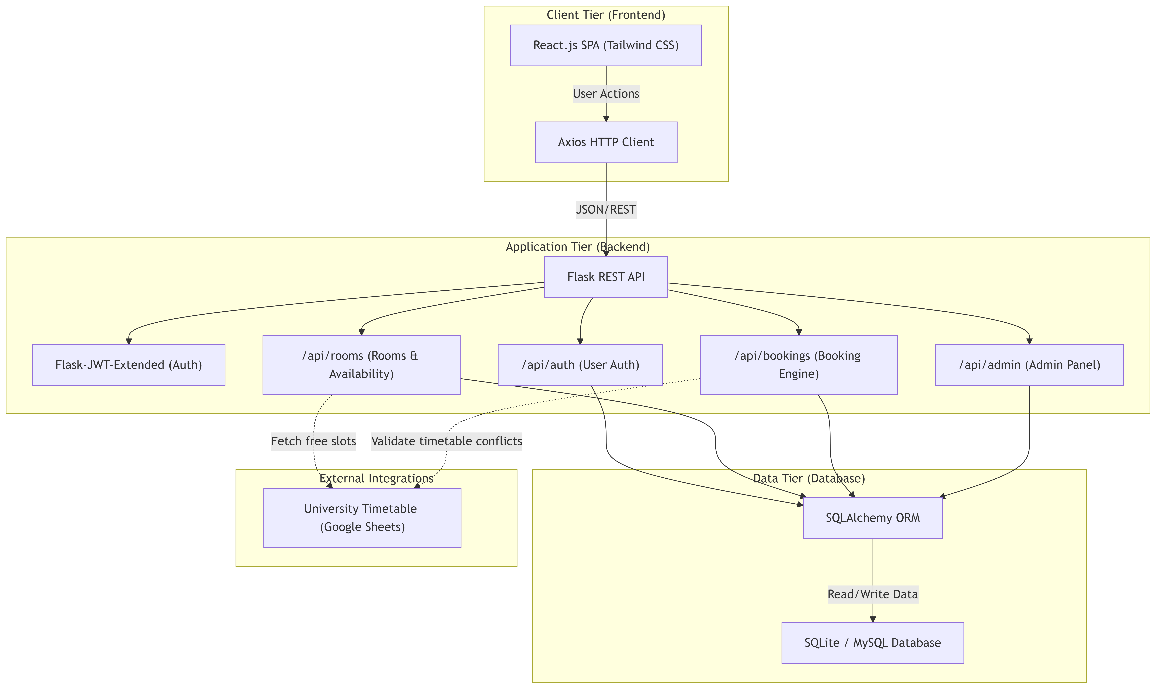

5. Key Features
The implemented system encompasses the following core features:
- - User Authentication & RBAC: Secure registration and login with JWT-based session management. Access is segregated by roles (Student, Faculty, Admin).
- - Room Search & Availability: Real-time filtering of rooms by date, time, type, and capacity, checking against both internal bookings and external timetables.
- - Booking Workflow: Users can request time slots. Faculty members benefit from a priority access extension that supersedes standard requests.
- - Admin Approval Dashboard: Administrators can review, approve, or reject pending requests with mandatory remarks. Approvals automatically reject conflicting pending requests.
- - Room Utilization Analytics: A comprehensive dashboard provides insights into room occupancy rates, booking frequencies, and system usage trends.

6. Verification & Validation (Testing)
Quality assurance was maintained through rigorous testing strategies, ensuring reliability and a seamless user experience:
- - Unit Testing: Verified core functions such as JWT generation, password validation, and input sanitization.
- - Integration Testing: Validated the seamless communication between the React frontend and Flask backend, particularly the booking submission and approval workflows.
- - System Testing: Simulated concurrent users to ensure the database correctly handled race conditions and prevented double-bookings using unique constraints.
- - User Acceptance Testing (UAT): Conducted with university students and faculty to ensure the UI was intuitive and the features met their real-world needs.

7. Conclusion & Lessons Learned
The successful development of URBS highlights the effectiveness of Agile methodologies and a well-selected technology stack in delivering a functional software product within a constrained timeline. The project successfully met all specified requirements, providing a robust solution to the university's room booking challenges.
Key lessons learned include:
- - The critical importance of comprehensive requirement gathering to align development with user needs.
- - Managing database race conditions is essential in concurrent booking systems.
- - Seamless integration with external data sources (like Google Sheets) significantly enhances the system's value.

