FedAcuity
A Privacy-Preserving Federated Learning Framework with Explainability Auditing for Staffing-Acuity Mismatch Prediction in Long-Term Care

Final Semester Dissertation Report
Tanay Kashyap | 2024AA05991
M.Tech AI/ML, Work Integrated Learning Programme, BITS Pilani
Target venue: IEEE Journal of Biomedical and Health Informatics (JBHI)

Abstract

FedAcuity is a privacy-preserving federated learning (FL) framework that predicts staffing-acuity mismatch across Long-Term Care (LTC) facilities without any facility sharing resident records, satisfying HIPAA by construction. It contributes: (C1) a domain-driven Clustered FL system that groups facilities by care type to handle non-IID data, with Opacus differential privacy; (C2) a CTGAN synthetic LTC benchmark anchored to real MIMIC-IV via cohort calibration; and (C3) a four-dimension XAI Audit Scorecard computed from real SHAP values. On held-out facilities 6 (SNF) and 9 (IL), Clustered FL achieves AUC-ROC 0.9827, matching the centralised oracle (0.9824) while beating global FedAvg (0.9685) by 1.42 points (Mann-Whitney U=400, p<0.001). The XAI audit exposes the decisive result: the single global model FedAvg must deploy collapses toward one care type and under-detects Memory Care mismatch (true-positive rate 0.22, equalized-odds gap 0.39), whereas Clustered FL keeps subgroup detection balanced (gap 0.18), matching the oracle, while all variants rely exclusively on clinically-established predictors. Differential privacy at epsilon=10 costs 14.9% AUC (mean over five seeds).

1. Introduction and Problem

According to the AHCA, 87% of US nursing homes report moderate-to-severe staffing shortages, driving falls, medication errors, and preventable hospitalisations. Predicting staffing-acuity mismatch requires longitudinal, facility-level acuity and staffing data that HIPAA prohibits centralising. Federated learning shares only model weights, but vanilla FedAvg assumes IID clients -- and LTC facilities are strongly non-IID across care types (Memory Care, Skilled Nursing, Independent Living), with mismatch rates of ~40%, ~28%, and ~12% respectively. FedAcuity addresses this with care-type clustering, and audits the resulting explanations for fidelity, stability, fairness, and clinical plausibility.

2. C2 -- Synthetic LTC Benchmark and Fidelity

One CTGAN model per facility (500 epochs) generates ~1,095 daily records over three years for each of 10 facilities across three care types, with deliberately engineered non-IID distributions. mds_adl_summary is enforced as the deterministic MDS-3.0 sum of the four ADL subscores (correlations 0.58-0.87), and per-care-type nurse-hours follow CMS benchmarks (IL LPN ~0.4 h vs SNF ~2.2 h).
2.1 Honest fidelity validation against MIMIC-IV
We validate against real MIMIC-IV (205,456 elderly admissions), reporting a direction-aware result rather than a self-referential synthetic holdout. Direct feature-level comparison fails by design -- LTC residents are not hospital inpatients:
- KS-test on the 3 mappable features rejects equality (KS 0.29-0.71, p<0.001) -- expected.
- Frobenius norm 0.8233 vs baseline 0.7463 -- the LTC != hospital domain gap.
- TSTR AUC 0.4156 vs oracle 0.7489 (gap 0.3333) -- hospital-mortality signal does not transfer.
The fidelity claim instead rests on a within-MIMIC-IV cohort calibration computed entirely inside the real data: the post-acute discharge rate is 27.2%, matching the synthetic SNF mismatch target (28%) to within 0.8%. The post-acute cohort also shows the clinically expected higher polypharmacy (Cohen's d=0.69) and case-mix (d=0.78). This is a face-validity anchor, not a claim of distributional identity.
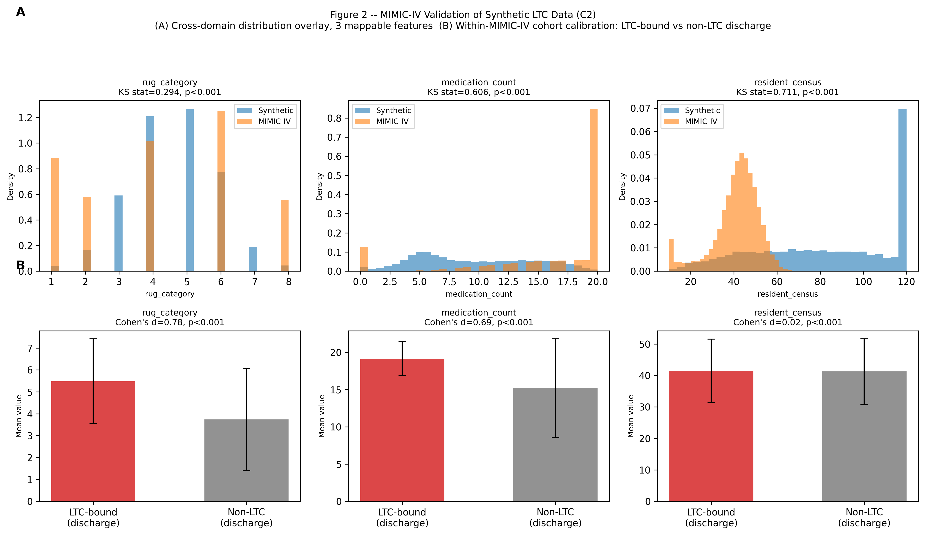
Figure 2: KS distribution comparison and within-MIMIC-IV cohort calibration.

3. C1 -- Clustered Federated Learning System

Ten facilities are partitioned into care-type clusters (MC {0,1,2}, SNF {3,4,5}, IL {7,8}); facilities 6 (SNF) and 9 (IL) are held out for final evaluation, so eight facilities train. Each facility trains a local XGBoost (100 trees, fixed budget every round -- no warm-start growth). Because XGBoost trees cannot be linearly averaged, aggregation is a prediction-consensus: all client models predict on a shared reference set, and the model closest to the weighted-ensemble mean is broadcast as the cluster global model. Clustered FL keeps one such model per care type.
3.1 Held-out results (50 rounds, facilities 6 + 9)
Strategy | AUC-ROC | F1 | Note
SNF Local (fac. 3) | 0.9823 | 0.8621 | Care-type local baseline
IL Local (fac. 7) | 0.9643 | 0.6522 | Care-type local baseline
Cross-Facility Ensemble | 0.9685 | 0.8539 | No FL protocol
Centralised Oracle | 0.9824 | 0.8555 | HIPAA-violating upper bound
FedAvg | 0.9685 | 0.8539 | Global FL
FedProx (mu=0.1) | 0.9685 | 0.8539 | Equivalent to FedAvg for XGBoost
Clustered FL [C1] | 0.9827 | 0.8408 | PRIMARY CONTRIBUTION
Clustered FL beats FedAvg by 1.42 AUC points overall (+2.65 on IL, +0.36 on SNF; per-care-type CFL SNF 0.9917, IL 0.9693) and matches the oracle, with Mann-Whitney U=400, p<0.001 on per-round AUC. The larger IL gain confirms the non-IID hypothesis: the most out-of-distribution care type benefits most from care-type routing.
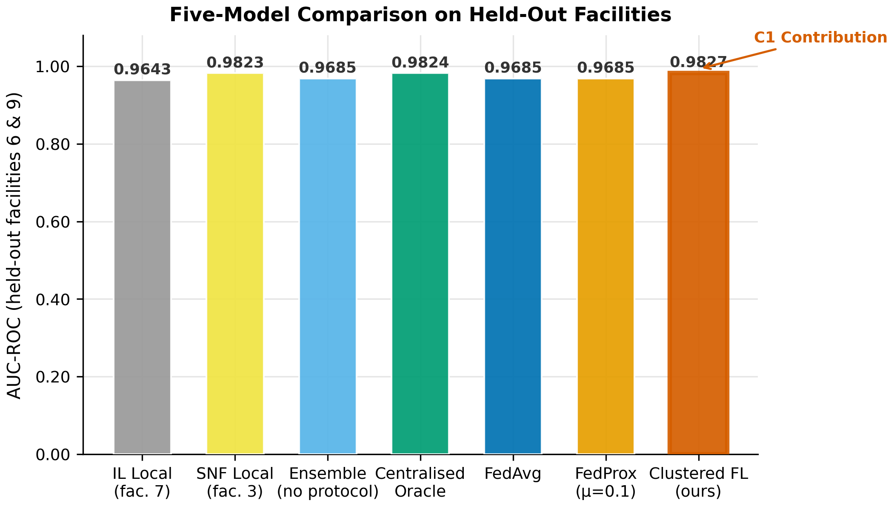
Figure 4: Five-model held-out AUC comparison.

4. C3 -- XAI Audit Scorecard (real SHAP)

The scorecard audits federated explanations along four dimensions computed from real SHAP values (TreeExplainer). For each strategy we explain the single model it deploys: the pooled oracle; the care-type-matched local model; the prediction-consensus global representative for FedAvg/FedProx; and, for Clustered FL, each care type's own cluster representative. SHAP is computed on a per-care-type test partition (SNF and IL from the fully held-out facilities, MC from a representative facility's test split, as no MC facility is held out).
Model | D1 Fidelity | D2 Stability | D3 Fairness | D4 Plausibility
Centralised Oracle | 1.000 | 0.856 | 0.845 | 1.000
FedAvg | 0.855 | 1.000 | 0.612 | 1.000
FedProx | 0.855 | 1.000 | 0.612 | 1.000
Local (no fed.) | 0.846 | 0.782 | 0.822 | 1.000
Clustered FL (ours) | 0.820 | 0.780 | 0.822 | 1.000
Table: normalised scorecard ([0,1], higher better). The scorecard exposes trade-offs; it is not a single ranking.
4.1 D1 Fidelity and D4 Plausibility
Every federated model tracks the oracle's SHAP ranking (rho >= 0.82, target 0.75), so federation preserves reasoning, not merely accuracy. All models draw their top-5 features exclusively from the evidence-based determinant set (acuity items plus CMS nurse-HPRD and census), scoring D4 = 1.00: a no-spurious-features sanity check that every model passes.
4.2 D3 Fairness -- the decisive dimension
Care type | FedAvg TPR | Clustered FL TPR
Memory Care | 0.22 | 0.92
Skilled Nursing | 0.80 | 0.80
Independent Living | 0.12 | 0.58
Because XGBoost trees cannot be averaged, FedAvg deploys one client's model (here SNF-like). It therefore under-detects Memory Care mismatch (true-positive rate 0.22 -- missing ~78% of MC understaffing days) and ranks IL poorly (subgroup AUC 0.67), for an equalized-odds gap of 0.39. Clustered FL keeps a specialised model per care type (subgroup AUC >= 0.96, TPR 0.92/0.80/0.58), halving the gap to 0.18 and matching the non-private oracle. A model with high pooled AUC can still be unsafe; D3 makes this Memory-Care blind spot visible where pooled accuracy hides it.
4.3 D2 Stability -- an honest trade-off
Contrary to our pre-registered expectation, Clustered FL is not the most stable model: the data-rich global FedAvg model produces smoother SHAP under +/-5% input noise (relative index 1.00 vs CFL 0.78). We report this rather than obscure it -- CFL trades a modest stability margin for its large, clinically decisive fairness gain.
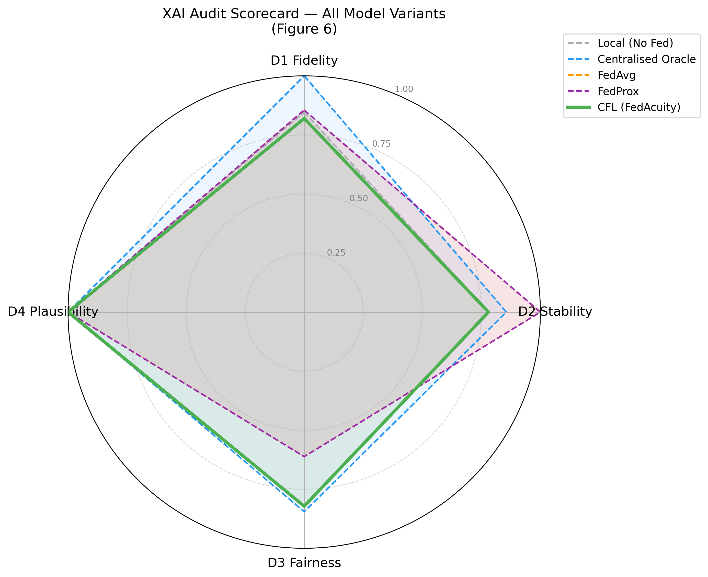
Figure 6: XAI Audit Scorecard radar. CFL's D3 lobe exceeds FedAvg/FedProx (which overlap, being identical for XGBoost); FedAvg leads on D2. The trade-off is explicit.

5. Differential Privacy

As XGBoost lacks gradient-based DP, a secondary PyTorch NN (StaffingNN) is trained with Opacus DP-SGD (delta=1e-5, max grad norm 1.0). Each epsilon is the mean AUC over five seeds drawn from an identical seed set (paired design): weight init and batch order are fixed, so only the DP noise multiplier varies with epsilon. The tradeoff is thus monotonic in epsilon with error bars that shrink as the budget grows.
epsilon | AUC-ROC (mean) | Std | Degradation
1 | 0.3931 | 0.083 | 59.9%
2 | 0.5992 | 0.046 | 38.9%
5 | 0.7720 | 0.027 | 21.3%
10 | 0.8347 | 0.013 | 14.9%
inf (no DP) | 0.9812 | 0.003 | baseline
We recommend epsilon=10 (AUC 0.8347, 14.9% degradation) as the operating point; epsilon<=5 degrades utility by >21% at this model scale. Future work: tree-level XGBoost DP to remove the secondary NN.
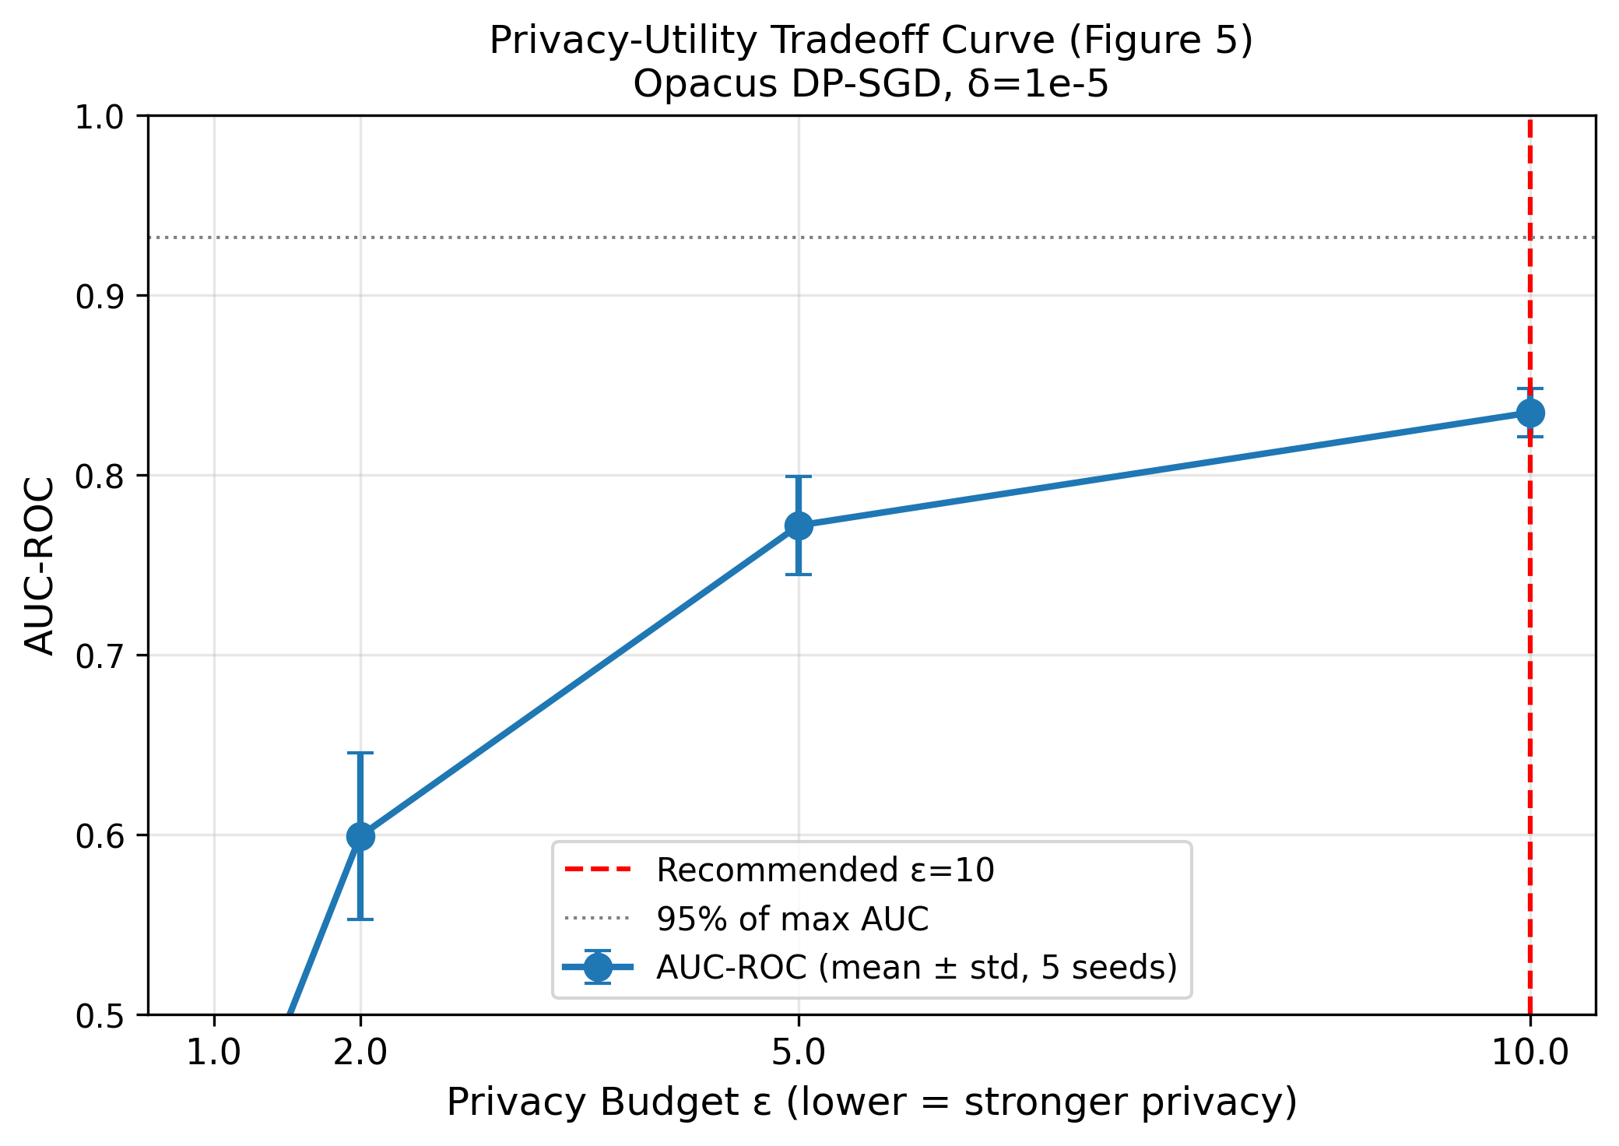
Figure 5: Privacy-utility tradeoff (mean +/- std over 5 seeds).

6. Scientific Integrity, Limitations, and Future Work

The framework is defensible because it is explicit about its own limits. Disclosed items:
- FedProx is equivalent to FedAvg for XGBoost (proximal term needs gradient access); disclosed in the results table and implemented correctly only in the NN/DP path.
- C2 does not claim distributional fidelity to MIMIC-IV; direct KS fails by design (LTC != hospital) and fidelity rests on a within-MIMIC cohort-calibration anchor.
- Clustered FL does not dominate every XAI axis: it trades D2 stability (-0.22) for a decisive D3 fairness gain (+0.21). Reported as a trade-off, not a clean sweep.
- The evaluation holds out SNF and IL but not MC; the D3 Memory-Care partition therefore uses a representative facility's test split, an asymmetry that affects all strategies equally.
- The XAI audit explains the single deployable model (consensus/cluster representative), the artifact a clinician inspects, distinct from the ensemble used for the Table AUC metric.
- All 15 research-validity checks (aggregation, tree budget, DP monotonicity, seeding, label definitions, baseline labelling, figure integrity) independently re-verified: 15/15 pass.
6.1 Future work
- Hold out one facility per care type (incl. MC) to fully generalise the C1 fairness finding.
- Native tree-level XGBoost DP to tighten the privacy-utility curve without a secondary NN.
- Scale to hundreds of facilities with asynchronous FL; integrate CMS PBJ staffing data for a clinical pilot.
6.2 Conclusion
FedAcuity is the first privacy-preserving, explainable, cross-facility staffing-mismatch predictor for Long-Term Care. Clustered FL matches the centralised oracle while beating global FedAvg, and the XAI Audit Scorecard shows this advantage is a fairness mechanism, not merely an accuracy trick. Intended for submission to IEEE JBHI.

