**SALE & PURCHASE AGREEMENT**

**OF**

**COPPER CATHODES 99.99%**

**Entered this date of** **December 5, 2023**

**By and Between**

**THE SELLER:**

|  |  |
| --- | --- |
| **GLENFIELD COMMODITIES LIMITED** | |
| **Address:** | **4609 Lunsemfwa Drive, Riverside Kitwe Copper belt Zambia** |
| **Signatory:** | **Mr. Jack Sidney Phiri / Commercial Director** |
| **Passport No:** | **ZP016722 Issued by the Republic of Zambia** |

**THE BUYER:**

|  |  |
| --- | --- |
| **TRANS EUROPEA RIVA,S.L. OR TBN.** | |
| **Address** | Juan Hurtado de Mendoza,5 |
| **Signatory:** | **xxxx** |
| **Passport No:** | **xxxx** |

**CONTRACT NO: GCLCUSSITCL23112023**

**DATE OF ISSUE: December 5, 2023**

**Buyer Information**:

**Business Information :** Overseas Commodity Trading

Company Name & Type :TRANS EUROPEA RIVA,S.L. OR TBN.

Registration No : xxxx

Street address : Juan Hurtado de Mendoza,5

Country : SPAIN

Telephone : +34 91 350 2361

Company Website : NA

Direct Mobile : xxxx

Direct Email : xxxx

**Signatory Information**

Signatory Name :Rafael Riva

Position in the Company : Director

Telephone, Fax & Email : +34 91 350 2361

Passport No & details : xxxx

**Buyer’s Bank information**

**FOR ISSUING PRE- ADVICE RWA & SBLC MT-760 OR DLC MT-700 THROUGH SWIFT MT 799 & MT760 AND FOR TELEGRAPHIC TRANSFER THROUGH SWIFT MT103 / BANK TRANSFER**:

NAME OF THE BANK : BANKINTER

BANK ADDRESS : Calle Doctor Fleming, 33-35 28036 Madrid

SWIFT CODE : BKBKESMM

ACCOUNT NAME : HISPANO PEGASO EUROPEA SL

ACCOUNT NUMBER : 0034/100037097

Account Signatory : xxxx

Address :C/Juan Hurtado de Mendoza, 5 - 1ͣ 28036 Madrid

Email : rafael@triva.es

Bank Phone : +34 918068971

Bank Officer : Mrs Ruth Martinez

Bank Email :rmtnezan@bankinter.com

Website : www.bankinter.com

I hereby swear under penalty of perjury that I am of the above account and the information given above is accurate and true and is subject to verification after signed contract is lodged through bank.

**Seller Information:**

**Business Information : Mining & Exporting**

**Company Name : GLENFIELD COMMODITIES LIMITED**

Registration No : 120220026263

Address  **:** 4609 Lunsemfwa Drive, Riverside Kitwe Copper belt

Country : ZAMBIA

Telephone : +260 966 609 886

Company Web-site : [www.glenfieldco.com](http://www.glenfieldco.com)

Direct Mobile : +260965869718

Direct E-Mail : [info@glenfieldco.com](mailto:info@glenfieldco.com)

**Signatory Information**

Signatory Name : Jack Sidney Phiri

Passport No & Details : ZP016722

Position in the Company : Commercial Director

Telephone, Fax : +260965869718

**Bank officer in charge of information**

Bank name : First National Bank Zambia

Bank address : Stand No. 22767, Corner Great East And Thabo

Mbeki Road Lusaka, Zambia

SWIFT code : FIRNZMLX

Account name : GLENFIELD COMMODITIES LIMITED

Account number : 62935005787 (USD)

Bank officer name **:** MIRRIAM CHAMA

**Bank officer direct line :** +260211366830

Bank officer email : [mirriam.chama@fnbzambia.co.zm](mailto:mirriam.chama@fnbzambia.co.zm)

I hereby swear under penalty of perjury that I am the sole administrator of the above company that is the owner of above bank account and the information given above is accurate and true and is subject to verification after signed contract is lodged through bank.

**Seller’s Financial Partner & Banking Details:**

Bank name : XXXXXX

Bank address : XXXXXX

SWIFT code : XXXXXX

Account name : XXXXXX

Address : XXXXXX

IBAN : XXXXXX

Account signatory name : XXXXXX

Email : XXXXXX

Phone : XXXXXX

Bank officer name : XXXXXX

Bank officer direct line : XXXXXX

We the undersigned hereby declare and confirm that we are ready, willing and able to sale and purchase the commodity as per the specifications, and in the quantity for the price specified, and on the terms and conditions as hereinafter set forth. This representation is made with full corporate authority and responsibility. Any information, sale/purchase conducted hereunder is that of a private transaction and for Private Use only.

1. **Product**:

Electrolytic Copper Cathodes, purity minimum 99.99%, LME Standards, Grade “A”,

Non - LME registered,

(Rejection if purity less than 99.97%)

Size: 914mm X 914mm X 12mm (36” X 36” X 0.5”) approx. Weight of each sheet: 125kgs +/- 1%

1. **Product Origin :** Democratic Republic of Congo/Zambia

1. **Loading Port** : Dare-Es-Salaam Port, Tanzania, or Walvis Bay, Namibia

1. **Port of unloading** : **SEA PORT OF CHINA [ XiaMen ].**
2. **Price**:

Average of LME published price of the three days upon the date of arrival at discharging port **LME less - 17% (twenty per cent) discounts.**

All costs till the cargo leaves the loading port with ocean freight prepaid will be borne by the Seller. All costs arising at the port of discharge are on the account of Buyer included the inspection charges.

1. **Delivery Incoterms**
2. CIF port of Discharge, **SEA PORT OF CHINA [ XiaMen ].**

**CONSIGNEE**:

TBA

1. **Payment Term**:
2. Buyer/Financier to issue **RWA MT 799** to the seller’s financier bank.

Upon acceptance of MT 799, Buyer/Financier to issue 100% total monthly sale value of **BANK GUARANTEE - MT760 or MT700** to seller financier Bank, BG must be Operative, irrevocable revolving, BG must be issued or confirmed by the Prime or Rated Bank.

1. Seller to issue 2% PB within 5 working days after receipt of swift MT760 or MT700 from buyer's bank.
2. Buyer will issue Bank Guarantee (BG) (valid for 365+1 days for the annual supplies, renewed close to the expiry dates).
3. Upon completion of successful trial shipment, the Buyer will enhance the BG value for the-regular quantity.

**The BG MT-760 or MT700 will be payable at destination port,** against SGS or equivalent report, BL, etc. and all the documents stated in Clause 15, issued by a primary bank clearly indicating the following payment terms:

1. 100% Invoice value (based on the final price) is payable upon presentation of quality and quantity inspection report issued (by SGS or Equivalent) at discharging Port of  **CHINA SEA PORTSEA [ XiaMen ].**
   1. The Buyer and the Seller agree that the International Surveyor (SGS or Equivalent) appointed by the Seller to carry out the quality and quantity inspection as well as the sampling and the analysis of the sample at loading port, shall be the same as the one appointed by the Buyer to carry out the quality and quantity inspection (as well as the sampling and relating analysis) at the discharging-destination port.
   2. If the Buyer fails to get the inspection report **within 05 working days** from the date of cargo arrival at destination port, the payment shall be released on the base of the loading port inspection report.

In case of discrepancy between the two inspection reports (at loading and destination ports) issued by the same international surveyor the payment shall be released based on the destination port inspection report.

* 1. Buyer will transmit the 100% final payment via TT settlement in MT103 format (in USD) to the Seller’s bank. **The deadline of transmitting the** **TT is 5 business days** **after the cargo is inspected at the destination port.** However, as per clause 7(b) above, if Buyer fails to complete inspection within 5 days, the payment will be released based on the loading port inspection report.

Seller issues 2% of BG value as Performance Bond, if Seller is late for the delivery upon the agreed period in this contract, Buyer has the right to collect this 2%, as compensation; if Seller delivers within the agreed period, 2% PB would be returned automatically.

1. **Quantity**:

**Order Quantity - 500 MT** (Five metric tons) x 01 month as Trial

**- 5000 MT** x 12 months as Regular with Rollover Extensions if required.

1. **Price adjustment**:

In case the copper percentage of the material delivered varies slightly below the agreed 99.97% the Parties agree to adjust the price accordingly by negotiating 50$ per 0.01% reduction. The Parties agree that the Buyer has the right to reject the cargo if the copper content of the delivered material is below the 99.95%.

1. **Product Delivery**:

First 500 MT ( five hundred metric tons) will be commenced to ship within 15 days from the date of BG issuance.

The following regular quantities will be shipped and delivered in next 30-day intervals for the remaining 12 months.

**THE CHEMICAL COMPOSITION OF COPPER CATHODES**

|  |  |  |
| --- | --- | --- |
| **Element** **Symbol** **Max**  Copper Cu **99.99%**  Silicon Si 0.3ppm | | |
| Cobalt | Co | 0.5ppm |
| Lead | Pb | 0.5ppm |
| Iron | Fe | 2.0ppm |
| Aluminium | Al | 0.5ppm |
| Manganese | Mn | 0.5ppm |
| Nickel | Ni | 0.5ppm |
| Antimony | Sb | 0.5ppm |
| Arsenic | AS | 0.1ppm |
| Bismuth | Bi | 0.5ppm |
| Tellurium | Te | 0.5ppm |
| Silver | Ag | 10ppm |
| Selenium | Se | 0.5ppm |
| Sulphur | S | 4ppm |
| Magnesium Mg | | 0.5ppm |
| Oxygen O2 | | 0.00ppm |

1. **PACKING**

Aluminium Band Bundles Stuffed freely into 20 feet FCL (Full Container Load) with a minimum weight loaded of 20 MT (metric tons) at Port of Loading. Net weight of each pallet 2 MT +/-1%, Weight per container: 20 MT / 22.2 MT approx.

1. **CONTRACT & SALE PROCEDURES**

1. Buyer and Seller agree terms, conditions, price, payment term, shipment and other matters to mutual satisfaction & the draft sales contract will be amended accordingly.
2. Buyer and Seller sign the sales contracts and exchange documents by e-mail in PDF format.
3. Seller provides Proforma invoice for the monthly quantity and buyer signs as acceptance.
4. Buyer provides RWA MT 799 for the total sale value of transaction in 4 working days for the receiver bank acceptance.
5. Seller provides **POP Video** with buyer name and date or **SKR** confirmation on the Stocks availability.
6. Upon acceptance of the POP, the Buyer would issue operative **BG (MT760 or MT700) for 100% of Total Sales Value-monthly** in 3 working days to cover the first trial shipment of 500 MT.
7. Seller confirms the receipt of **BG** and provides 2% PB within 5 days of receipt of **BG** by the overseas trade Financier
8. Seller ships the product to the buyer destination.
9. Seller holds the original documents and title till the full payment received from the buyer.
10. Buyer can check the Q&Q at destination port by third party agency. (SGS/Equivalent)
11. Upon submission of Q&Q report, buyer shall release the 100% payment to the Seller’s bank against commercial invoice.
12. The seller will hand over (send via DHL) the original documents to the buyer and transfer~~s~~ the title to the buyer.
13. **CONTRACT TERMS**

1. The Buyer confirms that said funds are good clean, cleared unencumbered, legitimately earned and of non-criminal origin.
2. Any change made in the Contract that are not initialed will make the Contract null and void.
3. If any party to this Agreement should make unauthorized contact with the bank of the Seller or the Buyer, such contact shall be considered interference with the Agreement and shall at the option of the Buyer or the Seller, constitute valid reason to terminate this Agreement. The interfering party will be charged with the loss of profits in this transaction by the injured party who will be entitled to file legal proceedings against the interfering party.
4. Signatures on this Agreement received by the way of facsimile, mail and/or email shall be an executed contract agreement enforceable and admissible for all purposes as may be necessary under the terms of the Agreement.
5. Electronic signature is valid and accepted as hand signature, EDT (electronic document transmissions).
6. EDT (electronic document transmissions) shall be deemed valid and enforceable in respect of any provisions of this Contract.
7. **DOCUMENTS REQUIRED FOR NEGOTITION AGAINST BANK GUARANTEE.**
8. Original commercial invoice issued by the seller, 1 original and 3 copies, duly signed and dated.
9. Duly signed and stamped packing list, 1 original and 1 copy
10. Full set clean on-board bill of lading made out to order quantity marked freight prepaid and notify applicant (full name and address) 3 original and 3 copies.
11. Certificate of origin ‘form A’ issued by the competent authorities, in 1 signed original and 3 signed copies.
12. 2 originals and 2 copies of quality/quantity and non-radioactivity inspection report issued by SGS or other equivalent International surveyor at loading port, appointed by the Seller, indicating quality, quantity, containers, and seal number(s).
13. 2 originals and 2 copies of quality/quantity and non-radioactivity inspection report issued by SGS or other equivalent International surveyor at the discharge port must be sent by issuing entity directly to applicant, who will send the same to our good bank that will provide to send it to the beneficiary’s bank by DHL air courier and will have to be submitted together with DHL receipt with other documents in **BG** validation.
14. Shipping company declaration attesting the actual date of arrival of the vessel and the actual date of unloading.
15. Seller declaration stating that goods are free and clear of all liens and encumbrances and freely tradable, exportable and of non-criminal origin.
16. Insurance policy/certificate, issued in favour of the applicant, covering all risks as per institute cargo clause (A), war and S.R.C.C. risks, for 110 pct of the value of goods defined on the base of the commercial invoice, with claims payable in Italy, evidencing the name and address of Italian agent, 2 originals and 2 copies.
17. Within 3 days of every shipment, Seller will send of one full set **pdf copy** of documents via email to TBA as well as a clear full set **paper copy** via DHL to:

Address : XXXX

Telephone : XXXX

**Additional Conditions**:

Delivery of the material shall be on CIF basis.

No variation to this contract will be effective unless in writing. To the extent permitted by law, this agreement embodies the entire understanding of the parties and constitutes the entire terms agreed upon between the parties and supersedes any prior agreement.

1. **TITLE AND RISK**

Title and Risk in product will pass from the Seller to the Buyer when the goods are paid for 100% of Invoice value to the seller followed by change of ownership in favour of the buyer.

1. **FORCE MAJEURE**

Should Seller be prevented from giving delivery hereunder or Buyer be prevented from taking delivery of product as a result of any strike, act of God, war, lockout, Combination of workmen, interference of Trade Unions, act of Government or Government appointed agents, suspension

of labour, fire, earthquakes, flood, storm, tempest, accident, lack of freight facilities or delays en-route, refusal of any necessary licenses or any other cause ("a force majeure event") beyond the reasonable control of the party so prevented ("the affected party"), then provided the affected party:

1. has given prompt written notice to the other party of the nature of the force majeure event, and
2. has taken all proper precautions, due care and reasonable alternative measures with the object of avoiding the effects of the force majeure event and of carrying out its obligations under the Agreement (but nothing shall require an affected party to settle or compromise a labour dispute except on terms satisfactory to itself). The deliveries which are or will be affected by the force majeure event shall be suspended during the period in which the force majeure event continues, provided that should a delivery be suspended in accordance with this clause for more than 3 (three) months, then the affected party may at its option cancel that delivery. The above provisions shall not apply to any product which has been priced, or in the event of product sold for delivery to destination.

1. **LAW**

All disputes in connection with this contract, or the execution thereof, shall be settled by amicable negotiations and friendly discussions between both parties. In case no settlement can be reached, this contract shall be governed by and construed with the laws of England and any disputes arising under this contract shall be refer only to the court of LCIA (London Court of International Arbitration) in England.

1. **OBLIGATION & PANALITIES**

The buyer needs to provide Operative SBLC within Seven (07) banking days to the Seller’s bank/SWIFT once the SPA is signed.

* The buyer has to pay commitment fee of 0.5% of instrument value if the SBLC is not issued within the time frame given in order to hold the receiver bank for the certain period till it is to be issued. If the amount is not paid within 05 working days, Seller shall terminate the contract without further notice and do not initiate business in future The buyer shall pay to seller 2% of value of shipment as the cost of Seller securing the goods for buyer if the failure of issuing payment is caused by buyer.
* The seller shall pay to buyer 2% of value of shipment as the cost for buyer if the failure of supplying goods is caused by seller.
* If the buyer fails in issuing the Payment Instrument, the agreement becomes null and void.

1. **ENTIRE AGREEMENT**

This contract expresses the entire understanding and agreement between seller and buyer and replaces and supersedes all previous arrangements, understandings, representations, either oral or written, including any quotes and all other documents prior to this contract and regarding the subject matter hereof.

1. **NON-CIRCUMVENTION AND NON-DISCLOSURE**

This contract is not to be freely circulated and is only for the purpose of the transaction contained herein. All disclosed information about the transaction to insurance agents, shipping companies, banking officials, and forwarding agents, related parties should not be held as breach of confidentiality, nor should buyer or seller be held responsible for the actions of officers or agents of such third parties. The parties accept and agree to the provisions of the international chamber of commerce, London, United Kingdom for non-circumvention and non-disclosure with regards to all and every one of the parties involved in this transaction and contract, additions, renewals, and third-party assignments, with full reciprocation for a period of 5 (five) years from the date of execution of this contract. This clause is extended to all subsidiaries and or affiliated companies and includes and protects the intermediary companies, acting as brokers. it is further agreed that any information of buyer and seller contained in this agreement is to be held in the strictest confidence.

1. **LEGAL COMPLIANCE**

If any provision of this contract is held to be invalid, illegal or unenforceable, the validity and/or enforce-ability of the remainder of this contract shall be in force as if such provision was not part thereof both parties hereby agree that all terms which are not specifically confirmed and agreed upon in this contract, have to be referred to the general rules of the I.C.C. Incoterms edition 2010 with latest amendments in force and grammar, spelling mistakes and misprints, if any, shall not be considered as discrepancies.

The seller and buyer each declare in to one another that the commodity offered herein and the origin of the funds used for purchasing the commodity do not contravene the drug trafficking offence act 1986, the criminal act 1988, the prevention of terrorism (temporary provisions) act 1989, the criminal justice (international cooperation) act 1990, the criminal justice act 1993 and the money laundering regulations 1993 or any other illegal or criminal activity and accordingly each party to this agreement indemnifies each other against any such allegations which may or may not be made in the future.

1. **SHIPMENT SCHEDULE**

|  |  |
| --- | --- |
| **MONTH** | **QUANITY OF ORDER in MT** |
| January’2024 | 500 MT  Port of destination  **[ XiaMen ].** |
| February’2024 | 5000 MT  Port of destination  **[ XiaMen ].** |
| March’2024 | 5000 MT  Port of destination  **[ XiaMen ].** |
| April’2024 | 5000 MT  Port of destination  **[ XiaMen ].** |
| May’2024 | 5000 MT  Port of destination  **[ XiaMen ].** |
| June’2024 | 5000 MT  Port of destination  **[ XiaMen ].** |
| July’2024 | 5000 MT  Port of destination  **[ XiaMen ].** |
| August’ 2024 | 5000 MT  Port of destination  **[ XiaMen ].** |
| September’ 2024 | 5000 MT  Port of destination  **[ XiaMen ].** |
| October’ 2024 | 5000 MT  Port of destination  **[ XiaMen ].** |
| November’ 2024 | 5000 MT  Port of destination  **[ XiaMen ].** |
| December’2024 | 5000 MT  Port of destination  **[ XiaMen ].** |
| January’2025 |  |

**CONFIRMED & ACCEPTED.**

**ACCEPTANCE BY COMPANY’S, CEO LEGAL Representative officer**

|  |  |
| --- | --- |
| **SIGNATURE** | **STAMP** |
| SELLER:  GLENFILED COMMODITIES LIMITED  REPRESENTED BY:  MR. JACK SIDNEY PHIRI  TITLE: COMMERCIAL DIRECTOR  DATE: December 5, 2023 | C:\Users\EMC-4\Downloads\IMG_7563.jpg |

|  |  |
| --- | --- |
| **SIGNATURE** | **STAMP** |
| BUYER: TRANS EUROPEA RIVA,S.L. OR TBN.    REPRESENTED BY: MR. RAFAEL RIVA  TITLE: DIRECTOR  DATE: December 5, 2023 |  |

**Seller Passport Copy**

**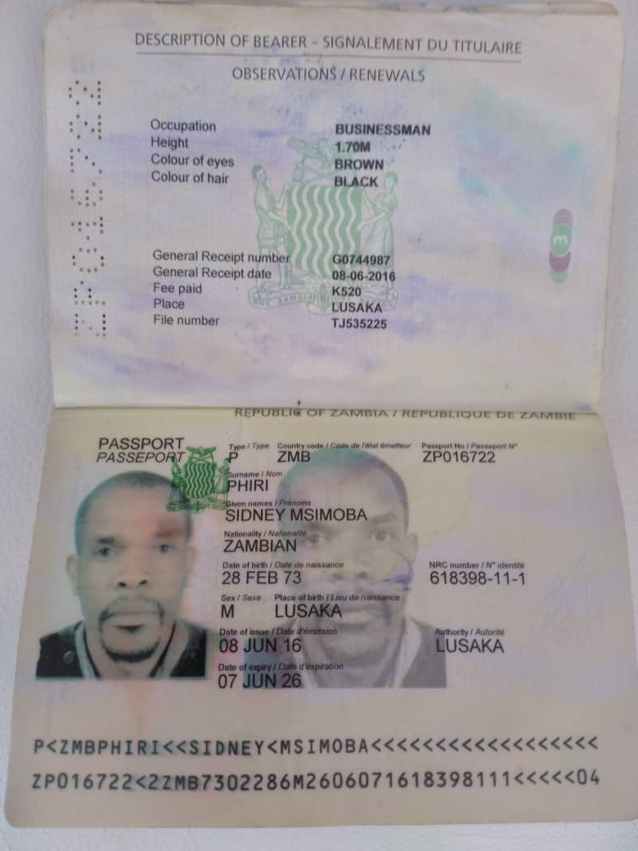**

**Seller certificate of Incorporation**

**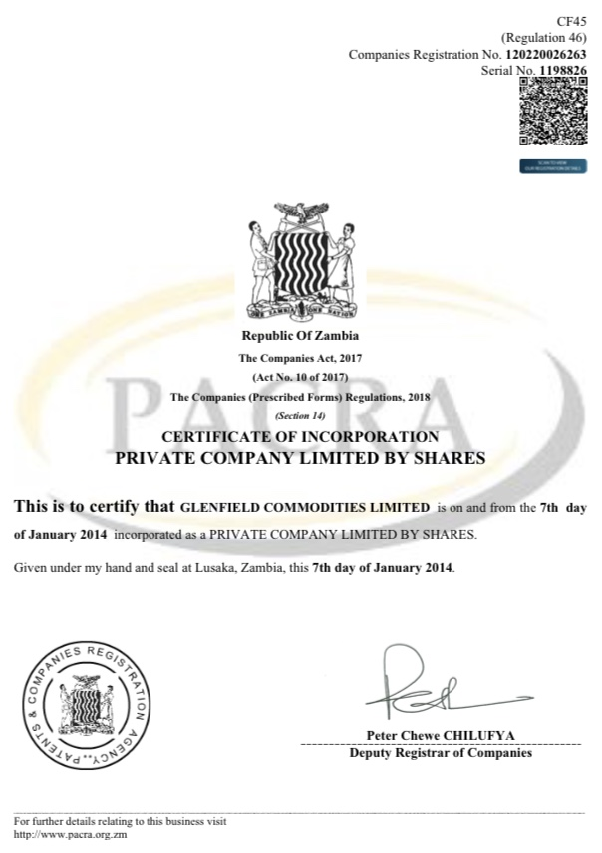**

**Buyer’s Passport Copy**

**Buyer’s certificate of Incorporation**