**Martha Restaurant**

**FLOW CHART =**

[**https://www.figma.com/file/wkqpegqknYpcZdE7uibqzI/Martha-Flow-Chart?node-id=0%3A1**](https://www.figma.com/file/wkqpegqknYpcZdE7uibqzI/Martha-Flow-Chart?node-id=0%3A1)

**DATABASE STRUCTURE =**

<https://drawsql.app/teams/code-thamizha/diagrams/martha-resturant>

**FIGMA UI DESIGN FILE =**

[**https://www.figma.com/file/qKXAc8HlM6n61uoyefUa75/Martha-Resturant?node-id=0%3A1**](https://www.figma.com/file/qKXAc8HlM6n61uoyefUa75/Martha-Resturant?node-id=0%3A1)

Final Output

<https://github.com/iamthasanthan/martharesturant.git>

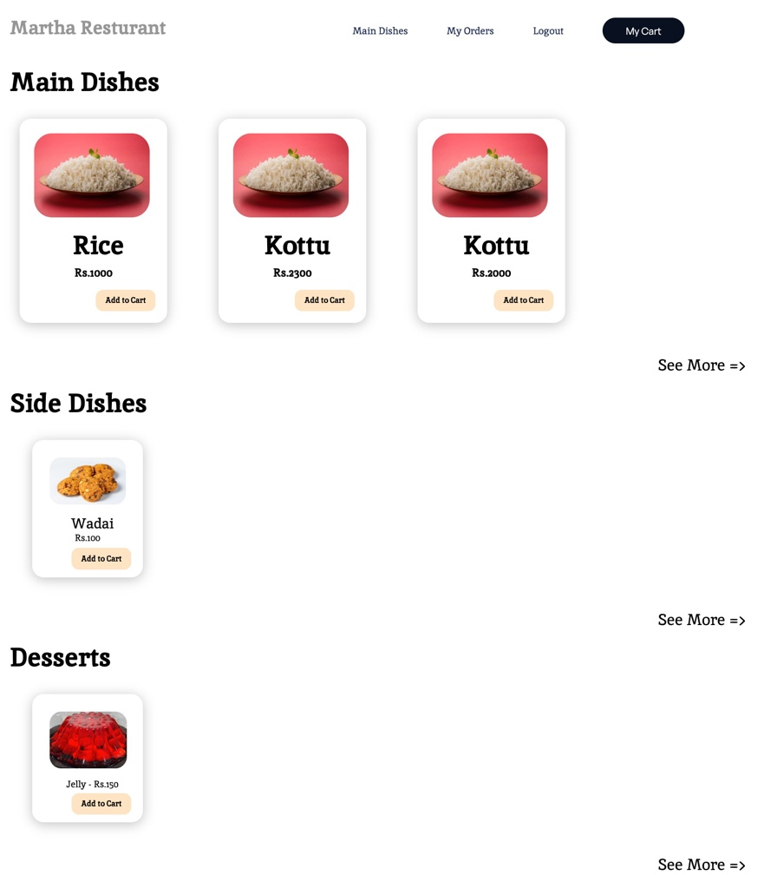

**USER GUIDE**

1. **setup your local python environment**
2. **Try ‘pip install -r requirements.txt’**
3. **And Make migrations and migrate the projects**
4. **Create super user to view admin panel**
5. **URL GUIDE**

'myorders/' – Customer Orders History

'logout/' – Logout

'login/' – Login in to portal

'register/' – Create Account

'main-dishes/' – All Main Dishes

'side-dishes/' – All Side Dishes

'desserts/' – All Desserts

'cart/' – User Cart

'waiter-portal/'. – Waiter Dashboard

**Short Tutorial Loom :**

[**https://www.loom.com/share/ce70f12893744d169f3d1d760b6a24fe**](https://www.loom.com/share/ce70f12893744d169f3d1d760b6a24fe)