Machine Learning Image Based Pest Species Identification For Embedded Systems
Joshua Mehlman, SFSU ID #903035606, JMehlman@sfsu.edu
SFSU ENGR 859 Spring 2024

Abstract
Background/Objectives (hypothesis)

Pest species are problematic in a wide variety of environments from agriculture to vulnerable ecosystems, and personal gardens. Invasive species are often intermixed with native and beneficial species, often consuming resources and causing significant dammage.

The environments these species are in often make it difficult or prohibitively expensive to use significant computational hardware. There are also often poor cellar service making a cloud based approach difficult, expensive, or impossible. Furthermore field equipment must be protected from the elements and often battery powered and can are damaged, destroyed, or stolen. These constraints require the use of low powered low cost hardware.

Methods

Results

Conclusions

Introduction
Literature Review
There have been a few projects using machine learning to detect an invasive species, even with a squirrel as the target [3][4]. However most of the work has been focused on cloud based computing[3] or using expensive and energy intensive hardware[4].

Discus the problem
In my garden we have several bird feeders. These feeders can help offset the resource scarcity that is triggered by our increasing development for the native native bird populations[]. However, invasive squirrels (Most noticeably the Eastern Fox Squirrel) will over consume the feed set out for the birds. Often a single animal will devour a weeks worth of bird feed in a single sitting. These pests are notoriously difficult to dissuade. Any garden store will be filled with failed gizmos to prevent squirrels from getting at the feed, and there are 1000s of books on the topic using a verity of techniques[], even capsaicin[].

State hypothesis (at the end)
We believe it is feasible to make a low cost, field deployable system to target a specific invasive species with a computer vision conventional neural network running on a low cost, low power micro controller.

Materials & Methods
Outline

The camera was placed in a fixed position relative to the bird feeder for each run.
Two streams of camera data were taken
- A “still” stream at QVGA (320x240), JPEG
- A BGR565 “video” stream at QVGA (320x240), YUV442

The realtime data-flow is as follows:
- Capture the still immediately on the video callback.
- Center crop the video image to 96x96
- The cropped image is converted to RGB565
- The RGB656 is sent to TFLite inference
- The results are interpreted as “Bird”, “Empty”, or “Squirrel”
- If “Bird” or “Squirrel” (Or while gathering training data)
  - The JPEG “still” is saved to SD
- A log file is written, with the inference results and save image number (-1 for no save)
- Send to serial Either:
  - Results, and tallys
  - Cropped RGB565 image stream
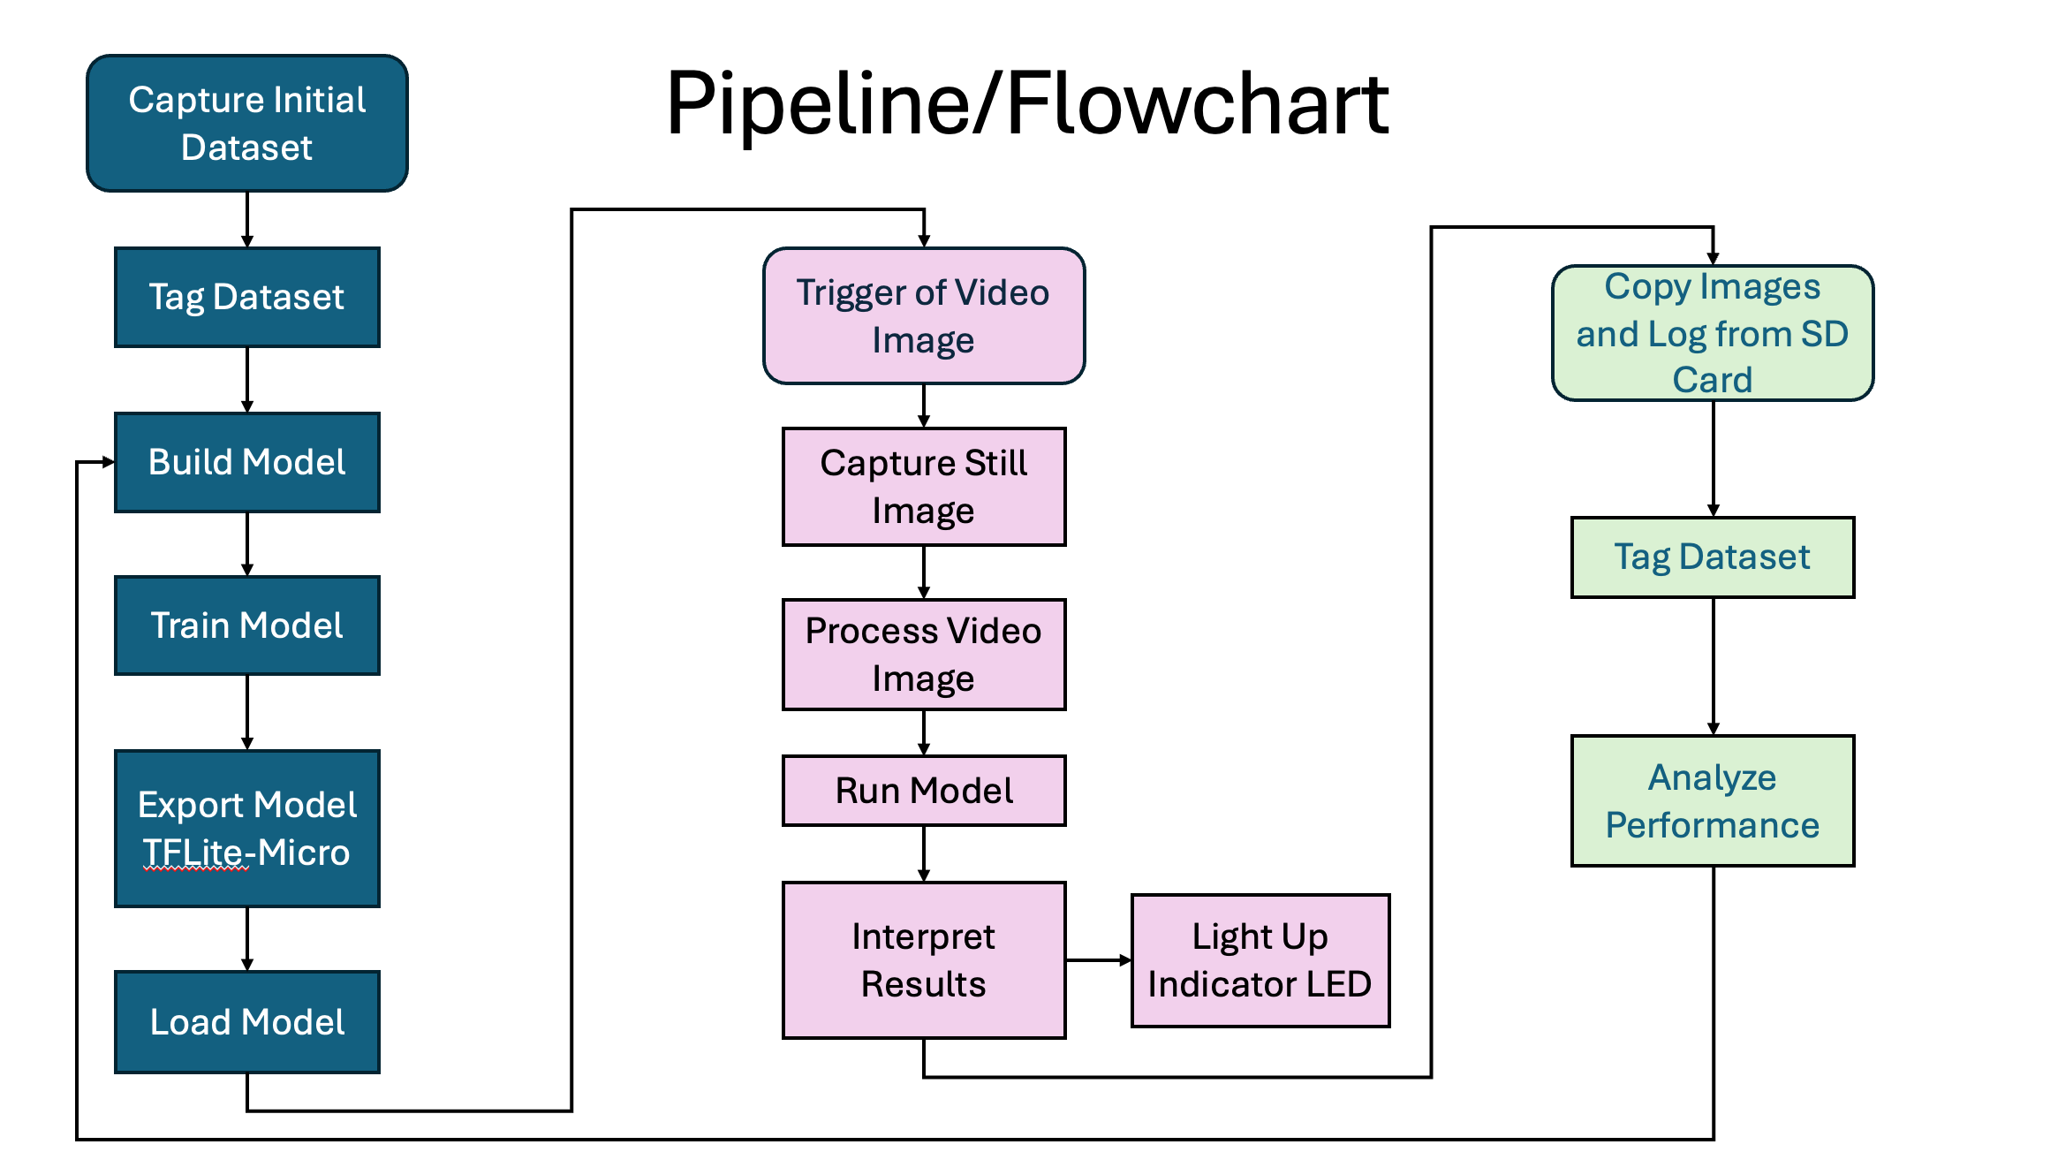

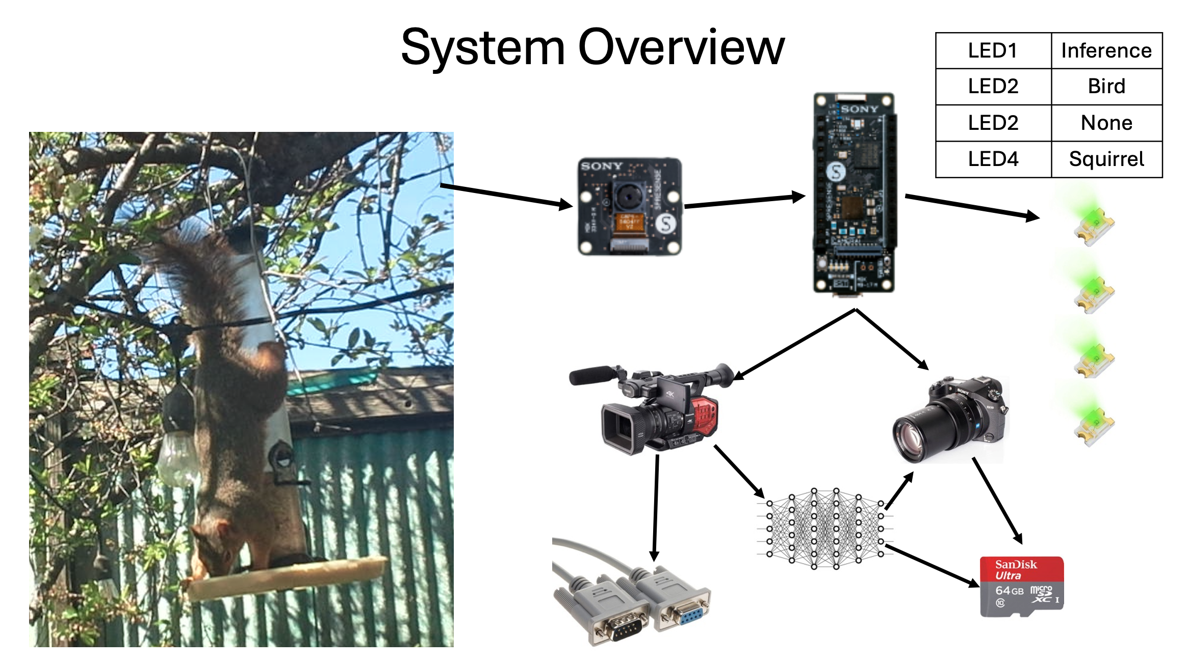

Materials
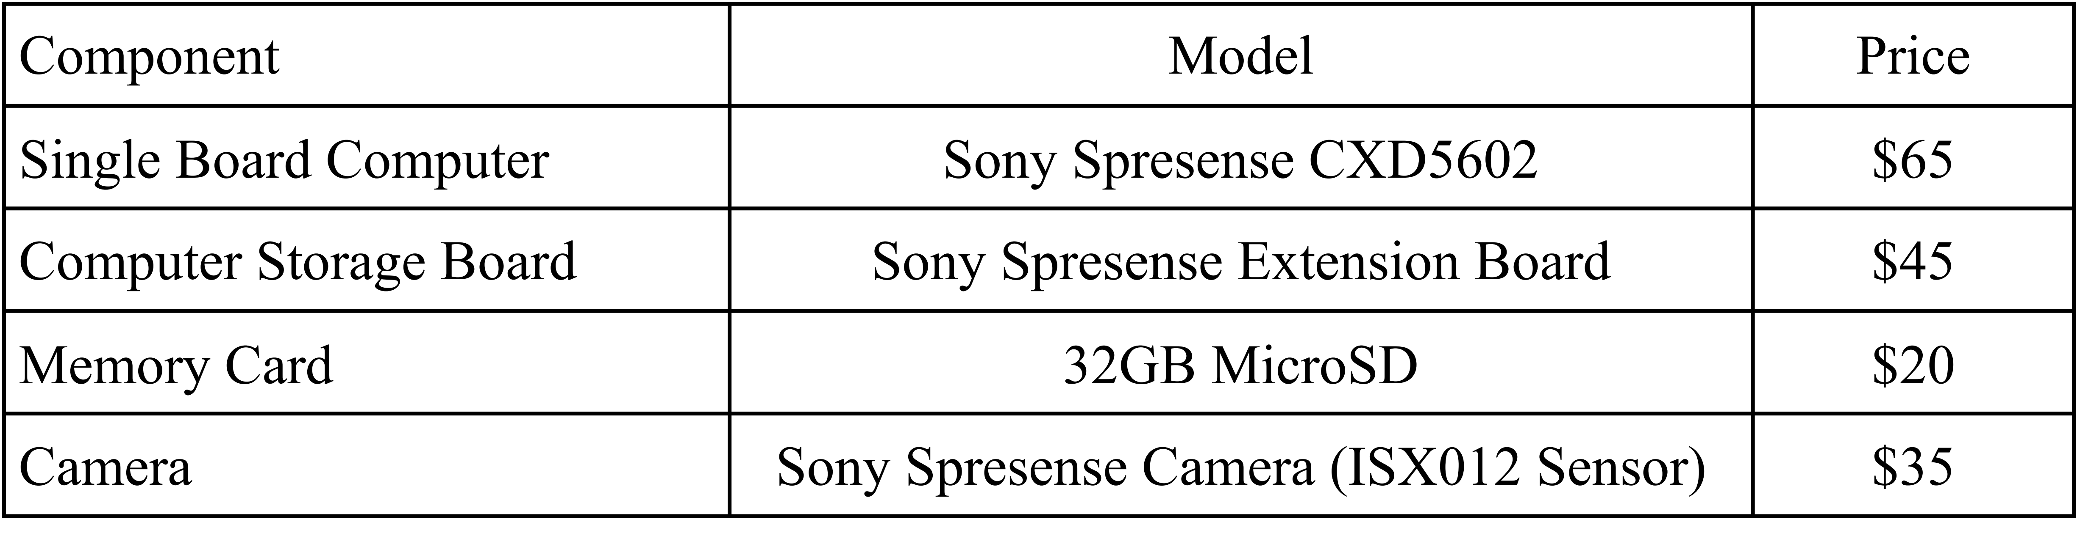
Microcontroller[2]:
- ARM Cortex-M4F @ 156 MHz
- SRAM: 1.5MB
Expansion Board
- SD Memory Card Slot
Camera
- Image Transfer: CMOS 8-Bit Parallel
- Control interface: I2C
- Sensor: 2,608x 1,960 (~5 M pixel)

The Model used was a LeNetV5 as follows (for 1 image batch):
=======================================================================================================
Layer (type (var_name)) Input Shape Output Shape Param # Trainable
=======================================================================================================
leNetV5 (leNetV5) [1, 2, 96, 96] [1, 3] -- True
├─Sequential (features) [1, 2, 96, 96] [1, 30, 22, 22] -- True
│ └─Conv2d (0) [1, 2, 96, 96] [1, 12, 98, 98] 228 True
│ └─BatchNorm2d (1) [1, 12, 98, 98] [1, 12, 98, 98] 24 True
│ └─ReLU (2) [1, 12, 98, 98] [1, 12, 98, 98] -- --
│ └─MaxPool2d (3) [1, 12, 98, 98] [1, 12, 49, 49] -- --
│ └─Conv2d (4) [1, 12, 49, 49] [1, 24, 47, 47] 2,616 True
│ └─BatchNorm2d (5) [1, 24, 47, 47] [1, 24, 47, 47] 48 True
│ └─ReLU (6) [1, 24, 47, 47] [1, 24, 47, 47] -- --
│ └─Conv2d (7) [1, 24, 47, 47] [1, 30, 45, 45] 6,510 True
│ └─BatchNorm2d (8) [1, 30, 45, 45] [1, 30, 45, 45] 60 True
│ └─ReLU (9) [1, 30, 45, 45] [1, 30, 45, 45] -- --
│ └─MaxPool2d (10) [1, 30, 45, 45] [1, 30, 22, 22] -- --
├─Sequential (linear) [1, 30, 22, 22] [1, 32] -- True
│ └─Flatten (0) [1, 30, 22, 22] [1, 14520] -- --
│ └─Linear (1) [1, 14520] [1, 32] 464,672 True
│ └─ReLU (2) [1, 32] [1, 32] -- --
│ └─Linear (3) [1, 32] [1, 32] 1,056 True
│ └─ReLU (4) [1, 32] [1, 32] -- --
├─Sequential (clasifyer) [1, 32] [1, 3] -- True
│ └─Linear (0) [1, 32] [1, 3] 99 True
=======================================================================================================
Total params : 475,313
MACs : 22,304,008
Input size (MB) : 0.07
=======================================================================================================

Image Format
The image format used is RGB565. This is a three color bitmap format.
Each color is stored is a 5-bit byte into 2 8 bit bytes as follows:

RGB565 | 8-Bit High Byte |  |  |  |  |  |  |  | 8-Bit Low Byte
8-Bit Data | 7 | 6 | 5 | 4 | 3 | 2 | 1 | 0 | 7 | 6 | 5 | 4 | 3 | 2 | 1 | 0
5-Bit Data | x | R4 | R3 | R2 | R1 | R0 | G4 | G3 | G2 | G1 | G0 | B4 | B3 | B2 | B1 | B0

The image input is therefore 2x96x96 = 18,432 bytes

Training procedure:
- Image format conversion
- Image augmentation
- Hyperperamiters

Installing model on a MicroProcessor:
Once the model was built and trained it was converted to TensorFlow Lite for Microcontrollers:
- Convert the model to ONNX using torch.onnx
  - Required input: Image Shape (2x96x96)
- Convert the ONNX file to TensorFlow using onnx2tf
  - Required input: mean and std of training images by pixel
- Export the TensorFlow file to TensorFlow Lite
  - Quantization of the model from 32 Bit Float to 8 Bit Int is done at this step.
    - Required input: Representative dataset
  - The input and output are held at 32 Bit Floats
- Hex dump the TensorFlow Lite file using xdd to save as a c header
  - shell> xxd -i leNetV5.tflite > leNetV5

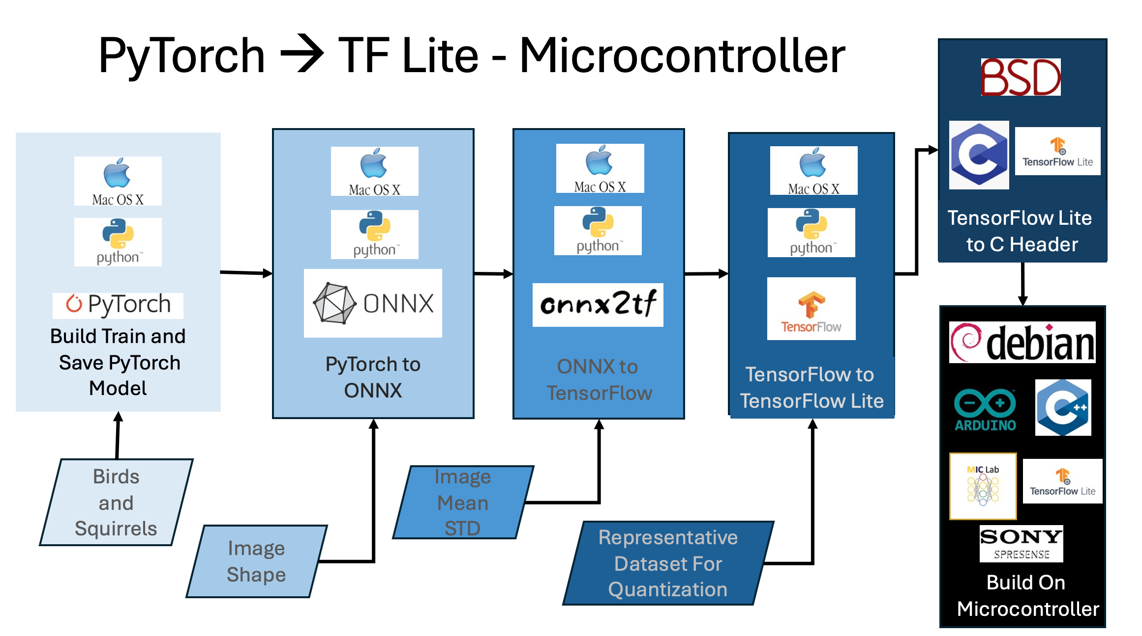

Quantization Sumary
Float 32 | 1,961 kB
Float 16 | 956 kB
Float 8 | 482 kB

The model size + the input image size is 18 kB + 482 kB = 500 kB

describe analysis tecquecs

Summary of Software written:
Module | Hardware/OS/Platform | File | Language
RealTime | Sony SpreSense/Arduino | sqVB1rd_art.ino | C++
RealTime | TensorFlow Lite | RGB2BGRleNetV5_trained.h | C Header
Serial Image Display | Processing: https://processing.org/ | processingScript.pde | Java
Image Capture/First Attempt at RealTime | Sony SpreSense/SDK | sqb_main.c, camera.c, camera.h, cardUtils.c, cartdUtils.h, DSC.config | C
Data Augmentation | DataAugment.py |  | Python
Image Loading | TorchVision | DataPreparation.py | Python
Convert Image | CV2 | BGR2RGB565.py | Python
Rename Images |  | fileOpps.py | Python
Model Training | PyTorch | main.py | Python
Model Definition | PyTorch | Model.py | Python
Model Training | PyTorch | Trainer.py | Python
Model Converting |  | saveModel.py | Python
Model Converting | *NIX | xxd -i leNetV5.tflite > foo.h | Unix Shell
Model Optimization (not used) | MIC Pruning Engine | optimize.py | Python
Model Validation | Tensor Flow | RunTfLite.py | Python
Model Validation | PyTorch | validate.py | Python
Data Analysis | Torch Metrics/SSklearn | analysis.py | Python
Model Analysis | thop | OpCounter.py | Python

Results
Present data
tables, figures etc.

Discussion
interpret results
explain meaning
discus limitations
suggest future work

Resources/References
- Krause, S. K., Kelt, D. A., & Van Vuren, D. H. (2010). Invasion, damage, and control options for eastern fox squirrels. In Proceedings of the Vertebrate Pest Conference (Vol. 24, No. 24).
- Anderies, J. M., Katti, M., & Shochat, E. (2007). Living in the city: resource availability, predation, and bird population dynamics in urban areas. Journal of theoretical biology, 247(1), 36-49.
- Koehler, A. E., Marsh, R. E., & Salmon, T. P. (1990). Frightening methods and devices/stimuli to prevent mammal damage--a review.
- Chapman, J. B. (1996). Effectiveness of capsaicin as a squirrel repellent at bird feeders. Mississippi State University.
- https://developer.sony.com/spresense/product-specifications
- Singla, N. (2014). Motion detection based on frame difference method. International Journal of Information & Computation Technology, 4(15), 1559-1565.
- LeCun, Y., Boser, B., Denker, J. S., Henderson, D., Howard, R. E., Hubbard, W., & Jackel, L. D. (1989). Backpropagation applied to handwritten zip code recognition. Neural computation, 1(4), 541-551.
- Paini, D. R., Sheppard, A. W., Cook, D. C., De Barro, P. J., Worner, S. P., & Thomas, M. B. (2016). Global threat to agriculture from invasive species. Proceedings of the National Academy of Sciences, 113(27), 7575-7579.
- King Nicola, Sadowski, (2001) ML-based Bird and Squirrel Detector, MagPi, https://magpi.raspberrypi.com/articles/ml-based-bird-and-squirrel-detector
- T. Mary. (2021). Solving the Problem of Squirrels Stealing from the Bird feeder: Prototyping Image Classification with the Deep Learning Workbench in Intel® DevCloud for the Edge. Intel Community, https://community.intel.com/t5/Blogs/Tech-Innovation/Artificial-Intelligence-AI/Solving-the-Problem-of-Squirrels-Stealing-from-the-Bird-feeder/post/1335676
- Sultana, F., Sufian, A., & Dutta, P. (2020). A review of object detection models based on convolutional neural network. Intelligent computing: image processing based applications, 1-16.

