
SFSU Engineering

ENGR 478
On Device Machine Learning
(Prof. Zhuwei Qin)

Final Project Proposal
Machine Learning Image Based Pest Species Identification For Embedded Systems

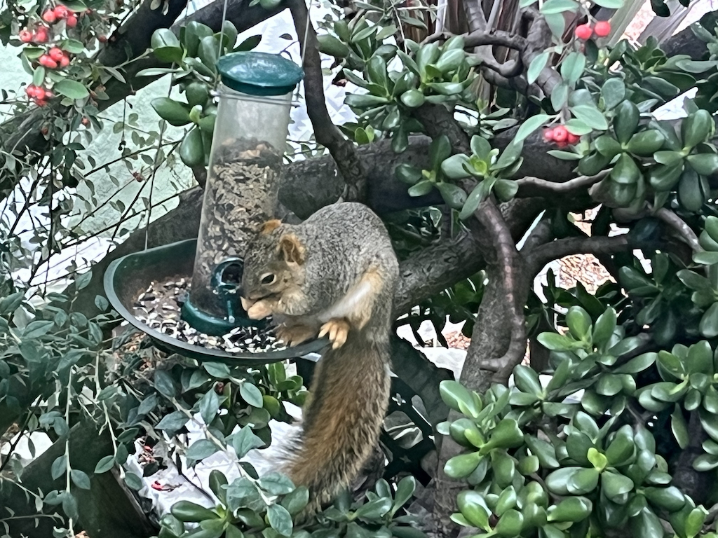

Joshua Mehlman, SFSU ID: 903035606, JMehlman@sfsu.edu
Background and Significance:
Pest species can be problematic in a wide variety of environments from agriculture to vulnerable ecosystems, and even personal gardens. Invasive species are often intermixed with native and beneficial species, often consuming resources and causing significant dammage.

The environments these species are in often make it difficult or prohibitively expensive to use significant computational hardware. There are also often poor cellar service making a cloud based approach impossible. Furthermore field equipment must be protected from the elements and often battery powered and often are damaged, destroyed, or stolen.. These constraints require the use of low powered low cost hardware.

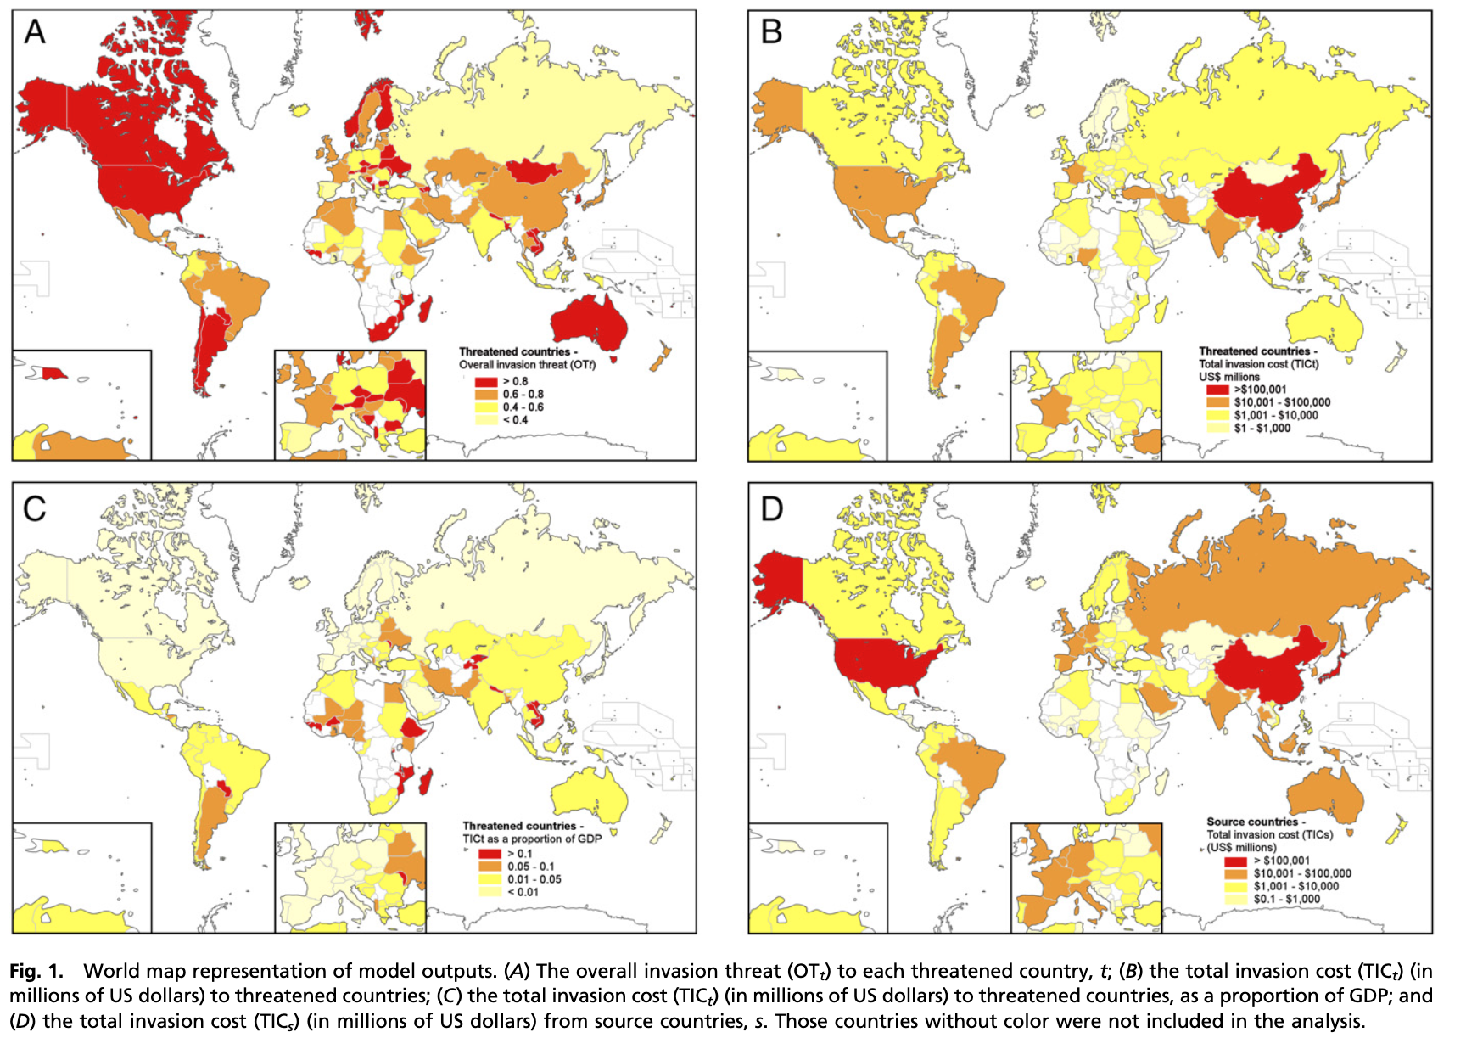
Fig x, Invasion Species Threat [1]

Research Goals:
A The system will be able to differentiate the target species from non-target species, or no species presnt:
- Target Species – Eastern Fox Squirrel, Invasive[2]
- Non-Target Species – Any Bird
- No-Species – There are no animals in view

The system will notify when the target species is present.
The system will be low cost so that if the hardware is damaged, destroyed or stolen during field deployment it will not be a significant financial burden.
- Board Cost
- Carrier Cost
- Camera Cost

The system will be on low power hardware so that it can be installed in a waterproof enclosure outdoors without overheating, and will require minimal power.

Literature Review:
There have been a few projects using machine learning to detect an invasive species, even with a squirrel as the target [3][4]. However most of the work has been focused on cloud based computing[3] or using expensive and energy intensive hardware[4].

Motion detection can be accomplished by generating a pixel by pixel difference between two successive frames [5].

Possibilities for the detection model include SSD, YOLO, RetinaNet, and RefineDet[6]. All single stage object detector/classifiers that are optimized for real time detection. Note, Sultana classifies SSD as a non Real time Detection, however it is more than fast enough for the task at hand.

Design and methodology:

Based on the system requirements that hardware selected is:
Component | Model | Price
Single Board Copmputer | Sony Spresense CXD5602 | $65
Computer Storage Board | Sony Spresense Extension Board | $45
Memory Card | 32GB MicroSD | $20
Camera | Sony Spresense Camera (ISX012 Sensor) | $35

A non-trapping lure will be set up with a camera aimed at it (referred to as: feeder, or bird feeder).

The camera will be set up in a fixed location with good daytime view of the lure.

The board will be set up to save a picture on motion detect. This will be done by subtracting successive frames[5] and summing the frame difference as a trigger score. Since the largest false trigger source is a tree, it will be interesting to not include the “G” channel. A convolutional averaging filter might also help to remove false positives. It should be noted that having some false positives will not affect the outcome as the images will be sent to a classifier that will be trained on negatives. In fact, having some false positives will be necessary to gather the training images.

A pre-trained machine vision model will be selected based on performance on sample images.

During the training and model selection phases images captured will be manual annotated (Squirrel, Bird, None), then used to train the ML model classifier, and to tune the model to the specific dataset.

During the testing phase images captured will be sent direction to the model. The hardware will notify via status indicators if the system is detecting an animal, and if that animal is a squirrel or a bird.

Expected outcomes:
The system will trigger on motion detect, make a prediction if this is a squirrel, bird or nothing. The system will notify on motion, and classification. The goal will be to achieve an 80% sensitivity.

Timeline:
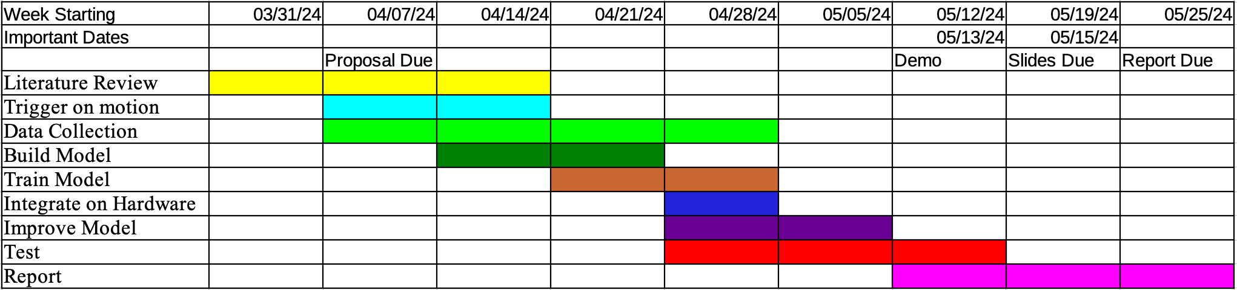
Figure x: Project Timeline

References
- Paini, D. R., Sheppard, A. W., Cook, D. C., De Barro, P. J., Worner, S. P., & Thomas, M. B. (2016). Global threat to agriculture from invasive species. Proceedings of the National Academy of Sciences, 113(27), 7575-7579.
- Krause, S. K., Kelt, D. A., & Van Vuren, D. H. (2010). Invasion, damage, and control options for eastern fox squirrels. In Proceedings of the Vertebrate Pest Conference (Vol. 24, No. 24).
- King Nicola, Sadowski, (2001) ML-based Bird and Squirrel Detector, MagPi, https://magpi.raspberrypi.com/articles/ml-based-bird-and-squirrel-detector
- T. Mary. (2021). Solving the Problem of Squirrels Stealing from the Bird feeder: Prototyping Image Classification with the Deep Learning Workbench in Intel® DevCloud for the Edge. Intel Community, https://community.intel.com/t5/Blogs/Tech-Innovation/Artificial-Intelligence-AI/Solving-the-Problem-of-Squirrels-Stealing-from-the-Bird-feeder/post/1335676
- Singla, N. (2014). Motion detection based on frame difference method. International Journal of Information & Computation Technology, 4(15), 1559-1565.
- Sultana, F., Sufian, A., & Dutta, P. (2020). A review of object detection models based on convolutional neural network. Intelligent computing: image processing based applications, 1-16.

