Report
Of
PraDCT and PrakritM2M:
Directional Checkpoint Transfer for
Low-Resource Prakrit-English
Neural Machine Translation
Submitted
To
School of Computer Science and Engineering
IILM University, Greater Noida, U.P.
In partial fulfilment of the requirement of degree of
B.Tech CSE

By
Roll Number of Student: CS-23411324
Name of Student: HIMANSH RAJ
Program & Semester: B.Tech CSE | Semester: VII
Batch: 2023-2027
2026-27

CANDIDATE'S DECLARATION
I, Himansh Raj, hereby declare that the internship report titled "PraDCT and PrakritM2M: Directional Checkpoint Transfer for Low-Resource Prakrit-English Neural Machine Translation" has been prepared by me in partial fulfilment of the requirements for the award of the degree of Bachelor of Technology in Computer Science and Engineering.
The work described in this report was carried out during my research internship at the Machine Intelligence Signals and Networks Lab, Indian Institute of Technology Delhi. All external datasets, software libraries, research papers, and other resources used during the work have been appropriately acknowledged. This report has not been submitted to any other institute for the award of any degree or diploma. I accept responsibility for the originality and academic integrity of the submitted work.
Signature: 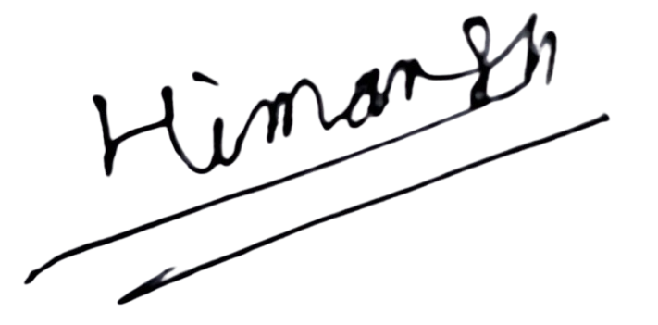
Student Name: Himansh Raj
Roll No.: CS-23411324
Date: 28 August 2026

ACKNOWLEDGEMENT
I express my sincere gratitude to Dr. Sandeep Kumar, Associate Professor at the Indian Institute of Technology Delhi, for providing me with the opportunity to undertake a research internship at the Machine Intelligence Signals and Networks Lab. His guidance and the research environment of the laboratory helped me approach an open-ended machine learning problem through data preparation, experimentation, evaluation, and critical analysis.
I am thankful to the Department of Electrical Engineering, the Yardi School of Artificial Intelligence, and the wider research community at IIT Delhi for providing an interdisciplinary environment for this work. I also acknowledge the developers and maintainers of the open-source datasets, pretrained models, and software libraries used in the project.
I thank the faculty members of the School of Computer Science and Engineering, IILM University, for their academic support. Finally, I express my gratitude to my parents and family for their encouragement throughout the internship.
Signature: 
Student Name: Himansh Raj
Roll No.: CS-23411324

TABLE OF CONTENTS
Chapter  No. | Chapter Name | Page  Nos.
 | Cover Page | ----
1. | Candidate's Declaration | i
2. | Acknowledgement | ii
3. | Internship Completion Certificate | ----
4. | Project Description  4.1 Introduction  4.2 Organization Profile  4.3 Problem Statement  4.4 Project Objectives  4.5 Scope of the Project  4.6 Technologies and Tools Used  4.7 System Architecture  4.8 Methodology  4.9 Expected and Achieved Outcomes  4.10 Internship Completion Certificate and Communication Evidence | 1  1  2  3  3  4  5  6  7  11  13
5. | Bibliography / References | 15

LIST OF TABLES
Table | Title | Page
4.1 | Internship placement details | 2
4.2 | Technologies and tools used | 5
4.3 | Curated dataset inventory | 7
4.4 | Evaluation-split similarity audit | 8
4.5 | Exploratory model experiments | 8
4.6 | Final translation training configuration | 8
4.7 | Synthetic-data generation summary | 9
4.8 | Prakrit-Sanskrit lexical experiment | 10
4.9 | Expected and achieved project outcomes | 11
4.10 | Limitations, implications, and next actions | 12

LIST OF FIGURES
Figure | Title | Page
4.1 | PraDCT and PrakritM2M system architecture | 6
4.2 | Directional checkpoint transfer sequence | 8
4.3 | Synthetic candidate generation and stability filtering | 9
4.4 | Automatic evaluation results | 11

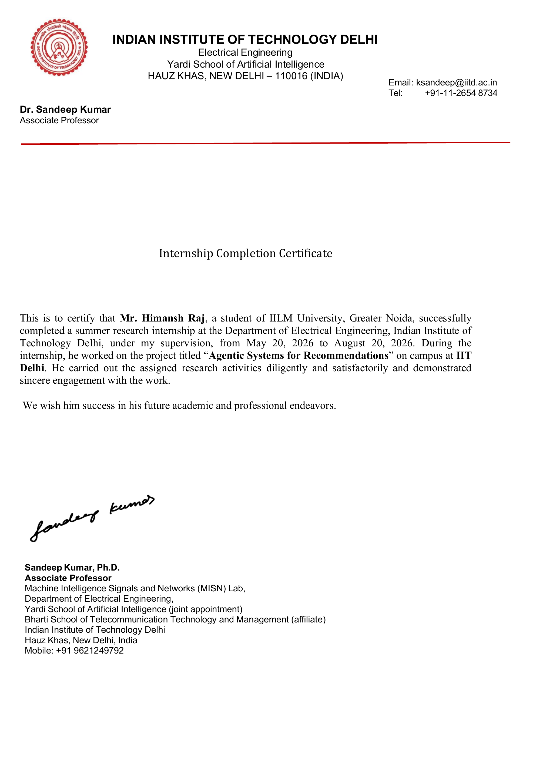

INTERNSHIP OFFER LETTER - SUPPORTING DOCUMENT
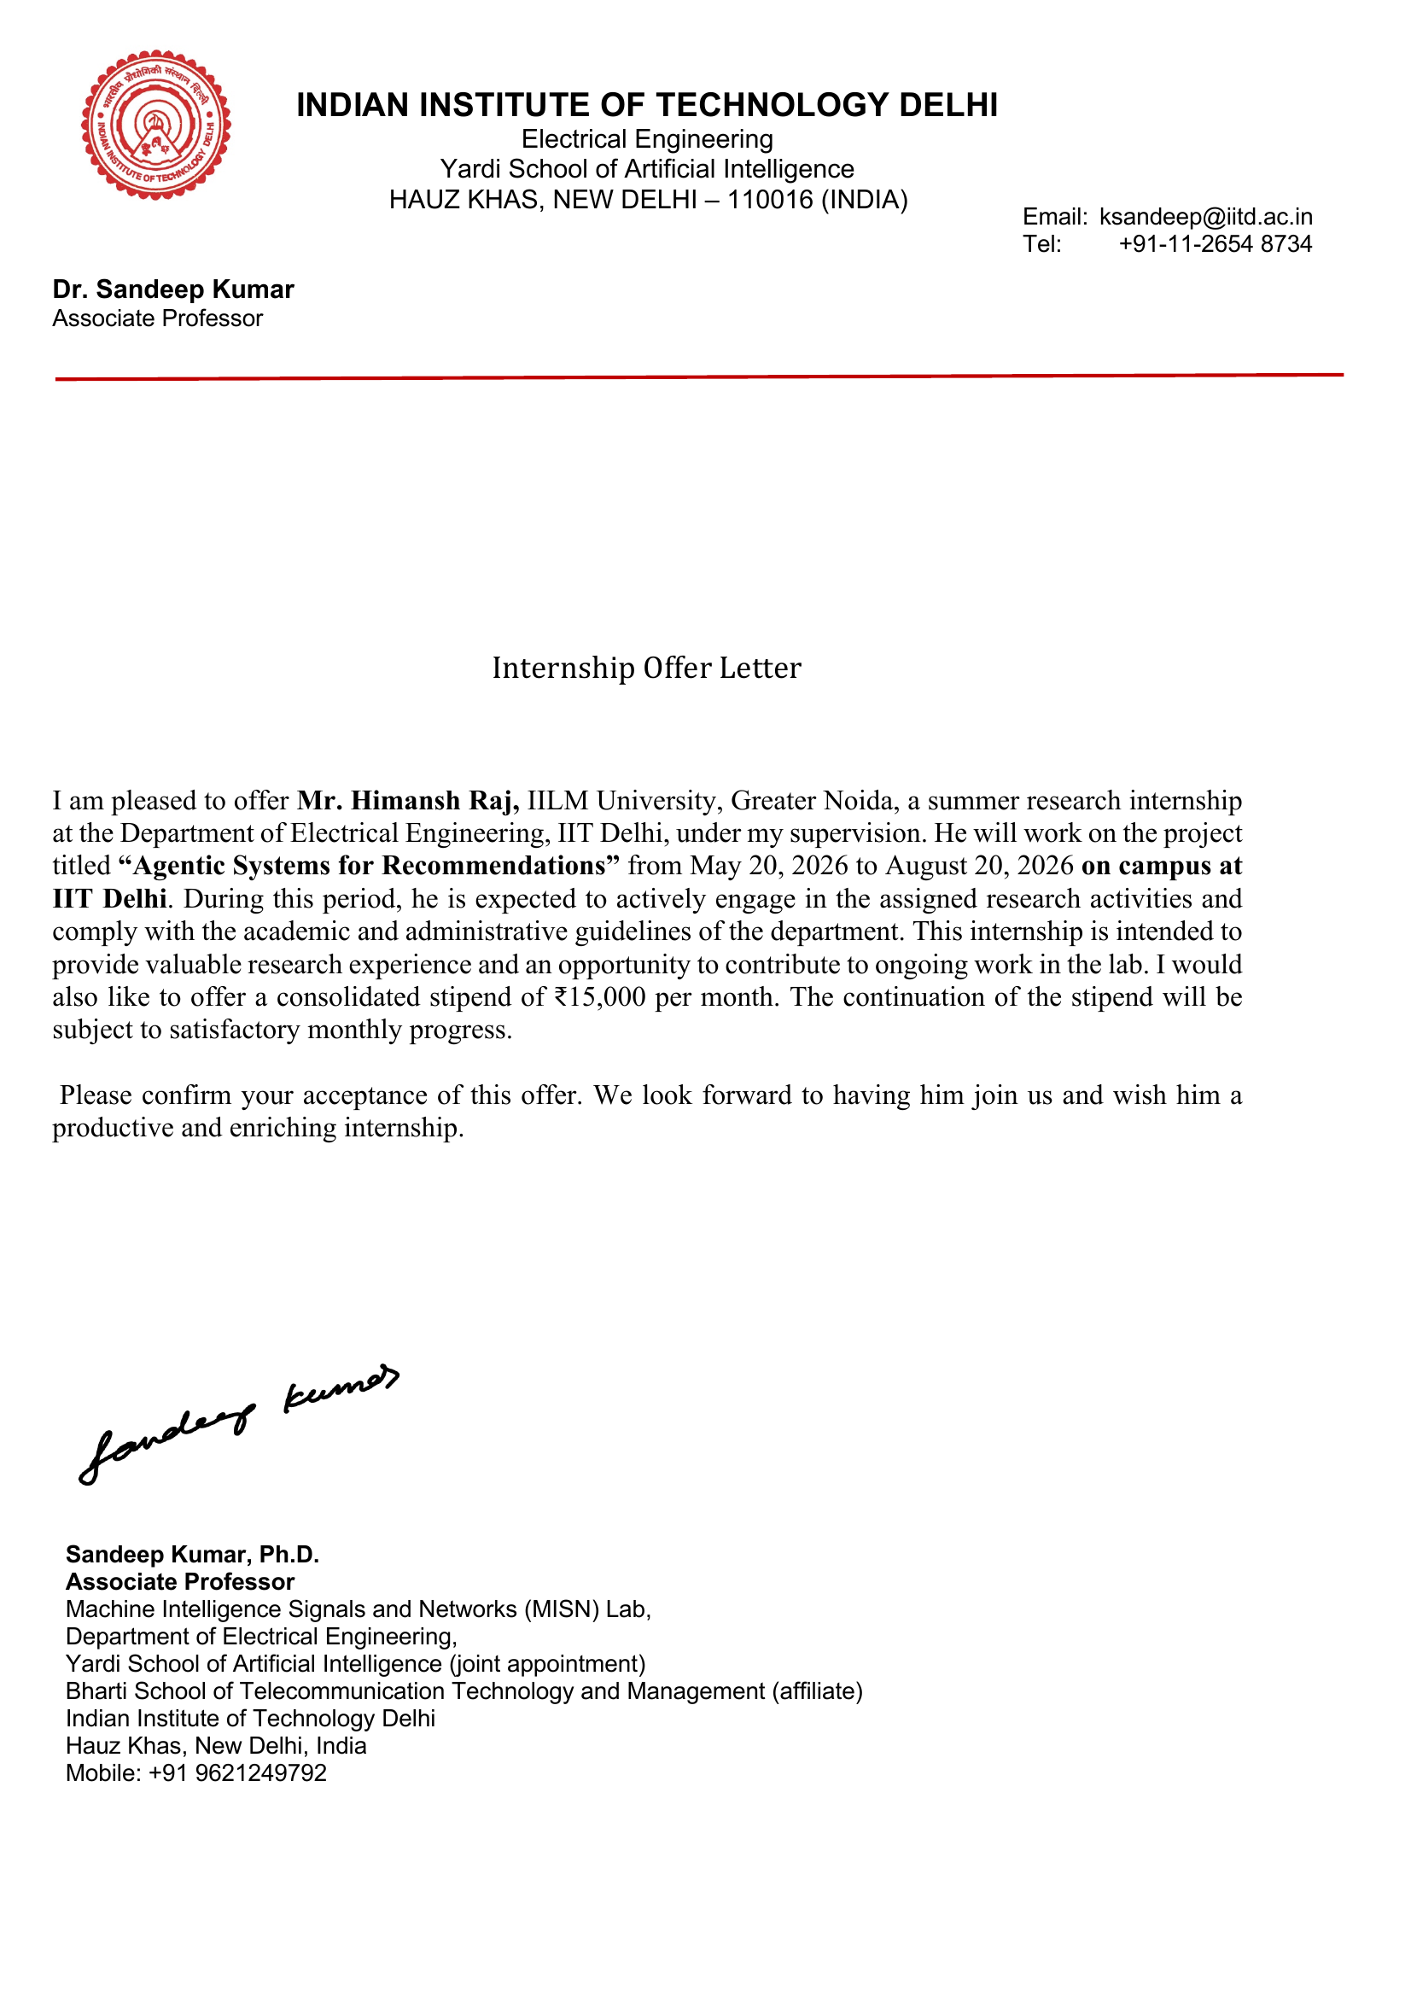

4. PROJECT DESCRIPTION

4.1 Introduction
Prakrit refers to a historically important group of Middle Indo-Aryan languages associated with literature, inscriptions, dramatic works, Jain traditions, and other historical sources. Its dialectal and grammatical diversity is well documented in linguistic scholarship [18]. Despite this cultural value, Prakrit remains severely under-represented in contemporary natural language processing, where reliable aligned Prakrit-English data are scarce.
Low-resource machine translation is affected by small parallel corpora, domain mismatch, noisy text, and unstable evaluation [4]. This internship investigated whether pretrained multilingual translation models could be adapted to Prakrit using a curated seed corpus, directional checkpoint transfer, and a separately auditable synthetic-data pipeline.
PraDCT means Prakrit Directional Checkpoint Transfer. The method first trains a Prakrit-to-English model, selects its best checkpoint, and uses that checkpoint to initialize the reverse English-to-Prakrit direction. PrakritM2M is the model family built by adapting M2M-100-418M [1], with PrakritM2M-P2E and PrakritM2M-E2P denoting the two translation directions.
The project also included an exploratory Prakrit-to-Sanskrit lexical task, comparisons with NLLB and IndicTrans2, a near-duplicate audit, and large-scale synthetic candidate generation. A recent 2026 preprint independently explored English-to-Prakrit transfer learning with a smaller Maharashtri Prakrit corpus [5]. Accordingly, this report does not claim the first Prakrit translation system; its contribution is a bidirectional M2M-100-based workflow with directional transfer, synthetic-resource filtering, lexical analysis, and explicit evaluation caveats.

Major Contributions
• Construction and cleaning of a 1,696-pair Prakrit-English seed corpus.
• Development of Prakrit-to-English and English-to-Prakrit model variants.
• Directional checkpoint transfer from the selected P2E checkpoint to E2P training.
• Generation and filtering of a 1.51-million-record synthetic resource.
• Exploratory Prakrit-to-Sanskrit lexical mapping, near-duplicate auditing, and reproducibility analysis.

4.2 Organization Profile
The internship was conducted on campus at the Machine Intelligence Signals and Networks (MISN) Lab, Indian Institute of Technology Delhi, from 20 May 2026 to 20 August 2026. The laboratory is associated with the Department of Electrical Engineering and operates in an interdisciplinary environment that connects machine learning, signal processing, optimization, networks, and intelligent systems.
The internship was supervised by Dr. Sandeep Kumar, Associate Professor at IIT Delhi. The official offer letter also identifies his joint appointment with the Yardi School of Artificial Intelligence and affiliation with the Bharti School of Telecommunication Technology and Management. This setting supported research-oriented experimentation, documentation, and critical interpretation of results.
Table 4.1: Internship placement details
Field | Details
Student | Himansh Raj
Host organization | Machine Intelligence Signals and Networks (MISN) Lab, IIT Delhi
Department | Department of Electrical Engineering
Supervisor | Dr. Sandeep Kumar, Associate Professor
Internship period | 20 May 2026 to 20 August 2026
Mode | On campus at IIT Delhi, Hauz Khas, New Delhi

Administrative note: the supplied offer letter records the appointment title "Agentic Systems for Recommendations." In accordance with the academic submission request, this report documents the Prakrit machine translation research work selected for internship evaluation.

4.3 Problem Statement
Modern neural machine translation normally depends on large, clean, and representative parallel corpora. Available Prakrit resources are small, fragmented, inconsistent in script and orthography, and drawn from different dialectal or editorial traditions. These properties make standard supervised training unreliable and complicate the interpretation of automatic evaluation scores.
• Very little aligned Prakrit-English training data is publicly available.
• Prakrit is not directly supported by many mainstream multilingual translation systems.
• IAST and Devanagari representations require consistent normalization.
• Dialectal and orthographic variation can produce multiple valid surface forms.
• Small evaluation sets are vulnerable to near-duplicate leakage and score inflation.
• Synthetic translations may increase volume while also reproducing model errors at scale.
• Exact-match evaluation is harsh for lexical outputs with legitimate morphological variation.
Central research question: Can a multilingual model be adapted to Prakrit using a small curated corpus, directional checkpoint transfer, and quality-controlled synthetic generation while openly documenting the limitations of the resulting evaluation?

4.4 Project Objectives
1. Study multilingual and low-resource neural machine translation methods.
2. Acquire, normalize, and consolidate publicly available Prakrit-English resources.
3. Create a cleaned seed corpus with documented filtering and splitting decisions.
4. Train a Prakrit-to-English model using multilingual transfer learning.
5. Initialize English-to-Prakrit training from the selected P2E checkpoint through PraDCT.
6. Compare the selected system with exploratory NLLB and IndicTrans2 experiments.
7. Generate three synthetic Prakrit candidates for each sentence in a large English pool.
8. Filter synthetic records with a transparent candidate-stability criterion.
9. Explore Prakrit-to-Sanskrit lexical mapping as an auxiliary task.
10. Evaluate translation and lexical outputs while auditing leakage and reproducibility risks.
11. Document successful, unsuccessful, and incomplete experimental paths for future work.

4.5 Scope of the Project
The project focused on sentence-level text translation between Prakrit and English, together with an auxiliary Prakrit-to-Sanskrit lexical experiment. The main computational scope was normalized Devanagari text, multilingual Transformer adaptation, synthetic candidate generation, and automatic evaluation. It was designed as a research baseline rather than a production service.

Included in Scope
• Dataset acquisition, cleaning, script normalization, and exact deduplication.
• Construction and audit of training and evaluation splits.
• Full fine-tuning of M2M-100-418M and exploratory low-rank adaptation.
• Bidirectional Prakrit-English translation and directional checkpoint transfer.
• Large-scale inference, candidate-stability filtering, and rejected-record archiving.
• BLEU, exact-match, longest-common-subsequence, and prefix-based evaluation.

Outside the Scope
• Optical character recognition of manuscripts or handwritten source recovery.
• A universal model covering every Prakrit dialect, historical period, or editorial convention.
• A commercial translation service or authoritative replacement for philological interpretation.
• Large-scale expert human evaluation or claims of complete semantic and grammatical accuracy.

4.6 Technologies and Tools Used
The implementation combined open-source machine-learning libraries, multilingual translation checkpoints, and data-processing tools. Only functions supported by the available project records are listed; exact package versions should be copied from the original environment before archival.
Table 4.2: Technologies and tools used
Technology / Tool | Role in the Project
Python | Data preparation, training, evaluation, and experiment automation
PyTorch | Neural model training and GPU execution
Hugging Face Transformers | Loading and fine-tuning multilingual sequence-to-sequence models [12]
Hugging Face Datasets | Dataset loading, transformation, and caching
M2M-100-418M | Final multilingual base checkpoint for PrakritM2M [1]
NLLB-200 | Exploratory multilingual baseline [2]
IndicTrans2 | Exploratory Indic-language transfer baseline [3]
LoRA | Parameter-efficient exploratory adaptation [10]
CTranslate2 | Efficient batched inference for synthetic generation [11]
SentencePiece | Subword tokenization used by multilingual models [9]
FP16 mixed precision | Reduced memory use and accelerated training
AdamW | Optimizer for full fine-tuning [13]
BLEU / SacreBLEU | Automatic translation evaluation [7, 8]
NumPy and pandas | Data analysis and result tabulation
Git | Source-code and experiment tracking

4.7 System Architecture
The system was organized into three connected paths. The supervised translation path created the seed corpus and trained the two PrakritM2M directions. The synthetic-resource path used the E2P checkpoint for high-throughput candidate generation and stability filtering. The auxiliary lexical path cleaned Prakrit-Sanskrit mappings and evaluated partial-form learning.
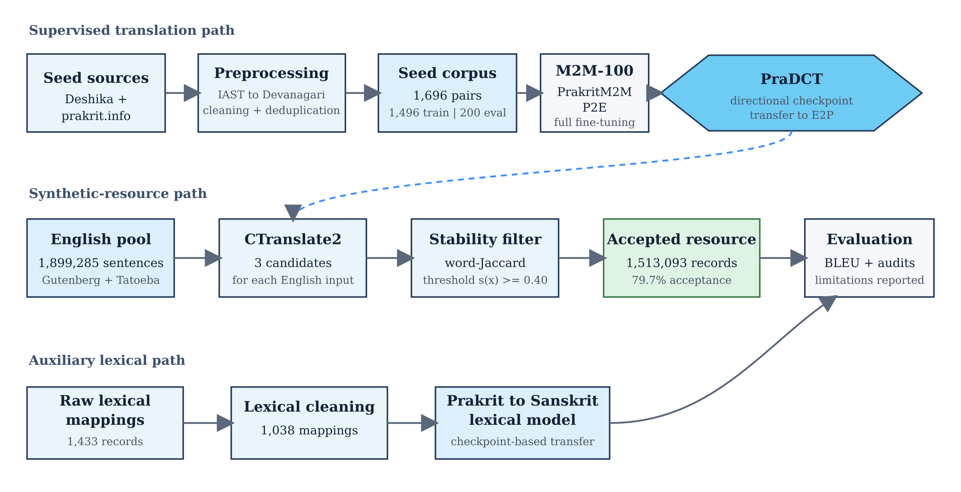
Figure 4.1: PraDCT and PrakritM2M system architecture

Architecture Components
• Data layer: heterogeneous parallel, monolingual, and lexical resources.
• Normalization layer: transliteration, language validation, filtering, and exact deduplication.
• Model layer: M2M-100 adaptation, checkpoint selection, and reverse-direction transfer.
• Generation layer: CTranslate2 decoding with three candidates per input.
• Evaluation layer: translation metrics, lexical metrics, near-duplicate audits, and limitation reporting.

4.8 Methodology

4.8.1 Literature and Baseline Study
M2M-100 demonstrated direct multilingual translation without routing every language pair through English [1]. NLLB subsequently expanded multilingual coverage to 200 languages [2], while IndicTrans2 provided open models for all 22 scheduled Indian languages [3]. These systems motivated transfer learning from multilingual checkpoints instead of training a Prakrit model from random initialization.
The low-resource MT literature emphasizes multilingual transfer, synthetic data, back-translation, careful filtering, and conservative evaluation [4, 6]. LoRA was explored as a parameter-efficient alternative [10], but the final PrakritM2M result used full M2M-100 fine-tuning. BLEU was retained as the primary translation score, with reporting caveats because BLEU measures n-gram overlap rather than direct semantic correctness [7, 8].

4.8.2 Data Acquisition and Preprocessing
The seed parallel corpus combined the Deshika dataset [14] with material collected from prakrit.info [15]. Non-Devanagari IAST content was transliterated to Devanagari, the English side was checked with language identification, punctuation was removed or normalized, records shorter than three characters were dropped, and exact duplicates were removed. Rejected records and intermediate counts were retained for reproducibility.
Table 4.3: Curated dataset inventory
Resource | Raw / Source Count | Usable Count | Project Split or Use
Deshika Prakrit-English | 1,212 | 1,212 | Combined seed corpus
prakrit.info Prakrit-English | 484 | 484 | Combined seed corpus
Combined parallel seed | 1,696 | 1,696 | 1,496 train / 200 evaluation
English monolingual pool | 1,899,285 | 1,899,285 | Synthetic candidate generation
Prakrit-Sanskrit lexical | 1,433 | 1,038 | 934 train / 104 evaluation

The seed split did not use a dedicated independent test set. The same 200-pair evaluation set was used for checkpoint selection and final reporting, so results describe performance on the project split rather than definitive out-of-domain generalization.

4.8.3 Evaluation-Split Audit
A character-trigram Jaccard audit measured similarity between each evaluation record and the training corpus. The audit revealed several highly similar pairs and therefore provides necessary context for the high Prakrit-to-English BLEU score.
Table 4.4: Evaluation-split similarity audit
Audit Measure | Result | Interpretation
Evaluation records | 200 | Small held-out project split
Maximum similarity >= 0.90 | 12 / 200 | Very close or near-duplicate relationship
Maximum similarity >= 0.70 | 33 / 200 | Substantial lexical overlap
Mean maximum similarity | 0.39 | Moderate average proximity to training data

4.8.4 Exploratory Model Experiments
NLLB-200, IndicTrans2, LoRA-based adaptation, full fine-tuning, and reinforcement-learning paths were explored. The following results used different training budgets and are not a controlled leaderboard. They are preserved as evidence of the development path rather than used to claim strict model superiority.
Table 4.5: Exploratory model experiments
Model / Approach | Training Point | BLEU | Status
NLLB-200 with LoRA | 150 steps | 2.67 | Exploratory
NLLB-200 with LoRA | 600 steps | 7.38 | Exploratory
NLLB-200 with LoRA | 9,000 steps | 7.69 | Exploratory
IndicTrans2 direct adaptation | 300 steps | 5.35 | Exploratory
IndicTrans2 two-stage adaptation | 330 steps | 3.52 | Exploratory
GRPO / early M2M paths | Various | Not reported | No validated final metric

4.8.5 Final PrakritM2M Training and PraDCT
The final system used M2M-100-418M with full fine-tuning. PrakritM2M-P2E was trained first. Its selected checkpoint then initialized PrakritM2M-E2P after reversing the parallel pairs. This directional transfer reduced the E2P starting loss from approximately 16.18 to 3.44 and made the reverse-direction optimization substantially more stable.
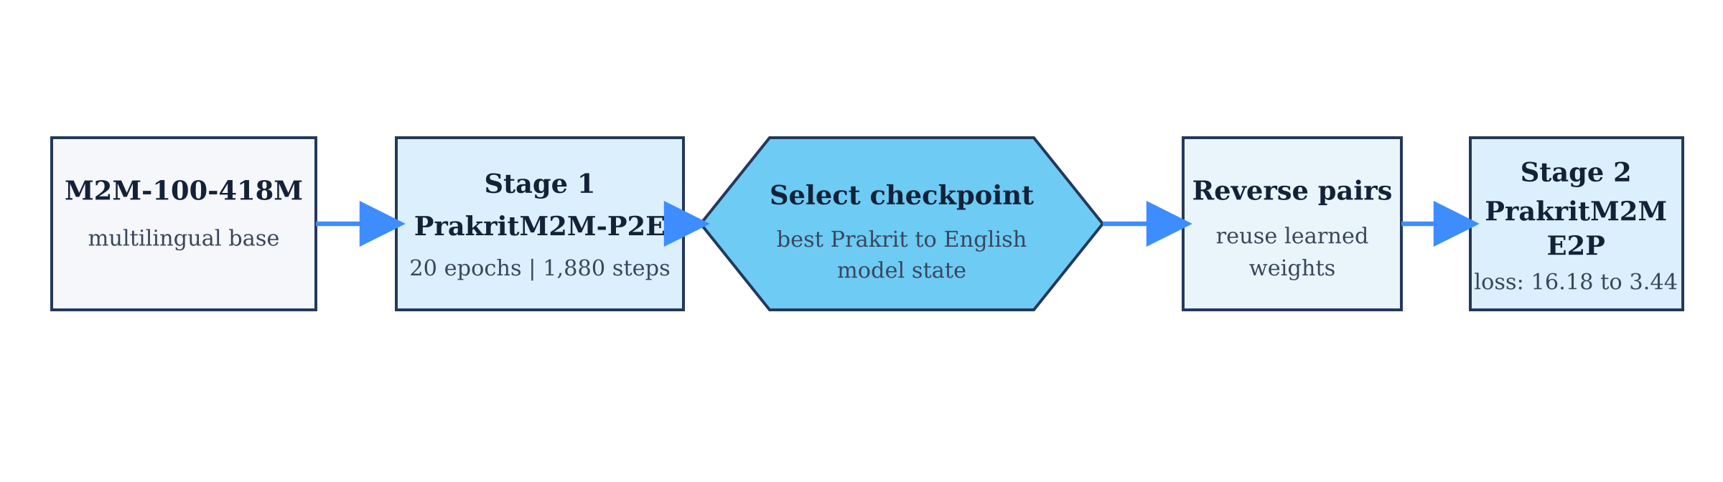
Figure 4.2: Directional checkpoint transfer sequence
Table 4.6: Final translation training configuration
Parameter | Configuration
Backbone | M2M-100-418M, full fine-tuning
Epochs / total steps | 20 epochs / 1,880 steps
Learning rate | 5e-5
Per-device batch size | 8
Gradient accumulation | 2
Maximum sequence length | 128
Weight decay | 0.01
Precision | FP16
Gradient clipping | 1.0
Warm-up | None
Optimizer and schedule | AdamW with a linear schedule
Random seed | No fixed training-loop seed was recorded

English-to-Prakrit performance reached its best region around epoch 15 and declined afterward. This checkpoint divergence demonstrates why the selected validation checkpoint, rather than the final epoch, must be preserved and reported.

4.8.6 Synthetic Data Generation and Filtering
An English pool of 1,899,285 sentences was assembled from Project Gutenberg [16] and Tatoeba [17]. CTranslate2 [11] generated three Prakrit candidates for each English input. The mean pairwise word-Jaccard agreement among candidates served as a stability score. Records with a score of at least 0.40 were retained, while rejected records were archived separately.
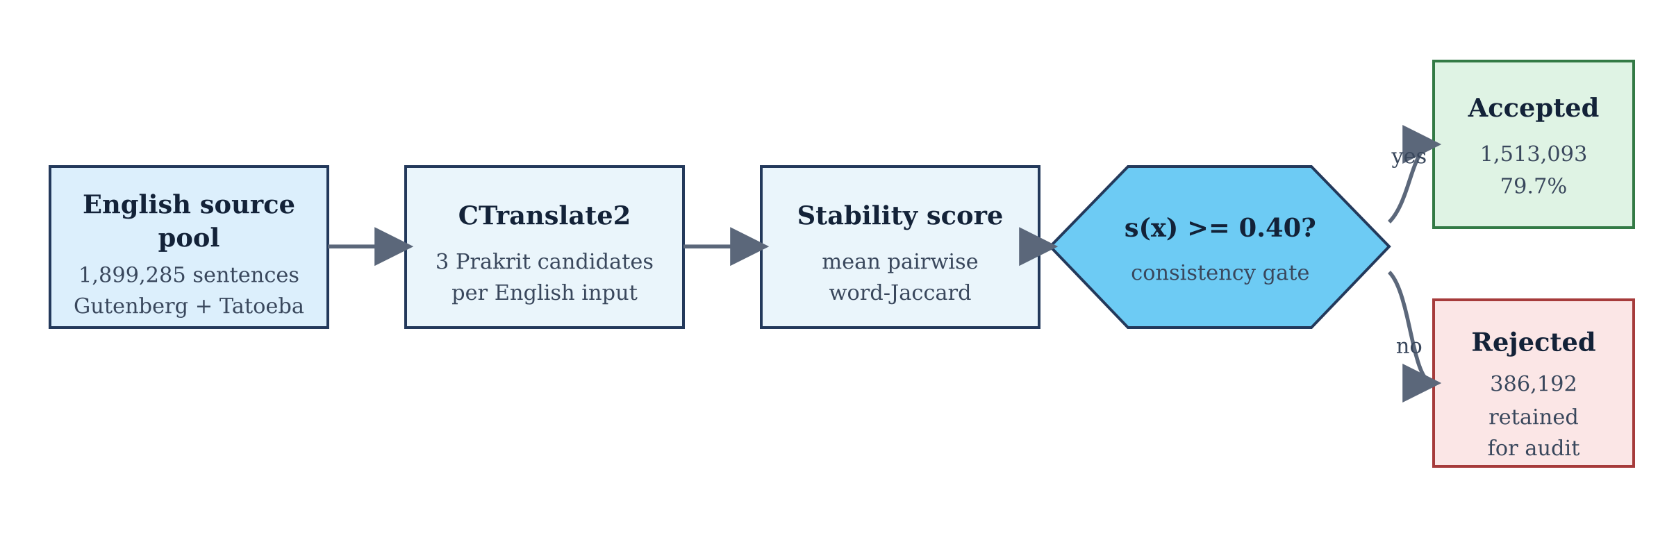
Figure 4.3: Synthetic candidate generation and stability filtering
Table 4.7: Synthetic-data generation summary
Stage | Records | Share / Note
English source pool | 1,899,285 | Gutenberg + Tatoeba
Generated candidate sets | 1,899,285 | Three candidates per source
Accepted synthetic records | 1,513,093 | 79.7%; stability >= 0.40
Rejected records | 386,192 | 20.3%; retained for audit

The stability filter measures agreement among generated candidates, not human-verified semantic correctness. The accepted collection is therefore a quality-filtered synthetic resource, not a gold-standard parallel corpus.

4.8.7 Prakrit-to-Sanskrit Lexical Task
The raw lexical resource contained 1,433 records. After removing 395 records without a usable Devanagari span and deduplicating by surface-form and lemma pair, 1,038 mappings remained. Fifty-four lemmas had multiple surface forms, and eight of these lemmas appeared across both training and evaluation splits, creating a disclosed leakage risk.
Table 4.8: Prakrit-Sanskrit lexical experiment
Item | Configuration / Count
Raw records | 1,433
Discarded without valid Devanagari span | 395
Usable mappings | 1,038
Train / evaluation split | 934 / 104
Multi-form lemmas | 54
Multi-form lemmas crossing split | 8
Epochs / learning rate | 8 / 3e-5
Batch / gradient accumulation | 16 / 2
Maximum length / weight decay | 32 / 0.10
Additional dropout values | 0.3 / 0.2 / 0.2

4.8.8 Evaluation Protocol
Translation quality was measured primarily with BLEU, which combines modified n-gram precision with a brevity penalty [7]. The report follows the recommendation to describe BLEU computation and avoid treating a score as a complete measure of semantic correctness [8]. Lexical mapping was evaluated with exact match, longest-common-subsequence similarity, and a three-character-prefix measure because exact match alone can hide partially correct or morphologically related outputs.
Automatic evaluation was paired with data audits. The 200-pair held-out set was also used for checkpoint selection and final scoring, so it is not an independent test set. No broad claim is made about unseen dialects, historical periods, or domains, and philologist-led human evaluation remains essential.

4.9 Expected and Achieved Outcomes

4.9.1 Expected Outputs
• A cleaned and documented Prakrit-English seed corpus.
• Functional Prakrit-to-English and English-to-Prakrit translation models.
• A directional checkpoint-transfer procedure and reproducible training configuration.
• A synthetic candidate generation and filtering workflow.
• An exploratory Prakrit-to-Sanskrit lexical model.
• Comparative baseline experiments, limitations, and learning documentation.

4.9.2 Achieved Results
Table 4.9: Expected and achieved project outcomes
Component | Reported Outcome | Status
Cleaned seed corpus | 1,696 pairs; 1,496 train / 200 evaluation | Achieved
Prakrit-to-English translation | BLEU 47.08 on the project split | Achieved with audit caveat
English-to-Prakrit translation | Best BLEU 14.38 | Achieved
Directional transfer | Starting E2P loss reduced from 16.18 to 3.44 | Achieved
Synthetic resource | 1,513,093 accepted records; 79.7% acceptance | Achieved
Lexical exact match | 5.8% | Exploratory
Lexical LCS similarity | 51.1% | Exploratory
Lexical 3-character-prefix match | 22.1% | Exploratory

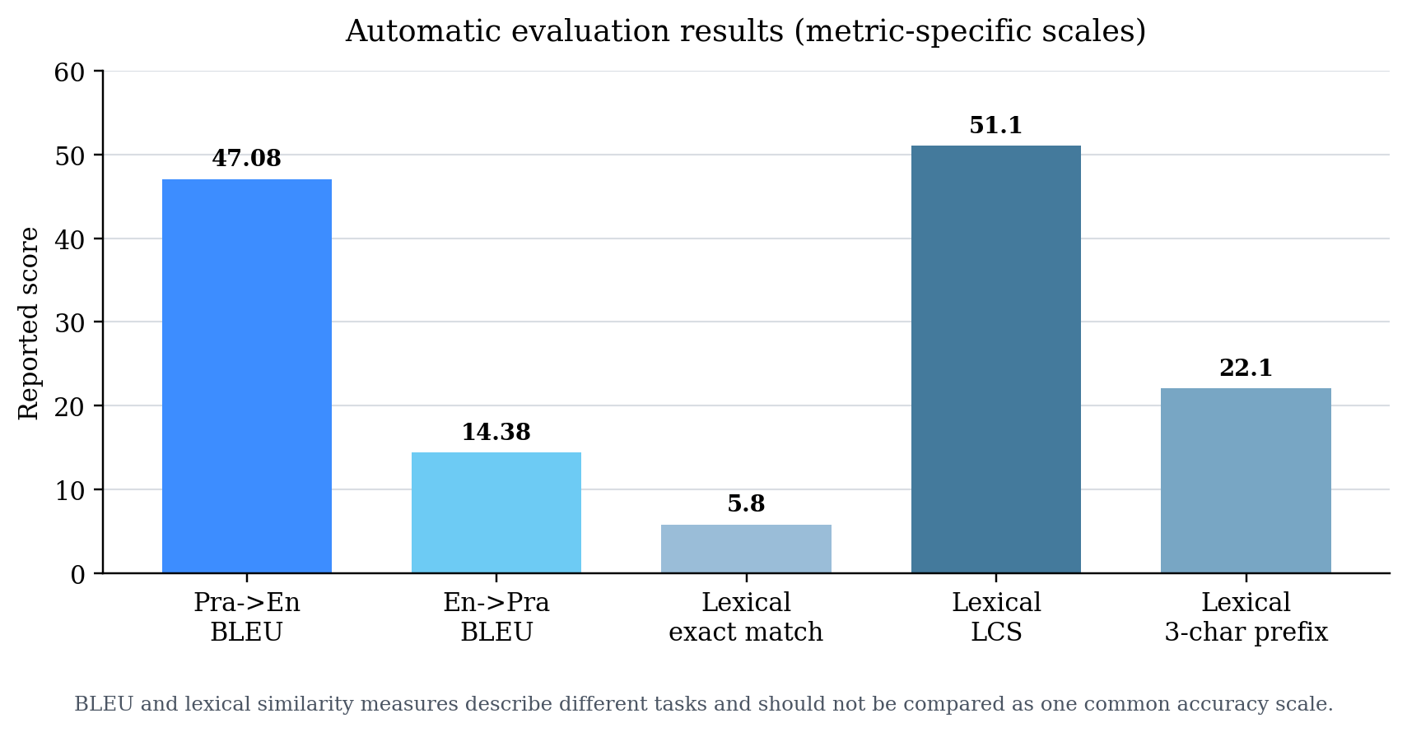
Figure 4.4: Automatic evaluation results

4.9.3 Interpretation
The results show that multilingual transfer can produce a functional Prakrit translation prototype from a very small supervised corpus. Directional initialization was especially useful for English-to-Prakrit optimization. The lower E2P BLEU is consistent with the difficulty of generating a morphologically and orthographically variable low-resource language.
The 47.08 P2E BLEU result must be interpreted together with the near-duplicate audit and the absence of an independent test set. It represents strong performance on the current project split, not evidence of general translation quality across all Prakrit varieties. The lexical gap between 5.8% exact match and 51.1% LCS similarity further shows why one automatic score is insufficient.

4.9.4 Limitations
Table 4.10: Limitations, implications, and next actions
Limitation | Implication | Recommended Next Action
Only 1,696 supervised pairs | High variance and limited coverage | Expand with expert-curated parallel data
Near duplicates in evaluation | Possible score inflation | Create a strict deduplicated test set
No independent final test set | Checkpoint selection and reporting are coupled | Reserve a sealed expert-reviewed test set
No fixed training-loop seed | Exact reruns may differ | Fix seeds and report multiple trials
Synthetic stability is not truth | Consistent candidates can still be wrong | Add confidence weighting and human sampling
Dialect and orthography variation | Valid outputs may be penalized | Add dialect metadata and human evaluation
Eight lexical lemmas cross splits | Auxiliary leakage risk | Split by normalized lemma family
Unequal exploratory budgets | No strict backbone ranking | Run matched compute and data controls

4.9.5 Learning Outcomes
• Formulating a research question for an under-resourced historical language.
• Building auditable data pipelines from heterogeneous sources.
• Handling Unicode, transliteration, script normalization, and orthographic variation.
• Fine-tuning multilingual sequence-to-sequence models with mixed precision.
• Using checkpoint selection and directional transfer in low-resource settings.
• Running efficient batched inference and filtering large synthetic collections.
• Auditing train-evaluation leakage, metric inflation, and reproducibility gaps.
• Recording negative results and distinguishing exploratory comparisons from controlled evidence.
The most important learning was that, in low-resource NLP, dataset construction and evaluation design can influence the conclusion as strongly as the model architecture.

4.9.6 Conclusion and Future Work
The internship established a complete experimental pipeline for Prakrit-English machine translation. PrakritM2M demonstrated that M2M-100 could be adapted for both translation directions, while PraDCT provided a practical way to transfer the selected P2E checkpoint into reverse-direction training. The project also produced a large, separately auditable synthetic collection and an auxiliary lexical analysis.
Future work should construct a philologist-reviewed and strictly deduplicated test set, fix random seeds, run multiple trials, add dialect and provenance metadata, and compare multilingual backbones under matched budgets. Human evaluation should assess meaning preservation, grammaticality, historical appropriateness, and dialect consistency. Synthetic pairs should be introduced gradually with confidence weighting or curriculum learning rather than treated as equally reliable.

4.10 Internship Completion Certificate and Communication Evidence
The submitted administrative records include the original IIT Delhi internship offer letter and the subsequently supplied internship completion certificate. Both are reproduced in the front matter. The documents record the internship period, host laboratory, supervising faculty member, institutional affiliation, and the administrative project title.
The completion certificate is inserted exactly as supplied, without changing its logo, signature, dates, wording, contact details, or visual layout. It records the administrative project title "Agentic Systems for Recommendations." As noted in Section 4.2, this report documents the Prakrit machine translation research work selected for academic internship evaluation.
Section 4.10.1 reproduces the supplied Gmail screenshot of the internship offer communication. It shows the offer email dated 15 May 2026, sent to iamthehimansh@gmail.com, with the internship period, project title, location, stipend, and supervisor details. The email documents the offer communication; completion is documented separately by the completion certificate.

4.10.1 Internship Offer Email Screenshot
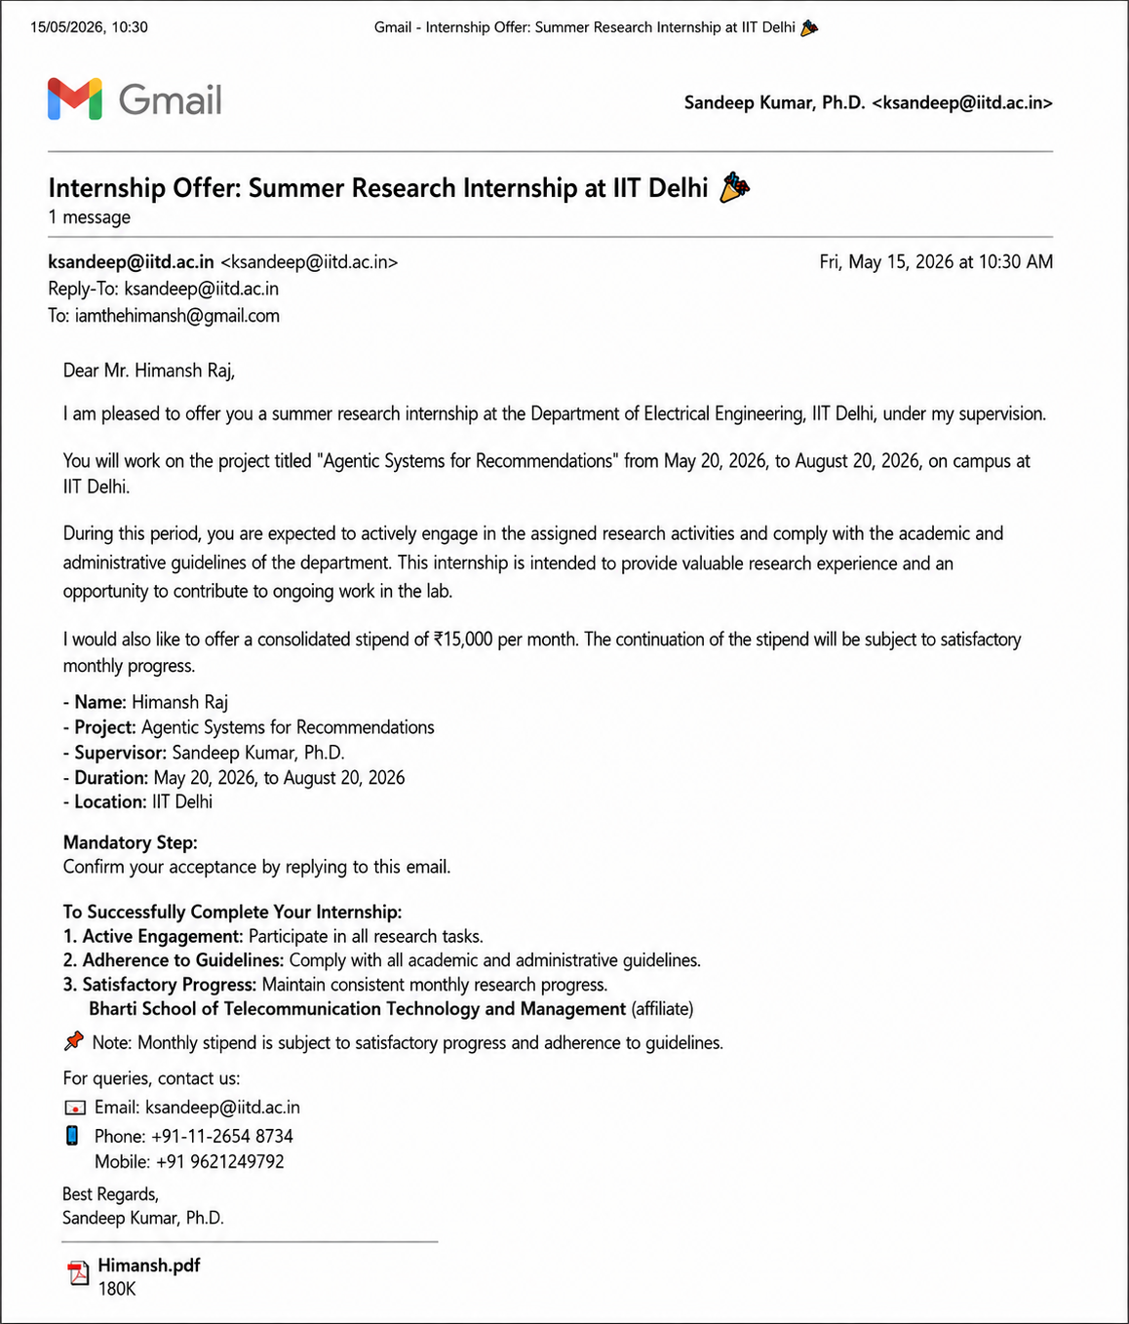

5. BIBLIOGRAPHY / REFERENCES
[1] A. Fan et al., "Beyond English-Centric Multilingual Machine Translation," Journal of Machine Learning Research, vol. 22, no. 107, pp. 1-48, 2021. https://jmlr.org/papers/v22/20-1307.html
[2] NLLB Team, M. R. Costa-jussa, J. Cross, et al., "Scaling Neural Machine Translation to 200 Languages," Nature, vol. 630, no. 8018, pp. 841-846, 2024. https://doi.org/10.1038/s41586-024-07335-x
[3] J. P. Gala et al., "IndicTrans2: Towards High-Quality and Accessible Machine Translation Models for All 22 Scheduled Indian Languages," Transactions on Machine Learning Research, 2023. https://openreview.net/forum?id=vfT4YuzAYA
[4] B. Haddow, R. Bawden, A. V. Miceli Barone, J. Helcl, and A. Birch, "Survey of Low-Resource Machine Translation," Computational Linguistics, vol. 48, no. 3, pp. 673-732, 2022. https://aclanthology.org/2022.cl-3.6/
[5] O. Choksi, S. Kareliya, S. Malviya, and P. Mishra, "English-to-Prakrit Machine Translation via Multilingual Transfer Learning," arXiv:2606.06038, 2026. https://arxiv.org/abs/2606.06038
[6] R. Sennrich, B. Haddow, and A. Birch, "Improving Neural Machine Translation Models with Monolingual Data," Proceedings of ACL, pp. 86-96, 2016. https://aclanthology.org/P16-1009/
[7] K. Papineni, S. Roukos, T. Ward, and W.-J. Zhu, "BLEU: A Method for Automatic Evaluation of Machine Translation," Proceedings of ACL, pp. 311-318, 2002. https://aclanthology.org/P02-1040/
[8] M. Post, "A Call for Clarity in Reporting BLEU Scores," Proceedings of the Third Conference on Machine Translation, pp. 186-191, 2018. https://aclanthology.org/W18-6319/
[9] T. Kudo and J. Richardson, "SentencePiece: A Simple and Language Independent Subword Tokenizer and Detokenizer for Neural Text Processing," Proceedings of EMNLP System Demonstrations, pp. 66-71, 2018. https://aclanthology.org/D18-2012/
[10] E. J. Hu et al., "LoRA: Low-Rank Adaptation of Large Language Models," International Conference on Learning Representations, 2022. https://openreview.net/forum?id=nZeVKeeFYf9
[11] G. Klein, D. Zhang, C. Chouteau, J. Crego, and J. Senellart, "Efficient and High-Quality Neural Machine Translation with OpenNMT," Proceedings of the Fourth Workshop on Neural Generation and Translation, pp. 211-217, 2020. https://aclanthology.org/2020.ngt-1.25/
[12] T. Wolf et al., "Transformers: State-of-the-Art Natural Language Processing," Proceedings of EMNLP System Demonstrations, pp. 38-45, 2020. https://aclanthology.org/2020.emnlp-demos.6/
[13] I. Loshchilov and F. Hutter, "Decoupled Weight Decay Regularization," International Conference on Learning Representations, 2019. https://openreview.net/forum?id=Bkg6RiCqY7
[14] sarch7040, "Deshika," Hugging Face Datasets. https://huggingface.co/datasets/sarch7040/Deshika
[15] prakrit.info, "Prakrit Language Resources." https://prakrit.info/
[16] Project Gutenberg, "Free eBooks." https://www.gutenberg.org/
[17] Tatoeba, "Collection of Sentences and Translations." https://tatoeba.org/
[18] R. Pischel, A Grammar of the Prakrit Languages, S. Jha, trans., 2nd rev. ed. Delhi: Motilal Banarsidass, 1981. https://catalog.hathitrust.org/Record/000148305

