User guide
BRD Agent
Version 1.1

Agent name | BRD Agent [confirm published tile name]
Platform | Microsoft Copilot Studio
Audience | End users
Status | Pilot
Owner | __________________________ (to be filled)
Version | 1.1
1 Overview & current status
The BRD Agent is a guided, contract-first assistant that helps you turn engagement documents into a consolidated, audit-ready Business Requirements Document (BRD). It reads your Statement of Work (SOW), Third-Party Agreement (TPA), and meeting notes, runs a structured discovery interview, and assembles a single BRD structured to the selected reporting offering.
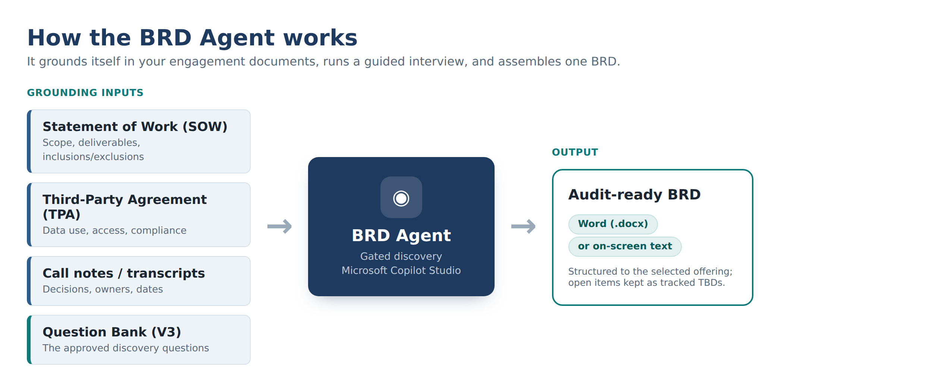
Current status
Pilot. The BRD Agent is available to pilot users and is actively being enhanced. Guided discovery is fully working; automated Word-file generation is being finalised (see Section 3 — What you get).
2 What the agent helps with
Use cases
- Draft a BRD faster — produce a strong first-draft BRD from a SOW, TPA and call notes.
- Run structured discovery — pick an offering and datasets, then answer a gated set of questions.
- Standardise output — the same offering always produces the same section structure, across authors.
- Capture business rules & dashboards — in a clear, client-ready format, with calculation logic for every metric.
- Track open items — unknowns become tracked TBDs, alongside a decision log and dependencies.
- Reconcile follow-ups — feed in later meeting notes and it updates the existing BRD instead of starting over.
Example prompts
“I want to create a BRD.”
“Ground to these files — here are the SOW, TPA and call notes.”
“Offering is Power BI; datasets are DDD/DDDMD, XPO/XPT, CRM and OneKey.”
“I don't know the data volume yet — can we continue?”
“Summarize the decision log.”
“Reconcile these new meeting notes.”
How it works
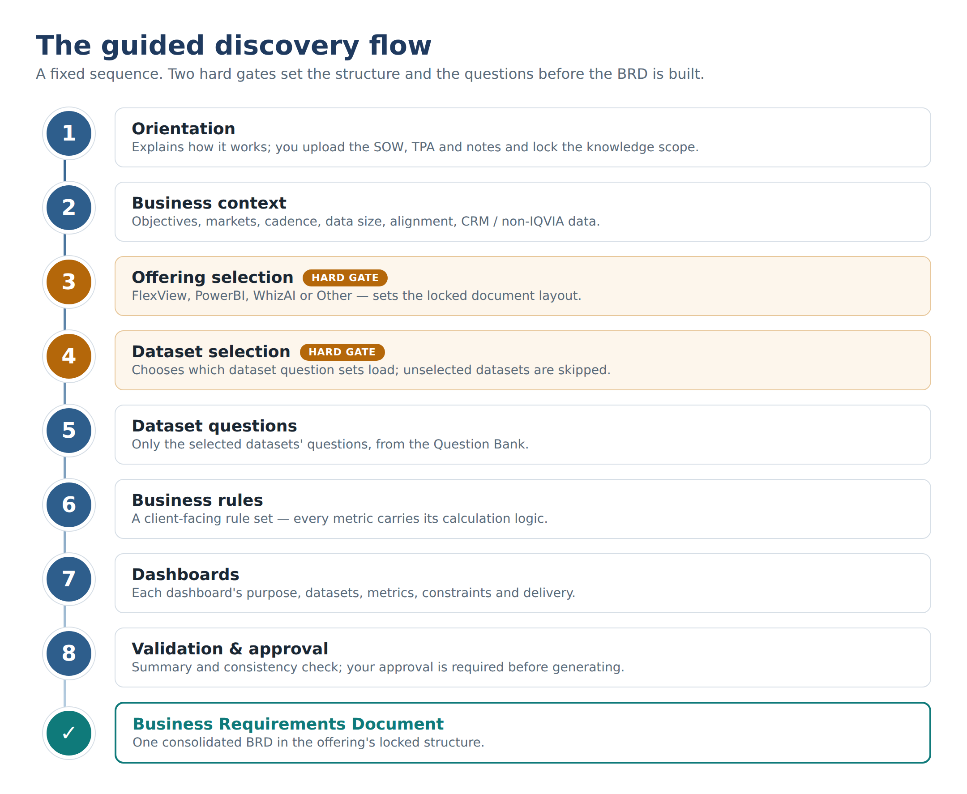
3 What you get (output options)
Depending on the environment configuration, the BRD is delivered in one of two ways:
Option A — Word document
The agent generates a downloadable Microsoft Word (.docx) BRD in the standard IQVIA structure. (This option depends on the document-generation flow, which is pending environment/permission setup.)

Option B — On-screen text
The agent returns the full BRD as structured on-screen text that you copy into a Word document and apply the IQVIA template. This is the interim output while Option A is being enabled.
4 What the agent is not (limitations & guardrails)
- Not a replacement for the BA/EM. It accelerates drafting; every BRD needs human review and sign-off.
- It will not invent requirements. Anything missing is marked [TBD – User Confirmation Required], never guessed.
- It will not override the SOW or TPA. Conflicts are flagged as “Requires Contract Clarification,” not resolved by the agent.
- Grounded only in what you provide. It does not pull from your full mailbox, Teams or the open web.
- Word output only. It does not produce PowerPoint, Excel or other formats.
- Questions come only from the approved question bank. It will not ask beyond it.
- Compliance guardrails. CRM-to-Rx relationships are treated as descriptive only (never causal); it honours the TPA and does not enable resale of IQVIA data.
- Not an analytics or build tool. It documents requirements — it does not run queries or build the dashboards.

5 How to access the agent
The following are the ways to access the BRD Agent. Keep the method your team uses and delete the others.
Before you start
You need your IQVIA (Microsoft 365) work account. If an installation link is required, it is: [paste installation link]. The agent tile may appear under its published name.
Way A — Microsoft Teams
Step 1 Open the installation link for Microsoft Teams.
Link: [paste Teams installation link]
Step 2 Select “Add” from the installation prompt.
Step 3 When you see “Added successfully,” choose “Open” (or “Open with Copilot”).
[ Paste screenshot: “Added successfully” dialog with Open ]
Step 4 The agent now appears in your Teams apps.
Recommended Pin the agent: right-click the app in the Teams left navigation and select Pin.
[ Paste screenshot: right-click app → Pin ]
Recommended Favorite the chat: right-click the chat in the left navigation and select Move to → Favorites.
[ Paste screenshot: Move to → Favorites ]
Way B — Microsoft 365 Copilot app
Step 1 Open the installation link for the M365 Copilot app.
Link: [paste M365 Copilot installation link]
Note: the link opens in your browser. Adding the agent there also makes it available in the M365 Copilot app.
Step 2 Select “Add” from the installation prompt.
Step 3 Choose “Open” to start using the agent.
[ Paste screenshot: install prompt / Open ]
Recommended Pin or favorite the agent the same way as in Teams for quick access.
Way C — Direct link (optional)
Step 1 Open the agent link in your browser and start chatting.
Link: [paste direct agent link]

Support & feedback
Questions or issues? Contact [owner / support channel]. First run tip: upload your SOW, TPA and notes when prompted, then follow the guided questions.

