*Selectors

- We can divide CSS selectors into Nine categories:

01.Universal Selector(*).

02.Element Selector.

03IdSelector.

04ClassSelector.

05DescendantSelectors (space).

06childSelector (>).

07AdjacentSiblingSelectors (+).

08GeneralSibling (~).

09GroupingSelector.

1.Universal Selector(*).

-The CSS **universal selector** (*) matches elements of any type.

Ex.

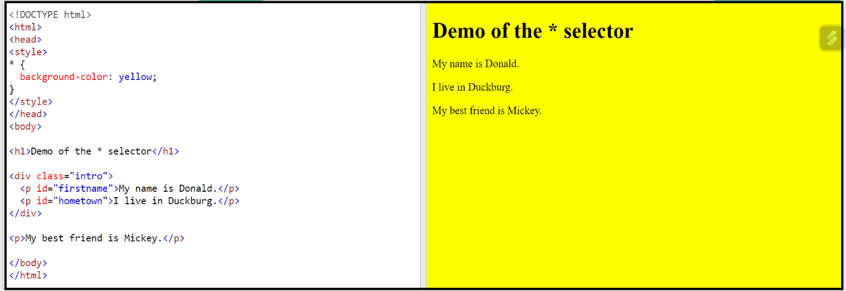

2. Element Selector.

- The [element](https://www.w3schools.com/jquery/sel_element.asp) selector can also be used to select multiple elements.

Ex.

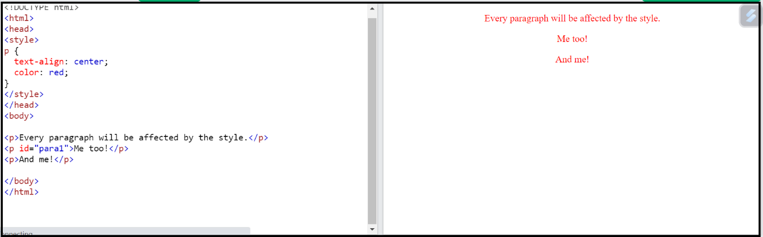

3.Id Selector (#).

-The id selector uses the id attribute of an HTML element to select a specific element.

The id of an element is unique within a page, so the id selector is used to select one unique element!

To select an element with a specific id, write a hash (#) character, followed by the id of the element.

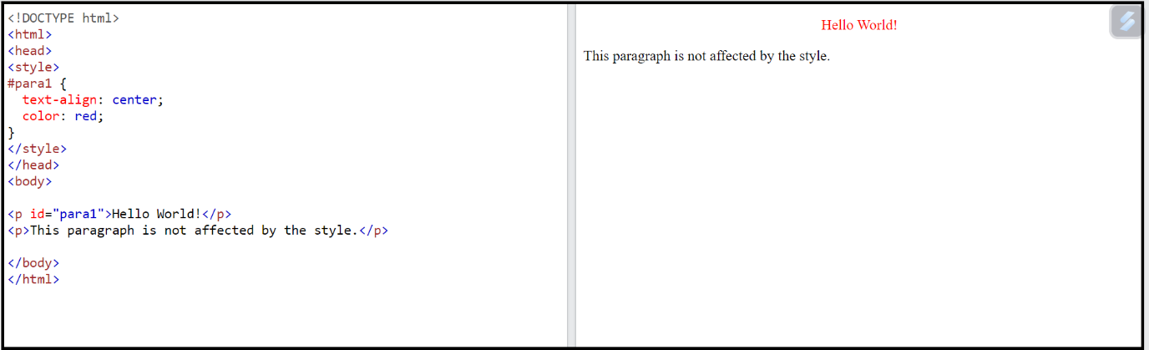

4.Class Selector (.).

-The .class selector selects elements with a specific class attribute.

To select elements with a specific class, write a period (.) character, followed by the name of the class.

Ex.

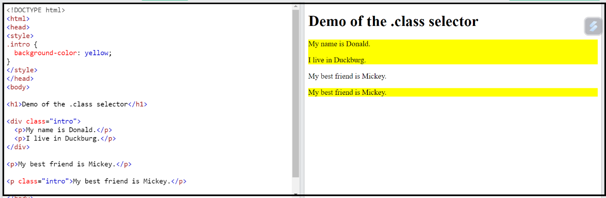

5.Descendant Selectors (space).

-The descendant selector matches all elements that are descendants of a specified element.

(element with pacification id ke class hogi ush ki pacification ush ke child pe play karvana ho tab descendant seclector use hota hai.)

Ex.

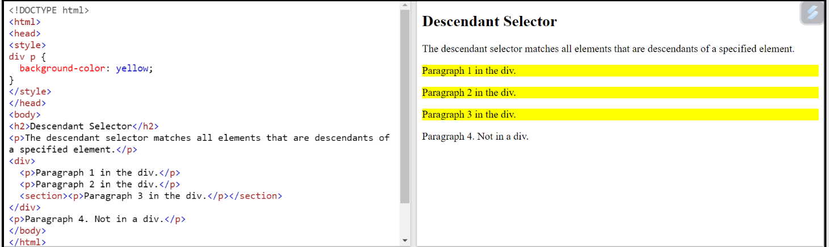

06childSelector (>).

- child directly > na symbol thi use kariye.

Ex.

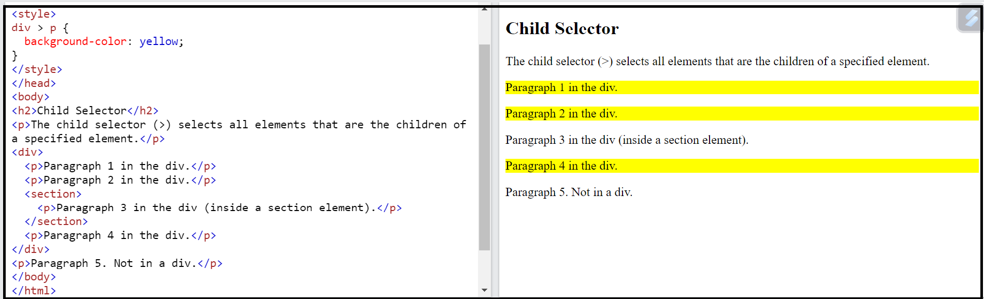

07AdjacentSiblingSelectors (+).

Ex. Immediately next +.

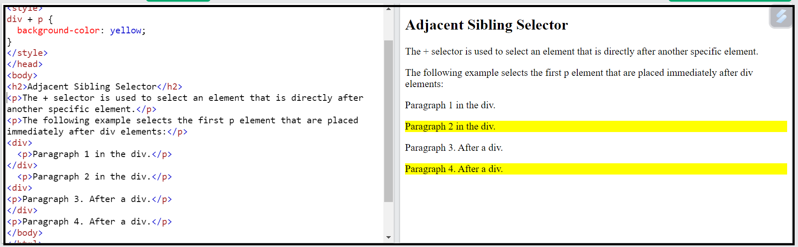

08GeneralSibling (~).

Ex.

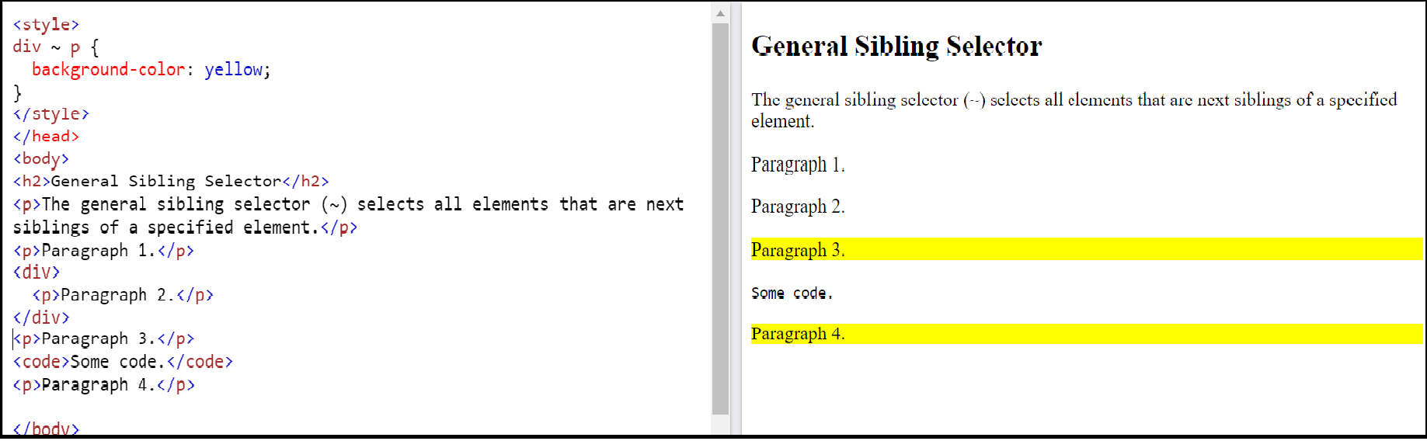

09GroupingSelector(~).

-( Multiple tag ko effect deni ho ya multiple tag ke andar ya element ke andar koma use kar ke propaties aplay karni ho tab grouping selector use hota hai.)

Ex. 