 Tables:-

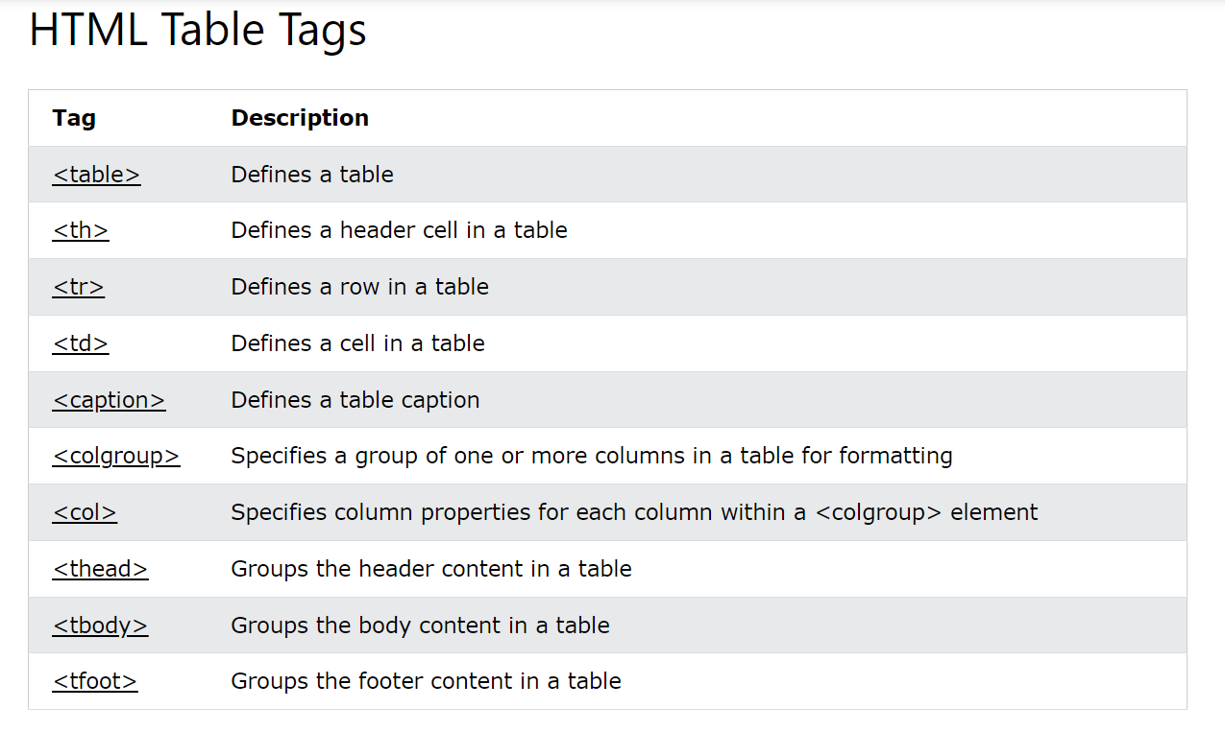

# HTML Table Borders:-

# 

# Collapsed Table Borders:-

# 

HTML Table Colspan & Rowspan:-

