## HTML Lists and CSS List Properties.

In HTML, there are two main types of lists:

* unordered lists (<ul>) - the list items are marked with bullets
* ordered lists (<ol>) - the list items are marked with numbers or letters

The CSS list properties allow you to:

* Set different list item markers for ordered lists
* Set different list item markers for unordered lists
* Set an image as the list item marker
* Add background colors to lists and list items

## Example of unordered lists:

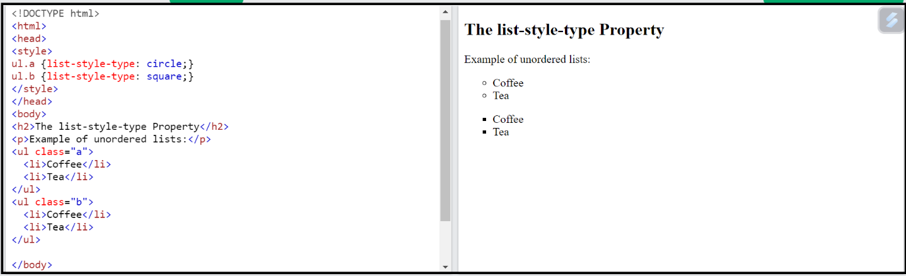

## Example of ordered lists:

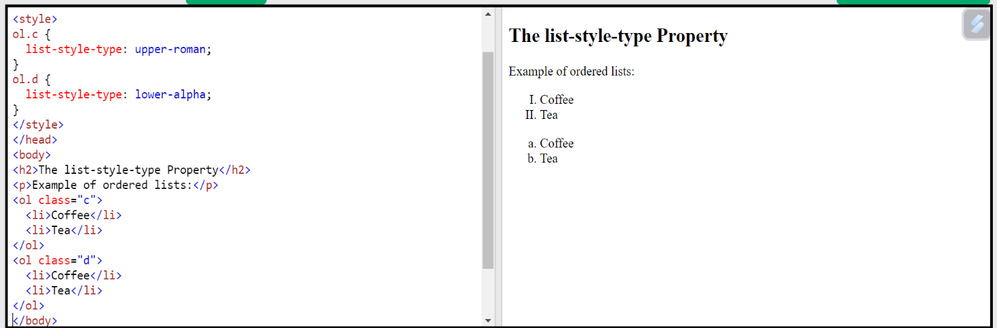

## Ex. The list-style-image property specifies an image as the list item marker:

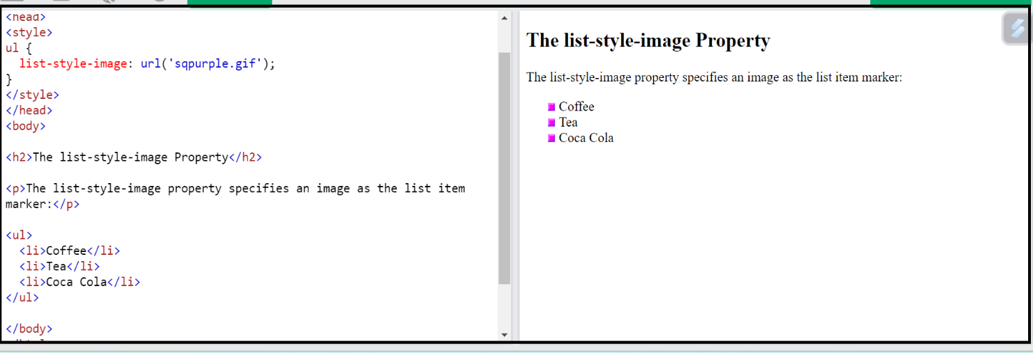

## Remove property.

## 

## list-style-image- property.

## Ex.

ul li {

    list-style-image: url(fast-forward.png);

}