BACKGROUND

The **background** shorthand CSS property sets all background style properties at once, such as color, image, origin and size, or repeat method. Component properties not set in the background shorthand property value declaration are set to their default values.

## [Constituent properties](https://developer.mozilla.org/en-US/docs/Web/CSS/background#constituent_properties):-

This property is a shorthand for the following CSS properties:

* [background-attachment](https://developer.mozilla.org/en-US/docs/Web/CSS/background-attachment)
* [background-clip](https://developer.mozilla.org/en-US/docs/Web/CSS/background-clip)
* [background-color](https://developer.mozilla.org/en-US/docs/Web/CSS/background-color)
* [background-image](https://developer.mozilla.org/en-US/docs/Web/CSS/background-image)
* [background-origin](https://developer.mozilla.org/en-US/docs/Web/CSS/background-origin)
* [background-position](https://developer.mozilla.org/en-US/docs/Web/CSS/background-position)
* [background-repeat](https://developer.mozilla.org/en-US/docs/Web/CSS/background-repeat)
* [background-size](https://developer.mozilla.org/en-US/docs/Web/CSS/background-size)

# Background-color:-

The **background-color** [CSS](https://developer.mozilla.org/en-US/docs/Web/CSS) property sets the background color of an element.

# Background-image:-

The **background-image** [CSS](https://developer.mozilla.org/en-US/docs/Web/CSS) property sets one or more background images on an element.

.back-img {

            background-image: url("ocean-3605547__340.jpg");

        }

# Background-attachment:-

The **background-attachment** [CSS](https://developer.mozilla.org/en-US/docs/Web/CSS) property sets whether a background image's position is fixed within the [viewport](https://developer.mozilla.org/en-US/docs/Glossary/Viewport), or scrolls with its containing block.

.background-attachment {

            background-image: url(ocean-3605547__340.jpg);

            background-attachment: local;

            background-attachment: scroll;

            background-attachment: fixed;

        }

fixed

The background is fixed relative to the viewport. Even if an element has a scrolling mechanism, the background doesn't move with the element. (This is not compatible with [background-clip: text](https://developer.mozilla.org/en-US/docs/Web/CSS/background-clip#values).)

local

The background is fixed relative to the element's contents. If the element has a scrolling mechanism, the background scrolls with the element's contents, and the background painting area and background positioning area are relative to the scrollable area of the element rather than to the border framing them.

scroll

The background is fixed relative to the element itself and does not scroll with its contents. (It is effectively attached to the element's border.)

# Background-clip:-

The **background-clip** [CSS](https://developer.mozilla.org/en-US/docs/Web/CSS) property sets whether an element's background extends underneath its border box, padding box, or content box.

.background-clip {

            background-image: url(ocean-3605547__340.jpg);

            border: 15px dashed rebeccapurple;

            padding: 50px;

            margin: 50px;

            background-clip:content-box;

             background-clip:border-box;

        }

**Background-clip-border-box:-**

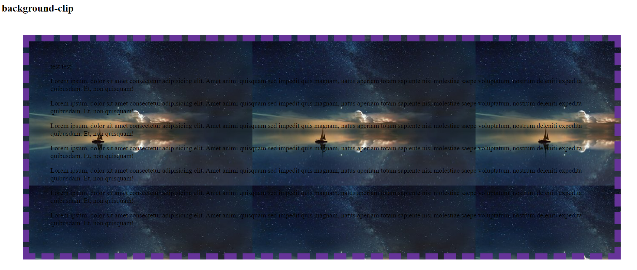

**Background-Clip-content-box:-**

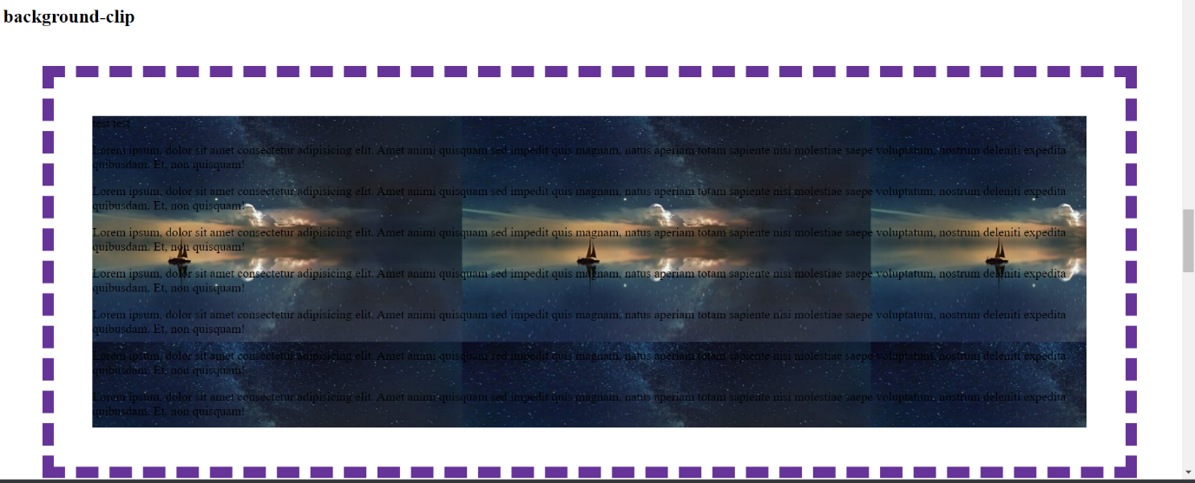

# Background-origin:-

The **background-origin** [CSS](https://developer.mozilla.org/en-US/docs/Web/CSS) property sets the background's origin: from the border start, inside the border, or inside the padding.

 .background-origin {

            background-image: url(ocean-3605547__340.jpg);

            border: 15px dashed rebeccapurple;

            padding: 50px;

            margin: 50px;

            background-origin:border-box;

            background-origin:content-box;

        }

**Background-origin-border-box:-**

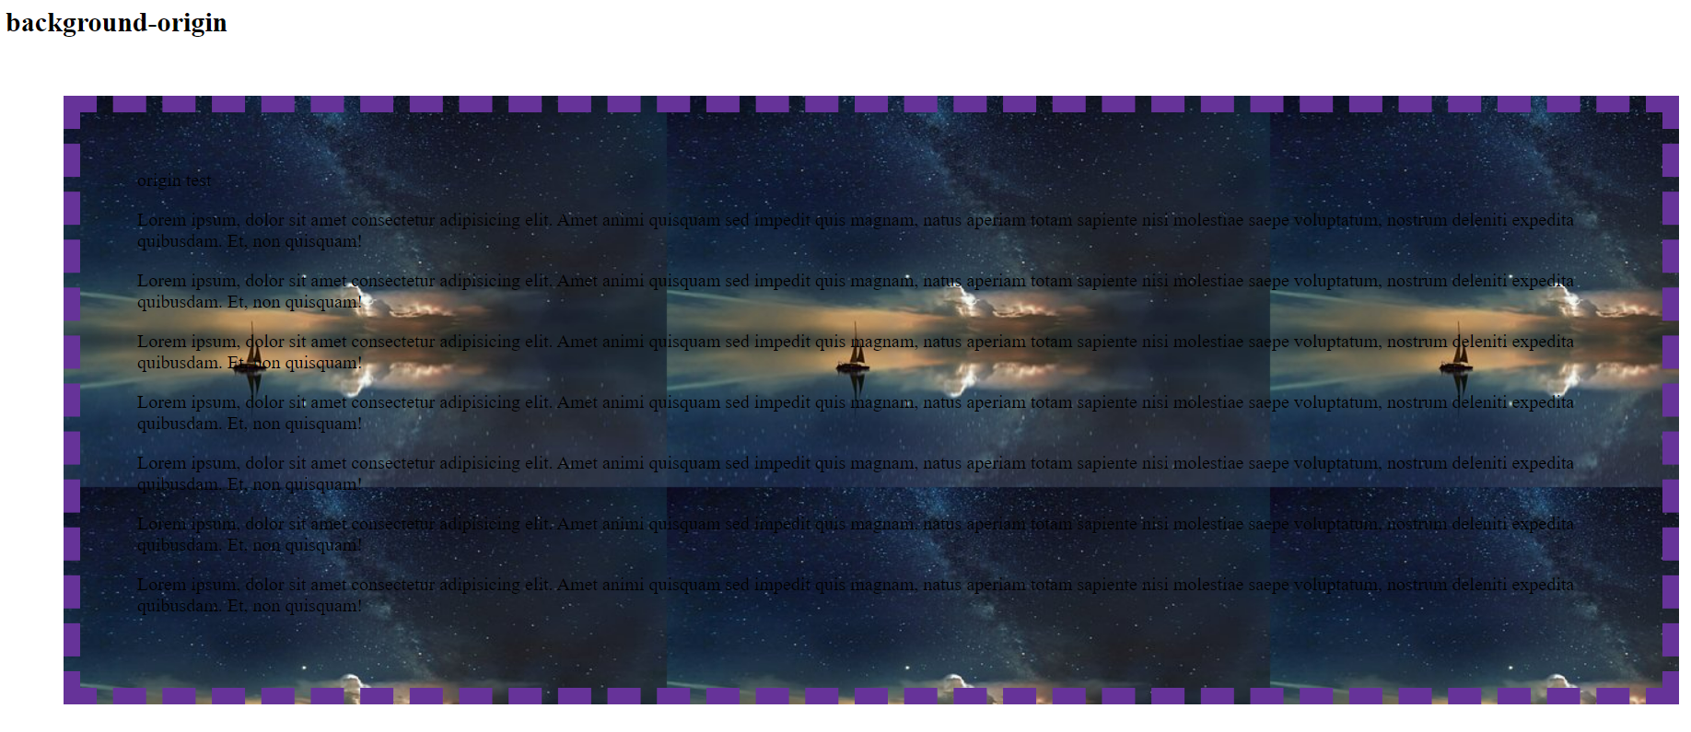

**Background-origin-Content-box:-**

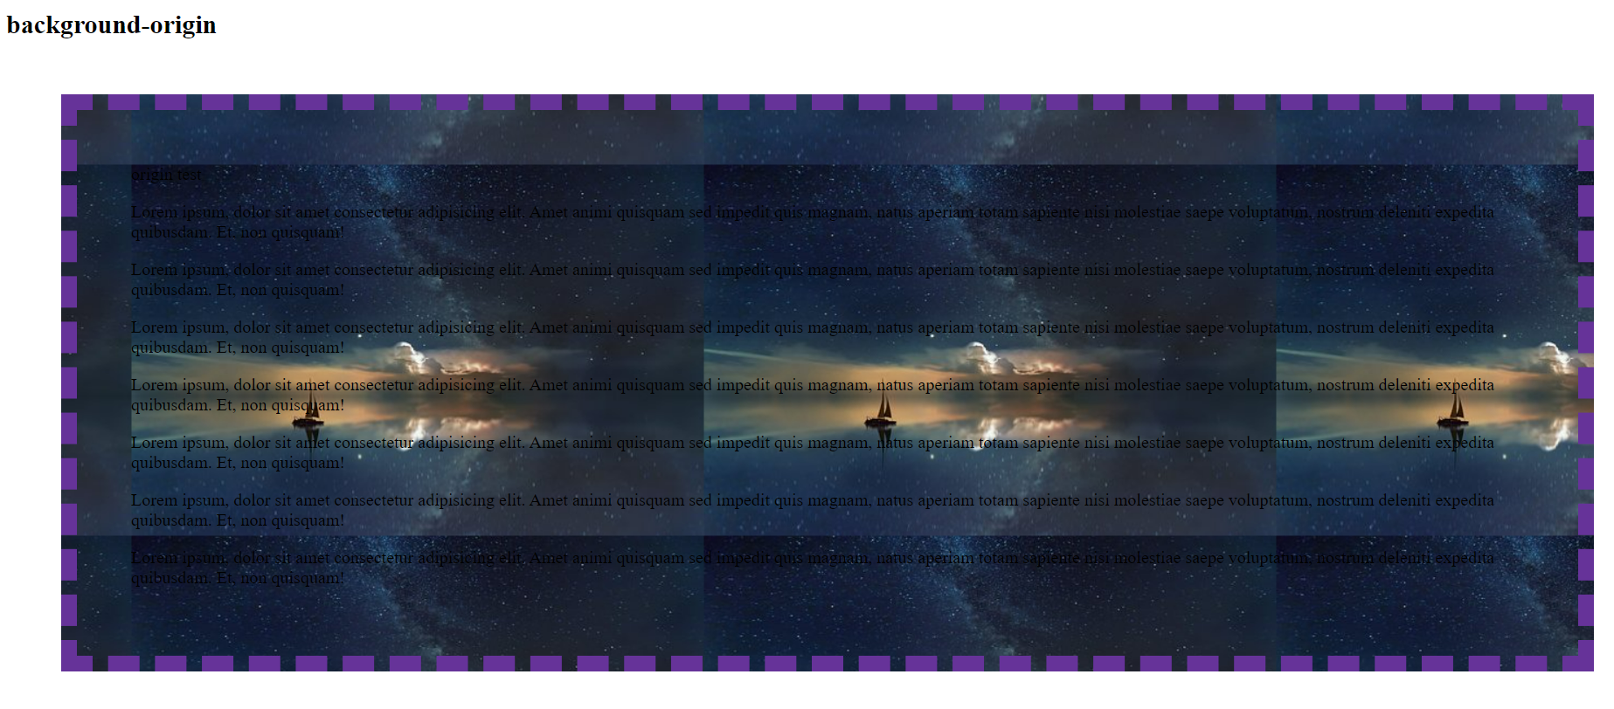

# Background-position:-

The **background-position** [CSS](https://developer.mozilla.org/en-US/docs/Web/CSS) property sets the initial position for each background image. The position is relative to the position layer set by [background-origin](https://developer.mozilla.org/en-US/docs/Web/CSS/background-origin).

  .background-position {

            background-image: url(ocean-3605547__340.jpg);

            background-position:50%;

            background-position:top;

            background-position:bottom;

            background-position:left;

            background-position:right;

        }

# Background-repeat:-

The **background-repeat** [CSS](https://developer.mozilla.org/en-US/docs/Web/CSS) property sets how background images are repeated. A background image can be repeated along the horizontal and vertical axes, or not repeated at all.

 .background-repeat {

            background-image: url("ocean-3605547__340.jpg");

            background-repeat: repeat-x;

            background-repeat: repeat-y;

            background-repeat: repeat;

            background-repeat: no-repeat;

            height: 600px;

        }

# Background-size:-

The **background-size** [CSS](https://developer.mozilla.org/en-US/docs/Web/CSS) property sets the size of the element's background image. The image can be left to its natural size, stretched, or constrained to fit the available space.

.background-size {

            background-image: url(ocean-3605547__340.jpg);

            background-size:contain;

            background-size:cover;

        }