UNIVERSITY OF TRANSPORT HO CHI MINH CITY INSTITUTE OF INFORMATION TECHNOLOGY


REQUIREMENT SPECIFICATION & DESIGN DOCUMENT

PROJECT: STUDENT MANAGEMENT SYSTEM (SMS)

Lecturer: Trần Thị Mỹ Tiên
Group: 06
Group members:
Trần Phúc Hậu
Nguyễn Sanh Tiến
Trương Thùy Tường Vân
Trần Phương Mai
Lê Nguyễn Minh Khoa
Nguyễn Tuấn Dương

Ho Chi Minh City, April 2026
LECTURER’S COMMENTS

Comments: ...................................................................................................................
......................................................................................................................................
......................................................................................................................................
......................................................................................................................................
......................................................................................................................................
......................................................................................................................................
......................................................................................................................................
......................................................................................................................................
......................................................................................................................................
......................................................................................................................................
......................................................................................................................................

Lecturer’s Signature

Trần Thị Mỹ Tiên
TABLE OF CONTENTS
List of members viii
CHAPTER I. FUNCTIONAL REQUIREMENTS 1
1. Authentication & Authorization 1
2. User Management 1
3. Academic Management 2
4. Course Registration 2
5. Grading & Attendance Management 3
CHAPTER II. NON-FUNCTIONAL REQUIREMENTS 4
CHAPTER III. DATA FLOW DIAGRAM (DFD) 5
1. Overview of DFD 5
2. DFD Diagram Level 0 – Context Diagram 5
2.1 Overview 5
2.2 External Entities 5
3. DFD Diagram Level 1 – Main Process Decomposition 7
7
3.1 Overview 10
3.2 Processes 10
3.3. Data Stores 11
4. DFD Level 2 – Decomposition Of Process 4.0 (Course Registration) 12
4.1 Overview 12
4.2 Sub-Processes 12
CHAPTER IV. USE CASE DIAGRAM 14
1. Use Case Diagram 14
2. List Of Actor 15
3. List Of Use Case 15
4. Create Accounts 17
4.1 Summary 17
4.2 Flow of Events 17
4.2.1. Main Flow 17
4.2.2 Alternative Flow 17
4.3 Special Requirements 17
4.4 Preconditions 17
4.5 Postconditions 17
4.6 Extension Points 17
5. Log in 18
5.1 Summary 18
5.2 Flow of Events 18
5.2.1 Main Flow 18
5.2.2 Alternative Flow 18
5.3 Special Requirements 18
5.4 Preconditions 18
5.5 Postconditions 18
5.6 Extension Points 18
6. Forgot Password 18
6.1 Summary 18
6.2 Flow of Events 18
6.2.1 Main Flow 18
6.2.2 Alternative Flow 19
6.3 Special Requirements 19
6.4 Preconditions 19
6.5 Postconditions 19
6.6 Extension Points 19
7. Log out 19
7.1 Summary 19
7.2 Flow of Events 19
7.2.1 Main Flow 19
7.2.2 Alternative Flow 19
7.3 Special Requirements 19
7.4 Preconditions 19
7.5 Postconditions 20
7.6 Extension Points 20
8. Change Password 20
8.1 Summary 20
8.2 Flow of Events 20
8.2.1 Main Flow 20
8.2.2 Alternative Flow 20
8.3 Special Requirements 20
8.4. Preconditions 20
8.5. Postconditions 20
8.6 Extension Points 20
9. View Profile 20
9.1 Summary 20
9.2 Flow of Events 20
9.2.1 Main Flow 20
9.2.2 Alternative Flow 20
9.3 Special Requirements 21
9.4 Preconditions 21
9.5 Postconditions 21
9.6 Extension Points 21
10. Update Profile 21
10.1 Summary 21
10.2 Flow of Events 21
10.2.1 Main Flow 21
10.2.2 Alternative Flow 21
10.3 Special Requirements 21
10.4 Preconditions 21
10.5 Postconditions 21
10.6 Extension Points 21
11. Manage Student Profile 21
11.1 Summary 21
11.2 Flow of Events 21
11.2.1 Main Flow 21
11.2.2 Alternative Flow 22
11.3 Special Requirements 22
11.4 Preconditions 22
11.5 Postconditions 22
11.6 Extension Points 22
12. Manage Lecturer Profile 22
12.1 Summary 22
12.2 Flow of Events 22
12.2.1 Main Flow 22
12.2.2 Alternative Flow 22
12.3 Special Requirements 22
12.4 Preconditions 22
12.5 Postconditions 22
12.6 Extension Points 22
13. Assign Lecturers 23
13.1 Summary 23
13.2 Flow of Events 23
13.2.1 Main Flow 23
13.2.2 Alternative Flow 23
13.3 Special Requirements 23
13.4 Preconditions 23
13.5 Postconditions 23
13.6 Extension Points 23
14. Manage Faculty 23
14.1 Summary 23
14.2 Flow of Events 23
14.2.1 Main Flow 23
14.2.2 Alternative Flow 23
14.3 Special Requirements 23
14.4 Preconditions 24
14.5 Postconditions 24
14.6 Extension Points 24
15. Manage Semester/Term 24
15.1 Summary 24
15.2 Flow of Events 24
15.2.1 Main Flow 24
15.2.2 Alternative Flow 24
15.3 Special Requirements 24
15.4 Preconditions 24
15.5 Postconditions 24
15.6 Extension Points 24
16. Manage Course 24
16.1 Summary 24
16.2 Flow of Events 24
16.2.1 Main Flow 24
16.2.2 Alternative Flow 25
16.3 Special Requirements 25
16.4 Preconditions 25
16.5 Postconditions 25
16.6 Extension Points 25
17. Manage Class/Section 25
17.1 Summary 25
17.2 Flow of Events 25
17.2.1 Main Flow 25
17.2.2 Alternative Flow 25
17.3 Special Requirements 25
17.4 Preconditions 25
17.5 Postconditions 26
17.6 Extension Points 26
18. View Training Program 26
18.1 Summary 26
18.2 Flow of Events 26
18.2.1 Main Flow 26
18.2.2 Alternative Flow 26
18.3 Special Requirements 26
18.4 Preconditions 26
18.5 Postconditions 26
18.6 Extension Points 26
19. Control Registration Period 26
19.1 Summary 26
19.2 Flow of Events 26
19.2.1 Main Flow 26
19.2.2 Alternative Flow 27
19.3 Special Requirements 27
19.4 Preconditions 27
19.5 Postconditions 27
19.6 Extension Points 27
20. View Available Classes 27
20.1 Summary 27
20.2 Flow of Events 27
20.2.1 Main Flow 27
20.2.2 Alternative Flow 27
20.3 Special Requirements 27
20.4 Preconditions 27
20.5 Postconditions 27
20.6 Extension Points 27
21. Register Courses 27
21.1 Summary 27
21.2 Flow of Events 28
21.2.1 Main Flow 28
21.2.2 Alternative Flow 28
21.3 Special Requirements 28
21.4 Preconditions 28
21.5 Postconditions 28
21.6 Extension Points 28
22. Cancel Registered Classes 28
22.1 Summary 28
22.2 Flow of Events 28
22.2.1 Main Flow 28
22.2.2 Alternative Flow 29
22.3 Special Requirements 29
22.4 Preconditions 29
22.5 Postconditions 29
22.6 Extension Points 29
23. Take Attendance 29
23.1 Summary 29
23.2 Flow of Events 29
23.2.1 Main Flow 29
23.2.2 Alternative Flow 29
23.3 Special Requirements 29
23.4 Preconditions 29
23.5 Postconditions 29
23.6 Extension Points 29
24. Enter Grades 29
24.1 Summary 29
24.2 Flow of Events 30
24.2.1 Main Flow 30
24.2.2 Alternative Flow 30
24.3 Special Requirements 30
24.4 Preconditions 30
24.5 Postconditions 30
24.6 Extension Points 30
25. Finalize Grades 30
25.1 Summary 30
25.2 Flow of Events 30
25.2.1 Main Flow 30
25.2.2 Alternative Flow 30
25.3 Special Requirements 30
25.4 Preconditions 31
25.5 Postconditions 31
25.6 Extension Points 31
CHAPTER V. CLASS DIAGRAM 32
CHAPTER VI. DATA MODEL 33
CHAPTER VII. INTERFACE DESIGN DESCRIPTION 34
1. Overall Interface Overview 34
2. Main Menu & Authentication Design 34
3. Role-Based Menu Design 34
3.1 Administrator Interface 34
3.2 Student Interface 34
3.3 Lecturer Interface 35
4. User Interaction and System Feedback 35
5. Interface Design Rationale 35

List of members
NO. | Name | StudentID | Progress
1. | Trần Phúc Hậu | 082206017584
2. | Trương Thùy Tường Vân | 048306000006
3. | Trần Phương Mai | 06630601443
4. | Nguyễn Sanh Tiến | 052206017689
5. | Lê Nguyễn Minh Khoa | 045206000016
6. | Nguyễn Tuấn Dương | 052206008788

CHAPTER I. FUNCTIONAL REQUIREMENTS
The Student Management System provides core features categorized by user roles and permissions (Admin, Student, Lecturer).

Authentication & Authorization
Registration: The system does not allow students or lecturers to register their own accounts. Only the Administrator has the right to create accounts based on admission or personnel records. Mandatory fields include: National ID (CCCD), Full Name, Date of Birth, Email, Gender, Phone Number, and Faculty/Major.
Username & Password Initialization: The Username will be automatically generated by the system based on the user's Student ID or Employee ID. The initial password is randomly generated and automatically sent to the student's or lecturer's email/phone number.
Log in: Allows all users to log in using their Username and Password. Upon successful authentication, the system automatically identifies the role (Admin, Student, Lecturer) to display the corresponding interface and features. If the credentials are incorrect, the system will display an error message.
Forgot Password: Users can request a password reset via their registered Email or Phone number. The system will send a secure, time-limited link or OTP to verify identity before allowing a new password to be set.
Log out: Allows users to log out at any time. The system will terminate the session and clear temporary data to ensure security.
Change Password: Users are required to enter their current password before setting a new one. The new password must meet complexity requirements (e.g., minimum 8 characters, including uppercase, numbers, and special characters). The system will require confirmation before saving the changes.

User Management
Student Management: The Admin has the right to view, add, update, and delete student records (CRUD). Each student must have a Status. Students can view and update their own personal contact information (Email, Phone Number), but are restricted from modifying identification data such as Student ID, National ID, and affiliated Faculty.
Lecturer Management: Similar to students, the Admin manages all records of the teaching staff. Lecturers can update basic personal information themselves, excluding their affiliated Faculty. The Admin is responsible for assigning lecturers to specific class sections.

Academic Management
Faculty Management: The Admin has the right to manage the Faculty catalog, including Faculty Code, Faculty Name, Email, and Phone Number.
Semester/Term Management: The Admin manages academic semesters including start dates, end dates, and event timelines (registration periods, exam weeks). All academic operations are tied to a specific semester.
Course Management: The Admin is allowed to view, create, edit, and delete courses. Course data must include: Course Code, Course Name, Credits, Managing Faculty, and Prerequisite Constraints.
Class/Section Management: A course can be opened as multiple class sections within a specific Semester. The Admin manages classes with: Class Code, Course Code, Semester, Maximum Capacity, Current Enrollment, and a specific Schedule (Day of the week, Start Time to End Time).
View Training Program (Curriculum): Students can view the standard curriculum framework for their major. The system displays the list of courses, credits, and prerequisites, and automatically labels the status as "Completed" or "Incomplete" based on the student's transcript.

Course Registration
Registration Period Control: The Admin has the right to open and close the course registration portal for a specific Semester.
Automated Course Filtering: When the portal is open, students view the list of available classes for the selected semester. The system automatically hides courses that the student has already completed.
Registration Eligibility Validation Algorithm: When a student attempts to register, the system must automatically check 4 constraints:Prerequisites: Has the student passed the prerequisite course?
Credit Limit: Does the total number of credits exceed the configured maximum limit for the semester?
Capacity: Has the class reached its maximum enrollment limit?
Schedule Conflict: Does the schedule of the selected class conflict (same day, overlapping time) with any previously registered classes?
Process Registration/Cancellation: If all conditions are met, the system records the registration and increases the class enrollment count by 1. If any constraint is violated, the system rejects the request and displays a detailed error message explaining the reason. Students can cancel a registered class within the permitted timeframe.

Grading & Attendance Management
Attendance: The system allows lecturers to take attendance for students in each session, track absences, and automatically calculate the attendance rate.
Gradebook: Lecturers can enter component grades (midterm, assignments, attendance) and final exam grades. The system automatically calculates the final summary grade based on the course's weighted formula, and assigns the letter grade (A, B, C, D, F).
Grade Finalization: Lecturers can save grades as "Draft". Once the grading deadline ends, the Admin or authorized role executes the "Finalize Grades" function. After finalization, grades cannot be altered.
GPA Calculation: The system automatically calculates both Semester GPA and Cumulative GPA based on the finalized grades.

CHAPTER II. NON-FUNCTIONAL REQUIREMENTS
Security: User passwords must be hashed before being stored in the database. Sessions must automatically expire after a period of inactivity. The system must strictly comply with Role-Based Access Control (RBAC).
Usability: The system interface must be intuitive and responsive. Error messages must be clear and guide users on how to fix the issue (e.g., highlighting the specific field causing the error or specifying which course causes a schedule conflict).
Reliability: Ensure data integrity and consistency through Transaction management (ACID). Data loss is strictly prohibited, even in the event of a system restart due to a crash. The system requires regular automated database backups.
Performance: The system must be capable of handling high concurrent access during course registration peaks without crashing. Response time for any user action must not exceed 2 seconds under normal load.
Maintainability: The system needs to be developed using a modular architecture to easily facilitate future upgrades and feature expansions. Code must be documented and follow standard naming conventions.
Design Constraints: The Student Management System using programming language Python.

CHAPTER III. DATA FLOW DIAGRAM (DFD)

Overview of DFD
This document provides a detailed description of three levels of the Data Flow Diagram (DFD) for the Student Management System (SMS). A DFD is a modeling tool used to represent information flows, processing functions, external entities, and data stores within a system.
The three DFD levels included in this document are
- DFD Level 0 (Context Diagram): A high-level overview treating the entire system as a single process, showing its interactions with external entities.
- DFD Level 1: Decomposes the main process into 5 sub-processes, showing more detailed data flows and the system's data stores.
- DFD Level 2: Further decomposes Process 4.0 (Course Registration) into 4 sub-processes, detailing the step-by-step logic of the registration workflow.

2. DFD Diagram Level 0 – Context Diagram

2.1 Overview
DFD Level 0, also known as the Context Diagram, represents the entire Student Management System as a single process labeled "0 – Student Management System (SMS)". This diagram defines the system boundary and describes the interactions between the system and three external entities: Admin, Student, and Lecturer.

2.2 External Entities

Entity | Role | Description
Admin | System Administrator | Manages the entire system with the highest level of access, responsible for configuration, user management, and academic data setup.
Student | End User | Uses the system to register for courses, view academic transcripts, check grades, and manage personal information.
Lecturer | End User | Uses the system to record attendance, enter grades for assigned classes, and view enrolled student lists.
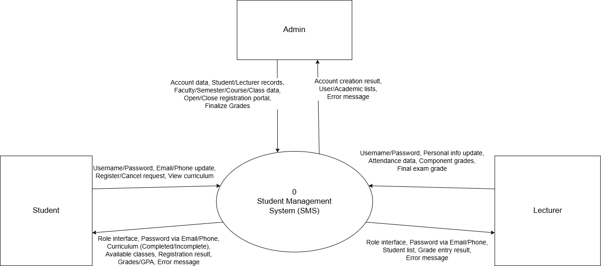
Table 1
Image 1: DFD diagram level 0

DFD Diagram Level 1 – Main Process Decomposition
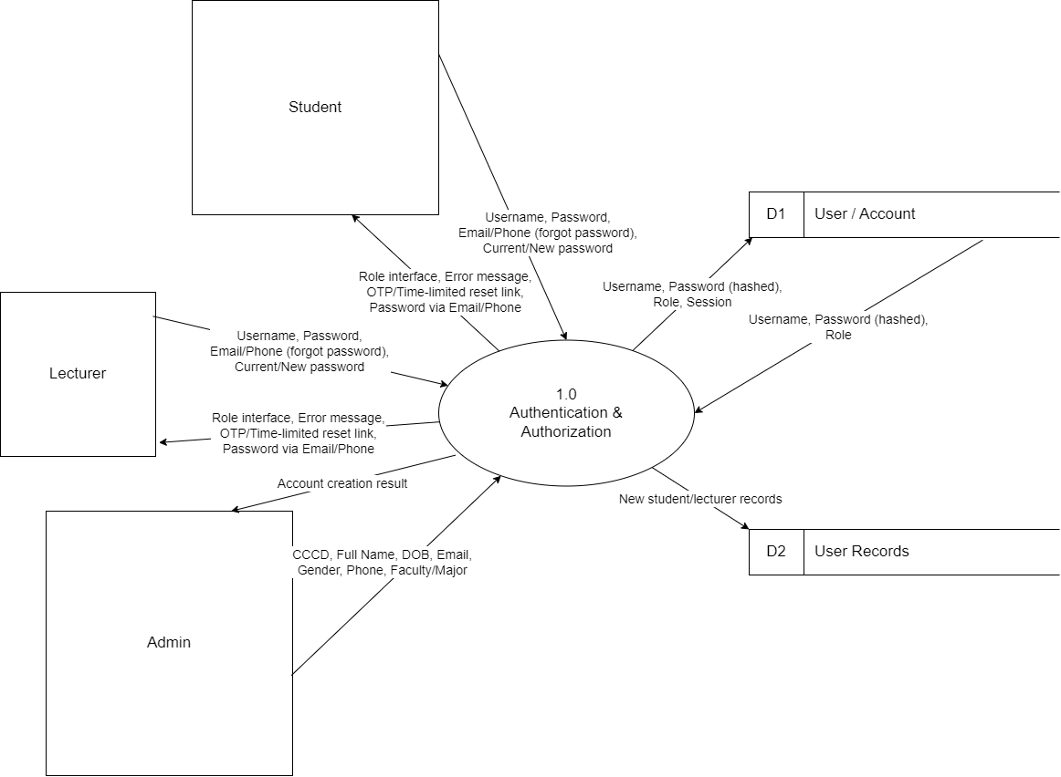
Image 2: Process 1
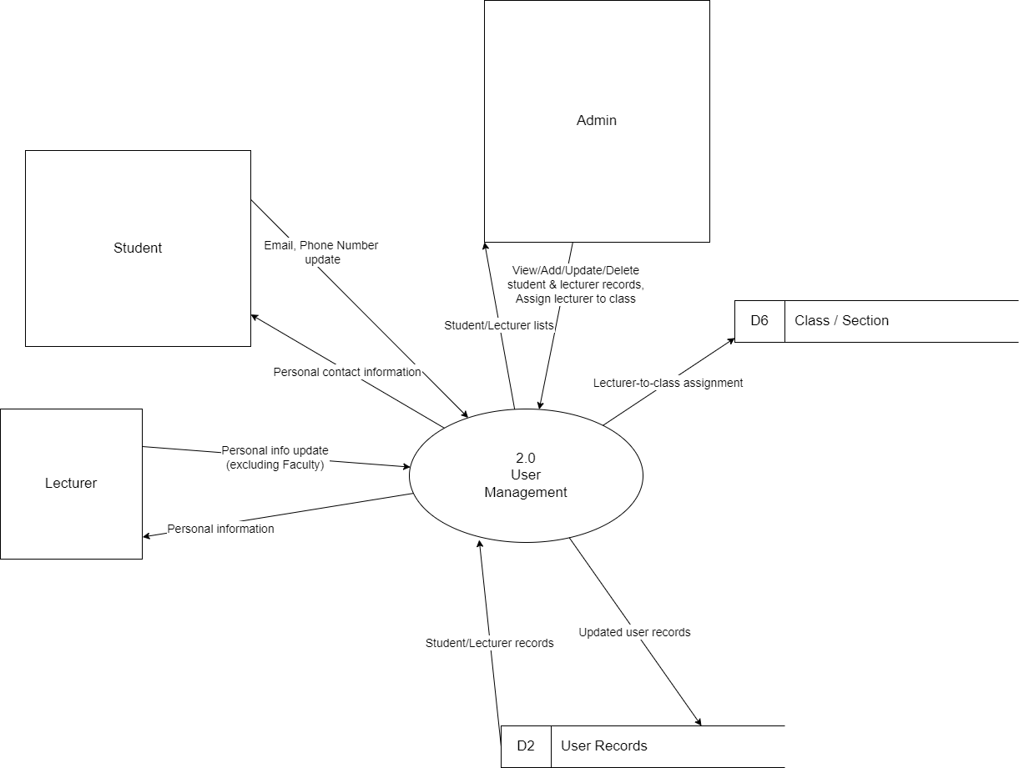
Image 3: Process 2
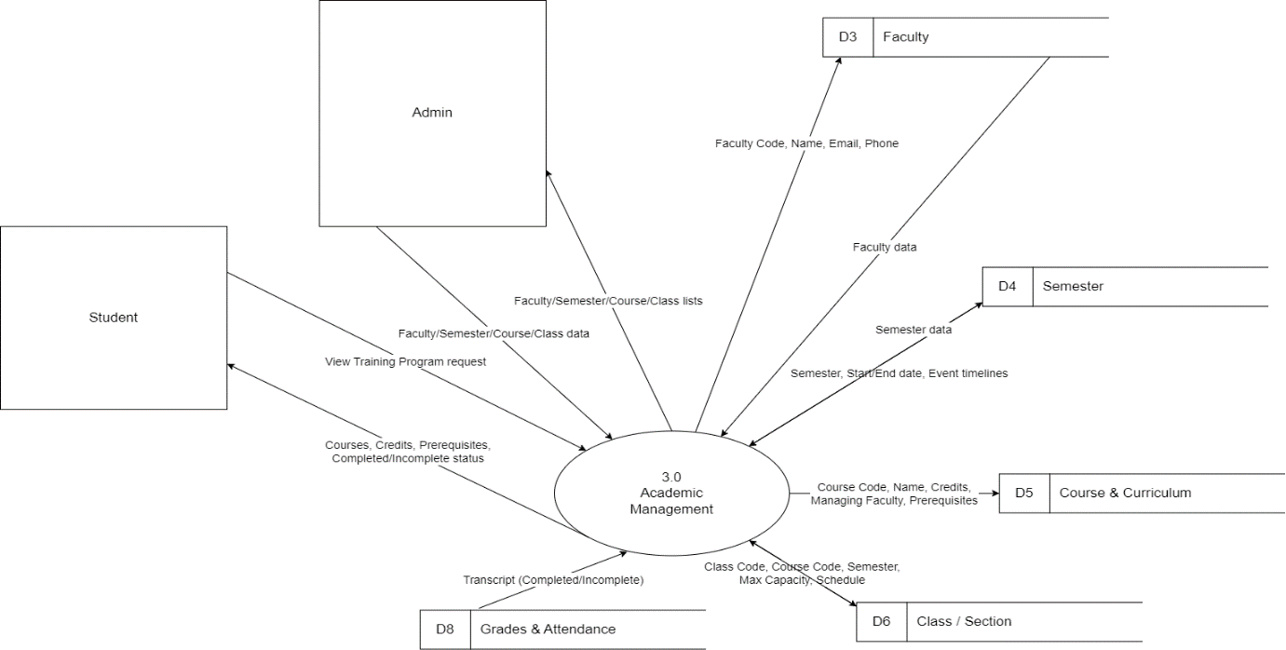

Image 4: Process 3
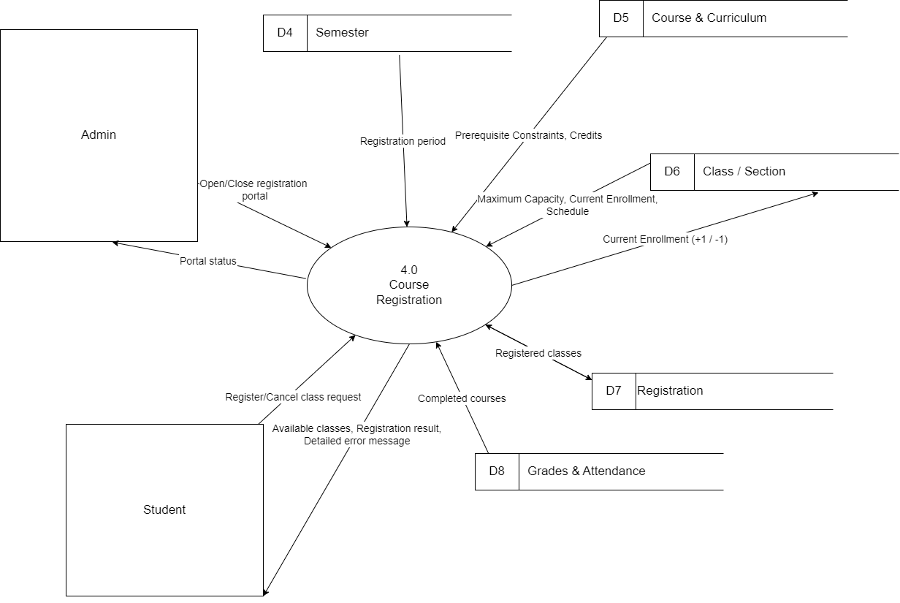
Image 5: Process 4
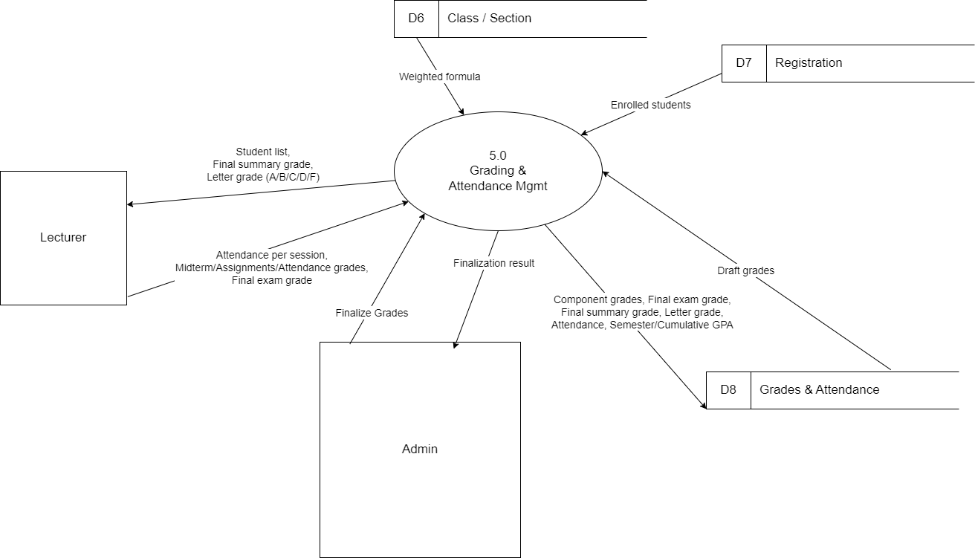
Image 6: Process 5

3.1 Overview
DFD Level 1 decomposes the central SMS process into 5 sub-processes, showing detailed data flows between external entities (Admin, Student, Lecturer), processing functions, and 8 data stores.

3.2 Processes

Process ID | Process Name | Functional Description
1.0 | Authentication & Authorization | Handles identity verification and role-based access control for all users (Admin, Student, Lecturer). Manages login sessions, password reset via OTP/email, and access token lifecycle.
2.0 | User Management | Manages user profiles: creating, updating, and deleting student and lecturer records. Handles personal contact information updates.
3.0 | Academic Management | Manages all academic data structures including faculties, semesters, courses, curricula, and class sections. Only Admin can create or modify academic data.
4.0 | Course Registration | Handles the full course registration and cancellation workflow for students. Validates eligibility, manages portal open/close status, and records enrollment.
5.0 | Grading & Attendance Mgmt | Manages per-session attendance records, component grade entry, final exam grades, and GPA calculation (semester and cumulative).
Table 2

3.3. Data Stores

Store ID | Name | Primary Contents
D1 | User / Account | Username, hashed password, user role, session information.
D2 | User Records | Detailed profiles: full name, national ID, date of birth, gender, email, phone number, faculty/major assignment.
D3 | Faculty | Faculty code, faculty name, contact email, phone number.
D4 | Semester | Semester code, start/end dates, event milestone timelines, registration portal status.
D5 | Course & Curriculum | Course code, course name, credit hours, managing faculty, prerequisite courses.
D6 | Class / Section | Class code, linked course code, semester, maximum capacity, current enrollment count, class schedule (day/time).
D7 | Registration | Student-class enrollment records: student ID, class ID, registration status.
D8 | Grades & Attendance | Component grades, exam grades, final summary grade, letter grade (A/B/C/D/F), attendance records, semester GPA, cumulative GPA.
Table 3

4. DFD Level 2 – Decomposition Of Process 4.0 (Course Registration)

4.1 Overview
DFD Level 2 decomposes Process 4.0 – Course Registration into 4 sub-processes. This is the deepest level of decomposition in the SMS DFD model, providing a precise view of each step in the enrollment workflow from period control to record persistence.

4.2 Sub-Processes

ID | Process Name | Detailed Description
4.1 | Registration Period Control | Controls the open/close status of the registration portal per semester. Admin activates or deactivates the portal; this process updates the status in D4 (Semester) and returns a confirmation to Admin.
4.2 | Automated Course Filtering | Automatically filters the list of class sections displayed to students: hides courses already completed, and shows only sections belonging to the currently open registration semester. Reads from D6, D8 (completed grades), and D4 (semester status).
4.3 | Registration Eligibility Validation | Validates 4 registration constraints in sequence: (1) all prerequisite courses completed, (2) no schedule conflict with existing registrations, (3) total registered credits do not exceed the maximum, (4) the class section still has available seats. All 4 must pass before proceeding to Process 4.4.
4.4 | Process Registration / Cancellation | Executes the actual enrollment or cancellation: creates or removes a record in D7 (Registration), updates the current enrollment count in D6 (Class/Section), and returns the outcome to the student.
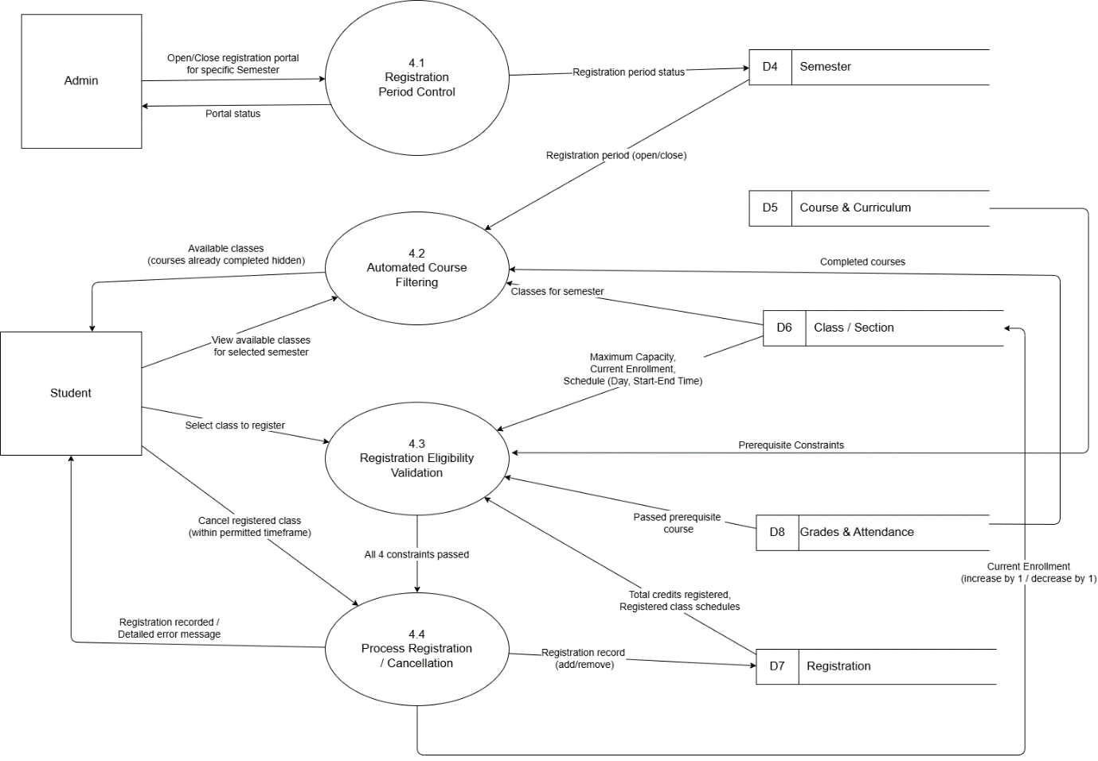
Table 4

Image 7: DFD diagram level 2

CHAPTER IV. USE CASE DIAGRAM

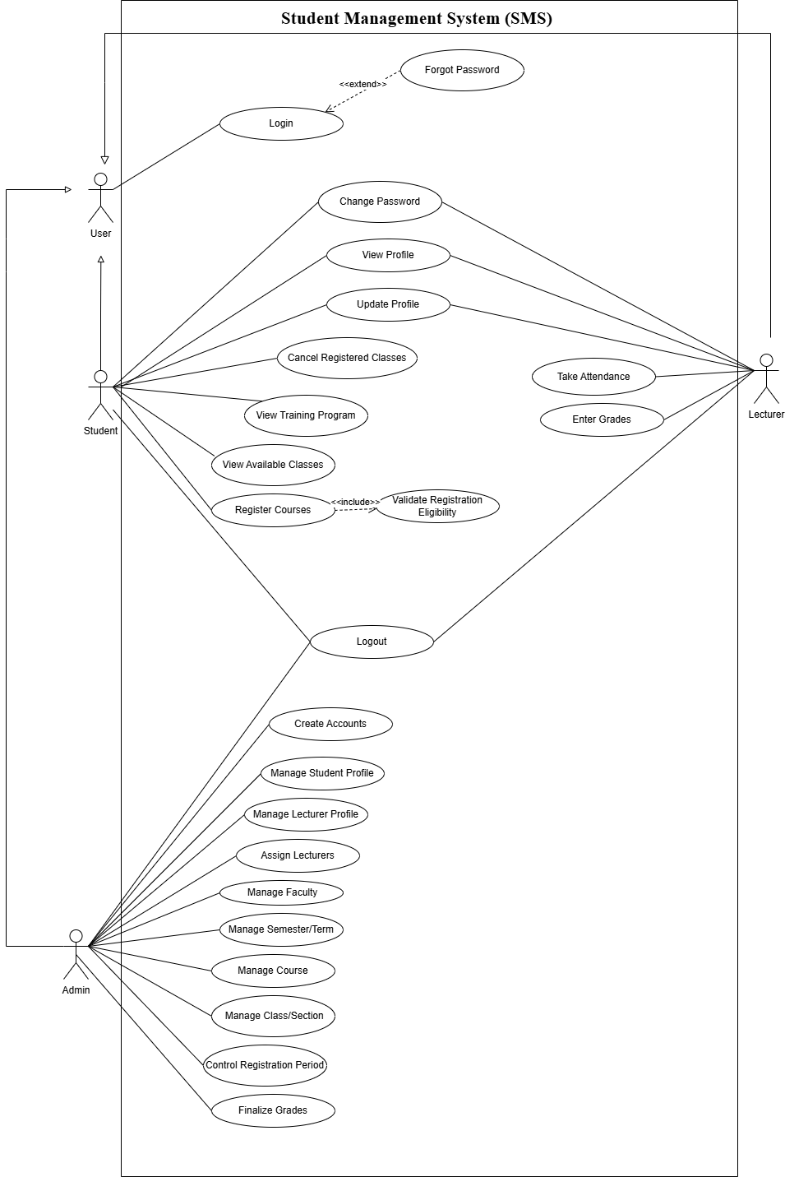
Use Case Diagram

Image 8: Use case diagram

List Of Actor
No. | Actor | Description
1. | User | Represents a user who is not logged in and can perform authentication.
2. | Student | Student can change password, view and update profile, view the training program and available classes, register for courses, and log out
3. | Lecturer | Lecturer can change password, view and update profile, take attendance, enter grades and log out
4. | Admin | Admin can manage users, assign lecturers, control registration, finalize grades, and manage academic data.
Table 5 : Actor

List Of Use Case
No. | Use case | Description
1. | Create Accounts | Only the admin has the right to create accounts based on admission or personnel records.
2. | Log in | Allows users to log in, the system verifies credentials and redirects based on role.
3. | Forgot Password | Allows users to request a password reset via their registered Email or Phone number.
4. | Log out | Allows users to log out of the system.
5. | Change Password | Users enter the current password, set a valid new one and confirm.
6. | View Profile | Allows users to view their information.
7. | Update Profile | Allows users to update their information.
8. | Manage Student Profile | Allows the admin to view, add, update, and delete student records
9. | Manage Lecturer Profile | Similar to students, the admin manages all records of the teaching staff.
10. | Assign Lecturers | Allows the admin to assign lecturers to class sections.
11. | Manage Faculty | Allows the admin to view, add, update, and delete faculty information
12. | Manage Semester/Term | Allows the admin to view, add, update, and delete semester/term information
13. | Manage Course | Allows the admin to view, add, update, and delete course information
14. | Manage Class/Section | Allows the admin to view, add, update, and delete class/section information
15. | View Training Program | Allows students to view the standard curriculum framework.
16. | Control Registration Period | Allows the admin to open and close the course registration portal for a specific Semester.
17. | View Available Classes | Allows students to view available classes for the selected semester.
18 | Register Courses | Allows students to register with validation checks.
19. | Cancel Registered Classes | Allows students to cancel registered classes.
20. | Take attendance | Allows lecturers to take attendance for students
21. | Enter Grades | Allows lecturers to enter component grades and final exam grades for students
22. | Finalize Grades | After the grading deadline, the admin or authorized role finalizes grades, which cannot be changed afterward.
Table 6 : Use case

4. Create Accounts

4.1 Summary
Only the admin can create user accounts, and students and lecturers cannot self-register.

4.2 Flow of Events

4.2.1. Main Flow
- The admin inputs mandatory fields: National ID (CCCD), Full Name, Date of Birth, Email, Gender, Phone Number, and Faculty/Major.
- The system automatically generates the Username based on the user's Student ID or Employee ID.
- The system randomly generates an initial password.
- The system automatically sends the generated password to the user's registered email or phone number.

4.2.2 Alternative Flow
If input is invalid, duplicate, or password delivery fails, the system shows an error and notifies the Admin.

4.3 Special Requirements
None.

4.4 Preconditions
The admin is logged into the system.

4.5 Postconditions
A new account is created with a system-generated username and password.

4.6 Extension Points
None.

5. Log in

5.1 Summary
Allows users to log in to the system using username and password.

5.2 Flow of Events

5.2.1 Main Flow
The use case begins when the user enters username and password.
- The system validates the credentials.
- The system identifies the user role.
- The system redirects the user to the appropriate interface.

5.2.2 Alternative Flow
If credentials are incorrect, the system displays an error message.

5.3 Special Requirements
The authentication process must be secure.

5.4 Preconditions
The user has a valid account.

5.5 Postconditions
The user is logged into the system.

5.6 Extension Points
Forgot Password

6. Forgot Password

6.1 Summary
Allows users to request a password reset via their registered Email or Phone number when they cannot log in to the system.

6.2 Flow of Events

6.2.1 Main Flow
The use case begins when the user selects the forgot password.
- The system prompts the user to enter their registered Email or Phone number.
- The user submits the required information.
- The system validates if the provided Email or Phone number exists in the database.
- The system sends a secure, time-limited link or OTP to the user's registered contact method to verify their identity.
- The user enters the OTP or accesses the secure link.
- The system verifies the identity.
- The system allows the user to set and confirm a new password.
- The system validates the password complexity, updates the password, and displays a success message.

6.2.2 Alternative Flow
- If the entered Email or Phone number is not found in the system, the system displays an error message.
- If the OTP or secure link is entered incorrectly or has expired, the system rejects the request, displays a clear error message, and requires the user to request a new one.

6.3 Special Requirements
The verification link or OTP generated by the system must be secure and time-limited to prevent unauthorized access.

6.4 Preconditions
The user is not logged in to the system. The user must have a previously registered account with a valid Email or Phone number.

6.5 Postconditions
If the use case is successful, the user's password is changed in the database, and they can use the new password to log in. Otherwise, the account credentials remain unchanged.

6.6 Extension Points
None

7. Log out

7.1 Summary
Allows users to log out of the system.

7.2 Flow of Events

7.2.1 Main Flow
The use case begins when the user selects logout.
- The system terminates the session.
- The system redirects to login the page.

7.2.2 Alternative Flow
None.

7.3 Special Requirements
None.

7.4 Preconditions
The user is logged in.

7.5 Postconditions
The user is logged out.

7.6 Extension Points
None.

8. Change Password

8.1 Summary
Allows users to change their password.

8.2 Flow of Events

8.2.1 Main Flow
The use case begins when the user selects the change password.
- The user enters the current password and a new password.
- The system validates the current password.
- The system updates the password.

8.2.2 Alternative Flow
If the current password is incorrect, the system displays an error message.

8.3 Special Requirements
The password must meet security rules.

8.4. Preconditions
The user is logged in.

8.5. Postconditions
Password is updated.

8.6 Extension Points
None.

9. View Profile

9.1 Summary
Allows users to view their personal information.

9.2 Flow of Events

9.2.1 Main Flow
The use case begins when the user selects the view profile.
- The system retrieves information.
- The system displays the profile.

9.2.2 Alternative Flow
None.

9.3 Special Requirements
Data must be accurate.

9.4 Preconditions
The user is logged in.

9.5 Postconditions
Profile is displayed.

9.6 Extension Points
None.

10. Update Profile

10.1 Summary
Allows users to update their personal information.

10.2 Flow of Events

10.2.1 Main Flow
The use case begins when the user updates the profile.
- The user edits the information.
- The system validates input.
- The system saves changes.

10.2.2 Alternative Flow
If the input data is invalid, the system displays an error message.

10.3 Special Requirements
Input must be validated.

10.4 Preconditions
The user is logged in.

10.5 Postconditions
Profile is updated.

10.6 Extension Points
None.

11. Manage Student Profile

11.1 Summary
Allows the admin to view, add, update, and delete student records (CRUD operations).

11.2 Flow of Events

11.2.1 Main Flow
- The admin accesses the student management section.
- The admin performs view, add, update, or delete actions on student records.
- For each student record, the admin ensures a "Status" is assigned.
- The system updates the student database.

11.2.2 Alternative Flow
If input data is invalid or missing, or the student profile does not exist, the system displays an error and prevents the update.

11.3 Special Requirements
Students are restricted from modifying identification data (Student ID, National ID, affiliated Faculty), so the admin retains full control over these fields.

11.4 Preconditions
The admin is logged into the system.

11.5 Postconditions
The student records are successfully managed in the system.

11.6 Extension Points
None.

12. Manage Lecturer Profile

12.1 Summary
Allows the admin to view, add, update, and delete teaching staff.

12.2 Flow of Events

12.2.1 Main Flow
- The admin accesses the lecturer management section.
- The admin manages records of the teaching staff.
- The system updates the lecturer database.

12.2.2 Alternative Flow
If input data is invalid or missing, or the lecturer profile does not exist, the system displays an error and prevents the update.

12.3 Special Requirements
Lecturers cannot update their affiliated faculty, so the admin manages this data.

12.4 Preconditions
The admin is logged into the system.

12.5 Postconditions
The lecturer records are successfully managed in the system.

12.6 Extension Points
None.

13. Assign Lecturers

13.1 Summary
Allows the admin to assign lecturers to specific class sections.

13.2 Flow of Events

13.2.1 Main Flow
- The admin selects a specific class section.
- The admin assigns a lecturer to the selected class section.
- The system saves the assignment.

13.2.2 Alternative Flow
If the lecturer or class is invalid, unavailable, or already assigned, the system displays an error and prevents the assignment.

13.3 Special Requirements
None.

13.4 Preconditions
The admin is logged into the system, and class sections/lecturers must exist.

13.5 Postconditions
The lecturer is successfully assigned to the class section.

13.6 Extension Points
None.

14. Manage Faculty

14.1 Summary
Allows the admin to view, add, update, and delete faculty catalog.

14.2 Flow of Events

14.2.1 Main Flow
- The admin accesses the faculty catalog.
- The admin manages faculty information including the Faculty Code, Faculty Name, Email, and Phone Number.
- The system saves the faculty catalog updates.

14.2.2 Alternative Flow
If input data is invalid, missing, or the faculty already exists, the system displays an error and prevents the operation.

14.3 Special Requirements
None.

14.4 Preconditions
The admin is logged into the system.

14.5 Postconditions
Faculty catalog data is updated.

14.6 Extension Points
None.

15. Manage Semester/Term

15.1 Summary
Allows the admin to view, add, update, and delete academic semesters, including dates and timelines.

15.2 Flow of Events

15.2.1 Main Flow
- The admin accesses semester management.
- The admin manages the semester's start dates, end dates, and event timelines (such as registration periods and exam weeks).
- The system records the semester details, ensuring all academic operations can be tied to it.

15.2.2 Alternative Flow
If input data is invalid, missing, or the semester already exists, the system displays an error and prevents the operation.

15.3 Special Requirements
None.

15.4 Preconditions
The admin is logged into the system.

15.5 Postconditions
Semester data is updated.

15.6 Extension Points
None.

16. Manage Course

16.1 Summary
Allows the admin to view, add, update, and delete courses.

16.2 Flow of Events

16.2.1 Main Flow
- The admin accesses the course management section.
- The admin performs view, add, update, or delete actions.
- The admin inputs or updates required course data: Course Code, Course Name, Credits, Managing Faculty, and Prerequisite Constraints.
- The system saves the course data.

16.2.2 Alternative Flow
If input data is invalid, missing, or the course already exists, the system displays an error and prevents the operation.

16.3 Special Requirements
None.

16.4 Preconditions
The admin is logged into the system.

16.5 Postconditions
Course data is successfully modified in the system.

16.6 Extension Points
None.

17. Manage Class/Section

17.1 Summary
Allows the admin to view, add, update, and delete class sections opened within a specific semester.

17.2 Flow of Events

17.2.1 Main Flow
- The admin selects a specific semester and course.
- The admin adds or updates a class section by entering: Class Code, Course Code, Semester, Maximum Capacity, Current Enrollment, and a specific Schedule (Day of the week, Start Time to End Time).
- The system saves the class section data.

17.2.2 Alternative Flow
If input data is invalid, missing, or the class/section already exists, the system displays an error and prevents the operation.

17.3 Special Requirements
A course can be opened as multiple class sections.

17.4 Preconditions
The admin is logged into the system, courses and semesters must be pre-configured.

17.5 Postconditions
The class section is configured and ready for enrollment.

17.6 Extension Points
None.

18. View Training Program

18.1 Summary
Allows students to view their training program.

18.2 Flow of Events

18.2.1 Main Flow
The use case begins when the student selects the training program.
- The system retrieves program data.
- The system displays required courses.

18.2.2 Alternative Flow
None.

18.3 Special Requirements
Information must be up-to-date.

18.4 Preconditions
The student is logged in.

18.5 Postconditions
The training program is displayed.

18.6 Extension Points
None.

19. Control Registration Period

19.1 Summary
Allows the admin to open and close the course registration portal for a specific semester.

19.2 Flow of Events

19.2.1 Main Flow
- The admin accesses the registration control module.
- The admin selects a specific Semester.
- The admin executes the action to either open or close the registration portal.
- The system updates the portal's status, allowing or restricting students from viewing available classes and registering.

19.2.2 Alternative Flow
If the selected semester is invalid, the action is not permitted (e.g., already open/closed), or the system encounters an error, the system displays an error message and does not update the registration status.

19.3 Special Requirements
None.

19.4 Preconditions
The admin is logged into the system, semesters must exist.

19.5 Postconditions
The registration portal is either opened or closed.

19.6 Extension Points
None.

20. View Available Classes

20.1 Summary
Allows students to view available classes.

20.2 Flow of Events

20.2.1 Main Flow
The use case begins when the student accesses the class list.
- The system displays available classes.
- The student searches or filters classes.

20.2.2 Alternative Flow
If no results are found, the system displays an empty list.

20.3 Special Requirements
The system should respond quickly.

20.4 Preconditions
The student is logged in.

20.5 Postconditions
The class list is displayed.

20.6 Extension Points
None.

21. Register Courses

21.1 Summary
Allows students to register for courses.

21.2 Flow of Events

21.2.1 Main Flow
The use case begins when the student selects a course.
- The system checks prerequisites.
- The system checks the credit limit.
- The system checks capacity.
- The system checks schedule conflict.
- The system confirms registration.

21.2.2 Alternative Flow
- If the student has not completed the required prerequisite courses, the system displays an error message and prevents registration.
- If the total registered credits exceed the allowed limit, the system displays an error message and prevents registration.
- If the selected class has reached its maximum capacity, the system displays an error message and prevents registration.
- If the selected class schedule conflicts with another registered class, the system displays an error message and prevents registration.

21.3 Special Requirements
Validation must be accurate.

21.4 Preconditions
Registration is open.

21.5 Postconditions
The course is registered.

21.6 Extension Points
None.

22. Cancel Registered Classes

22.1 Summary
Allows students to cancel registered for classes.

22.2 Flow of Events

22.2.1 Main Flow
The use case begins when the student selects a registered class.
- The system verifies conditions.
- The system removes class.

22.2.2 Alternative Flow
If the cancellation deadline has passed, the system displays an error message and prevents cancellation.

22.3 Special Requirements
Must follow policy.

22.4 Preconditions
The student has registered for classes.

22.5 Postconditions
Class is removed.

22.6 Extension Points
None.

23. Take Attendance

23.1 Summary
Allows lecturers to record student attendance.

23.2 Flow of Events

23.2.1 Main Flow
The use case begins when the lecturer selects a session.
- The system displays the student list.
- The lecturer marks attendance.
- The system saves data.

23.2.2 Alternative Flow
If the selected session does not exist, the system displays an error message.

23.3 Special Requirements
Must be accurate.

23.4 Preconditions
The lecturer is logged in and the session exists.

23.5 Postconditions
Attendance is recorded.

23.6 Extension Points
None.

24. Enter Grades

24.1 Summary
Allows lecturers to enter and manage student grades.

24.2 Flow of Events

24.2.1 Main Flow
The use case begins when the lecturer selects a course.
- The system displays students.
- The lecturer enters grades.
- The lecturer saves the grades as a draft.
- The system confirms that the grades are saved successfully.

24.2.2 Alternative Flow
If the grades have already been finalized, the lecturer cannot edit them and the system displays a notification.

24.3 Special Requirements
Must store history.

24.4 Preconditions
The lecturer is logged in and the course exists.

24.5 Postconditions
Grades saved.

24.6 Extension Points
None.

25. Finalize Grades

25.1 Summary
Allows the admin (or authorized role) to finalize course grades once the grading deadline ends.

25.2 Flow of Events

25.2.1 Main Flow
- The admin verifies that the grading deadline has ended.
- The admin executes the "Finalize Grades" function for the entered drafts.
- The system automatically calculates both Semester GPA and Cumulative GPA based on these finalized grades.

25.2.2 Alternative Flow
If the grading deadline has not ended or grade data is incomplete/invalid, the system displays an error message and does not finalize the grades.

25.3 Special Requirements
After finalization, grades cannot be altered.

25.4 Preconditions
The admin is logged into the system. Lecturers must have entered grades (saved as "Draft").

25.5 Postconditions
Grades are locked and cannot be changed. Semester and Cumulative GPAs are calculated.

25.6 Extension Points
None

CHAPTER V. CLASS DIAGRAM

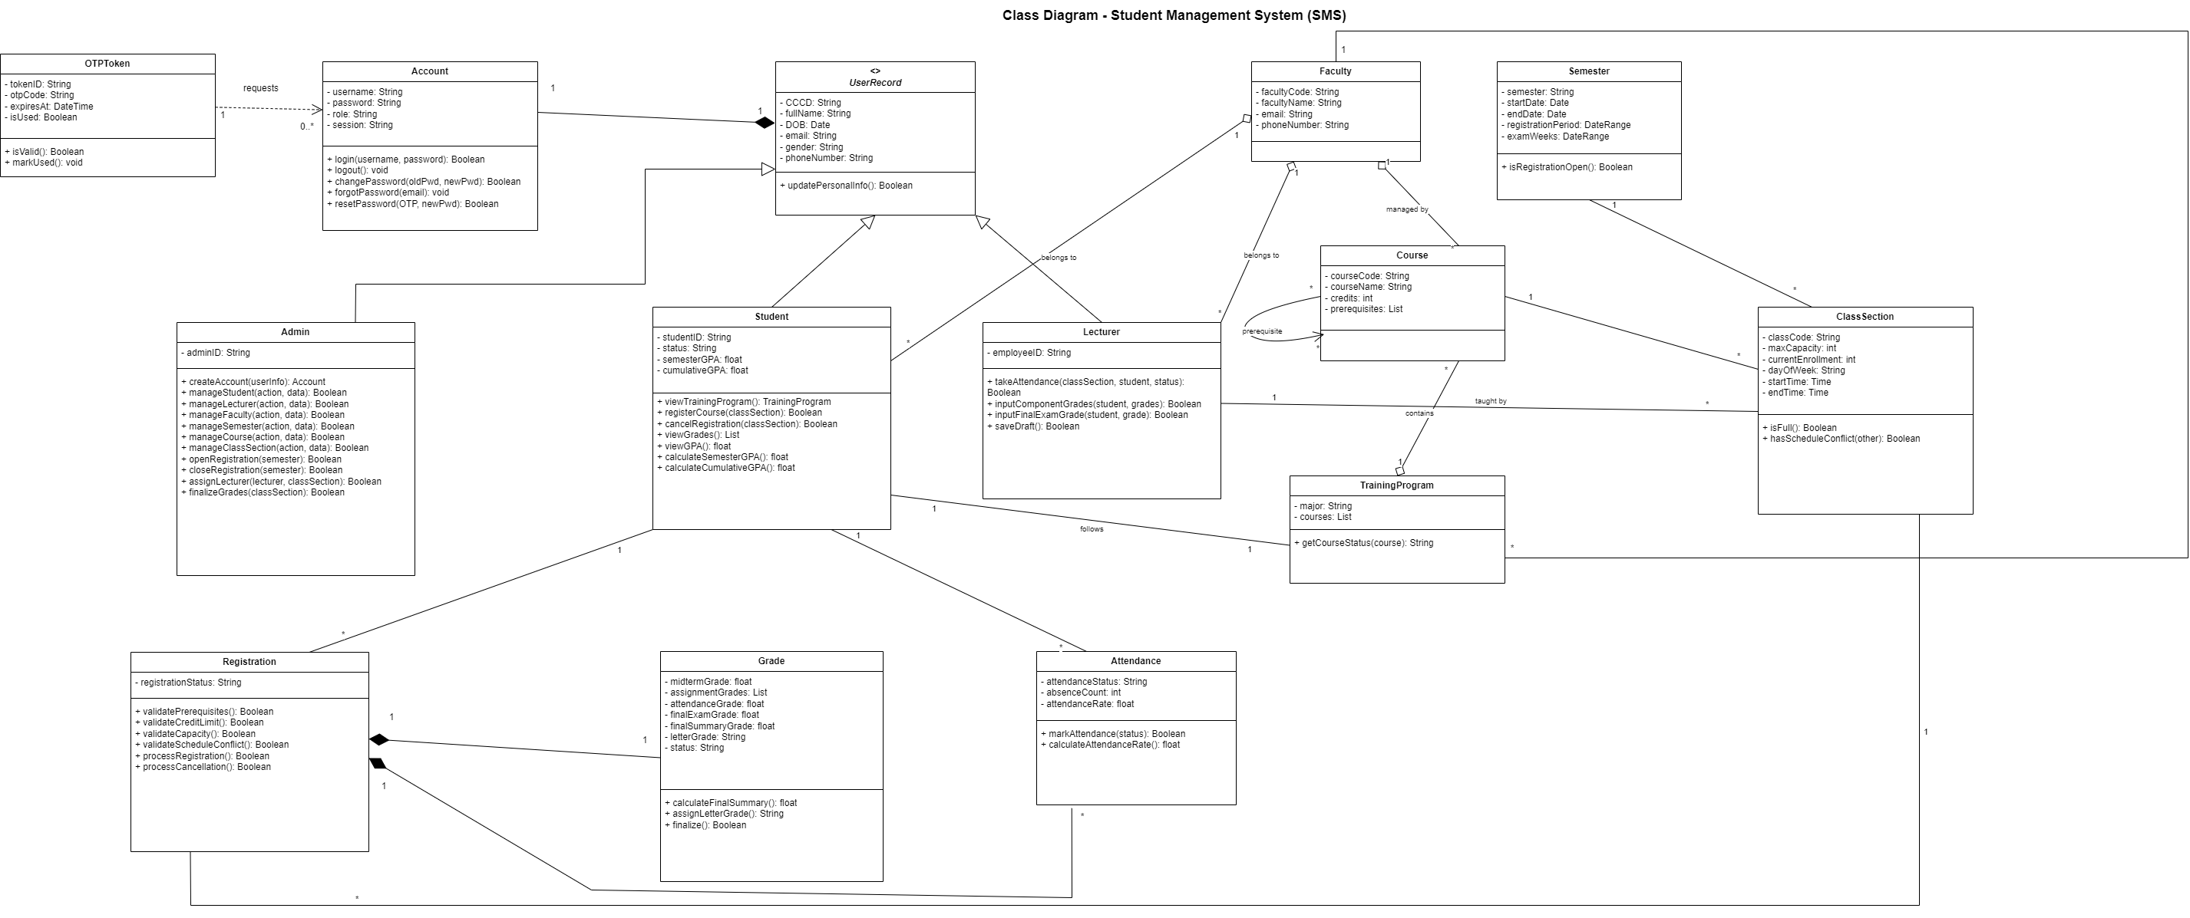

CHAPTER VI. DATA MODEL

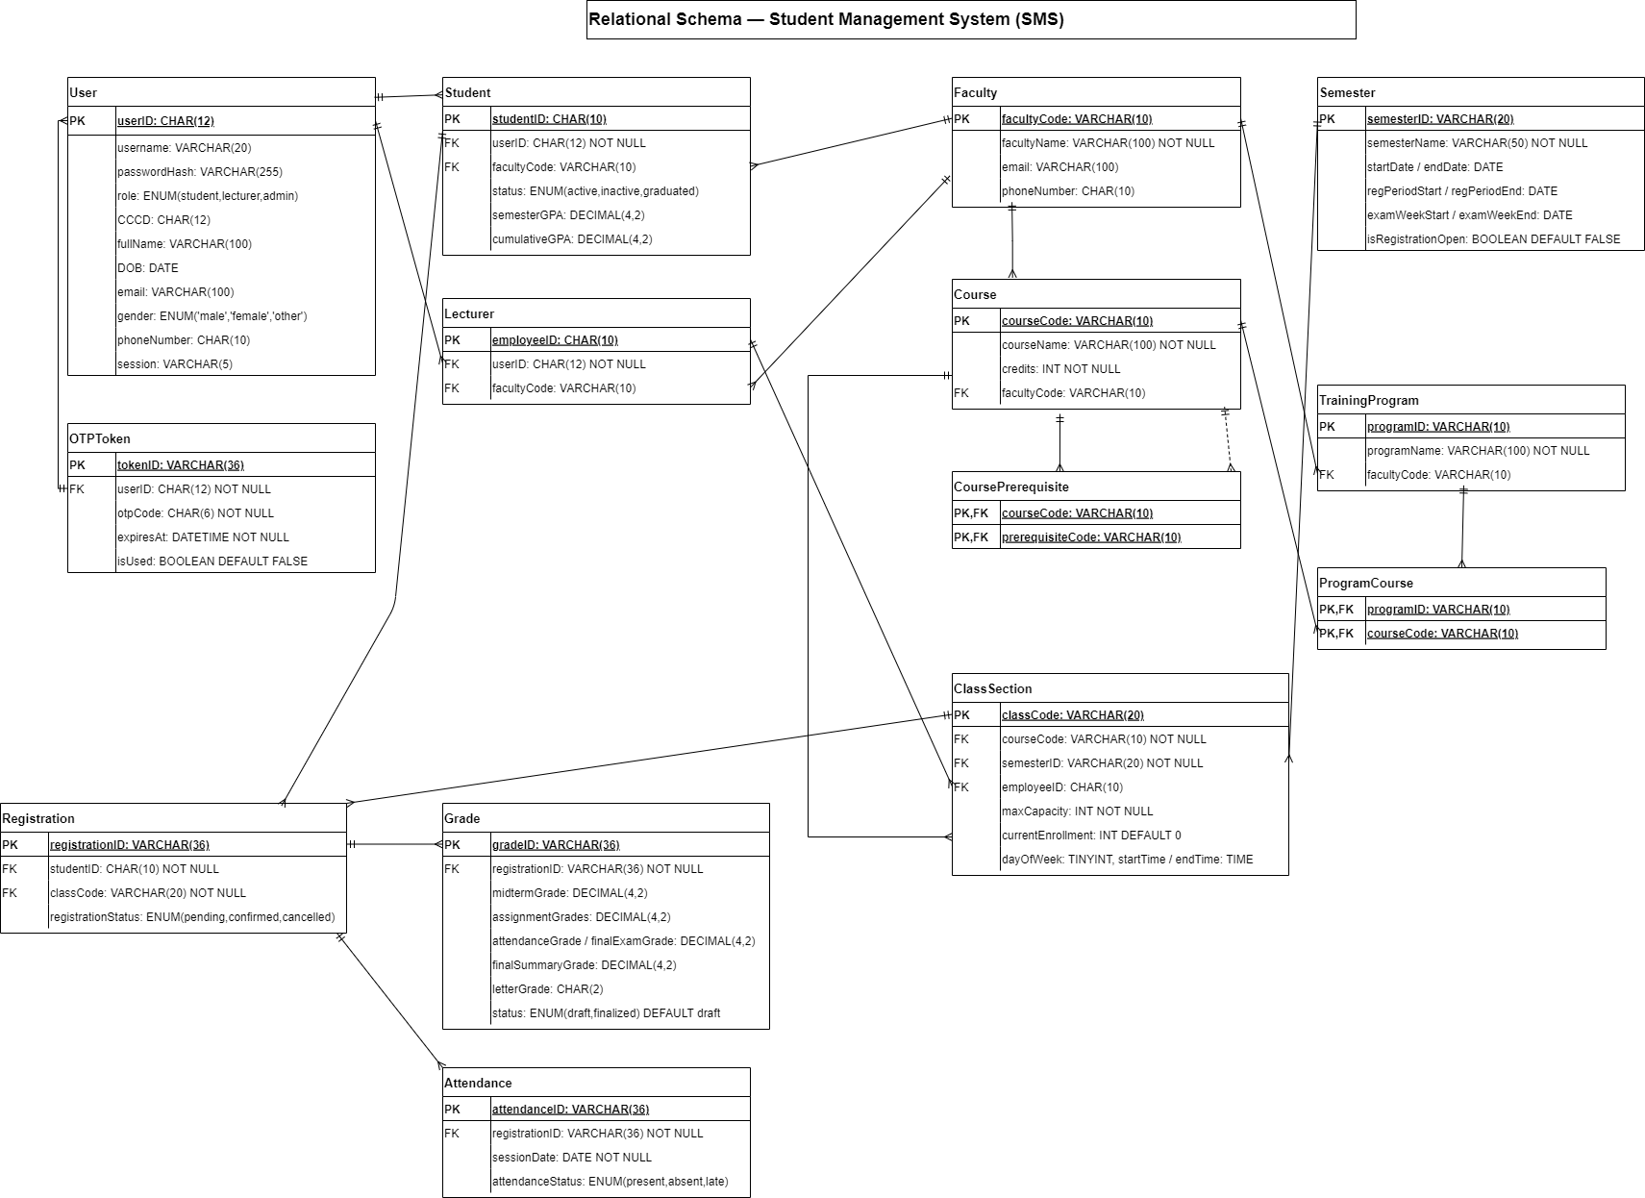

CHAPTER VII. INTERFACE DESIGN DESCRIPTION

Overall Interface Overview
The Student Management System (SMS) is implemented as a modern application with a graphical user interface (GUI). The system interface must be intuitive and responsive. Users interact with the system through visual forms, dashboards, and navigation menus rather than text-based console inputs. Based on user roles, including the admin, the student, and the lecturer, the system provides separate menus with functions appropriate to each role. The system must strictly comply with Role-Based Access Control (RBAC).

Main Menu & Authentication Design
When the application starts, the system displays a main authentication menu that serves as the entry point for all users. The main menu provides the following options
- Log in using a Username and Password.
- Forgot Password to request a password reset via registered Email or Phone number. The system will send a secure, time-limited link or OTP to verify identity.
Upon successful authentication, the system automatically identifies the role (Admin, Student, Lecturer) to display the corresponding interface and features.

Role-Based Menu Design
To ensure clear separation of responsibilities and secure access control, the system implements role-based menus. Each role is provided with a distinct set of functions.

3.1 Administrator Interface
The administrator interface allows administrators to manage academic data, system configurations, and user accounts. Main functions provided to administrators include
- Creating accounts based on admission or personnel records.
- Managing student and lecturer profiles (view, add, update, delete).
- Assigning lecturers to specific class sections.
- Managing the Faculty catalog, Semesters/Terms, Courses, and Class/Sections.
- Controlling the registration period by opening and closing the portal.
- Executing the "Finalize Grades" function once the grading deadline ends.
- Changing passwords and logging out of the system.

3.2 Student Interface
The student interface is designed to support course registration and academic planning activities. Students can perform the following actions
- Viewing and updating their own personal contact information (Email, Phone Number).
- Viewing the standard curriculum framework for their major, with statuses automatically labeled as "Completed" or "Incomplete".
- Viewing the list of available classes for the selected semester.
- Registering for courses and canceling registered classes within the permitted timeframe.
- Changing passwords and logging out of the system.

3.3 Lecturer Interface
The lecturer interface provides basic teaching-related functionalities. Lecturers are able to
- Updating basic personal information, excluding their affiliated Faculty.
- Taking attendance for students in each session and tracking absences.
- Entering component grades and final exam grades and saving grades as "Draft"
- Changing passwords and logging out of the system.

User Interaction and System Feedback
The system provides immediate and clear feedback after each user action.
- If an operation is completed successfully, the system proceeds with the action, such as requiring confirmation before saving password changes or displaying a success message.
- If an operation fails or credentials are incorrect, the system will display an error message.
- Error messages must be clear and guide users on how to fix the issue.
- The system provides specific visual feedback, such as highlighting the specific field causing the error.
- During course registration, the system provides detailed error messages explaining the reason if constraints (Prerequisites, Credit Limit, Capacity, Schedule Conflict) are violated. For example, the system will specify which course causes a schedule conflict.

Interface Design Rationale
A responsive Graphical User Interface (GUI) was selected for this system due to the following reasons
- The non-functional requirements explicitly mandate that the system interface must be intuitive and responsive.
- The system requires advanced visual error handling, such as highlighting specific fields causing errors, which is effectively implemented in GUI or web-based environments rather than standard console applications.
- The interface effectively manages the display of complex academic data, such as curriculum frameworks, automated course filtering, and gradebooks.

