DASH NO. | TYPE OR MODEL | NEXT ASSY | REV | DESCRIPTION OF CHANGE | APPROVED | DATE
-01 | TrueBeam | 100040928 | 1 | Engineering Release M.PINTO 3-14-11 | M.Iskandar | 4-12-11

THIS DOCUMENT CONTAINS INFORMATION WHICH IS THE PROPRIETARY PROPERTY OF VARIAN MEDICAL SYSTEMS. REPRODUCTION, DISCLOSURE OR RELEASE TO OTHERS, MANUALLY OR ELECTRONICALLY, WITHOUT PRIOR WRITTEN CONSENT OF VARIAN MEDICAL SYSTEMS IS STRICTLY PROHIBITED.
● | ORIGINATOR: | MARCO PINTO | DATE: | 3-11-2011
● | CHECKER: | MOUSSA ISKANDAR | DATE: | 4-12-2011
● | APPROVED: | MOUSSA ISKANDAR | DATE: | 4-12-2011
● | APPROVED: |  | DATE:

Title: FPGA, PROGRAMMED, POWER, DB (DTR)

-01 SHOWN

Target device
VARIAN PART NUMBER - 6260573170
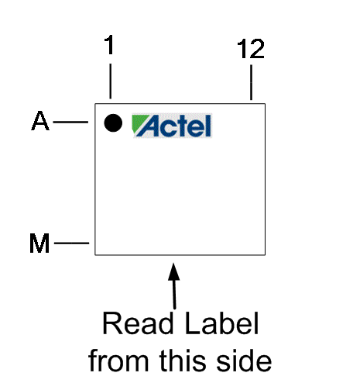

Layout of Label

100047705-01
Rev 1
Version 1.6
VARIAN

ZIP FILE
DRAWING NUMBER | DASH NUMBER | REVISION
100047705 | -01 | 1

ZIP FILE CONTENT
FILE NAME/DESCRIPTION | VERSION
100047705-1.stp [output file] | 1.0
100047705-1_Release Memo.doc | 1
100047705-1.doc (FPGA, PROGRAMMED, POWER, DB (DTR) | 1

REFERENCE DOCUMENT: 100053565-01 HET Actel FPGA Build Procedure, Rev 1.0.
PARTS LIST
PART NUMBER | DESCRIPTION OR MATERIAL | QTY
8836012770 | LABEL,PS,0.312X.312,WHITE,ROHS | 1
6260573170 | IC, A3P060, FGG-144 ,ROHS | 1

NOTES: UNLESS OTHERWISE SPECIFIED.
1. PROGRAM FPGA (6260573170) USING 100047705-01.stp
2. STP FILE IS AVAILABLE IN ‘PUBLIC’ DRIVE
3. IDENTIFY PROGRAMMED CPLD WITH PART NUMBER, REVISION LEVEL
4. CAUTION: STATIC ELECTRICAL DISCHARGE CAN DAMAGE THIS DEVICE
HANDLE & PACKAGE PER M60-8023.

