Video conferencing: An E-Learning Tool for Remote Education (E-Edu Care)

A Project Report is submitted in partial fulfillment of the requirements for the Degree of “Master of Science in Computer Science” to the department of Computer Science and Engineering.

Submitted by

**Md.Al Amin Mridha**

ID: CSE202003013

Supervised by-

Professor Dr. Imdadul Islam

Department of Computer Science and Engineering

Jahangirnagar University

Savar, Dhaka- 1342



Department of Computer Science and Engineering

Jahangirnagar University

Savar, Dhaka- 1342

Declaration

The project report submitted to the department of Computer Science and Engineering, Jahangirnagar University, Savar, Dhaka, in partial fulfillment of the requirements for the Degree of Master of Science in Computer Science under PMSCS program. I hereby declared that this report entitled, Video conferencing: An E-Learning Tool for Remote Education has not published anywhere for the requirement of any kind of degree or publication.

Signature ………………………

**Md.Al Amin Mridha**

ID: CSE202003013 ,

Department of Computer Science and Engineering

Jahangirnagar University

Savar, Dhaka

Approval and Acceptance

A project report written by **Md. Al Amin Mridha** (Student ID: CSE202003013) entitled is submitted to the PMSCS program Department of computer Science and Engineering, Jahangirnagar University in the partial fulfillment of the requirement for the degree of Master of Science in Computer Science. The project is done under the supervision of Professor **Dr. Imdadul Islam, Department** of Computer Science and Engineering, Jahangirnagar University.

I have examined this report and recommend its acceptance.

……………………………………………..

**Prof. Dr. Imdadul Islam**

Supervisor & 1st Examiner

Department of Computer Science and Engineering,

Jahangirnagar University

Savar, Dhaka, Bangladesh

……………………………………………..

**Prof. Dr. Jugal Krishna**

2nd Examiner

Department of Computer Science and Engineering,

Jahangirnagar University

Savar, Dhaka, Bangladesh

**Accepted By**

………………………………………………

**Prof. Md. Golam Moazzam**

Coordinator

PMSCS Program, 2021

Department of Computer Science and Engineering,

Jahangirnagar University

Savar, Dhaka, Bangladesh.

**Acknowledgement**

It is a great honor and privilege for me to record this deep sense of gratitude and indebtedness to my respected supervisor Professor Dr.Imdadul Islam, Department of Computer Science and Engineering, Jahangirnagar University who guided me during the project work. He was always ready to help me by his proper guidance and valuable advice I become succeed to complete my project tasks, I am also thankful to all the faculty members and teachers who helped me a lot when I was in the troubles and made it possible for me to complete my project. It was a great experience for me to complete this project. Especial thanks to my parents and all my friends who encourage and support me for this project.

Sincere gratefulness due to authors and contributors of all the intellectual materials, software, hardware, information resources that I have learned and used for project work. Without such knowledge, this study would not have been successful.

Abstract

Due to the pandemic COVID-19, the lives of the world association have been changed significantly especially in the field of education. The pandemic has a huge impact on education. To reduce the impact of outbreaks, the Remote learning is a duplicate way for the world association. One of the Variant of face-to-face learning is online and virtual learning. Without being in classroom, to achieve learning goal the online meeting applications is very useful process. That process also conveniences for students as well as the teachers. This Apps helps us in using online meeting applications to learn during the outbreak period. In the teaching and learning process between teachers and students, this application is very helpful for each other. In Solving remote learning problems, the effect towards usage of online meeting applications is increase day by day. In small states and developing countries like Bangladesh, where the education access is widening and the delivery method of cost- effectiveness can play a significant role. Remote learning can be more cost-effective than traditional learning. Drop-out rates can be reduced and students can interact with the expert teachers even at the remote areas. Currently the students are engaged in e-learning activities. For this reason, Students are able to construct their own knowledge through self-directed learning. Due to the implementation of e-learning, performance of the students may increase day by day at the remote places. The students can be benefited by using advanced e–learning technologies even after the lecture classes via E-learning portal through intranet facilities. This paper discusses how a video conferencing apps could be exploited and applied in remote learning for effective service delivery in the pandemic situation.

List of Content

APPROVAL OF ACCEPTENCE……………………………………………………………...ii

ACKNOWLEDGEMENT……………………………………………………………………..iii

ABSTRACT…………………………………………………………………………………....iv

Chapter One

* 1. Introduction………………………………………………………...………………. 1
  2. Motivation………….……………………………………………………………......1
  3. Literature Review……………………………………………………………………2
  4. Features………………………………………………………………………………2
  5. Objective Of this work.………………………………………………………………2
  6. Problems of existing system...……………………………………………………….2
  7. Organization of the Work….………………………………………………………...2

Chapter Two

2.1 Introduction..……………………………………………………………………….. 3

2.2 History of Android…………………………………………………………………. 3

2.3 Cross Platform Apps and Native Apps…...………………………………………… 3

2.4 Challenges in Android Development..……………………………………………… 4

2.5 Android Basics overview…………………………………………………………… 4

2.6 Mobile App Feature………………………………………………………………… 7

2.7 Mobile App Specifications ………………………………………………………… 8

2.8 Android Programming Language ………………………………………………….. 8

2.8.1 Java.……………………………………………………………………….. 8

2.8.2 Kotlin...……………………………………………………………………. 9

2.8.3 Python.…………………………………………………………………….. 9

2.8.4 HTML, CSS, JAVASCRIPT……………………………………………… 9

2.8.5 DART.…………………………………………………………………….. 9

2.9 Apps Database……………………………………………………………………… 10

2.10 Application ……………………………………………………………………….. 12

2.11 Summary.…………………………………………………………………………. 13

Chapter Three

3.1 Introduction………………………………………………………………………… 13

3.2 System Description………………………………………………………………… 14

3.3 System Functionality…..…………………………………………………………... 14

3.3.1 System Administrator and User Function…………………….………….. 14

3.3.2 System Administrator Function...………………………………………… 14

3.3.3 System user Functions……..….………………………………………….. 14

3.3.4 System Nonfunctional Requirement...……….…………………………… 15

3.4 System Components...……………………………………………………………… 15

3.5 System analysis and design using UML………………..……………………………16

3.5.1 Use Case for Create/Join Meeting..………………………………………. 16

3.5.2 Use case for call operation………………………………………………... 16

3.6 Sequence diagram……………………………………………………………………17

3.6.1 Sequence diagram for register……………………………………………..17

3.6.2 Sequence diagram for login………………………………………….…… 17

3.6.3 Code Segment for login……………………………………………………18

3.6.4 Sequence diagram for create a meeting….…………………………….…. 19

3.6.5 Code segment for create a Meeting………………………………………. 20

3.6.6 Sequence diagram for joining Meeting.…………………………………... 22

3.6.7 Code segment for Join a Meeting…..…………………………………….. 22

3.7 Conclusion.…………………………………………………………………………. 25

Chapter Four

4.1 Introduction…………………………………………………………………………. 26

4.2 System Design……………………………………………………………………… 26

4.3 System Description…………………………………………………………………. 26

4.4 Log in to the System.……………………………………………………………….. 27

4.5 Data Flow Diagram…………………………………………………………………. 28

4.6 Entity Relationship Diagram (E-R)………………………………………………… 29

4.7 Use Case Diagram…………………………………………………………………... 30

4.8 Summary….………………………………………………………………………… 30

Chapter Five

5.1 Introduction………………………………………………………………………… 31

5.2 Initial Interfaces……………………………………………………………………...32

5.3 Log in / Sign up with………………..……………………………………………….32

5.4 Home Interfaces……………………………………………………………………. 33

5.5 Create a meeting with audio and Video……………………………………………. 34

5.6 Join audio and video meeting……………………………………………………… 35

5.7 Chat……………………...………………………………………………………….36

5.8 Screen share Facility……...………….……………….…………………………….37

5.9 Hand Rise Option ….…...……………………………….………………………....37

5.10 Mute everyone except yourself & Disable everyone’s camera except yourself....38

**List of Figure**

Figure 2.1 Layout of Android Studio…………………………….……………………………. 5

Figure 2.2 Life cycle of Android Application.………………….……………………………. .7

Figure 3.1 Use case diagram for creating a meeting………….……………………………... .16

Figure 3.2 Use case diagram for making a call.…………….………………………………. .17

Figure 3.3 Sequence diagram for user registration.………...………………………………... 17

Figure 3.4 Sequence diagram for user log in.….……………………………………………...18

Figure 3.5 Code Segment for log in..............………………………………...……………......19

Figure 3.6 Sequence diagram for create a meeting.……….………………….………... …….20

Figure 3.7 Code Segment for create a meeting………………………………….…….……….21

Figure 3.7 Sequence diagram for joining a meeting......……………………………. ….…….22

Figure 3.9 Code Segment for Join a meeting...…………………………………………. ........24

Figure 4.1 Log in activity diagram…………………………………………………….………27

Figure 4.2 Data flow diagram online learning through meeting apps…………………………28

Figure 4.3 Entity Relationship diagram…………………………………………………. .......29

Figure 4.4 General use case diagram………………………………………………………….30

Figure 5.1 Initial Interface…………………………...……………………………….……....32

Figure 5.2 Sign in with google……………………………………………………….……….32

Figure 5.3 Home Interface……….……………………………………………………………33

Figure 5.4 Create a meeting with audio and video……...…………………………………….34

Figure 5.5 Join an audio and video meeting….………………………………………….........36

Figure 5.6 Chat ……………………………………………………………………………….37

Figure 5.7 Screen share Facility……...……….…………………………………….…….......38

Figure 5.8 Hand Rise Option ….…...………………………………….…………………......38

Figure 5.9 Mute & Disable everyone’s camera except yourself…………………….……......39

Chapter 1

Introduction

* 1. **Overview**

Online-based platforms can be a solution to the learning process at this time continues to run smoothly. Virtual meetings through online applications provide many facilities. Especially through videoconferencing which makes the learning process easier. Video conferencing can make a sense of togetherness and have interactive communication. Online learning is an a that can be used as a learning medium during COVID-19. Online learning opens up new solutions in the education world through the innovation of technology. Online learning must be supported by supporting devices such as software and hardware. The hardware equipment includes computers in CPUs, laptops, webcams, microphones, and internet networks. From the software, the teachers and students need to have special knowledge to use online learning support applications such as the use of teleconferences or video call applications, such as WhatsApp, Zoom, and others. Video conference is a technology that allows users in different locations to hold prominent meetings without having to move or meet at the same location. This technology is felt comfortable and practical when learning is done directly (live). It certainly can save time without having difficulties related to travel so that it can complete the work but still be safe in their homes - even though there is a plague. Indeed, teachers and students should take the opportunity to use technology to improve the quality of learning. Various media can be used to support online learning, for example, online learning using Google Classroom, Zoom, and many more and instant messaging applications such as WhatsApp. In distance learning, the use of technology makes an immense contribution to educational institutions. This study was conducted to identify the platforms that are often used in virtual classes during online learning and obtain an overview of the factors that influence the choice of these platforms during the implementation of distance learning.

**1.2 Motivation**

Motivation can influence what we learn, how we learn and when we choose to learn . Research shows that motivated learners are more likely to undertake challenging activities, be actively engaged, enjoy and adopt a deep approach to learning and exhibit enhanced performance, persistence and creativity. Comparative studies between online and on-campus students are common using this approach and findings indicate that online students are more intrinsically motivated than their on-campus counterparts.

Student motivation is considered a crucial factor for success in online learning environments and is a primary reason for the current study. Collectively, these factors point to the need to reconsider motivation to learn in technology-rich environments. But before turning our attention to motivation it is important to start by defining what is meant by online learning.

**1.3 Literature Review**

Almost 99.6% of phones runs on either IOS or Android. A native mobile app is an application which only looks for particular operating system by using their IDE and SDK. A cross platform application is a mobile app which is well-matched with multiple operating systems and can therefore run on any smart phones or tablets. It gives the Cross Platforms on which development of android and IOS both platforms application can be developed, explained in [1].

In [2], new communication idea without going through the server (client-client), in addition, this idea makes video conference used by mobile multimedia phone. However, this media cannot be used to carry out written judgments so that other media is required as an additional standard of taking written scores discussed in [3].

The Current Scenario of Education in Bangladesh during COVID-19 in general, were too disorganized, uncoordinated, and chaotic. Participation in distant learning by different categories is lower measure. Causes of not participating in distant learning is a deficiency of hardware support also discussed in [4].

IoT framework has very significant role for managing the educational process in distance learning specially on COVID-19 situation. IoT application in educational activities will simplify the adaptation of studying process at universities to the new circumstances. In [5] author discuss about the framework that gathers detailed information, facilitates most appropriate learning materials and eliminates cheating during tests and examinations.

In [6], Artificial-intelligence-driven tools and systems have gained traction among all the parties involved in the educational process. AI can also determine the factors that influence the performance of students and provide descriptive information in order to improve the quality of education.

To investigate strategies that teachers used and challenges that they encountered when they were delivering online learning. Teachers found some challenges: they were internet connection, unresponsive students, cheating during tests and examinations and problems with the operation of the equipment at the beginning of the pandemic discussed in [7].

To examine the determinants resulting in students’ perceived learning outcomes and their influence on student satisfaction. The factors–interaction in the classroom, student motivation, course structure, instructor knowledge, and facilitation–are positively influencing students’ perceived learning outcome and student satisfaction explained in [8].

The growth of EdTech Start-ups during the time of pandemic and natural disasters and includes suggestions for academic institutions of how to deal with challenges associated with online learning. The importance of online learning and Strengths, Weaknesses, Opportunities, & Challenges (SWOC) analysis of e-learning modes in the time of crisis explained in [9].

Finally, the disadvantage for distance learning proposed in [3] and [4] may be overcome by using the Internet of Things technology and with the help of artificial intelligence discussed in [5].

**1.3 Features**

The main features of this project about-

* The Project is very much efficient
* It is user friendly
* It is use in any time and any place
* High-Quality Student-Tutor Interactions
* Online Learning Offers Convenience and Flexibility
* More Students Can Enroll at Once
* Virtual Libraries/Repositories of Documents, Presentations, and Videos
* Web-Based Learning Will Grow in Popularity
* Retention Rates Are Higher
* More Cost-Effective
  1. **Objective Of this work**
* To develop a reliable Group Calls and Meeting
* Integrates seamlessly with classroom and other Google workspace for Education product to make joining and presenting easy In
* Add multiple co-hosts to empower other to help set up and facilitate the class
* Experience high-quality video and audio across operating system and devices even optimized low bandwidth and dark Environment
  1. **Problem of existing system**
* Turn off their videos or cameras. So that the teacher cannot confirm whether the students are there or not.
* Students who forget to turn their audio on or off. It could be that when the teacher delivers the material there is another sound coming from students who forget to turn off the audio feature in Google Meet.
* An error from the device or from the internet network, both students and teachers often exit the Google Meet application without any intention.
* However, this media cannot be used to carry out written assessments so that other media is needed as an additional medium of taking written scores.
  1. **Organization of the Work**

In chapter 2 provides basic overview on mobile apps, chapter 3, provides methodology on System Analysis and Design, Chapter 4 provides system design with working procedure and chapter 5 provide result scenario and conclude the entire project work.

Chapter 2

Overview on Mobile Apps

**2.1 Introduction**

Android is an open source and Linux-based operating system that powers more than one billion Smart Phone and Tablet Computers. Smart devices make our lives easier. Android operating system also used Android auto Car, TV, watches and camera nowadays. Most of the phone uses use android phone and they use Internet access using their smart phone. There is big market for android apps. Android was developed by Android Inc and other Companies which is bought by google in 2005. Around 3.3 million apps are built for the Smart Phone for running on android platform which is used to develop the android apps is known as android studio. These executable apps are known as Android Package Kit.

**2.2 History of Android**

Operating Systems have developed a lot in last 15 years. Starting from black and white phones to recent smart phones or mini computers, mobile OS has come far away. Especially for smart phones, Mobile OS has greatly evolved from Palm OS in 1996 to Windows pocket PC in 2000 then Blackberry OS and Android.

One of the most widely used mobile OS these days is ANDOID. Android does a software bunch comprise not only operating system but also middleware and key applications. Android Inc. was founded in Palo Alto of California, U.S. by Andy Rubin, Rich Miner, Nick Sears and Chris White in 2003. Later Android Inc. was acquired by Google in 2005.

**2.3** **Cross Platform Apps and Native Apps**

Almost 99.6% of phones runs on either IOS or Android. A native mobile app is an application which only looks for particular operating system by using their IDE and SDK. A cross platform application is a mobile app which is compatible with multiple operating systems and can therefore run on any smart phones or tablets. It gives the Cross Platforms on which development of android and IOS both platforms application can be developed.

**2.4** **Challenges in Android Application Development**

The following are the challenges faced by the Android App developers:

1. Multiple Devices:

* Different devices with different screen sizes, resolution etc.
* Version specific details need to be checked
* Affects the cost and budget implications.
* problem available to migrate the existing code to new platform.

1. Testing of Android Application

* Does not have enough tools for testing.
* Need of testing techniques for the Android Platform.
* Debugging features must be made available.

C. Limited Capabilities of Different Devices

D. Emulators/Simulators Problem

E. Data Intensive Apps

F. Lack of Software/Hardware Integration

G. Security Issue

**2.5 Android Basics overview**

1. Android Programming Languages –

COTLIN and JAVA are used to develop back-end. And XML is for front-end.

1. Android Elements –

Apps elements are:

1. Activities,
2. Services,
3. Broadcast Receiver,
4. Content provider.
5. **Activities:** UI - User Interaction is the main focus of activities. Activities. Lunch while the application is starting

Public Class Main Activity extends Activity {

}

1. **Services:** To ensure non – stop services without any Interaction with the user.

Public Class Myservices extends serices {

}

1. **Broadcast Receiver:** To Handle communication between

Android OS and application.

Public Class MyReceiver extends BroadcastReceiver {

Public void onreceive (context, intent) {

}

}

1. **Content Provides:** To transfer the data from one App to another.
2. **Layout of Android Studio:** Layout of Android Studio is shown in figure 2.5

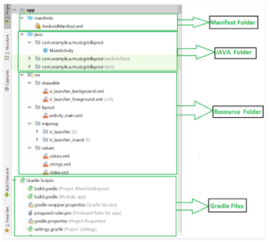

Fig:2.5 Layout of Android Studio

1. **Lifecycle of Android Application:** Lifecycle of Android Application gives in figure **2.6**

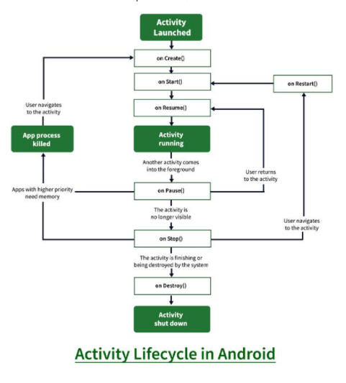Fig: 2.6 Lifecycle of Android Application

## **2.6 Mobile App Feature**

Android is still leading the competition with the hold on [about 85.9% global market shares](https://www.statista.com/statistics/263453/global-market-share-held-by-smartphone-operating-systems/). Google announced that there were over [2 billion monthly active devices on Android](https://www.theverge.com/2017/5/17/15654454/android-reaches-2-billion-monthly-active-users). The Android Apps are ruling most of the business industries. Moreover, the [mobile app development trends](https://www.mindinventory.com/blog/mobile-app-development-trends-2018/) keeping renewing, offering a scope to add new and interesting features that draw the user attention instantly and is customer-friendly as well.

## Simple and User-Friendly Interface

## Registration or Login Page should be Simple

## The Space for User Feedback

## Integrating the Social Media Tools

## Fast Loading Speed

## Supporting the Multiple Languages

## **2.7 Mobile App Specifications**

## **Hardware requirements**

workstation should meet or exceed these hardware requirements:

* A 64-bit environment is required for Android 2.3.x (Gingerbread) and higher versions, including the master branch. It is possible to compile older versions on 32-bit systems.
* 250GB of free disk space to check out the code and an extra 150 GB to build it. additional space may be needed if necessary.
* 16 GB of available RAM is required, but Google recommends 64 GB.

**Software requirements**

* Software Development Kit (JDK)
* Integrated Development Kit

To Create, debug and emulate Application we need SDK. IDE provide GUI and an interface to write code. Android Studio is the preferred IDE. JDK is installed to provides an interpretation of the Java program.

**2.8 Android Programming Language**

### **2.8 .1 Java**

### Java was the official language for Android App Development (but now it was replaced by Kotlin) and consequently and it is also the most supported language by Google.

Java is a great language to experience the full joys of Android App Development. However, it is complex with beginner who would prefer to start with something easier and then return to it.

### **2.8.2**[**Kotlin**](https://www.geeksforgeeks.org/kotlin-language-android-now-official-google/)

Now Kotlin is the official language for Android App Development declared by Google since 2019. Kotlin is a cross-platform language which is used as an alternative to Java for Android App Development. Kotlin can interoperate with Java and it runs on the Java Virtual Machine.

Why Kotlin

* Kotlin removes the superfluous features of Java such as null pointer exceptions.
* It also removes the necessity of ending every line with a semicolon.
* Kotlin is much simpler for beginners to try as compared to Java
* it can also be used as an “entry point” for Android App Development.

**2.8.3 Python**

Python that is an open-source Python library used for developing mobile apps. It supports Android and also encourages rapid app development.

### **2.8.4 HTML, CSS, JAVASCRIPT**

Android apps can be created using HTML, CSS, and JavaScript. By using the Adobe PhoneGap framework that is powered by Apache Cordova. The PhoneGap framework basically allows the usage of web development skills to create hybrid apps.

Adobe PhoneGap framework is enough for basic tasks in the realm of Android App Development, but it hardly requires much programming. it needs a lot of work to even create a decent app.

### **2.8.5 DART**

Dart is an open-source programming language that power the **Flutter framework**

* FLUTER has the ability to deliver beautiful and performance app for the web, desktop, and mobile in lesser time.
* FLUTER is designed by Google as a client-optimized language for fast apps on any platform.
* Dart mainly focuses on making UI development easier for developers
* Hot-reload, Developers can see changes instantly while working on the app.
* Dart is also known for its fast performance
* Dart compiles to ARM and x64 machine code for mobile, desktop, and backend. And to JavaScript for the web apps.

**2.9 Apps database**

Mobile App Database is an important database for storing user information and making it’s easy when needed. It’s important to marry for the better mobile requirement to the mobile database that compliments it the best. A good database can importantly impact the performance of your mobile app.

**Importance of selecting the Right Database for the Mobile Apps:**

1. This data you can access anywhere when you use a database for mobile apps. You may get wireless and offline data access too.
2. It’s easy to maintain with minimum effort.
3. It helps many of users access the data in a time.
4. It permits data to be seamlessly synchronized across laptops, smartphones, devices, wearable, tablets and may more.

**Types of Mobile App Databases:**

1. **Data Warehouses.**

**Benefits of Data Warehouses:**

1. Subject Oriented – Analyzing data about any particular functional area.
2. Integrated – Data warehouses can store data from various sources and consolidates them in a central position.
3. Time – variant – Analyses the changes in data over time.
4. Non – volatile – Once the data can carry to the warehouse, it remains constant.
5. **Distributed Warehouses**

**Benefits of Distribute Warehouses:**

1. Network Transparency
2. Replication Transparency
3. Fragmentation Transparency
4. Increased reliability and availability
5. Easier expansion
6. Better performance
7. **Operational Database**

**Benefits of Operational Database:**

1. Greatly versatile
2. Fault – tolerant and Highly Scalable
3. Highly secured
4. Can work with multiple apps without losing the state of the database
5. More economical
6. **Relational Database.**

**Benefits of Relational Database:**

1. Flexibility
2. Reduced Redundancy
3. Ease of backup and disaster recovery

**Things to Consider While Selecting Mobile App Databases:**

1. Data Structure & Mobile App Requirements
2. Data Size & Storage Requirements
3. Data Security & Flexibility
4. Data Model Flexibility
5. Mobile App Platform support
6. Mobile App Database Scalability & Speed
7. Resolving Data Conflicts between Devices

Popular Mobile App Databases Available in the Market:

1. **SQLite**

Key features of SQLite **–**

1. Zero – configuration
2. Less Server
3. Single Database File
4. Stable Cross – Platform File
5. Manifest typing
6. Compact
7. Readable source code
8. Variable – length records
9. **Realm DB**

Key Features of Realm DB

1. Create Mobile Apps
2. Concurrency Control
3. Object – Oriented Data Model
4. Log Component for synchronization
5. Query Interface
6. Storage Architecture
7. **MongoDB**

Key Features of MongoDB –

1. Replication feature for better stability and data availability
2. Appropriate indexing for better query executions
3. Ad – hoc queries for optimizer, real-time analytics
4. Load Balancing
5. Sharing
6. **Couchbase**

Key Features of Couchbase -

1. Memory First
2. Elastic Scalability
3. Transactions
4. Persistence
5. Analytics

**2.10 Application**

* These are the basics of android application.
* Android application are composed of one or more application components.
* Each component performs several roles in overall application behavior and should also declare all application needs such as the minimum version of Android required.
* Non -code application resources should include alternatives for different devices configuration.

**2.11 Summary**

This chapter covers android framework, programming language and SQLite database. Dart programing Provides comprehensive set of function for working with it. Subsequently we learn supporting language and designing tool.

**Chapter 3**

**System Analysis and Design**

**3.1 Introduction**

This chapter discuss a general description of the system and its functions and clarifies the system components and deals with detailed analysis of the operations of the system.

**3.2 System Description**

Virtual Learning System like Video conferencing that provide sign in option both to the administrator and user. It' provides to the user after registration two options create or join a meeting. Create meeting option will create a unique meeting key the user can use it or writes his own key the system. Join meeting option will ask the user to enter the key, take the username through mail authentication and if the key is found all the system functions (chat, record, share desktop and share file) will appear to the user. system will check if its unique and after a permission will be given to the user to allow the system to use the camera and microphone, user can allow to use.

**3.3 System Functionality**

The system divides users according to their authority into two roles: 1. Administrator: we mean by administrator the person who has ability to view, add users and rooms throw the App UI, 2. User: the user is the person who can join meeting.

**3.3.1 System Administrator and User Functions**

There is only one common function between administrator and user Login operation that allows the system administrator or user to login into App UI by entering username and password.

**3.3.2 System Administrator Functions**

The administrator has many functions such as: add users, view users and delete users and room.

**• Add users**

This function allows the administrator to add new user to the system.

**• View users**

This function allows the administrator to view all registered users in the system.

**• End Call**

It allows the administrator to end the meeting that were created.

**3.3.3 System user** **Functions**

The system user has activity such as: sign up, create room or join room, voice or video call, chat, share files or desktop and voice or video record.

**• Sign up**

It allows the system administrator or user to sign up into the application by entering email, username and password.

**• Join a Call**

This function asks the user to enter a room key and connect the user to other users on this meeting.

**• Voice call**

This function allows the user to connect to users on the same room throw a voice call.

**• Video call**

This function allows the user to connect to users on the same room throw a video call.

• **Chat**

This function allows the users to communicate using text messages in a group.

**3.3.4 System Nonfunctional Requirement**

The system has many nonfunctional Requirement such as portability, security and availability.

**• Portability**

The users shall be able to use the system from anywhere any operating system.

**• Security**

Gmail Authentication provide a huge security area. Until now, most services have typically treated security as option, users can be assured that their data remains safe and private. The main premise of having encryption by default is that a call is private always. Security and encryption are no longer considered to be optional features.

**• Availability**

The service is to be available to all users at any time.

**3.4 System Components**

The System components are divided into two categories, hardware and software.

**System hardware Components**

The hardware divided into two devices:

**• Server device**

The server device should be at least a core I5 device and has a 16 Gigabyte ram.

**• User device**

The device must contain a camera, microphone and speaker. System Software Components The software divided into two parts:

**• User Part**

This section uses android operating system and requires access to the Internet.

**• Administrator Part**

Is a database that stores information about users and rooms, it is created using SQLite.

**3.5 System analysis and design using UML**

**3.5.1Use case for Create/Join Meeting**: The creator Create an operation which can make share, chat, call and record. This illustrated in figure (3.1).

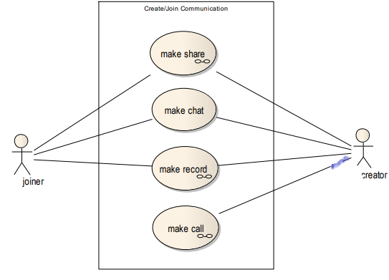

Fig: 3.1 Use Case Diagram for creating a meeting

**3.5.2 Use case for call operation**

The room creator and room joiners can make voice or video calls. This illustrates in figure (3.2).

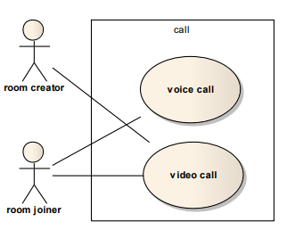

Fig: 3.2 Use Case Diagram for making a call

**3.6 Sequence diagram**

**3.6.1 Sequence diagram for register**

The user first enters username, user and email in the system interface, when he clicks sign up data will be sent to the server then the database, the database check if this information valid to save it or not. This illustrates in figure (3.3).

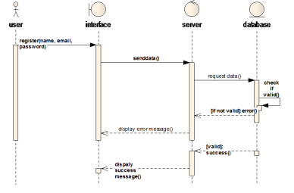

Fig 3.3 Sequence diagram for User registration

**3.6.2 Sequence diagram for login**

All users must login to use the system operations, to log in users first enter the username and password in the system interface, when they click log in data will be sent to the server then the database, the database check if this user exists to login or not. This illustrates in figure (3.4).

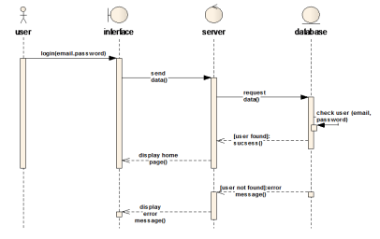

Fig 3.4 Sequence diagram for User login

**3.6.3 Code Segment for login:** Code Segment for login is illustrates in figure (3.5).

import 'package: flutter/material. Art';

import 'package:zoom_clone_tutorial/resources/auth_methods.dart';

import 'package:zoom_clone_tutorial/widgets/custom_button.dart';

class LoginScreen extends StatefulWidget {

  const LoginScreen({Key? key}) : super(key: key);

  @override

  State<LoginScreen> createState() => _LoginScreenState();

}

class _LoginScreenState extends State<LoginScreen> {

  final AuthMethods _authMethods = AuthMethods();

  @override

  Widget build(BuildContext context) {

    return Scaffold(

      body: Column(

        mainAxisAlignment: MainAxisAlignment.center,

        children: [

          const Text(

            'Start or join a meeting',

            style: const TextStyle(

              fontSize: 24,

              fontWeight: FontWeight.bold,

            ),

          ),

          Padding(

            padding: const EdgeInsets.symmetric(vertical: 38.0),

            child: Image.asset('assets/images/onboarding.jpg'),

          ),

          CustomButton(

            text: 'Google Sign In',

            onPressed: () async {

              bool res = await _authMethods.signInWithGoogle(context);

              if (res) {

                Navigator.pushNamed(context, '/home');

              }

            },

          ),

        ],

      ),

    );

  }

}

Fig:3.5 Code Segment for login

**3.6.4 Sequence diagram for create a Meeting**

The user enters the meeting id in system interface, then data will be sent to the server and then to the database, database check if this meeting id is unique or not to create it. This illustrates in figure (3.6).

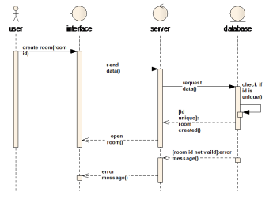

Fig:3.6 Sequence diagram for create a Meeting

**3.6.5 Code segment for create a Meeting:** Code segment for create a Meeting is illustrates in figure (3.7).

import 'dart:math';

import 'package:flutter/material.dart';

import 'package:zoom_clone_tutorial/resources/jitsi_meet_methods.dart';

import 'package:zoom_clone_tutorial/widgets/home_meeting_button.dart';

class MeetingScreen extends StatelessWidget {

  MeetingScreen({Key? key}) : super(key: key);

  final JitsiMeetMethods _jitsiMeetMethods = JitsiMeetMethods();

  createNewMeeting() async {

    var random = Random();

    String roomName = (random.nextInt(10000000) + 10000000).toString();

    _jitsiMeetMethods.createMeeting(

        roomName: roomName, isAudioMuted: true, isVideoMuted: true);

  }

  joinMeeting(BuildContext context) {

    Navigator.pushNamed(context, '/video-call');

  }

  @override

  Widget build(BuildContext context) {

    return Column(

      children: [

        Row(

          mainAxisAlignment: MainAxisAlignment.spaceEvenly,

          children: [

            HomeMeetingButton(

              onPressed: createNewMeeting,

              text: 'New Meeting',

              icon: Icons.videocam,

            ),

            HomeMeetingButton(

              onPressed: () => joinMeeting(context),

              text: 'Join Meeting',

              icon: Icons.add_box_rounded,

            ),

            HomeMeetingButton(

              onPressed: () {},

              text: 'Schedule',

              icon: Icons.calendar_today,

            ),

            HomeMeetingButton(

              onPressed: () {},

              text: 'Share Screen',

              icon: Icons.arrow_upward_rounded,

            ),

          ],

        ),

        const Expanded(

          child: Center(

            child: Text(

              'Create/Join Meetings with just a click!',

              style: TextStyle(

                fontWeight: FontWeight.bold,

                fontSize: 18,

              ),

            ),

          ),

        ),

      ],

    );

  }

}

Fig:3.7 Code segment for create a Meeting

**3.6.6 Sequence diagram for joining Meeting**

The user get into Meeting id in system interface, then data will be send to server and then to the database, database check if this Meeting id is exists and opened now to join it or not. This illustrates in figure (3.8).

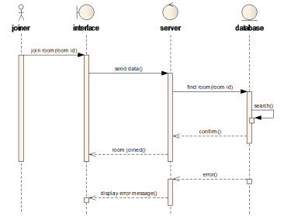

Fig:3.8Sequence diagram for joining Meeting

**3.6.6 Code segment for Join a Meeting:** Code segment for Join a Meeting is illustrates in figure (3.9).

import 'package:flutter/material.dart';

import 'package:jitsi_meet/jitsi_meet.dart';

import 'package:zoom_clone_tutorial/resources/auth_methods.dart';

import 'package:zoom_clone_tutorial/resources/jitsi_meet_methods.dart';

import 'package:zoom_clone_tutorial/utils/colors.dart';

import 'package:zoom_clone_tutorial/widgets/meeting_option.dart';

class VideoCallScreen extends StatefulWidget {

  const VideoCallScreen({Key? key}) : super(key: key);

  @override

  State<VideoCallScreen> createState() => _VideoCallScreenState();

}

class _VideoCallScreenState extends State<VideoCallScreen> {

  final AuthMethods _authMethods = AuthMethods();

  late TextEditingController meetingIdController;

  late TextEditingController nameController;

  final JitsiMeetMethods _jitsiMeetMethods = JitsiMeetMethods();

  bool isAudioMuted = true;

  bool isVideoMuted = true;

  @override

  void initState() {

    meetingIdController = TextEditingController();

    nameController = TextEditingController(

      text: _authMethods.user.displayName,

    );

    super.initState();

  }

  @override

  void dispose() {

    super.dispose();

    meetingIdController.dispose();

    nameController.dispose();

    JitsiMeet.removeAllListeners();

  }

  _joinMeeting() {

    _jitsiMeetMethods.createMeeting(

      roomName: meetingIdController.text,

      isAudioMuted: isAudioMuted,

      isVideoMuted: isVideoMuted,

      username: nameController.text,

    );

  }

  @override

  Widget build(BuildContext context) {

    return Scaffold(

      appBar: AppBar(

        elevation: 0,

        backgroundColor: backgroundColor,

        title: const Text(

          'Join a Meeting',

          style: TextStyle(

            fontSize: 18,

          ),

        ),

        centerTitle: true,

      ),

      body: Column(

        children: [

          SizedBox(

            height: 60,

            child: TextField(

              controller: meetingIdController,

              maxLines: 1,

              textAlign: TextAlign.center,

              keyboardType: TextInputType.number,

              decoration: const InputDecoration(

                fillColor: secondaryBackgroundColor,

                filled: true,

                border: InputBorder.none,

                hintText: 'Room ID',

                contentPadding: EdgeInsets.fromLTRB(16, 8, 0, 0),

              ),

            ),

          ),

          SizedBox(

            height: 60,

            child: TextField(

              controller: nameController,

              maxLines: 1,

              textAlign: TextAlign.center,

              keyboardType: TextInputType.number,

              decoration: const InputDecoration(

                fillColor: secondaryBackgroundColor,

                filled: true,

                border: InputBorder.none,

                hintText: 'Name',

                contentPadding: EdgeInsets.fromLTRB(16, 8, 0, 0),

              ),

            ),

          ),

          const SizedBox(height: 20),

          InkWell(

            onTap: _joinMeeting,

            child: const Padding(

              padding: EdgeInsets.all(8),

              child: Text(

                'Join',

                style: TextStyle(

                  fontSize: 16,

                ),

              ),

            ),

          ),

          const SizedBox(height: 20),

          MeetingOption(

            text: 'Mute Audio',

            isMute: isAudioMuted,

            onChange: onAudioMuted,

          ),

          MeetingOption(

            text: 'Turn Off My Video',

            isMute: isVideoMuted,

            onChange: onVideoMuted,

          ),

        ],

      ),

    );

  }

  onAudioMuted(bool val) {

    setState(() {

      isAudioMuted = val;

    });

  }

  onVideoMuted(bool val) {

    setState(() {

      isVideoMuted = val;

    });

  }

}

Fig:3.9 Code segment for Join a Meeting

**3.7 Conclusion**

This chapter deal with a description and analysis of the system, where addressed to describe the system and processes provided by the system for the user and the system administrator, also addressed to the hardware and software components of the system. On the other hand, this section takes to analysis the operations of the system using the schemes UML and Code segment analysis.

**Chapter 4**

**System Design**

* 1. **Introduction**

Dart is a client-optimized language for developing fast apps on any platform. Its goal is to offer the most productive programming language for multi-platform development, paired with a [flexible execution runtime platform](https://dart.dev/overview#platform) for app frameworks.

Android is a software platform and Linux -based operating (OS) designed primarily for touch screen mobile devices. It OS is upgradeable and new feature are usually available in each new version release. In addition, android is an open source which is freely available for application Developer. The increasing demand of android devices makes it great platform to leverage on.

* 1. **System Design**

The most creative and challenging phase of the life cycle is Stem design. To solve actual software engineer or a team incorporate a development strategy

that encompasses the process, method and tools and generic phase. In this section we have to show the design of E-R diagram, data flow diagram, activity diagram, Data flow diagram.

* 1. **System Description**

In meeting that provides to the administrator the ability to delete users. It' provides to the user after registration two options create or join.

Create option will create a unique room key the user can use it or writes his own key the system will check if its unique and after a permission will be shown to user to allow the system to use the camera and microphone, user can allow both or deny.

Join room option will ask the user to enter the room key and if the room was found all the system functions (chat, record, share desktop and share file) will appear to the joiner user with a special feature (attendance) that will only appear to the room creator.

**4.4 Log in to the System**

The system user has many activities such as: sign up, create or join, voice or video call, chat.

• Sign up

It allows the system administrator or user to sign up into the application by entering email, username and password. Sign up is illustrates in figure (4.1).

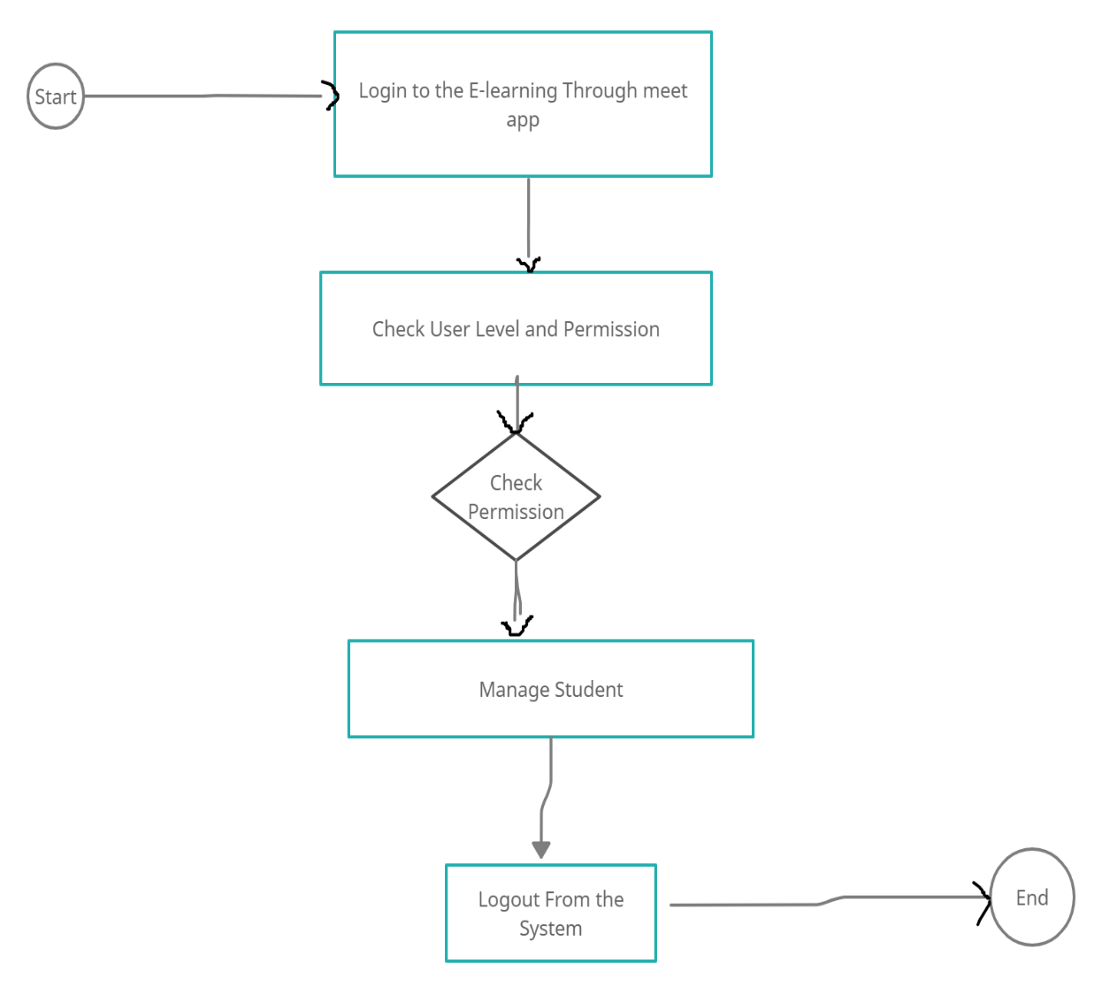

Fig 4.1 Log in Activity Diagram

**4.5 Data Flow Diagram**

A Data Flow Diagram illustrates how data is processed by a system in term of input and output. It focuses on the flow of information, where the data comes from, where it goes, how it gets stored.Data Flow Diagram is illustrating in figure (4.2).

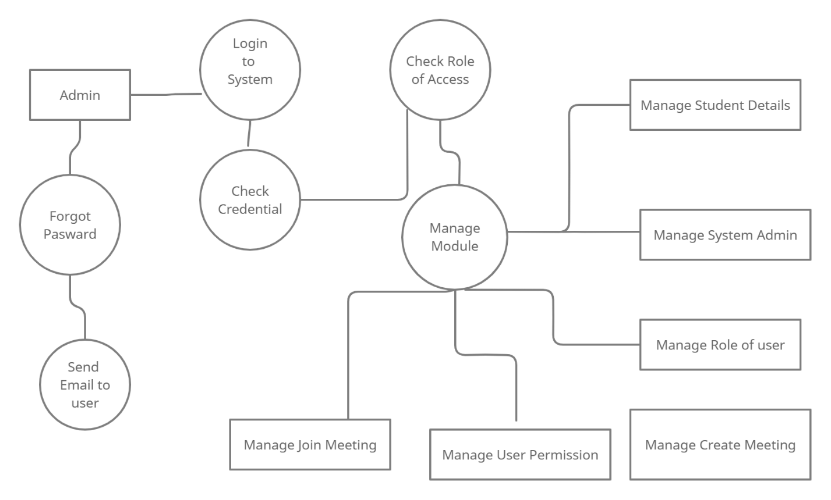

Fig 4.2 Data Flow Diagram online learning through meeting apps

* 1. **Entity Relationship Diagram(E-R)**

The entity Relationship data model is based on perception of a real world that consists of basic object called entities and of relationship among this object. An entity is thing or object in the real world that is distinguishable from object.Entity Relationship Diagram(E-R)is illustrates in figure (4.3).

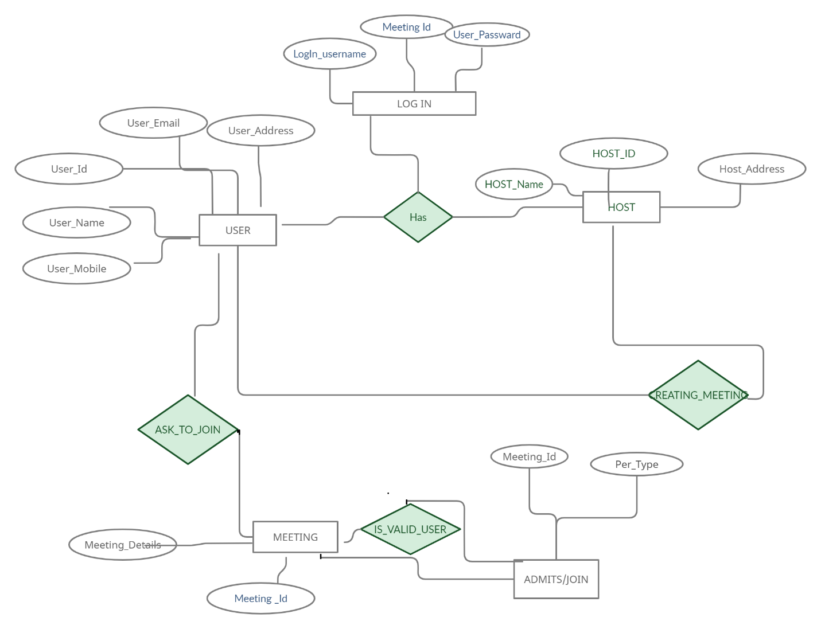

4.3 Fig: Entity Relationship Diagram(E-R)

* 1. **Use Case Diagram**

The purpose of a use case diagram in UML is to demonstrate the different ways that a user might interact with a system.

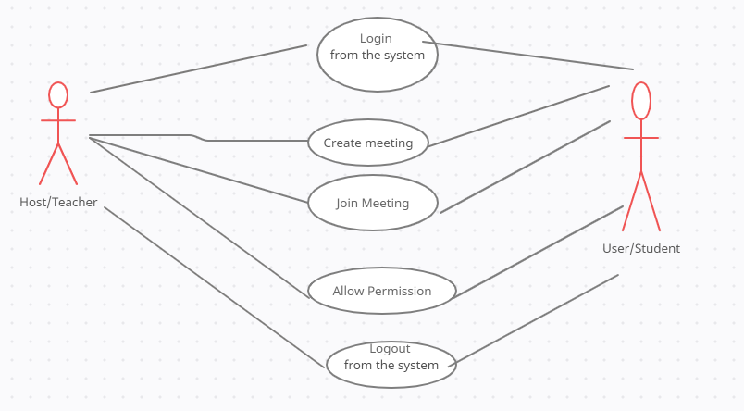

Figure 4.4 General use case diagram

* 1. **Summary**

In this chapter we discuss about system analysis which is very essential part of a successful system development and we also show our system work flow diagram which is indicate our project aim. we also discuss about, how we design our system and what we want, which helps us to design the whole system. Also know about the planning with flow diagram, activity diagram, E-R diagram and key representation of our system clearly.

**Chapter 5**

**Implementation and Tools**

**5.1 Introduction**

This chapter shows the system administrator, user’s graphical interfaces, explains system functions and how it works and shows the techniques and tools that were used to achieve the objectives of the project.

Android output design is the most important and direct source of information to the user. Efficient, intelligible output design should improve the system relationship with the user and help in environment decision making.

The objective of this project was to design and develop an android application which allows user to join a call or create a call. After completion our project, I run it through emulator and after install .ask file on our android mobile phone. Then I run the project I consider even types of categories as seven different android apps. That why I install these apps separately on our android smartphones. Each individual device run successfully. According to our design and implementation, it provides the expected result.

**5.2 Initial** **Interfaces**

This is the first page shown when the user opens the smartphone screen. From this picture we can see the Video conferencing: An E-Learning Tool for Remote Education app. After double clicking we can get the next screen.

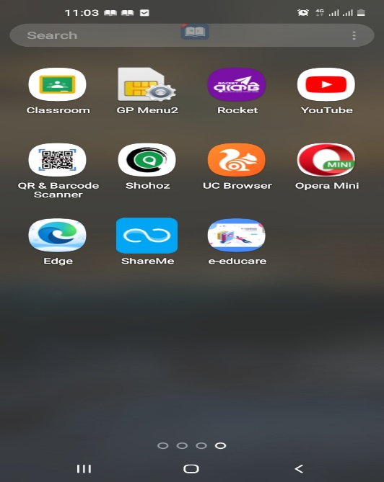

Fig 5.1 Initial interface

**5.2 Login/Sign in with Google**

Login First, the system administrator must log in to the system to be able to use the system as shown in Figure (5.2).

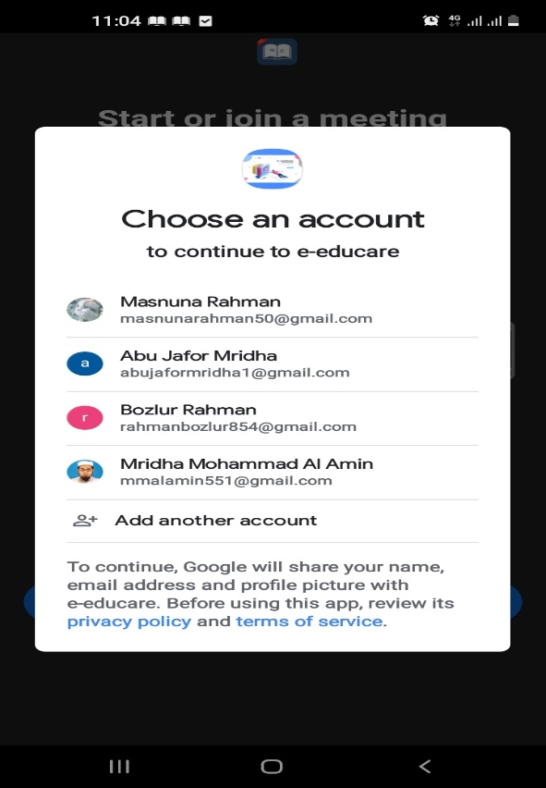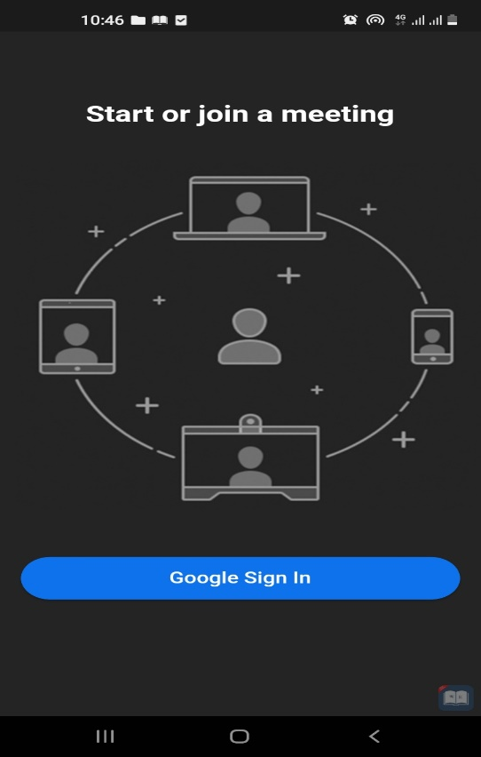

Fig 5.2 Sign in with google

**5.3 Home Interfaces**

After sign in with google, flowing screen appear in Figure (5.3).

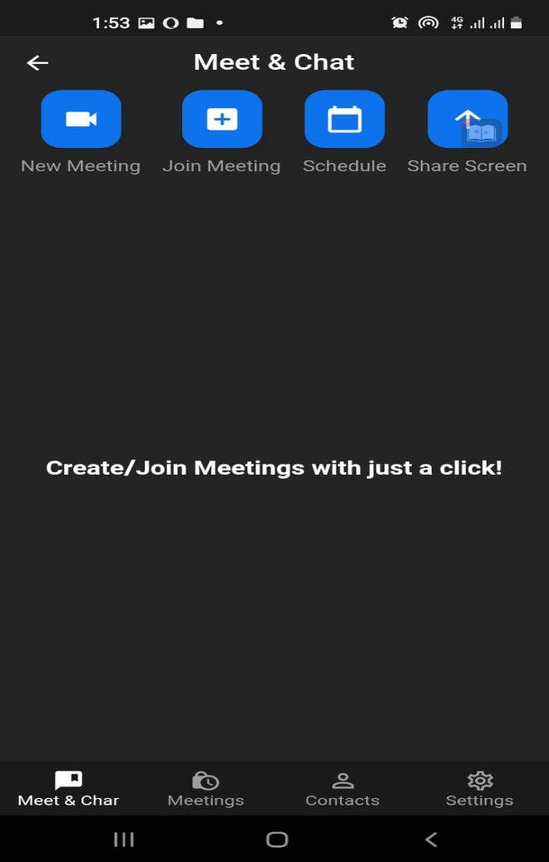

Fig 5.3 Home Interfaces

**5.4 Create a meeting with audio and video**

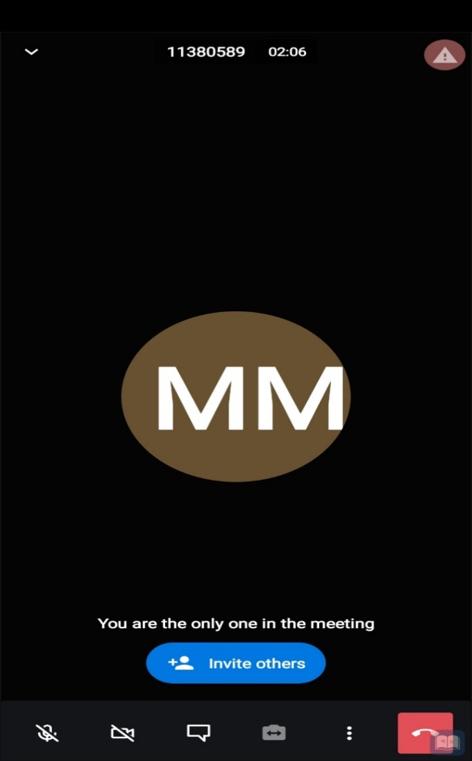After logging in to the system the user will have two options (create a call or join a call). To create a meeting the host should generate a new key, that will be created as shown in Figure (5.4).

Fig:5.4Create a meeting with audio and video

**5.5 Join audio and video meeting**

The user enters a key to join the meeting with that key as shown in Figure (5.5).

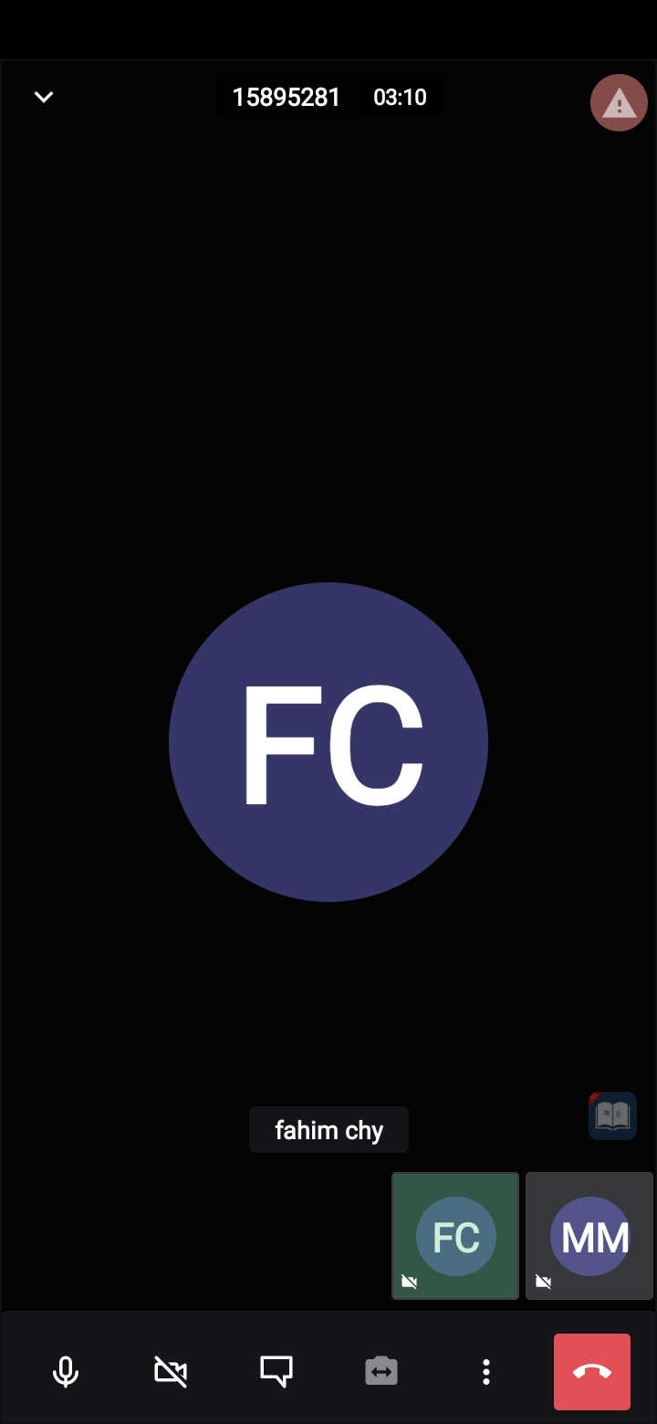

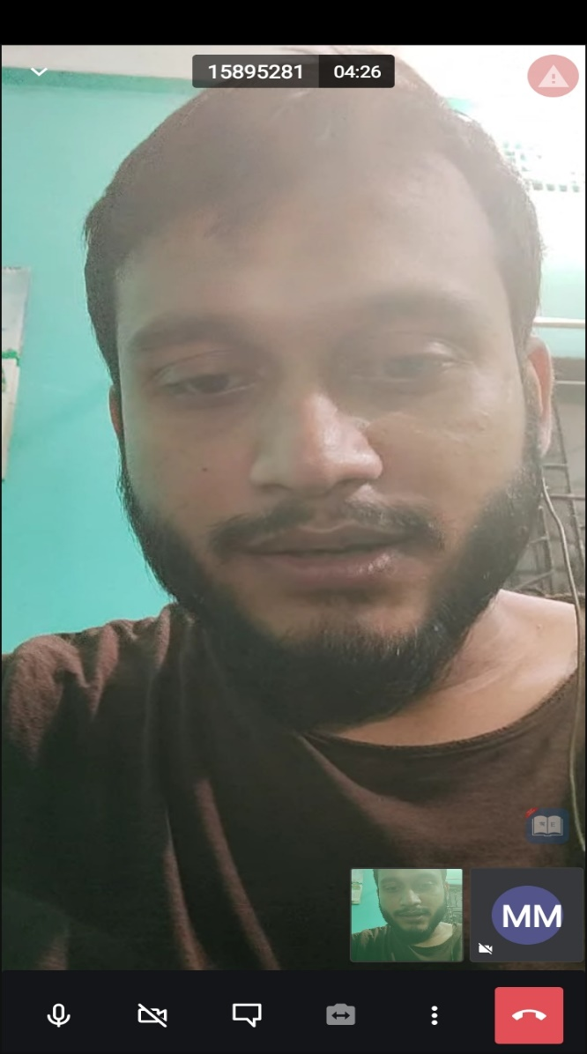



Fig 5.5 Join an audio and video meeting

**5.6 Chat**

After joining a room, a user can chat with the room members as shown in Figure (5.6).

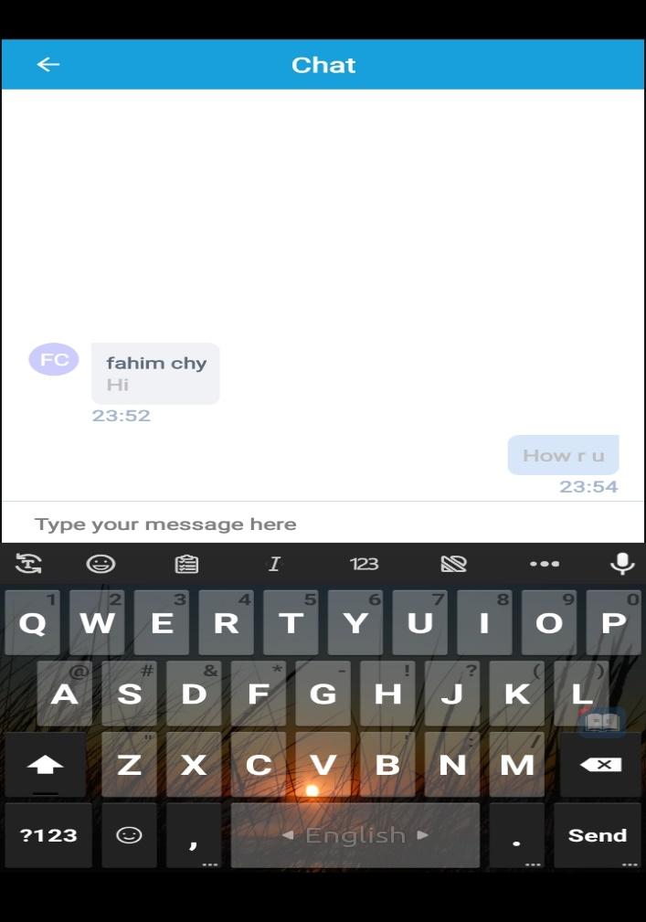

Fig: 5.6 Chat with the user

**5.7 Screen share Facility**

After joining a room, a host/user can share screen with the room members as shown in Figure (5.7).

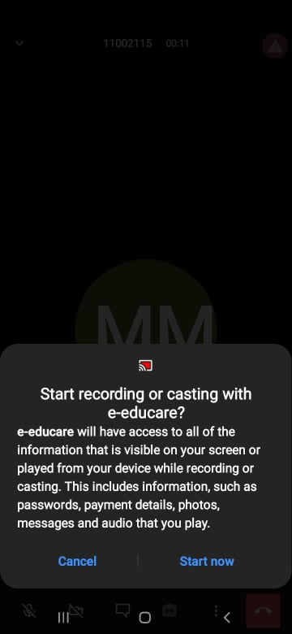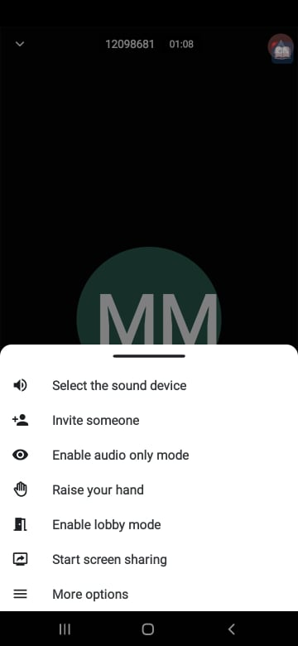

Fig5.7 Screen share Facility

**5.8 Hand Rise Option**

After joining a room, a user can hand rise to take attention to the room members as shown in Figure (5.8).

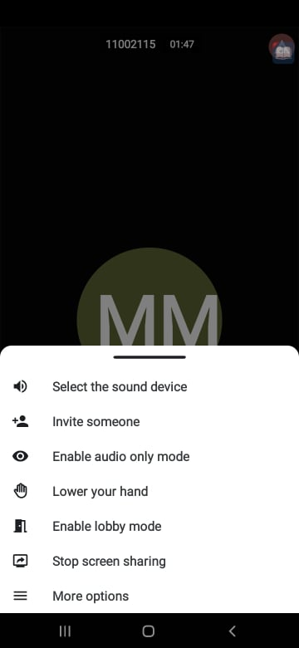

Fig: 5.8 Hand Rise Option

**5.9 Mute everyone except host & Disable everyone’s camera except host**: After joining a room, a host can Mute everyone except yourself & Disable everyone’s camera except yourself if necessary as shown in Figure (5.9).

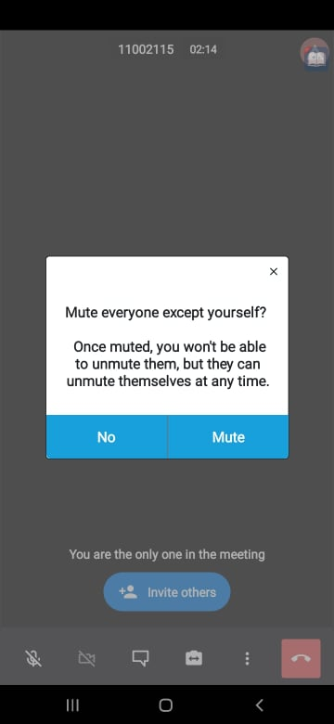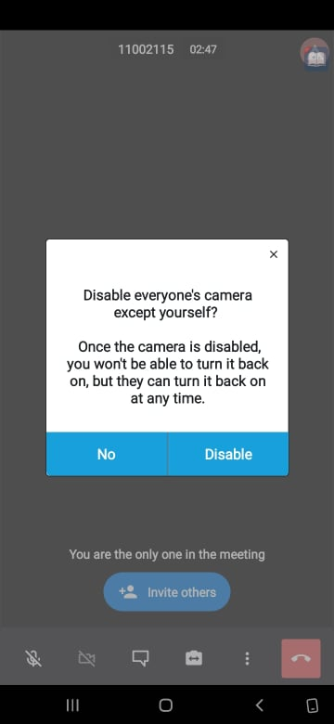

Fig: 5.9 Mute everyone except yourself & Disable everyone’s camera except yourself

Future Scope

At this moment, we have provided some basic features. In the future we'll improve our app by including many more features like the following:

1. Chat language translation

2. Written Exam Assessment

3. Screen Share option

4. Virtual Assistant

5. Attendance Tracker

Conclusion

online learning classes and video conferences can overcome the distance issue so that anyone in any part of the biosphere can share information, especially sharing news declarations about the spread of adversity. This e-learning technology is confirmed effective in all levels and phases of life, and even each user is no longer inadequate to visual or audio appearance. It also can send files and interrelate like conventional meetings such as writing the contents of meetings on a digital whiteboard. It definitely changes the paradigm in education that the learning process or activity should not always have to be carried out in the class. Therefore, the use of applications is not only done when there is an adversity, but also as a new learning style in attaining learning objectives in the future. The goal of this research is to decrease the effort and difficulty of flexibility to communicate and to create a video conference that supports the characteristics of voice calls, video calls, share files in different format and attendance for who attend. These goals have been achieved. The system is not perfect, perfection is not something humans can accomplish but we as developers did our best to provide all the features we need to ease communication, health care, education and all other fields meeting in our country.

# References

[1]Neha Verma1, S. K. (2018). ‘Development of Native Mobile Application Using Android Studio for Cabs and Some Glimpse of Cross Platform Apps,’ International Journal of Applied Engineering Research ISSN 0973-4562 Volume 13, pp. 12527-12530.

[2]Mr. Mohamed Khalifa, D. C.(2015). ‘Video conference Android platform by your mobile phone,’(IJACSA) International Journal of Advanced Computer Science and Applications, pp. 276-281.

[3]Aswir1, M. S. (2021). ‘Google Meet Application as an Online Learning Media for Descriptive Text Material,’ Jurnal Studi Guru dan Pembelajaran, Vol. 4, No. 1, pp. 189-194.

[4]Mohammad Monirujjaman Khan, S. M. (2021). ‘Online Education System in Bangladesh during COVID-19 Pandemic,’Creative Education, pp. 441-452.

[5]Galina Ilieva 1, 2. T. (2020). ‘IoT in Distance Learning during the COVID-19 Pandemic ,’TEM Journal. Volume 9, Issue 4, Pages 1669‐1674.

[6]Razvan Bologa, A. T.-S. (2021). ‘The Evolution of AI-Driven Educational Systems during the COVID-19 Pandemic,’Sustainability, pp. 13501.

[7]N.K.S. Widarini1, I. P. (2021). ‘TEACHERS STRATEGIES IN ONLINE LEARNING DURING COVID PANDEMIC,’ Jurnal Pendidikan Biologi Indonesia Vol. 9 No. 2 , pp.2615-2800.

[8]Baber, H. (2020). ‘Determinants of Students’ Perceived Learning Outcome and Satisfaction in Online Learning during the Pandemic of COVID19,’ Journal of Education and e-Learning Research Vol. 7, No. 3, 285-292, Vol. 7, No. 3, 285-292.

[9]Shivangi Dhawan1, 2. (2020). ‘Online Learning: A Panacea in the Time of COVID-19 Crisis,’ Journal of Educational Technology, pp.5-22.

[10] <https://www.researchgate.net/publication/34436169>

[11] <https://e-journal.my.id/jsgp/article/view/533>

[12] <https://www.tandfonline.com/doi/full/10.1080/10494820.2020.1830121>

[13] https://elearningindustry.com/why-online-learning-is-future-of-education.

[14] https://www.geeksforgeeks.org/android-tutorial/

[15] https://www.tutorialspoint.com/android/index.htm

[16] https://www.freeprojectz.com/