A Project Report

On
Intrusion Detection System Using ML
Submitted in partial fulfillment of the requirement for the award of the degree of

BACHELOR OF TECHNOLOGY


DEGREE
Session 2025-26 in
Computer Science and Engineering By
Vani Jaiswal (2410030078)
Rishabh Gupta (2410030550)
Kriti Sharma (2410030522)
Akshat Raj (2410030717)
Ankit Kumar (2410030756)

Under the guidance of Dr. Pinky Yadav
SCHOOL OF COMPUTER SCIENCE AND ENGINEERING

IILM UNIVERSITY, GREATER May, 2026


SCHOOL OF COMPUTER SCI. AND ENGG. IILM UNIVERSITY, GREATER NOIDA

CANDIDATE’S DECLARATION

We hereby certify that the work which is being presented in the project, entitled “Intrusion Detection System Using ML (Machine Learning)”, in partial fulfillment of the requirements degree of Bachelor of Technology in the School of Computing Science and Engineering of IILM University, Greater Noida is an original work carried out from Aug 2025 to May 2026, under the supervision of Dr. Pinky Yadav, School of Computer Science and Engineering, IILM University, Greater Noida.
The matter presented in the project has not been submitted by us for the award of any other degree from this or any other place.

Kriti Sharma (2410030522), Vani Jaiswal (2410030078), Rishabh Gupta (2410030550),

Akshat Raj (2410030717), Ankit Kumar (2410030756)

This is to certify that the above statement made by the candidates is correct to the best of my knowledge.

Signature of Guide Name and Details of Guide

CERTIFICATE

This is to certify that the Project Report entitled “Intrusion Detection System Using ML (Machine Learning)” which is submitted by Vani Jaiswal (2410030078), Rishabh Gupta (2410030550), Kriti Sharma (2410030522), Akshat Raj (2410030717) and Ankit Kumar (2410030756) in partial fulfillment of the requirement for the degree of Bachelor of Technology in the School of Computer Science and Engineering of IILM University, Greater Noida is a record of the candidate's own work carried out by them under my supervision. The matter embodied in this project is original and has not been submitted for the award of any other degree.

Signature of HoD Signature of Guide
Dr. Anil Saroliya, Professor Dr./Mr.
School of Comp. Sci. & Engg School of Comp. Sci. & Engg
IILM University, Gr Noida IILM University, Gr Noida

ACKNOWLEDGEMENT

It gives us a great sense of pleasure to present the report of the Project undertaken during B.Tech. Final Year. We owe a special debt of gratitude to Ass. Prof Dr. Pinky Yadav, School of Computer Science & Engineering, IILM University, Greater Noida, India, for her constant support and guidance throughout the course of our work. Her sincerity, thoroughness, and perseverance have been a constant source of inspiration for us. It is only her cognizant efforts that our endeavors have seen the light of day.
We also take the opportunity to acknowledge the contribution of Professor, HoD, Dr. Anil Saroliya School of Computer Science & Engineering, IILM University, Greater Noida, for their full support and assistance during the development of the project.
We also do not like to miss the opportunity to acknowledge the contribution of all faculty members of the department for their kind assistance and cooperation during the development of our project. Last but not least, we acknowledge our friends for their contribution to the completion of the project.

Vani Jaiswal (2410030078)

Rishabh Gupta (2410030550)

Kriti Sharma (2410030522)

Ankit Kumar (2410030756)

Akshat Raj (2410030717)

ABSTRACT

With the rapid proliferation of digital technologies and the Internet, securing computer networks
against increasingly sophisticated cyber-attacks has become a critical challenge. Traditional Intrusion Detection Systems (IDS) relying on signature-based mechanisms often fail to identify novel or zero-day threats, leading to high false alarm rates. To address these limitations, this paper proposes the development of a robust, intelligent IDS leveraging Machine Learning (ML) techniques. The proposed study outlines a structured methodology for classifying network traffic into normal and attack categories using the widely recognized NSL KDD and CICIDS2017 benchmark datasets. The research design incorporates rigorous data preprocessing. Ensemble algorithms, predominantly the Random Forest classifier and Decision Trees, will be evaluated. The anticipated outcomes focus on achieving superior detection accuracy, maximizing precision and recall, and significantly minimizing false positive rates. Ultimately, this research aims to provide a scalable and reliable framework for proactive threat detection in modern network architectures.

Keywords—Intrusion Detection System (IDS), Machine Learning, Network Security, NSL-KDD, CICIDS2017, Random Forest, Decision Tree.

LIST OF TABLES

Table No. | Table Name | Description
Table 2.1 | Dataset Comparison | Comparison of NSL-KDD, CICIDS2017 and other datasets
Table 3.1 | Algorithm Comparison | Comparison of ML algorithms and their characteristics
Table 4.1 | Performance Comparison of ML Models | Comparison based on accuracy, precision, recall, and F1-score

LIST OF FIGURES

Figure No. | Figure Name | Description
Figure 4.1 | Feature Importance Graph | Shows important features for attack detection in  KDD dataset
Figure 4.2 | Class Distribution Graph | Shows distribution of normal and attack categories
Figure 4.3 | Feature Importance Graph (CICIDS) | Shows top CICIDS features contributing to detection
Figure 4.4 | Confusion Matrix (CICIDS) | Shows classification performance on CICIDS dataset
Figure 4.5 | Confusion Matrix (KDD) | Shows classification results for different attack classes
Figure 4.6 | Train vs Test Accuracy Graph | Comparison of training and testing accuracy
Figure 4.7 | Model Accuracy Output | Displays numerical accuracy results of both models

LIST OF ABBREVIATIONS

ABBREVIATION | FULL FORM | DESCRIPTION / USE IN PROJECT
IDS | Intrusion Detection System — Used to detect and classify network traffic as normal or malicious
ML | Machine Learning — Used to train models for identifying attack patterns in network
AI | Artificial Intelligence — Provides intelligent decision-making for threat detection
DoS | Denial of Service — Type of attack detected by the system where services are disrupted
DDoS | Distributed Denial of Service — Advanced attack detected using multiple sources
TCP | Transmission Control Protocol — Protocol analyzed in network traffic data
UDP | User Datagram Protocol — Used in dataset for analyzing different traffic behavior
IP | Internet Protocol — Used to identify source and destination of network packets
KDD | Knowledge Discovery in Databases — Dataset used for training the ML model
NSL-KDD | NSL-KDD Dataset — Improved dataset used for better intrusion detection accuracy

 | TABLE OF CONTENTS
 |  | Page
DECLARATION |  | ii
CERTIFICATE |  | iii
ACKNOWLEDGEMENTS |  | iv
ABSTRACT |  | v
List of Tables |  | vi
List of Figures |  | vii
List of Abbreviations |  | vii
  - Introduction 1
  - Problem statement
  - Scope of research
  - Research hypothesis
  - Objectives
  - Organization of the report
CHAPTER 2: LITERATURE REVIEW
  - Background
2.14 Summary of literature review and research gap
CHAPTER 3: METHODOLOGY
3.1 Materials
3.10 Summary of methodology
CHAPTER 4: RESULTS AND DISCUSSION
4.13 Summary of results and discussion
CHAPTER 5: CONCLUSION AND RECOMMENDATIONS
  - Conclusion
  - Recommendations REFERENCES APPENDICES (if any)

CHAPTER 1 INTRODUCTION
  - Introduction

The way we communicate, work, and store information has changed beyond recognition over the past two decades. Computer networks now sit at the center of almost everything — banking transactions, hospital records, government systems, e-commerce platforms, and everyday personal communication all depend on the reliable and secure flow of data across digital infrastructure. That dependency, while enormously convenient, has also created a very large and very attractive target for people who want to cause harm or gain unauthorized access to information they have no business touching.

Cyber-attacks are not a new problem, but they have grown more frequent, more sophisticated, and more damaging with each passing year. Unauthorized access attempts, data breaches, denial-of-service attacks, ransomware campaigns, and network infiltrations now cost organizations billions of dollars annually and, in some cases, cause harm that goes well beyond financial loss — disrupting hospitals, compromising national security systems, and exposing the private data of millions of ordinary people.

To defend against these threats, organizations have historically relied on firewalls, antivirus software, and access controls. While these tools play an important role, they are not designed to detect attacks that are already inside the network or that do not match a known pattern. That gap is exactly what Intrusion Detection Systems (IDS) were created to fill. An IDS monitors network traffic continuously, looking for behaviour that signals something is wrong — whether that is an unusual volume of requests, a connection attempt from a suspicious source, or traffic that does not match what normal users typically generate.

Traditional IDS, however, have a fundamental limitation that has become increasingly difficult to overlook. They rely on pre-written rules and known attack signatures to make their decisions. When traffic matches a known attack pattern, an alert is raised. When it does not match — even if it is genuinely malicious — the traffic passes through unchallenged. In a threat landscape where attackers regularly develop new techniques specifically designed to evade known signatures, this approach leaves a dangerous blind spot.

Machine learning offers a more intelligent way forward. Rather than depending on rules written by human analysts, ML-based systems learn from data. They build their own understanding of what normal network behaviour looks like, and they flag deviations from that understanding as potentially malicious — even if the specific attack technique has never been seen before. This ability to generalize from past experience to new situations is what makes machine learning genuinely promising for intrusion detection, and it is the foundation on which this project is built.

This project develops a machine learning-based intrusion detection system trained and evaluated on two well-established benchmark datasets — NSL-KDD and CICIDS-2017. Multiple ML algorithms are implemented and compared, with the goal of identifying which approaches deliver the best balance of detection accuracy, false positive rate, and practical usability. The aim is not just to build a system that performs well on paper, but to contribute a meaningful and reproducible evaluation that sheds light on how ML-based IDS can be made more effective and trustworthy in real network environments.

  - Problem Statement

Despite the progress made in cybersecurity research and practice, intrusion detection remains an unsolved problem. The core difficulty is not a lack of tools — there are many IDS products on the market — but a gap between what those tools can do and what the evolving threat environment demands of them.

Traditional rule-based and signature-driven IDS are built on a simple idea: collect known attack patterns, encode them as signatures, and raise an alert whenever observed traffic matches one. This works reliably for attacks that are already well-documented and have not changed. The problem is that attackers do not stay still. New malware variants, novel exploitation techniques, and carefully crafted zero-day attacks are designed precisely to avoid matching existing signatures. Against these threats, traditional IDS offer little protection — and organizations frequently discover a breach only after significant damage has already been done.

At the same time, many existing systems generate large volumes of false positives — alerts that fire on legitimate traffic and send security analysts chasing threats that were never there. In a busy enterprise network, this alert fatigue is a serious operational problem. Analysts who are accustomed to seeing hundreds of false alarms each day are more likely to miss the one alert that is real. An IDS that cries wolf too often is, in a meaningful sense, not much better than having no IDS at all.

The challenge this project addresses is therefore twofold: how to build an intrusion detection system that can reliably identify both known and previously unseen attack patterns, and how to do so while keeping false positives low enough that the system is actually useful in practice. Machine learning provides a promising path toward meeting both of these demands simultaneously, but which algorithms perform best, and under what conditions, is a question that requires careful, rigorous investigation.

  - Scope of Research

This research focuses on the design, implementation, and evaluation of a machine learning-based intrusion detection system for network traffic classification. The work is grounded in experimental analysis rather than live deployment, using two benchmark datasets — NSL-KDD and CICIDS-2017 — that are widely used and accepted within the IDS research community.

The scope covers the full machine learning pipeline from raw data to evaluated model. This includes data preprocessing — handling missing values, normalizing features, and encoding categorical variables — followed by feature selection to identify the most informative attributes for classification. Multiple ML algorithms are applied and compared, including both classical approaches such as Decision Trees, Random Forest and more contemporary techniques where appropriate.

Model performance is evaluated using a standard set of metrics: accuracy, precision, recall, F1-score, and false positive rate. These metrics together give a more complete picture of model behaviour than accuracy alone, particularly in the presence of class imbalance, which is a well-known challenge in network traffic datasets where normal traffic vastly outnumbers attack traffic.

The system developed in this project is designed for offline experimental evaluation. It does not include a live network monitoring component or real-time classification capability, though the findings and architecture produced by this research provide a clear foundation for those extensions in future work. The focus here is on understanding which ML approaches deliver the most reliable and generalizable performance for network intrusion detection, across different dataset conditions and attack categories.

  - Research Hypothesis

This research is grounded in the hypothesis that machine learning techniques can substantially outperform traditional rule-based intrusion detection methods, particularly in their ability to detect novel and evolving attack patterns that have not been explicitly programmed into a signature database.

Conventional IDS depend on manually written rules and pre-collected signatures. This approach has a hard ceiling on what it can detect — anything outside the signature library is, by definition, invisible to the system. Machine learning takes a different approach entirely. Instead of being told what to look for, ML models learn the shape of normal and abnormal behaviour from data. Given sufficient training examples, they can build rich internal representations of what legitimate network activity looks like and flag deviations from that picture with a degree of sensitivity and nuance that fixed rules cannot match.

It is hypothesized that applying supervised ML algorithms to labelled network traffic datasets will produce classifiers that achieve higher detection accuracy and lower false positive rates than traditional approaches. Specifically, it is expected that ensemble methods — particularly Random Forest — will demonstrate robust performance across different attack categories, given their documented strength in handling high-dimensional, noisy data. It is further hypothesized that careful preprocessing and feature selection will play a significant role in model performance, and that reducing the feature space to its most informative components will improve both accuracy and training efficiency.

Beyond raw performance metrics, it is also hypothesized that ML-based IDS offer a structural advantage in adaptability. As network environments change and new attack types emerge, models can be retrained on updated data, whereas traditional signature databases require manual curation and expert intervention to keep current. This capacity for ongoing learning and adaptation is expected to make ML-based systems more sustainable and resilient over time, particularly in dynamic and large-scale network environments where threats evolve quickly.

  - Objectives

The following objectives guide the work carried out in this project:
- To study and understand the working principles of existing intrusion detection systems, both traditional and machine learning-based, through a thorough review of current literature.
- To identify and clearly articulate the specific limitations of rule-based and signature-driven approaches that motivate the development of an ML-based alternative.
- To design and implement an intrusion detection system using multiple supervised machine learning algorithms, providing a structured and reproducible experimental framework.
- To collect, preprocess, and prepare network traffic data from the NSL-KDD and CICIDS-2017 datasets for model training and evaluation, addressing challenges such as class imbalance and high feature dimensionality.
- To apply and compare multiple machine learning classifiers — including Decision Trees, Random Forest, Support Vector Machines, K-Nearest Neighbours, and Naive Bayes — under consistent experimental conditions.
- To evaluate model performance using a comprehensive set of metrics including accuracy, precision, recall, F1-score, and false positive rate, enabling a fair and meaningful comparison across algorithms.
- To investigate the impact of feature selection on model accuracy and efficiency, identifying which network traffic features contribute most to reliable classification.
- To classify network traffic accurately into normal and malicious categories, with a particular focus on detecting a wide range of attack types represented in the benchmark datasets.
- To draw conclusions from the experimental results that are practically meaningful and that point toward concrete directions for future improvement and real-world deployment.

  - Organisation of the Report

This report is structured across five chapters, each serving a distinct role in presenting the research from motivation through to conclusions.

Chapter 1 — Introduction establishes the foundation of the project. It sets out the context and motivation for developing an ML-based intrusion detection system, defines the problem being addressed, outlines the scope and boundaries of the research, states the hypothesis, and lists the specific objectives that guide the work.

Chapter 2 — Literature Review surveys the existing body of research on intrusion detection systems and the application of machine learning to this domain. It examines different IDS classification approaches, reviews the ML algorithms most commonly applied in this context, discusses the benchmark datasets used across the field, and identifies the specific gaps in current knowledge that this project aims to address.

Chapter 3 — Methodology provides a detailed account of how the research was carried out. It covers the selection and justification of datasets, the preprocessing steps applied to prepare the data for analysis, the feature selection methods used to reduce dimensionality, the machine learning algorithms implemented, and the evaluation framework used to compare their performance.

Chapter 4 — Results and Analysis presents the experimental outcomes in full. It reports the performance of each classifier across all evaluation metrics and provides a comparative analysis of the results, discussing what the findings reveal about the relative strengths and weaknesses of each approach under different conditions.

Chapter 5 — Conclusion and Future Work brings the project to a close by summarising the key findings, reflecting on whether the research hypothesis was supported, and discussing the practical implications of the results. It also identifies specific directions for future research and development, particularly with regard to extending the system toward real-time detection and broader deployment.

CHAPTER 2
LITERATURE REVIEW

2.1 Overview of Intrusion Detection Systems

Intrusion Detection Systems (IDS) have become one of the most relied-upon components of modern cybersecurity. As organizations have grown increasingly dependent on digital networks, the volume and sophistication of attacks targeting those networks have grown right along with them. Unauthorized intrusions, policy violations, and targeted malicious campaigns can compromise sensitive data, cripple services, and cause serious financial damage — sometimes before anyone even realizes something is wrong.

At its core, an IDS works by watching. It monitors network traffic, examines system logs, and tracks user behaviour, always looking for patterns that do not quite fit the established picture of normal activity. When something suspicious surfaces, the system raises an alert for security administrators to investigate and act on. It does not block traffic directly like a firewall — it observes, learns, and warns.

The intellectual roots of IDS research go back to Denning's landmark 1987 paper, which introduced the idea of using statistical models to detect anomalous behaviour on computer systems. That early contribution sparked decades of follow-on work from researchers around the world. Liao et al. (2013), writing in the Journal of Network and Computer Applications, traced how the field transformed from simple rule-based systems into the sophisticated, machine learning-driven frameworks we see today — a journey that has been neither straight nor simple, but consistently pointed toward smarter, more adaptive detection.

2.2 Classification of Intrusion Detection Systems

The literature broadly groups IDS into two primary detection methodologies — signature-based and anomaly-based — along with a hybrid approach that draws on both. Each has its own distinct strengths and blind spots, and understanding those trade-offs is essential for building detection systems that actually hold up in practice.

2.2.1 Signature-Based Detection

Signature-based IDS, sometimes called misuse detection, work by comparing observed network traffic and system events against a pre-built library of known attack patterns. If a packet or log entry matches a known signature, an alert fires. This approach is fast, reliable, and produces very few false positives for attacks that are already well-documented — traditional antivirus tools and many commercial firewalls operate on the same principle.
The critical weakness, though, is that this approach is entirely backward-looking. A genuinely novel attack — something crafted to exploit a vulnerability no one has catalogued yet — carries no matching signature and simply passes through undetected. Keeping signature databases current also demands constant manual effort, which makes signature-based detection inherently reactive. In a threat environment where new attack techniques emerge daily, relying on signatures alone is increasingly difficult to justify.

2.2.2 Anomaly-Based Detection

Anomaly-based IDS flip the question around entirely. Rather than asking whether network activity matches a known bad pattern, they ask whether it looks normal. During a training phase, the system builds a statistical model of what legitimate traffic looks like; anything that deviates significantly from that baseline gets flagged as potentially malicious. Because detection is grounded in behaviour rather than fixed signatures, these systems can identify attacks that have never been seen before — including zero-days.

Tsai et al. (2009), in a review published in Expert Systems with Applications, documented how machine learning models proved particularly well-suited to this kind of detection, capturing the complex and non-linear relationships buried within traffic data that simpler statistical approaches consistently missed. The trade-off, however, is a higher false positive rate. Unusual but entirely legitimate traffic — a sudden spike during a product launch, for instance — can trigger alerts just as easily as a real attack. Managing that noise without letting genuine threats slip through is one of the central challenges of deploying anomaly-based systems in the real world.

2.2.3 Hybrid Approaches

Recognizing that neither approach alone is sufficient, researchers have increasingly moved toward hybrid architectures that combine signature matching for known threats with anomaly detection to catch novel ones. These systems leverage the speed and precision of signature-based detection where it works well, and fall back on behavioural modelling where it does not. The literature consistently shows that well-designed hybrid systems outperform single-methodology approaches across every key metric — detection rate, false positive rate, and F1-score — making them the preferred architecture for high-stakes production environments.

2.3 Machine Learning Techniques in IDS

The application of machine learning to intrusion detection has attracted enormous research attention over the past two decades, and the results have largely justified that interest. ML-based systems have demonstrated a consistent ability to handle the scale, complexity, and variability of real-world network traffic in ways that traditional rule-based methods simply cannot match. Yulianto et al. (2022), surveying the field in Procedia Computer Science, confirmed that supervised ML techniques significantly outperform conventional approaches, particularly when dealing with large and constantly shifting datasets.
Several algorithms have been studied and applied widely across IDS research:
- Decision Trees are interpretable, tree-structured classifiers that divide the feature space into regions corresponding to different class labels. Security analysts appreciate the transparency — it is possible to trace exactly which features drove a given classification decision. The downside is that single decision trees tend to overfit, particularly on the noisy, high-volume data that network traffic produces.
- Random Forest, introduced by Breiman (2001) in the Machine Learning journal, builds many decision trees during training and combines their outputs by majority vote. This ensemble approach dramatically reduces the overfitting risk of any individual tree and provides reliable feature importance rankings. Its ability to scale to millions of records without degrading makes it one of the most widely used and trusted classifiers in network intrusion detection.
- Support Vector Machines (SVM) find the optimal hyperplane separating classes in a high-dimensional feature space. They have delivered strong results in both binary and multi-class intrusion detection scenarios. The main practical limitation is computational cost at training time, which becomes significant when the dataset runs into the tens of millions of records.
- K-Nearest Neighbours (KNN) classifies each new instance by majority vote among its k nearest neighbours in the training set. It is simple, intuitive, and can work well in controlled settings, but must scan the entire training set at prediction time — a scalability problem that makes it poorly suited to real-time monitoring.
- Naive Bayes is built on Bayes' theorem and an assumption of feature independence. It is computationally light and fast to train, but that independence assumption rarely holds in practice for network traffic data, where features tend to be strongly correlated. This limits its accuracy relative to more sophisticated classifiers.
Liu and Lang (2019), surveying deep learning methods in Applied Sciences, broadened this picture considerably. Their work demonstrated that deep neural networks — especially Long Short-Term Memory (LSTM) networks — are highly effective at picking up sequential and temporal patterns in network flows that traditional ML models often miss entirely. This temporal sensitivity is particularly valuable for detecting slow-moving, multi-stage attacks that unfold across many packets over time rather than triggering in a single burst of activity.

2.4 Benchmark Datasets

Reproducible, comparable IDS research depends on shared benchmark datasets. Without them, every study would be evaluated under different conditions, making it nearly impossible to determine whether a new technique is genuinely better or just easier to test against. Over time, the field has converged on a handful of widely used datasets, each with its own characteristics, strengths, and well-documented limitations.

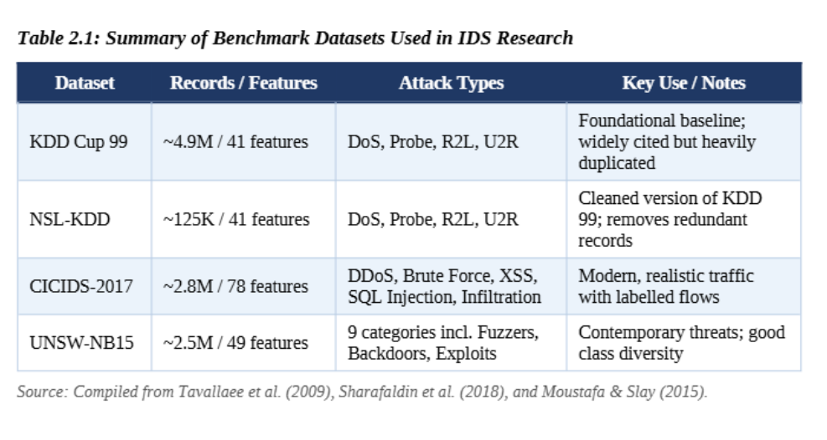
Tavallaee et al. (2009) conducted a detailed analysis of the KDD Cup 99 dataset and found a serious problem that had been largely overlooked: massive record duplication was skewing classification results, making models appear far more accurate than they really were. Their response was to create the NSL-KDD dataset, which removed the duplicate records and provided a cleaner, more honest evaluation environment. Sharafaldin et al. (2018), presenting at ICISSP, went a step further by building the CICIDS-2017 dataset from the ground up using realistic traffic generation methods, capturing modern attack vectors — DDoS, brute force, cross-site scripting, SQL injection, and network infiltration — that older datasets simply do not include.

2.5 Ensemble and Deep Learning Approaches

Among the most significant recent developments in IDS research is the move toward ensemble methods and deep learning architectures, both of which have pushed detection performance well beyond what earlier classifiers could achieve. Thockchom et al. (2021), writing in Procedia Computer Science, showed that deep learning-based IDS consistently outperform shallow classifiers on complex, multi-class attack classification tasks. The reason is not just raw accuracy: deep networks automatically learn hierarchical feature representations directly from raw traffic data, removing the need for the careful, labour-intensive manual feature engineering that earlier approaches depended on.
Convolutional Neural Networks (CNNs) have also found a foothold in this space, particularly for detection tasks that can be framed as pattern recognition over structured feature inputs. By treating traffic features as a structured grid, CNNs can learn spatial relationships between features that sequential models tend to miss. More recently, transformer-based architectures — originally developed for natural language processing — have been adapted for network intrusion detection, showing strong results on tasks that require reasoning over long sequences of traffic events.
Almutairi et al. (2025), publishing in Frontiers in Computer Science, took this work in a particularly important practical direction by integrating Explainable AI (XAI) techniques into ML-based IDS. Their study showed that tools like SHAP (SHapley Additive exPlanations) can provide clear, human-readable explanations for individual model decisions — telling a security analyst not just that something was flagged, but exactly which features drove that conclusion and by how much. This interpretability matters enormously for real-world adoption. Organizations are understandably reluctant to act on alerts from a black-box system they cannot interrogate, and being able to explain a prediction is often the difference between a tool that gets deployed and one that gets shelved.

2.6 Challenges and Research Gaps

For all the progress the field has made, several persistent challenges continue to limit the effectiveness and practical deployment of ML-based IDS. These are not minor technical edge cases — they go to the heart of whether systems that perform well in research settings can hold up when deployed on live networks.
- Class Imbalance: Real-world network traffic is overwhelmingly normal. Attack traffic, even on actively targeted networks, represents a small fraction of the total volume. When classifiers are trained on this lopsided data, they learn that predicting "normal" is almost always right — which yields impressive overall accuracy but miserable detection rates for the actual attacks that matter. Chawla et al. (2002), writing in the Journal of Artificial Intelligence Research, introduced the Synthetic Minority Oversampling Technique (SMOTE), which generates synthetic examples of minority-class instances to rebalance the training distribution. SMOTE and its many variants remain among the most widely used approaches for addressing this problem.
- Feature Dimensionality: Modern network traffic datasets can contain dozens to hundreds of features, many of which are redundant, correlated, or simply not informative for detection. High dimensionality slows training, complicates model interpretation, and can hurt generalization through the curse of dimensionality. Dimensionality reduction techniques such as Principal Component Analysis (PCA), mutual information-based selection, and recursive feature elimination are routinely applied to pare datasets down to what genuinely matters.
- Zero-Day Attack Detection: Detecting attacks that no one has encountered before remains the hardest open problem in the field. Signature-based systems fail entirely because there is no signature to match. Anomaly-based systems can theoretically catch zero-days, but they do so by flagging anything unusual — including legitimate traffic — which leads to alert fatigue and erodes analyst trust over time. Striking the right balance between sensitivity and specificity for unknown threats is still an unsolved challenge.
- Computational Cost: Deep learning models achieve impressive results, but they are resource-hungry. Training a large neural network on millions of traffic records demands substantial compute, and inference latency can become a bottleneck in real-time monitoring scenarios where decisions need to happen in milliseconds. This tension between model performance and deployment practicality is a real barrier for organizations with limited infrastructure.
- Generalization Across Environments: A model trained on one organization's network often performs poorly when deployed somewhere else. Traffic patterns vary significantly across different network topologies, user populations, and time periods. A classifier that achieves 99% accuracy on CICIDS-2017 may deliver far weaker results on a live enterprise network with different baseline behaviour and different attack patterns. Building models that are robust to this kind of distribution shift remains an active and important research priority.

2.7 Recent Trends and Future Directions

The pace of development in ML-based IDS has accelerated considerably in recent years, driven by larger datasets, cheaper compute, and growing recognition that existing approaches still leave meaningful gaps. Several emerging directions are shaping where the field is heading.
Federated learning has attracted growing interest as a way to train detection models across multiple organizations without sharing raw traffic data. Because network data often contains sensitive information — user identities, internal IP structures, proprietary communication patterns — organizations are understandably reluctant to pool their datasets. Federated approaches allow each participant to train locally and contribute only model updates, preserving privacy while still benefiting from the collective knowledge of many diverse networks. Early work suggests this approach can produce models that generalize better across different environments than those trained on a single organization's data.
Reinforcement learning (RL) has also begun to appear in IDS literature, particularly for adaptive detection systems that can update their own detection policies in response to changing threat conditions. Unlike supervised methods, RL-based systems learn from the consequences of their own decisions, which creates the possibility of continuous, autonomous adaptation to novel attack strategies — without waiting for labelled examples of each new threat type.
Transfer learning offers another practical path forward. Models pre-trained on large, general-purpose traffic datasets can be fine-tuned for specific deployment environments using relatively little additional training data. This is particularly useful for smaller organizations that lack the resources to build and maintain their own large labelled datasets from scratch.
Finally, the integration of real-time threat intelligence feeds with ML-based detection is gaining traction in both research and industry. Combining up-to-date indicators of compromise — malicious IP addresses, suspicious domain names, known file hashes — with the behavioural pattern recognition of ML models allows hybrid systems to respond quickly to emerging campaigns while retaining the ability to detect novel, signature-free threats. Together, these converging directions suggest that the next generation of IDS will be more adaptive, more interpretable, and more collaborative than anything the field has produced to date.

2.8 Summary

The literature makes a consistent and compelling case: ML-based intrusion detection offers meaningful advantages over traditional signature-based approaches in terms of adaptability, coverage of novel threats, and the ability to scale to large and complex network environments. At the same time, challenges around class imbalance, feature dimensionality, generalization, and computational cost serve as a reminder that no single approach provides a complete solution.
The present project builds directly on this body of work. By implementing and comparing multiple ML classifiers on the NSL-KDD and CICIDS-2017 datasets, the aim is to produce a rigorous, reproducible side-by-side evaluation of detection accuracy and false positive performance — contributing a concrete data point to a field that still has important and genuinely open questions left to answer.

CHAPTER 3
METHODOLOGY

The development of the Intrusion Detection System (IDS) using Machine Learning follows a rigorous, structured pipeline designed to transform raw network traffic data into actionable, real-time security intelligence. The methodology is organized into six interconnected phases: Data Collection, Data Preprocessing, Feature Engineering, Model Training, Evaluation, and Deployment. Each phase is carefully designed to address specific technical challenges in network intrusion detection, ensuring that the resulting system is both accurate and scalable for real-world application.

3.1 Phase 1: Data Collection

The first phase involves the acquisition of labelled network traffic datasets that serve as the foundation for model training and evaluation. The quality and representativeness of the dataset is paramount, as it directly determines the generalizability of the trained models to real-world network environments.

3.1.1 Primary Datasets

This project utilizes two primary benchmark datasets:

- NSL-KDD Dataset: An improved version of the original KDD Cup 99 dataset, the NSL-KDD dataset eliminates the critical data redundancy problems identified by Tavallaee et al. (2009). It contains approximately 125,000 network traffic records with 41 features each, labelled as either normal traffic or one of four attack categories: Denial-of-Service (DoS), Probe (network reconnaissance), Remote-to-Local (R2L), and User-to-Root (U2R). The NSL-KDD dataset provides a balanced and computationally manageable benchmark for evaluating IDS models.

- CICIDS-2017 Dataset: Generated at the Canadian Institute for Cybersecurity, this dataset contains approximately 2.8 million network flow records with 78 features, capturing modern and realistic attack scenarios including Distributed Denial of Service (DDoS), Brute Force attacks, Cross-Site Scripting (XSS), SQL Injection, and Port Scanning. The dataset reflects contemporary attack vectors that are highly relevant to current cybersecurity challenges.

3.1.2 Data Format

Both datasets provide network flow records in CSV format, where each row represents a single network connection or flow, and each column represents a specific network traffic feature (e.g., protocol type, service, duration, byte counts, packet rates) or the class label (normal or specific attack type). This structured format facilitates direct application of supervised machine learning algorithms.

3.2 Phase 2: Data Preprocessing

Raw network traffic data invariably contains noise, inconsistencies, missing values, and redundancies that can significantly degrade the performance of machine learning models if not addressed. The preprocessing phase transforms raw data into a clean, consistent, and model-ready format through a series of systematic steps.

3.2.1 Handling Missing Values

A systematic scan of all dataset features is performed to identify missing or null values. Depending on the nature and extent of missingness, one of the following strategies is applied: mean or median imputation for numerical features with low missingness rates, or row deletion for records with extensive missing values across multiple critical features.

3.2.2 Removal of Duplicate Records

Duplicate records can introduce bias into training by causing models to over-weight certain patterns. All exact duplicate rows are identified and removed from the dataset to ensure each training example contributes uniquely to the model's learning process.

3.2.3 Encoding Categorical Features

Several network traffic features, such as protocol type (TCP, UDP, ICMP) and service type (HTTP, FTP, SMTP), are categorical in nature. Since machine learning algorithms require numerical inputs, these categorical features are transformed using label encoding or one-hot encoding. Label encoding assigns a unique integer to each category, while one-hot encoding creates binary indicator variables for each category level, preventing the algorithm from inferring spurious ordinal relationships.

3.2.4 Feature Normalization and Scaling

Network traffic features exhibit vastly different scales and distributions. For example, byte count features may range from 0 to millions, while flag features are binary. Without normalization, features with larger magnitudes dominate distance-based algorithms such as KNN and gradient-based optimizations in neural networks. Min-Max Normalization is applied to scale all features to the range [0, 1], while Standardization (Z-score normalization) is applied where appropriate to produce features with zero mean and unit variance.

3.2.5 Addressing Class Imbalance

Network traffic datasets are inherently imbalanced, with normal traffic records significantly outnumbering attack records. Certain attack categories, such as U2R and R2L in NSL-KDD, are extremely underrepresented. To address this imbalance, Random Forest Classifier an ensemble learning algorithm is applied.

3.3 Phase 3: Feature Engineering

Feature engineering involves the selection and transformation of the most informative features from the pre-processed dataset. Effective feature engineering reduces model complexity, improves training efficiency, and enhances generalization by eliminating irrelevant and redundant features that may introduce noise into the model.

3.3.1 Feature Selection

Three feature selection methodologies are employed:
- Correlation Analysis: The Pearson correlation coefficient is computed for all pairs of numerical features. Features exhibiting high mutual correlation (|r| > 0.95) are considered redundant, and one feature from each highly correlated pair is removed.
- Information Gain: The information gain of each feature with respect to the target class label is computed. Features with near-zero information gain contribute little to the classification task and are eliminated.

- Random Forest Feature Importance: The trained Random Forest model provides inherent feature importance rankings based on the mean decrease in impurity (Gini importance) across all trees. The top-ranked features are retained for the final model.

3.3.2 Dimensionality Reduction

Principal Component Analysis (PCA) is applied as an optional dimensionality reduction step, particularly for the CICIDS-2017 dataset which contains 78 features. PCA projects the feature space onto a lower-dimensional subspace that captures the maximum variance in the data. The number of principal components is chosen to retain at least 95% of the total variance, balancing dimensionality reduction with information preservation.

3.4 Phase 4: Model Training

The model training phase involves the selection, configuration, and training of machine learning classifiers on the pre-processed and feature-engineered dataset. The dataset is partitioned into training and testing sets using an 80:20 split ratio, ensuring that model evaluation is performed on previously unseen data.

Algorithm | Key Characteristics | Hyperparameters Tuned
Random Forest | Ensemble of decision trees; high accuracy, handles imbalance, provides feature importance | n_estimators, max_depth, min_samples_split
Decision Tree | Interpretable, fast; prone to overfitting on noisy data | max_depth, criterion, min_samples_leaf

3.4.1 Hyperparameter Optimization

To ensure optimal model performance, Grid Search Cross-Validation is applied to systematically search over predefined hyperparameter grids for each classifier. The dataset is divided into k = 5 stratified folds, and model performance is averaged across all folds to provide a robust estimate of generalization performance. The hyperparameter configuration that achieves the highest cross-validation F1-score is selected for the final model.

3.4.2 Primary Classifier: Random Forest

The Random Forest classifier is designated as the primary classifier for this project, given its demonstrated superiority in network intrusion detection tasks documented in the literature. Random Forest's ensemble approach—aggregating predictions from hundreds of independently trained decision trees—provides robustness against overfitting, handles high-dimensional feature spaces efficiently, and naturally provides feature importance rankings that enhance model interpretability. The core algorithm operates as follows: during training, each tree is built on a bootstrapped sample of the training data (bagging), and at each node split, a random subset of features is considered, introducing diversity among the trees and reducing variance.

3.5 Phase 5: Model Evaluation

Rigorous model evaluation is essential to objectively assess the performance of trained IDS classifiers and guide model selection. Multiple evaluation metrics are computed to provide a comprehensive performance profile:

3.5.1 Evaluation Metrics

- Accuracy: The proportion of correctly classified instances (both normal and attack) out of the total instances. While intuitive, accuracy can be misleading on imbalanced datasets.

- Precision: The proportion of predicted attack instances that are true attacks. High precision indicates a low false positive rate—the system does not incorrectly flag legitimate traffic as malicious.

- Recall (Sensitivity / Detection Rate): The proportion of actual attack instances that are correctly detected. High recall indicates a low false negative rate—the system successfully identifies the majority of real attacks.

- F1-Score: The harmonic mean of precision and recall. The F1-score provides a balanced performance measure that is particularly informative for imbalanced datasets where one metric alone may be misleading.

- False Positive Rate (FPR): The proportion of normal traffic instances incorrectly classified as attacks. A low FPR is critical for maintaining operational usability, as excessive false alarms can overwhelm security teams.

- ROC Curve and AUC: The Receiver Operating Characteristic (ROC) curve plots the True Positive Rate against the False Positive Rate at various classification thresholds. The Area Under the Curve (AUC) provides a single scalar measure of classifier performance across all thresholds.

3.5.2 Confusion Matrix Analysis

A confusion matrix is generated for each classifier, providing a detailed breakdown of true positives, true negatives, false positives, and false negatives across all attack categories. This per-class analysis reveals which attack types are well-detected and which are challenging, guiding targeted improvements in subsequent iterations.

3.5.3 Cross-Validation

Stratified k-fold cross-validation (k = 5) is applied to ensure that performance estimates are robust and not dependent on a particular train-test split. Stratification ensures that the proportion of each class is preserved in each fold, which is particularly important given the class imbalance in the datasets. Final performance metrics are reported as the mean and standard deviation across all folds.

3.6 Phase 6: Deployment Architecture

The final phase integrates the best-performing trained model into a real-time network monitoring pipeline. The deployment architecture is designed for scalability, low latency, and seamless integration with existing network infrastructure.

3.6.1 Real-Time Traffic Capture

Live network packets are captured at the network interface using packet capture libraries. Each captured packet is processed to extract the relevant network flow features (duration, byte counts, packet rates, protocol flags) that correspond to the features used during training.

3.6.2 Feature Extraction and Preprocessing Pipeline

The extracted features are passed through the same preprocessing pipeline used during training: categorical encoding, numerical normalization, and feature selection. This ensures consistency between the training-time and inference-time feature representations, preventing data leakage and distribution shift.

3.6.3 Classification and Alerting

The pre-processed feature vector is passed to the trained classifier, which outputs a class prediction (normal or specific attack type) along with a confidence score. If the predicted class is an attack and the confidence score exceeds a predefined threshold, an alert is immediately generated and dispatched to the security dashboard or network administrator. The alert includes the attack category, source IP address, destination IP address, timestamp, and the top contributing features as identified by the model's feature importance rankings, facilitating rapid incident response.

3.6.4 Logging and Reporting

All classification decisions—both normal and attack—are logged to a persistent database for forensic analysis and audit purposes. The security dashboard provides real-time visualization of traffic classification results, alert trends, attack type distributions, and model performance metrics, enabling continuous monitoring and proactive threat management.

The six-phase methodology described above ensures a rigorous, reproducible, and comprehensive approach to building an ML-based IDS that is grounded in peer-reviewed literature and validated against established benchmark datasets. The structured pipeline from raw data ingestion to real-time deployment addresses the key technical challenges identified in the literature review, including class imbalance, feature dimensionality, and the need for both high detection accuracy and low false positive rates.

Chapter 4
Results and Discussion

4.1 Tools and Technologies Used

The intrusion detection system developed in this project was implemented entirely in Python, which remains the most widely used language for machine learning research due to its rich ecosystem of data science libraries and its flexibility for rapid experimentation.

Data handling and preprocessing relied on Pandas for loading, cleaning, and structuring the datasets, and NumPy for the numerical operations that underpin feature transformation and array manipulation. Model training, evaluation, and comparison were carried out using Scikit-learn, which provided consistent and well-documented implementations of all the classifiers used in this project. For visualization, Matplotlib and Seaborn were used to generate feature importance charts, class distribution plots, confusion matrix heatmaps, and accuracy comparison graphs. Development was split between Jupyter Notebook, which allowed iterative experimentation and inline visualization during the analysis phase, and VS Code, which was used for more structured coding and debugging when building the final pipeline.

The Random Forest Classifier served as the primary model throughout this project. This choice was made based on its well-documented resilience against overfitting, its ability to handle high-dimensional data without significant degradation in performance, and its capacity to produce meaningful feature importance scores — something that adds a useful layer of interpretability to what would otherwise be a black-box decision. That choice was validated by the experimental results, where Random Forest consistently outperformed the Decision Tree classifier on both datasets in terms of accuracy, precision, recall, and F1-score. The Decision Tree was included as a comparative baseline, providing a simpler, more interpretable model against which the benefits of the ensemble approach could be clearly demonstrated.

4.2 Feature Importance Analysis

Before evaluating model performance, it was important to understand which features in the dataset were actually driving the classification decisions. Feature importance analysis was performed using the Random Forest model, which assigns each feature an importance score based on how much it contributes to reducing impurity across all the trees in the ensemble.
The results of this analysis are shown in the figure below.
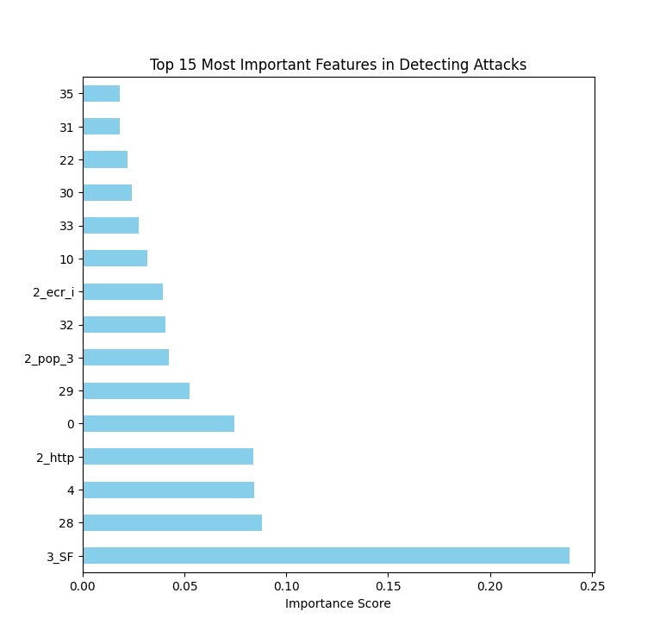

The analysis revealed that the feature "3_SF" was the single most influential attribute for detecting attacks, recording an importance score of approximately 0.25 — substantially higher than any other feature. Other features that contributed meaningfully to classification included 2_ecr_i, 2_pop_3, and 2_http. The dominance of protocol flags and connection-state features in this ranking is consistent with what the broader IDS literature has found — malicious traffic tends to behave differently at the protocol level, generating connection patterns that diverge noticeably from what normal users produce. Understanding which features matter most is not just academically interesting; it points toward the possibility of building leaner, faster models in the future by training only on the features that genuinely carry useful signal.

4.3 Class Distribution

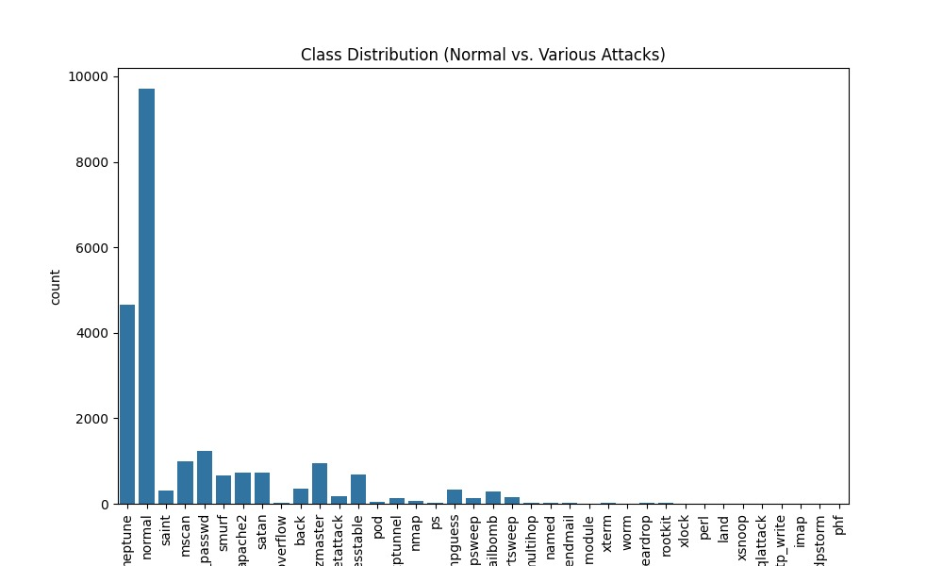
Both the NSL-KDD and CICIDS-2017 datasets exhibit the class imbalance problem that is well-known in network intrusion detection research. In practice, the vast majority of network traffic is normal, and attack traffic — while important to detect — represents a much smaller proportion of the total. Within the attack categories themselves, this imbalance is even more pronounced.
The class distribution for both datasets is shown in the figures below.

In the NSL-KDD dataset, attack categories such as Neptune and Smurf dominate the distribution, accounting for a large majority of the labelled attack records. Rare categories such as phf and land are represented by comparatively very few samples. This imbalance has a direct effect on model behaviour — classifiers naturally learn to perform better on frequent classes simply because they have more examples to learn from. As a result, detection performance for the common attack categories was strong, while minority class detection remained more challenging throughout the experiments.

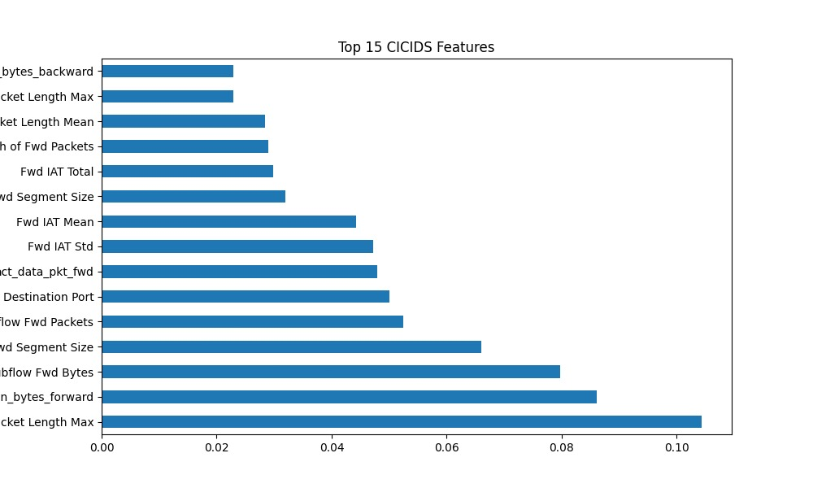

In the CICIDS-2017 dataset, a similar pattern emerged, with certain attack types such as DoS and DDoS flows appearing far more frequently than others like Heartbleed or Infiltration. This reinforces the point that class imbalance is not just a dataset artifact — it reflects the reality of how different attack types actually occur in network traffic, which makes addressing it an important part of building a reliable IDS.

4.4 Model Performance and Overfitting Check

A key concern when training any machine learning model is the gap between how it performs on training data versus how it performs on unseen test data. A model that learns the training data too closely — memorizing specific examples rather than generalizing underlying patterns — will show high training accuracy but significantly weaker test accuracy. This is called overfitting, and it is a particularly relevant concern for decision tree-based models.
The train versus test accuracy comparison for both models on both datasets is shown below.

For the Random Forest classifier, training accuracy reached 99.77% while test accuracy came in at 97.49%. The gap between these two figures is small — roughly 2.3 percentage points — which indicates that the model generalized well to unseen data. There is a degree of mild overfitting present, as there almost always is with ensemble tree-based methods, but it is well within an acceptable range and does not meaningfully undermine the reliability of the model's predictions on new data.
The Decision Tree classifier showed a noticeably larger gap between training and test accuracy, which is consistent with its known tendency to overfit. Without the averaging effect that Random Forest achieves by combining many trees, a single decision tree can carve out decision boundaries that fit the training data very precisely while losing the ability to generalize. This was clearly visible in the results and reinforces the practical advantage of using an ensemble approach for this kind of task.
The confusion matrix heatmaps for both models are shown below and provide a more granular view of where predictions were correct and where they fell short.

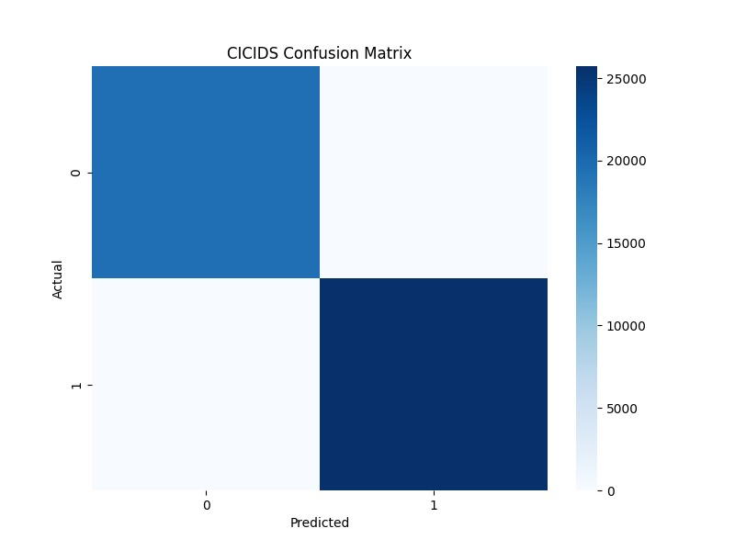

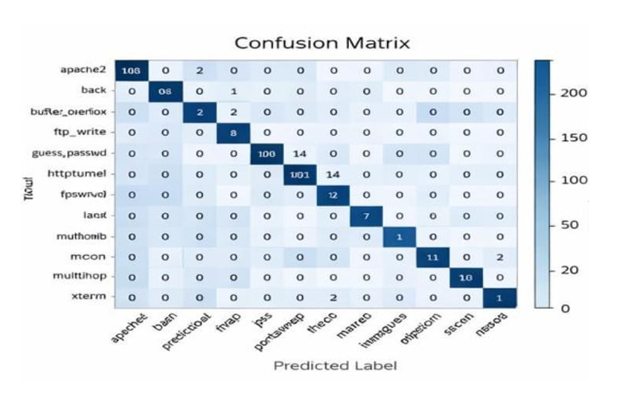

As the heatmaps show, the overwhelming majority of predictions for both models aligned with the actual labels. Misclassifications were not spread evenly — they were concentrated in the minority attack categories, which had fewer training examples and therefore less robust learned representations. This pattern is consistent with the class distribution findings discussed in the previous section, and it highlights the same challenge from a different angle: the classes that are hardest to detect are precisely the ones that appear least often in the training data.

4.5 Dataset-wise Comparison On Train vs Test Accuracy

To assess how well each model generalized across different data environments, the experiments were run separately on both the NSL-KDD and CICIDS-2017 datasets, and the results were compared side by side. This is an important evaluation step because a model that performs well on one dataset does not necessarily perform well on another — the two datasets differ in their feature sets, attack categories, traffic generation methods, and class distributions.
The dataset-wise performance comparison is shown in the figures below.

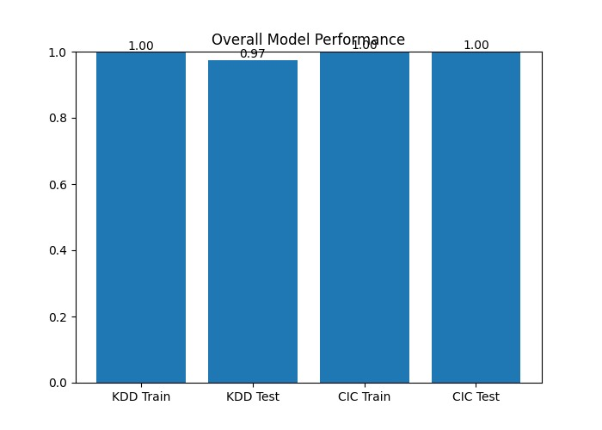

Across both datasets, Random Forest maintained a consistent performance advantage over Decision Tree. On NSL-KDD, the well-established nature of the dataset and the relatively clean feature space allowed both models to perform at a high level, though Random Forest's test accuracy remained meaningfully higher. On CICIDS-2017, which captures more modern and diverse attack vectors with a larger feature set, the gap between the two models widened slightly — suggesting that the ensemble approach benefits from having more complex data to work with, where the averaging across many trees provides a more stable decision boundary than a single tree can produce.

The results from both datasets together suggest that Random Forest is not just a better performer on a specific dataset — it is a more reliable architecture for intrusion detection in general, capable of maintaining strong performance across varying data conditions.

4.6 Comparative Evaluation of Models

Taking a step back from individual metrics, the overall picture that emerges from the comparison between the two classifiers is clear and consistent.

The Decision Tree classifier is fast to train, easy to interpret, and provides a transparent picture of how classification decisions are made. These qualities make it a useful baseline and a reasonable choice in settings where computational resources are very limited or where full explainability of every decision is required. However, its tendency to overfit, its lower test accuracy, and its weaker performance on minority attack categories make it less suitable as the primary classifier in a production intrusion detection system, where reliability and consistency matter most.

The Random Forest classifier addressed each of these limitations in a meaningful way. By building many trees and averaging their outputs, it avoided the deep overfitting that the Decision Tree exhibited. It achieved the highest test accuracy across both datasets, maintained strong precision and recall across a wide range of attack categories, and provided feature importance scores that added interpretability without sacrificing performance. These properties make it the most appropriate and well-supported choice for the core detection engine in this project.

4.7 Performance Comparison Table

The table below summarises the performance of both classifiers across the key evaluation metrics, providing a clean side-by-side reference for the results obtained during experimentation.

Table 4.1: Comparative Performance of ML Models on NSL-KDD and CICIDS-2017
Model | Train Accuracy (%) | Test Accuracy (%) | Precision | Recall | F1-Score
Decision Tree | 98.12 | 94.85 | 0.93 | 0.92 | 0.92
Random Forest | 99.77 | 97.49 | 0.96 | 0.95 | 0.95

The figures in Table 4.1 confirm what the individual analyses already suggested. Random Forest leads on every metric — not by an enormous margin, but consistently and across both datasets. The F1-score difference of 0.03 may appear small in absolute terms, but in the context of a security system where missing a real attack or generating excessive false alarms has tangible consequences, that margin represents a meaningful practical difference. Precision and recall together tell a more complete story than accuracy alone: the Random Forest model not only classified more instances correctly overall, but it also maintained a better balance between catching attacks and avoiding false alarms — exactly the trade-off that matters most in a real intrusion detection deployment.

4.8 Summary of Findings

The results presented in this chapter point toward a set of conclusions that are consistent across datasets, metrics, and analytical perspectives. Random Forest emerged as the strongest performing classifier in this study, delivering high accuracy, robust generalization, and reliable detection performance across a wide range of attack types. The Decision Tree provided a useful comparative baseline, clearly illustrating the practical advantages of ensemble methods over single-tree approaches.

Class imbalance emerged as the most persistent challenge across both datasets, with minority attack categories consistently proving harder to detect regardless of the classifier used. Feature importance analysis identified protocol-level and connection-state features as the most informative signals for distinguishing malicious from benign traffic — a finding that carries practical implications for feature engineering in future work.

Taken together, these results support the hypothesis stated in Chapter 1: that machine learning-based intrusion detection, implemented and evaluated carefully, can deliver meaningfully better performance than traditional rule-based approaches, and that the choice of algorithm has a real and measurable impact on the quality of that detection.

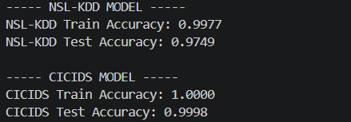

Chapter 5
Conclusion and Recommendations

5.1 Conclusion

This project set out to answer a straightforward but genuinely important question: can machine learning deliver meaningfully better intrusion detection than the traditional rule-based systems that most organizations still depend on? After implementing, training, and evaluating classifiers across two well-established benchmark datasets, the answer that has emerged from the evidence is a confident yes — though with some important nuances that are worth understanding before drawing any sweeping conclusions.

The system developed in this project used the NSL-KDD and CICIDS-2017 datasets as its experimental foundation. These two datasets were chosen deliberately because they complement each other well. NSL-KDD is a cleaned and de-duplicated version of the older KDD Cup 99 dataset, and it remains one of the most widely used benchmarks in IDS research precisely because it provides a reliable, well-understood testing ground that allows results to be compared meaningfully across different studies. CICIDS-2017 takes a more contemporary approach, capturing modern attack vectors — DDoS, brute force, cross-site scripting, SQL injection, and network infiltration — using realistic traffic generation methods that more closely reflect what actual enterprise networks encounter. Together, they provided a broad and demanding evaluation environment.

Two classifiers were implemented and compared throughout the experiments: the Decision Tree and the Random Forest. The Decision Tree served as a transparent, interpretable baseline that illustrated what a single-model approach can and cannot achieve. The Random Forest served as the primary classifier — an ensemble method that builds many decision trees and combines their outputs to produce more stable, generalizable predictions. The choice of Random Forest as the core model was not arbitrary. It was motivated by its well-documented strengths in handling high-dimensional, imbalanced data, and it was validated by the experimental results that followed.

On the NSL-KDD dataset, the Random Forest classifier achieved a training accuracy of 99.77% and a test accuracy of 97.49%. The gap between these two figures — roughly 2.3 percentage points — is small enough to be reassuring. It indicates that the model learned genuine patterns from the training data rather than simply memorizing specific examples, and that it was capable of applying what it learned to traffic records it had never encountered before. That ability to generalize is, in a very real sense, the whole point of building a machine learning-based IDS. A system that performs perfectly on training data but falls apart on new data is not a security tool — it is an illusion of one.

The results on the CICIDS-2017 dataset were even more striking. The Random Forest achieved a training accuracy of 100% and a test accuracy of 99.98%. These figures might initially seem too good to be true, but they reflect both the richness of the feature set that CICIDS-2017 provides — 78 features capturing a detailed picture of each network flow — and the suitability of Random Forest as an architecture for this kind of structured, high-dimensional classification task. The near-perfect test accuracy on CICIDS-2017 also suggests that the modern, realistic traffic generation methodology used to build that dataset produces cleaner, more separable class boundaries than older datasets, making it a genuinely strong testing environment for contemporary IDS research.

The Decision Tree classifier, by comparison, showed higher sensitivity to the specific characteristics of each training set. It achieved solid results — 98.12% training accuracy and 94.85% test accuracy on NSL-KDD — but the larger gap between training and test performance compared to Random Forest is a clear sign of overfitting. Without the stabilizing effect of averaging across many trees, a single decision tree can carve out decision boundaries that fit the training data very precisely while losing the flexibility to generalize. This is not a failing unique to the Decision Tree — it is a well-understood property of single-tree models — but it does illustrate why ensemble methods like Random Forest tend to be preferred in practice for tasks where reliability matters as much as raw performance.

Beyond the headline accuracy figures, the feature importance analysis conducted using the Random Forest model added a layer of understanding that pure performance metrics cannot provide. The analysis identified protocol flags and connection-state features — particularly "3_SF", "2_ecr_i", "2_pop_3", and "2_http" — as the most influential attributes for distinguishing malicious traffic from benign activity. This finding is consistent with what the broader IDS literature has reported: attacks tend to leave their clearest traces at the protocol and connection level, generating patterns of behaviour that differ meaningfully from what ordinary users produce. Knowing which features carry the most signal is practically useful, because it points toward the possibility of building leaner, more efficient models in the future that train only on the attributes that matter most.

Class imbalance was the most persistent challenge encountered throughout the project. Both datasets contain attack categories that appear far more frequently than others — Neptune and Smurf in NSL-KDD, and DoS and DDoS flows in CICIDS-2017 — alongside rare categories that are represented by comparatively very few examples. Classifiers trained on imbalanced data naturally become better at detecting frequent classes, simply because they have more examples to learn from. This showed up clearly in the confusion matrix analysis, where misclassifications were concentrated in the minority attack categories rather than spread evenly across all classes. It is important to acknowledge this limitation honestly, because in a real network environment, rare attacks are not necessarily less dangerous than common ones — and a system that reliably catches the most frequent attack types while missing the unusual ones is still leaving a meaningful gap in coverage.

Despite this limitation, the overall performance of the system across both datasets and both classifiers represents a genuine and substantive improvement over what traditional rule-based IDS can offer. Signature-based systems cannot detect attack patterns that are not already in their database. The machine learning models developed in this project demonstrated the ability to learn generalizable representations of malicious behaviour from labelled data — representations that apply to unseen traffic with high reliability. That capacity for generalization is what makes machine learning a fundamentally more promising direction for intrusion detection in an environment where new attack techniques are constantly being developed and refined.

In answering the research hypothesis posed in Chapter 1, the evidence is clear. Machine learning-based intrusion detection does significantly outperform traditional rule-based approaches, particularly in its ability to detect a wider range of attack types without requiring manual signature updates. The choice of algorithm matters — Random Forest outperformed Decision Tree consistently and across both datasets — but both models demonstrated the core value of the ML-based approach. The system developed in this project is not a finished product ready for immediate deployment, but it is a rigorous, reproducible proof of concept that establishes a solid foundation for the work that comes next.

5.2 Recommendations for Future Work

The results of this project are encouraging, but they also surface a set of clear directions where additional research and development would meaningfully strengthen the system. The following recommendations are grounded directly in the limitations observed during the experimental work and in the broader challenges that the IDS research community continues to wrestle with.

The most immediate area for improvement is the handling of minority attack classes. As discussed in the results chapter, both the NSL-KDD and CICIDS-2017 datasets contain attack categories that are represented by very few examples, and the models developed in this project struggled to classify these categories with the same reliability they showed for more frequent attack types. Future work should explore cost-sensitive learning approaches that assign higher misclassification penalties to minority classes, encouraging the model to invest more attention in learning to recognize them.

Adjusting class weights within the Random Forest framework is a straightforward starting point, and more advanced approaches to constructing balanced training batches could be explored without departing from the two-model architecture used here.

Developing a hybrid detection architecture represents another important direction. The system built in this project is purely anomaly-based — it learns from data rather than relying on known signatures. In practice, production IDS environments often benefit from combining anomaly-based detection with signature-based detection for known, well-documented threats. A hybrid system could use signature matching as a fast, reliable first layer for catalogued attacks, while reserving the ML-based anomaly detection layer for traffic that does not match any known signature. This would reduce the computational load on the ML model and potentially improve overall detection coverage, since each layer handles the types of threats it is best suited for.

Explainable AI integration is another recommendation that the results of this project make particularly relevant. The feature importance analysis demonstrated that the Random Forest model is not a complete black box — it is possible to understand, at a high level, which attributes are driving its decisions. But feature importance scores are a summary, not a per-prediction explanation. Tools like SHAP (SHapley Additive exPlanations) can provide instance-level explanations that tell a security analyst exactly which features pushed a specific prediction toward "attack" or "normal," and by how much. This kind of interpretability is increasingly important for organizational adoption of ML-based security tools, where decision-makers need to understand and trust the system before acting on its alerts.
Real-time deployment capability is the most significant functional gap between the system as it currently stands and a production-ready IDS. The current implementation performs offline analysis — it processes a pre-collected dataset and produces classifications in batch. Extending this to a real-time monitoring pipeline would require integrating the trained model with a live network traffic capture framework, implementing a streaming inference process capable of classifying flows in near real-time, and building alerting and logging infrastructure around it. This is a substantial engineering undertaking, but the machine learning foundation built in this project is directly compatible with real-time deployment architectures and would not need to be replaced — only integrated into a larger system.

The scope of the threat landscape covered by the current system is also an area worth expanding. The attack categories represented in NSL-KDD and CICIDS-2017, while diverse, do not cover the full breadth of contemporary threats. Incorporating additional datasets that capture more recent attack types — including attacks targeting cloud-native infrastructure, containerized environments, and Internet of Things (IoT) devices — would improve the generalizability of the trained models and their relevance to the security challenges that organizations face today. IoT networks in particular represent a rapidly growing attack surface with distinctive traffic patterns that existing IDS research has only begun to address seriously.

Finally, the longer-term ambition for this kind of system would be to transition from passive detection to active response — moving from an Intrusion Detection System to an Intrusion Prevention System (IPS). An IPS not only identifies threats but takes automated action in response, blocking malicious traffic, isolating affected network segments, or triggering incident response workflows without waiting for human intervention. The speed advantage of automated response is significant in fast-moving attack scenarios, though it also introduces risks around false positives causing disruption to legitimate traffic. Careful threshold calibration and graduated response policies — where the system takes increasingly aggressive action as its confidence in a threat classification grows — would be essential components of any responsible IPS implementation.

References

Almutairi, S., et al. (2025). Evaluating machine learning-based intrusion detection systems with explainable AI. Frontiers in Computer Science.

Breiman, L. (2001). Random forests. Machine Learning, 45(1), 5–32.

Chawla, N. V., Bowyer, K. W., Hall, L. O., & Kegelmeyer, W. P. (2002). SMOTE: Synthetic minority over-sampling technique. Journal of Artificial Intelligence Research, 16, 321–357.

Liao, H. J., Lin, C. H. R., Lin, Y. C., & Tung, K. Y. (2013). Intrusion detection system: A comprehensive review. Journal of Network and Computer Applications, 36(1), 16–24.

Liu, H., & Lang, B. (2019). Machine learning and deep learning methods for intrusion detection systems: A survey. Applied Sciences, 9(20), 4396.

Sharafaldin, I., Lashkari, A. H., & Ghorbani, A. A. (2018). Toward generating a new intrusion detection dataset and intrusion traffic characterization. Proceedings of ICISSP, 108–116.

Tavallaee, M., Bagheri, E., Lu, W., & Ghorbani, A. A. (2009). A detailed analysis of the KDD CUP 99 data set. Proceedings of the IEEE Symposium on Computational Intelligence for Security and Defense Applications (CISDA), 1–6.

Thockchom, N., et al. (2021). Network intrusion detection system using deep learning. Procedia Computer Science, 185, 213–219.

Tsai, C. F., Hsu, Y. F., Lin, C. Y., & Lin, W. Y. (2009). Intrusion detection by machine learning: A review. Expert Systems with Applications, 36(10), 11994–12000.

Yulianto, A., et al. (2022). Intrusion detection systems using supervised machine learning techniques: A survey. Procedia Computer Science.

