Problem: Find w that minimize function
parameter
d = number of dimension of w
a = bound

OPE algorithm

1. Initialize ( in (0,1) for i = 1...d)
2. set a = 0, b = 0
3. for t = 1...T
3.1 choose random a or b with probability {0.5 , 0.5}
then increase by 1

3.2

3.3

3.4 Find that minimize with respect to

3.5 set

Detail:
3.3 R is non-differentiable at some point w, so at that points, we choose random right differential or left differential with probability {0.5, 0.5}

3.4 to find , we choose to be a vertex of domain
because D is convex, and 3.4 problem is linear programing.
So one element of is or , other elements are zeros.

In GIST package, authors implemented loss functions :
Least :n is number of sample
L2SVM :
Logistic :

Some discussion on OPE in logistic regression:
1. About sparsity of w
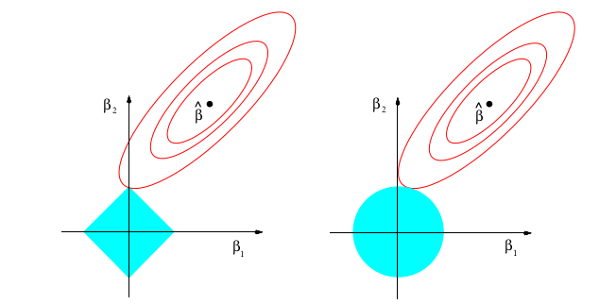
As we can see, in general lasso penalty, the point we found is actually a vertex of the rectangle. So the w is parse.
But in our OPE algorithm, we do not gain the vertex point, in stead, we reach on edge point, so the result is not parse.

