NGSIM Peachtree Street (Atlanta) Data Analysis

prepared for
Federal Highway Administration
prepared by
Cambridge Systematics, Inc.

June 2007www.camsys.com
summary

report
(4:00 p.m. to 4:15 p.m.)

summary report
NGSIM Peachtree Street (Atlanta) Data Analysis
(4:00 p.m. to 4:15 p.m.)

prepared for
Federal Highway Administration
prepared by
Cambridge Systematics, Inc.
555 12th Street, Suite 1600
Oakland, California 94607
June 2007

Table of Contents
Introduction 1
Study Area Description 1
Vehicle Detection and Tracking 4
Data Analysis 5
Vehicle Type 7
Origin-Destination Distribution 7
Traffic Volume Analysis 9
Speed Analysis 12
Travel Time Analysis 15
Lane Change Analysis 16
Headway Analysis 19
Spacing Analysis 19
Gap Analysis 20

List of Tables
1. Vehicle Type 7
2. Origin-Destination Distribution 8
3. Traffic Volume at Intersection 1 (in Vehicles) 9
4. Traffic Volume at Intersection 2 (in Vehicles) 10
5. Traffic Volume at Intersection 3 (in Vehicles) 10
6. Traffic Volume at Intersection 4 (in Vehicles) 11
7. Traffic Volume at Intersection 5 (in Vehicles) 11
8. Average Speed in Section 2 (NB) (Feet Per Second) 12
9. Average Speed in Section 2 (SB) (Feet Per Second) 12
10. Average Speed in Section 3 (NB) (Feet Per Second) 13
11. Average Speed in Section 3 (SB) (Feet Per Second) 13
12. Average Speed in Section 4 (NB) (Feet Per Second) 13
13. Average Speed in Section 4 (SB) (Feet Per Second) 14
14. Average Speed in Section 5 (NB) (Feet Per Second) 14
15. Average Speed in Section 5 (SB) (Feet Per Second) 14
16. Average Travel Time on Peachtree St. (NB) (in Seconds) 15
17. Average Travel Time on Peachtree St. (SB) (in Seconds) 15
18. Number of Lane Changes by O-D Pairs 17
19. Average Lane Changes by O-D Pairs 18
20. Average Headway on Peachtree St. (NB) (in Seconds) 19
21. Average Headway on Peachtree St. (SB) (in Seconds) 19
22. Average Spacing on Peachtree St. (NB) (in Feet) 20
23. Average Spacing on Peachtree St. (SB) (in Feet) 20
24. Average Lead and Lag Gaps on Peachtree St. (NB) (in Feet) 21
25. Average Lead and Lag Gaps on Peachtree St. (SB) (in Feet) 21
List of Figures
1. Study Area and Camera Coverage 2
2. Study Area Schematic 3
3. Vehicle Detection and Tracking Process 4
4. Study Area Schematic with Various Identification Numbers 6
5. Number of Lane Changes Per Vehicle 16

■ Introduction
This report summarizes a data collection and processing effort undertaken to provide a dataset of arterial vehicle trajectories data completed as part of the Federal Highway Administration’s (FHWA) Next Generation Simulation (NGSIM) project, and provides a detailed analysis of a subset of the data. The data analyzed in this report represent vehicle trajectories on a segment of Peachtree Street in Atlanta, Georgia collected between 4:00 p.m. and 4:15 p.m. on November 8, 2006. Aggregate summaries of flow and speed of the vehicles, number of lane changes, headway and gap analysis, and an input-output analysis of flows are provided. The results are aggregated by time and intersection.

Study Area Description
Data presented in this report represent travel on Peachtree Street, an arterial running primarily north-south in Atlanta, Georgia. The speed limit on the Peachtree Street is 35 mph. These data were collected using video cameras mounted on a 30-story building, which is located at 1100 Peachtree Street NE, Atlanta, Georgia.
Figure 1 provides an aerial image of the location with the camera coverage. Figure 2 presents a schematic illustration of the location for the vehicle trajectory dataset. The site was approximately 2,100 feet in length, with five intersections and two to three arterial through lanes in each direction through the section. Lane numbering is incremented from the left-most lane.
Video data were collected using eight video cameras, cameras 1 through 8, with camera 1 recording the southernmost and camera 8 recording the northernmost section of the study area, as shown in Figure 1. Digital video images were collected over an approximate 6.5-hour period from 9:30 a.m. to 1:30 p.m. and from 4:00 p.m. to 6:30 p.m. on November 8, 2006, and 4-hour period from 8:00 a.m. to 12:00 p.m. on November 9, 2006. Complete vehicle trajectories were transcribed for two 15 minute periods – one from 12:45 p.m. to 1:00 p.m. and the other from 4:00 p.m. to 4:15 p.m. – for a total of 30 minutes at a resolution of 10 frames per second. The data in this report summarizes only the period from 4:00 p.m. to 4:15 p.m.
Figure 1. Study Area and Camera Coverage
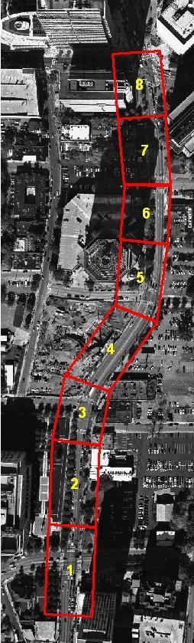
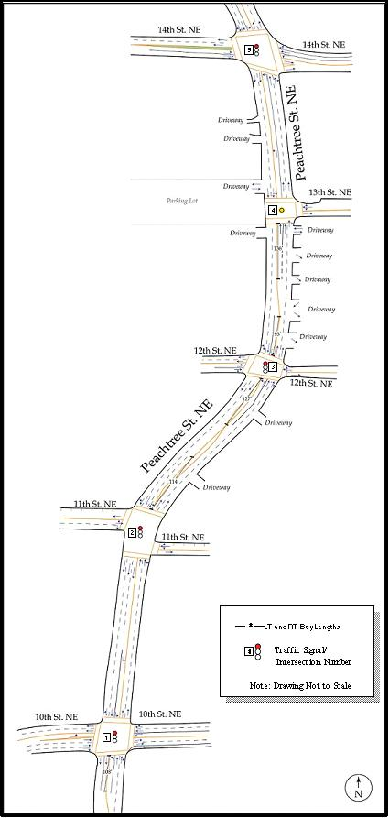
Figure 2. Study Area Schematic

Vehicle Detection and Tracking
Vehicle trajectory data were transcribed from the video data using a customized software application, Next Generation SIMulation - Vehicle Interaction and Detection Environment for Operations (NGSIM-VIDEO), developed for NGSIM. This program detects and tracks vehicles from video images and transcribes the trajectory data to a database.
The flow process for the vehicle transcription is shown in Figure 3. The software detects vehicles in a user-defined detection zone, and then tracks vehicles from the point of detection.
Figure 3. Vehicle Detection and Tracking Process
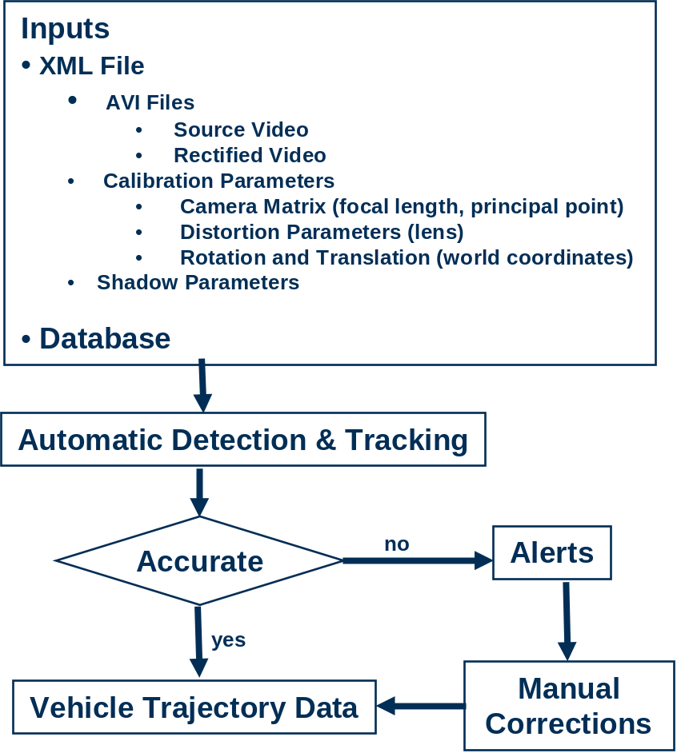

Tracking was performed for the data from 4:00 p.m. to 4:15 p.m. Immediately after 4:15 p.m., vehicle detection was stopped; however, to account for full vehicle trajectories, tracking continued to allow the vehicles which were already detected to be tracked completely to the end of the study area. Therefore, for the vehicle trajectory dataset of 4:00p.m. to 4:15 p.m., the actual tracking time is from 4:00:00 p.m. to 4:17:13 p.m.
A total of 30 minutes of vehicle trajectories was processed from the video data collected on November 8, 2006, representing the period from 12:45 p.m. to 1:00 p.m. and 4:00 p.m. to 4:15 p.m. The data were divided into two 15-minute periods for processing and analysis.
Subsequent sections of this report provide analysis of the transcribed data. This report provides data analysis for the period from 4:00 p.m. to 4:15 p.m. A separate report is available providing the same performance statistics for the preceding 12:45 p.m. to 1:00 p.m. period.
■ Data Analysis
Data analysis was performed for specific locations in the study area. Therefore, it is necessary to define those locations herein. Figure 4 shows the study area schematic with identification numbers for origins, destinations, intersections, sections, and lanes.
- Origin – These were numbered from 101 through 123. There are 20 origins in the study area. Destinations 204, 207, and 209 are one-way parking lot entries; hence, there are no associated origin numbers 104, 107, and 109.
- Destination – There are 22 destinations in the study area, numbered from 201 through 223. Origin 119 is a one-way parking lot exit; hence, there is no associated destination number 219.
- Intersection – These were numbered from 1 to 5, with intersection 1 at the southernmost, and intersection 5 at the northernmost section of the study area. Intersections 1, 2, 3, and 5 in this report correspond to signal numbers 51, 52, 53, and 73, respectively (Intersection 4 is a stop-controlled intersection).
- Section – Peachtree St. was further divided into six sections between neighboring intersections.
- Lane – – Lane numbering was incremented from the lane closest to the median, except for locations where left-turn or right-turn bays exist. Left-turn bays were numbered starting from 11 and were incremented from the left-turn bay closest to the median.

- Figure 4. Study Area Schematic with Various Identification Numbers
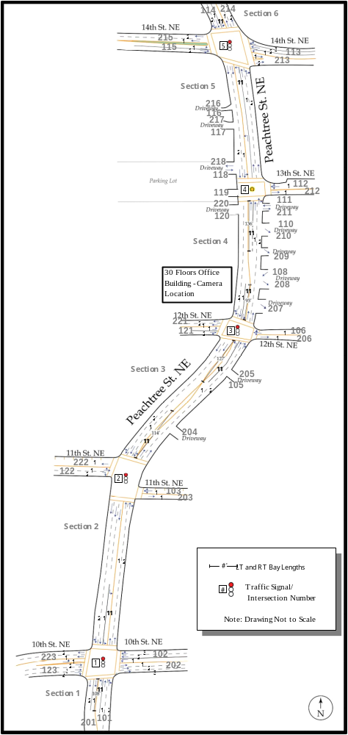

Vehicle Type
Vehicles are classified into three categories: 1) motorcycle, 2) automobile, and 3) truck and buses. The distribution of vehicle types is shown in Table 1.
Table 1. Vehicle Type
Time Period | Motorcycle |  | Automobile |  | Truck and Buses |  | All
Time Period | Vehicle | Percentage | Vehicles | Percentage | Vehicles | Percentage | Vehicles | Percentage
4:00 p.m.-4:05 p.m. | 1 | 0.3% | 373 | 96.1% | 14 | 3.6% | 388 | 100.0%
4:05 p.m.-4:10 p.m. | 0 | 0.0% | 419 | 98.8% | 5 | 1.2% | 424 | 100.0%
4:10 p.m.-4:15 p.m. | 0 | 0.0% | 407 | 99.3% | 3 | 0.7% | 410 | 100.0%
All | 1 | 0.1% | 1,199 | 98.1% | 22 | 1.8% | 1,222 | 100.0%

Origin-Destination Distribution
There are 20 origins and 22 destinations in the study area, as illustrated in Figure 4. The distribution of vehicles from origins to destinations is provided in Table 2.

Table 2. Origin-Destination Distribution
Origin | Destination |  |  |  |  |  |  |  |  |  |  |  |  |  |  |  |  |  |  |  |  |  | Sum
Origin | 201 | 202 | 203 | 204 | 205 | 206 | 207 | 208 | 209 | 210 | 211 | 212 | 213 | 214 | 215 | 216 | 217 | 218 | 220 | 221 | 222 | 223 | Sum
101 | 15 | 12 | 0 | 0 | 0 | 2 | 1 | 0 | 0 | 0 | 0 | 1 | 2 | 67 | 8 | 0 | 0 | 0 | 0 | 5 | 3 | 25 | 141
102 | 8 | 0 | 1 | 0 | 0 | 0 | 0 | 0 | 0 | 0 | 0 | 0 | 0 | 18 | 3 | 0 | 0 | 0 | 1 | 1 | 1 | 87 | 120
103 | 0 | 0 | 0 | 0 | 0 | 0 | 0 | 0 | 0 | 0 | 0 | 0 | 0 | 1 | 0 | 0 | 0 | 0 | 0 | 0 | 7 | 1 | 9
105 | 0 | 0 | 0 | 0 | 0 | 0 | 0 | 0 | 0 | 0 | 0 | 0 | 0 | 1 | 0 | 0 | 0 | 0 | 0 | 1 | 0 | 0 | 2
106 | 0 | 0 | 0 | 0 | 0 | 0 | 0 | 0 | 0 | 0 | 0 | 0 | 0 | 3 | 2 | 0 | 0 | 0 | 3 | 10 | 0 | 0 | 18
108 | 0 | 0 | 0 | 0 | 0 | 0 | 0 | 0 | 0 | 0 | 0 | 0 | 0 | 3 | 1 | 0 | 0 | 0 | 0 | 0 | 0 | 0 | 4
110 | 0 | 1 | 0 | 0 | 0 | 0 | 0 | 0 | 0 | 0 | 0 | 0 | 0 | 0 | 0 | 0 | 0 | 0 | 0 | 0 | 0 | 0 | 1
111 | 1 | 0 | 0 | 0 | 0 | 0 | 0 | 0 | 0 | 0 | 1 | 0 | 0 | 0 | 1 | 0 | 0 | 0 | 0 | 0 | 0 | 0 | 3
112 | 1 | 0 | 0 | 0 | 0 | 0 | 0 | 0 | 0 | 0 | 0 | 0 | 0 | 9 | 2 | 0 | 0 | 0 | 0 | 1 | 0 | 0 | 13
113 | 1 | 0 | 0 | 0 | 0 | 0 | 0 | 0 | 0 | 0 | 0 | 0 | 0 | 30 | 37 | 0 | 0 | 0 | 0 | 0 | 0 | 0 | 68
114 | 73 | 17 | 1 | 0 | 0 | 6 | 0 | 0 | 0 | 1 | 0 | 24 | 72 | 9 | 75 | 0 | 0 | 0 | 0 | 3 | 3 | 11 | 295
115 | 28 | 4 | 2 | 0 | 0 | 2 | 0 | 0 | 0 | 1 | 0 | 6 | 94 | 47 | 0 | 0 | 0 | 0 | 1 | 3 | 3 | 9 | 200
116 | 0 | 0 | 0 | 0 | 0 | 0 | 0 | 0 | 0 | 0 | 0 | 0 | 0 | 1 | 0 | 0 | 0 | 0 | 0 | 0 | 0 | 0 | 1
117 | 0 | 0 | 0 | 0 | 0 | 0 | 0 | 0 | 0 | 0 | 0 | 0 | 0 | 0 | 0 | 0 | 0 | 0 | 0 | 0 | 0 | 0 | 0
118 | 0 | 1 | 0 | 0 | 0 | 0 | 0 | 0 | 0 | 0 | 0 | 2 | 0 | 0 | 1 | 0 | 0 | 0 | 0 | 0 | 0 | 3 | 7
119 | 4 | 1 | 0 | 0 | 0 | 3 | 0 | 0 | 0 | 0 | 0 | 0 | 0 | 2 | 4 | 0 | 0 | 0 | 0 | 2 | 0 | 2 | 18
120 | 2 | 3 | 1 | 0 | 0 | 10 | 0 | 1 | 0 | 0 | 0 | 0 | 0 | 2 | 0 | 0 | 0 | 0 | 1 | 1 | 1 | 1 | 23
121 | 13 | 22 | 11 | 0 | 0 | 0 | 0 | 0 | 0 | 0 | 0 | 0 | 0 | 1 | 1 | 0 | 0 | 0 | 0 | 0 | 0 | 8 | 56
122 | 22 | 155 | 2 | 0 | 0 | 0 | 0 | 0 | 0 | 1 | 0 | 0 | 1 | 17 | 2 | 0 | 0 | 0 | 0 | 0 | 2 | 40 | 242
123 | 1 | 0 | 0 | 0 | 0 | 0 | 0 | 0 | 0 | 0 | 0 | 0 | 0 | 0 | 0 | 0 | 0 | 0 | 0 | 0 | 0 | 0 | 1
Sum | 169 | 216 | 18 | 0 | 0 | 23 | 1 | 1 | 0 | 3 | 1 | 33 | 169 | 211 | 137 | 0 | 0 | 0 | 6 | 27 | 20 | 187 | 1,222

Traffic Volume Analysis
The tables in this section provide traffic volume for each intersection. Intersections are numbered as 1, 2, 3, 4, and 5, as shown in Figure 4, and include:
- Peachtree and 10th Street NE,
- Peachtree and 11th Street NE,
- Peachtree and 12th Street NE,
- Peachtree and 13th Street NE,
- Peachtree and 14th Street NE.
Traffic volume is grouped by moving direction [i.e., north-bound (NB), south-bound (SB), east-bound (EB), and west-bound (WB)], by movement [i.e., through (TH), left-turn (LT), and right-turn (RT)], by lane, and by time period.
Due to the severe shooting angle of the cameras, several of the start and end-lanes for Intersections 1 and 5 were obscured. Hence for volume analysis, vehicle volumes by movement were aggregated for mutiple start/end lanes as indicated in the tables below. .

Table 3. Traffic Volume at Intersection 1 (in Vehicles)
Time Period | NB |  |  |  | SB |  |  |  | EB |  |  | WB |  |  | Sum
Time Period | LT | TH |  | RT | LT | TH |  | RT | LT | TH | RT | LT | TH | RT
Time Period | 11 | 1 | 2 | <* | 11 | 1 | 2 | < | 1 | 2&3 | 4 | 1 | 2&3 | <
4:00 p.m.-4:05 p.m. | 7 | 24 | 14 | 0 | 12 | 12 | 12 | 0 | 12 | 37 | 0 | 0 | 6 | 8 | 144
4:05 p.m.-4:10 p.m. | 9 | 18 | 6 | 0 | 20 | 34 | 14 | 0 | 9 | 57 | 0 | 0 | 4 | 3 | 174
4:10 p.m.-4:15 p.m. | 8 | 22 | 5 | 0 | 14 | 25 | 16 | 0 | 18 | 51 | 0 | 0 | 1 | 4 | 164
Sum | 24 | 64 | 25 | 0 | 46 | 71 | 42 | 0 | 39 | 145 | 0 | 0 | 11 | 15 | 482
* > and < symbols are associated with shared lanes.

Table 4. Traffic Volume at Intersection 2 (in Vehicles)
Time Period | NB |  |  | SB |  |  |  |  | EB |  |  | WB |  |  | Sum
Time Period | TH |  | RT | LT | TH |  |  | RT | LT | TH | RT | LT | TH | RT | Sum
Time Period | 1 | 2 | < | 11 | < | 1 | 2 | < | > | 1 | 2 | 1 | < | < | Sum
4:00 p.m.-4:05 p.m. | 8 | 1 | 0 | 0 | 21 | 15 | 5 | 1 | 0 | 1 | 0 | 0 | 1 | 2 | 55
4:05 p.m.-4:10 p.m. | 14 | 0 | 1 | 3 | 22 | 21 | 9 | 3 | 0 | 0 | 0 | 0 | 0 | 0 | 73
4:10 p.m.-4:15 p.m. | 25 | 0 | 0 | 0 | 33 | 22 | 4 | 3 | 0 | 0 | 0 | 0 | 1 | 0 | 88
Sum | 47 | 1 | 1 | 3 | 76 | 58 | 18 | 7 | 0 | 1 | 0 | 0 | 2 | 2 | 216

Table 5. Traffic Volume at Intersection 3 (in Vehicles)
Time Period | NB |  |  |  | SB |  |  |  | EB |  |  | WB |  |  | Sum
Time Period | LT | TH |  | RT | LT | TH |  | RT | LT | TH | RT | LT | TH | RT | Sum
Time Period | 11 | 1 | 2 | < | 11 | 1 | 2 | < | 1 | 2 | < | 1 | 1 | < | Sum
4:00 p.m.-4:05 p.m. | 3 | 16 | 16 | 1 | 2 | 24 | 18 | 3 | 0 | 2 | 0 | 0 | 0 | 0 | 85
4:05 p.m.-4:10 p.m. | 2 | 22 | 17 | 1 | 4 | 28 | 28 | 3 | 0 | 0 | 0 | 0 | 0 | 0 | 105
4:10 p.m.-4:15 p.m. | 2 | 36 | 14 | 0 | 5 | 35 | 25 | 3 | 0 | 0 | 0 | 0 | 0 | 0 | 120
Sum | 7 | 74 | 47 | 2 | 11 | 87 | 71 | 9 | 0 | 2 | 0 | 0 | 0 | 0 | 310

Table 6. Traffic Volume at Intersection 4 (in Vehicles)
Time Period | NB |  |  |  | SB |  |  | EB |  |  | Sum
Time Period | TH |  |  | RT | LT | TH |  | LT | TH | RT | Sum
Time Period | 11 | 1 | 2 | < | > | 1 | 2 | > | 1 | < | Sum
4:00 p.m.-4:05 p.m. | 2 | 14 | 13 | 1 | 4 | 34 | 24 | 0 | 0 | 0 | 92
4:05 p.m.-4:10 p.m. | 4 | 23 | 18 | 0 | 14 | 24 | 30 | 0 | 0 | 0 | 113
4:10 p.m.-4:15 p.m. | 7 | 35 | 16 | 0 | 11 | 33 | 24 | 0 | 0 | 0 | 126
Sum | 13 | 72 | 47 | 1 | 29 | 91 | 78 | 0 | 0 | 0 | 331

Table 7. Traffic Volume at Intersection 5 (in Vehicles)
 | NB |  |  |  | SB |  |  | EB |  |  | WB |  |  | Sum
 | LT | TH |  | RT | LT | TH | RT | LT | TH | RT | LT | TH | RT | Sum
 | 11 | 1 | 2 | < | 11 | 1&2 | < | 1 | 2 | < | 1 | 2&3 | < | Sum
4:00 p.m.-4:05 p.m. | 4 | 13 | 16 | 1 | 22 | 56 | 0 | 0 | 0 | 1 | 0 | 8 | 8 | 129
4:05 p.m.-4:10 p.m. | 8 | 27 | 14 | 2 | 27 | 46 | 0 | 0 | 0 | 2 | 0 | 0 | 1 | 127
4:10 p.m.-4:15 p.m. | 14 | 35 | 18 | 0 | 23 | 37 | 0 | 0 | 0 | 3 | 0 | 0 | 0 | 130
Sum | 26 | 75 | 48 | 3 | 72 | 139 | 0 | 0 | 0 | 6 | 0 | 8 | 9 | 386

Speed Analysis
Speed analysis was performed at the midpoints of each section on Peachtree Street, which are between two neighboring intersections as shown in Figure 4. The following tables provide average speeds for both moving directions (NB and SB) and for each lane.
Table 8. Average Speed in Section 2 (NB) (Feet Per Second)
Movement | TH |  | TH+RT |  |  | Average
Lane | 1 |  |  | 2
 | Count | Speed |  | Count | Speed
4:00 p.m.-4:05 p.m. | 31 | 26.80 |  | 24 | 31.85 | 29.00
4:05 p.m.-4:10 p.m. | 22 | 28.30 |  | 13 | 36.52 | 31.36
4:10 p.m.-4:15 p.m. | 34 | 26.48 |  | 14 | 29.82 | 27.45
All | 87 | 27.05 |  | 51 | 32.48 | 29.06

Table 9. Average Speed in Section 2 (SB) (Feet Per Second)
Movement | TH |  | TH+RT |  | LT |  | Average
Lane | 1 |  | 2 |  | 11
 | Count | Speed | Count | Speed | Count | Speed
4:00 p.m.-4:05 p.m. | 19 | 34.38 | 19 | 35.78 | 13 | 33.65 | 34.72
4:05 p.m.-4:10 p.m. | 29 | 31.60 | 24 | 29.80 | 18 | 38.93 | 32.85
4:10 p.m.-4:15 p.m. | 31 | 34.33 | 29 | 35.38 | 12 | 40.70 | 35.82
All | 79 | 33.34 | 72 | 33.63 | 43 | 37.83 | 34.44
Table 10. Average Speed in Section 3 (NB) (Feet Per Second)
Movement | TH |  | TH+RT |  | Average
Lane | 1 |  | 2 |  | Average
 | Count | Speed | Count | Speed | Average
4:00 p.m.-4:05 p.m. | 26 | 28.49 | 25 | 29.19 | 28.83
4:05 p.m.-4:10 p.m. | 22 | 36.76 | 11 | 36.83 | 36.78
4:10 p.m.-4:15 p.m. | 34 | 30.43 | 14 | 34.60 | 31.64
All | 82 | 31.51 | 50 | 32.38 | 31.84

Table 11. Average Speed in Section 3 (SB) (Feet Per Second)
Movement | TH |  | TH+RT |  | Average
Lane | 1 |  | 2 |  | Average
 | Count | Speed | Count | Speed | Average
4:00 p.m.-4:05 p.m. | 22 | 27.13 | 17 | 31.53 | 29.05
4:05 p.m.-4:10 p.m. | 24 | 29.72 | 27 | 28.83 | 29.25
4:10 p.m.-4:15 p.m. | 33 | 24.57 | 25 | 30.17 | 26.98
All | 79 | 26.85 | 69 | 29.98 | 28.31

Table 12. Average Speed in Section 4 (NB) (Feet Per Second)
Movement | TH |  | TH+RT |  |  | LT |  |  | Average
Lane | 1 |  |  | 2 |  |  | 11 |  | Average
 | Count | Speed |  | Count | Speed |  | Count | Speed | Average
4:00 p.m.-4:05 p.m. | 15 | 35.47 |  | 15 | 39.68 |  | 0 | - | 37.58
4:05 p.m.-4:10 p.m. | 30 | 37.28 |  | 16 | 36.66 |  | 0 | - | 37.06
4:10 p.m.-4:15 p.m. | 39 | 37.72 |  | 17 | 37.15 |  | 0 | - | 37.54
All | 84 | 37.16 |  | 48 | 37.78 |  | 0 | - | 37.38

Table 13. Average Speed in Section 4 (SB) (Feet Per Second)
Movement | TH |  | TH+RT |  |  | LT |  |  | Average
Lane | 1 |  |  | 2 |  |  | 11 |  | Average
 | Count | Speed |  | Count | Speed |  | Count | Speed | Average
4:00 p.m.-4:05 p.m. | 28 | 28.61 |  | 25 | 32.48 |  | 2 | 31.38 | 30.47
4:05 p.m.-4:10 p.m. | 29 | 34.98 |  | 31 | 31.92 |  | 1 | 27.83 | 33.31
4:10 p.m.-4:15 p.m. | 37 | 26.62 |  | 30 | 28.13 |  | 0 | - | 27.29
All | 94 | 29.79 |  | 86 | 30.76 |  | 3 | 30.19 | 30.25

Table 14. Average Speed in Section 5 (NB) (Feet Per Second)
Movement | TH |  | TH+RT |  |  | LT |  | Average
Lane | 1 |  |  | 2 |  | 11 |  | Average
 | Count | Speed |  | Count | Speed | Count | Speed | Average
4:00 p.m.-4:05 p.m. | 15 | 35.47 |  | 15 | 39.68 | 0 | - | 37.58
4:05 p.m.-4:10 p.m. | 30 | 37.28 |  | 16 | 36.66 | 0 | - | 37.06
4:10 p.m.-4:15 p.m. | 39 | 37.72 |  | 17 | 37.15 | 0 | - | 37.54
All | 84 | 37.16 |  | 48 | 37.78 | 0 | - | 37.38

Table 15. Average Speed in Section 5 (SB) (Feet Per Second)
Movement | TH |  | TH+RT |  |  | Average
Lane | 1 |  |  | 2 |  | Average
 | Count | Speed |  | Count | Speed | Average
4:00 p.m.-4:05 p.m. | 28 | 28.61 |  | 25 | 32.48 | 30.44
4:05 p.m.-4:10 p.m. | 29 | 34.98 |  | 31 | 31.92 | 33.40
4:10 p.m.-4:15 p.m. | 37 | 26.62 |  | 30 | 28.13 | 27.29
All | 94 | 29.79 |  | 86 | 30.76 | 30.25

Travel Time Analysis
Average travel times for vehicles traveling NB on Peachtree Street from the southernmost to the northernmost section of the study area are provided in Table 16., representing a distance covered of approximately 2019 ft. Similarly, average travel times for vehicles traveling SB on Peachtree Street from the northernmost to the southernmost section of the study area are provided in Table 17, representing a distance covered of approximately 1954 ft.
Table 16. Average Travel Time on Peachtree St. (NB) (in Seconds)
From Lane | 1 |  | 2 |  | Average
To Lane | 1 | 2 | 1 | 2 | Average
4:00 p.m.-4:05 p.m. | 163 | 152.7 | 144.4 | 152.3 | 153.1
4:05 p.m.-4:10 p.m. | 128.4 | 149.6 | 75.6 | 103.2 | 114.2
4:10 p.m.-4:15 p.m. | 144.8 | 160.2 | - | 128.4 | 144.5
Average | 145.4 | 154.2 | 110.0 | 128.0 | 134.4

Table 17. Average Travel Time on Peachtree St. (SB) (in Seconds)
From Lane | 1 |  | 2 |  | Average
To Lane | 1 | 2 | 1 | 2 | Average
4:00 p.m.-4:05 p.m. | 155.6 | 123.7 | 160.2 | 130.5 | 142.5
4:05 p.m.-4:10 p.m. | 122.1 | 113.4 | 116.1 | 124.0 | 118.9
4:10 p.m.-4:15 p.m. | 133.8 | 122.7 | - | 145.9 | 134.1
Average | 137.2 | 119.9 | 138.2 | 133.5 | 131.8

Lane Change Analysis
An analysis of lane changes occurring in the study area is provided in this section. It should be noted that vehicles making either left turns or right turns to the closest receiving lane were not counted as lane changes. The number of lane changes per vehicle for all vehicles in the study area is shown in Figure 5. The number of lane changes by each origin-destination (O-D) pair is provided in Table 18. Table 19 provides the average lane changes by each O-D pair, which was calculated by dividing the number of lane changes by the number of vehicles for that O-D pair.
Figure 5. Number of Lane Changes Per Vehicle
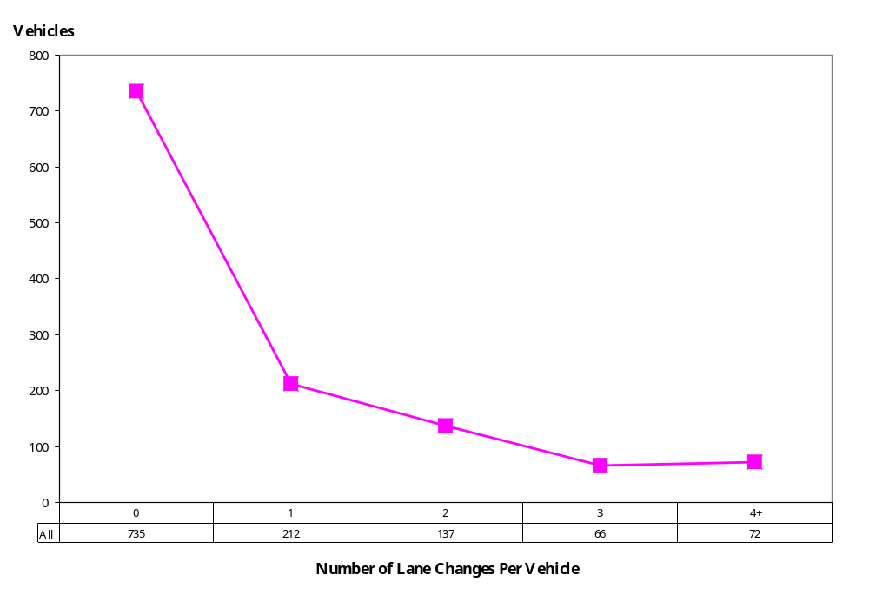

Table 18. Number of Lane Changes by O-D Pairs
Origin | Destination |  |  |  |  |  |  |  |  |  |  |  |  |  |  |  |  |  |  |  |  |  | Sum
Origin | 201 | 202 | 203 | 204 | 205 | 206 | 207 | 208 | 209 | 210 | 211 | 212 | 213 | 214 | 215 | 216 | 217 | 218 | 220 | 221 | 222 | 223 | Sum
101 | 0 | 17 | 0 | 0 | 0 | 5 | 4 | 0 | 0 | 0 | 0 | 5 | 3 | 59 | 17 | 0 | 0 | 0 | 0 | 24 | 3 | 31 | 168
102 | 1 | 0 | 3 | 0 | 0 | 0 | 0 | 0 | 0 | 0 | 0 | 0 | 0 | 51 | 14 | 0 | 0 | 0 | 5 | 3 | 1 | 19 | 97
103 | 0 | 0 | 0 | 0 | 0 | 0 | 0 | 0 | 0 | 0 | 0 | 0 | 0 | 3 | 0 | 0 | 0 | 0 | 0 | 0 | 0 | 2 | 5
105 | 0 | 0 | 0 | 0 | 0 | 0 | 0 | 0 | 0 | 0 | 0 | 0 | 0 | 6 | 0 | 0 | 0 | 0 | 0 | 2 | 0 | 0 | 8
106 | 0 | 0 | 0 | 0 | 0 | 0 | 0 | 0 | 0 | 0 | 0 | 0 | 0 | 9 | 7 | 0 | 0 | 0 | 6 | 2 | 0 | 0 | 24
108 | 0 | 0 | 0 | 0 | 0 | 0 | 0 | 0 | 0 | 0 | 0 | 0 | 0 | 13 | 4 | 0 | 0 | 0 | 0 | 0 | 0 | 0 | 17
110 | 0 | 7 | 0 | 0 | 0 | 0 | 0 | 0 | 0 | 0 | 0 | 0 | 0 | 0 | 0 | 0 | 0 | 0 | 0 | 0 | 0 | 0 | 7
111 | 7 | 0 | 0 | 0 | 0 | 0 | 0 | 0 | 0 | 0 | 1 | 0 | 0 | 0 | 2 | 0 | 0 | 0 | 0 | 0 | 0 | 0 | 10
112 | 3 | 0 | 0 | 0 | 0 | 0 | 0 | 0 | 0 | 0 | 0 | 0 | 0 | 19 | 4 | 0 | 0 | 0 | 0 | 1 | 0 | 0 | 27
113 | 6 | 0 | 0 | 0 | 0 | 0 | 0 | 0 | 0 | 0 | 0 | 0 | 0 | 6 | 1 | 0 | 0 | 0 | 0 | 0 | 0 | 0 | 13
114 | 58 | 41 | 5 | 0 | 0 | 18 | 0 | 0 | 0 | 2 | 0 | 27 | 1 | 0 | 5 | 0 | 0 | 0 | 0 | 9 | 11 | 15 | 192
115 | 39 | 22 | 9 | 0 | 0 | 6 | 0 | 0 | 0 | 1 | 0 | 7 | 2 | 56 | 0 | 0 | 0 | 0 | 1 | 6 | 7 | 8 | 164
116 | 0 | 0 | 0 | 0 | 0 | 0 | 0 | 0 | 0 | 0 | 0 | 0 | 0 | 4 | 0 | 0 | 0 | 0 | 0 | 0 | 0 | 0 | 4
117 | 0 | 0 | 0 | 0 | 0 | 0 | 0 | 0 | 0 | 0 | 0 | 0 | 0 | 0 | 0 | 0 | 0 | 0 | 0 | 0 | 0 | 0 | 0
118 | 0 | 5 | 0 | 0 | 0 | 0 | 0 | 0 | 0 | 0 | 0 | 3 | 0 | 0 | 2 | 0 | 0 | 0 | 0 | 0 | 0 | 14 | 24
119 | 6 | 0 | 0 | 0 | 0 | 0 | 0 | 0 | 0 | 0 | 0 | 0 | 0 | 0 | 0 | 0 | 0 | 0 | 0 | 0 | 0 | 0 | 6
120 | 20 | 7 | 0 | 0 | 0 | 7 | 0 | 0 | 0 | 0 | 0 | 0 | 0 | 9 | 10 | 0 | 0 | 0 | 0 | 7 | 0 | 10 | 70
121 | 11 | 9 | 4 | 0 | 0 | 1 | 0 | 1 | 0 | 0 | 0 | 0 | 0 | 6 | 0 | 0 | 0 | 0 | 1 | 0 | 2 | 3 | 38
122 | 23 | 45 | 6 | 0 | 0 | 0 | 0 | 0 | 0 | 0 | 0 | 0 | 0 | 3 | 5 | 0 | 0 | 0 | 0 | 0 | 0 | 3 | 85
123 | 7 | 31 | 2 | 0 | 0 | 0 | 0 | 0 | 0 | 5 | 0 | 0 | 1 | 24 | 9 | 0 | 0 | 0 | 0 | 0 | 0 | 0 | 79
Sum | 181 | 184 | 29 | 0 | 0 | 37 | 4 | 1 | 0 | 8 | 1 | 42 | 7 | 268 | 80 | 0 | 0 | 0 | 13 | 54 | 24 | 105 | 1,038

Table 19. Average Lane Changes by O-D Pairs
Origin | Destination |  |  |  |  |  |  |  |  |  |  |  |  |  |  |  |  |  |  |  |  |  | Avg.
Origin | 201 | 202 | 203 | 204 | 205 | 206 | 207 | 208 | 209 | 210 | 211 | 212 | 213 | 214 | 215 | 216 | 217 | 218 | 220 | 221 | 222 | 223 | Avg.
101 | 0.0 | 1.4 | 0.0 | 0.0 | 0.0 | 2.5 | 4.0 | 0.0 | 0.0 | 0.0 | 0.0 | 5.0 | 1.5 | 0.9 | 2.1 | 0.0 | 0.0 | 0.0 | 0.0 | 4.8 | 1.0 | 1.2 | 1.2
102 | 0.1 | 0.0 | 3.0 | 0.0 | 0.0 | 0.0 | 0.0 | 0.0 | 0.0 | 0.0 | 0.0 | 0.0 | 0.0 | 2.8 | 4.7 | 0.0 | 0.0 | 0.0 | 5.0 | 3.0 | 1.0 | 0.2 | 0.8
103 | 0.0 | 0.0 | 0.0 | 0.0 | 0.0 | 0.0 | 0.0 | 0.0 | 0.0 | 0.0 | 0.0 | 0.0 | 0.0 | 3.0 | 0.0 | 0.0 | 0.0 | 0.0 | 0.0 | 0.0 | 0.0 | 2.0 | 0.6
105 | 0.0 | 0.0 | 0.0 | 0.0 | 0.0 | 0.0 | 0.0 | 0.0 | 0.0 | 0.0 | 0.0 | 0.0 | 0.0 | 6.0 | 0.0 | 0.0 | 0.0 | 0.0 | 0.0 | 2.0 | 0.0 | 0.0 | 4.0
106 | 0.0 | 0.0 | 0.0 | 0.0 | 0.0 | 0.0 | 0.0 | 0.0 | 0.0 | 0.0 | 0.0 | 0.0 | 0.0 | 3.0 | 3.5 | 0.0 | 0.0 | 0.0 | 2.0 | 0.2 | 0.0 | 0.0 | 1.3
108 | 0.0 | 0.0 | 0.0 | 0.0 | 0.0 | 0.0 | 0.0 | 0.0 | 0.0 | 0.0 | 0.0 | 0.0 | 0.0 | 4.3 | 4.0 | 0.0 | 0.0 | 0.0 | 0.0 | 0.0 | 0.0 | 0.0 | 4.3
110 | 0.0 | 7.0 | 0.0 | 0.0 | 0.0 | 0.0 | 0.0 | 0.0 | 0.0 | 0.0 | 0.0 | 0.0 | 0.0 | 0.0 | 0.0 | 0.0 | 0.0 | 0.0 | 0.0 | 0.0 | 0.0 | 0.0 | 7.0
111 | 7.0 | 0.0 | 0.0 | 0.0 | 0.0 | 0.0 | 0.0 | 0.0 | 0.0 | 0.0 | 1.0 | 0.0 | 0.0 | 0.0 | 2.0 | 0.0 | 0.0 | 0.0 | 0.0 | 0.0 | 0.0 | 0.0 | 3.3
112 | 3.0 | 0.0 | 0.0 | 0.0 | 0.0 | 0.0 | 0.0 | 0.0 | 0.0 | 0.0 | 0.0 | 0.0 | 0.0 | 2.1 | 2.0 | 0.0 | 0.0 | 0.0 | 0.0 | 1.0 | 0.0 | 0.0 | 2.1
113 | 6.0 | 0.0 | 0.0 | 0.0 | 0.0 | 0.0 | 0.0 | 0.0 | 0.0 | 0.0 | 0.0 | 0.0 | 0.0 | 0.2 | 0.0 | 0.0 | 0.0 | 0.0 | 0.0 | 0.0 | 0.0 | 0.0 | 0.2
114 | 0.8 | 2.4 | 5.0 | 0.0 | 0.0 | 3.0 | 0.0 | 0.0 | 0.0 | 2.0 | 0.0 | 1.1 | 0.0 | 0.0 | 0.1 | 0.0 | 0.0 | 0.0 | 0.0 | 3.0 | 3.7 | 1.4 | 0.7
115 | 0.0 | 0.0 | 0.0 | 0.0 | 0.0 | 0.0 | 0.0 | 0.0 | 0.0 | 1.0 | 0.0 | 1.2 | 0.0 | 1.2 | 0.0 | 0.0 | 0.0 | 0.0 | 1.0 | 2.0 | 2.3 | 2.0 | 0.6
116 | 0.0 | 0.0 | 0.0 | 0.0 | 0.0 | 0.0 | 0.0 | 0.0 | 0.0 | 0.0 | 0.0 | 0.0 | 0.0 | 4.0 | 0.0 | 0.0 | 0.0 | 0.0 | 0.0 | 0.0 | 0.0 | 0.0 | 4.0
117 | 0.0 | 0.0 | 0.0 | 0.0 | 0.0 | 0.0 | 0.0 | 0.0 | 0.0 | 0.0 | 0.0 | 0.0 | 0.0 | 0.0 | 0.0 | 0.0 | 0.0 | 0.0 | 0.0 | 0.0 | 0.0 | 0.0 | 1.3
118 | 0.0 | 0.0 | 0.0 | 0.0 | 0.0 | 0.0 | 0.0 | 0.0 | 0.0 | 0.0 | 0.0 | 1.5 | 0.0 | 0.0 | 2.0 | 0.0 | 0.0 | 0.0 | 0.0 | 0.0 | 0.0 | 0.0 | 4.3
119 | 0.0 | 7.0 | 0.0 | 0.0 | 0.0 | 0.0 | 0.0 | 0.0 | 0.0 | 0.0 | 0.0 | 0.0 | 0.0 | 0.0 | 0.0 | 0.0 | 0.0 | 0.0 | 0.0 | 0.0 | 0.0 | 0.0 | 7.0
120 | 7.0 | 0.0 | 0.0 | 0.0 | 0.0 | 0.0 | 0.0 | 0.0 | 0.0 | 0.0 | 0.0 | 0.0 | 0.0 | 4.5 | 0.0 | 0.0 | 0.0 | 0.0 | 0.0 | 7.0 | 0.0 | 0.0 | 3.3
121 | 3.0 | 0.0 | 0.0 | 0.0 | 0.0 | 0.0 | 0.0 | 0.0 | 0.0 | 0.0 | 0.0 | 0.0 | 0.0 | 6.0 | 0.0 | 0.0 | 0.0 | 0.0 | 0.0 | 0.0 | 0.0 | 0.0 | 2.1
122 | 0.3 | 0.0 | 0.0 | 0.0 | 0.0 | 0.0 | 0.0 | 0.0 | 0.0 | 0.0 | 0.0 | 0.0 | 0.0 | 0.2 | 2.5 | 0.0 | 0.0 | 0.0 | 0.0 | 0.0 | 0.0 | 0.0 | 0.1
123 | 7.0 | 0.0 | 0.0 | 0.0 | 0.0 | 0.0 | 0.0 | 0.0 | 0.0 | 0.0 | 0.0 | 0.0 | 0.0 | 0.0 | 0.0 | 0.0 | 0.0 | 0.0 | 0.0 | 0.0 | 0.0 | 0.0 | 79.0
Avg. | 1.1 | 0.9 | 1.6 | 0.0 | 0.0 | 1.6 | 4.0 | 1.0 | 0.0 | 2.7 | 1.0 | 1.3 | 0.0 | 1.3 | 0.6 | 0.0 | 0.0 | 0.0 | 2.2 | 2.0 | 1.2 | 0.6 | 0.8

Headway Analysis
Tables 20 and 21 provide average headway of vehicles traveling on Peachtree Street NB and SB, respectively. In addition to average headway for each time period, headways were also analyzed based on vehicle speed (i.e., less than 5 mph, 5 to 20 mph, and more than 20 mph).
Table 20. Average Headway on Peachtree Street (NB) (in Seconds)
Time Period | Speed (mph) |  |  | Average Headway
Time Period | <5 | 5-20 | >20 | Average Headway
4:00 p.m.-4:05 p.m. | 136.62 | 9.07 | 6.50 | 50.92
4:05 p.m.-4:10 p.m. | 256.68 | 12.28 | 8.30 | 85.23
4:10 p.m.-4:15 p.m. | 216.23 | 7.99 | 5.30 | 95.50
Average Headway | 201.20 | 9.39 | 6.62 | 78.63

Table 21. Average Headway on Peachtree Street (SB) (in Seconds)
Time Period | Speed (mph) |  |  | Average Headway
Time Period | <5 | 5-20 | >20 | Average Headway
4:00 p.m.-4:05 p.m. | 162.20 | 7.51 | 6.70 | 55.15
4:05 p.m.-4:10 p.m. | 242.98 | 6.65 | 6.68 | 105.88
4:10 p.m.-4:15 p.m. | 184.41 | 7.37 | 6.20 | 63.07
Average Headway | 206.53 | 7.15 | 6.52 | 77.75

Spacing Analysis
Spacing, or distance headway, was analyzed for each time period and for each speed group. Tables 22 and 23 provide average spacing of vehicles traveling on Peachtree Street NB and SB, respectively.
Table 22. Average Spacing on Peachtree Street (NB) (in Feet)
Time Period | Speed (mph) |  |  | Average Spacing
Time Period | <5 | 5-20 | >20 | Average Spacing
4:00 p.m.-4:05 p.m. | 55.19 | 143.03 | 214.06 | 116.78
4:05 p.m.-4:10 p.m. | 62.47 | 142.85 | 246.28 | 144.99
4:10 p.m.-4:15 p.m. | 37.80 | 118.42 | 187.04 | 96.50
Average Spacing | 50.86 | 134.15 | 215.15 | 116.96

Table 23. Average Spacing on Peachtree Street (SB) (in Feet)
Time Period | Speed (mph) |  |  | Average Spacing
Time Period | <5 | 5-20 | >20 | Average Spacing
4:00 p.m.-4:05 p.m. | 29.60 | 137.27 | 206.52 | 118.28
4:05 p.m.-4:10 p.m. | 26.45 | 113.86 | 194.95 | 91.99
4:10 p.m.-4:15 p.m. | 27.18 | 124.88 | 178.25 | 99.23
Average Spacing | 27.43 | 123.31 | 192.38 | 99.27

Gap Analysis
Tables 24 and 25 present the accepted lead and lag gaps by vehicles during lane-changing on Peachtree Street NB and SB, respectively. In addition to average gaps for each time period, lead and lag gaps were also analyzed based on vehicle speed (i.e., less than 5 mph, 5 to 20 mph, and more than 20 mph).
Table 24. Average Lead and Lag Gaps on Peachtree Street (NB)
(in Feet)
Time Period | Lead Gap (Feet) |  |  |  | Lag Gap (Feet)
Time Period | <5 mph | 5-20 mph | >20 mph | Average | <5 mph | 5-20 mph | >20 mph | Average
4:00 p.m.-4:05 p.m. | - | 87.50 | 78.40 | 82.44 | - | 101.75 | 103.20 | 102.56
4:05 p.m.-4:10 p.m. | - | 69.00 | 61.50 | 66.86 | - | 79.80 | 60.00 | 74.14
4:10 p.m.-4:15 p.m. | 8.00 | 67.75 | 115.00 | 72.71 | 18.00 | 107.75 | 62.50 | 82.00
Average | 8.00 | 74.31 | 82.78 | 74.74 | 18.00 | 95.15 | 84.56 | 87.65

Table 25. Average Lead and Lag Gaps on Peachtree Street (SB)
(in Feet)
Time Period | Lead Gap (Feet) |  |  |  | Lag Gap (Feet)
Time Period | <5 mph | 5-20 mph | >20 mph | Average | <5 mph | 5-20 mph | >20 mph | Average
4:00 p.m.-4:05 p.m. | 37.00 | 50.60 | 54.00 | 50.60 | 9.00 | 50.20 | 93.50 | 63.40
4:05 p.m.-4:10 p.m. | - | 56.00 | 44.50 | 52.71 | - | 80.40 | 24.50 | 64.43
4:10 p.m.-4:15 p.m. | - | 51.00 | 70.60 | 61.32 | - | 62.67 | 101.40 | 83.05
Average | 37.00 | 52.21 | 63.19 | 56.67 | 9.00 | 64.05 | 89.81 | 73.97

