**Dance forms**

Listed below are the most popular dance forms used as an exercise by people around the world

1. Zumba



Suggested time: 1 hour  
It is a mixed dance of salsa and merengue, which focuses on the entire body.

2. Hip Hop

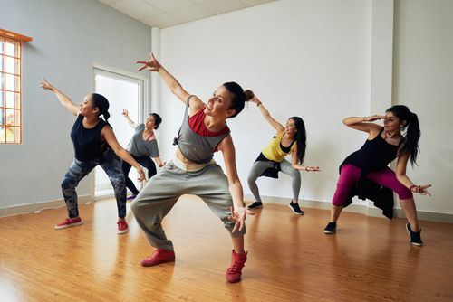

Suggested time: 1 hour.  
A very intensive routine that focuses on the hips and waist.



Suggested time: 30 minutes.   
An Exotic dance form, which focuses on the hips, back, buttocks and abs.

4. Freestyle

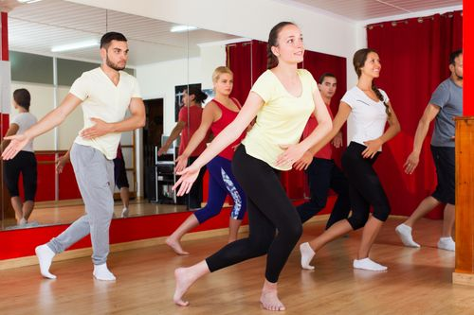

Suggested time: 30 minutes.  
Move free. Do not worry about the exact dance steps or body movements. Set your own pace.

5. Pole Dance



Suggested time: 1 hour.  
Pole dancing is a form of dance that is effective in toning muscles and shaping your body. However, this dance form is considered to be a bit difficult to master.

**Where you can find them**

There are a lot of dance classes being offered for kids and adults. Several gyms offer aerobics and Zumba classes. If you’re uncomfortable dancing in public, you can download an app for dance [workouts](https://www.healthifyme.com/blog/top-10-bollywood-songs-for-workouts-2/), or watch videos that help you learn and train.

## Things to know

Dance as a [weight-loss](https://www.healthifyme.com/blog/weight-loss-exercises-benefits-home-workouts/) medium is a great idea. But before you get into it, make sure you know everything about it. Intensity level of dance forms depend on the routine you choose. Fast-moving dance styles are more intense than slower dances. Most dance routines use your whole body and will challenge your brain as you learn the choreography and form and learn to keep up.

### Most common marked areas in your body while dancing:

**Core**Core muscles are the deepest muscles of your body. Depending on the type of dance chosen, some of the steps and moves will employ the core muscles.

**Arms**  
Even though most dances focus on your lower body, you’re also moving your arms to the beat.

**Legs**  
The dance routine will have you making moves that work your lower body, including your thigh muscles and hamstrings.

**Buttocks**  
Hip hop, belly dancing and ballet, among others, include moves that engage the buttocks.

**Back**  
Dance uses your core muscles, including those in your back.

#### Also helps improve:

**Flexibility**  
Most of the dance workouts include moves that improve your flexibility.

**Raises heart rate**  
Dancing raises your heart rate, improves your breathing. The more upbeat the dancing style, the better it is for your heart.

**Strength**  
Even though you aren’t lifting weights, you are lifting yourself up- bodyweight counts, that helps in building muscle strength.

## Start your dancing journey

### 1. Set a goal. Know your goal. Remember your goal.

Choose the dance form. Choose something you love doing so you’ll be less likely to drop out. Set a time limit. Know your comfort zone- it’s okay to push your boundaries a bit, but not too much. Step up your game steadily for more and positive progress.

### 2. Tag along someone OR tag someone along

When you’re with someone, you either motivate them or they motivate you. If you think you’ll end up quitting midway, have someone with you who’ll get you back on track.

### 3. Dress proper

You move your entire body in dance. Wear the right shoes, so your feet don’t get hurt. And wear clothes that are not too tight nor too lose- comfortable. Women, especially, need to make sure they are in the right outfit that holds and protects their breasts from bobbing too much.

### 4. Warm-up

Stretch and loosen up before you start dancing, just like you would for any other workout. Warming up makes sure your muscles are ready for the routine. If you don’t, you might pull a muscle and get hurt.

## Steps to dancing at home

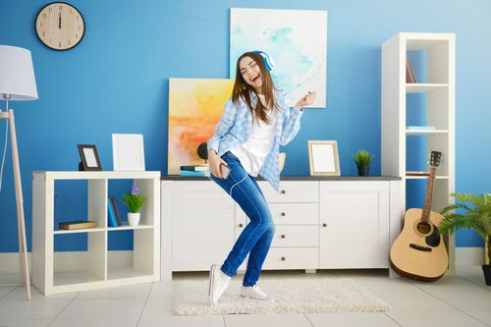

Many aren’t all that comfortable dancing in public spaces, even a studio. Learning to dance at home is really great. You can work at your own pace. No matter what, it is important to make sure that you are dancing safely and not pushing your body too hard. If you want to do it at home, here are some tips that will help you out. Follow these steps and dancing at home will be a breeze!

### 1. Pick a style

Browse through the various styles- look at videos online, watch dancers perform or read articles and books, and pick one that suits you. Explore as many different dance styles as you can before fixing on one.

### 2. Set your space

Clear a large area in your house so you can move freely without hitting furniture in the middle of your steps. Cramped space will cramp your style. Set your video in a place where you can see it without disrupting your routine too much.

### 3. Master the basics

Before you go full-on into the dance, learn the basic moves. For hip hop, practice the basic step touch move. For ballet, learn the five positions. Spin a partner around for ballroom dancing. Whatever it is, take it nice and slow. Do not over pace yourself.

### 4. Learn the routine

You will probably have to watch the video you chose multiple times and practice before you get the hang of it. Once you do, the steps will flow. Dance in front of a mirror to see how you’re doing and how you can improve.

### 5. Get in the groove

Make sure to warm up before you dance. Move your arms and legs to the beat. The more you dance, the more at ease you will be. Maybe one day you’ll be confident enough to go dancing with your family or friends!

### 6. Keep up the routine

Do not do it for a couple of days and give up. If you’re too tired, reduce the time and take breaks in between. If your plan is a one-hour routine, take a break every 20 minutes.

### 7. Eat Healthy

Last but not least, make sure your diet goes well with your routine. Your body exerts a lot during the dance, so have a balanced diet to compliment that. You sweat a lot, so drink plenty of water. Keep yourself hydrated.

## Common questions asked by beginners

#### ****Can you start if you’ve never danced?****

Yes. There are dance classes and videos for beginners. If you’re just starting out, give yourself time and have the patience to learn the moves. It won’t happen overnight, but it will happen if you keep at it.

#### ****Should it be done indoors or outdoors?****

Most dance classes are taught in studios. If you have some empty space at home, where you can sweat it out a bit, go for it!

#### ****Do I need to get something specific for my dance workout?****

Sometimes. Not usually. Some classes will require specific shoes- like ballet; for others like hip hop, all you need are sneakers. You will obviously need a pole for pole dancing.

#### ****Can I dance if I have a health condition?****

If you have any medical conditions like diabetes or high blood pressure, take note on how you feel before, during, and after dancing. If it is stressing you out too much, consult your doctor once. If you have an injury, let it heal before you start dancing.

## Summary

Depending on the style of dance you choose, you can improve your heart, joints, overall strength, balance and coordination, and a sense of well-being. If you can’t afford classes, try a dance workout DVD or follow an online video at home. Happy Dancing!

Freestyle dancing allows for individual expression dancers are encouraged to create new moves and develop a personal style. freestyle dance classes are funky, modern and fun. It's all about freedom to express movement to the wide variety of music trends.

"Zumba combines high energy and motivating music with unique moves and combinations that allow the Zumba participants to dance away their worries. It is based on the principle that a workout should be "FUN AND EASY TO DO" allowing Zumba participants to stick to the Zumba Fitness program and achieve long-term health benefits. Zumba is a “feel-happy” workout that is great for both the body and the mind.