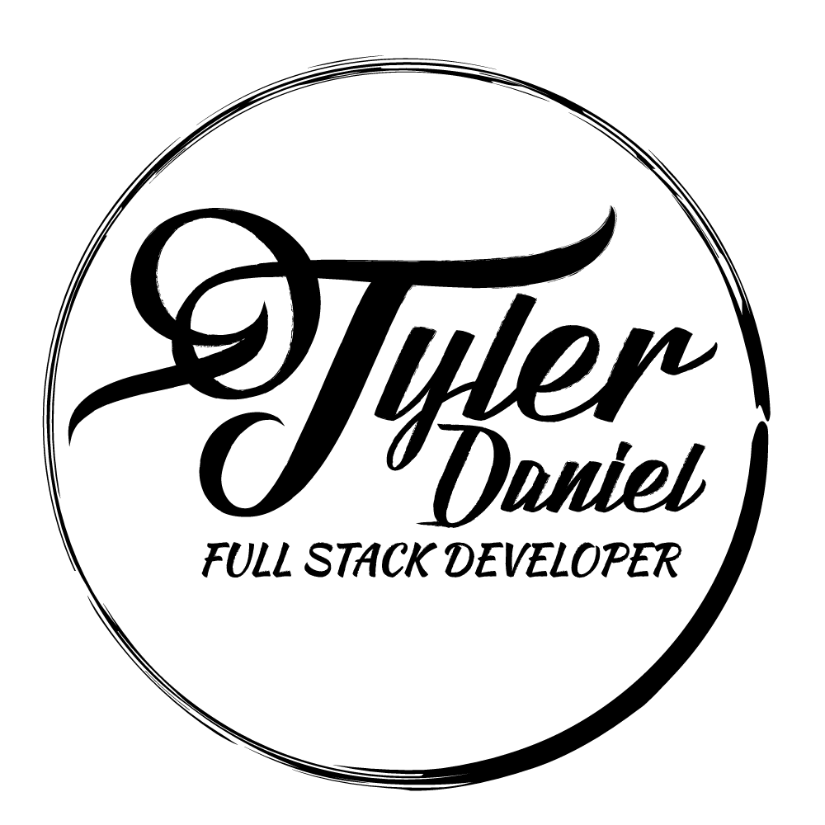
Tyler Daniel
Phone: 931.273.7734
Email: tylerdanielwork@gmail.com
Location: Nashville, TN (open to relocation)
Personal: www.tylerdaniel.com Github: www.github.com/iamtylerd LinkedIn: www.linkedin.com/in/tyler-daniel-67991698

PROFESSIONAL EXPERIENCE
Nashville Software School, Nashville, TN 05/2016 - 11/2016
Apprentice Web Developer
- Full stack developer with an emphasis on Node.js (Socket.io), MongoDB/SQL, and Angular
- Created database driven applications that used SQL, MongoDB, and Firebase
- Was the team lead on many group projects that consisted of 3-5 people with a focus on source control
- Working in an environment that focuses on source control
- Learned how to build an application in with a TDD mindset.
- Learned how to deploy an application on Firebase, Heroku, AWS, and Mlab

Projects

Blogular
-Created a CMS using only front end technologies
-Used Firebase as a database using the RESTful API
-The CMS had a blog, user authentication with Google, and had image storage
Github: github.com/iamtylerd/capstone-blog
Live: www.jttravels.co

Space Race
- Created a game that used Node.js as a server
- Used Socket.io to allow for multiplayer and many games at once
- Rendered HTML on the server with Pug
Github: github.com/iamtylerd/space-race
Live: space-race-.herokuapp.com/

Dickson Resources, Nashville, TN 10/2015 - 04/2016
I.T. Recruiter
- Generate leads from various outlets
- Follow up on client and candidate leads
- Recruit candidates for our clients
- Supply the most qualified candidates for the position
- Engage with clients/candidates through lunches and/or social events

Nova Copy, Nashville, TN 07/2015 - 10/2015
Help Desk Hotline
- Answer phone calls quickly and efficiently
- Troubleshoot networking issues
- Setup and use remote sessions to assist clients
- Submit and route ticket issues to technicians in the field

CoreCommerce, Franklin, TN 04/2014 - 07/2015
Technical Support Level II
- Tested and submitted bugs through Jira
- Provided excellent service to our customers 24/7
- Front end design tweaks with HTML & CSS
- Network support (DNS, Hosting support, Email support/setup)
- Maintained over a 95% quality assurance rating
- Supported customers through tickets, chats, and phones

Onlife Health, Brentwood, TN 10/2013 – 04/2014
Participant Service Operator
- Maintained great customer service
- Lead the in house interface design project
- Worked closely with developers as a QA on testing out bug fixes

SKILLS
- HTML/CSS/JavaScript (ES6)/jQuery
- Testing (Mocha/Chai, Jasmine, Karma)
- NPM / Bower
- Bootstrap, Materialize, UIkit
- Remote access tools (VPN & Teamviewer)
- Gulp with Sass/SCSS
- Node, MongoDB, and RESTful APIs
- Modular style developing (Browserify)
- Javascript frameworks (React, Ionic, Express, and Angular)
- Heroku and Firebase usage/deployment
- Templating with Handlebars, Pug (Jade), and EJS

EDUCATION
Nashville Software School “Apprentice” 05/2016 - 11/2016
- Full Stack Web Developer
- Focusing on HTML/CSS, JavaScript, AngularJS, NoSQL, Node.js, testing, MongoDB, Express

Middle Tennessee State University, Murfreesboro, TN
- Bachelor of Computer Information Systems (Senior – Not Complete)
- Blue Raider Scholarship award winner

