**CSE 5524 Final Project Report**

**Infant Face Detection and Censor Using NCC and Covariance Tracking**

**Team Members**: Chowduri Suhrit and Utkarsh Pratap Singh Jadon

**Introduction:**

Due to privacy reasons, infant’s faces are blurred out in images posted on social media by people and celebrities. We aim to automate this task using two computer vision algorithms for Template Matching: Normalized Cross Correlation and Covariance Tracking. We have also incorporated image pyramids and gaussian blurring in the algorithms to handle different search image and template image sizes and to improve the performance.

**Data set:**

The input images used have been downloaded from the following royalty free image collection websites – [Pexels](https://www.pexels.com/), [Pinterest](https://www.pinterest.com/) and [Adobe Stock Images](https://www.stock.adobe.com/).

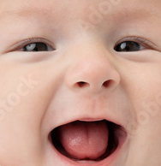

Template Image

**Algorithms Used:**

1. ***Normalized Cross Correlation (NCC):***NCC technique was used to perform Template Matching by using a common template of an infant along with multiple search images.
2. ***Covariance Tracking:***Covariance Tracking was performed by matching the feature vectors of the template image with those of the different patches in search image to find the best possible match
3. ***Image Pyramids:***We performed downscaling of the images so that search images of different sizes can be handled
4. ***Gaussian Blur:***Censoring of the faces of the matched infant was performed using Gaussian Blur technique

**Contribution per team member:**

*Suhrit* – Worked on Normalized Cross Correlation. Using one template containing generic image of an infant, will perform NCC on given dataset, perform gaussian blurring in the region around best match in each image, generate output images, and calculate censor accuracy using Intersection over Union (IOU)

*Utkarsh* – Worked on Covariance Tracking. Using covariance matrix of one template containing generic image of an infant, will perform Covariance Tracking on given dataset, perform gaussian blurring in the segmented section in each image, generate output images, and calculate censor accuracy using Intersection over Union (IOU).

**Results**

Following are the results obtained for four different input images from the dataset.

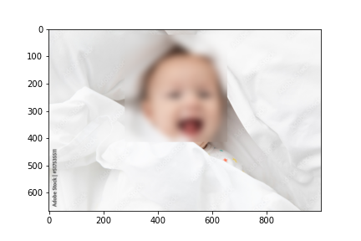 **Image 1:**

Input Image NCC Accuracy: 80.43% Covariance Accuracy: 75.41%

**Image 2:**

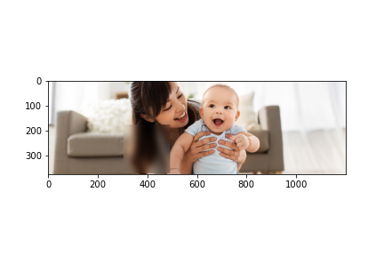

Input Image NCC Accuracy: 24.06% Covariance Accuracy: 0%

**Image 3:**

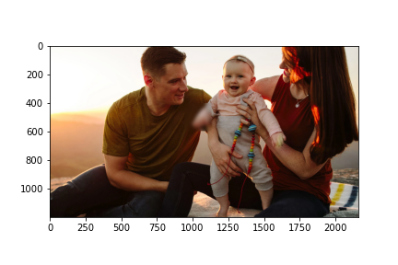



Input Image NCC Accuracy: 0% Covariance Accuracy: 0%

**Image 4:**

Input ImageNCC Accuracy: 62.12% Covariance Accuracy: 34.42%

**Evaluate the results:**

**Detection Accuracy -** Percentage of images in the dataset that were detected correctly. Detection accuracy of NCC - 75% and Detection accuracy of Covariance - 50%

**Censor Accuracy** - Amount of overlap between the predicted and ground truth bounding box using Intersection Over Union –

|  |  |  |
| --- | --- | --- |
| Input | NCC | Covariance |
| 1 | 80.43% | 75.41% |
| 2 | 24.06% | 0% |
| 3 | 0% | 0% |
| 4 | 62.12 | 34.42% |

Table 1: Censor Accuracy (IOU) for input images

**Problems encountered:** Algorithm did not perform well in cases where there is lower contrast between the primary subject versus the remaining objects in the search image

**Lessons learned:** NCC works better than covariance tracking when we perform detection using a single template-image

**What else could be done (if you had more time)?:** We would have explored techniques like Mean Shift and super-pixel segmentation to get better results on Edge Cases

**Conclusion:**

The different computer vision techniques including NCC, and covariance tracking were explored for the task of infant face detection and blurring. Additionally, techniques like Image Pyramids and Gaussian Blurring were used to significantly improve the performance of the algorithm.