Billing Agent Implementation Guide
Application architecture and store service workflows
The Billing Agent supports a customer from product discovery through comparison, a draft quote, confirmed placement and after-sale billing support. Customer, Cashier and Admin modes share the chat interface while retaining different account permissions and approval authority.
The service records invoice and refund outcomes and supports local store credit. Payment collection, card routing, bank receipt verification and external support-message delivery remain outside its operating scope.

Application architecture
Application request flow
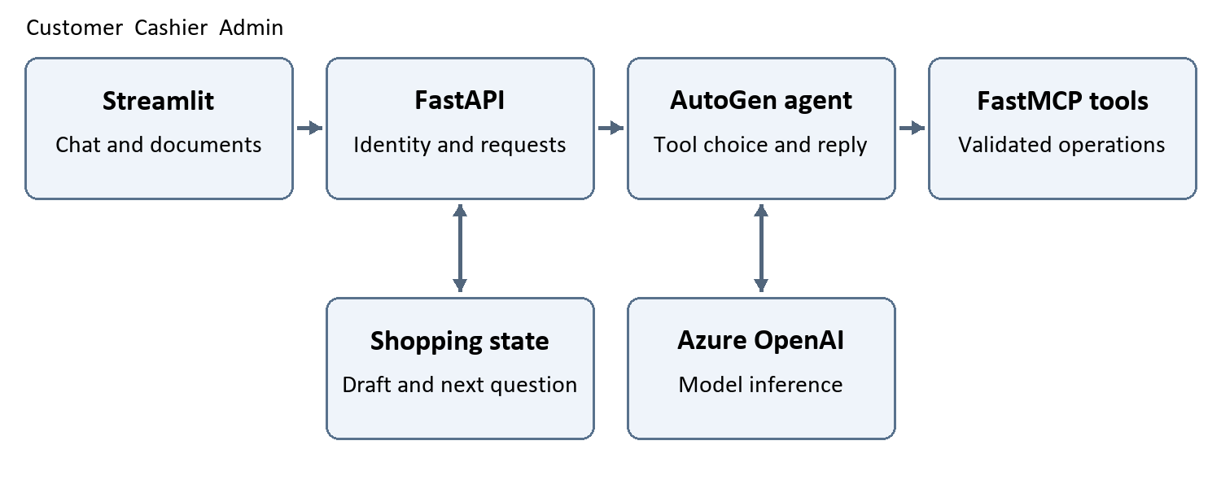
Streamlit sends authenticated HTTP requests to FastAPI. FastAPI verifies the conversation and access mode, coordinates request identity and calls the AutoGen billing agent. Azure OpenAI interprets the request and selects permitted FastMCP tools through a local stdio connection. Tool results supply the facts used in the response.
The interface presents one plain-English answer with available invoice attachments. Requested admin charts are validated tool artifacts rendered by the interface. Shopping context is carried forward within the customer’s conversation.

Tools and access modes
The application exposes twelve tools in total. It selects the permitted tool set for the active mode and supplies trusted customer scope. A chat claim cannot change the caller’s role or select another customer’s private account.
Tool | Available to | Main behavior
execute_sql_query | Customer  Cashier  Admin | Flexible read-only product and permitted-record questions. Admin requests may include a validated chart.
request_order | Customer | Create or reuse an owned draft and calculate an estimate without reserving stock.
place_order | Customer | Place the approved draft, recheck prices and stock, issue an invoice and prevent duplicate placement.
apply_promotion | Customer | Validate a customer-supplied code without mutation, or apply that specific code to a draft with permission.
download_invoice | Customer  Cashier  Admin | Prepare an accessible invoice document. Confirmed contact corrections are customer-only; staff access is read-only.
billing_analysis | Admin | Invoice summaries, cost estimates, rankings, pending-approval reports and local refund reconciliation.
billing_anomalies | Admin | Read-only checks for inconsistent billing records and other items needing review.
manage_draft | Customer  Admin | Customer draft edits, cancellation, local credit and billing-review notes. Admin shipment/delivery transitions only.
manage_customer | Customer | Confirmed update of the signed-in customer’s profile. Account creation uses the registration form.
process_refund | Customer  Cashier  Admin | Customer previews and requests, local status/escalation, bulk requests and controlled staff approval.
compare_products | Customer | Compare distinct products by recorded features, stock, dated price and merchandise budget.
find_cheaper_alternatives | Customer | Find cheaper available options matching the source purpose and recorded requirements.

Cashiers cannot create customer refund requests or access admin analytics. Admins can approve eligible requests and record shipment or delivery, but cannot use the customer checkout or profile-update tools.

Customer conversation and order lifecycle
Customer shopping and service flow
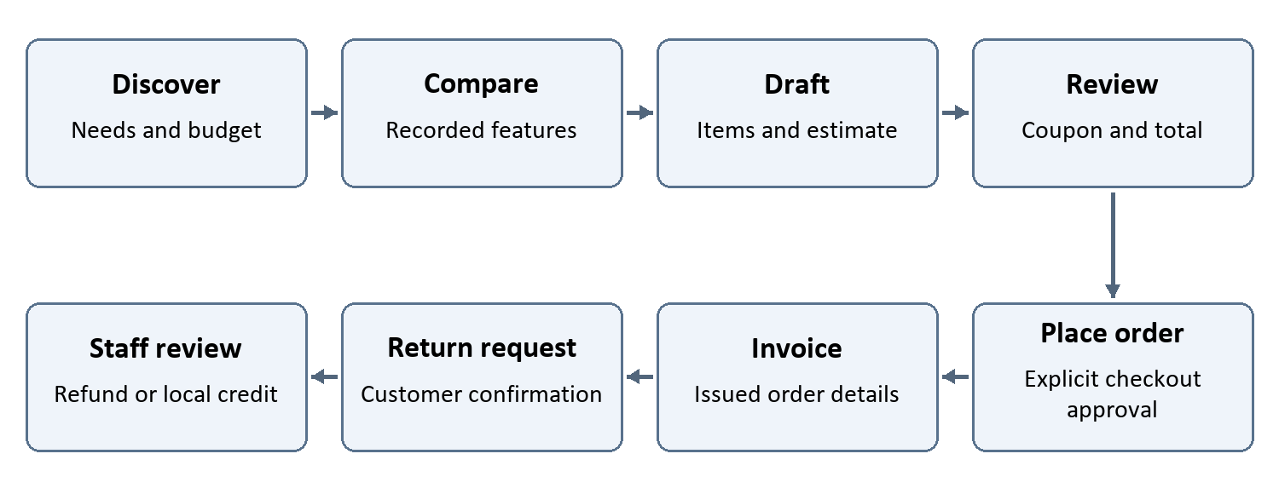
Public product browsing is available before sign-in. Personal orders, invoices, profile changes and refund requests require a verified customer account. The conversation asks for missing needs, budget, quantity and features, then carries the choices forward instead of repeatedly asking the same questions.

Shopping context
Structured state retains needs, budget scope and currency, preferred features, observed and selected product IDs, compared products, the current draft, the last order and the next question. A pending proposal identifies the action and relevant order facts. When those facts change, the saved proposal becomes invalid and the customer must review the updated quote or action.
Observed tool facts are checkpointed so a later model error does not erase a completed action from the conversation state. Coupon evidence comes from customer messages and trusted saved state, not model-written preferences.
Order state | Meaning
Draft | An editable estimate with no issued invoice. It does not reserve inventory.
Placed | An issued order with fixed billed items and invoice identity. Repeated placement returns the existing order rather than reducing stock again.
Cancelled | A terminal order state. The order cannot be reopened or purchased again. An issued invoice is retained as a historical document.

Shipment and delivery are tracked separately from the order state. Only an eligible whole order can be cancelled before shipment. Unknown shipment status needs verification; shipped or delivered orders follow the return process. Adding or removing placed invoice lines is rejected.

Product matching coupons and quote accuracy

Product search and comparison
Human product names and categories are normalized for Unicode, letter case, spaces, underscores, hyphens and common plural endings. For example, power banks and power_banks match consistently. Narrowly scoped product filters receive the same local treatment. Product codes, SKUs, customer IDs, amounts and units keep exact semantics.
A name matching several products returns choices instead of selecting an arbitrary item. The assistant counts all matches before describing a page of results, preserves filters during pagination and does not call a limited sample the complete store selection.
Comparison accepts two to five distinct products and checks current applicable prices, requested quantity, stock, recorded features and the total merchandise budget. Feature-key case and separators are normalized while values and units remain intact. Conflicting or missing features are unknown. A recommendation identifies the lowest-priced qualifying option, not an unsupported overall quality winner.
Cheaper alternatives stay within the recorded product category and satisfy required features, stock and budget. Where the category is unavailable, shared-name matches are tentative. Comparison budgets cover merchandise before promotion, tax and shipping; the draft provides the final estimate.

Coupon privacy and permission
Customers cannot enumerate store coupon codes. Only a code supplied in actual customer messages or trusted saved evidence can be checked. Assistant suggestions and model-supplied scope arguments cannot authorize a coupon. The bot does not choose the highest discount on the customer’s behalf.
Validation is read-only and does not alter a draft. Applying a code requires an explicit request for that exact code, or an affirmative reply to the unchanged saved proposal for the same code and draft. Informational, hypothetical, ambiguous or multiple-code requests require clarification. An explicitly named order cannot be replaced with another draft.
Only one unexpired coupon is permitted per order, and a different second coupon is rejected. Code matching ignores case but rejects ambiguous stored variants. Coupon expiry and quote eligibility are checked again before use and placement.

Quote and placement
Amounts use Decimal arithmetic rounded to two places. Subtotal is the sum of quantity times applicable unit price. The discount reduces the taxable subtotal; the invoice total adds tax and shipping. The conversation obtains checkout approval before placement. Placement rechecks stock, prices, coupon and currency, then records the fixed invoice and reduces stock atomically. It does not collect payment or arrange a carrier delivery.

Refund requests approvals and local credit

Separate preview request and approval
A refund quote calculates an eligible amount without creating a request. Only the verified customer can submit the pending request. Staff cannot originate a request and approve it themselves. Approval must use the saved amount, currency, reason, returned items, disposition and target cart unchanged.
Control | Enforced behavior
Return window | Requests and approvals must fall within the configured inclusive window from order date. The default is 30 UTC calendar days. Admin status cannot override an expired window.
Approver | Cashier approval is allowed up to and including the configured limit, by default 100 USD. Higher amounts and other currencies require admin. Admin may also approve below the limit.
Return evidence | For merchandise returns, staff must confirm physical receipt unless an authenticated admin documents a waiver. A waiver cannot create a customer request or bypass financial checks.
Duplicate protection | An existing recorded refund blocks another refund. The current rule permits one refund per order, including a partial refund, with no later top-up.
Refund destination | Only the recorded original method or local store credit is accepted. Another card is rejected. Orders using store credit must return to store credit.

Amounts and cancellation
Item returns use billed quantities and recorded invoice values, allocating actual discount and tax proportionally and excluding nonrefundable shipping. A buy-two-get-one return uses the discount already recorded on the invoice; the service does not invent conditional-offer eligibility or repricing rules.
An eligible unshipped whole-order cancellation retains its invoice, restores inventory once and creates a pending cancellation refund. Approval still requires the existing customer request. A shipped order requires a return instead.

Local credit and follow up
Approved store-credit refunds create credit for the same customer and currency. It can be allocated to an owned active draft. Placement rechecks the available balance and redeems it once in the same transaction as the order. If the target cart has closed, the credit remains on the customer’s account.
Status reports distinguish pending and approved local records from bank receipt. A confirmed escalation stores a staff-review reference. Bulk preview checks every order in an explicit date range; confirmed submission creates eligible pending requests individually and returns per-order outcomes. It never mass-approves refunds or sends money.

Invoice documents and billing reports
Document | Behavior
Invoice | Prepare the issued order document using billed items, recorded totals and accessible customer details.
Tax invoice | Include the company, billing address and tax registration number. Missing required details prevent generation.
Pro forma invoice | Prepare a clearly labeled estimate for an active draft. It does not place the order, issue an invoice or reserve stock.
Contact correction | After customer confirmation, save a contact-only revision and regenerate the document. Preserve original invoice lines, amounts and snapshot. Identical repeats do not add another revision.

The interface uses returned attachment information to prepare the accessible PDF download. It does not invent a download link. Staff may retrieve documents but cannot perform customer contact corrections through staff mode.

Admin reports
Billing analysis provides filtered issued-invoice totals, discounts, tax, shipping, recorded refunds, refund-adjusted invoice amounts and product/customer rankings. Costs and margins use current item costs as estimates, not historical profit accounts. Financial summaries require one currency; mixed-currency selections must be narrowed or queried separately. Trend outputs keep currencies separate. Drafts are excluded from issued sales.
Pending-refund reports identify the required approver and requests above the cashier threshold. Local refund reconciliation uses approval dates and compares request approval with the order refund and any related store credit. Undated history gaps are reported separately. This is not bank-settlement reconciliation.
Rule-based anomaly checks flag inconsistent arithmetic, missing supporting evidence, unusual values and other records needing review. A flag is not proof of fraud or authority to change a charge. Requested admin charts are attached only from validated executed results and rendered in the interface.

Billing explanations and policy handoff
Order-to-order cost explanations compare billed quantities, unit prices, applied discounts, tax and shipping, with dated price history as supporting evidence. Partial-charge and duplicate-charge complaints are saved as review issues without inventing a payment transaction or shipment status.
Original-method refunds have a 5–10 business-day staff-handling policy; the app cannot confirm bank receipt. Closed-card questions go to the original issuer and store support. Cash-on-delivery repayment requires the store’s approved secure channel outside chat. The service does not collect bank details, reroute cards or claim to identify captured-but-uninvoiced orders without capture evidence.

Identity access and request handling

Verified customer and staff access
Customers sign in with their own account credentials for private work. Registration cannot take over an existing customer account, and an email address alone is not proof of ownership. Passwords use salted PBKDF2 SHA256 hashes, and only token hashes are retained for sessions. Sessions expire after 12 hours. Five failed attempts cause a 15-minute lock. Local password reset follows independent customer verification and revokes existing sessions.
A spouse relationship, email address or claimed manager title in chat grants no authority. The API rechecks account and role ownership before private conversation, message and invoice access. Customer reads contain only that customer’s private records and public product information. Staff credentials are separate, distinct secrets of at least 16 characters.
Sensitive credentials stay in account forms or local configuration rather than model messages. Before a confirmed profile update, the conversation carries forward contact values the customer has not changed; the tool replaces the submitted contact fields. Other customers’ records and staff-only financial details remain outside customer access.
API route | Purpose
GET /health | Local configuration status. It does not prove live Azure authentication or network connectivity.
POST /customers/register  POST /customers/login  POST /customers/logout | Create an account, authenticate it or revoke a customer session.
POST /conversations | Create a conversation in the authorized mode and customer scope.
GET /conversations/{conversation_id} | Resume authorized messages, attachments and shopping context.
GET /admin/access  GET /cashier/access | Check the separate staff credentials.
POST /chat  POST /chat/stream | Process a message with conversation_id, request_id and message. Streaming can deliver admin chart artifacts before the final answer.
GET /invoices/{invoice_number} | Retrieve the permitted PDF after conversation and invoice ownership checks.

Each chat request carries a request_id UUID. Repeating a completed request with the same ID and text returns its saved response; reusing the ID for different text is rejected. A timeout can follow a successful tool action, so the current order/refund state must be checked before submitting another change.

Performance reliability and verification

Reduce avoidable overhead
The API warms the MCP process at startup and reuses tool definitions, Azure client connections and HTTP clients. Static metadata is cached; live product and billing values are still read for the request. Tool JSON is compacted by removing unnecessary whitespace without dropping values.
Independent read tools can share one model-selected round. Mutating operations and invoice generation run one at a time, and a mixed write batch is rejected before execution. Dependent actions use a later round after their required inputs are known.
Each turn receives a fresh model context with recent conversation and structured shopping state. The application uses one worker and one active-turn lock to prevent shared transport state from crossing customer scopes. This trades parallel throughput for predictable ownership and write ordering.

Failure handling and output
The service distinguishes Azure authentication, permission, resource, quota, connection and timeout failures. Failed or cancelled transports are discarded. Financial changes are not automatically replayed. Successful tool facts remain checkpointed even if the final answer fails.
Plain-English cleanup removes internal response envelopes from the customer-facing answer. Invoice attachments and validated chart artifacts are delivered separately. Admin chart streaming is distinct from token-by-token text streaming.
Performance logs separate queue wait, model inference, tool execution and total-turn time. A request may need multiple Azure calls. Inference, network conditions, tool rounds and queued requests determine live response time; no fixed response-time guarantee is imposed.

Regression coverage
Automated checks cover customer ownership, staff authority, coupon privacy and permission, product normalization, ambiguous features, explicit order states, idempotent placement, invoice documents, refund calculations, return windows, pending-request approval, concurrency, store credit, reports, chart delivery and reply cleanup.
Replay-based model tests validate the local integration and business controls. A live Azure request is a separate check of deployment connectivity, language behavior and response time. The accompanying requirements workbook maps the 27 service scenarios to implementation locations, named tests and operating limits.

