Billing Agent Technical Design
Version 6 implementation and operating guide
Current project version_6_latest
Updated 14 October 2026

Purpose
The Billing Agent assists a store customer from initial product questions through comparison, quotation, confirmed checkout and after-sale billing support. A separate read-only Admin mode supports store-wide reporting and record inspection.
This guide describes the current application, its twelve tools, conversation behavior, permissions, setup and operating limits. It replaces the earlier six-tool Ollama proposal. Customer preferences and shopping context carry forward within a conversation, including when that conversation is resumed.
Area | Current behavior
Assistant | One logical AutoGen assistant using Azure OpenAI
Customer experience | Centered chat with product discovery, comparisons, quotes and invoice downloads
Tools | Twelve registered tools; ten available in Customer mode and four in Admin mode, with two shared
Admin experience | Read-only billing reports, anomaly review and optional visual summaries
Financial scope | Invoice calculations and recorded refunds; no payment-provider integration

1 Customer experience and conversation flow
The conversation follows the customer from choosing a product to receiving an invoice. The diagram shows the main path; detailed tool rules appear in Sections 5 to 8.
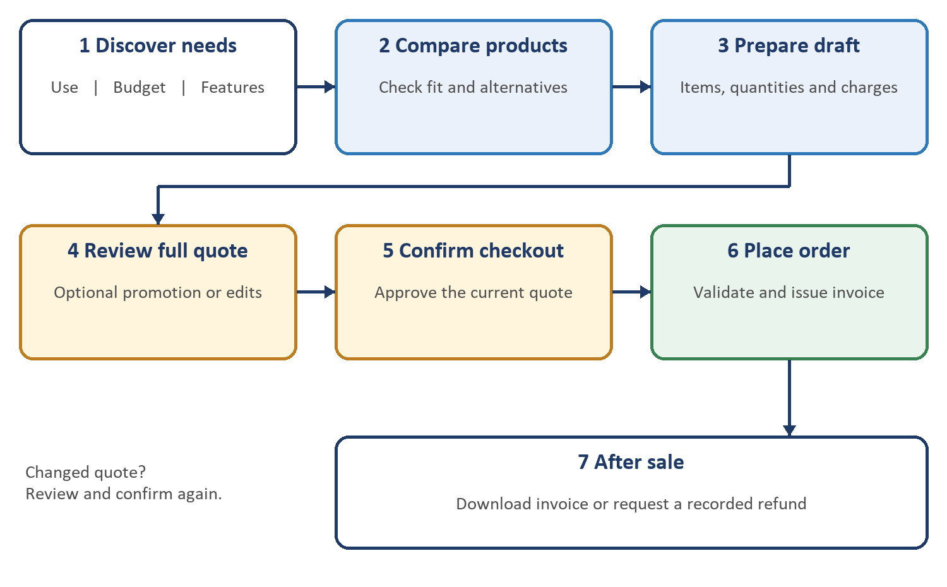
Figure 1 Customer shopping journey

Conversation principles
Ask only for missing information, preserve stated preferences and clarify ambiguous references. Product questions do not require an account; personal records and order changes require an associated customer. Changes to a quote return the conversation to review and approval.
Store staff handle physical returns, delivery tracking, warranty decisions and payment settlement. The assistant explains these boundaries when relevant to the request.

2 Architecture and application components
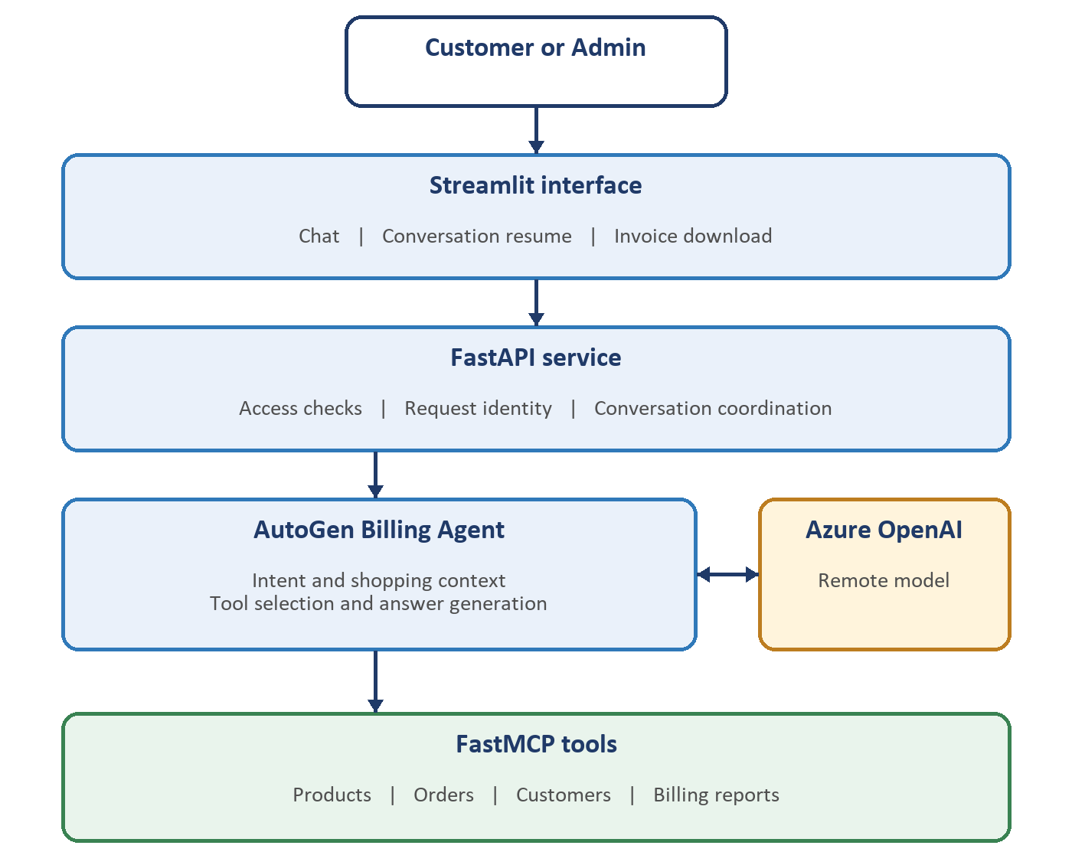
Figure 2 Application architecture and request path
The frontend sends requests over HTTP. FastAPI coordinates access and conversation scope. AutoGen uses Azure OpenAI for interpretation and selects permitted tools through FastMCP over local stdio. Results return through the same components to the chat interface.

3 Service components and API

Application lifecycle
Startup prepares the service and warms MCP. Azure client creation is lazy. Shared clients and tool definitions are reused, while each turn receives a fresh model context built from recent messages and shopping state. A single worker and an application lock serialize chat turns.

API routes
Method and route | Purpose
GET /health | Configuration status; does not prove a successful live Azure connection
POST /conversations | Create a conversation with customer association and mode
GET /admin/access | Validate the separate Admin credential
GET /conversations/{conversation_id} | Resume messages, attachments and shopping context
POST /chat | Process a message with conversation and request identifiers
GET /invoices/{invoice_number} | Return a PDF after access checks

A completed request repeated with the same identifier and content returns its saved response. A different message using that identifier is rejected. After a timeout, inspect the order status before repeating a possible action; the action may have completed before the answer failed.

4 Tools and access modes
FastMCP registers twelve tools. The application controls which tools each mode can use and supplies trusted customer scope. A chat message cannot grant Admin access or change ownership.
Tool | Customer | Admin | Purpose
execute_sql_query | Yes | Yes | Retrieve permitted information for product questions and reports
request_order | Yes | No | Prepare an order draft and estimate
place_order | Yes | No | Confirm placement and issue an invoice
apply_promotion | Yes | No | Apply one promotion to an unplaced draft
download_invoice | Yes | Yes | Prepare an accessible invoice PDF
billing_analysis | No | Yes | Summarize billing, rankings and estimated costs
billing_anomalies | No | Yes | Identify billing records needing review
manage_draft | Yes | No | Replace a draft basket or cancel it
manage_customer | Yes | No | Create or update approved customer details
process_refund | Yes | No | Record an eligible refund
compare_products | Yes | No | Compare products against customer requirements
find_cheaper_alternatives | Yes | No | Find cheaper products meeting stated needs

Shared rules
Customer mode may access public product information and the associated customer’s records. Other customers’ records, procurement costs and audit history are excluded. Admin can inspect store-wide records but cannot place orders, change customer details or issue refunds through Admin mode.
The model may combine multiple tools to answer a wider question. For example, it can retrieve matching products, compare their features and then prepare a quote. New tools are not required for every wording of a product question.

5 Product discovery and recommendations

execute_sql_query
This read-only tool retrieves permitted information for product discovery and flexible questions. It supports complete category counts, filtered product lists and paginated browsing, as well as more specific questions that combine product features, prices and relationships. It cannot perform customer or order changes.
The assistant distinguishes the total number of matches from the number displayed. It qualifies joined fields, avoids interpreting a limited result as a complete list, and requests the next page when needed. Customer access remains restricted even when questions become more complex.

compare_products
compare_products(products, quantity=1, budget=None, required_features=None)
Compares two to five distinct product references. Ambiguous names return choices for clarification. Results cover price, quantity cost, stock, category, recorded features and whether requirements are matched, different or unknown.
Recommendations are conditional on available evidence. The assistant should explain why a product fits the stated use and avoid claiming an overall quality winner without supporting information.

find_cheaper_alternatives
find_cheaper_alternatives(product_reference, quantity=1, budget=None,
required_features=None, limit=5)
Finds cheaper in-stock alternatives in the source product’s category. Where the category is missing, name-based matches are tentative. Candidates are checked against requested quantity, merchandise budget and known requirements.
Comparison and alternative tools interpret budget as total merchandise cost for the requested quantity, before discounts, tax and shipping. Use a draft quote to establish the final payable invoice amount.

6 Order drafts promotions and checkout

request_order
request_order(customer_id, items, order_id=None)
Validates the customer, selected products, quantities, stock and applicable prices, then prepares a draft with estimated charges. Drafts do not reserve stock and do not have an issued invoice. Reusing an existing order identifier is safe only when its owner and requested items agree.

manage_draft
manage_draft(order_id, customer_id, action, items=None,
reason="", confirmed=False)
Supports replace_items and cancel. Replacement uses the complete desired basket; omitted lines are removed. Display the revised basket and obtain approval before execution. Cancellation requires a reason. Issued invoices cannot be edited through this tool.

apply_promotion
apply_promotion(order_id, customer_id, promo_code)
Applies or replaces one promotion on an owned, unplaced draft and recalculates its charges. Promotions do not stack. Discounts cannot exceed the subtotal. Issued orders cannot be changed with this tool.

place_order
place_order(order_id, customer_id)
After approval of the complete quote, placement validates availability and charges, deducts stock and assigns an invoice number. Insufficient stock or a changed quote prevents placement until resolved. Repeating a successfully placed order returns the existing result without deducting stock twice.

Charge calculation
Subtotal is quantity multiplied by applicable unit price. The discount reduces the taxable subtotal. The final total is subtotal minus discount plus tax and shipping. Monetary calculations use Decimal and round to two places. The assistant explains every component in plain English.
Placement records fulfillment within the application. It does not collect payment or book a delivery. A changed currency requires a new draft; a changed quote requires renewed approval.

7 Customer details invoices and refunds

manage_customer
manage_customer(customer_id, name, company="", email="",
action="create", confirmed=False)
Creates or updates customer details after the displayed information is approved. Updates replace the contact fields, so unspecified existing values must be preserved; blank company or email clears that value. A successfully created customer can be associated with an anonymous conversation.
An anonymous conversation cannot adopt an existing account merely by claiming its identifier. Customer association is controlled by the application. Previously issued invoice contact details remain unchanged.

download_invoice
download_invoice(invoice_number, customer_id)
Checks access and prepares a PDF using the issued invoice details, charges and recorded refund information. The interface offers a download control. The assistant must use the returned attachment information rather than inventing a download link.

process_refund
process_refund(order_id, customer_id, reason, amount=None)
Records one full or partial refund for an owned, placed order. The amount must be positive and cannot exceed the charged amount. Omitting the amount requests a full refund. Establish and confirm amount, currency, reason and the fact that this is a recorded action before calling the tool.
An existing refund prevents another refund, including topping up a partial refund. The tool does not transfer funds, return stock, change invoice lines or issue a credit note. Store staff handle payment-provider actions and return-policy decisions.

8 Admin billing reports and review

billing_analysis
billing_analysis(customer_id=None, order_id=None,
date_from=None, date_to=None, top_n=10)
Provides Admin summaries of issued invoices for the selected customer, order or inclusive order-date period. Optional filters combine, and totals cover all eligible invoices rather than only the displayed ranking. Drafts are excluded from invoice totals.
Reports include subtotal, discount, tax, shipping, charged amount, refunds and refund-adjusted billed amount. Product and customer rankings help explain where billed amounts and quantities are concentrated. Average invoice values support comparisons across selected periods.
Cost and margin figures are estimates using current product costs, not historical purchasing costs or profit accounts. Refund-adjusted billed amount is not evidence of money received. Mixed-currency reports require separate currency selections.

billing_anomalies
billing_anomalies(customer_id=None, order_id=None,
date_from=None, date_to=None, max_findings=25,
high_charge_threshold=5000.0)
Finds records needing review, including inconsistent invoice arithmetic, missing supporting information, unusual refund values and invoices above a selected charge threshold. Results explain the evidence and remain bounded by the requested findings limit.
An anomaly is a review flag, not proof of fraud or authorization to alter a charge. Admin mode remains read-only. Store staff must investigate and decide the appropriate response.

Visual summaries
When requested, Admin can receive a chart alongside the explanation to summarize a trend, comparison or distribution. The assistant selects a suitable supported presentation, labels measures and filters clearly, and avoids combining incompatible currencies. Missing or unsuitable information is explained rather than invented.

Example questions
“Summarize this month’s invoiced amounts and refunds.” “Which products account for the most billed units?” “Show the monthly billing trend.” “Which invoices need review, and why?”

9 Shopping memory prompts and response quality

Structured shopping context
The assistant tracks the customer’s intended use, budget, preferred features, quantity, known products, displayed choices, selected and compared products, current draft, last order and pending confirmation. Product filters and browsing position carry forward to follow-up requests.
Recent completed messages accompany this context. Resuming a conversation refreshes the current draft and customer scope. An old proposal cannot authorize a changed quote. A saved proposal records what was discussed, not that it was approved.

Natural conversation
Ask only for missing details. Resolve phrases such as “the second one” using displayed products when unambiguous, and clarify when several interpretations remain. Preserve earlier requirements unless the customer changes them. Corrections and unrelated questions do not approve a pending action.

One visible answer
The customer sees one plain-English response. Internal structured output is consumed by the application and must not appear as a second JSON reply. Explanations should be direct, with clear amounts and units, without decorative symbols or unnecessary technical detail.

Prompt responsibilities
Mode-specific instructions define access, financial boundaries, tool selection, confirmation handling and output behavior. Conversation instructions carry shopping state forward. Separate Admin instructions focus on read-only reporting. Prompts guide behavior, while tool validation and access checks enforce permitted actions.

Speed and reliability
MCP stays warm, tool definitions are reused and shared clients avoid repeated initialization. Recognized simple product-overview questions can take a direct tool path. More complex questions use sequential tool calls as needed. Detailed instructions and multiple tool rounds can increase latency; no fixed response-time guarantee is made.
Automatic action retries are disabled. Shared connections reduce startup overhead; the single active-turn lock limits simultaneous throughput.

10 Setup and configuration
Run commands from version_6_latest. Python 3.13 is the verified environment. Install the locked dependencies to retain the tested AutoGen, MCP and FastMCP combination. Preserve an existing .env during updates.
py -3.13 -m venv .venv
.venv\Scripts\Activate.ps1
python -m pip install -r requirements-lock.txt
For a new installation, copy .env.example to .env and replace placeholders with the actual Azure and service settings. Keep secret keys in the local .env.
Setting | Meaning
AZURE_OPENAI_ENDPOINT | Azure resource endpoint
AZURE_OPENAI_API_KEY | Your Azure resource key
AZURE_OPENAI_DEPLOYMENT | Exact deployment name from Azure
AZURE_OPENAI_MODEL | Underlying model name for that deployment
AZURE_OPENAI_API_VERSION | API version supported by the deployment
BILLING_ADMIN_API_KEY | Separate Admin credential with at least 16 characters
API_HOST / API_PORT | API bind address and port; defaults 127.0.0.1 and 8000
API_URL | Streamlit target address, typically http://127.0.0.1:8000
CHAT_TIMEOUT_SECONDS | Agent timeout; default 180 seconds
MAX_TOOL_ITERATIONS | Maximum tool rounds; default 12

Start the service and interface
python app.py
In a second activated terminal in the same project:
python -m streamlit run ui/streamlit_app.py
Restart the API after changing configuration or prompts. A configured health response does not verify Azure credentials or deployment compatibility; a live chat exercises those settings.

11 Troubleshooting verification and boundaries

Common failures
Symptom | Action
MCP RequestContext import error | Recreate or repair the virtual environment using requirements-lock.txt and launch with that Python.
Azure authentication or model error | Check endpoint, key, deployment, model and API version, then restart the API.
UI cannot connect | Confirm app.py is running and API_URL matches the API address.
Admin unlock fails | Check the separate Admin credential and its minimum length.
Timeout after checkout or refund | Inspect the existing order status before repeating an action.
Second JSON reply appears | Use the current shared reply cleanup and prompt files; restart both processes.

Verification scope
Recorded automated checks cover order workflows, access controls, product browsing, shopping memory and response handling. The historical full run passed 276 tests; later focused checks cover prompt and reply-cleanup changes. One transient MCP startup failure passed on retry.
These are recorded development results, not a fresh application test run for this documentation revision. Model responses were replayed in automated checks; live Azure answer quality was not verified locally because Azure credentials were unavailable. No finite test suite proves every possible conversation.

