MA – Daily List Docket – Vendor Collection Instructions



Version History
DATE | ANALYST | VERSION | DESCRIPTION
03/31/2026 | Byron Koontz | 1.0 | New Entry

Data Collection Instructions
Site Access
- The following Site URLs will be collected:

DocketURL
https://www.masscourts.org/reports/DailyList_Site336.pdf
https://www.masscourts.org/reports/DailyList_Site383.pdf
https://www.masscourts.org/reports/DailyList_Site384.pdf
https://www.masscourts.org/reports/DailyList_Site387.pdf
https://www.masscourts.org/reports/DailyList_Site389.pdf
https://www.masscourts.org/reports/DailyList_Site391.pdf
https://www.masscourts.org/reports/DailyList_Site395.pdf
https://www.masscourts.org/reports/DailyList_Site397.pdf
https://www.masscourts.org/reports/DailyList_Site398.pdf
https://www.masscourts.org/reports/DailyList_Site400.pdf
https://www.masscourts.org/reports/DailyList_Site402.pdf
https://www.masscourts.org/reports/DailyList_Site408.pdf
https://www.masscourts.org/reports/DailyList_Site409.pdf
https://www.masscourts.org/reports/DailyList_Site411.pdf
https://www.masscourts.org/reports/DailyList_Site413.pdf
https://www.masscourts.org/reports/DailyList_Site417.pdf
https://www.masscourts.org/reports/DailyList_Site418.pdf
https://www.masscourts.org/reports/DailyList_Site419.pdf
https://www.masscourts.org/reports/DailyList_Site420.pdf
https://www.masscourts.org/reports/DailyList_Site422.pdf
https://www.masscourts.org/reports/DailyList_Site424.pdf
https://www.masscourts.org/reports/DailyList_Site426.pdf
https://www.masscourts.org/reports/DailyList_Site429.pdf
https://www.masscourts.org/reports/DailyList_Site430.pdf
https://www.masscourts.org/reports/DailyList_Site431.pdf
https://www.masscourts.org/reports/DailyList_Site433.pdf
https://www.masscourts.org/reports/DailyList_Site435.pdf
https://www.masscourts.org/reports/DailyList_Site437.pdf
https://www.masscourts.org/reports/DailyList_Site438.pdf
https://www.masscourts.org/reports/DailyList_Site443.pdf
https://www.masscourts.org/reports/DailyList_Site445.pdf
https://www.masscourts.org/reports/DailyList_Site447.pdf
https://www.masscourts.org/reports/DailyList_Site449.pdf
https://www.masscourts.org/reports/DailyList_Site451.pdf
https://www.masscourts.org/reports/DailyList_Site453.pdf
https://www.masscourts.org/reports/DailyList_Site455.pdf
https://www.masscourts.org/reports/DailyList_Site458.pdf
https://www.masscourts.org/reports/DailyList_Site460.pdf
https://www.masscourts.org/reports/DailyList_Site462.pdf
https://www.masscourts.org/reports/DailyList_Site465.pdf
https://www.masscourts.org/reports/DailyList_Site467.pdf
https://www.masscourts.org/reports/DailyList_Site470.pdf
https://www.masscourts.org/reports/DailyList_Site473.pdf
https://www.masscourts.org/reports/DailyList_Site474.pdf
https://www.masscourts.org/reports/DailyList_Site476.pdf
https://www.masscourts.org/reports/DailyList_Site477.pdf
https://www.masscourts.org/reports/DailyList_Site478.pdf
https://www.masscourts.org/reports/DailyList_Site480.pdf
https://www.masscourts.org/reports/DailyList_Site484.pdf
https://www.masscourts.org/reports/DailyList_Site486.pdf
https://www.masscourts.org/reports/DailyList_Site487.pdf
https://www.masscourts.org/reports/DailyList_Site490.pdf
https://www.masscourts.org/reports/DailyList_Site491.pdf
https://www.masscourts.org/reports/DailyList_Site493.pdf
https://www.masscourts.org/reports/DailyList_Site494.pdf
https://www.masscourts.org/reports/DailyList_Site496.pdf
https://www.masscourts.org/reports/DailyList_Site497.pdf
https://www.masscourts.org/reports/DailyList_Site502.pdf
https://www.masscourts.org/reports/DailyList_Site504.pdf
https://www.masscourts.org/reports/DailyList_Site506.pdf
https://www.masscourts.org/reports/DailyList_Site507.pdf
https://www.masscourts.org/reports/DailyList_Site509.pdf
https://www.masscourts.org/reports/DailyList_Site514.pdf
https://www.masscourts.org/reports/DailyList_Site588.pdf
https://www.masscourts.org/reports/DailyList_Site665.pdf
https://www.masscourts.org/reports/DailyList_Site670.pdf
https://www.masscourts.org/reports/DailyList_Site672.pdf
https://www.masscourts.org/reports/DailyList_Site805.pdf
https://www.masscourts.org/reports/DailyList_Site815.pdf
https://www.masscourts.org/reports/DailyList_Site1126.pdf
https://www.masscourts.org/reports/DailyList_Site1165.pdf
https://www.masscourts.org/reports/DailyList_Site1175.pdf
https://www.masscourts.org/reports/DailyList_Site1176.pdf
https://www.masscourts.org/reports/DailyList_Site1177.pdf
https://www.masscourts.org/reports/DailyList_Site1178.pdf
https://www.masscourts.org/reports/DailyList_Site1179.pdf
https://www.masscourts.org/reports/DailyList_Site1180.pdf
https://www.masscourts.org/reports/DailyList_Site1181.pdf
https://www.masscourts.org/reports/DailyList_Site1185.pdf
https://www.masscourts.org/reports/DailyList_Site1186.pdf
https://www.masscourts.org/reports/DailyList_Site1187.pdf
https://www.masscourts.org/reports/DailyList_Site1195.pdf
https://www.masscourts.org/reports/DailyList_Site1196.pdf
https://www.masscourts.org/reports/DailyList_Site1245.pdf

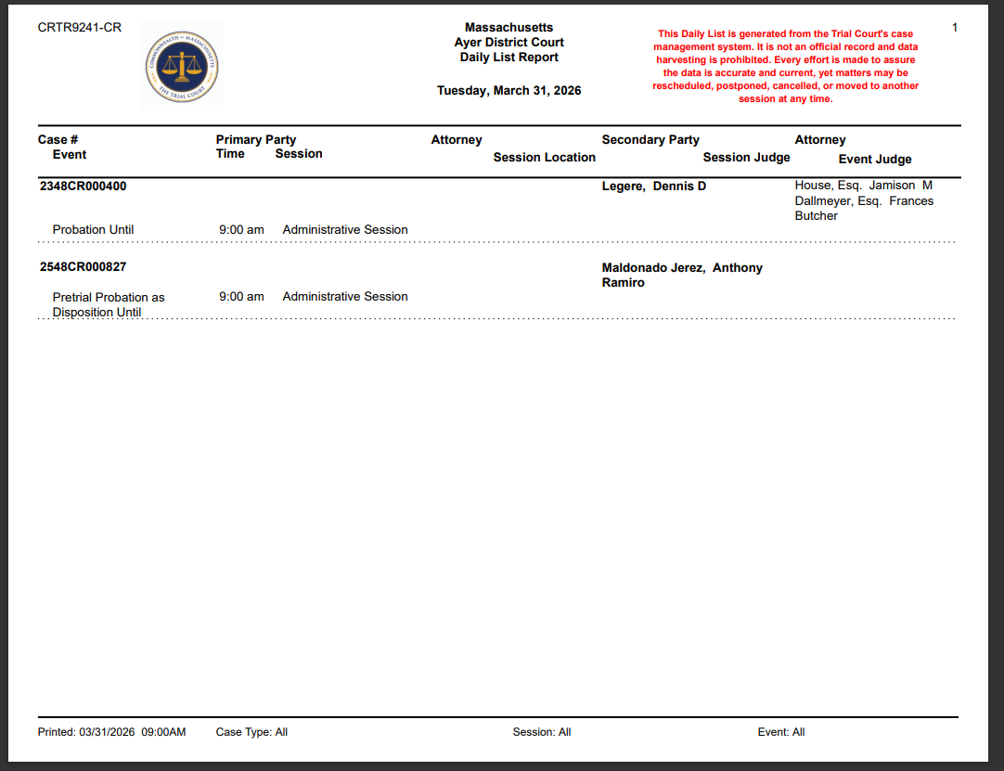

How to Collect Data

- Navigate to a URL in the Site Access list.


- Ensure that the report date matches the date of collection. Note: It may be necessary to adjust for timezone differences depending on the exact time of collection.
  - If the report date is correct, collect all pages of data.
  - If the report date is incorrect, attempt collection at a later time.
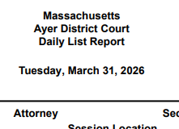
- Repeat steps 1 through 3 until all pages of all URLs are collected.

Data Map
URL:
1
Report Title:
2
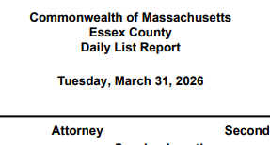
3
Case/Event Listing:
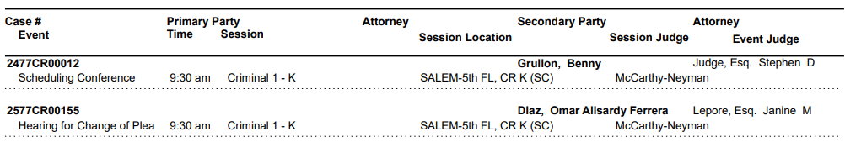
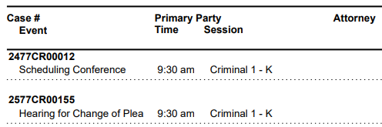
5
7
6
4
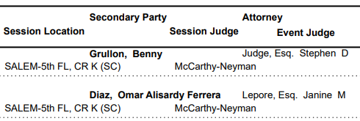
10
11
9
8
Position | Output Field | Website Name | Example
1 | Jurisdiction | Site # | 1177
2 | CourtName | Report Title | Commonwealth of Massachusetts Essex County
3 | CaseStatusDate | Report Date | Tuesday, March 31, 2026
4 | CaseNumber | Case # | 2477CR00012
5 | PrimaryParty | Primary Party | Blank
6 | CaseStatus | Event | Scheduling Conference
7 | Session | Session | Criminal 1 – K
8 | NameRaw | Secondary Party | Grullon, Benny
9 | SessionLocation | Session Location | SALEM-5th FL, CR K (SC)
10 | SessionJudge | Session Judge | McCarthy-Neyman
11 | EventJudge | Event Judge | Blank

