MA – MassCourts Case Access – Vendor Collection Instructions



Version History
DATE | ANALYST | VERSION | DESCRIPTION
3/31/2026 | Daniel O’Brien | 1.0 | New Entry
4/15/2026 | Daniel O’Brien | 1.1 | Made updates based on feedback.
04/15/2026 | Robert Griffith | 2.0 | Updated per review

Data Collection Instructions
Site Access
- Site URL: https://www.masscourts.org/eservices/home.page.2

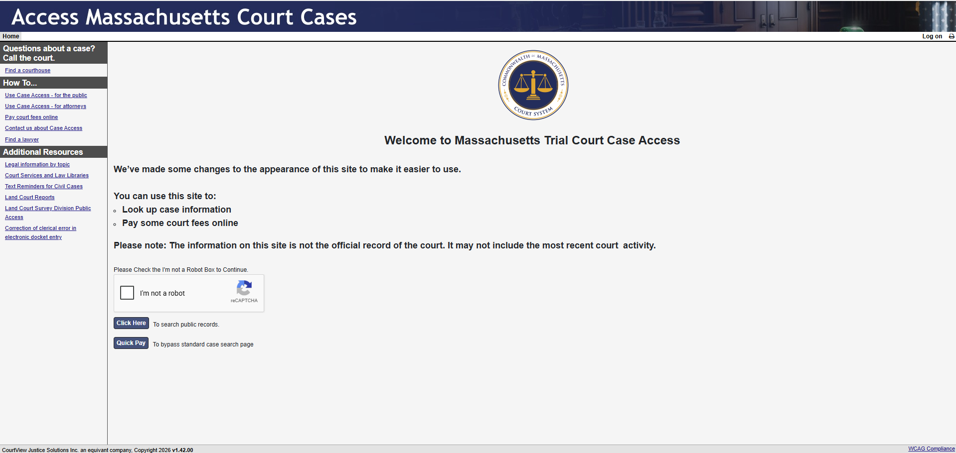

How to Enter a Search by Case Type and Date
- Solve the reCAPTCHA, if present, and click Click Here to the left of “To search public records”.
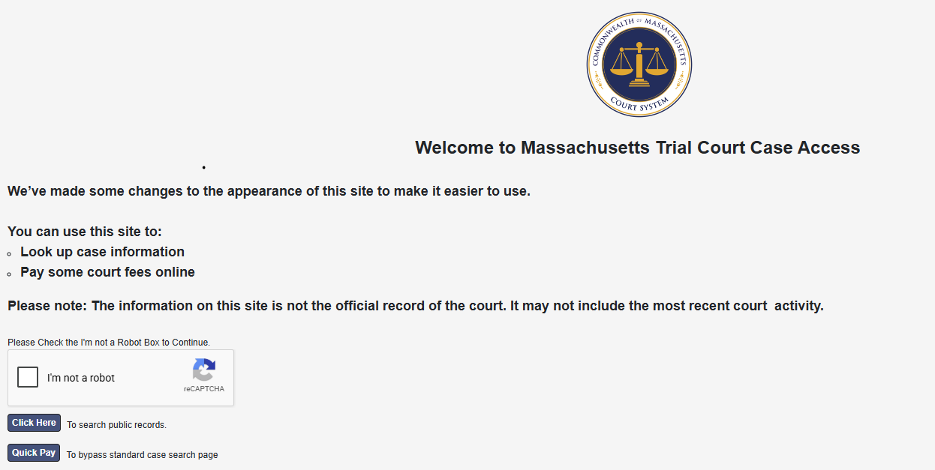

- On the next page, click the drop down below Number of Results and select 75.
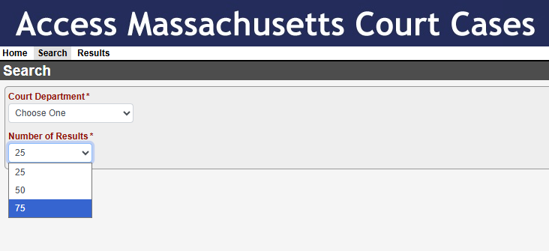
- Click the drop down below Court Department and select the court.
  - Example: BMC
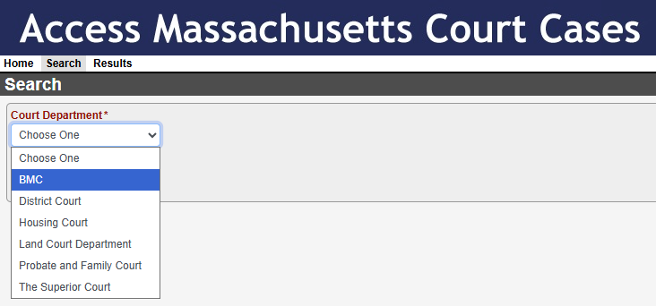
- A new dropdown will appear to the right. Under Court Division select the assigned court.
  - Example: BMC Brighton
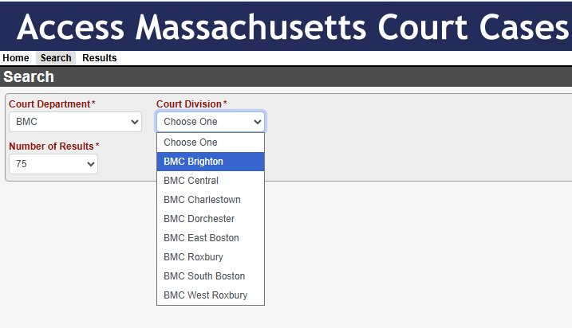
- New fields will populate, click Case Type.
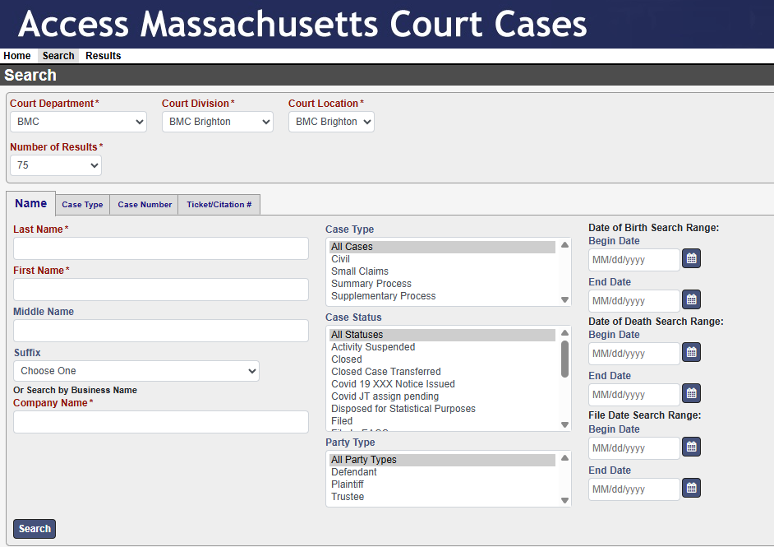
- Enter a date in each of the “Begin Date” and “End Date” fields in the format MM/DD/YYYY. The date range can be a maximum of one month.
  - Example: Begin Date = 01/01/2020 and End Date = 01/31/2020.
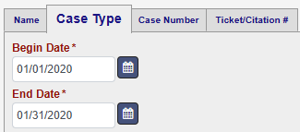
  - The maximum results displayed is 100, if there are more than 100 results when searching by month, search by week. If there are more than 100 results when searching by week, search by day.
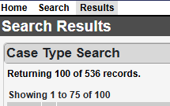
- Populate the Case Type according to leadlist instructions. In this example, “Criminal”.
- Select “All Cities” in the City/Town list, “All Statuses” in the Case Status list and “Defendant” in the Party Type list as seen below.
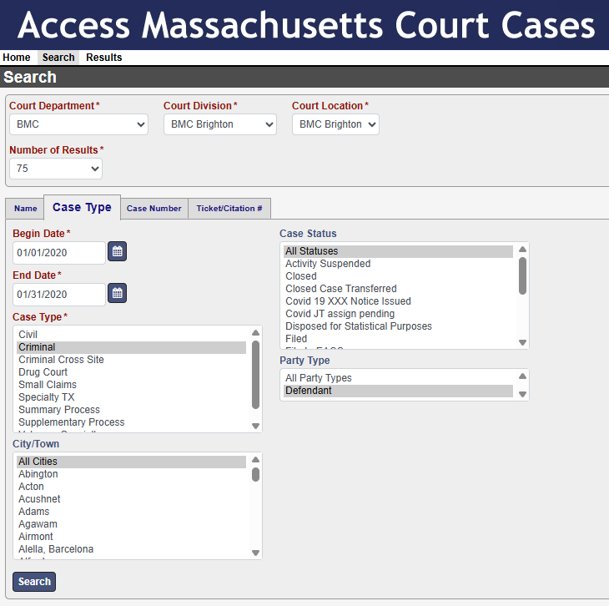
- Click Search.

- Search results page will populate. Collect all necessary information on this page per the datamap.

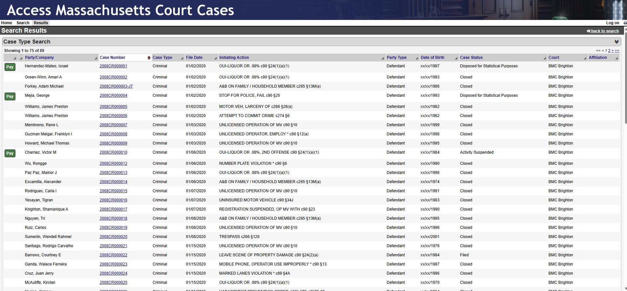

- Click on the hyperlinked Case Number.
- By default, the Case Details page will display.
  - Collect all necessary information per the datamap.
  - Screenshots below are all from Case Details page.
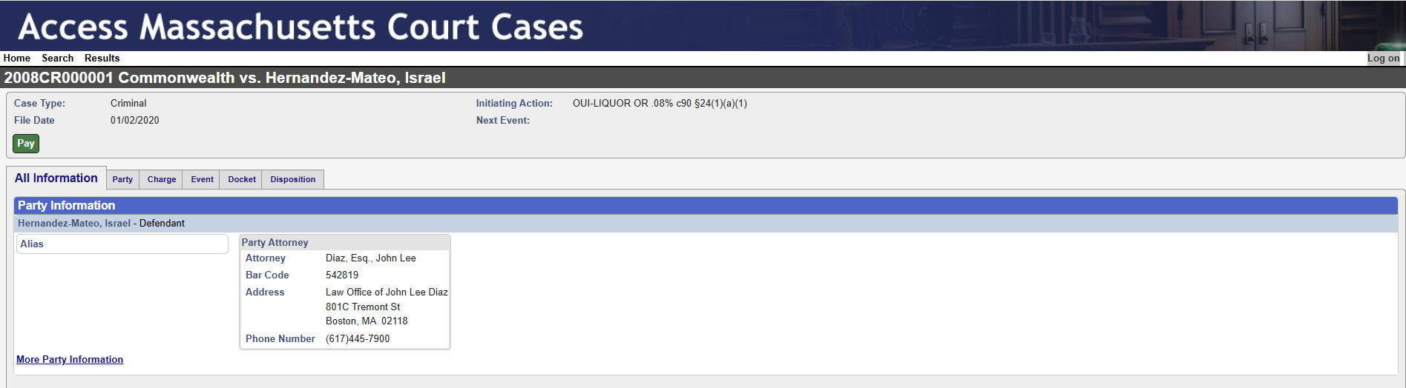
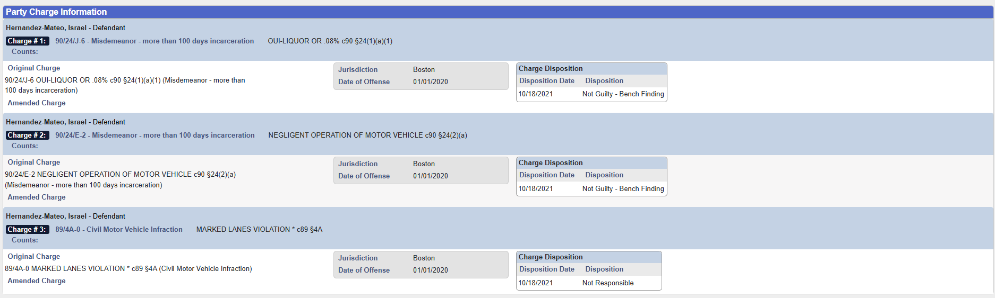
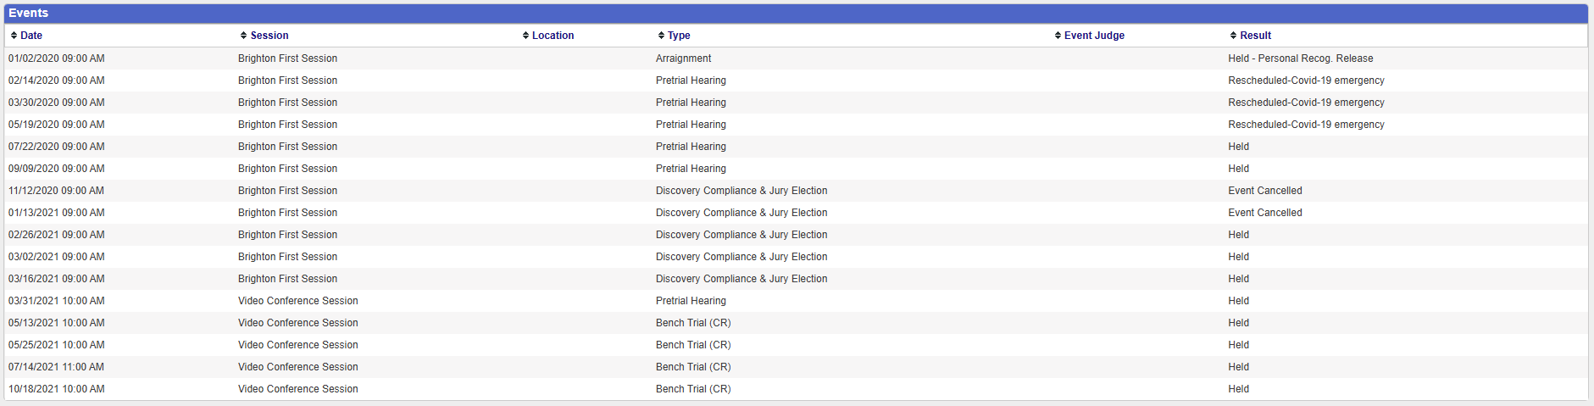
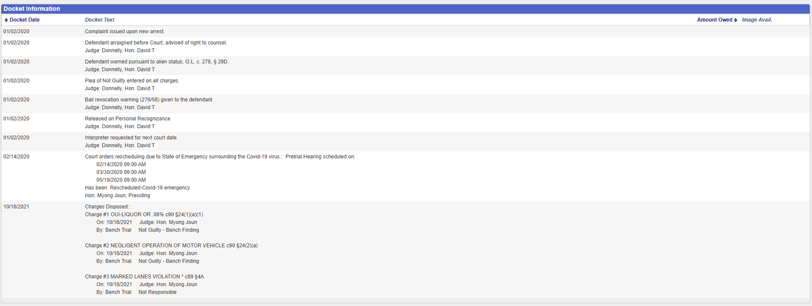
  - If there are more than 5 charges, only the first 5 charges are visible by default. Click the option to display all charges to capture all charges per case. See screenshot below for example from case #2008CR000004
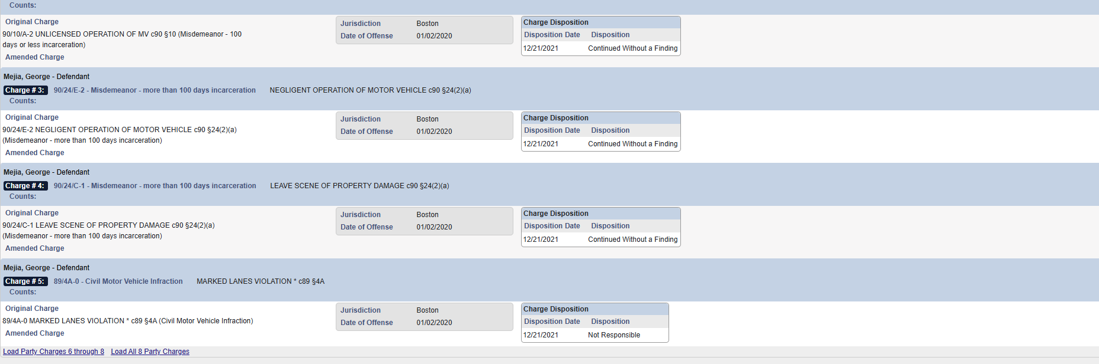
- Once all case information is collected, click Results to return to the search results page.
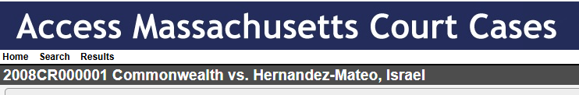
- Repeat steps 11-13 until all search results are collected.
- Repeat steps 2-14 until all courts searched and all search results collected.

How to Enter a Search by Case Number
- Solve reCAPTCHA, if present, and click Click Here to the left of “To search public records”.


- On the next page, click the drop down below Number of Results and select 75.

- Click the drop down below Court Department and select the court.
  - Example: BMC

- A new dropdown will appear to the right. Under Court Division select the assigned court.
  - Example: BMC Brighton

- New fields will populate, click Case Number.

- Enter a Case Number into the box below Case Number.
  - Ex: 2008CR000001
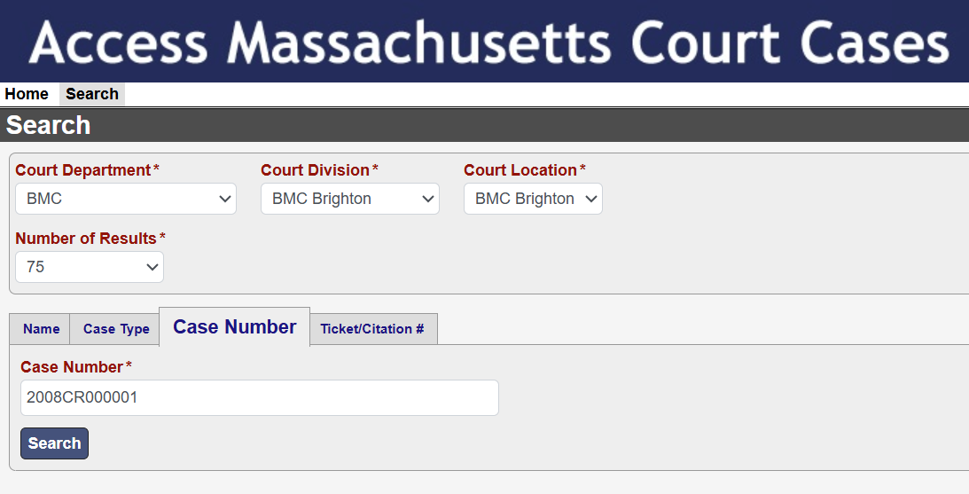

- Click Search.

- Search Results will populate. Collect all necessary information on this page per the datamap.
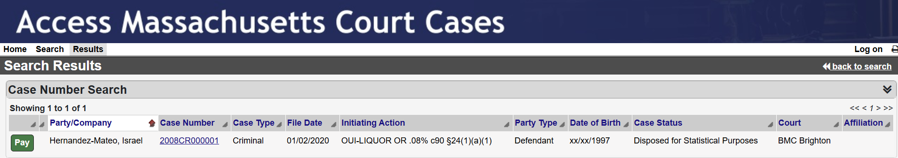
- Click on the hyperlinked Case Number.
- By default, the Case Details page will display.
  - Collect all necessary information per the datamap.
  - Screenshots below are all from Case Details page.




  - If there are more than 5 charges, only the first 5 charges are visible by default. Click the option to display all charges to capture all charges per case. See screenshot below for example from case #2008CR000004

- Once all case information is collected, click Results to return to the search results page.

- Repeat steps 8-11 until all search results are collected.
- Repeat steps 2-12 until all Case Numbers are searched and all search results are collected.

Data Map
CASE SEARCH PAGE
6
5
4
3
2
1
CASE DETAILS PAGE
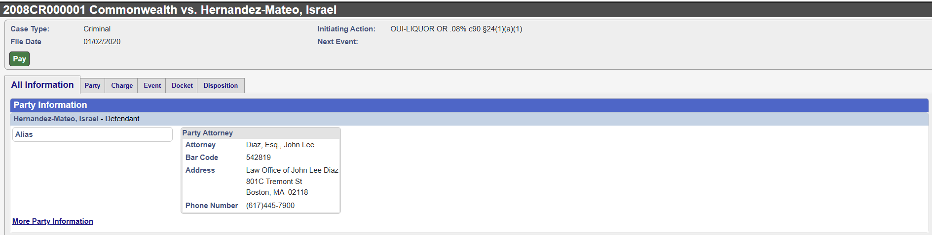
8
7
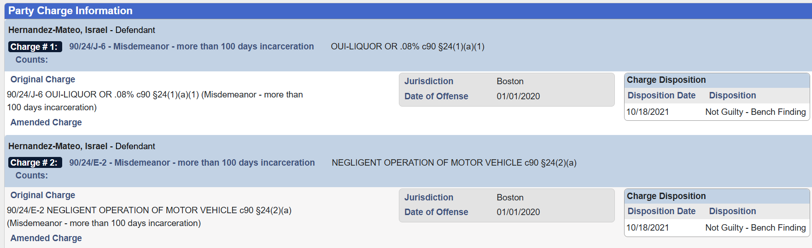
10
10
11
11
9
12
12
13
13
14
14
9

See Case #2008CR000001 for example with both Original Charge and Amended Charge
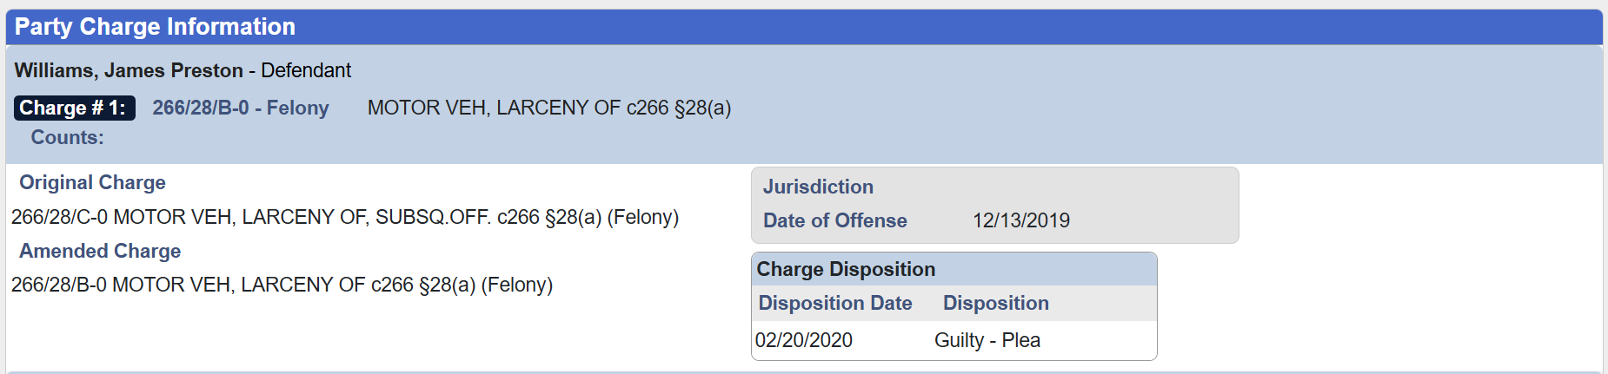
14
13
12
9
10
11
16
15

Notes:
- If multiple Dispositions exist, collect the most recent. For the example seen below, Disposition= “Dismissed – After Continuance Without a Finding” and Disposition Date = “10/19/2021”.
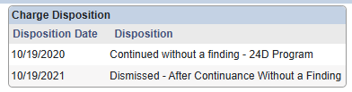
- For Alias, collect all values in a single output separated by a semicolon and space from Alias(s) (8).
- When a case contains multiple charges, collect all charges present.
- Statute (11) and Statute Description (10) should be mapped according the logic provided below:
  - Statute Description should contain text which describes the violation.
  - Statute should contain numbers and characters usually following the letter “c” and a number. From the examples in this document, “c90” begins the capture of the staute.
- Dispsotion Date (13) and Disposition (14) must be mapped to their corresponding charge. Ensure that the diposition on the website is mapped to the charge to the left and above the Disposition Date/Disposition.
- When collecting NameRaw (7), only collect name that corresponds to “Defendant”. In example seen above in the datamap, “- Defendant” follows “Hernandez-Mateo, Israel”. That is the name should be collected.

Position | Output Field | Website Name | Example
1 | CaseNumber | Case Number | 2008CR000001
2 | CourtCaseType | Case Type | Criminal
3 | FilingDate | File Date | 01/02/2020
4 | DOBRaw | Date of Birth | xx/xx/1997
5 | CaseStatus | Case Status | Disposed for Statistical Purposes
6 | Jurisdiction | Court | BMC Brighton
7 | NameRaw | Defendant | Hernandez-Mateo, Israel
8 | Alias | Alias
9 | ChargeLevel | Charge # | Misdemeanor
10 | StatuteDescription | Original Charge | OUI-LIQUOR OR .08%
11 | Statute | Original Charge | C90 24(1)(a)(1)
12 | OffenseDate | Date of Offense | 01/01/2020
13 | DispositionDate | Disposition Date | 10/18/2020
14 | Disposition | Disposition | Not Guilty – Bench Finding
15 | AmendedStatuteDescription | Amended Charge | MOTOR VEH, LARCENY OF
16 | AmendedStatute | Amended Charge | c266 28(a)

