Developer Kit – The Foundation

I started my career in software purely for the love of technology. When the first time, I saw the computer and first time, I saw a color monitor in my first job, the first program “Hello World” I wrote in 'C', everything related to programming made me happy.

I did coding for a decade.

But things do change in life. I at one point of time, wanted to know how to manage a project, people so I moved on from technology role to a management role. I enjoyed this role also. It was my choice. I enjoyed, being a leader, I enjoyed managing people, I enjoyed guiding them, saw the full picture of a software delivery from a project manager perspective

I did management for a decade.

I have come around a full circle. Now being in top of that circle, I am getting ready for my second round. This time, the full circle is going to be in technology only. Yes, I am getting myself ready to be a developer. I am not chasing a fancy designation as “Architect” “SME” etc., I am a developer who should be able to architect, design, write code, build, test, deploy.

The full picture. You are getting it right? When I started my career each of this will be done by a different person. But in today's context, a developer should do the full life cycle of activities. From architecting to pre production deployment. In somecases, production deployment.

So this being our current state of a development career, and I am again starting from the letter “A”, I started thinking what is the best way to start learning. There are way too many choices for a developer today, but there should be a rock solid foundation one should have, there should be a development kit every developer should own, the kit he is master of.

This development kit will form his bedrock and on top of that he / she will learn and become more expert in certain areas or add more tools to his / her tool kit.

So what that development kit should consist of?

I set out to find the answer. Thanks to my friend in USA, who colloborated with me in this search, I have figured out the tools.

Let see one by one.

1. Learn Linux

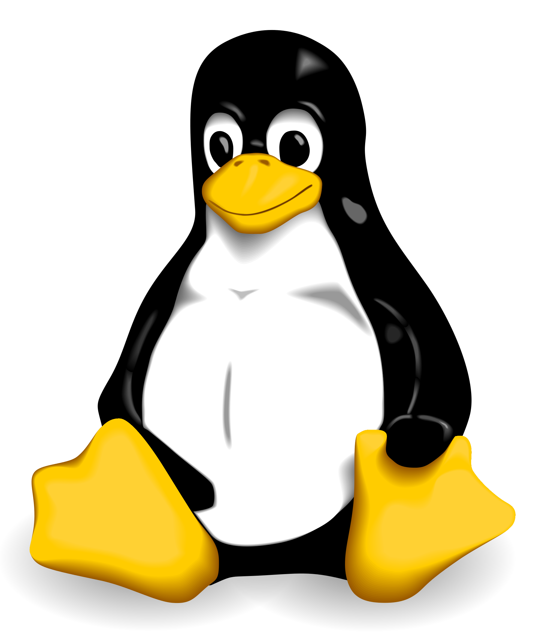

Linux is everywhere. Be it enterprise servers, data processing (Big Data), IOT, you name a tech field and linux is there. So for a developer learning Linux is very important. He should be very comfortable in handling day to day tasks related to development and administration in Linux. From here one should technically grow to compile a kernal and create a customized distro. This will be the final goal for this learning unit.

2. Learn a Language (inclusive of Functional)


Why to learn a functional language? Read it here
https://www.quora.com/Why-should-I-learn-a-functional-programming-language

Also watch the embedded video in that post.

Why Scala? I am coming from a Java background, so Scala became my natural choice. Infact I was tied up between Java8 and Scala, but chose Scala, due it's simplicity.

Haskell is another language one can look at, as suggested in the link given above. Again it's your choice. My choice is Scala.

3. Learn a Scripting Language
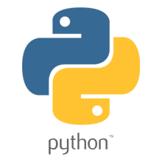

Today everything is getting automated. Automation range from OS automation, to Software development life cycle automation, to automation of business tasks, automation directly relates to saving time and in turn saving cost. So knowing a scripting language is a must for a developer. My choice here is Python and Bash.

I am not going into Why Python? Or Why sh? Both are very much established languages in their own.

Why two languages, because, Python is used everywhere, since Linux is there, sh is the defacto shell scripting language in Linux, it's must to learn it.

4. Learning a programming IDE

We are programmers and we need to use an IDE to write our code. So no need to justify more than this.



For both Scala and Python, I am going to use Ecplise.

5. Learn a general purpose text editor

You need to effectively and efficiently create, edit, save text files in your life as a coder. So need to know one advanced general purpose text editor. My choice is
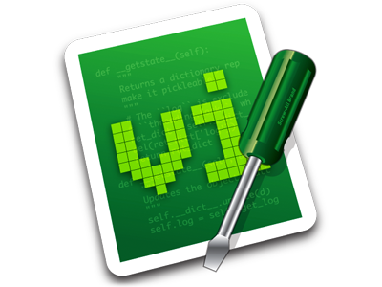

6. Learn an RDBMS & Non Relational DB

Data is everywhere. Relational or Non Relational. So a developer should master one Relational and one Non Relational DB. My choice here is
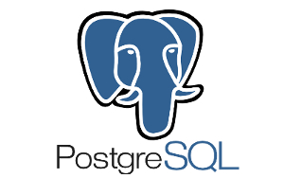

with PostgreSQL 9.4 providing advanced JSON support, this DB has become a mix of Relational and Non Relational. So better to learn PostgreSQL first.

7. Learn Messaging


I was instructed by my friend to learn Apache Kafka. This is important because messaging has become a core infrastructural component in integration of disparate systems that passes tons of data as messages up and down.

8. Learn Cross Cutting Concerns – (Transactions, Security, Logging)

You cannot write an application without touching any of these. So better learn it.

9. Learn protocols (Rest, Websockets and HTTP)

Everything is a service and everything connects to every other things and everything runs on HTTP. Can't justify beyond this on why to learn these protocols.

10. Learn Social Coding Tool (Github)

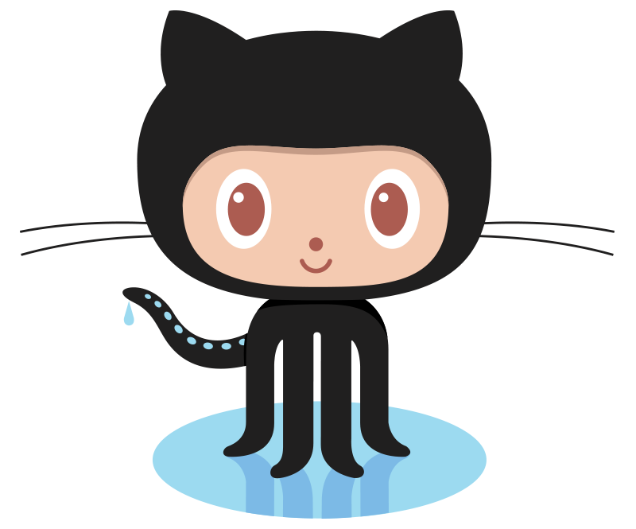

GitHub is must and should be learned. No need to justify on why to learn this.

11. Learn Build automation (Maven, Gradle)

What you write as a code, should be built and deployed. Dependency management tools makes your life easier and reduces surprises and headaches. So learn Maven and Learn Gradle. Nothing wrong in learning two.

12. Learn atleast one cloud suite (AWS)

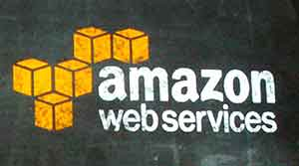

Everything is moving to cloud. So a developer should learn, atleast one cloud infrastructure. I chose AWS due to it's availability for me to use it for free for an year.

13. Learn Continous Deployment (Chef or Puppet)

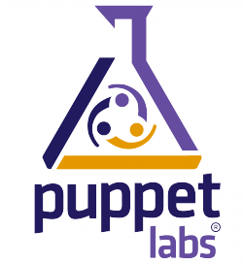

Chef or Puppet should be learned. Today entire software delivery process has been automated using either of these. No one has time to do things manually. With emergence of cloud that changed how we provision infrastructure, every step from coding, testing, deploying is automated as technology for that is now available. Learn Chef or Puppet.

14. Learn Virtualization, Containers (Docker)

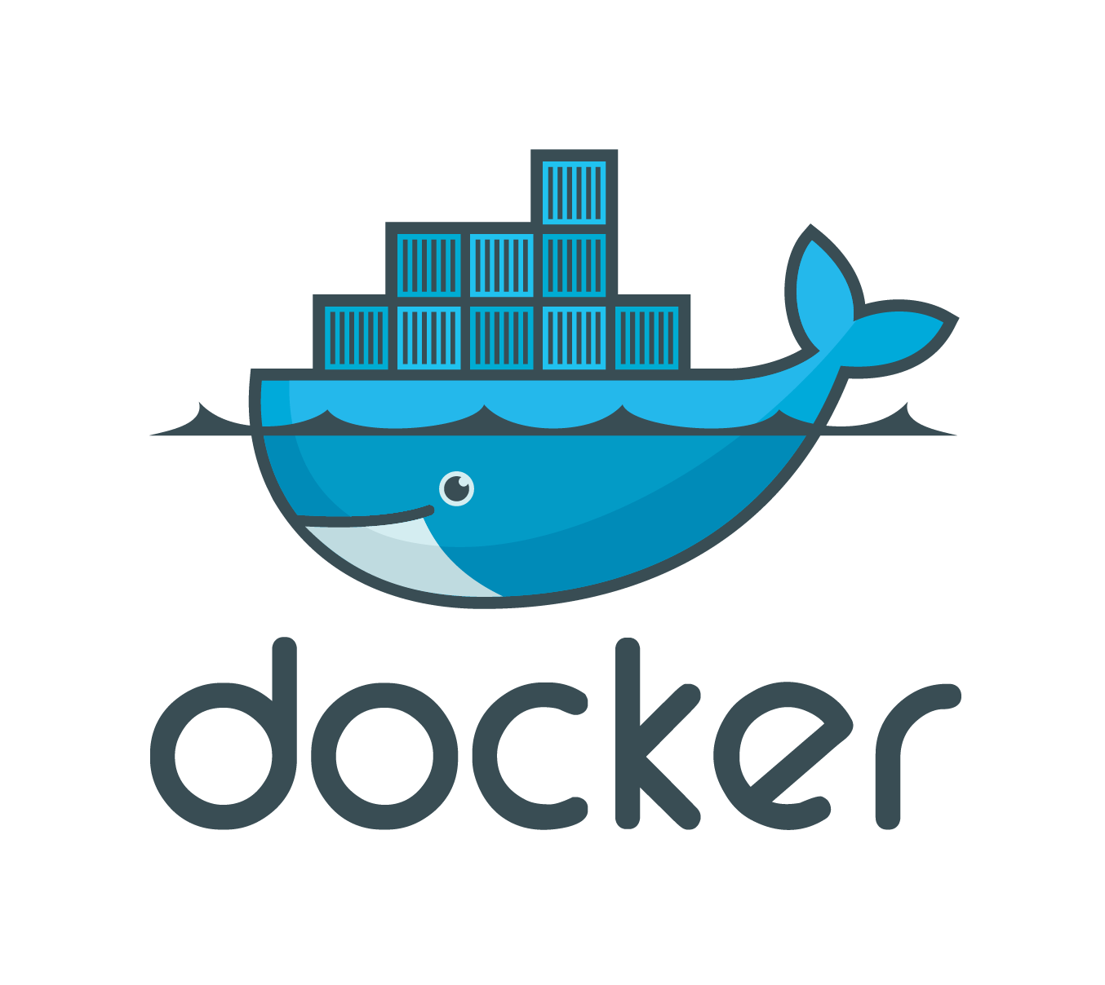

With advent of cloud, virtualization has become a mainstream technology. On top of that now Containers have started impacting how we deploy our software across environments. Docker is one such container, that should be learned.

Epilogue:

This is not some kind of list, that need's to be completed. This is a journey. An interesting one, that is. Learning should also not to be done in a mechanical way, like, I will read that tutorial, this book etc., But every single day of learning should have a list of tasks I need to accomplish which will take me forward by a bit.

Technology learning should be task oriented. Not content oriented. So before starting to learn a technology, figure out what are the basic tasks, advanced tasks that can be achieved. Write down this list, go ahead and do that. Once you complete the last task in that list, I should have attained a comfortable stage in that, which I can use in my day work to write professional software.

Mastery does not happen in a short period of time, By doing and learning over a period of time, one attains mastery. So the goal of this learning journey is not to attain mastery but to re-align myself with the developer community and contribute back by writing my own app or contributing in a open source project.

This Learn – Do cycle is life long journey. I am happy to be back to the fold.

Do let me know what you think about this list and whether this is useful for your in your learning journey.

