Installing Scala IDE in Ubuntu

I hope you have already installed Scala in your system. If not, follow the following steps.

sudo wget www.scala-lang.org/files/archive/scala-2.11.7.deb
sudo dpkg -i scala-2.11.7.deb
sudo apt-get update
sudo apt-get install scala

You can check scala version by using this command

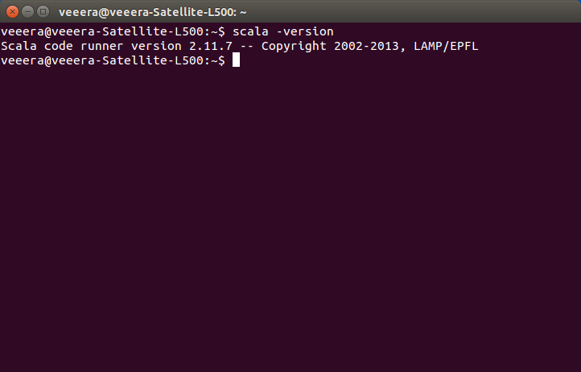

With that done, follow below steps to install ScalaIDE.

1. Download ScalaIDE from the following link.

http://downloads.typesafe.com/scalaide-pack/4.3.0-vfinal-luna-211-20151201/scala-SDK-4.3.0-vfinal-2.11-linux.gtk.x86_64.tar.gz

2. Extract this compressed file into /opt/ directory

cd /opt/ && sudo tar -zxvf ~/Downloads/eclipse-*.tar.gz

3. Create a desktop icon for installed ScalaIDE

sudo gedit /usr/share/applications/eclipse.desktop

this will open the eclipse.desktop file in gedit text editor

[Desktop Entry]
Name=ScalaIDE 4
Type=Application
Exec=/opt/eclipse/eclipse
Terminal=false
Icon=/opt/eclipse/icon.xpm
Comment=Integrated Development Environment
NoDisplay=false
Categories=Development;IDE;
Name[en]=ScalaIDE

Now use Unity to search for Scala and find the result.

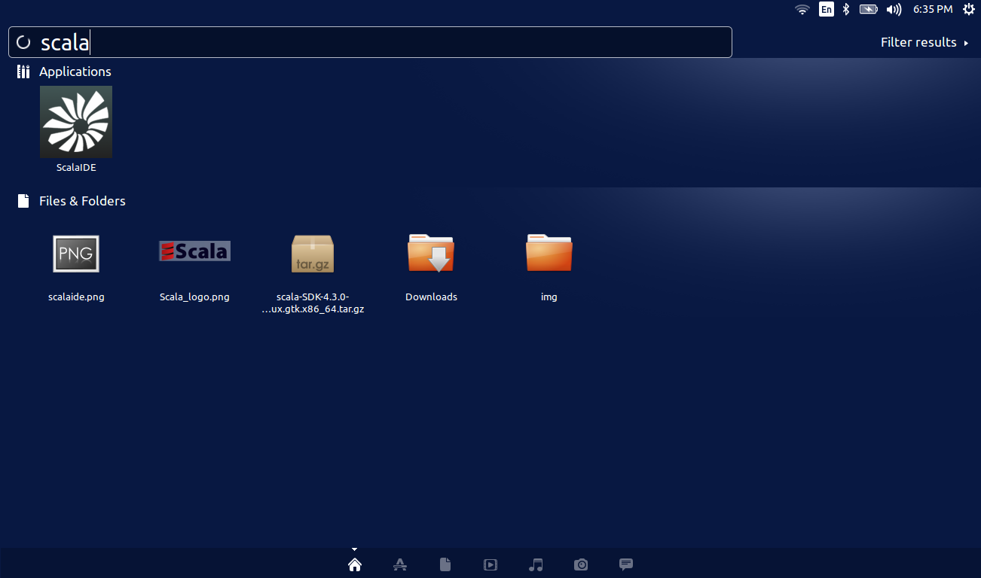

Hope these instructions were useful to you.

Let's now start to learn to code in Scala.

