DAY6

Vel Yogesh C B

727721EUCS175

1)

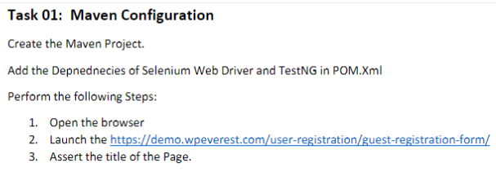

CODING:

package com.testNG;

import org.testng.annotations.Test;

import io.github.bonigarcia.wdm.WebDriverManager;

import org.testng.annotations.BeforeMethod;

import org.openqa.selenium.WebDriver;

import org.openqa.selenium.chrome.ChromeDriver;

import org.openqa.selenium.chrome.ChromeOptions;

import org.testng.Assert;

import org.testng.annotations.AfterMethod;

public class ce1 {

WebDriver driver;

*@Test*

public void check() {

driver.get("https://demo.wpeverest.com/user-registration/guest-registration-form/");

String exp="Guest Registration Form – User Registration";

String act=driver.getTitle();

driver.manage().window().maximize();

Assert.*assertEquals*(exp, act);

}

*@BeforeMethod*

public void beforeMethod() {

ChromeOptions co=new ChromeOptions();

co.addArguments("--remote-allow-origins=\*");

WebDriverManager.*chromedriver*().setup();

driver=new ChromeDriver();

}

*@AfterMethod*

public void afterMethod() {

driver.close();

}

}

OUTPUT:

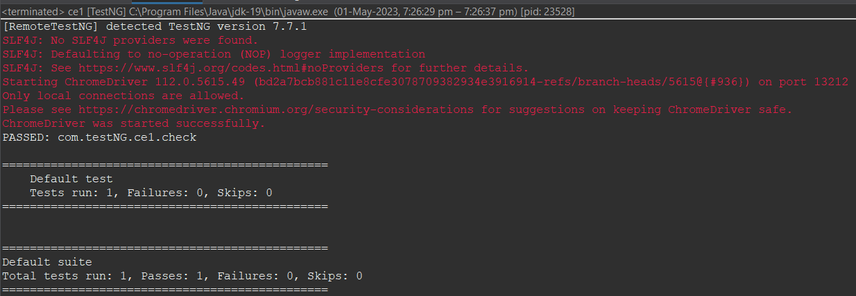

2)

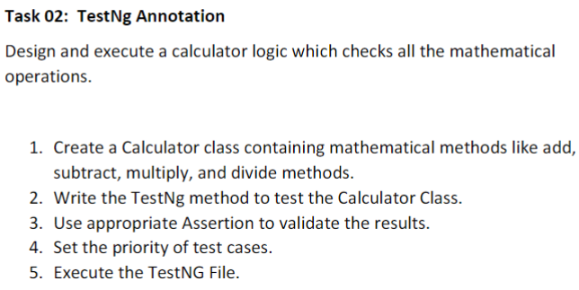

CODING:

package com.testNG;

import org.testng.annotations.Test;

import org.testng.annotations.BeforeMethod;

import org.testng.Assert;

import org.testng.annotations.AfterMethod;

public class ce2 {

int a=100,b=20,res=0;

@Test (priority=2)

public void add() {

res=a+b;

System.out.println(res);

Assert.assertEquals(res,120);

}

@Test (priority=3)

public void sub() {

res=a-b;

System.out.println(res);

Assert.assertEquals(res,80);

}

@Test (priority=1)

public void div()

{

res=a/b;

System.out.println(res);

Assert.assertEquals(res,5);

}

@Test (priority=4)

public void multiply()

{

res=a\*b;

System.out.println(res);

Assert.assertEquals(res,2000);

}

@BeforeMethod

public void beforeMethod() {

}

@AfterMethod

public void afterMethod() {

}

}

OUTPUT:

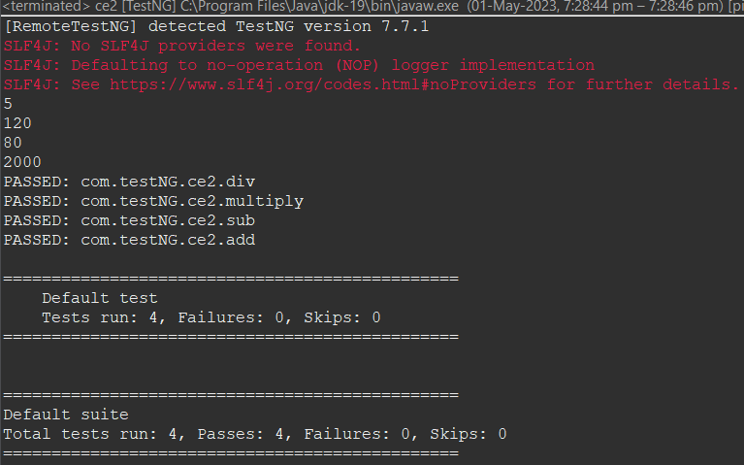

3)

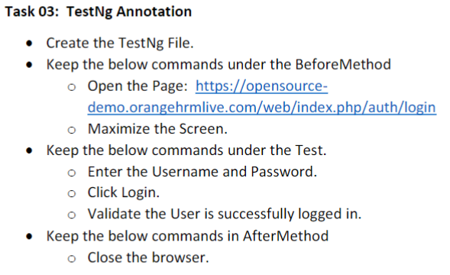

CODING:

package com.testNG;

import org.testng.annotations.Test;

import io.github.bonigarcia.wdm.WebDriverManager;

import org.testng.annotations.BeforeMethod;

import org.openqa.selenium.By;

import org.openqa.selenium.WebDriver;

import org.openqa.selenium.WebElement;

import org.openqa.selenium.chrome.ChromeDriver;

import org.openqa.selenium.chrome.ChromeOptions;

import org.testng.Assert;

import org.testng.annotations.AfterMethod;

public class ce3 {

WebDriver d;

@Test

public void Test() throws InterruptedException {

WebElement name=d.findElement(By.name("username"));

name.click();

name.sendKeys("Admin");

WebElement pwd=d.findElement(By.name("password"));

pwd.sendKeys("admin123");

d.findElement(By.xpath("//\*[@id=\"app\"]/div[1]/div/div[1]/div/div[2]/div[2]/form/div[3]/button")).click();

Thread.sleep(4000);

String tname=d.findElement(By.xpath("//\*[@id=\"app\"]/div[1]/div[2]/div[2]/div/div[2]/div/div[1]/div/p")).getText();

Assert.assertEquals(tname, "My Actions");

}

@BeforeMethod

public void beforeMethod() throws InterruptedException {

ChromeOptions co=new ChromeOptions();

co.addArguments("--remote-allow-origins=\*");

WebDriverManager.chromedriver().setup();

d=new ChromeDriver();

d.get("https://opensource-demo.orangehrmlive.com/web/index.php/auth/login");

d.manage().window().maximize();

Thread.sleep(4000);

}

@AfterMethod

public void afterMethod() {

d.close();

}}

OUTPUT:

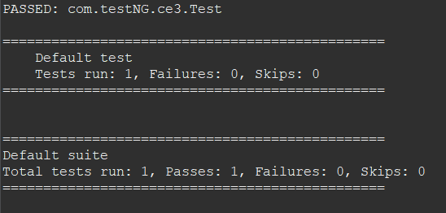

4)

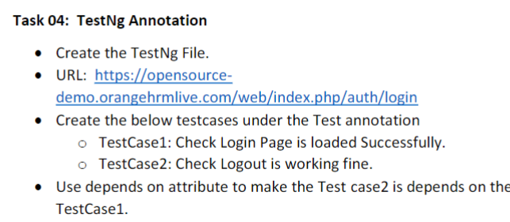

CODING:

package com.testNG;

import org.testng.annotations.Test;

import io.github.bonigarcia.wdm.WebDriverManager;

import org.openqa.selenium.By;

import org.openqa.selenium.WebDriver;

import org.openqa.selenium.WebElement;

import org.openqa.selenium.chrome.ChromeDriver;

import org.openqa.selenium.chrome.ChromeOptions;

import org.testng.Assert;

import org.testng.annotations.AfterClass;

import org.testng.annotations.BeforeClass;

public class ce4 {

WebDriver driver;

@Test(priority=1)

public void Test1() throws InterruptedException {

WebElement name=driver.findElement(By.xpath("//\*[@id=\"app\"]/div[1]/div/div[1]/div/div[2]/div[2]/form/div[1]/div/div[2]/input"));

name.sendKeys("Admin");

WebElement pwd=driver.findElement(By.xpath("//\*[@id=\"app\"]/div[1]/div/div[1]/div/div[2]/div[2]/form/div[2]/div/div[2]/input"));

pwd.sendKeys("admin123");

Thread.sleep(1000);

driver.findElement(By.xpath("//\*[@id=\"app\"]/div[1]/div/div[1]/div/div[2]/div[2]/form/div[3]/button")).click();

Thread.sleep(2000);

String act="Dashboard";

String s=driver.findElement(By.xpath("//\*[@id=\"app\"]/div[1]/div[1]/header/div[1]/div[1]/span/h6")).getText();

Assert.assertEquals(act, s);

Thread.sleep(15000);

}

@Test(dependsOnMethods= {"Test1"})

public void Test2() throws InterruptedException {

driver.findElement(By.xpath("//\*[@id=\"app\"]/div[1]/div[1]/header/div[1]/div[2]/ul/li/span/img")).click();

driver.findElement(By.xpath("//\*[@id=\"app\"]/div[1]/div[1]/header/div[1]/div[2]/ul/li/ul/li[4]/a")).click();

Thread.sleep(2000);

String s1="Login";

String s2=driver.findElement(By.xpath("//\*[@id=\"app\"]/div[1]/div/div[1]/div/div[2]/h5")).getText();

Assert.assertEquals(s1, s2);

}

@BeforeClass

public void beforeMethod() throws InterruptedException {

ChromeOptions co=new ChromeOptions();

co.addArguments("--remote-allow-origins=\*");

WebDriverManager.chromedriver().setup();

driver=new ChromeDriver();

driver.navigate().to("https://opensource-demo.orangehrmlive.com/web/index.php/auth/login");

driver.manage().window().maximize();

Thread.sleep(2000);

}

@AfterClass

public void afterMethod() {

driver.close();

}}

OUTPUT:

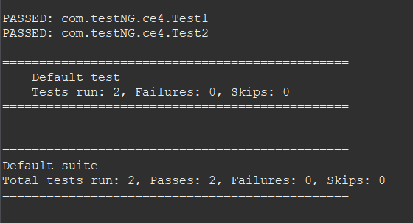

5)

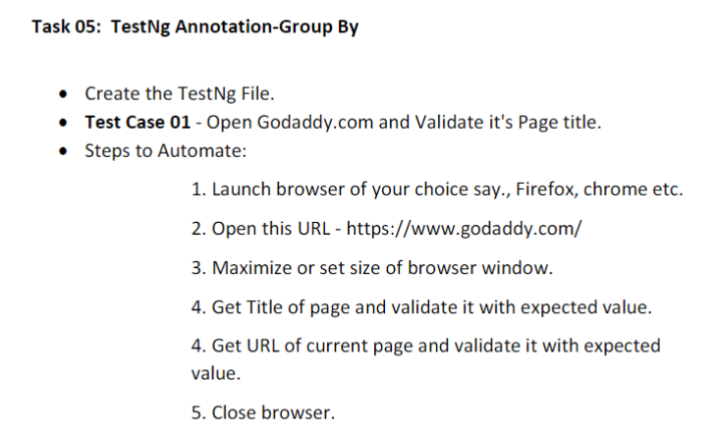

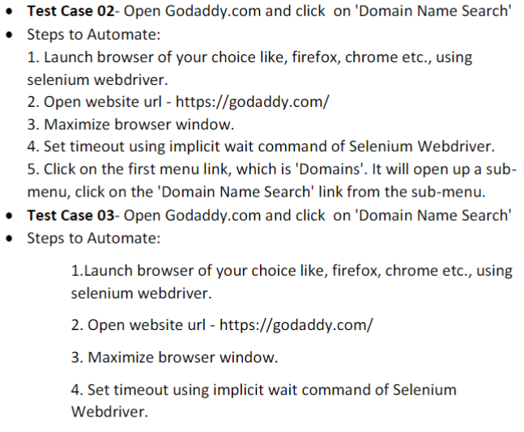

CODING:

package com.testNG;

import org.testng.annotations.Test;

import io.github.bonigarcia.wdm.WebDriverManager;

import org.testng.annotations.BeforeClass;

import java.util.concurrent.TimeUnit;

import org.openqa.selenium.By;

import org.openqa.selenium.WebDriver;

import org.openqa.selenium.WebElement;

import org.openqa.selenium.chrome.ChromeDriver;

import org.openqa.selenium.chrome.ChromeOptions;

import org.testng.Assert;

import org.testng.annotations.AfterClass;

public class ce5 {

WebDriver driver;

*@Test*(groups="SmokeTest")

public void check() {

String text = driver.getTitle();

String expected="Domain Names, Websites, Hosting & Online Marketing Tools - GoDaddy IN";

Assert.*assertEquals*(text,expected);

}

*@SuppressWarnings*("deprecation")

*@Test*(groups="RegressionTest")

public void testcase2() throws InterruptedException

{

driver.findElement(By.*xpath*("//\*[@id=\"id-631b049a-e9c0-4d24-8710-c504745206dd\"]/div[2]/div[1]/ul/li[1]/button")).click();

driver.manage().timeouts().~~implicitlyWait~~(4000,*TimeUnit*.SECONDS);

driver.findElement(By.*xpath*("//\*[@id=\"id-631b049a-e9c0-4d24-8710-c504745206dd\"]/div[2]/div[1]/ul/li[1]/div/div[2]/div[1]/ul/li[2]/a")).click();

driver.manage().timeouts().~~implicitlyWait~~(4000,*TimeUnit*.SECONDS);

}

*@BeforeClass*

public void beforeClass() throws InterruptedException {

ChromeOptions co=new ChromeOptions();

co.addArguments("--remote-allow-origins=\*");

WebDriverManager.*chromedriver*().setup();

driver=new ChromeDriver();

driver.get("https://www.godaddy.com/");

driver.manage().window().maximize();

Thread.*sleep*(6000);

}

*@AfterClass*

public void afterClass() throws InterruptedException {

Thread.*sleep*(6000);

driver.close();

}

}

OUTPUT:

