Business Requirements Document (BRD)
E-commerce Order Management System (OMS)
Portfolio case study - hypothetical company and synthetic data (Jan-Jun 2026)

Field | Detail
Prepared by | Vikash Verma - Business Analyst (portfolio project)
Version | 1.0 (for review)
Date | 13 October 2026
Status | Draft for stakeholder sign-off
Approvers | Product Manager, Operations Manager, Finance Head

1. Business Objective
Replace the current fragmented order handling with a single Order Management System (OMS) that gives accurate stock, reliable payments, on-time fulfilment and full order visibility, so that the company grows revenue while lowering support cost.
Business Requirement | Target / baseline from data
BR-01 | Reduce late deliveries (baseline 24.8% delayed vs. promised date; target <=10%)
BR-02 | Recover revenue lost to failed payments (baseline 3.0% of orders lost; Net Banking 11.3% attempt failure)
BR-03 | Make inventory accurate in real time (baseline 26% of SKUs mismatched at audit; target <=5%)
BR-04 | Give customers and staff full order-status visibility (21% of tickets are 'where is my order')
BR-05 | Cut avoidable support tickets (baseline 1,081 tickets on 6,000 orders; target -35%)
BR-06 | Makes cancellations, returns and refunds fast and transparent (137 refunds pending; avg refund-delay ticket 4.7 days)

2. Problem Statement
The company is receiving growing complaints about delayed orders, cancellations, failed payments, inventory mismatches, excessive support tickets and poor visibility of order status. Analysis of 6,000 orders (Jan-Jun 2026) shows the problem is measurable:
- 24.8% of delivered orders arrived after the promised date; average order-to-delivery is 6.2 days, of which 2.3 days is dispatch.
- 5.4% of orders are cancelled (1.8% because of dispatch delay, 1.0% because stock ran out after the order).
- 3.0% of orders are lost to payment failure; Net Banking fails 11.3% and Debit Card 7.4% of attempts versus 4.7% for UPI. Bank timeout and OTP failure are the top reasons.
- 26% of SKUs differ between system and physical stock at the June audit.
- 1,081 support tickets were raised (about 18 per 100 orders); 55% are 'delayed order' and 21% 'order status inquiry'.
- Fashion has a 16.7% return rate, double the next category; 137 refunds worth INR 9.5 lakh are still pending.
- Only 18.4% of sessions end in an order; the funnel loses 58% between product view and add-to-cart.
Source: SQL analysis in /sql/analysis_queries.sql run on the project dataset (see docs/sql_results.md).

3. Scope

In scope
- Checkout, payment handling (retry, idempotency) and order confirmation
- Real-time inventory check, reservation and reconciliation
- Order status lifecycle, customer tracking page and notifications
- Warehouse allocation, carrier assignment and SLA-risk alerts
- Self-service cancellation, returns and automated refunds
- Support 'Order 360' view, audit log and KPI dashboard

Out of scope
- Product catalogue, pricing and promotions engine
- Marketing / recommendation features
- Replacing the payment gateway or building a new WMS
- Seller / marketplace onboarding
- Physical logistics network redesign

4. Stakeholder Analysis
Stakeholder | Role | Influence | Interest | Needs / concerns | Engagement
Customer | End user placing and tracking orders | High | Medium | Fast delivery, no payment failures, clear status, easy refunds | Keep informed (notifications); validated through surveys/UAT personas
Customer Support | Handles complaints and tickets | Medium | High | Single view of order, fewer 'where is my order' tickets | Consult; process owner for FR-14; UAT participant
Operations Manager | Owns delivery SLA and fulfilment performance | High | High | SLA visibility, early delay alerts, carrier accountability | Manage closely; business sponsor
Warehouse Team | Pick, pack, dispatch, stock counts | Medium | High | Accurate stock, clear pick lists, realistic cut-off times | Consult; UAT participant for FR-08/15
Finance | Payments, refunds, reconciliation | High | Medium | Correct refunds, reconciliation, reduced revenue leakage | Manage closely; sign-off on FR-13
Product Manager | Owns roadmap and priorities | High | High | Business value, scope control, release timing | Manage closely; approves BRD and backlog
Developer | Builds the solution | Low | Medium | Clear, testable requirements; stable scope | Keep informed; refinement sessions
QA | Verifies the solution | Low | Medium | Testable acceptance criteria, traceability | Keep informed; owns test cases and RTM execution
Payment Gateway (external) | Third-party payment processing | Medium | Medium | Correct API usage, idempotency, low failure/timeouts | Monitor; SLA/contract; integration spec

High influence + high interest (Product Manager, Operations Manager, Finance) are managed closely and sign off the BRD; Support and Warehouse are consulted continuously because they run the process daily; Customer needs are represented through personas and surveys.

5. As-Is Process and Bottlenecks
Current flow: Customer places order > Payment > Inventory check > Warehouse > Shipment > Delivery > Return/Refund. Inventory is checked after payment, so stock-outs are discovered too late; there is no retry for failed payments, no SLA alert in the warehouse and no proactive customer communication.
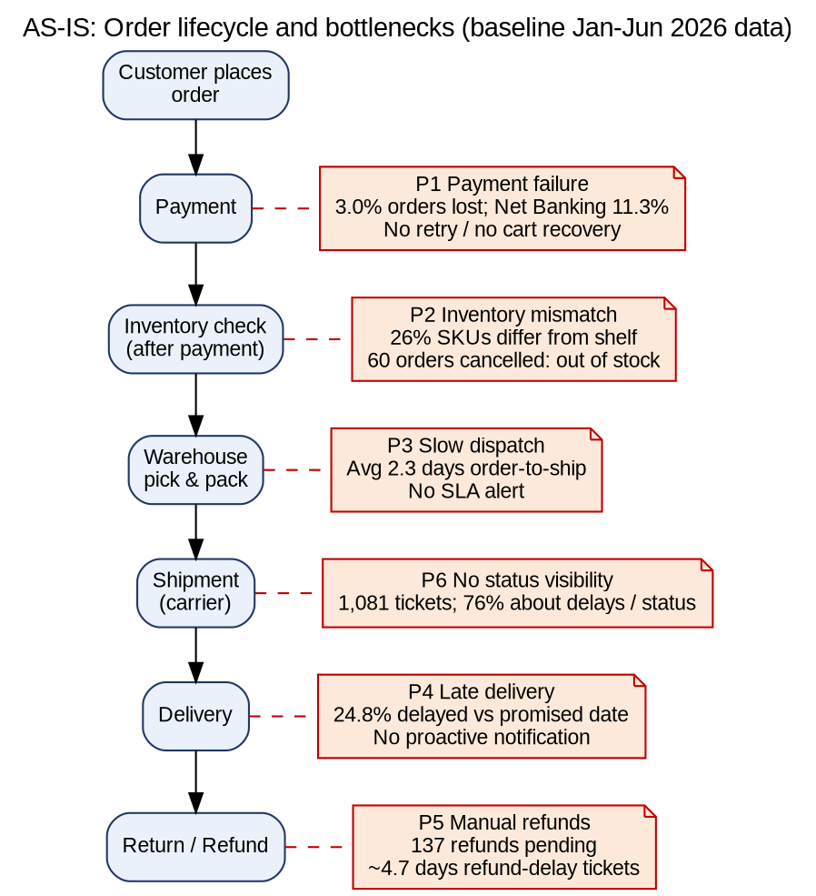
# | Bottleneck | Evidence | Impact
P1 | Payment failure without retries | 3.0% orders lost; Net Banking 11.3% failure | Lost revenue, abandoned carts
P2 | Inventory checked after payment | 26% SKU mismatch; 60 out-of-stock cancellations | Cancellations, refunds, trust
P3 | Slow dispatch, no SLA alert | 2.3 days average order-to-ship | Late delivery, dispatch-delay cancellations
P4 | Late delivery | 24.8% delayed; XpressBees and Mumbai warehouse weakest | Complaints, returns
P5 | Manual refunds | 137 pending, 4.7-day refund-delay tickets | Finance exposure, complaints
P6 | No status visibility | 76% of tickets about delay or status | Support cost

6. To-Be Process
Key design changes: (1) stock is checked and reserved before payment, (2) payment can be retried or switched without losing the cart, (3) the order is confirmed only after payment success, (4) orders are auto-allocated to the nearest stocked warehouse with a 24-hour pick/pack alert, (5) carriers are assigned by performance and tracked, (6) customers get proactive notifications, and (7) cancellations, returns and refunds are self-service and automated.
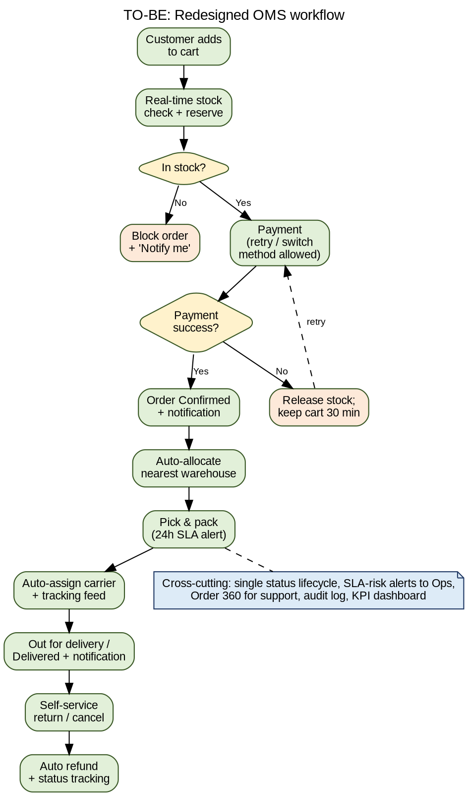

7. Functional Requirements
ID | Requirement | Linked BR | Priority
FR-01 | Create an order as 'Confirmed' only after payment success (or COD confirmation); failed payment leaves order in 'Payment Pending'. | BR-02 | High
FR-02 | Allow payment retry and switching to an alternate method within 30 minutes without re-entering the cart; payments must be idempotent (no double charge). | BR-02 | High
FR-03 | Check livestock and reserve quantity at checkout; release the reservation if payment fails or times out. | BR-03 | High
FR-04 | Block checkout for out-of-stock items and offer 'Notify me' / similar products. | BR-03 | High
FR-05 | Maintain a single order status lifecycle (Placed > Confirmed > Packed > Shipped > Out for Delivery > Delivered, plus Cancelled/Returned) with a timestamp for every change. | BR-04 | High
FR-06 | Provide a customer order-tracking page showing current status and estimated delivery date. | BR-04 | High
FR-07 | Send proactive SMS/e-mail/WhatsApp notifications on every key status change and on any predicted delay. | BR-04 | Medium
FR-08 | Auto-allocate each order to the nearest warehouse holding stock; alert the warehouse if pick/pack exceeds 24 hours. | BR-01 | High
FR-09 | Auto-assign a carrier by pin code and performance score and ingest carrier tracking events. | BR-01 | Medium
FR-10 | Flag any order at risk of missing its promised date (SLA breach) to Operations in real time. | BR-01 | High
FR-11 | Let customers cancel self-service until the order is shipped; trigger refund automatically. | BR-06 | High
FR-12 | Let customers raise a return request within 7 days of delivery with reason code and pickup slot. | BR-06 | Medium
FR-13 | Automate refunds to the original payment source within 5 business days of return QC pass, with visible refund status. | BR-06 | High
FR-14 | Give support agents an 'Order 360' view (payment, inventory, shipment, history) on one screen. | BR-05 | Medium
FR-15 | Reconcile system stock with warehouse cycle counts and log every adjustment with a reason. | BR-03 | Medium
FR-16 | Provide operations/management dashboards for order volume, SLA, cancellations, payment failures, returns and complaints. | BR-01 | Medium
FR-17 | Keep an audit log of all order, payment and inventory state changes (who/what/when). | BR-04 | Low

8. Non-Functional Requirements
ID | Category | Requirement
NFR-01 | Performance | Checkout and order-status pages respond in <=2 seconds for 95% of requests at 500 concurrent users.
NFR-02 | Availability | 99.9% monthly uptime for order placement; planned maintenance outside 1-5 AM IST window only.
NFR-03 | Scalability | Handle 3x current peak order volume (festival sales) without code change.
NFR-04 | Security | PCI-DSS compliant payment handling; card data never stored in OMS; role-based access control.
NFR-05 | Data privacy | Customer PII encrypted at rest and in transit; compliant with India's DPDP Act 2023.
NFR-06 | Reliability | No order lost on payment-gateway or carrier API failure; retry queue with dead-letter alerts.
NFR-07 | Auditability | All status changes retained for 7 years and searchable by order ID.
NFR-08 | Usability | Customer can complete tracking/cancellation in <=3 clicks; mobile-first responsive UI.
NFR-09 | Integration | REST APIs with versioning for payment gateway, carriers, WMS and notification services.
NFR-10 | Reporting latency | Dashboards refresh at most every 15 minutes.

9. Assumptions
- The existing payment gateway supports retry and idempotency keys through its API.
- Carriers provide tracking events via API or webhook at least every 4 hours.
- Each warehouse can run cycle counts weekly.
- The promised delivery date is 7 days from order date unless the product page states otherwise.
- Customers have a verified mobile number or e-mail for notifications.
- Stakeholders are available for weekly refinement and sprint reviews.

10. Constraints
- Delivery within 8 weeks (4 two-week sprints) with one development team.
- Must reuse the current payment gateway, WMS and carrier contracts.
- PCI-DSS and DPDP Act compliance are mandatory.
- No change to the product catalogue or pricing engine.
- Budget limits SMS/WhatsApp volume; templates must be pre-approved.

11. Risks
Risk | Probability | Impact | Mitigation
Carrier APIs are unreliable, so tracking data is late | Medium | High | Fallback polling; carrier scorecard; contractual SLA
Warehouse staff resist cycle-count and scan discipline | Medium | High | Involve warehouse leads in design and UAT; training
Payment gateway changes break retry logic | Low | High | Contract test suite; sandbox monitoring
Scope creep from Operations and Support requests | High | Medium | Change control via Product Manager; MoSCoW prioritisation
Data migration errors in opening stock | Medium | High | Dry run with reconciliation sign-off by Warehouse and Finance
Notification costs exceed budget | Low | Medium | Channel preference (e-mail first); cap SMS to key events

12. Success Metrics
KPI | Baseline | Target (3 months after go-live)
Late deliveries | 24.8% | <= 10%
Orders lost to payment failure | 3.0% | <= 1.5%
SKUs with stock mismatch | 26% | <= 5%
Support tickets per 100 orders | 18 | <= 12 (-35%)
Dispatch time (order to ship) | 2.3 days | <= 1.5 days
Pending refunds older than 5 business days | 137 | 0

13. Related Deliverables
- User stories and acceptance criteria: OMS_Project_Tracker.xlsx > User Stories
- Jira backlog and sprint plan: Jira Backlog, Sprint Plan sheets
- UAT and Requirements Traceability Matrix: UAT, RTM sheets
- SQL analysis: /sql and docs/sql_results.md
- Dashboard: /Power Bi

