Process and Data
IT Service Desk Ticket and SLA Analytics (Part 3 of 4)
About this document
Project | IT Service Desk Ticket and SLA Analytics
Author | Vikash
Date | 16 October 2026
Version | 1.0 (simple version)
Builds on | Part 1 and Part 2
Data used | Made-up tickets from 14 Oct 2025 to 15 Oct 2026

1. How tickets are handled today (assumed)
I have not watched a real service desk, so this is my assumption of the current process. The diagram is on the next pages.
Step | What happens | Who | Possible problem
1 | Employee sends a request (email, call or free-text form) | Employee | Details may be missing
2 | Agent reads it and picks a category and priority | Agent | Different agents may choose differently
3 | Agent picks a team | Agent | Ticket may go to the wrong team
4 | Team solves the problem | Resolver team | Hard to see who is overloaded
5 | Agent closes the ticket | Agent | Reopened tickets are not tracked
6 | Manager makes a report when asked | Manager | No clear definition of "on time"

2. Proposed process
Step | What happens | Who | Build status
1 | Employee or agent fills in a ticket form with fixed lists | Employee / agent | Partly built (DEF-01, DEF-02)
2 | System checks the values | System | Partly built
3 | System works out the SLA due time | System | Built
4 | AI suggests a category (only advice) | System | Built
5 | Agent confirms or changes the category and picks a team | Agent | Built
6 | Team solves the ticket and saves a resolution code | Resolver team | Partly built (resolution code not in the form)
7 | System saves times and history | System | Partly built (history not built)
8 | Manager checks the dashboard | Manager | Built
9 | Manager escalates late tickets | Manager | Not built (rule to be confirmed)

Current process (assumed)
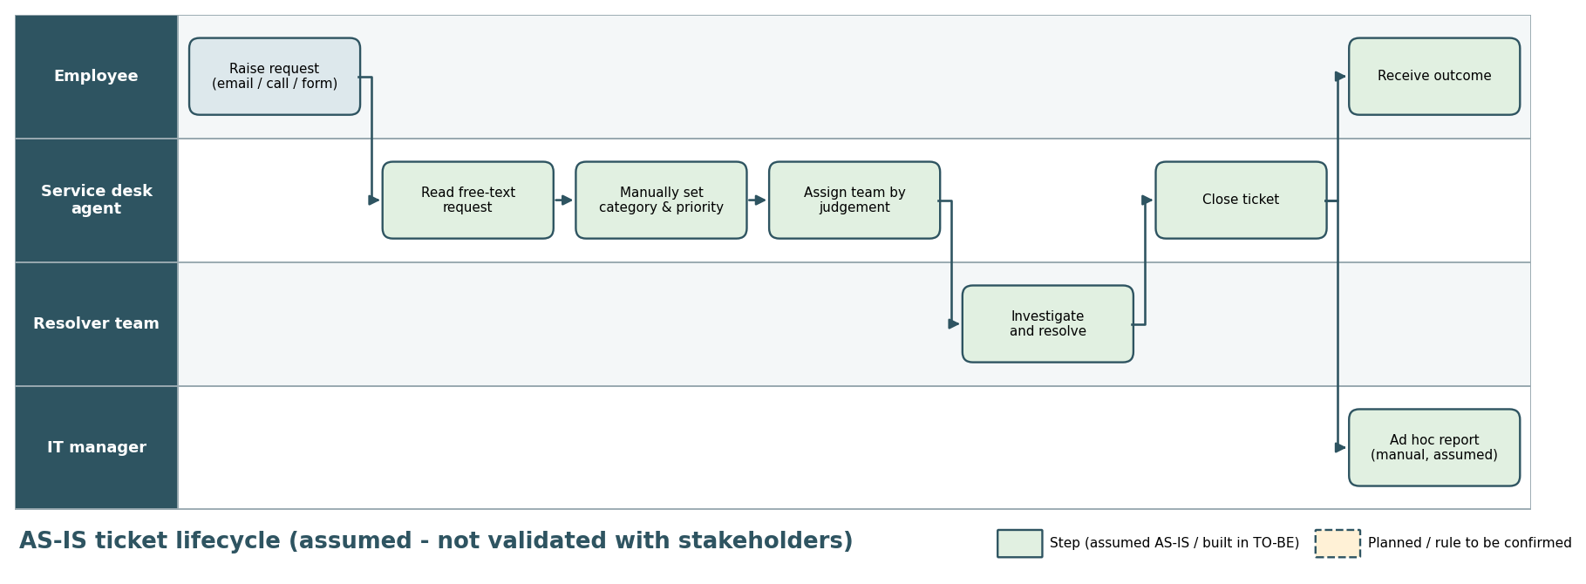

Proposed process
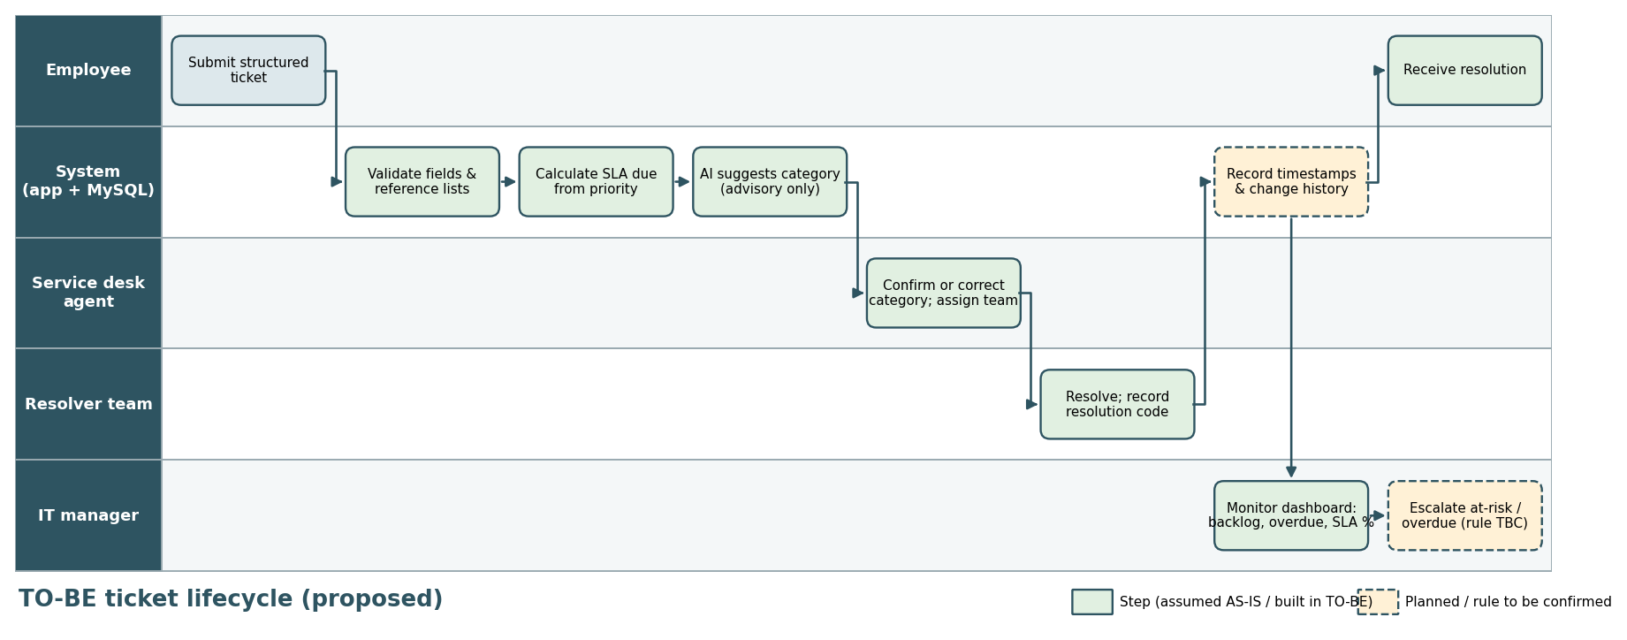

3. Gaps between today and the proposed process
ID | Area | Today (assumed) | Proposed | In my build | What to do
GAP-01 | Ticket data | Free text, mixed values | Fixed lists, checked | Lists in the form only; server accepts any text | Check values on the server
GAP-02 | SLA time | Unclear | Automatic | Works, but an unknown priority fails quietly | Show an error (DEF-01)
GAP-03 | SLA clock | Unknown | Business hours | Clock hours only | Ask the SLA owner (CR-02)
GAP-04 | Reopened tickets | Not tracked | Counted | Count never goes up | Fix status update (DEF-03)
GAP-05 | History | None | All changes saved | Table exists, empty | Build it later (CR-01)
GAP-06 | Real users | Not asked | Needs confirmed | All assumed | Do interviews

4. Data

4.1 Tables
Table | What it holds
support_tickets | The tickets (main table)
categories, priorities, departments, support_teams | The allowed values for the lists
sla_policies | SLA hours for each priority
ticket_history | Change history (empty for now)
vw_ticket_kpis (view) | Adds resolution hours, first response hours and SLA status to each ticket. Power BI reads from this.
The category, priority, department and team in a ticket are saved as plain text and are not linked to the list tables with foreign keys. That is why the database cannot stop a wrong value (GAP-01). Adding foreign keys would fix this.

4.2 Main fields in support_tickets
Field | Meaning | Notes
ticket_id | Unique ID | Primary key
title, description | What the problem is | Required
category | Type of problem | 7 values, for example Hardware, Network, Password Reset
priority | How urgent | Critical, High, Medium, Low
department, assigned_team | Who asked and who works on it | Chosen from lists
status | Where the ticket is | Open, In Progress, Pending, Resolved, Closed
created_at | When it was created | Set by the system
first_response_at | First reply from an agent | The app does not set this (DEF-04)
resolved_at | When it was resolved | Used for resolution time and SLA
sla_due_at | Deadline | Created time + SLA hours
reopened_count | Times reopened | The app does not increase this (DEF-03)
resolution_code | Reason it was resolved | Not in the form (DEF-04)

4.3 Data checks
Check | Done by my script? | Result
Total ticket count | Yes | Dashboard shows 5,003; the data file has 5,000 (I added a few tickets by hand)
Resolved time before created time | Yes | To be confirmed
First response before created time | Yes | To be confirmed
Missing title / description / SLA due time | Yes | To be confirmed
First response after resolved time | No (could add) | 54 tickets in the data file have this problem

5. SQL queries and KPIs
My SQL file has nine queries. I wrote part of them myself.
ID | Query | Question it answers | Rule
Q-01 | Total tickets and backlog | How many tickets, how many open? | BRL-05
Q-02 | Monthly volume | How many tickets per month? | -
Q-03 | Resolution hours by category | Which categories take longest? | BRL-06
Q-04 | Resolved SLA compliance | Are resolved tickets on time? | BRL-03
Q-05 | Open overdue tickets | Which open tickets are late? | BRL-04
Q-06 | Backlog age | How old are open tickets? | BRL-05
Q-07 | Reopen rate | How many tickets are reopened? | BRL-07
Q-08 | Workload | How is work spread across teams? | -
Q-09 | Data checks | Is the data clean? | -

KPI | How it is calculated | Dashboard value
Total tickets | Count of all tickets | 5,003
Open backlog | Tickets not Resolved or Closed | 2,304
Average resolution hours | Average (resolved - created), resolved tickets only | 31.88 hours
Resolved SLA compliance | On-time resolved / all resolved | 51%
Open overdue | Open tickets past their due time | 2,298
Reopen rate | Tickets reopened / all tickets | 15%

6. Dashboard
I built the Power BI dashboard myself. It has three pages and the same five filters on each page.
Page | What it shows | My review
Executive Overview | Four KPI cards and tickets per month | Good. The month chart mixes months from two different years, and its axis starts at 380 so the ups and downs look bigger than they are (DEF-05).
Operational Performance | Resolution hours by category, volume by category and priority, backlog age, team workload | Good. The horizontal bars for volume are a bit hard to read.
SLA and Improvement | Open overdue, SLA compliance, reopen rate, compliance by priority, list of overdue tickets | Good.

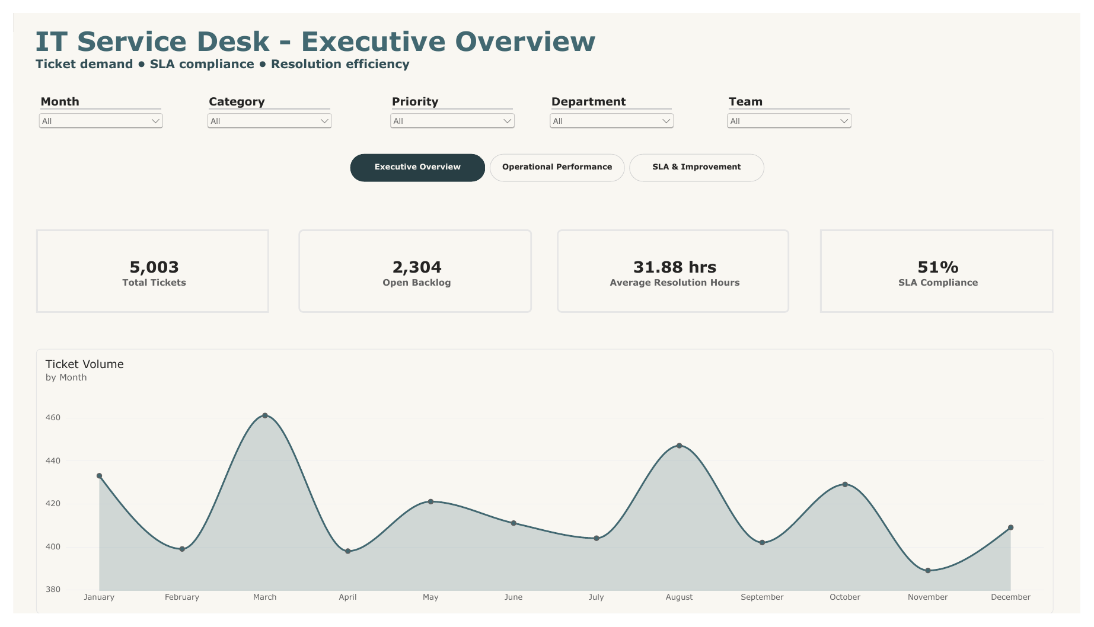
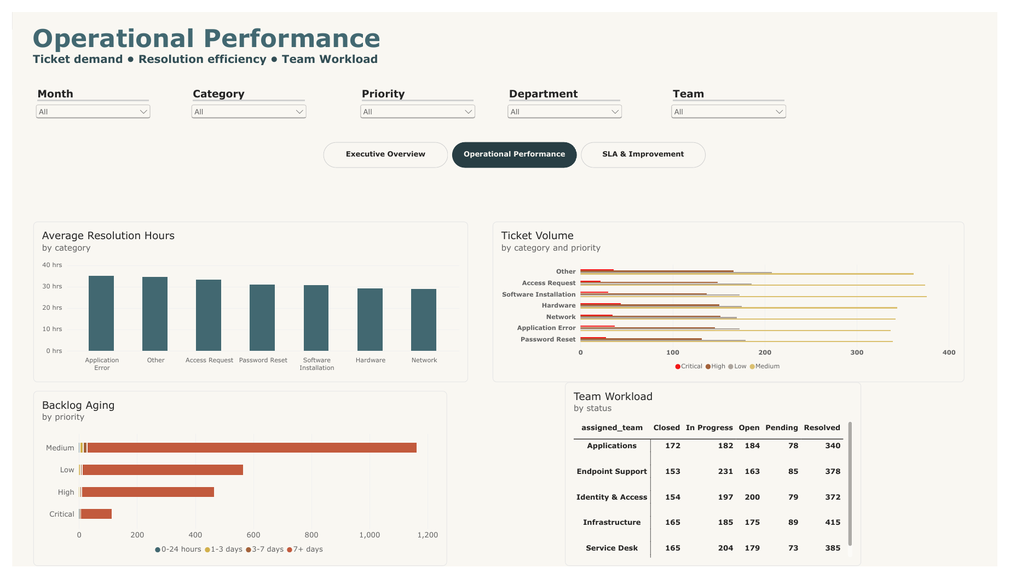
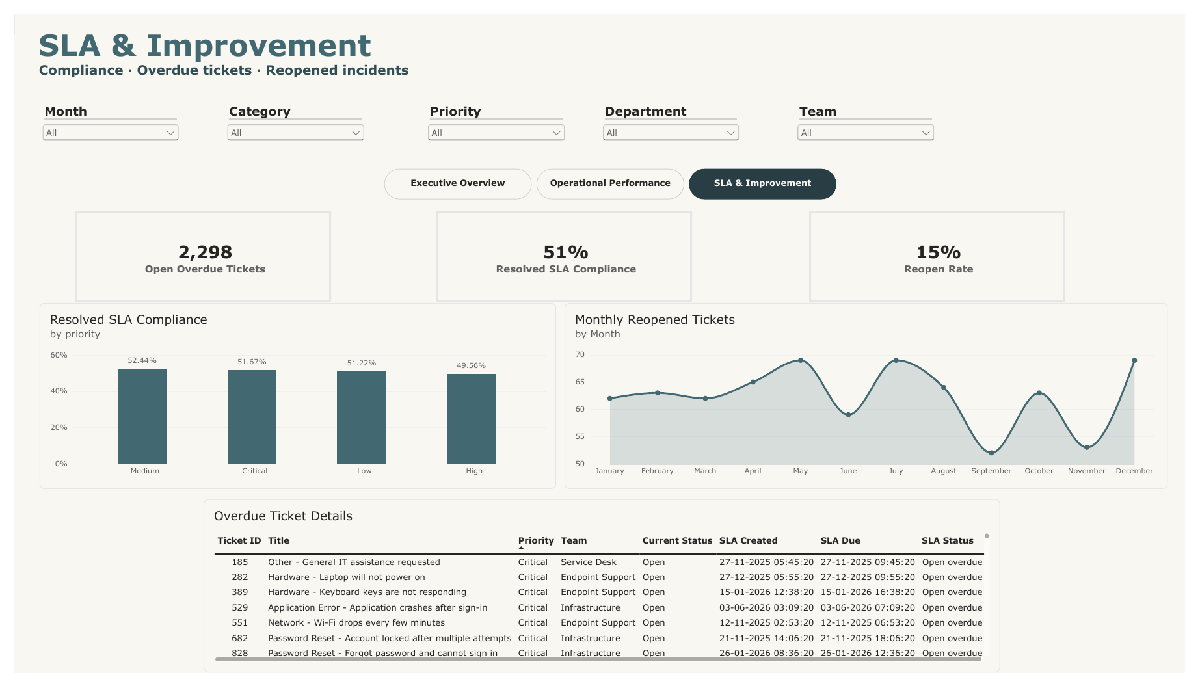

7. What to know about the made-up data
When I checked the data file, I found that some results come from how the data was created, so they are not real business findings:
- About 46% of tickets are still open, and almost all of them are overdue, because old tickets never got resolved in the data.
- SLA compliance is about 51% for every priority. The data was created so that about half of tickets meet the deadline.
- Resolution time is about the same for every category, because categories and teams were picked at random.
- There are only 14 different ticket descriptions. This is why the AI model looks perfect.
- 54 tickets have a first response after the resolved time.
So, these numbers prove that my calculations work, but they do not tell us anything about a real company.

